INNOMATICS RESEARCH LABS
Next Word Prediction using LSTM
Deep Learning / NLP Project Documentation
Sumit Mangalwedhekar | September 2026

1. Problem Statement
Natural Language Processing (NLP) powers predictive text systems, chatbots and virtual assistants. Next Word Prediction is a fundamental NLP task: given a sequence of words, the model predicts the most probable next word.
The objective of this project is to build a deep learning model using an LSTM (Long Short-Term Memory) network that predicts the next word in a sequence, and to use it for typing assistance and simple text generation.

2. Data Collection
The dataset is the full text of Pride and Prejudice by Jane Austen, downloaded directly from Project Gutenberg (a public-domain source) inside Google Colab. The Gutenberg header and licence footer were removed so that only the novel text remains.
Property | Value
Source | Project Gutenberg (public domain)
Text type | Classic English literature (novel)
Training sequences built | 121,209
Vocabulary size | 6,725 unique words (6,726 including the padding index)

Why this dataset: it is free, well-structured, needs no login, and is large enough to train an LSTM within Colab limits. Its limitation is that it is a single book with an old-fashioned writing style (see Section 6).

3. Data Preprocessing
The following steps were applied in order:
Step | What was done
Sentence splitting | Text split on . ! ? so training sequences never cross sentence boundaries
Text cleaning | Removed numbers, punctuation and special characters (kept letters only)
Lowercasing | All text converted to lowercase for uniformity
Tokenization | Keras Tokenizer maps each word to an integer index
N-gram sequences | For each sentence, every prefix becomes one sample (input words) with the following word as the target
Sequence length | Capped at 12 words (11 input words + 1 target) to keep training fast
Padding | Shorter sequences pre-padded with zeros to a uniform length of 11
Word embedding | Handled by a trainable Embedding layer (100 dimensions) inside the model

Stopword removal was skipped on purpose: a next-word model must learn to predict common words such as 'the', 'to' and 'had', which are a large part of natural text.
Data split: 121,209 sequences were divided 90% / 10% into 109,088 training and 12,121 validation samples (fixed random seed 42 for reproducibility).

4. Model Building

4.1 Architecture
Layer | Output Shape | Parameters
Embedding (vocab 6,726 → 100 dims) | (None, 11, 100) | 672,600
LSTM (256 units) | (None, 256) | 365,568
Dropout (rate 0.3) | (None, 256) | 0
Dense + Softmax (6,726 classes) | (None, 6726) | 1,728,582
Total trainable parameters |  | 2,766,750

The Embedding layer converts word indices into dense vectors, the LSTM captures the order of words (temporal dependencies), Dropout reduces overfitting, and the softmax layer outputs a probability for every word in the vocabulary.

4.2 Compilation and Training
Setting | Value
Loss function | Sparse categorical cross-entropy
Optimizer | Adam (initial learning rate 0.001)
Batch size | 256
Maximum epochs | 40
Early stopping | Monitor val_loss, patience 2, restore best weights
Learning-rate schedule | ReduceLROnPlateau (factor 0.5, patience 1)
Hardware | Google Colab, NVIDIA T4 GPU

Note on the loss: sparse categorical cross-entropy is mathematically the same as categorical cross-entropy, but it takes integer word labels directly. This avoids one-hot encoding a 6,726-word vocabulary for 100,000+ samples, which would use too much memory.

5. Model Evaluation

5.1 Metrics
Training stopped automatically at epoch 11. The best validation loss occurred at epoch 9, and those weights were restored, so the final model is the epoch 9 model.
Metric | Training (epoch 9) | Validation (final model)
Accuracy | 15.75% | 14.23%
Top-5 accuracy | 34.52% | 32.73%
Loss | 4.72 | 5.36
Perplexity | - | 211.65

Accuracy counts a prediction as correct only if the single most likely word matches the real next word. Top-5 accuracy counts it as correct if the real word is among the five most likely. Perplexity is e raised to the validation loss; lower is better.

5.2 Model Analysis
Training and validation curves move together for roughly the first 4 epochs. After that the validation loss flattens near 5.35 while the training loss keeps falling (4.49 by the last epoch), and the same gap appears in accuracy (about 17.1% training vs 14.7% validation). This widening gap is overfitting: the model is starting to memorise the training text. Validation loss was lowest at the 9th epoch (x = 8 in the plots, which count from 0), so early stopping restored those weights and ended training at epoch 11.
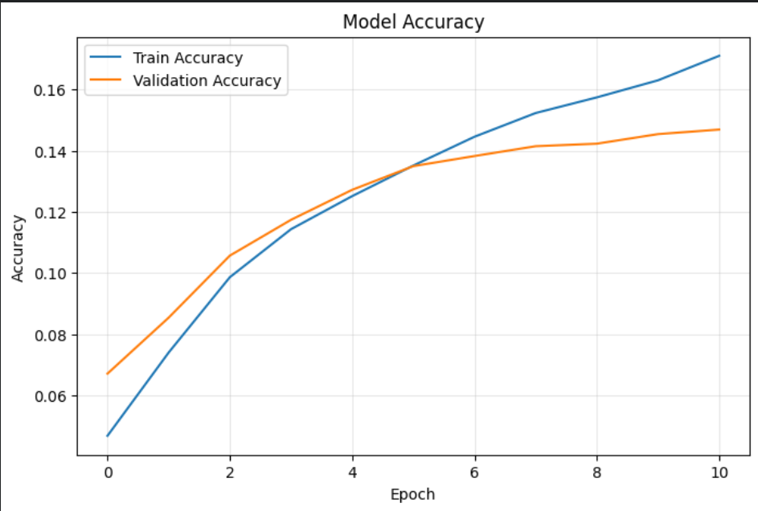
Figure 1: Training and validation accuracy per epoch (epochs counted from 0)
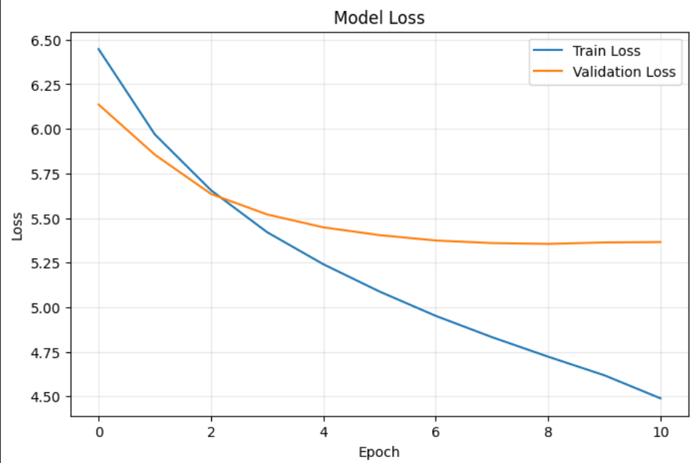
Figure 2: Training and validation loss per epoch (epochs counted from 0)

5.3 Sample Next-Word Predictions
Input text | Top 3 predictions (probability)
it is a truth universally | to (1.7%), said (1.3%), very (1.1%)
mr darcy was | to (5.9%), a (5.4%), the (2.6%)
elizabeth felt that she | had (26.1%), was (15.7%), could (8.8%)
i have not the pleasure of | the (6.7%), my (5.6%), his (4.2%)

5.4 Human Evaluation of Generated Text
Text was generated word by word from a short seed using temperature sampling (temperature 0.8, 15 words). Examples:
it is a truth of you who will not herself to another of qualities for i i believe him
mr bennet said elizabeth did she been a month s uncle and is in first four miles of
elizabeth was a second arrival was rather for in her and to the following miss hope do
she could not help him a second dear i will not add yourself for think my dear cousin but

Observations:
- Word choice matches the style and vocabulary of the novel (names such as Elizabeth and Mr Bennet, phrases such as 'my dear cousin').
- Short stretches are often grammatical (for example 'she could not help him', 'i will not add'), and the predictions are sensible where grammar strongly limits the options: after 'elizabeth felt that she' the model correctly favours 'had', 'was' and 'could'.
- Long-range coherence is weak. Generated sentences drift and do not form a complete meaning.
- Where many words are possible (for example after 'mr darcy was'), probabilities are spread thin and the top word has only about 6% confidence.

6. Limitations and Future Work
- Small corpus: one novel (about 120k training sequences) is not enough for fluent generation. Training on several books or a larger corpus such as Wikipedia would help most.
- Style bias: the model predicts 19th-century English and will not suit modern chat or typing assistance without modern training data.
- Model size: stacked or bidirectional LSTM/GRU layers, pre-trained embeddings (GloVe or Word2Vec), or a Transformer could improve accuracy.

7. Conclusion
An LSTM-based next-word prediction model was built end to end: data collection, preprocessing, model building, training and evaluation. On the validation set the model reaches 14.2% top-1 accuracy, 32.7% top-5 accuracy and a perplexity of about 212. These are reasonable results for a single-book corpus. The model learns the vocabulary and local grammar of the text, but generation quality is limited by the small dataset.

Tools and Files
Python, TensorFlow/Keras, NumPy, scikit-learn, Matplotlib, Google Colab (T4 GPU).
Saved artifacts: next_word_model.keras (trained model), tokenizer.pkl (word-index mapping), config.pkl (sequence length).

