Size of data is 143285 and it contain 147 variable . Created some variable for better analysis so the number of variable increased to 164 . For analysis age below 24 years is omitted. Data for analysis contain age above 24 years .

**Participation in financial markets along the life cycle**

Spilt liabilities into five categories

* Secure loan
* Other debt
* Unsecure loan
* Mortgage debt
* Gold loan

Below figures show the participation in financial market along the life cycle. Below figures report the shares of population that hold positive amounts of different asset and debt

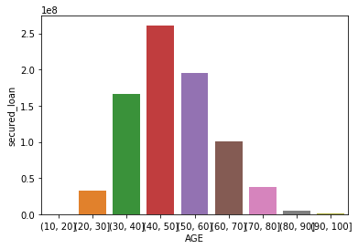

Above figure shows that secured loan is highest during the age group of 40-50 . Initially it start increasing with age but after the age group of 40-50 it start declining .

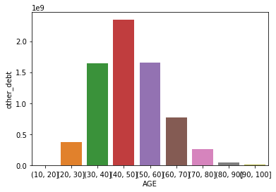

Above figure shows that other debts are highest during the age group of 40-50 . Initially it start increasing with age but after the age group of 40-50 it start declining .

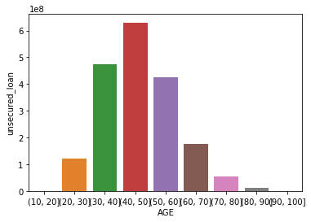

Above figure shows that unsecured loan are highest during the age group of 40-50 . Initially it start increasing with age but after the age group of 40-50 it start declining

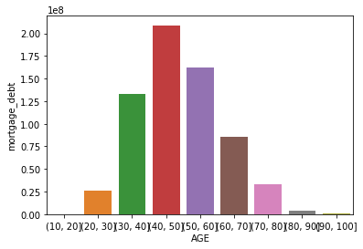

Above figure shows that mortgage loan is highest during the age group of 40-50 . Initially it start increasing with age but after the age group of 40-50 it start declining .

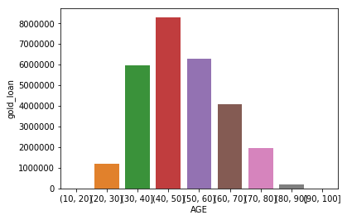

Above figure shows that gold loan is highest during the age group of 40-50 . Initially it start increasing with age but after the age group of 40-50 it start declining .

Split assets into four categories :

* Gold
* Real Estate
* Financial Asset
* Durable Asset

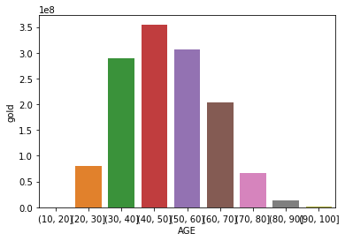

Above figure shows that gold is highest during the age group of 40-50 . Initially it start increasing with age but after the age group of 40-50 it start declining .

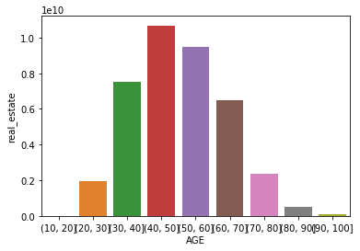

Above figure shows that real estate is highest during the age group of 40-50 . Initially it start increasing with age but after the age group of 40-50 it start declining .

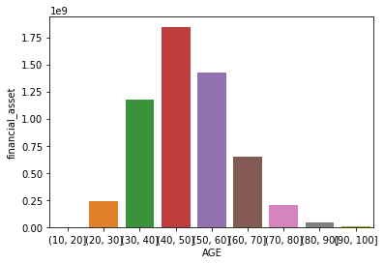

Above figure shows that financial asset is highest during the age group of 40-50 . Initially it start increasing with age but after the age group of 40-50 it start declining .

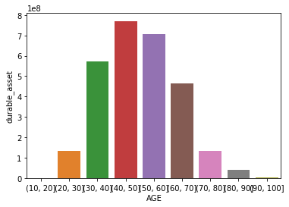

Above figure shows that durable asset is highest during the age group of 40-50 . Initially it start increasing with age but after the age group of 40-50 it start declining .

**Balance sheet allocation of household assets**

Below figures show balance sheet allocation of household assets. Below figures report average share of different asset classes relative to total household wealth.

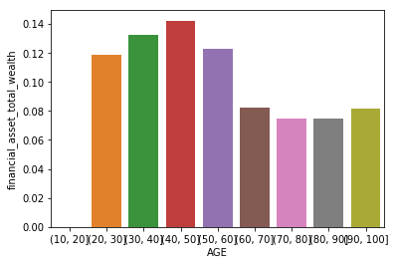

Above figure shows that average financial asset relative to total wealth is highest during the age group of 40-50 . Initially it start increasing with age but after the age group of 40-50 it start declining and stay steady after that.

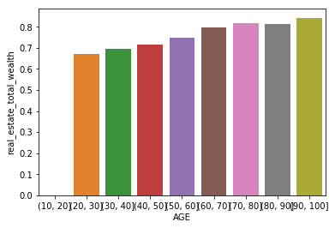

Above figure shows that average real estate relative to total wealth increases with age.

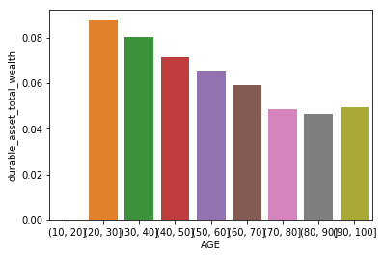

Above figure shows that average durable asset relative to total wealth is highest during the age group of 20-30 . After the age group of 20-30 it start declining and stay steady after that.

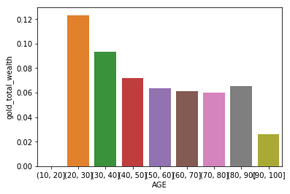

Above figure shows that average gold relative to total asset is highest during the age group of 20-30 . After the age group of 20-30 it start declining and stay steady after that.

**Key factors that lead to participation and allocation in formal financial market**

Create a new variable i.e. participation , assign value 1 if household participate and allocate in formal financial market and assign value 0 if household does not participate and allocate in formal financial market.

Participation and allocation in formal financial market using XGBClassifier

Model achieves about 64.09% accuracy

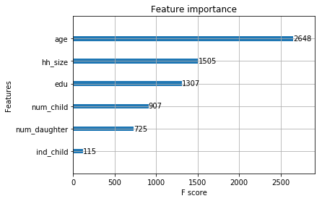

Above figure shows important features that lead to participation and allocation in formal financial market.

It is clear from above figure that **age** is most important feature that lead to participation and allocation in formal financial market.