**Palm Recognition System (Palmistry)**

Enrolment No.(s) : 12103530,12103528,12103509

Name of Student(s) : Sumit Bansal, Vrishti Gahlaut, Aman Singhal

Name of Supervisor(s): Mr Manish Kumar Thakur

Mrs Somya Jain



June-2016

Submitted in partial fulfilment of the Degree of

Bachelor of Technology

In

Computer Science Engineering

Department of Computer Science Engineering and Information Technology

Jaypee Institute of Information Technology, NOIDA

**(I)**

**TABLE OF CONTENTS**

**Chapter No. Topics Page No.**

Student Declaration II

Certificate from the Supervisor III

Acknowledgement IV

Summary V

List of Figures VI

List of Tables VII

List of Symbols and Acronyms VIII

**Chapter 1** **Introduction** 1-2

1.1 General Introduction

1.2 List some relevant current/open problems.

1.3 Problem Statement

1.4 Overview of proposed solution approach and Novelty/benefits

**Chapter 2** **Background Study** 3-8

2.1 Literature Survey

2.1.1 Summary of papers

2.1.2 Integrated summary of the literature studied

2.2 Details of Empirical Study

**Chapter 3 Analysis, Design and Modeling**  9-13

3.1 Overall Description Of The Project

3.2 Functional requirements

3.3 Non Functional requirements

3.4 Design Documentation

3.4.1Use Case diagrams

3.4.2 Control Flow Diagrams

3.4.3 Activity diagrams

**Chapter-4 Implementation Details And Issues** 14-24

4.1 Implementation details and issues

4.1.1 Implementation Issues

4.1.2 Data Structures and Algorithms / Protocols

4.2 Risk Analysis and Mitigation Plan

**Chapter-5 Testing** 25-30

5.1 Testing Plan

5.2 Component decomposition and type of testing required

5.3 List all test cases in prescribed format

5.4 Limitations of the solution

**Chapter-6 Findings & Conclusion** 31-32

6.1 Findings

6.2 Conclusion

6.3 Future Work

References 33

Appendices 34

Brief Bio-data 35-41

**(II)**

**DECLARATION**

We hereby declare that this submission is our own work and that, to the best of my knowledge and belief, it contains no material previously published or written by another person nor material which has been accepted for the award of any other degree or diploma of the university or other institute of higher learning, except where due acknowledgment has been made in the text.

Place: Noida Signature: ___________

Date: 07-04-2016 Name: Sumit Bansal

Enrollment No: 12103530

Signature: ___________

Name: Vrishti Gahlaut

Enrollment No: 12103528

Signature: ___________

Name: Aman Singhal

Enrollment No: 12103509

**(III)**

**CERTIFICATE**

This is to certify that the work titled **“PALM RECOGNITION SYSTEM**” submitted by **“Sumit Bansal , Vrishti Gahlaut and Aman Singhal”** in partial fulfillment for the award of degree of Bachelors of Technology (Computer science engineering) of Jaypee Institute of Information Technology University, Noida has been carried out under my supervision. This work has not been submitted partially or wholly to any other University or Institute for the award of this or any other degree or diploma.

Signature of Supervisor ____________

Name of Supervisor Dr.Manish Kumar Thakur

Designation Assistant Professor (Senior Grade)

Signature of Supervisor ____________

Name of Supervisor Mrs Somya Jain

Designation Assistant Professor (Grade-I)

Date 07-04-2016

**(IV)**

**ACKNOWLEDGEMENT**

This project consumed huge amount of research and dedication. Implementation would not have been possible if we did not have support of many individuals and organizations. Therefore we would like to extend our sincere gratitude to all of them.

We would like to thank our mentor, Mr. Manish Kumar Thakur and Ms Somya Jain for their continuous guidance and support and providing necessary information for our project. We would also like to thank JIIT staff members for helping us in different ways.

Nevertheless, we express our gratitude toward our families and colleagues for their kind co-operation and encouragement which help us in completion of this project.

Signature of the Student _____________

Name of Student Vrishti Gahlaut

Enrollment Number 12103528

Date 07-04-2016

Signature of the Student _____________

Name of Student Sumit Bansal

Enrollment Number 12103530

Date 07-04-2016

Signature of the Student _____________

Name of Student Aman Singhal

Enrollment Number 12103509

Date 07-04-2016

**(V)**

**SUMMARY**

The Project titled “Palm Recognition System” with the aim of implementing key concepts in Data Mining was found to meet all objectives. Utmost care has been taken to see that the results obtained are true and the underlying procedures are implemented in true form. The aim of this project is to present a novel software based selection method that can be used by anyone to get predictions by scanning only the image of their hands. It provides a User-Friendly way to select the lines they want to interpret for future predictions. We have used as our basic and core algorithm for computing and predicting the result. The proposed method will provide a novel way to read lines in an affective budget friendly way.

__________________ __________________

Signature of Student Signature of Supervisor I

Name: Sumit Bansal Name: Dr.Manish Kumar Thakur

Date: 07-04-2016 Date: 07-04-2016

__________________ __________________

Signature of Student Signature of Supervisor II

Name: Vrishti Gahlaut Name: Mrs. Somya Jain

Date: 07-04-2016 Date: 07-04-2016

__________________

Signature of the Student

Name: Aman Singhal

Date: 07-04-2016

**(VI)**

**LIST OF FIGURES**

|  |  |
| --- | --- |
| **Figure No.** | **Title** |
| 1 | Canny Image Detection |
| 2 | Use case diagram |
| 3 | Control flow diagram |
| 4 | Activity diagram |
| 5 | Weighted Inter-Relationship Graph |
| 6 | GUI of Palmistry |
| 7 | Canny Edge Detection Method Applied |
| 8 | Edges of Palm |
| 9 | Add new data of person |
| 10 | Calculate Ratios & Predicting |

**(VII)**

**LIST OF TABLES**

|  |  |
| --- | --- |
| **Table No.** | **Title** |
| 1.1-1.11 | Summary of papers |
| 2 | Integrated summary of the literature studied |
| 3 | Risk analysis |
| 4 | Prioritizing Risk Areas as per IG Graph |
| 5 | Risk Enumeration |
| 6 | Testing Strategy |
| 7 | Test Tam Details |
| 8 | Test Schedule |
| 9 | Type of Testing |
| 10 | Black Box Testing |

**(VIII)**

**LIST OF SYMBOLS AND ACRONYM**

|  |  |
| --- | --- |
| **Acronyms** | **Description** |
| K | Number of clusters |
| IEEE | Institute of Electrical and Electronics Engineers |

**CHAPTER 1**

**INTRODUCTION**

**1.1 General Introduction**

Palmistry has changed very little over the years. For thousands of years, in diverse cultures, people have believed that an individual's destiny is previewed in the hands. Some people believe that every palm holds, in its own unique network of lines and markings, the key to life's potential. Palmistry can be used as a tool to enhance ones view on life. A palm reading can open your eyes to characteristics you may be unaware of. Palm readers usually compare the subject's right and left hand, looking for differences. A dominant hand can reveal choices the person has made and what may lie ahead for them.

**1.2 Some Relevant Current / Open Problems**

Palm reading and analyzing the past, present and future has been increasingly in demand since the last decade. Needless to say that with everything going digital ,a lot of platforms are trying to bring technical system for the same. No algorithm or mathematical model till now has been able to predict 100% correct future or past of a person. So every researcher is trying to add extra attributes, devising new methods and possibilities to improve this ratio . In Traditional System there are doctors who can predict the diseases based on the lines but they require more time & also they get poor result. The previously stated works and other simple studies have obviously demonstrated the need to propose and create a good model for the analysis. Every new research in this field bring about a variety of possibilities to be manipulated ,used or mixed with different parameters to get a new and better result.

**1.3 Problem Statement**

Palmistry deals with studying the lines , their lengths and ratios. As stated earlier in older times the manual calculation of ratios was not always correct .Let alone common man could not differentiate the frauds from the learned .The validation of any universal rule made during the ancient time does not exist even in the modern time. The problem is “Pattern Classification in the field of palmistry and validation of traditional rules.”

.

**1.4** **Overview of proposed solution and Novelty/Benefits**

We will solve the problem in various steps starting from data extraction, data sorting, classification, calculating ratios and finally making predictions. There have been a lot of work done in this area but each research is majorly based on three lines-education, head and brain line. Then we predict that this ratio is good ,average or bad on the basis of previous data. If the prediction correlates with the reality the rule for prediction is validated however if it does not it proves that not all rules of prediction are precise.

Until now no one has made efforts to validate the rules of palmistry and thus this branch of astrology has always been a victim of faith despite being accurate a lot of times. We will apply data mining algorithms to calculate the clusters inorder to decide the ranges and predict about performance in that particular area.

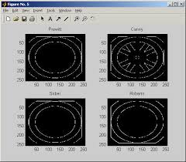

**Figure 2 – Canny Image Detection**

**CHAPTER 2**

**BACKGROUND STUDY**

**2.1 Literature Survey**

**2.1.1 Summary of papers**

**PAPER 1**

|  |  |
| --- | --- |
| **Title** | Application of Digital Image Processing and Analysis in Healthcare Based on Medical Palmistry |
| **Authors** | Mr. D.Thirumal Reddy M.Tech, Mr. P.Balaramudu M.Tech |
| **Year of Publication** | 2015 |
| **Publication Details** | International Journal for Development In Computer Science and Technology |
| **Summary** | In this paper, an application of digital image processing and analysis techniques has been discussed, which can be useful in healthcare domain to predict some major diseases for human being. Discussion on the steps involved in image processing is given.Also a short description on patterns important in palmistry is published. |
| **Web Link** | http://ijdcst.com/pdf/Application%20of%20Digital%20Image%20Processing%20and%20Analysis%20in%20Healthcare%20Based%20on%20Medical%20Palmistry.pdf |
| Table 1.1: Research paper 1 | |

**PAPER 2**

|  |  |
| --- | --- |
| **Title** | Study and Comparison of Various Image Edge Detection Techniques |
| **Authors** | Dr..Raman Maini ,Dr. Himanshu Aggarwal | |
| **Year of Publication** | 2009 | |
| **Publication Details** | International Journal of Image Processing (IJIP), Volume (3) : Issue (1) | |
| **Summary** | Edges characterize boundaries and are therefore a problem of fundamental importance in image processing. Image Edge detection significantly reduces the amount of data and filters out useless information, while preserving the important structural properties in an image. Since edge detection is in the forefront of image processing for object detection, it is crucial to have a good understanding of edge detection algorithms. In this paper the comparative analysis of various Image Edge Detection techniques is presented. | |
| **Web Link** | http://people.ucalgary.ca/~dasaid/CPSC535/lab10/IJIP-15.pdf | |
| Table 1.2: Research paper 2 | | |

**PAPER 3**

|  |  |
| --- | --- |
| **Title** | Automated Medical Palmistry System based on Image Processing Techniques |
| **Authors** | Ms.Disha Desai, Mrs.Mugdha Parekh, Mr.Devanshi Shah, Prof. Vinaya Sawant, Prof. Anuja Nagare |
| **Year of Publication** | November, 2014 |
| **Publication Details** | International Journal of Advanced Research in Computer Science and Software Engineering |
| **Summary** | Palmistry is the art of characterization and foretelling the future through the study of the palm, also known as palm reading, or chorology. Palm lines and fingers are useful for recognizing the characteristics of a person and to foretell his future. This paper describes an application of digital image processing and analysis technique. This can be useful in healthcare domain to predict diseases for human being. The images of human palm form input to the system. Then, system applies digital image processing techniques on input images to identify certain features in the image and by using knowledge base of medical palmistry it analyzes certain features in image and predicts probable disease. |
| **Web Link** | <http://www.ijarcsse.com/docs/papers/Volume_5/1_January2015/V5I1-0287.pdf> |
| Table 1.3: Research paper 3 | |

**PAPER 4**

|  |  |
| --- | --- |
| **Title** | A Novel Approach for Hand Analysis Using Image Processing Techniques |
| **Authors** | Manish Kumar Thakur,Vishwaratana Nigam , Divakar Yadav |
| **Year of Publication** | 2010 |
| **Publication Details** | (IJCSIS) International Journal of Computer Science and Information Security, Vol. XXX, No. XXX, 2010 |
| **Summary** | With the help of palm lines and fingers one can know the characteristics as well as can foretell the future of a person but still this field is not much technically developed and a person has to analyze hands personally. In this paper we propose a ratio based system to characterize persons on the basis of their palm width-length and their finger length. We applied image processing techniques to generate and analyze the results. |
| **Web Link** | http://www.researchgate.net/profile/Divakar_Yadav2/publication/44288389_A_Novel_Approach_for_Hand_Analysis_Using_Image_Processing_Techniques/links/0deec5314033aa7ca0000000.pdf |
| Table 1.4: Research paper 4 | |

**2.1.2 Integrated summary of the literature studied**

|  |  |  |  |  |
| --- | --- | --- | --- | --- |
| S.No. | Title | Strength | Weakness | Feature |
| **1.** | Application of Digital Image Processing and Analysis in Healthcare Based on Medical Palmistry | A lot of prediction rules related to health have been researched in the paper. | Attributes like brain and education line have been neglected. | An application of digital image processing and analysis techniques has been discussed, which can be useful in healthcare domain. |
| **2.** | Study and Comparison of Various Image Edge Detection Techniques | .Image Edge detection significantly reduces the amount of data and filters out useless information, while preserving the important structural properties in an image. | Edges characterize boundaries and are therefore a problem of fundamental importance in image processing. | Comparative analysis of various Image Edge Detection techniques is presented. |
| **3.** | Automated Medical Palmistry System based on Image Processing Techniques | lines and fingers are useful for recognizing the characteristics of a person and to foretell his future. | Attributes like brain and education line have been neglected. | Applies digital image processing techniques on input images to identify certain features in the image and by using knowledge base of medical palmistry it analyzes certain features in image and predicts probable disease. |
| **4.** | A Novel Approach for Hand Analysis Using Image Processing Techniques | A new approach in this field | Edge detection is not focused. | a ratio based system to characterize persons on the basis of their palm width-length and their finger length. |

**Table 2**

**2.2 Details of empirical study**

1. **MATLALB**

(Matrix laboratory) is a [multi-paradigm](https://en.wikipedia.org/wiki/Multi-paradigm_programming_language) [numerical computing](https://en.wikipedia.org/wiki/Numerical_analysis) environment and [fourth-generation programming language](https://en.wikipedia.org/wiki/Fourth-generation_programming_language). A proprietary developed by [MathWorks](https://en.wikipedia.org/wiki/MathWorks), MATLAB allows [matrix](https://en.wikipedia.org/wiki/Matrix_(mathematics)) manipulations, plotting of [functions](https://en.wikipedia.org/wiki/Function_(mathematics)) and data, implementation of [algorithms](https://en.wikipedia.org/wiki/Algorithm), creation of [user interfaces](https://en.wikipedia.org/wiki/User_interface), and interfacing with programs written in other languages, including [C](https://en.wikipedia.org/wiki/C_(programming_language)), [C++](https://en.wikipedia.org/wiki/C%2B%2B), Java, Fortran and [Python](https://en.wikipedia.org/wiki/Python_(programming_language)).

**CHAPTER 3**

**ANALYSIS, DESIGN AND MODELLING**

**3.1 Overall Description Of The Project**

This project is aimed at creating a predictive and validating model for all. Using algorithms proposed in papers inclusive of the novel approach discussed earlier. The datasets of people ,their educational background, health and social background are used to create clusters using data mining algorithm. This will help us to calculate the range of the ratios .This range will help us know whether the calculated length ratio is good or bad. Then for the image readability we first convert it into a 2D matrix format .Once the image can be read we use the canny’s algorithm by using the same command as the name suggests. Now we will have an image with only edges and palm lines .After the palm lines are read and patterns are detected we need to calculate the ratios. These ratios will be analysed to see they fall under which category according to the previous data. The accuracy and performance of the particular palmistry rule will be measured. Lastly, if the prediction completely agrees with the reality this data will be added to the data set.

**Requirements Specification**

**Software Requirement**

1. Operating system: windows 7/10
2. Language: python

**Hardware requirement**

1. CPU: 500 MHz processor
2. Computer Processor: Intel i5 or Intel i3 core
3. Computer Memory: 500Mb or more
4. Graphics hardware: Not required
5. Network: No internet connection

**3.2 Functional Requirements**

**Functional Requirements**

1. Requirement ID R1.01

Title: Data Extraction

Description: This event extracts the required data from the

User along with the scanned image of the palm.

1. Requirement ID R1.02

Title: Feature selection

Description: This event selects the appropriate features for the

Classification of datasets extracted.

1. Requirement ID R1.03

Title: data classification

Description: This event classifies data using various proposed

Algorithms

1. Requirement ID R1.04

Title: Prediction

Description: This event will give the prediction based on the user input.

**3.3 Non-functional Requirements**

* 1. Safety Requirements - For the safety requirements nothing but an operation of weekly backups for the data should take place.
  2. Security and Privacy Requirements - There are no specific security requirements, anyone can access and use the information since it is for the public use.
  3. Reliability - The solution should provide reliability to the user that the product will run with all the features mentioned in this document and execute perfectly. It should be tested and debugged completely. All exceptions should be well handled.
  4. Accuracy - The solution should be able to reach the desired level of accuracy, also keeping in mind that this model is for implementing the concept of the project.

**3.5 Design Documentation**

**3.5.1 Use Case Diagrams**

<<extends>>

<<extends>>

<<extends>>

<<extends>>

**Figure 2 – Usecase Diagram**

**3.5.2 Control Flow Diagrams**

UI in Python

* Add New Person
* Browse Image
* Select Gender
* Update Model
* Predict
* Check Trend
* Report

Check

Trend

Update Model

Hand Image Selection

Predict Future

Gender

Male / Female

REPORT

**Figure 3 – Control Flow Diagram**

**3.5.3 Activity Diagrams**

Enter User data and Image

Convert the image in readable format and calculate length and width.

Make ranges for each field.

Make data set apply K-means algorithm for clustering.

Calculate the ratios and send for prediction

Display the result.

If it matches add the data to data set.

Select the section that needs to be predicted.

**User System**

**Figure 4 – Activity Diagram**

**CHAPTER 4**

**IMPLEMENTATION DETAILS AND ISSUES**

**4.1 Implementation Details and Issues**

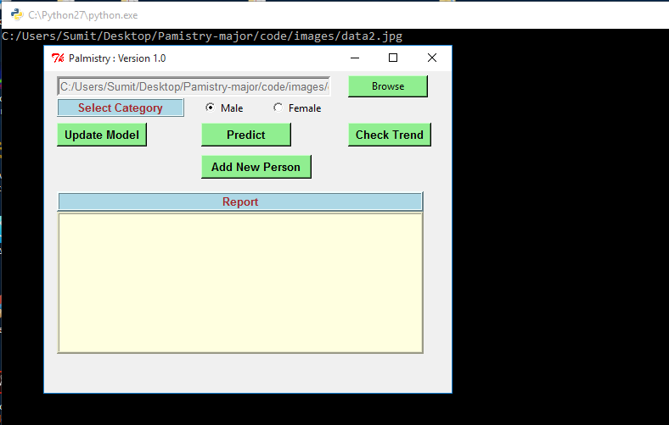

**Figure 6 – GUI of Palmistry**

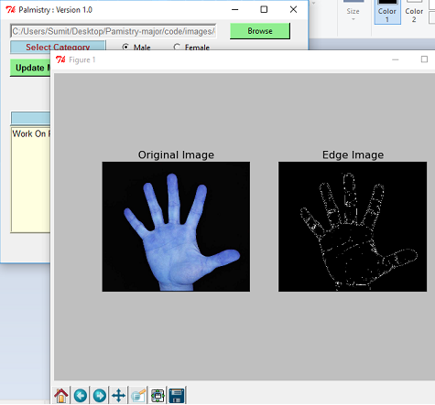

**Figure 7 – Canny Edge Detection Method Applied**

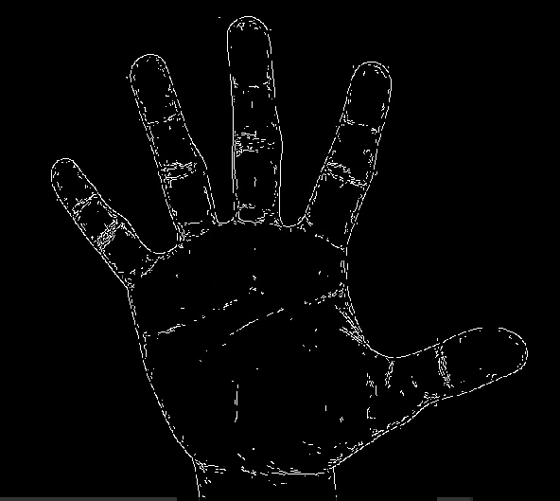

**Figure 8 – Edges of palm**

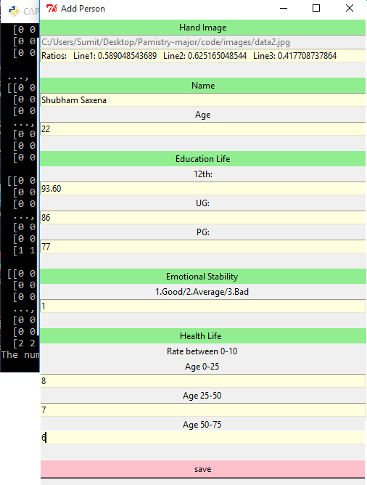

**Figure 9 – Add New Data Of Person**

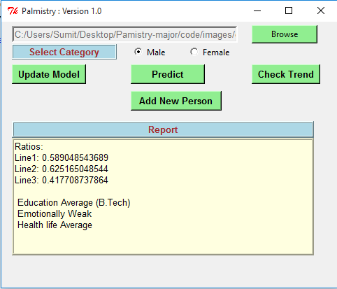

**Figure 10 – Calculate Ratios & Predicting**

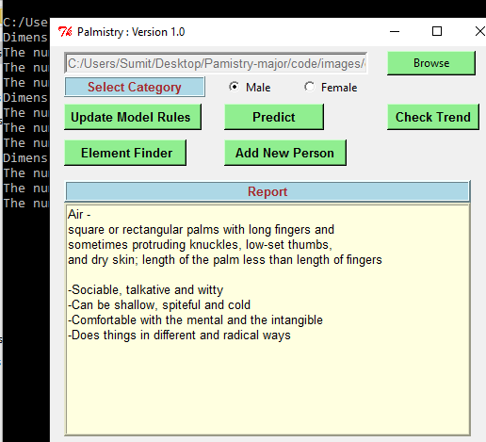

**4.1.2 Data Structure and Algorithms used**

There are many ways to perform edge detection. However, the most may be grouped into two categories, gradient and Laplacian. The gradient method detects the edges by looking for the maximum and minimum in the first derivative of the image. The Laplacian method searches for zerocrossings in the second derivative of the image to find edges. This first figure shows the edges of an image detected using the gradient method (Roberts, Prewitt, Sobel) and the Laplacian method (Marrs- Hildreth).

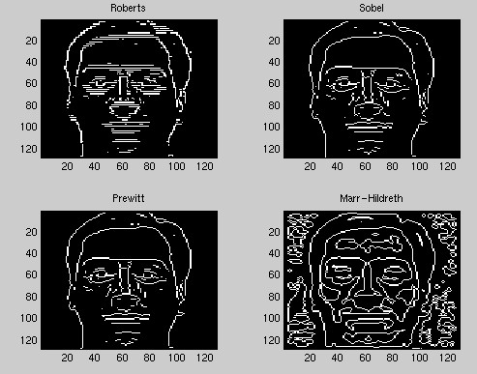

The **Canny edge detector** is an [edge detection](https://en.wikipedia.org/wiki/Edge_detection) operator that uses a multi-stage [algorithm](https://en.wikipedia.org/wiki/Algorithm) to detect a wide range of edges in images.

**Prediction**

After the palm lines are read and patterns are detected we need to calculate the ratios. These ratios will be analysed to see they fall under which category according to the previous data.

**Clustering**

For clustering we have use K-means algorithm using Euclidian Distance between the centroids and other points in the cluster. Initially k(number of clusters) points are randomly selected as centroids then the distance of all other points to these points is calculated and the closest centroid gets the respective point.In the next iteration new centroid are calculated by taking the average of the existing points in the cluster.Iteration is repeated until stable clusters are formed.

**4.2 Risk Analysis and Mitigation Plan**

Probability and Impact: 1- Low 3- Medium 5- High

|  |  |  |  |  |  |  |
| --- | --- | --- | --- | --- | --- | --- |
| **1** | **2** | **3** | **4** | **5** | **6** | **7** |
| **Risk Id** | **Classification**  **(Acc to SEI**  **taxonomy)** | **Description of**  **Risk** | **Risk Area** | **Probability** | **Impact** | **RE(R*I)** |
| 1 | Familiarity | Familiarity with the development process covers knowledge of experience in, and comfort with the prescribed process. Development of the project | Project Scope | 1 | 3 | 3 |
| 2 | Planning | The planning attribute addresses risks associated with the developing a well-defined plan. Requirement analysis of the project | Project Development | 3 | 3 | 9 |
| 3 | Stability | Change in the requirements. Development of more functionality since current combination may not give the desired result | Project Development | 3 | 5 | 15 |
| 4 | Maintainability | Engineering specialties. Coding standards are not followed. | Implementation | 3 | 3 | 9 |
| 5 | Validity | Misinterpretation of the requirements.  Development of wrong functionalities in the system | Performance | 1 | 5 | 5 |
| 6 | Product Control | Development Process. One of the requirements is not met. (Not Crawled every data set) | External Input | 3 | 5 | 15 |
| 7 | Environment | Integration and testing. Parts of the model not compatible with the software / Hardware. (External Tester only demo version) | Project Scope | 1 | 5 | 5 |
| 8 | Functionality | Algorithm selection. Selection of Algorithm feasible to the system | Performance | 1 | 5 | 5 |
| 9 | Testability | Testing Code not designed properly for testing | Testing | 3 | 3 | 9 |
| 10 | Unit Test | Preparation and planning for resources. Testing of the features | Testing | 3 | 3 | 9 |
| 11 | Coding | Inadequate systems properties. System properties do not match with tool’s requirements | Implementation | 1 | 5 | 5 |
| 12 | Suitability | Development process. Functionalities provided by the tool are not suitable | Project Development | 1 | 5 | 5 |
| 13 | Capacity | Development system. Large size of image can make the process slower | Performance | 3 | 5 | 15 |
| 14 | Usability | Development system. Tool developed may not be easy to use or understand | Performance | 1 | 3 | 3 |
| 15 | Planning | Project Management. One group member is not able to complete his/her work on time | Personal related | 3 | 5 | 15 |
| 16 | Project Organization | Project Management. One member does not implements the actual work assigned to him/her | Personal related | 3 | 5 | 15 |
| 17 | Functionality | Restricted input files.  Only text are allowed. | External Input | 5 | 3 | 15 |
| 18 | Performance | Efficient Design. Model may not be efficient on large text . | Performance | 3 | 5 | 15 |
| 19 | Difficulty | Functional requirements difficult to implement. Implementing cost estimation using regression | Implementation | 3 | 5 | 15 |
| 20 | Quality Assurance | It refers to keeping the quality of the project at its best always | Testing | 2 | 5 | 10 |
| 21 | Capacity | Risk associated with capacity of the insufficient processing power etc. | Project Development | 5 | 1 | 5 |

**Table 3 – Risk Analysis**

**C:\Users\Shubham\Downloads\Untitled Diagram.png**

**Figure 5 – Weighted Inter-Relationship Graph**

|  |  |  |  |  |  |
| --- | --- | --- | --- | --- | --- |
| **S.N.** | **Risk Area** | **# of Risk Statements** | **Weights(In + Out)** | **Total Weight** | **Priority** |
| 1 | Performance | 8 | 9+3+9+3+1+3+9+3 | 40 | 1 |
| 2 | Project Development | 6 | 9+3+3+9+1+3 | 28 | 2 |
| 3 | Implementation | 6 | 9+3+3+1+3+3 | 22 | 3 |
| 4 | Testing | 4 | 9+3+3+3 | 18 | 4 |
| 5 | Project Scope | 5 | 9+3+1+1+3 | 17 | 5 |
| 6 | External Inputs | 4 | 1+3+3+3 | 10 | 6 |
| 7 | Personnel Related | 3 | 1+3+3 | 7 | 7 |

**Table 4 - Prioritizing Risk Areas as per IG Graph**

|  |  |  |  |
| --- | --- | --- | --- |
| **Risk Id** | **Risk Area** | **Risk Statement** | **Priority of Risk Area in IG** |
| 13 | Performance | Large Size of text file can make the process slower but that will happen only once in a while during clustering. | 1 |
| 17 | External Inputs | Data files with right format are allowed for e.g. cs.txt | 6 |
| 10 | Testing of the features | Testing the code was a risk as the codes were on different platforms. So, the testing like integration testing was medium level risk analysis | 4 |

**Table 5 - Risk Enumeration**

**CHAPTER 5**

**TESTING**

Testing includes series of steps. The first step is making a test plan. A test plan is a document. Which describes ((i) Scope of testing, (ii) Approach used for testing, (iii) personal responsible for various stages of testing, (iv) Schedule of testing, (v) various guidelines and (vi) level of testing used for each unit of the software. Test cases and reports are generated for each unit of the product; and the reports are analyzed.

**5.1 Testing Plan**

|  |  |  |  |
| --- | --- | --- | --- |
| **Type Of Test** | **Performed?** | **Comments/Explanations** | **Software Components** |
| Requirements Testing | Yes | Requirement testing is done because it will let us know the needs and constraints of the project, which will eventually help us in the better development of the project. We have to estimate the time required, technology required, etc. for the project, so that we can properly start the project. | Python components |
| Unit Testing | Yes | Unit testing is the most important of all testing levels. It will help in finding the bugs during the progress of the project, which is much more economical to fix as compared to than after the completion of the project. | Python classes |
| Integration  Testing | Yes | Integration testing will be performed to verify functional, performance, and reliability requirements placed on major design items. It is required to test that all components within the group of units interact completely. | Integration testing is performed after unit testing taking as input the modules that have been unit tested, grouping it in larger aggregates, and then tested. |
| Performance | No | Performance testing is performed to determine how fast some aspect of a system performs under a particular workload. |  |
| Stress | No | Stress Testing is a form of testing that is used to determine the stability of a given system or entity. It involves testing beyond normal operational capacity, often to a breaking point, in order to observe the results. |  |
| Compliance | No | Compliance testing means checking the behavior of the system at run time to determine if it behaves as desired. |  |
| Security | No | Security testing is a process to determine that an information  System protects data maintain functionalities intended. |  |
| Load | Yes | Load Testing is important as this stage as we are dealing with real time data right now | Real time data extracted |
| Volume | Yes | Volume Testing belongs to the group of non- functional tests i.e. for non-functional requirements. It means testing a software application with a certain amount of data. This generally involves testing the software with a file. | Real Time data  extracted |

**Table 6 – Testing Strategy**

* **Requirement Testing:** For our project we had constraints like the file should be in the correct format else differentiating in data would be difficult.
* **Unit Testing:** We calculated the clusters and the ranges correctly that matches the data set as well.
* **Integration Testing:** We tested the rules of prediction on the people around for each line education,brain,health line.And found the results if results validate the reality.

**Test Team Details**

|  |  |  |
| --- | --- | --- |
| **Role** | **Name** | **Specific Responsibilities** |
| Test Designer | RV1 | 1. Ensure Phase 1 is delivered to schedule and quality. 2. Produce High level and Detailed Test conditions. 3. Ensure test system problems are reported immediately and followed up. |
| Tester | RV2 | 1. Identifying the appropriate techniques and guidelines to implement the required tests. 2. Analyzing the inputs, its effects and distinguishing clearly between the test cases. 3. Report progress at regular status reporting meetings. 4. Raise software error reports. |

**Table 7 – Test Team Details**

**Test Environment**

**Software Requirements**

We have done most of the testing manually as we don’t have license of the testing tools so we wrote the test cases the functionality of the application and then we try to remove the error.

**Hardware Requirements**

* Operating System : Windows 7 or windows 8 or above
* Computer Processor: Intel i5 or Intel i3 core
* Computer Memory: 500Mb or more

**Test Schedule**

|  |  |  |  |
| --- | --- | --- | --- |
| **Activity** | **Start Date** | **End Date** | **Hours** |
| Information Gathering | 20/08/2015 | 30/08/2015 | 5 |
| Test planning | 1/09/2015 | 15/09/2015 | 8 |
| Test Case Development | 1/10/2015 | 15/10/2015 | 10 |
| Test Execution | 18/11/2015 | 30/11/2015 | 20 |
| Implementation | 01/12/2015 | 22/11/2015 | 48 |

**Table 8 – Test Schedule**

**5.2** **Component decomposition and identification of tests required**

|  |  |  |  |
| --- | --- | --- | --- |
| **S.NO** | **List of various modules where testing is required** | **Type of testing required** | **Technique for writing the test cases** |
| 1. | Data Extraction | Requirement testing, Unit Testing, Integration Testing, Load testing,  Volume testing | White box testing and black box testing |
| 2. | Clustering application | Requirement testing, Unit Testing, Integration Testing | White box testing and black box testing |
| 3. | Calculating ratios | Requirement testing, Unit Testing, Integration Testing | White box testing and black box testing |
| 4. | Display of prediction | Unit Testing, Compliance testing | White box testing and black box testing |

**Table 9 – Type of Testing**

**5.3 Test Cases**

|  |  |  |  |  |
| --- | --- | --- | --- | --- |
| **Test Case Id** | **Module** | **Input** | **Expected output** | **Status** |
| 1. | Data Set | Available people | Data in txt file | Pass |
| 2. | Clustering the data set | Txt file | Clustered data with range | Pass |
| 3. | Calculating ratios | Image file | Ratios | Pass |
| 4. | Predicting the result | Ratios | prediction | Pass |

**Table 10 – Black Box Testing**

**5.5 Limitations of the Solution**

* Not possible if previous data is not available.
* User must be familiar with python environment.
* Only file in txt format compatible.
* The user is not clear about which area of palm is related to which prediction.

**CHAPTER 6**

**FINDINGS AND CONCLUSION**

**6.1 Findings**

1. Finding suitable datasets is the most important part as all the information and conclusions are drawn from the mining of the data we use. So in the absence of an appropriate dataset, we won’t find any significance results.

2. Although there are many predicting rules of palmistry only a few can be validated without any exception to it.

3. Our application runs on a Python application which unlike other techniques doesn’t demand very high system requirements

4. The project and the plots are quite self-explanatory, so even a user who doesn’t have much idea about the Data Mining can draw fair enough conclusions.

**6.2 Conclusion**

Predicting human’s past, present or future hundred percent accurately is an impossible task. Data mining algorithms can only predict it accurately to some extent. Also not every predicting rule is error proof. This newly developed model could help to validate the accuracy of each rule. Until now palmistry did not have a solid data set to prove if it correct but now slowly and gradually as the data set increases new trends will come into action. It is a simple and an accurate mathematical approach used for classification of ratios into good,average or bad category. This model will provide a mathematical fact for the fixation of certain value for a particular rule and also apply it. Not only will palmistry gain trust of people it will also be recognized as a mainstream research area with some solid results to back up the predictions. It will also save people to hire any astrologer, rather they can do this on their own, which also saves them from frauds and fake astrologers.

**6.3 Future Work**

* Validating more lines and rules.
* Increasing the dataset of already explored ones.
* Making plots more insightful for better comparisons.
* Making system more robust and scalable.
* More techniques for the visualization for the results.

**(IX)**

**References**

[1] Mr. D.Thirumal Reddy M.Tech, Mr. P.Balaramudu M.Tech “Application of Digital Image Processing and Analysis in Healthcare Based on Medical Palmistry” International Journal for development in Computer Technology, April, 2015.

[2] Dr.Raman Maini,Dr.Himanshu Aggarwal“Study and Comparison of Various Image Edge Detection Techniques” International Journal of Image Processing (IJIP), Volume (3) : Issue (1).

[3] Ms.Disha Desai, Mrs. Mugdha Parekh, Mrs.Devanshi Shah, Prof. Vinaya Sawant, Prof. Anuja Nagare “Automated Medical Palmistry System based on Image Processing Techniques” International Journal of Advanced Research in Computer Science and Software Engineering ,

[4] Dr. Manish Kumar Thakur, Mr.Thakur Vishwaratana Nigam ,Dr. Divakar Yadav “A Novel Approach for Hand Analysis Using Image Processing Techniques” (IJCSIS) International Journal of Computer Science and Information Security, Vol. XXX, No. XXX, 2010

[5] <http://www.wikihow.com/Read-Palms> - Deciphering the Lines , Identify the four major lines , Interpreting the Hands, Fingers, etc. , hand shape and elements.

**-**

**(X)**

**Appendix**

1. Project Plan (Work Break down structure)

1 Major Project

|  |  |
| --- | --- |
| **1.1** | **Research** |
| 1.1.1 | Data collection |
| 1.1.2 | Tabulating data |
| 1.1.3 | Algorithm implementation |

|  |  |
| --- | --- |
| **1.2** | **Project Requirements** |
| 1.2.1 | Software Installation |
| 1.2.2 | Hardware requirements |
| 1.2.3 | Functional requirements |
| 1.2.4 | Non-functional requirements |

|  |  |
| --- | --- |
| **1.3** | **Coding** |
| 1.3.1 | Data Set clustering |
| 1.3.2 | Tabulating data |
| 1.3.3 | Algorithm implementation |

|  |  |
| --- | --- |
| **1.4** | **Testing and Analyzing** |
| 1.4.1 | Analyzing output |
| 1.4.2 | Testing performance |
| 1.4.3 | Fixing errors |

**VRISHTI GAHLAUT**

**Phone no**:8585927154

**Email**:vrishti13@gmail.com

6th Semester Undergraduate,B.Tech

Computer Science and Engineering,

**Jaypee Institute of Information Technology.**

OBJECTIVE: Learning and understanding my professional role by utilizing my managerial, technical and creative skills for the benefit of the firm .

EDUCATION:

|  |  |  |  |
| --- | --- | --- | --- |
| B.tech  (6th semester)  Computer Science | Jaypee Institute Of Information Technology,Noida | 2012-and still pursuing | CGPA:  8.3/10.0 |
| CLASS 12th | Delhi Public School,kalyanpur,Kanpur | 2011 | 91.6% |
| CLASS 10th | St.Thomas School,Kanpur | 2009 | 92% |

PROJECTS:

* **IPV4 Network Monitoring Tool**( **Intern at Department of C.S.E. I.I.T. Kanpur**):The tool has been designed for TCP (Transmission Control Protocol), UDP (User Datagram Protocol) .It traces timestamp, source IP, destination IP, source port, destination port and packet length. To keep the track record of all the communication and all the data transfer taking place, we need various network tools.
* **Chat Over Donut(A mobile application):** This is an android based application .Using this a person can chat in three ways namely :via Inboxing(the receiver does not need to have this application),via Bluetooth(the receiver needs to have the application),via mail.There is also a gaming section.
* **Pacman (A gaming application):** An algorithm based project implementing algorithms like shortest path dijkastra’s , greedy .The player can control the pacman while it is chased by his six enemies .Different enemies use different algorithm to chase pacman. If pacman is touched by any enemy it dies.
* **City Help Center(A DS based project):** This project was made in a group of four members ,C programming language was used.It aims at leading a person to his nearest possible destination .It constitutes of maps, entertainment section ,library that has details of various books.

SMALLER SOLO PROJECTS:

(Android Based):

* Basic calculator
* Snake game
* Tic Tac Toe game
* DrawBoard

AREA OF INTEREST:

* Data Structures
* Algorithm

AIDED SKILLS AND ACHIEVEMENTS:

* Declared GOOGLE STUDENT AMBASSADOR for year 2014-2015.There were only 75 students from **all over India** declared as GSA’s for that particular year.
* Coordinator of Knuth Programming Hub (2014-2015) (JIIT Programming Hub), organized several algorithm based coding competitions and events throughout the year.
* Qualified Facebook Hacker Cup’s first round .
* Won High Commendation Award, Certificate Of Merit, Special Recognition in YP.
* Bluetooth Chat Application Certified by BRICS (ran by ex- IITians).Web based application Certified by NIIT.
* Ranks 2nd (in girl ranking),35th (allover college)in the institution based ranking on Codechef.
* Currently ranked 2565 in India and 3547 in world ranking on Codechef.

**Sumit bansal**

203 , Rameshwar Dham ,

Opposite Kedia Palace , Murlipura ,  **Phone**: +91-8447502000

Jaipur , Rajasthan - 302039 **E-mail**:sumitbansal291994@gmail.com

|  |
| --- |
| **OBJECTIVE** |

A Computer Science undergraduate seeking opportunities to work in an environment which can provide me a platform to solve challenging industrial problems with an efficient solution, learn and innovate , improve upon my technical skills , and enhance my personality.

|  |  |  |  |
| --- | --- | --- | --- |
| **EDUCATIONAL QUALIFICATIONS** | | | |
|  |  |  |  |
| **Year** | **Degree/Certificate** | **Institute/School** | **Scores** |
| 2015  7th Sem | B. Tech.  (Computer Science Engineering) | Jaypee Institute of Information Technology, Sec-62,Noida,up. | 8.1 |
| 2011 | 12th Board(RBSE) | N.K. Public School, Jaipur | 78.46 % |
| 2009 | 10th Board(RBSE) | N.K. Public School, Jaipur | 88.50 % |

|  |
| --- |
| **AREA OF INTEREST** |

* Algorithms.
* Data Structures.
* competitive programming.
* **Eager to learn new things.**

**ACADEMIC CERTIFICATIONS**

|  |  |
| --- | --- |
| **Certifications**  **&**  **Achievements** | * Currently **ranked 546** in India on **codechef.com**. Solved more than **100+ problems**.   Username: **bitbyte** (As of Sep 2015).   * Currently **ranked 539** in world on **Interviewbit.com.**   Username: **bitbyte** (As of July 2015)   * Honorable mention **in ACM-ICPC Kanpur 2013**. * Honorable mention in **ACM-ICPC Amritapuri 2013**. * **Ranked 1st** in **Execute 13.2** , intra-college competition **at JIIT,Noida , Mar 2013**. * **Ranked 1s**t in **Knuth entrivista**, intra-college competition at **JIIT , noida , Mar 2014.** * **Top 100** **in Code-sprint** (Hackerrank all india level coding compitition). * **Semi-finalist** of **TCS-codevita** (Tcs coding compitition). * Qualified for Online Round 1 of **Google Code Jam 2015.** * Qualified for **Facebook Hacker Cup.** * Qualified for online Round 2 Elimination of  **CodeChef SnackDown 2015.** * **PcRemote** android application certificate. * Certificate of participation in **SAP Techniversity** Event. * Certificate of excellence in **Rio+21 IYWC india certification Program** (Excellence Grade **A** ). |

|  |
| --- |
| **Technical skills** |

* **Programming/Designing/Database languages:**

C, C++, Java.

Android , Python. (Beginner)

* **Operating Systems**: Linux, Windows.

|  |
| --- |
| **POSITIONS OF RESPONSIBILITY** |

* Coordinator of Knuth Programming Hub (2014-2015) (JIIT Programming Club), organized several algorithm based coding competitions and events in Impressions’14 (JIIT annual fest).
* Member of Organizing Committee of ICCC Conference.

|  |
| --- |
| **PROJECTS** |

**Research Intern at Department of C.S.E. I.I.T. Delhi :** (May 2015 – July 2015)

A **Machine Learning** based live project of All India Institute of Medical Sciences (A.I.I.M.S.) under Professor **K.K. Biswas , IIT-DELHI**. The project involves training of weekly obtained body parameters (Temperature, IBI, Heart Rate , etc ...) of doctors and nurses to obtain a report whether a person is worthy for performing his/her duty on a particular day or on a particular case . The system is fully automated and the data is trained using SVM . The project is made in python.

**PcRemote:** (ANDROID APPLICATION)( Sept 2014 -Dec 2014)

An Android based mobile application, by which we can connect a mobile device to a computer and control the computer remotely. The app has options to shutdown, Restart, Volume up/down/mute, Lock screen, play media, create file and delete files on the computer. Apart of these, the app can be used to give any system command to be executed by the computer. This whole process is facilitated by a java program pre-installed on the computer.

**FreeDom :** (WEB DEVELOPMENT)( Sept 2014 -Dec 2014)

A Web Development project (in a group of 4) was created using Html5, PHP, MySQL, CSS, and JavaScript to facilitate social networking among people. It includes multiple features like chat, comments, photo & video upload, share, like, friend requests and popular trends.

**PacMan Game :** (ALGORITHM BASED)( Feb 2014 -May 2014)

An Algorithm Based Project was created using Java. The player controls Pac-Man through a maze , eating pac-dots (also called pellets or just dots). When all pac-dots are eaten, Player Won. Six enemies (in which different algorithm applied to catch PacMan – Dijkstra Shortest path , Greedy , Backtracking etc. ) roam the maze, trying to catch Pac-Man. If an enemy touches Pac-Man, a life is lost and the Pac-Man itself withers and dies. When all lives have been lost, the game ends.

**Alpha++ :** (NETWORKING BASED)( Feb 2015 -May 2015)

A server-client based project (group of 4) developed using **python** in which a central server is connected to multiple clients. On the request of a client, the server downloads a particular file using multiple threads to enhance the downloading speed and then transfers the file to the client. This file is now also stored at the server so that the request for the same file by any other client can be served instantly.

**City Help Center :** (DATA STRUCTURE)(Feb 2013-May 2013)

A Data Structure Based project (group of 4). The Aim is to facilitate a tourist to search and reach his destination. This project includes the map of city, library (book details), games etc. The project is made in C language and uses circular doubly linked list as its data structure.

**MY OTHER INTERESTING PROJECTS (using java language):**

* DrawArt (demo version of paint)
* Wordpad++ (demo version of notepad)
* Multi- Clients GUI chat room.
* 2048 laptop java game (3*3 grid).
* Graph plotter. (Plot graph of any mathematical equation)
* LiveWord (notepad – Through this user can watch, what the other person is typing).
* Same Sounding Words Detector .

**AMAN SINGHAL 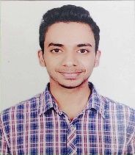 E-mail**: aman4165@gmail.com **Phone**: +91-8800663443

|  |
| --- |
| **OBJECTIVE** |

A platform which provides me opportunity to work at my full potential. Learn something new every day and work on revolutionary ideas.

|  |  |  |  |  |
| --- | --- | --- | --- | --- |
| **EDUCATIONAL QUALIFICATIONS** | | |  |  |
|  |  |  | |  |
| **Year** | **Degree/Certificate** | **Institute/School** | | **Scores** |
| 2016  EXPECTED | B. Tech.  (Computer Science Engineering) | Jaypee Institute of Information Technology  , Noida | | CGPA: 6.7/10  (till 6th sem) |
| 2011 | 12th Board(CBSE) | RAINBOW SCHOOL, SAHARANPUR ,UP | | 86.00% |
| 2009 | 10th Board(CBSE) | RAINBOW SCHOOL, SAHARANPUR, UP | | 90.00% |

|  |
| --- |
| **ACADEMIC PROJECTS** |

**Social Art Forum Website:**

* Social networking site for amateur artists where they can display their work.
* Include image crawling, video crawling and profile interface.

**Mini operating system in C++:**

* Uses Data structure to implement various basic features of an operating system. .

**Digital Audio Processing and Recognition:**

* Digital signal processing of media and speech recognition in peer to peer network using python.

|  |
| --- |
| **EXTRA-CURRICULAR ACTIVITIES** |

* Playing guitar and chess
* Sketching
* Basketball, badminton, swimming

|  |
| --- |
| **TECHNICAL SKILLS** |

**Programming/designing languages:** C (proficient), C++ and python (prior knowledge)

|  |
| --- |
| **POSITIONS OF RESPONSIBILITY** |

* Captain of college Basketball team
* Sports co-ordinator of college event FSM(fun sports meet)
* Co-ordinator of college Creative hub

**ACHIEVEMENTS**

|  |  |
| --- | --- |
|  | * Top 10 in JIIT, Noida in ACM ICPC 2014 * Gold medal in inter Jaypee Sports meet (BASKETBALL) * Gold medal in IMS sports meet (BASKETBALL) * Two times selected UP STATE BASKETBALL CHAMPIONSHIP |