Software Requirements Specification (SRS)

Project: Automated Expenditure Tracker with QR-Integrated Payment Gateway Log Analysis
Institution: NITRA Technical Campus, Ghaziabad
Methodology: Agile Development

Core Team:
- Sumit Kushwaha: Project Lead, Git/Agile Manager, Cross-functional Integration.
- Anuj Kushwaha: Backend Developer (Python logic, OS integrations, Database, Intent Fallbacks).
- Saurabh Yadav: Frontend Developer (UI/UX design, Flet framework routing, built-in visualizations).
- Uday Paswan: Data Analyst (Pure Python logic, heuristic auto-categorization, Regex mapping).

1. Introduction

1.1 Purpose
The purpose of this document is to present a detailed description of the Automated Expenditure Tracker mobile application. It will explain the purpose and features of the system, the interfaces of the system, what the system will do, and the constraints under which it must operate.

1.2 Document Conventions
This document follows a standard structured format. Critical architectural constraints, particularly the "Lean Tech Stack" mandate (using pure Python over heavy data science libraries), are highlighted where applicable to emphasize the performance goals.

1.3 Project Scope
The application is a centralized, lightweight Python-based mobile payment tracker. Instead of acting as a payment gateway itself, it utilizes OS-level UPI Deep Linking (Intents) to route payments through existing UPI apps (GPay, PhonePe, etc.) and captures the transaction callbacks. It features a sub-500ms launch latency, local-first AES-256 encryption, and pure Python-based heuristic data categorization to eliminate manual data entry.

2. Overall Description

2.1 Product Perspective
This system acts as an overarching tracking layer that sits above the user's existing UPI applications. It does not replace UPI apps but orchestrates them using deep linking, capturing the financial metadata securely on the edge device without routing through external servers.

2.2 User Classes and Characteristics
- End Users: Individuals who make frequent UPI transactions and struggle to track expenses across multiple apps. They require a fast, frictionless, and privacy-focused UI.

2.3 Operating Environment
- Platform: Android OS (Android-first ecosystem).
- Framework: Python Flet framework (cross-platform compatible UI).
- Dependencies: PyJNIus for Android native API interaction.

2.4 Design and Implementation Constraints
- Lean Architecture: Complete exclusion of heavy libraries like Pandas, NumPy, or Scikit-Learn to keep the APK size under 25MB and launch time under 500ms.
- Pure Python Logic: All data analysis, regex parsing, and mathematical anomaly detection must be handled via standard Python data structures.
- Zero-Knowledge Architecture: No financial data can be transmitted to a cloud server; all data must reside locally, encrypted via SQLCipher.
- OS Lifecycle Limitations: The system must implement "State Preservation" to handle scenarios where the Android OS kills the app in the background while the external UPI app is active.

3. System Features (Functional Requirements)

3.1 User Onboarding & Security
- Description: Secure entry into the application and initial profile setup.
- Requirements:
  - REQ-1: The system shall allow users to define a monthly budget goal and default expense categories.
  - REQ-2: The system shall integrate biometric authentication (fingerprint/face unlock) upon cold start to secure financial logs.

3.2 Payment Initiation & State Preservation
- Description: The core module for initiating transactions and preventing data loss due to OS kills.
- Requirements:
  - REQ-3: The system shall provide an in-app QR code scanner and contact selector.
  - REQ-4: Upon scanning or manual VPA entry, the system shall prompt the user to enter the amount and select their preferred installed UPI application.
  - REQ-5: Crucial: Before launching the intent, the system shall save the transaction details (Amount, VPA, Time) into a temporary pending_transactions state in the local DB.
  - REQ-6: The system shall generate an OS-level upi://pay intent to launch the selected third-party app.

3.3 Automated Logging & Fallback Mechanism
- Description: Capturing the transaction result without manual input.
- Requirements:
  - REQ-7: The system shall actively listen for the onActivityResult callback from the selected UPI app.
  - REQ-8: Upon a SUCCESS flag, the system shall retrieve the matching pending transaction, append the txnId, save it to the main log, and clear the pending state.
  - REQ-9 (Intent Fallback): If the callback is stripped by the OS, returns RESULT_CANCELED, or if the app was killed in the background, the system (upon next launch) shall detect the pending state and trigger a 1-tap verification popup ("Did your last payment of ₹[X] to [Y] succeed?").

3.4 Data Science: Smart Categorization & Anomaly Detection
- Description: Extracting insights from raw transaction data without heavy ML libraries.
- Requirements:
  - REQ-10 (First-Time Tagging): If a payee is unrecognized (e.g., a local merchant "Ramesh Kumar"), the user will be prompted to tag it once. The system will memorize this mapping locally for future auto-tagging.
  - REQ-11 (Heuristics): The system shall utilize Python Regex and string-matching to auto-categorize known payees (e.g., assigning "Zomato" to "Food").
  - REQ-12 (Mathematical Anomaly Detection): The system shall calculate the Mean and Standard Deviation of category spending using standard Python math libraries. It shall flag transactions that exceed a calculated Z-Score threshold as an "Unusual Spending Spike."

3.5 Dashboard & Reporting
- Description: Visualizing the financial data.
- Requirements:
  - REQ-13: The system shall generate dynamic financial dashboards utilizing Flet's native charting components (avoiding Matplotlib/Plotly overhead).
  - REQ-14: The system shall calculate and display a "Financial Health Score" based on budget adherence.
  - REQ-15: The system shall allow users to split bills with contacts via a post-payment popup.
  - REQ-16: The system shall allow users to export their transaction history as a CSV file to local storage.

4. System Models

4.1 Use-Case Scenarios
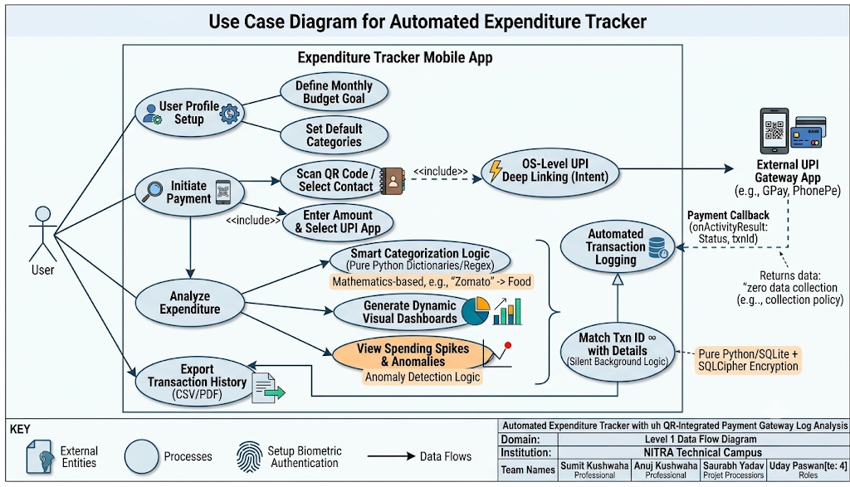
Use Case 1: First-Time Payment to a Local Merchant
- Actor: User
- Action: User scans a static QR code of a local tea stall ("Ramesh Kumar").
- System: App reads VPA ramesh@upi and prompts for the amount.
- Action: User enters ₹50 and selects PhonePe.
- System: App saves state to pending_transactions and opens PhonePe via Intent.
- Action: User enters PIN in PhonePe; payment succeeds. PhonePe closes.
- System: App catches onActivityResult, logs ₹50 to "Ramesh Kumar".
- System Prompt: "We don't recognize Ramesh Kumar. What category is this?"
- Action: User selects "Food & Dining".
- System: Saves mapping. Future payments to ramesh@upi are auto-categorized.
Use Case 2: The Background Kill Fallback
- Actor: User (on a low-RAM device)
- Action: Initiates ₹2000 payment for groceries.
- System: Saves to pending_transactions, launches GPay.
- Event: Android OS kills the Tracker App in the background to free RAM.
- Action: User completes payment in GPay. Returns to home screen.
- Action: User re-opens Tracker App.
- System: Detects uncleared pending_transactions during cold start.
- System Prompt: "Did your ₹2000 payment to Grocery Store succeed? (Yes/No)".
- Action: User taps "Yes".
- System: Logs transaction successfully.

4.2 Data Flow Diagram (Text Description)

- Level 0 (Context Level):
  - External Entities: User, Target UPI App (GPay/PhonePe).
  - Central Process: Automated Tracker App.
  - Data Flows: User provides Setup Data, QR Data, and Amount. App sends Intent URI to Target UPI App. Target UPI App returns Callback Data. App provides Visual Dashboard to User.
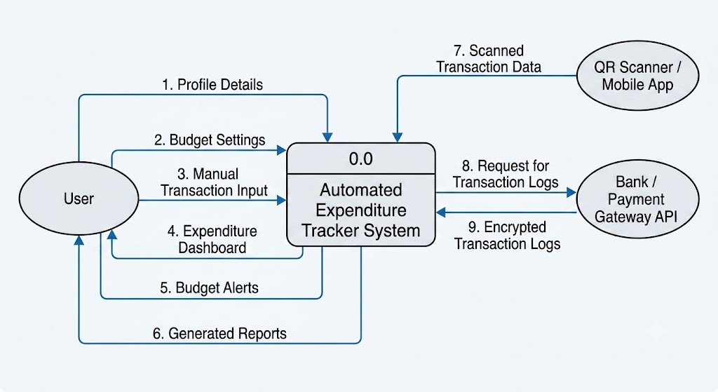
- Level 1 (Process Level):
  - Process 1 (Initiation): Receives QR Data/VPA. Passes Amount and VPA to Process 2.
  - Process 2 (State Management): Writes Pending Data to Local Encrypted Database. Generates Intent.
  - Process 3 (Callback Listener): Receives OS Callback OR User Fallback Input. Matches with Pending Data. Sends Success Flag to Process 4.
  - Process 4 (Analytics Engine): Receives Success Flag. Queries Database for Historical Mappings (Regex). Runs Math functions for Anomaly checking. Updates Transaction Logs in Database.
  - Process 5 (Visualization): Reads Transaction Logs and generates Dashboard UI for the User.
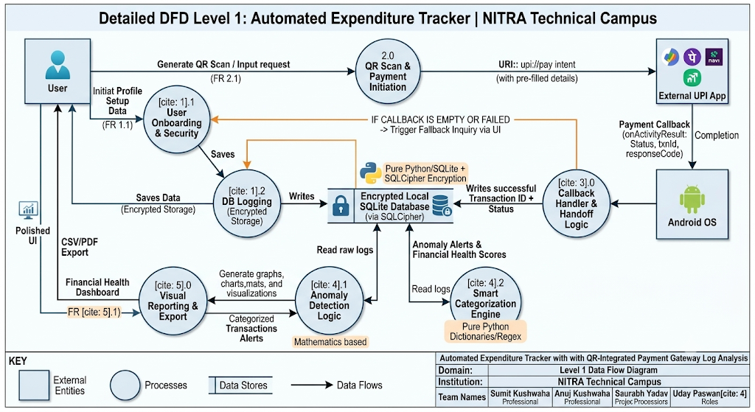

5. External Interface Requirements

5.1 User Interfaces
The UI will be built entirely using the Python Flet framework, prioritizing a dark-mode friendly, minimalist layout. Navigation will be handled via a bottom routing bar.

5.2 Hardware Interfaces
- Camera API: Required for the QR code scanning module.
- Biometric Sensor: Required for secure app launch.

5.3 Software Interfaces
- OS Intents: Android Intent API (accessed via PyJNIus) to broadcast upi:// schemes and receive activity results.
- SQLite / SQLCipher: Local embedded database with 256-bit AES encryption for secure storage.

6. Non-Functional Requirements

6.1 Performance Requirements
- Cold Start Latency: The application must launch and be ready for input in under 500 milliseconds.
- Storage Footprint: The compiled APK must remain under 25MB.

6.2 Security Requirements
- Data Encryption: All transaction logs must be encrypted at rest using SQLCipher.
- Privacy: Strict Zero Data Collection policy. No network requests shall be made regarding user financial data.

6.3 Reliability & Availability
- State Resilience: The app must not lose transaction context if killed by the OS.
- Offline Functionality: Analytics, history viewing, and CSV exports must function 100% offline without internet access.
v1.1 Specification Lock — Lean Stack & REQ-15 Bill Split Verification
• Strict Lean Dependency Mandate (<25-35MB APK, <500ms Warm Resume): Only Python Flet (`flet>=0.24.0`) and Python standard library modules (`sqlite3`, `re`, `statistics`, `math`, `csv`, `urllib.parse`) are permitted. Heavy libraries (`pandas`, `numpy`, `scipy`, `scikit-learn`, `matplotlib`, `plotly`) are strictly forbidden.
• REQ-15 Post-Payment 3-Second Quick Tags & Bill Splitting: Supported natively via the 6th SQLite table (`bill_splits`) linked to `transactions(txn_id)`.
• NPCI UPI 2.0 Signed Merchant QR Compatibility: All `upi://pay` deep-link constructions must preserve original cryptographic query parameters (`mc`, `sign`, `orgid`, `tr`, `mode`) while injecting `am` and `cu=INR`.

