**Industrial Internship Report on**

**”Banking Information System”**

**Prepared by**

**[Sumit Patil]**

|  |
| --- |
| *Executive Summary* |
| This report provides details of the Industrial Internship provided by upskill Campus and The IoT Academy in collaboration with Industrial Partner UniConverge Technologies Pvt Ltd (UCT).  This internship was focused on a project/problem statement provided by UCT. We had to finish the project including the report in 4 weeks’ time.  My project was creating a banking information system, which helps the user to manage the baking related information and easy to handle the application.  This internship gave me a very good opportunity to get exposure to Industrial problems and design/implement solution for that. It was an overall great experience to have this internship. |

**TABLE OF CONTENTS**

1 Preface 3

2 Introduction 4

2.1 About UniConverge Technologies Pvt Ltd 4

2.2 About upskill Campus 8

2.3 Objective 9

2.4 Reference 9

3 Problem Statement 11

4 Existing and Proposed solution 12

5 Proposed Design/ Model 13

5.1 High Level Diagram (if applicable) 13

5.2 Low Level Diagram (if applicable) 13

6 Performance Test 14

6.1 Test Plan/ Test Cases 14

6.2 Performance Outcome 14

7 My learnings 15

8 Future work scope 16

# Preface

In this whole 4-week internship I got to learn a lot of things related with technical terms as well as terms related with industrial experience too. In this project of creating banking system, we have created a user-friendly interface which helps the user to easily access the bank details .. We have completed this project with the help of tinker. We have submitted every week’s progress of this project where you will find the detailed slow and steady progress of our project. We are really grateful to get this opportunity from UCT/USC. There is a massive need of relevant Internship in career development, which is fulfilled by this opportunity.

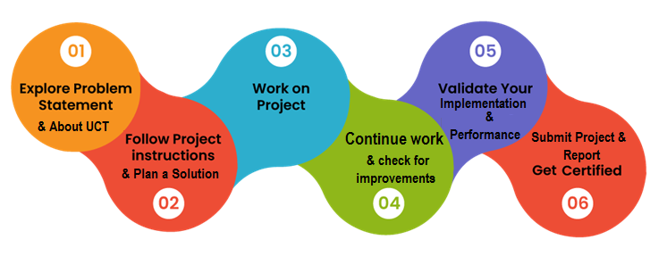

I really felt overwhelmed when I got this amazing opportunity at this stage, where a learner needs such more opportunities for inspiration and increase industrial as well as learning experiences.

# Introduction

## About UniConverge Technologies Pvt Ltd

A company established in 2013 and working in Digital Transformation domain and providing Industrial solutions with prime focus on sustainability and RoI.

For developing its products and solutions it is leveraging various**Cutting Edge Technologies e.g. Internet of Things (IoT), Cyber Security, Cloud computing (AWS, Azure), Machine Learning, Communication Technologies (4G/5G/LoRaWAN), Java Full Stack, Python, Front end**etc.

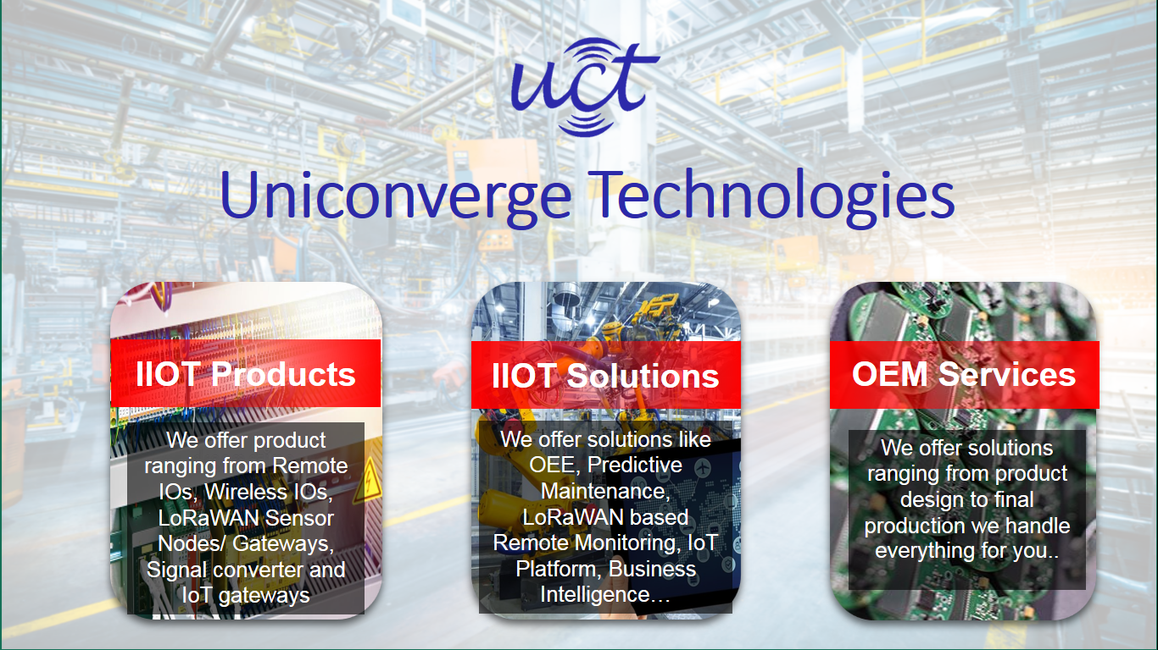

1. UCT IoT Platform **(****)**

**UCT Insight** is an IOT platform designed for quick deployment of IOT applications on the same time providing valuable “insight” for your process/business. It has been built in Java for backend and ReactJS for Front end. It has support for MySQL and various NoSql Databases.

* It enables device connectivity via industry standard IoT protocols - MQTT, CoAP, HTTP, Modbus TCP, OPC UA
* It supports both cloud and on-premises deployments.

It has features to  
• Build Your own dashboard  
• Analytics and Reporting  
• Alert and Notification  
• Integration with third party application(Power BI, SAP, ERP)  
• Rule Engine

 

1. **Smart Factory Platform (****)**

Factory watch is a platform for smart factory needs.

It provides Users/ Factory

* with a scalable solution for their Production and asset monitoring
* OEE and predictive maintenance solution scaling up to digital twin for your assets.
* to unleased the true potential of the data that their machines are generating and helps to identify the KPIs and also improve them.
* A modular architecture that allows users to choose the service that they what to start and then can scale to more complex solutions as per their demands.

Its unique SaaS model helps users to save time, cost and money.

 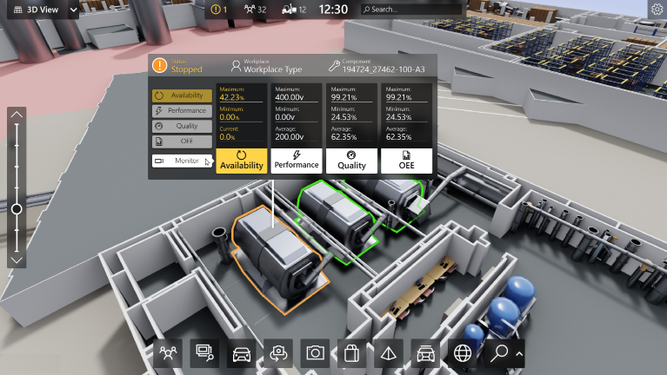

1.  based Solution

UCT is one of the early adopters of LoRAWAN teschnology and providing solution in Agritech, Smart cities, Industrial Monitoring, Smart Street Light, Smart Water/ Gas/ Electricity metering solutions etc.

1. Predictive Maintenance

UCT is providing Industrial Machine health monitoring and Predictive maintenance solution leveraging Embedded system, Industrial IoT and Machine Learning Technologies by finding Remaining useful life time of various Machines used in production process.



## About upskill Campus (USC)

upskill Campus along with The IoT Academy and in association with Uniconverge technologies has facilitated the smooth execution of the complete internship process.

USC is a career development platform that delivers **personalized executive coaching** in a more affordable, scalable and measurable way.



Seeing need of upskilling in self paced manner along-with additional support services e.g. Internship, projects, interaction with Industry experts, Career growth Services

<https://www.upskillcampus.com/>

upSkill Campus aiming to upskill 1 million learners in next 5 year

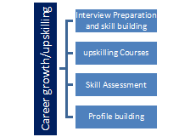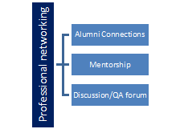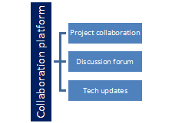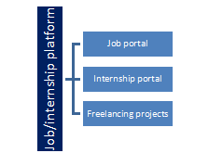

## The IoT Academy

The IoT academy is EdTech Division of UCT that is running long executive certification programs in collaboration with EICT Academy, IITK, IITR and IITG in multiple domains.

## Objectives of this Internship program

The objective for this internship program was to

 ☛ get practical experience of working in the industry.

 ☛ to solve real world problems.

 ☛ to have improved job prospects.

 ☛ to have Improved understanding of our field and its applications.

 ☛ to have Personal growth like better communication and problem solving.

## Reference

[1] GitHub

[2] YouTube

[3] AI platform

# Problem Statement

Banking Information System

Description:

A Banking Information System (BIS) is a software system that manages various banking activities such as account management, transactions, loans, and customer service. The scope of a BIS project typically includes the following key components:

Account Management: This module handles the creation, modification, and deletion of customer accounts. It also includes features like balance inquiries, account statements, and account closures.

Transaction Processing: The system processes various types of transactions such as deposits, withdrawals, fund transfers, and bill payments. It ensures that these transactions are executed accurately and securely.

Scope:The scope of a BIS project may vary depending on the specific requirements of the bank and the complexity of the banking operations. It is essential to define the scope clearly at the beginning of the project to ensure that all stakeholders have a common understanding of the project goals and deliverables.

# Existing and Proposed solution

## The purpose of a Banking Information System project is to create a comprehensive and efficient system that automates and manages various banking operations. The key purposes of a Banking Information System project include:

## Efficiency

## Accuracy

## Customer Service

## Risk Management

## Compliance

## Data Management

## Decision Making

## Code submission (Github link)

## Report submission (Github link) : first make placeholder, copy the link.

# Proposed Design/ Model

## High Level Diagram (if applicable)

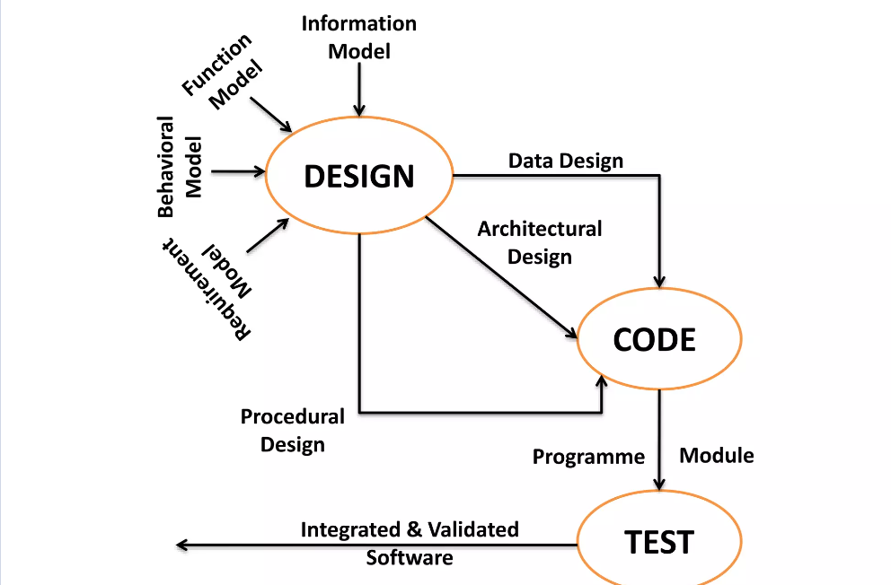

## Low Level Diagram (if applicable)

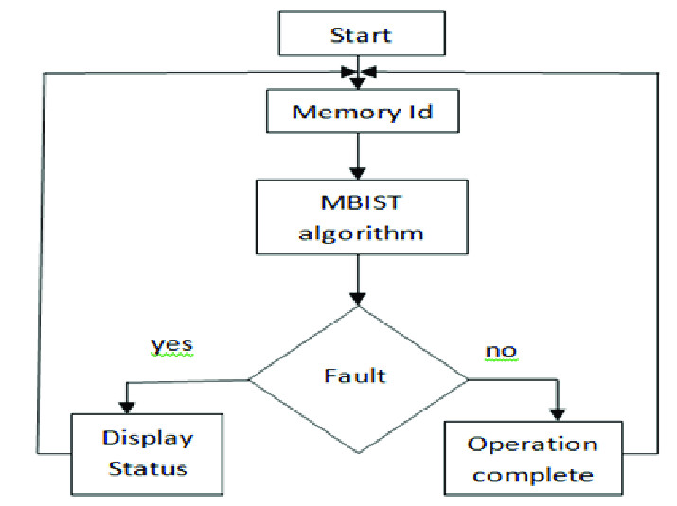

# Performance Test

This is very important part and defines why this work is meant of Real industries, instead of being just academic project.

Here we need to first find the constraints.

How those constraints were taken care in your design?

What were test results around those constraints?

Constraints can be e.g. memory, MIPS (speed, operations per second), accuracy, durability, power consumption etc.

In case you could not test them, but still, you should mention how identified constraints can impact your design, and what are recommendations to handle them.

## Test Plan/ Test Cases

**Account Creation:**

Test Case 1: Verify that a new account can be created with valid customer information.

Test Case 2: Verify that an error is displayed if invalid customer information is provided.

**Account Management:**

Test Case 3: Verify that account details can be updated successfully.

Test Case 4: Verify that an account can be closed, and the balance is updated accordingly.

**Transaction Processing:**

Test Case 5: Verify that a deposit transaction updates the account balance correctly.

Test Case 6: Verify that a withdrawal transaction updates the account balance correctly.

Test Case 7: Verify that a fund transfer transaction between accounts updates the balances correctly.

**Loan Management:**

Test Case 8: Verify that a new loan application can be submitted successfully.

Test Case 9: Verify that a loan approval updates the account balance and loan status correctly.

**Customer Relationship Management (CRM):**

Test Case 10: Verify that customer information can be viewed and updated by authorized personnel.

Test Case 11: Verify that a marketing campaign can be created and targeted to specific customer segments.

**Security and Compliance:**

Test Case 12: Verify that access to sensitive information is restricted based on user roles.

Test Case 13: Verify that transaction logs are maintained for auditing purposes.

**Reporting and Analytics:**

Test Case 14: Verify that financial reports can be generated accurately.

Test Case 15: Verify that analytics features provide meaningful insights into banking operations.

## Performance Outcome

The performance outcomes of a Banking Information System (BIS) project can have a significant impact on the efficiency, effectiveness, and overall success of the system. Some key performance outcomes include:

Efficiency: A well-designed BIS can improve operational efficiency by automating manual tasks, reducing processing times, and streamlining workflows. This can lead to faster transaction processing, quicker account management, and overall cost savings for the bank.

Customer Satisfaction: A BIS that provides convenient access to banking services, quick response times, and personalized customer experiences can lead to higher customer satisfaction and loyalty.

Accuracy and Reliability: A reliable BIS ensures that banking transactions are processed accurately, account information is up-to-date, and customer data is secure. This can help build trust with customers and regulatory authorities.

Risk Management: A BIS with robust risk management features can help banks identify, assess, and mitigate various risks, such as credit risk, operational risk, and compliance risk. This can help protect the bank's assets and reputation.

Compliance: A BIS that complies with regulatory requirements and industry standards can help the bank avoid fines, penalties, and other regulatory issues. It can also help the bank build a reputation for integrity and trustworthiness.

Data Management: A BIS that efficiently manages large volumes of banking data can provide valuable insights for decision-making and strategic planning. It can also help the bank meet reporting requirements and improve business intelligence.

Scalability and Flexibility: A BIS that is scalable and flexible can adapt to changing business needs and technology trends. This can help the bank stay competitive and innovative in the rapidly evolving banking industry.

# My learnings

In this java project, I have focused on developing a banking information system. Through this project, I have enhanced my problem-solving skills and deepened my understanding of Java programming. I have learned about various concepts such as data encryption, inheritances, and user interface design.

This project has not only improved my technical skills but also my ability to manage and organize complex information securely. As I progress in my career, these skills will be invaluable in roles that require software development data management.

Overall, this project has been instrumental in my learning journey, equipping me with the skills and knowledge necessary for my career growth in the field of technology.

# Future work scope

The feature scope of a Banking Information System (BIS) project includes the functionalities and capabilities that the system will offer. Here are some key features that might be included in the scope of a BIS project:

**Account Management:**

Account creation, modification, and deletion

Balance inquiries and account statements

Account closure and archival

**Transaction Processing:**

Deposit and withdrawal processing

Fund transfer between accounts

Bill payment processing

**Loan Management:**

Loan application submission and approval

Loan disbursement and repayment management

Interest calculation and loan restructuring

**Customer Relationship Management (CRM):**

Customer profile management

Marketing campaign management

Feedback collection and management

**Security and Compliance:**

Access control and user authentication

Data encryption and secure transmission

Audit trails and compliance reporting

**Reporting and Analytics:**

Financial reporting and analysis

Performance monitoring and forecasting

Risk analysis and management reporting

**Integration:**

Integration with external systems (e.g., payment gateways, credit bureaus)

API support for third-party developers

**User Interface:**

Intuitive and user-friendly interface

Support for multiple devices (e.g., desktop, mobile)

Scalability and Performance: