**GALGOTIAS COLLEGE OF ENGINEERING AND TECHNOLOGY**

**SUBJECT NAME: PYTHON PROGRAMMING**

**SUBJECT CODE: KNC302**

**SEMESTER 3**

**BRANCH: COMPUTER SCIENCE ANDENGINEERING**

**SECTION: B2**

# PROJECT NAME: - Stock Market Prediction



**Team Member’s Name:**

1. ***Yashica chauhan***
2. ***Sumit sharma***
3. ***Sunidhi yadav***
4. ***Suprateek goyal***
5. ***Utsav gupta***

**Submitted to: Ms. Arti ranjan**

Stock Price Prediction

Abstract:

Nowadays, the most significant challenges in the stock market is to predict the stock prices. The stock price data represents a financial time series data which becomes more difficult to predict due to its characteristics and dynamic nature.



Fig no. 1

<https://www.indianfolk.com/understanding-stock-forecasting/>

INTRODUCTION:

Stock investments provide one of the highest returns in the market. Even though they are volatile in nature, one can visualize share prices and other statistical factors which helps the keen investors carefully decide on which company they want to spend their earnings on. Developing this simple project idea using the Dash library (of Python), we can make dynamic plots of the financial data of a specific company by using the tabular data provided by yfinance (Yahoo Finance) python library. On top of it, we can use a machine learning algorithm to predict the upcoming stock prices.

The stock market is known for being volatile, dynamic, and nonlinear. Accurate stock price prediction is extremely challenging because of multiple (macro and micro) factors, such as politics, global economic conditions, unexpected events, a company’s financial performance, and so on.

But, all of this also means that there’s a lot of data to find patterns in. So, financial analysts, researchers, and data scientists keep exploring analytics techniques to detect stock market trends. This gave rise to the concept of [algorithmic trading](https://en.wikipedia.org/wiki/Algorithmic_trading), which uses automated, pre-programmed trading strategies to execute orders.

1.1 What is stock prediction**:**

Stock market prediction is the act of trying to determine the future value of company stock or other financial instruments traded on an exchange.

The successful prediction of a stock’s future price could yield a significant profit. In this application, we used the LSTM network to predict the closing stock price using the past 60-day stock price.

Stock Price Prediction using machine learning helps you discover the future value of company stock and other financial assets traded on an exchange. The entire idea of predicting stock prices is to gain significant profits.

Predicting how the stock market will perform is a hard task to do. There are other factors involved in the prediction, such as physical and psychological factors, rational and irrational behaviour, and so on.

All these factors combine to make share prices dynamic and volatile. This makes it very difficult to predict stock prices with high accuracy.

1.2 Framework:

1. Getting started with required files and dependencies
2. The basic layout of the application will be built using Dash in this task.
3. Generating a company's information and graphs
4. We are going to use the finance python library to get company information (name, logo and description) and stock price history. Dash's call back functions will be used to trigger updates based on change in inputs.
5. Creating the machine learning model
6. We are now going to build a machine learning model - Support Vector Regression (SVR) for predicting the stock prices.

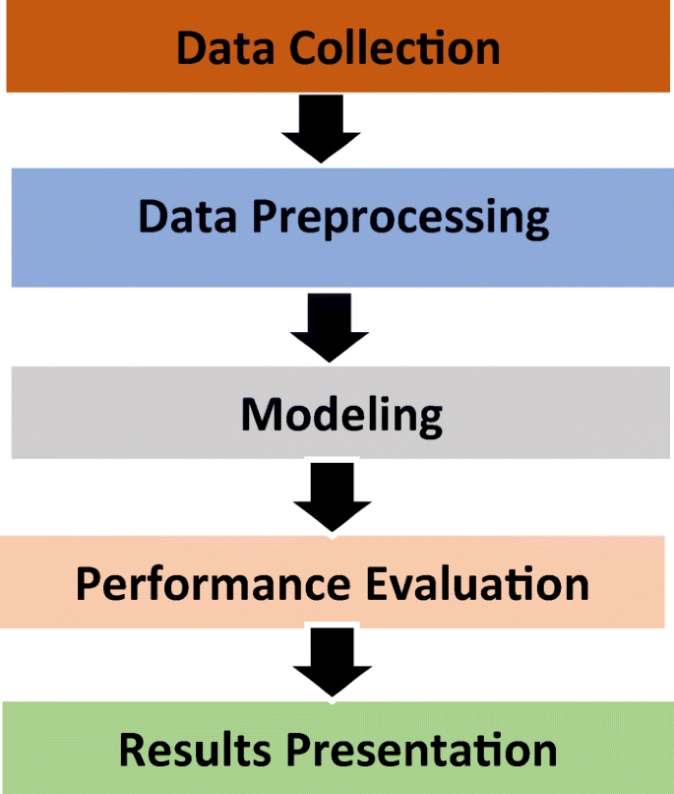

Fig no. 2

<https://link.springer.com/article/10.1007/s11042-021-10579-8>

**PROBLEM FORMULATION:**

The successful prediction of a stock’s future price could yield a significant profit.

Hence, stock price prediction will one predict the stock price.

In this section, we will examine the stock price of Microsoft Corporation (MSFT) as reported by the National Association of Securities Dealers Automated Quotations (NASDAQ). The stock price data will be supplied as a Comma Separated File (.csv), that may be opened and analysed in Excel or a Spreadsheet.

MSFT’s stocks are listed on NASDAQ and their value is updated every working day of the stock market. It should be noted that the market does not allow trading on Saturdays and Sundays, therefore there is a gap between the two dates. The Opening Value of the stock, the Highest and Lowest values of that stock on the same days, as well as the Closing Value at the end of the day, are all indicated for each date.

The Adjusted Close Value reflects the stock’s value after dividends have been declared (too technical!). Furthermore, the total volume of the stocks in the market is provided, With this information, it is up to the job of a Machine Learning/Data Scientist to look at the data and develop different algorithms that may extract patterns from the historical data of the Microsoft Corporation stock.

**OBJECTIVE:**

The project is a single-page execution code using Dash (a python framework) and some machine learning models which will show company information (logo, registered name and description) and stock plots based on the stock code given by the user.

Also, the ML model will enable the user to get predicted stock prices for the date inputted by the user.

**METHODOLOGY:**

**Expected Output:**

After finishing all this, we should have a complete project where user input - stock, code can give us the company information and relevant plots. Also, user input number of days can give us a forecast plot.

**Future scope:**

Stock market consists of various buyers and sellers of stock. Stock market prediction means determining the future scope of market. A system is essential to be built which will work with maximum accuracy and it should consider all important factors that could influence the result. Various researches have already been done to predict stock market prices. The research is done over business and computer science domain. Sometime the stock market does well even when the economy is falling because there are various reasons for the profit or loss of a share. Predicting the performance of a stock market is tough as it takes into account various factors.

**The main aim is to identify the sentiments of investors. It is usually difficult as there must be rigorous analysis of national and international events. It is very important for an investor to know the current price and get a very close estimation of the future price.**

**References:**

[1] Dash Layout, Dash HTML Components, Dash Core Components

[2] CSS Tutorial

[3] Basic Callbacks , Plotly Express, Hands-On Guide To Using YFinance library In Python

[4] [www.towardsdatascience.com](http://www.towardsdatascience.com)

[5] [www.analyticsvidhya.com](http://www.analyticsvidhya.com)

[6] [www.simplilearn.com](http://www.simplilearn.com)

[7] [www.scholar.google.co.in](http://www.scholar.google.co.in)

[8] Wikipedia