Overview
The First Pay Tracker application is a powerful tool designed to automate and simplify the submission, review, and consolidation of payroll-related documents. The system supports a dual-role workflow, with distinct functionalities for both general users and managers.

For General Users
The user's primary function is to submit documents and track their status. Key features for users include:
- Document Upload: A simple, two-step process to upload documents and their corresponding approved emails in supported formats (.xls, .xlsx, .msg, .eml).
- Template Download: Access to a dedicated section where official templates for Payroll, IRefer, and Transport Deduction can be downloaded to ensure accurate data formatting.
- Dashboard: A personal dashboard to view the status, upload date, and remarks for all submitted documents.

For SPOC/Managers
Managers have elevated permissions to review, manage, and finalize all submitted documents. The manager's workflow includes:
- Centralized Dashboard: A comprehensive dashboard with a quick overview of all pending, approved, and rejected requests.
- Document Review: The ability to download both the template and the approved email for each submission to perform a thorough review.
- Actionable Feedback: The option to Reject unsatisfactory documents, which prompts for comments to guide the user in correcting the file.
- File Management: The ability to Replace a rejected file by re-uploading a new version, automatically updating the file status.
- Consolidation & Final Approval: A unique feature that allows the manager to select and Consolidate multiple files into a single merged document, which can then be given final Approval.

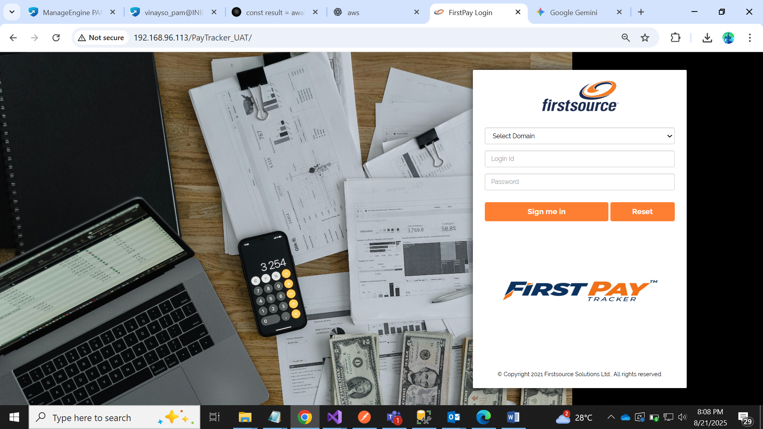

1. Logging In to First Pay Tracker
This section will guide you through the process of logging into the First Pay Tracker application.

Login Page Overview

Using the url: http://192.168.96.113/PayTracker_UAT/
The login page is your gateway to the application. It features a simple form with three main fields and two action buttons.

Step-by-Step Login Guide
- Select Your Domain: Click on the dropdown menu labeled "Select Domain". From the list that appears, choose your organization's domain.
- Enter Your Login ID: In the field labeled "Login Id", type your unique user ID.
- Enter Your Password: In the "Password" field, enter your password. For security, the characters you type will be hidden.
- Sign In: Once you have entered your credentials, click the orange "Sign me in" button to access your account.

Additional Options
- Reset: If you need to clear the information you have entered in all three fields, click the orange "Reset" button. This will wipe all data and allow you to start over.

ROLE : USER / ADMIN
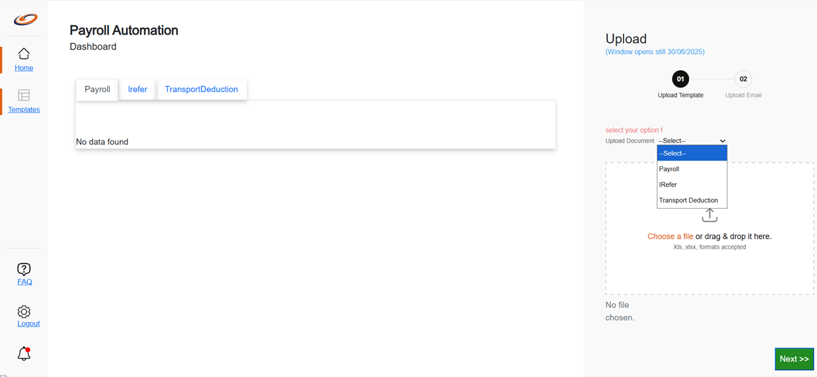

1. Uploading Documents
This section guides you through the process of uploading your documents to the First Pay Tracker system. The upload process is a simple two-step procedure.

Step 1: Upload Template
- On the Dashboard page, navigate to the Upload section on the right side of your screen.
- You will see a dropdown menu labeled "Upload Document". Click on this dropdown.
- Select the type of document you want to upload. Your options are:
  - Payroll
  - IRefer
  - Transport Deduction
- Once you have selected a document type, you can upload your file in one of two ways:
  - Drag & Drop: Click and drag the file from your computer's folder directly into the designated dashed box area.
  - Choose a File: Click the "Choose a file" link to open a file explorer window, then select the file you wish to upload.
- Please note that only .xls and .xlsx file formats are accepted.
- After a file has been selected, the name of the file will appear below the upload area.
- Click the green "Next >>" button located at the bottom right of the page to proceed to the next step.
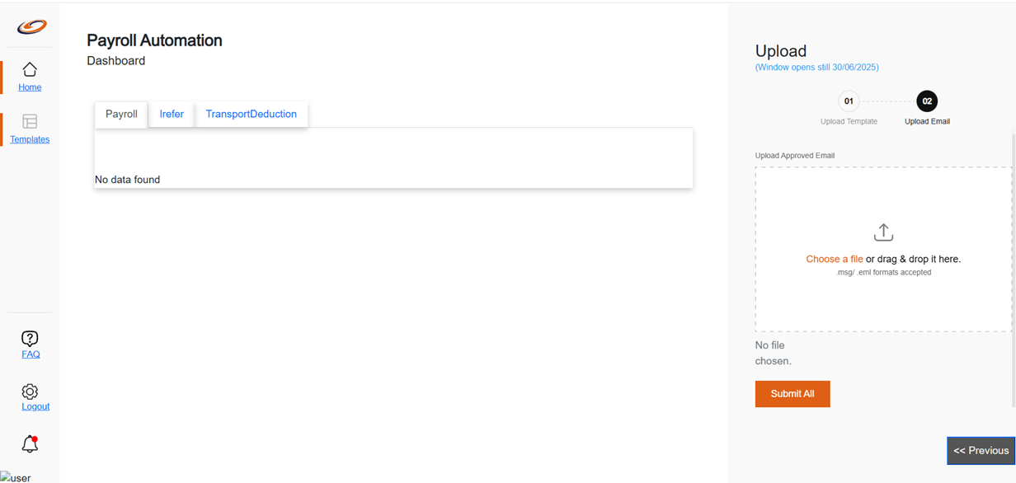

Step 2: Upload Approved Email
After uploading your document template, the next step is to upload the corresponding approved email.
- The upload window will automatically transition to "02 Upload Email".
- You will see a prompt to "Upload Approved Email".
- You can upload the approved email file in one of two ways:
  - Drag & Drop: Click and drag the email file from your computer directly into the dashed box area.
  - Choose a File: Click the "Choose a file" link to open a file explorer and select your email file.
- Please note that only .msg and .eml file formats are accepted for this step.
- After the file has been selected, its name will appear below the upload area.
- Once you are satisfied with your selection, click the orange "Submit All" button to finalize the entire upload process.
Note: You can click the "<< Previous" button at any time to go back to the first step if you need to change your document template.

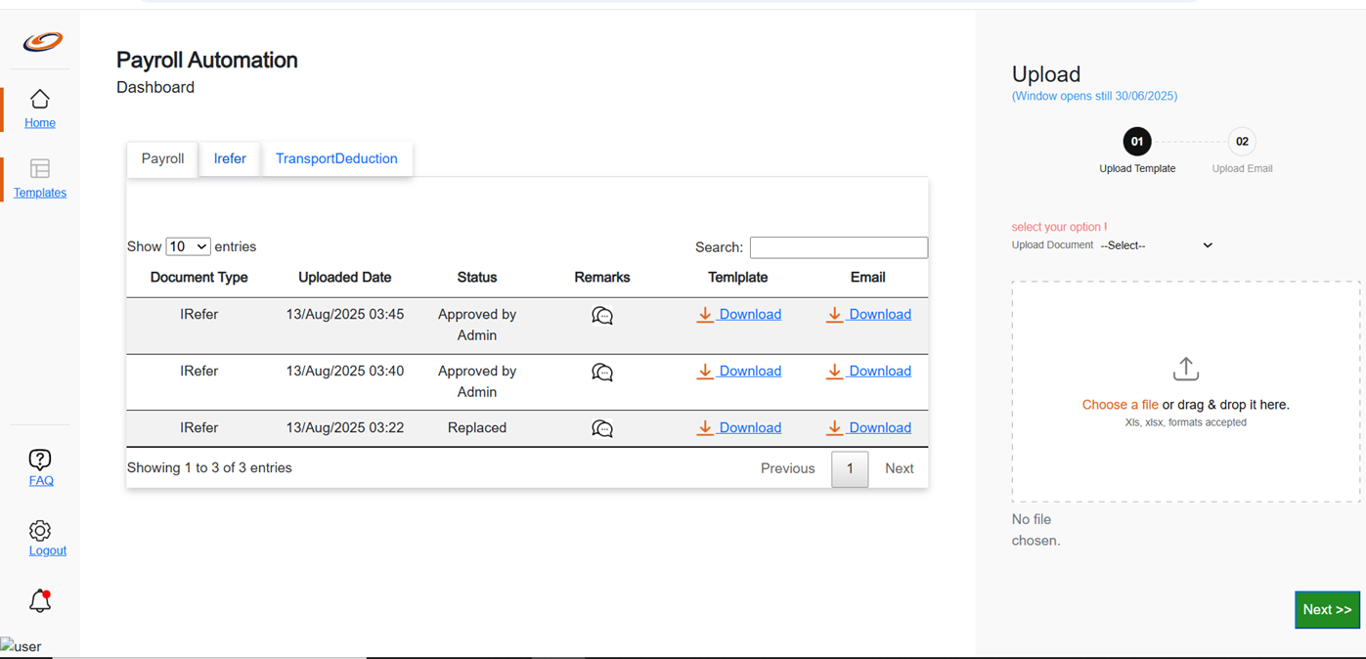

Viewing & Managing Uploaded Files
After uploading your files, you can view their status, download them, and track their progress directly from the Dashboard.

Accessing Your Uploaded Files
- On the Dashboard page, you will see three tabs in the main content area: Payroll, Irefer, and TransportDeduction.
- Click on the respective tab to view the list of files you have uploaded for that document type.

Understanding the Dashboard Table
The dashboard displays a list of your uploaded documents in a table with the following columns:
- Document Type: Indicates the type of document that was uploaded (e.g., IRefer, Payroll, etc.).
- Uploaded Date: Shows the exact date and time the file was uploaded.
- Status: Displays the current stage of the file's processing. Examples include "Approved by Admin" , "Replaced" etc.
- Remarks: A small icon (e.g., a speech bubble) that allows you to view any comments or remarks made regarding the file.
- Template: A "Download" link that allows you to download the originally uploaded spreadsheet (.xls or .xlsx) file.
- Email: A "Download" link that allows you to download the originally uploaded approved email (.msg or .eml) file.

Searching and Pagination
- Search: Use the Search box at the top of the table to quickly find a specific entry by typing in keywords.
- Entries per Page: Use the "Show entries" dropdown to adjust how many entries are displayed on a single page.
- Navigation: Use the "Previous" and "Next" buttons at the bottom of the table to navigate through multiple pages of your uploaded history.

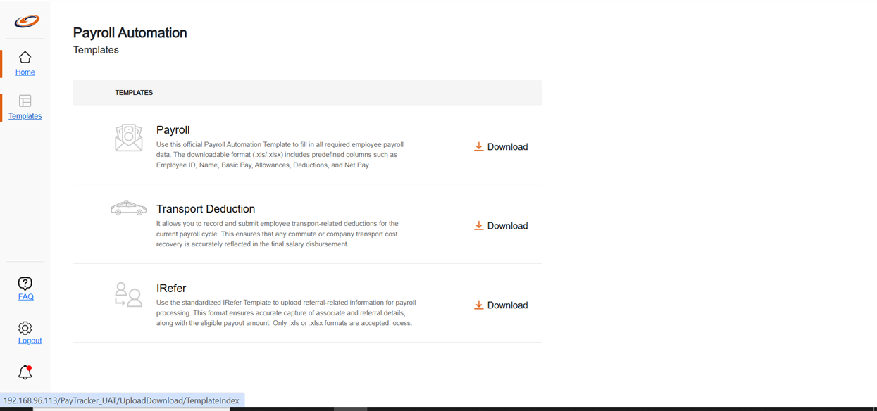

The Templates Section
This page provides you with all the necessary templates for uploading your data. Using these standardized templates ensures that your data is correctly formatted for the First Pay Tracker system.

Accessing and Downloading Templates
- From the navigation menu on the left, click on the "Templates" link.
- On this page, you will see a list of official templates, each with a brief description of its purpose.
- To download any template, simply click the "Download" link located below its description.
Here is a breakdown of the available templates:
- Payroll:
  - Purpose: The official template for all required employee payroll data. Use this to fill in details such as Employee ID, Name, Basic Pay, Allowances, Deductions, and Net Pay.
  - File Format: The file will be in .xls or .xlsx format.
- Transport Deduction:
  - Purpose: Use this template to record and submit any transport-related deductions for the current payroll cycle.
- IRefer:
  - Purpose: This standardized template is used to upload referral-related information for payroll processing, ensuring the accurate capture of associate and referral details, and the eligible payout amount.
  - File Format: The file will be in .xls or .xlsx format.
ROLE : USER / ADMIN
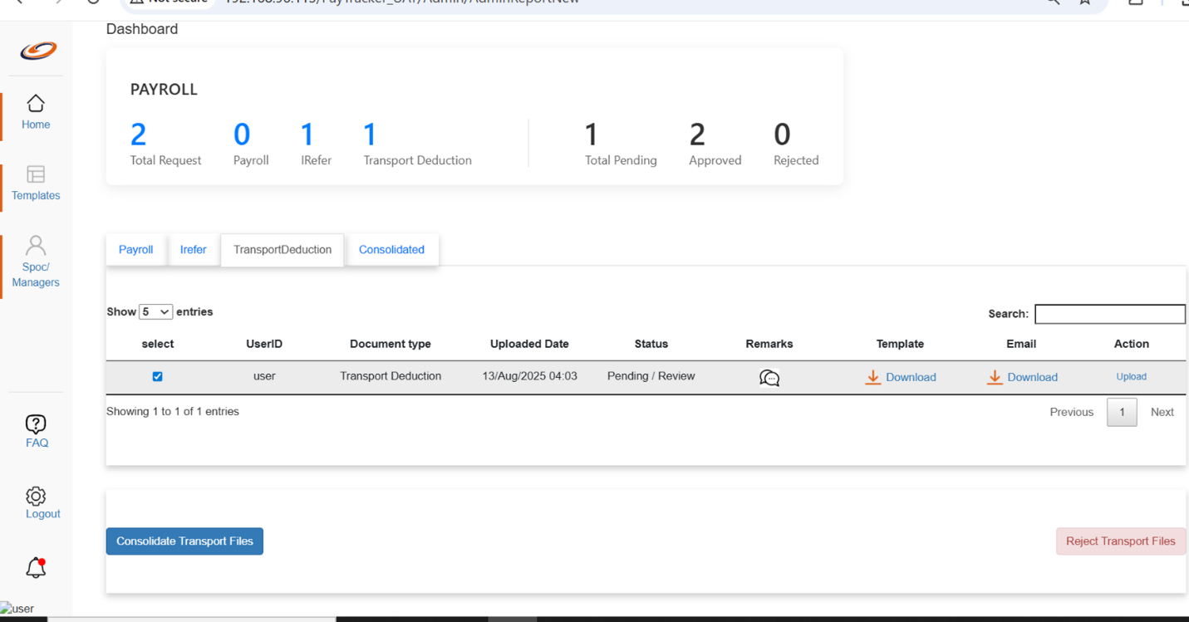
This section is for SPOCs (Single Point of Contact) and Managers who are responsible for reviewing and taking action on uploaded payroll documents.

Dashboard Overview
The manager's dashboard provides a summary of all uploaded requests. At the top of the page, you can see a quick count of total requests, broken down by document type, and their current status (Pending, Approved, or Rejected).
You can switch between the document types by clicking on the respective tabs: Payroll, Irefer, TransportDeduction, and Consolidated.

Reviewing and Taking Action on Files
The main table on the dashboard shows a list of uploaded files that are pending your review.
- Downloading and Reviewing Files:
  - To review an uploaded document, click the "Download" link under the Template column. This will download the spreadsheet (.xls/.xlsx) file.
  - To review the approved email, click the "Download" link under the Email column. This will download the email file (.msg/.eml).
- Rejecting a File:
  - If a file is not satisfactory, you can reject it.
  - In the table, locate the file you wish to reject and click the checkbox in the "select" column for that entry.
  - Click the red "Reject [Document Type] Files" button at the bottom right of the page.
  - A prompt will appear, asking you to provide comments on why the file is being rejected. This helps the uploader understand what needs to be fixed.
- Replacing a File:
  - If you need to replace an existing document with a new version, you can do so directly from the dashboard.
  - In the "Action" column, click the "Upload" link for the entry you want to replace.
  - Follow the prompts to upload the new file. Once the new file is uploaded, the status of the original entry will be updated to "Replaced".
- Consolidating Files:
  - This feature allows you to merge multiple selected files into a single, consolidated document.
  - Click the checkbox in the "select" column for each of the files you want to consolidate.
  - Once you have selected all the files, click the blue "Consolidate [Document Type] Files" button at the bottom left of the page. The system will then process these files into one merged document.

Dashboard Metrics
The top of the dashboard provides a quick, at-a-glance summary of the status of all uploaded files. These numbers are a valuable tool for managers to monitor the workload and track the progress of document processing without having to look at individual entries.
The metrics are broken down as follows:
- Total Request: This number indicates the total count of all files that have been uploaded by users.
- Payroll: The total number of uploaded documents categorized as Payroll.
- Irefer: The total number of uploaded documents categorized as IRefer.
- Transport Deduction: The total number of uploaded documents categorized as Transport Deduction.
- Total Pending: The total number of files across all categories that are currently in a "Pending / Review" status, awaiting your action.
- Approved: The total number of files that have been reviewed and Approved by a manager.
- Rejected: The total number of files that have been reviewed and Rejected by a manager.

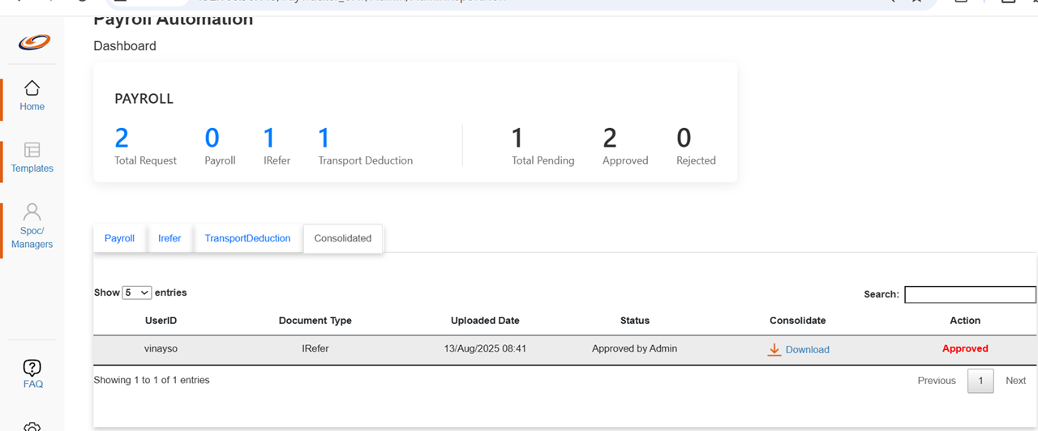

Consolidating and Finalizing Files
The "Consolidated" tab is where you can view and perform the final approval on files that have been merged into a single document.
When you click on the "Consolidated" tab, a table will display a list of all files that have been successfully consolidated.

Consolidated Files Table
The table in this section has specific columns to manage these merged files:
- UserID: Shows the user who originally uploaded the documents.
- Document Type: Indicates the type of documents that were consolidated.
- Uploaded Date: The date and time the consolidation was completed.
- Status: The current status of the consolidated file, such as "Approved by Admin."
- Consolidate: A "Download" link that allows you to download the final, merged file. This is the single document created from all the individual files you selected earlier.
- Action: This is the final step in the approval process. The button in this column, labeled "Approved", signifies that the merged file has received its final approval from you. This is the last action required to complete the process.

End of Document

