ENERGYTRUST PROTOCOL · ARCHITECTURE RECORD
ETP Architecture Record
High-level and low-level design for the EnergyTrust Protocol, plus a verified snapshot of what actually runs today.
FIELD | VALUE
Repository | SumitAG008/apacheiceberg
Commit | 35938de5
Recorded | 21 September 2026
Target | ISV design partner — November 2026
Status basis | Executed and observed, not specified

FIGURE 1

High-level design

Seven components carrying proof from the ingestion wire through to the answer a person or an agent receives. The claim the whole system rests on: the verification that happens at the gateway is still checkable at query time, days or years later.
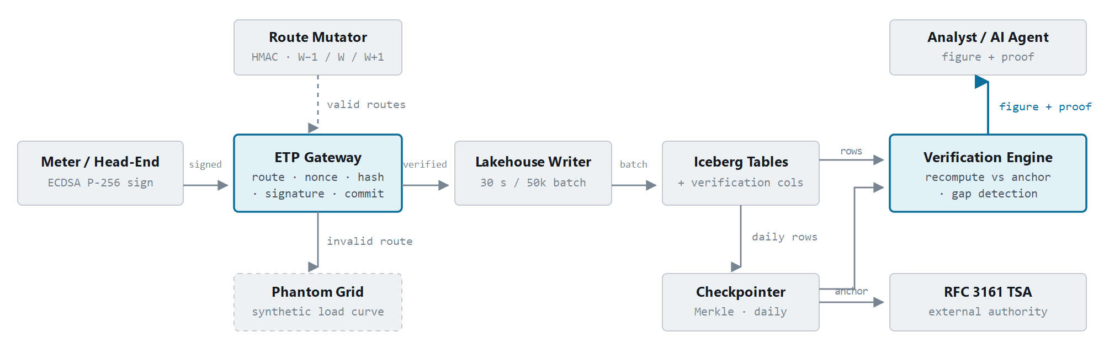
Figure 1 — Proof survives the hop into storage. Conventional systems authenticate the reading on the wire and drop that guarantee at the database boundary. The highlighted path — checkpoint recomputed against an externally anchored root, returned with the figure — is the edge that disappears if you remove ETP.

FIGURE 2

Low-level design

The gateway pipeline, ordered cheapest-check-first so an attacker cannot make the system spend elliptic-curve mathematics on a forged block. State is mutated only at step 7, after every check has passed. Timings are measured single-threaded on commodity hardware.
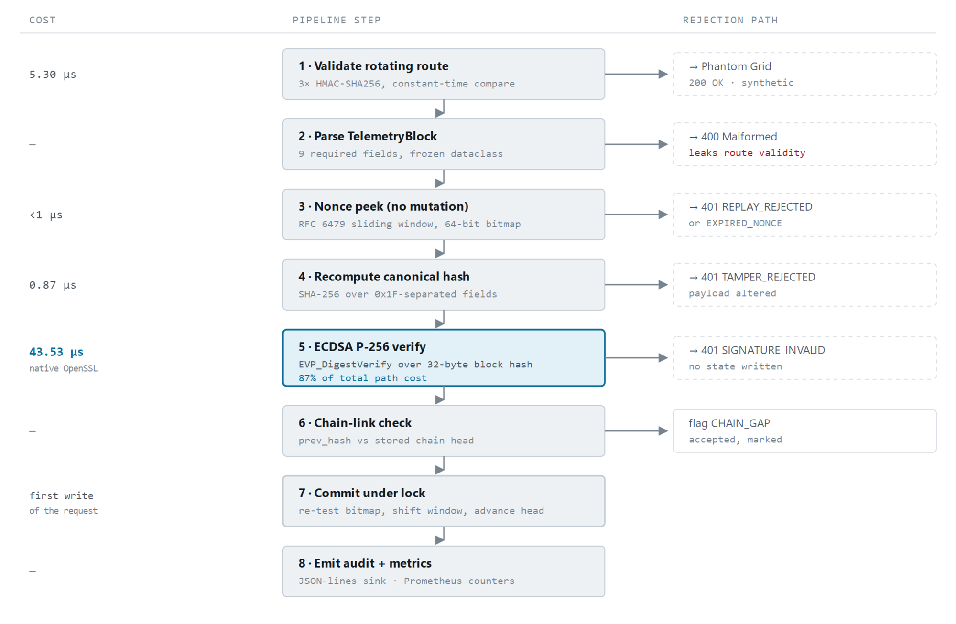
Figure 2 — Ordering is the DoS defence; ECDSA is the ceiling. Steps 1–4 cost about 6 µs combined, so a forged block is discarded long before the expensive mathematics. That same measurement caps throughput.

What the measurement means for the C++ core
At 43.53 µs per signature verification — 87% of the measured request path — no rewrite in any language reaches 35,000 verifications per second per core while one signature is verified per reading. The arithmetic is decisive: a 35,000/sec target allows 28.6 µs per block, which is less than the cost of the single mandatory operation. ECDSA verification is already native OpenSSL code when called from Python, so a C++ port removes interpreter overhead, not the bottleneck.
Batching one signature per meter-day (48 half-hourly readings) reduces the per-reading cost to 1.77 µs, or roughly 563,000 readings per second — twenty-five times past the target, achievable without writing any C++. This is an architectural change, not a language change.

FIGURE 3

Where we are today

The same topology as Figure 1, coloured by what has actually been executed and observed — not by what is written in the specification. Every component marked verified below was confirmed by running it against commit 35938de5.
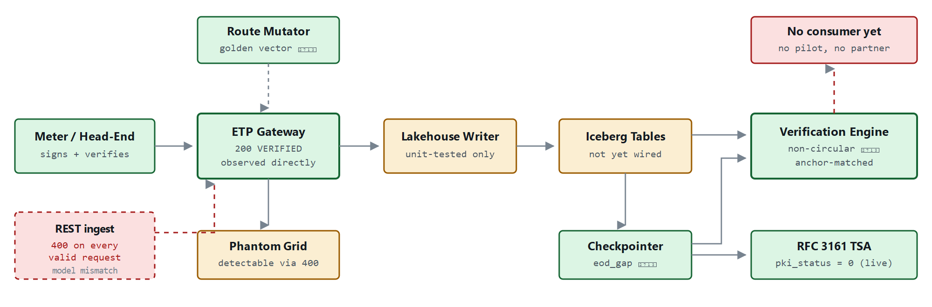
Figure 3 — A working engine behind a broken door. The cryptographic core returns 200 VERIFIED when called directly, and the anchor is a genuine timestamp token. But the REST layer that exposes it rejects every valid request, and nothing downstream of the writer has run against real storage.

Verification register
COMPONENT | STATE | EVIDENCE OBSERVED
Gateway verification core | Verified | 200 · VERIFIED · real ECDSA block
RFC 3161 external anchor | Verified | pki_status = 0 · FreeTSA · 4.6 KB token
Omission detection (UC-09) | Verified | eod_gap folded into anchor digest
Replay window (RFC 6479) | Verified | backfill accepted · replay rejected
Golden vectors, both languages | Verified | generated · regenerates identical
Audit sink + Prometheus | Verified | JSON-lines · /metrics live
REST /v1/etp/ingest | Broken | 400 · request model ≠ TelemetryBlock
Nonce store under replicas | Blocking | in-process dict vs replicas 2 → 10
C++20 native core | Unproven | CI job added · never yet executed
Honeypot concealment | Leaky | 400 vs 200 distinguishes live route
Iceberg write path | Unwired | unit-tested, no real table
Design partner | None | no pilot, no contract, no channel

PLAN

Path to a November design partner

Ten weeks from this record to the end of November. The engineering fits comfortably; the constraint is that a design partner cannot be found in the last fortnight. Both tracks have to run at once from week one.
WHEN | WHAT
Wk 1 · Sep | Close the door that's broken. Add block_hash to the ingest request model, pop route before constructing the block, write the endpoint test that would have caught it. In parallel: send the first ten ISV emails.
Wk 2–3 · Oct | Make it survive a second replica. Redis nonce store with the sliding window in a Lua CAS script. Until this lands, replay protection is void above one pod, which makes every scale claim unsafe to repeat.
Wk 3–4 · Oct | Prove the C++ and equalise the honeypot. First green run of the native CI job — the golden-vector assertion is where a Python/C++ divergence would surface. Make every rejection on a valid route indistinguishable from the phantom path.
Wk 5–6 · Oct | Build the sixty-second demo. Synthetic estate, delete six readings, watch ANCHORED_WITH_GAPS fire with a real timestamp token behind it. This is the only artefact that sells UC-09, and it needs no customer data.
Wk 7–10 · Nov | Convert a conversation. Demo to analytics ISVs and systems integrators. A design partner — unpaid, collaborative, willing to test against their data — is realistic here. A signed commercial contract is not: procurement alone outruns the window.

On the November target
A design partner by end of November is achievable, but only if outreach starts in week one rather than after the demo is polished. The engineering needs roughly six weeks; finding the right person takes eight to twelve. Run them in sequence and the date slips to February — not because the software was late, but because the first email was.

What a partner will check first
They will curl the ingest endpoint, run the test suite, and read the commit log against the diffs. All three are inside your control this week, and all three currently have a defect. Fix them before the first demo rather than after the first question.

