Cryptographic Data-Chain Verification with Dynamic Cyber Deception and Moving Target Defense for Smart Infrastructure

1. Title of the Invention
Cryptographic Data-Chain Verification with Dynamic Cyber Deception and Moving Target Defense for Smart Infrastructure.

2. Field of the Invention
The present invention relates generally to industrial Internet of Things (IoT) security and smart grid management systems. More particularly, the invention relates to an active cryptographic and network protection layer for ingestion gateways and edge telemetry devices — such as smart electricity meters, solar inverters, and electric vehicle charging points — utilising Moving Target Defense (MTD) route scrambling, Verifiable Delay Functions (VDFs) for temporal protection, and active honeypot routing (cyber deception) to neutralise telemetry-injection and reconnaissance scanning attacks.

3. Background of the Invention and Prior-Art Limitations
Existing utility smart grids rely on automated meter reading and distribution grid endpoints transmitting data packets to ingestion endpoints. This structure is highly vulnerable to cyber-attacks owing to the following structural limitations:
- Static ingress routes. Telemetry ingestion endpoints are fixed (e.g., /api/v1/telemetry). Adversaries can perform port scanning and network reconnaissance to identify these ingress paths, exposing them to distributed denial-of-service (DDoS) attacks and targeted exploitation.
- Post-facto verification. Cryptographic checks and anomaly filtering are typically performed long after ingestion in database persistence layers, leaving the system vulnerable to database pollution and resource depletion.
- Lack of active deception. Traditional security protocols block malicious IP addresses. This immediately alerts the adversary that the attack was detected, prompting them to change their source IP, lease new proxies, or modify their attack strategy.
- Static cryptography. Hardcoded algorithms do not allow systems to upgrade dynamically to handle key compromises or to migrate to post-quantum signatures (e.g., Dilithium) without complete firmware replacement.

4. Brief Description of the Drawings
The specification is accompanied by the following figures (formal drawing sheets to be attached separately — see Section 7 for descriptive reproductions pending formal drafting):
Figure 1 System architecture. The overall physical deployment layout, including the edge smart meters, the API gateway, the Moving Target Defense (MTD) route mutator, the threat sentinel engine, and the sandboxed Phantom Grid decoy container.
Figure 2 Telemetry block formats. The data schema of the chained telemetry blocks containing versioned cryptographic registries, payload metrics, sequential hashes, and signatures.
Figure 3 Ingress route mutation. Generation and verification of dynamic API routes based on time-epoch windows and a rotation secret key, highlighting clock-drift tolerance.
Figure 4 Active deception decision loop. The state machine of the Threat Sentinel engine executing the staged mitigation pipeline (S0 Ingest through S5 Contain / Deceive / Mutate).

5. Detailed Description of Preferred Embodiments
The following description sets out the preferred embodiments of the EnergyTrust Protocol (ETP) system with reference to the drawings. Sections 5.1 through 5.4 below incorporate corrections to the original draft relating to undefined parameters, hash coverage, VDF verification mechanics, and key-distribution/rotation. Section 5.5 is carried forward unchanged.

5.1 Merkle-Chained Telemetry Block Structure
Telemetry data generated by an edge meter is structured into a self-validating cryptographic block. Unlike a standard transaction record, the block contains explicit parameters for cryptographic agility and replay protection:
crypto_suite_id A versioned registry identifier specifying the cryptographic algorithms in force for the block (e.g., ECDSA-P256 with SHA-256, or a hybrid classical/post-quantum suite incorporating a lattice-based signature scheme such as Dilithium). Inclusion of this field within the hashed payload, rather than alongside it, prevents an adversary from substituting a weaker or compromised suite after the fact without invalidating the signature.
key_id Identifies the specific public key registered on the gateway used to verify the signature. As with crypto_suite_id, this field is covered by the hash so that key substitution is independently detectable.
nonce A monotonically increasing counter maintained per-meter inside the hardware secure element. The counter is initialised at manufacture, persists across power cycles and firmware updates, and is incremented exactly once per block. The gateway maintains the last-accepted nonce value per meter_id and rejects any incoming block whose nonce is not strictly greater than the last accepted value. This provides replay protection independent of, and complementary to, the timestamp and VDF proof described below, since an attacker who captures and replays a previously valid block cannot reuse its nonce.
prev_hash The SHA-256 hash of the preceding block in the meter's telemetry sequence.
block_hash Computed dynamically using the algorithm given in Equation 1.
signature The cryptographic signature of the computed block_hash, generated inside the hardware secure element on the meter using the private key corresponding to key_id.
H_block = SHA256( meter_id ‖ reading_kwh ‖ timestamp ‖ prev_hash ‖ nonce ‖ crypto_suite_id ‖ key_id )
EQUATION 1 — BLOCK HASH
The inclusion of crypto_suite_id and key_id within the hash input, rather than as unhashed metadata travelling alongside the block, ensures that any attempt to alter the declared cryptographic suite or signing key after block creation is detected as a hash mismatch at the gateway, rather than silently accepted as a parsing-level field.

5.2 Temporal Freshness Verification (VDF Proof)
To prevent replay of recently-captured blocks without retaining a per-meter cache of previously seen timestamps, the telemetry block optionally incorporates a Verifiable Delay Function (VDF) proof binding the block to a specific time interval.

Challenge construction
The VDF challenge is not an independent or attacker-influenceable input. It is derived deterministically from data already committed to the block:
Challenge = SHA256( prev_hash ‖ timestamp )
EQUATION 2A — VDF CHALLENGE DERIVATION
Binding the challenge to prev_hash prevents an adversary from pre-computing a valid proof before the preceding block in the chain exists, and binding it to timestamp prevents reuse of a previously computed proof against a different time window.

Sequential proof
Proof = Hash^N ( Challenge )
EQUATION 2B — SEQUENTIAL VDF PROOF
The exponent N is a calibrated iteration count selected at deployment time such that, on the reference secure-element hardware specified for the meter class in question, evaluating Hash^N takes approximately T_target seconds, where T_target is set according to the maximum tolerable telemetry latency for the deployment (typically in the range of 1–5 seconds for smart-meter telemetry). N is recorded as part of crypto_suite_id's versioned parameter set so that it can be re-calibrated for new hardware generations without a protocol redesign.

Verification
Sequential hash chains of this form are computationally asymmetric: evaluation is inherently sequential and cannot be parallelised, but a short proof attesting to correct evaluation can be verified quickly. In a preferred embodiment, the meter additionally returns a compact non-interactive proof of correct sequential evaluation (for example, a Wesolowski-style or Pietrzak-style proof of exponentiation adapted to the iterated-hash construction), and the gateway verifies this proof directly — that is, verification establishes that the N sequential hash operations were genuinely performed, rather than inferring this indirectly from wall-clock timing. Measured elapsed time between the block timestamp and the time of receipt at the gateway is retained as a secondary, coarse sanity bound (to catch grossly stale or grossly early submissions) but is not itself the cryptographic freshness guarantee, since network jitter and processing delay make wall-clock timing alone an unreliable security control.

5.3 Moving Target Defense (MTD) Route Mutation
The gateway implements an active defense boundary that hides the actual telemetry ingestion route from network reconnaissance.

Key provisioning
Each authorised meter is provisioned with a shared rotation key (SecretKey) at the time of manufacture or commissioning, written into the hardware secure element such that it is not extractable via the meter's external interfaces. The gateway maintains the corresponding SecretKey value, indexed by meter_id, in a hardware security module (HSM) or equivalent protected key store. No rotation key is transmitted over the network at any point after initial provisioning.

Route computation
The active route is computed dynamically according to a time window (e.g., every 60 seconds):
EpochWindow = ⌊ CurrentTime / WindowSeconds ⌋
EQUATION 3 — EPOCH WINDOW
ScrambleHex = FirstChars( SHA256( SecretKey ‖ EpochWindow ), 12 )
EQUATION 4 — SCRAMBLE TOKEN
ActiveRoute = BaseRoute + "/rotated_" + ScrambleHex
EQUATION 5 — ACTIVE ROUTE
To tolerate network latency and clock drift between the meters and the gateway, the gateway maintains an active route registry containing three valid routes: the current window (offset 0), the previous window (offset −1), and the next window (offset +1).

Key rotation and compromise recovery
Because SecretKey is long-lived relative to the 60-second route-mutation window, the protocol provides an independent mechanism for rotating SecretKey itself, distinct from the route mutation it drives:
- Scheduled rotation. The gateway may issue a signed key-rotation directive to a meter over an already-authenticated route, instructing the meter's secure element to derive or accept a new SecretKey. The directive is itself authenticated using the meter's existing key_id so that an attacker cannot inject a rotation directive without already possessing a valid signing key.
- Compromise recovery. If a SecretKey is suspected compromised (for example, following anomalous S2/S3 escalation events against a specific meter_id, per Section 5.5), the gateway can mark that meter's crypto_suite_id entry as revoked and require physical or out-of-band re-provisioning before the meter is re-admitted, preventing an attacker who has obtained SecretKey from predicting future routes indefinitely.
- Migration. Because crypto_suite_id is versioned and decoupled from the route-mutation mechanism, the underlying signature scheme (e.g., migrating from ECDSA-P256 to a post-quantum or hybrid suite) can be upgraded independently of, and without disrupting, the route-mutation key schedule.

5.4 Active Cyber Deception (Phantom Grid Honeypot)
If a scanner or attacker attempts to access an expired or invalid ingress route (e.g., accessing /api/v1/telemetry/rotated_oldhash), the gateway intercepts the request. Rather than blocking the IP address — which would alert the attacker that the attack was detected — the gateway:
- Flags the IP address in a threat registry.
- Secretly routes the traffic to a sandboxed decoy network (the “Phantom Grid”).
- Returns synthetic telemetry responses (e.g., dummy acknowledgment messages), keeping the attacker engaged in a fake system while capturing their intrusion methods.
Network isolation. The Phantom Grid decoy container is deployed on a network segment with no route, firewall exception, or shared credential store connecting it back to the API Ingestion Gateway (200) or the Secure Data Lake (300). Telemetry-like data captured from interactions within the Phantom Grid is exported to the Threat Sentinel Engine (220) via a one-way export mechanism (e.g., a unidirectional data diode or a write-only logging channel) so that the decoy cannot itself be used by an attacker as a pivot point back into production infrastructure, and cannot be made to write into the live ledger.

5.5 Automated Stepwise Escalation Loop
The gateway operates a multi-stage defence control loop that triggers responses based on verification flags:
S0 · ADMIT Validates block structure.
S1 · VERIFY Performs cryptographic validation of the signature and block-hash sequence.
S2 · OBSERVE Sentinel analyses consumption ratios to flag deviations from baselines.
S3 · CONTAIN If validation fails, ingestion is suspended for the specific device ID.
S4 · DECEIVE If an invalid route is hit, traffic is redirected to the Phantom Grid.
S5 · MUTATE Triggers dynamic rotation of the secret keys or API paths to restore system integrity.

6. Abstract of the Disclosure
An active security protocol and gateway system protect smart grid telemetry ingestion from unauthorised data injection and reconnaissance. The system calculates dynamic ingress routes that rotate deterministically over time based on a shared key and time epochs. Incoming requests are checked against the active routes, allowing for minor clock drift. If a request is received on an expired or invalid route, it is flagged as reconnaissance and the traffic is redirected to a sandboxed decoy container (a “Phantom Grid”) which serves synthetic telemetry responses, isolated from production infrastructure. Requests received on valid routes undergo sequential cryptographic chain checks, replay-protected by a per-device monotonic nonce and an optionally-verified delay-function proof, and secure-element signature verification before ingestion. The shared route-rotation key is independently provisioned, rotated, and recoverable from compromise without disrupting the cryptographic suite used for block signatures, which is itself versioned to permit migration to post-quantum schemes.

7. Drawings (Descriptive Reproduction — Formal Sheets Required)

Figure 1 — System Architecture
Reference numerals: 100 Smart Meter (with Secure Element Key Store) → 200 API Ingestion Gateway, comprising 210 MTD Route Mutator and 220 Threat Sentinel Engine. Valid traffic flows from 200 to 300 Secure Data Lake (Apache Iceberg & Ledger). Invalid/reconnaissance traffic is diverted from 200 to 400 Phantom Grid Decoy (Sandboxed Container).
Edge meters transmit signed telemetry to the gateway; valid traffic is forwarded to the secure data lake while invalid or reconnaissance traffic is diverted to the sandboxed Phantom Grid decoy.

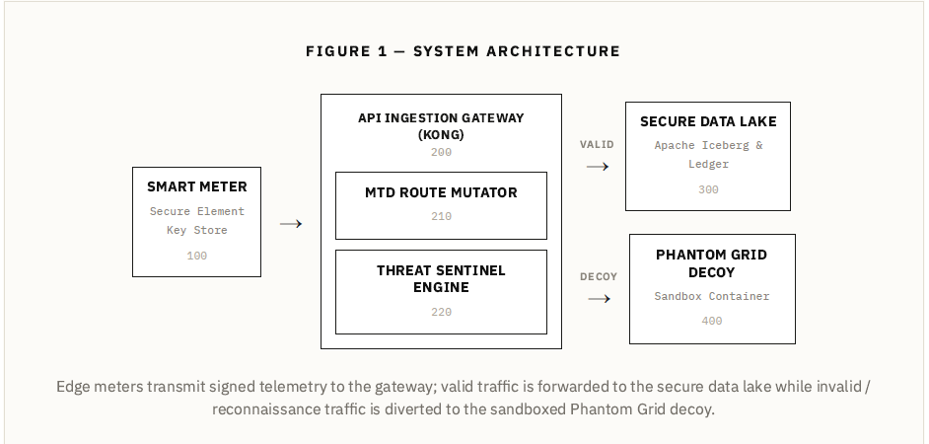

Figure 2 — Cryptographic Block Schema
Telemetry Block N−1 and Telemetry Block N each comprise: meter_id, reading_kwh, timestamp, prev_hash, block_hash, signature, crypto_suite_id, key_id. The prev_hash field of Block N references the block_hash of Block N−1, forming the chain link.
Each block's prev_hash field references the block_hash of its predecessor, forming a tamper-evident sequential chain per meter.

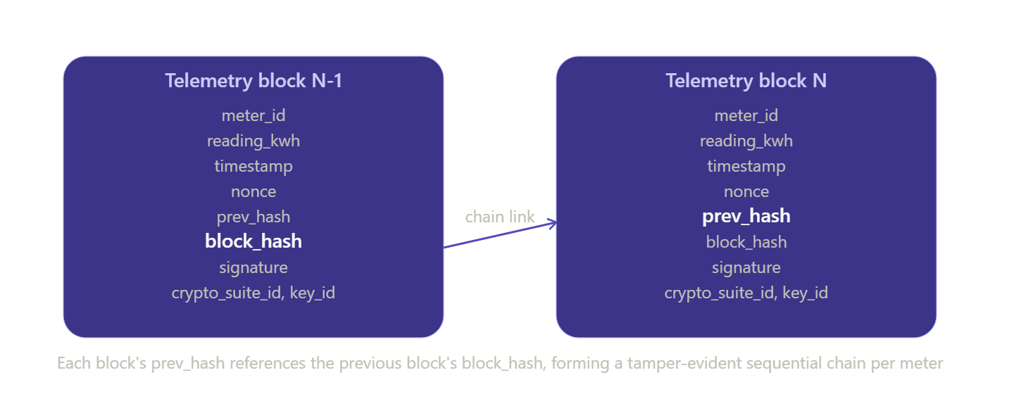

Figure 3 — Ingress Route Mutation Timeline
N − 1 (Previous · Offset −1) | N (Current · Offset 0) | N + 1 (Next · Offset +1)
/rotated_a1b2 | /rotated_c3d4 | /rotated_e5f6

Active route registry — 60-second windows, clock-drift tolerant. Three consecutive 60-second windows are simultaneously valid; the registry tolerates network latency and clock drift between meters and gateway.
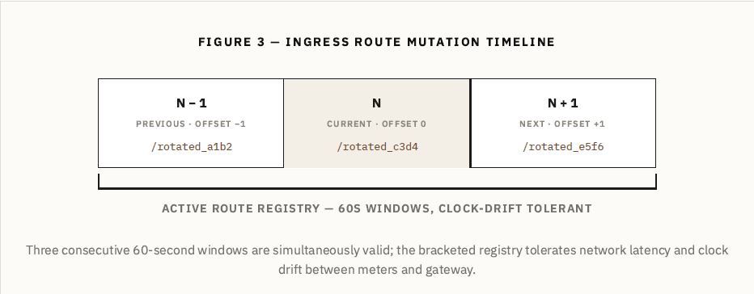

Figure 4 — Active Deception Decision Logic
Decision flow: START → Route Active? — if NO, route to Phantom Grid (S4, reference 400), return synthetic telemetry. If YES → Block Hash & Signature Valid? — if FAIL, quarantine IP & reject ingestion (S3). If PASS, write to Apache Iceberg Ledger (reference 300) → SUCCESS.
Threat Sentinel decision flow: route validity is checked first (deception branch), then cryptographic chain and signature verification gate ledger ingestion.
Drawing reference numerals: 100 Smart Meter · 200 API Ingestion Gateway · 210 MTD Route Mutator · 220 Threat Sentinel Engine · 300 Secure Data Lake / Ledger · 400 Phantom Grid Decoy Container. Stage labels S0–S5 correspond to the escalation loop of Section 5.5.

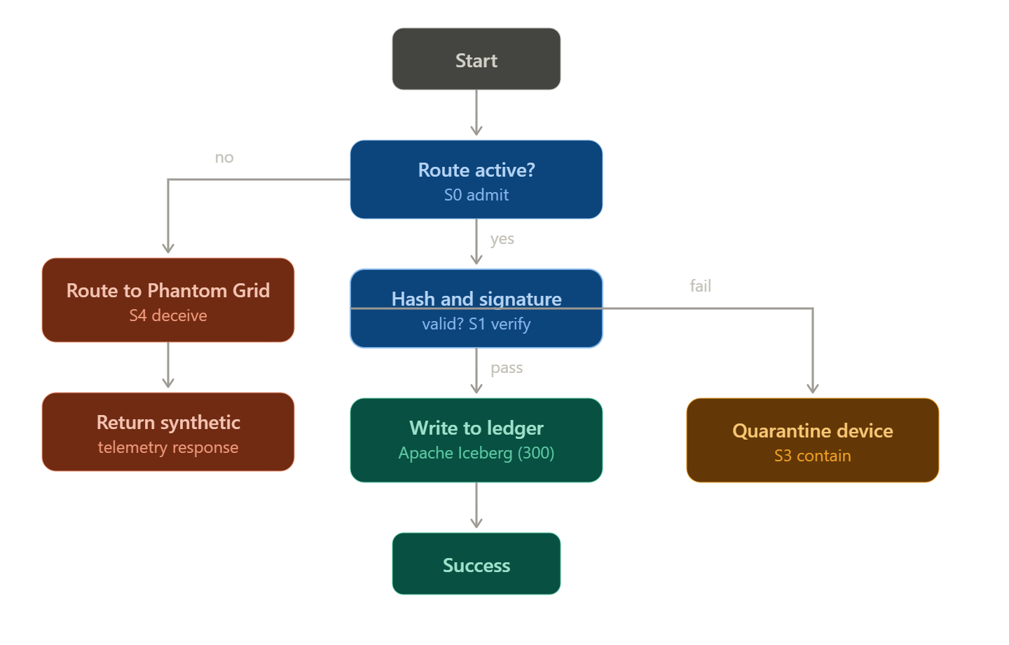

8. Claims

System Claims
1. A telemetry ingestion security system for smart infrastructure, comprising: an edge telemetry device comprising a hardware secure element configured to generate a cryptographic block comprising a payload, a previous-block hash, a monotonic per-device nonce, a cryptographic suite identifier, a key identifier, and a signature computed over the payload, the previous-block hash, the nonce, the cryptographic suite identifier, and the key identifier; an ingestion gateway comprising a route mutator configured to compute, from a shared secret value and a current time-epoch window, a currently-active ingress route distinct from a base route, and to accept incoming requests directed to the currently-active ingress route or to a defined number of temporally adjacent ingress routes computed from adjacent time-epoch windows; and a threat sentinel engine configured to, responsive to a request received at an ingress route other than the currently-active ingress route or a temporally adjacent ingress route, redirect the request to a sandboxed decoy container without indicating to a source of the request that the request has been identified as invalid.
2. The system of claim 1, wherein the threat sentinel engine is further configured to return, from the sandboxed decoy container, a synthetic telemetry acknowledgment response to the source of the request.
3. The system of claim 1, wherein the sandboxed decoy container is deployed on a network segment having no route back to the ingestion gateway or to a data persistence layer storing accepted telemetry blocks, and wherein data captured from interactions at the sandboxed decoy container is exported to the threat sentinel engine via a one-way export mechanism.
4. The system of claim 1, wherein the edge telemetry device is further configured to compute a verifiable delay function proof over a challenge value derived from the previous-block hash and a timestamp associated with the cryptographic block, and wherein the ingestion gateway is configured to verify the verifiable delay function proof independently of measuring elapsed wall-clock time.
5. The system of claim 1, wherein the gateway is configured to reject a cryptographic block whose nonce is not strictly greater than a last-accepted nonce value previously recorded for the same edge telemetry device.
6. The system of claim 1, wherein the route mutator is configured to compute the currently-active ingress route as a function of a scramble value derived from a cryptographic hash of the shared secret value concatenated with the current time-epoch window, the time-epoch window being computed as a floor division of a current time by a fixed window duration.
7. The system of claim 1, wherein the gateway is configured to issue, over an already-authenticated ingress route, a signed key-rotation directive authenticated using an existing key identifier of the edge telemetry device, the key-rotation directive instructing the hardware secure element to adopt a replacement shared secret value for use in subsequent ingress route computation.

Method Claims
8. A method of protecting a telemetry ingestion endpoint for smart infrastructure, comprising: generating, at an edge telemetry device, a cryptographic block comprising a payload, a previous-block hash, a monotonic per-device nonce, a cryptographic suite identifier, and a key identifier, and computing a signature over a hash that includes the payload, the previous-block hash, the nonce, the cryptographic suite identifier, and the key identifier; computing, at a gateway, a currently-active ingress route as a function of a shared secret value and a current time-epoch window; receiving a request at the gateway; determining whether the request was received at the currently-active ingress route or at a temporally adjacent ingress route computed from an adjacent time-epoch window; and, responsive to determining that the request was not received at the currently-active ingress route or a temporally adjacent ingress route, redirecting the request to a sandboxed decoy container without signalling to a source of the request that the request has been identified as invalid, and otherwise, responsive to determining that the request was received at the currently-active ingress route or a temporally adjacent ingress route, performing cryptographic verification of the signature and of a chain of previous-block hashes prior to admitting the payload to a data persistence layer.
9. The method of claim 8, further comprising computing a verifiable delay function challenge from the previous-block hash and a timestamp, computing a sequential proof over the challenge at the edge telemetry device, and verifying the sequential proof at the gateway independently of measured elapsed time between the timestamp and a time of receipt of the cryptographic block.
10. The method of claim 8, further comprising rejecting the cryptographic block where the monotonic per-device nonce is not strictly greater than a last-accepted nonce value previously recorded for the edge telemetry device, independently of the result of the cryptographic verification of the signature.
11. The method of claim 8, further comprising, responsive to a pattern of requests at one or more temporally adjacent or invalid ingress routes associated with a common source, flagging the common source in a threat registry and routing subsequent requests from the common source to the sandboxed decoy container for a defined containment period.
12. The method of claim 8, further comprising migrating the edge telemetry device from a first cryptographic suite identified by a first cryptographic suite identifier to a second cryptographic suite identified by a second cryptographic suite identifier, without altering a key-rotation schedule governing the shared secret value used for ingress route computation.

Dependent Refinement Claims
13. The system of claim 1, wherein the defined number of temporally adjacent ingress routes comprises exactly one immediately preceding time-epoch window and one immediately following time-epoch window relative to the current time-epoch window.
14. The system of claim 1, wherein the cryptographic suite identifier identifies a hybrid signature scheme comprising a classical elliptic-curve signature component and a post-quantum lattice-based signature component.
15. The method of claim 8, wherein generating the cryptographic block is performed entirely within a hardware secure element of the edge telemetry device such that a private key corresponding to the key identifier is not exposed outside the hardware secure element.

