**DBMS Mini Project: Airline Management**

**Tech Used:**

Front End – HTML, CSS, Javascript, PHP, Bootstrap

Back End: Xampp, MySQL

**Screenshots:**

Login Page

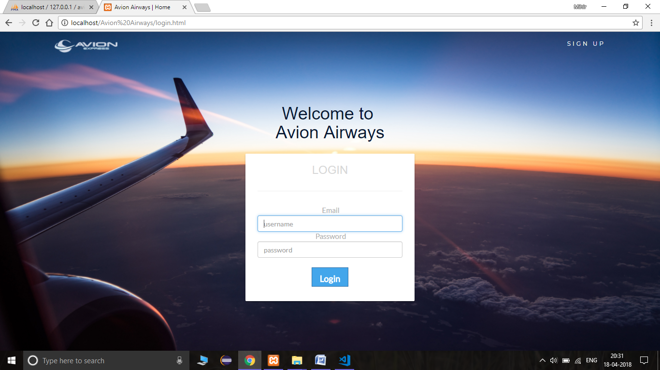

Sign Up Page

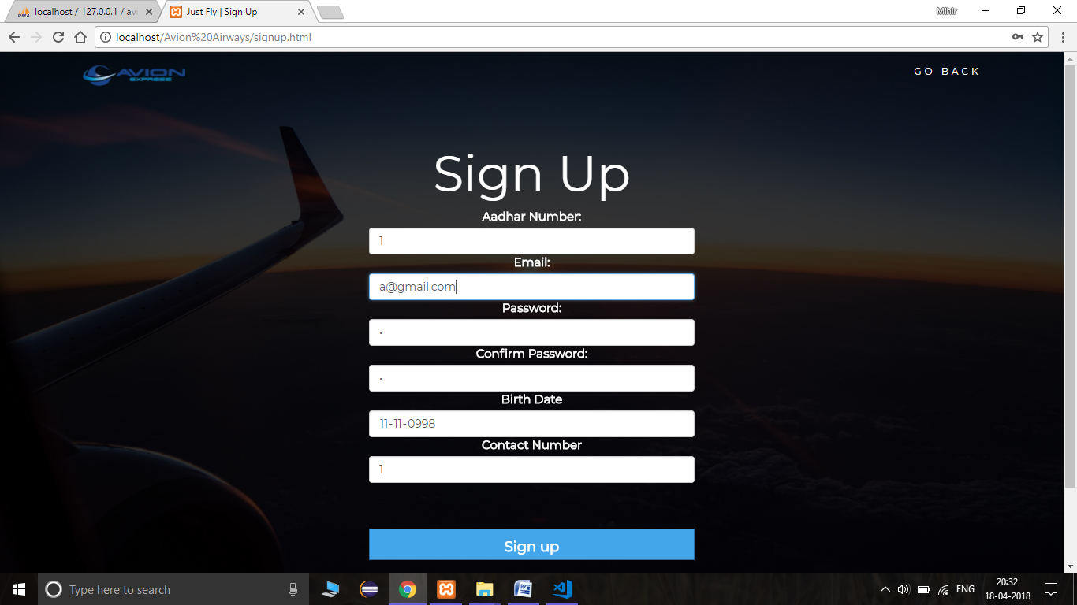

Flight Booking Page

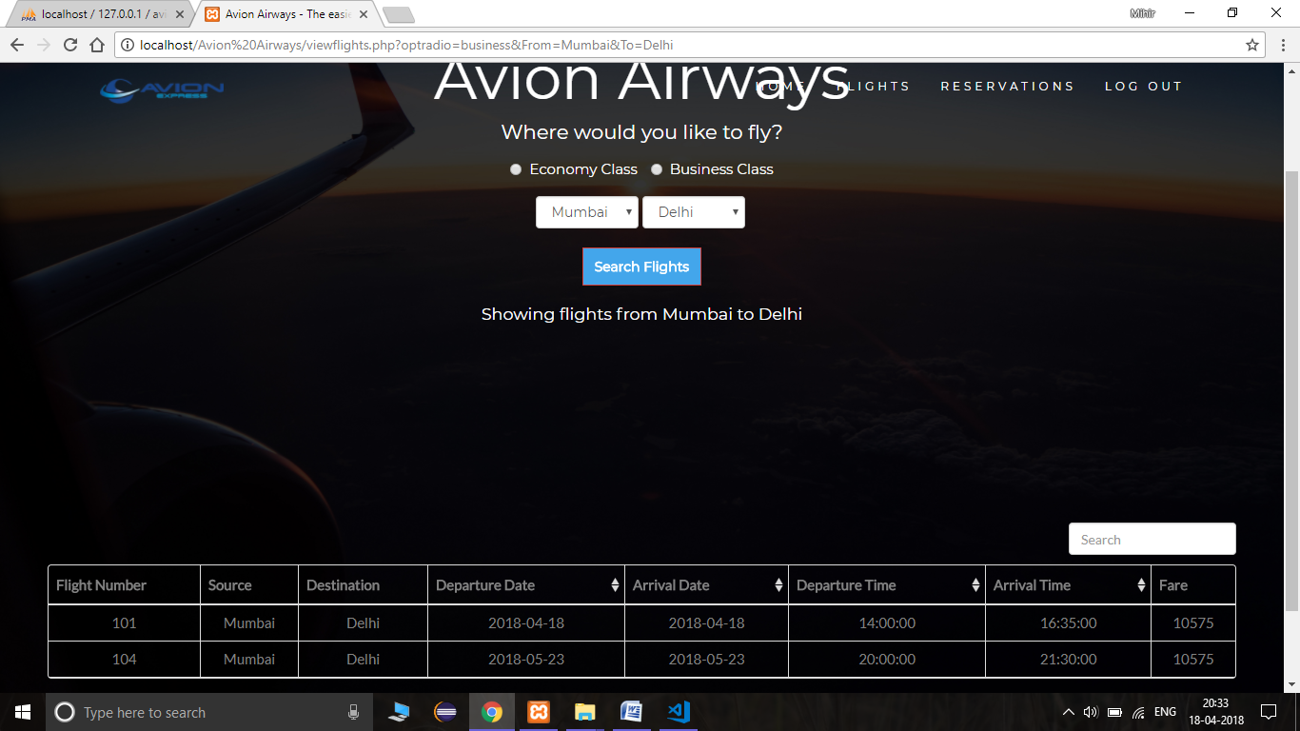

Booking Successful Page

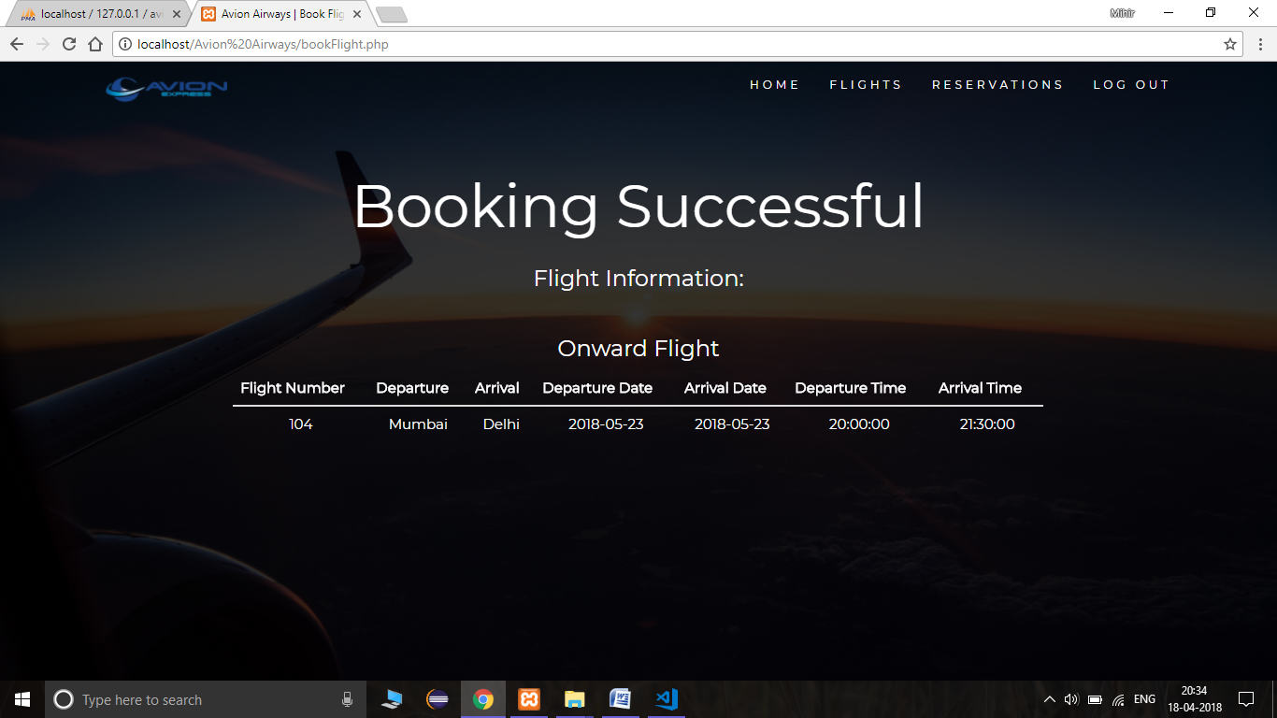

Reservations Page

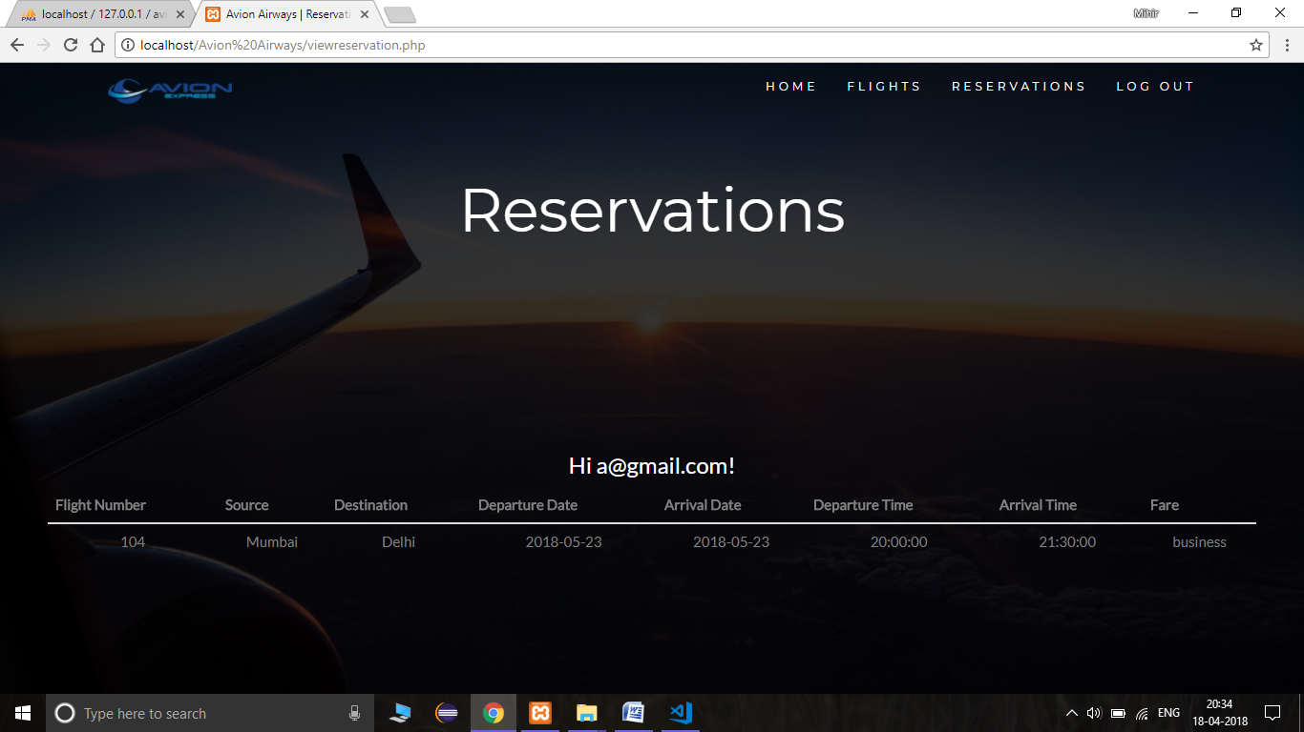

Passenger Table

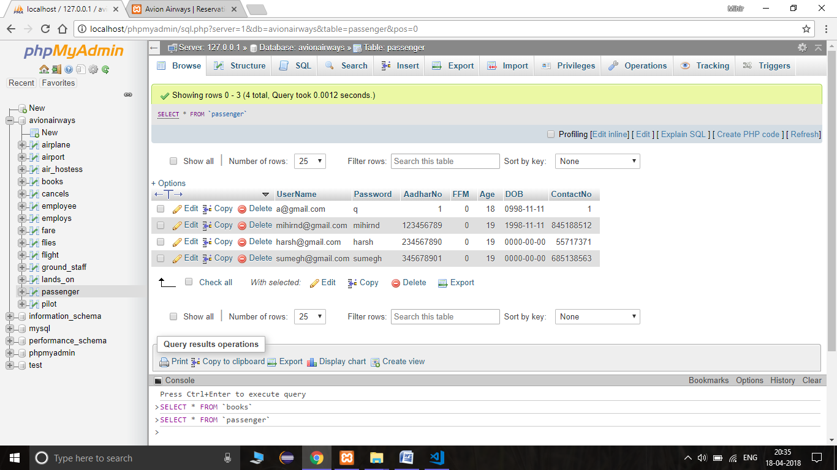

Flights Table

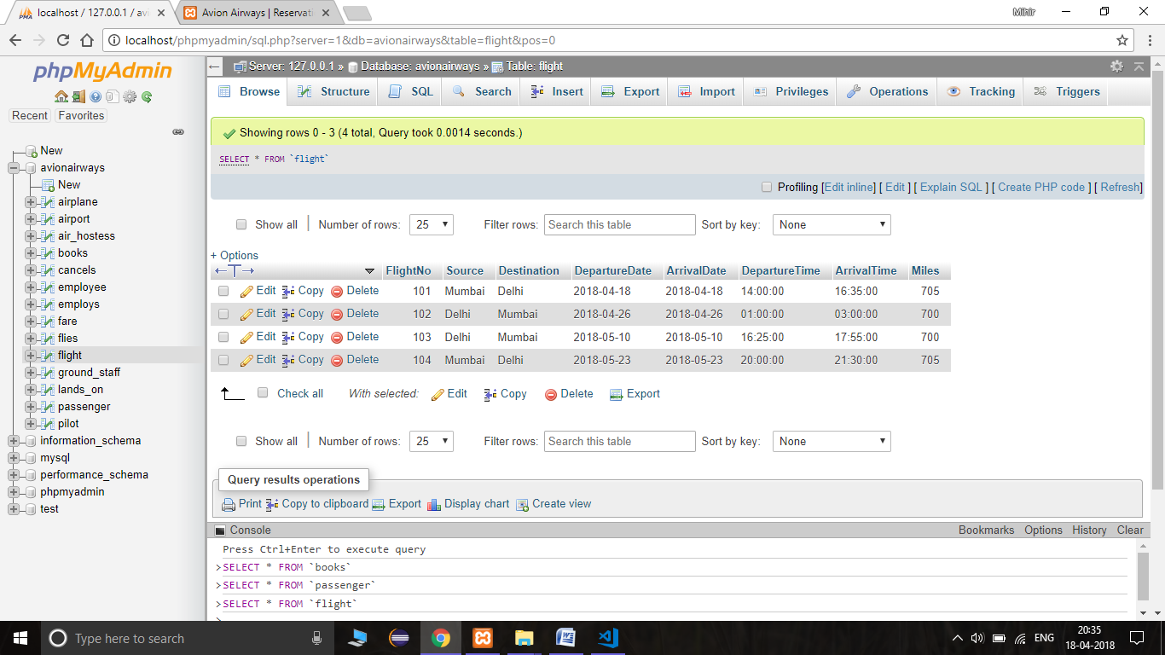

Contribution by each team member:

Mihir Deodhar – User Authentication and Sign Up

Sumegh Anglekar – Flights

Harsh Dave – Book Flights