***INDEX FOR LAB WORKS***

|  |  |  |  |  |  |
| --- | --- | --- | --- | --- | --- |
| **Lab No.** | | **Title** | **Submission Date** | **Signature** | **Remarks** |
| **1.** | **a.** | Greatest Common Divisor (GCD) of two numbers | 2081-07-27 |  |  |
| **b.** | Find nth Fibonacci number |  |
| **c.** | Sequential Search |  |
| **d.** | Bubble Sort |  |
| **e.** | Selection Sort |  |
| **f.** | Insertion Sort |  |
| **g.** | Min and Max finding in a list (minmax algorithm) |  |
| **2.** | | Binary search using divide and conquer approach |  |
| **3.** | | Maximum and minimum element using divide and conquer approach |  |
| **4.** | **a.** | Heap Sort |  |
| **b.** | Quick Sort |  |
| **c.** | Randomized quick Sort |  |
| **d.** | Merge Sort |  |
| **5.** | | Job Sequencing with deadline using greedy algorithm |  |
| **6.** | | Floyd Warshall’s algorithm using dynamic programming approach |  |
| **7.** | | Matrix Chain Multiplication using dynamic programming algorithm |  |

**LAB WORKS**

1. **Write iterative algorithm for the following problem, write program in C/C++. Also analyze their complexity.**
2. **Greatest Common Divisor (GCD)**

**Algorithm:**

**Step** **1**: Start

**Step** **2**: Read any two numbers, say a and b

**Step 3**: If b == 0, return the value of a as the answer and terminate

**Step 4**: If a == 0, return the value of b as the answer and terminate

**Step 5**: Divide a by b and assign the value of the remainder to r

**Step** **6**: Assign the value of b to a and the value of r to b, then go to step 3

**Step** **7**: Stop.

**Source Code:**

#include<stdio.h>

void GCD(int a, int b) {

if(a==0)

printf("GCD(%d, %d) = %d",a, b, b);

else if(b==0)

printf("GCD(%d, %d) = %d",a, b, a);

else{

printf("GCD(%d, %d) = ",a, b);

while(b!=0) {

int r=a%b;

a=b;

b=r;

} printf("%d",a); } }

main() {

int a, b;

printf("Enter a and b: ");

scanf("%d %d", &a, &b);

GCD(a, b);

return 0;

}

**Output:**

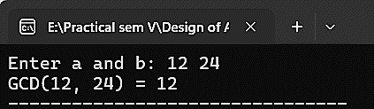

1. **Fibonacci Number**

**Algorithm:**

**Step** **1**: Start

**Step** **2**: Set first = 0, second = 1

**Step 3**: Read term of Fibonacci number, say n

**Step 4**: Set I = 2

**Step 5**: While(i <= n)

5.1: Set temp = first + second

5.2: Set first = second

5.3: Set second = temp

5.4: Increment I by 1 as i++

**Step 6**: Print temp as required Fibonacci number

**Step 7**: Stop.

**Source Code:**

#include<stdio.h>

fibonacci(n) {

int i, first=0, second=1, temp=1;

for (i=2; i<=n; i++) {

temp=first+second;

first=second;

second=temp;

} return temp; }

main() {

int n;

printf("Enter the value for n: ");

scanf("%d", &n);

printf("The %dth fibonacci number is %d.", n, fibonacci(n));

return 0;

}

**Output:**

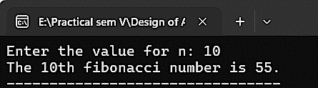

1. **Sequential Search**

**Algorithm:**

**Step** **1**: start

**Step** **2**: Read the search element

**Step** **3**: Compare the search element with the first element in the list

**Step** **4**: If both are matching, then display “Given element found!!!” and terminate the program

**Step** **5**: If both are not matching, then compare the search element with the next element in the list

**Step** **6**: Repeat steps 4 and 5 until the search element is compared with the last element in the list

**Step** **7**: If the last element in the list is also doesn’t match, then display “Element not found!!!” and terminate the program

**Step** **8**: Stop.

**Source Code:**

#include<stdio.h>

int sequentialSearch(int E[], int n, int key) {

int i;

for (i=0; i<n; i++) {

if (E[i]==key)

return i; }

return -1; }

int main() {

int i, n, E[n], key;

printf("Enter total number of elements: ");

scanf("%d", &n);

printf("Enter %d elements: ", n);

for(i=0; i<n; i++)

scanf("%d", &E[i]);

printf("Enter the key to be searched: ");

scanf("%d", &key);

printf("The searched element '%d' is found at index '%d'.",key, sequentialSearch(E, n, key));

return 0;

}

**Output:**

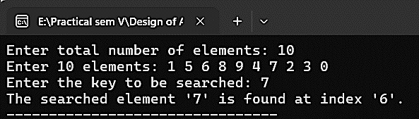

1. **Bubble Sort**

**Algorithm:**

**Step** **1**: Start

**Step** **2**: For the first iteration, compare all the elements n. For the subsequent runs, compare (n-1) (n- 2) and so on

**Step** **3**: Compare each element with its right side neighbor

**Step 4**: Swap the smallest element to the left

**Step 5**: Keep repeating steps 1-3 until the wholw list is covered

**Step 6**: Stop.

**Source Code:**

#include <stdio.h>

void bubble_sort(int arr[], int n) {

int i, j, temp;

for (i = 0; i < n - 1; i++) {

for (j = 0; j < n - i - 1; j++) {

if (arr[j] > arr[j + 1]) {

temp = arr[j];

arr[j] = arr[j + 1];

arr[j + 1] = temp;

} }

} }

void print_array(int arr[], int n) {

int i;

for (i = 0; i < n; i++)

printf("%d ", arr[i]);

printf("\n");

}

int main()

{

int i, n;

printf("Enter the number of elements: ");

scanf("%d", &n);

int arr[n];

printf("Enter %d elements: ", n);

for (i = 0; i < n; i++)

scanf("%d", &arr[i]);

printf("\nOriginal array: ");

print_array(arr, n);

bubble_sort(arr, n);

printf("Sorted array: ");

print_array(arr, n);

return 0;

}

**Output:**

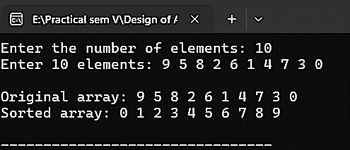

1. **Selection Sort**

**Algorithm:**

**Step 1**: Start

**Step 2**: Consider the first element to be sorted and the rest to be unsorted

**Step 3**: Assume the first element to be the smallest element

**Step 4**: Check if the first element is smaller than each of the other elements:

4.1: If yes, do nothing

4.2: If no, choose the other smaller element as minimum and repeat step 3

**Step 5**: After completion of one iteration through the list, swap the smallest element with the first element of the list

**Step 6**: Now consider the second element in the list to be the smallest and so on till all the elements in the list are covered

**Step 7**: Stop.

**Source Code:**

#include <stdio.h>

void selection_sort(int arr[], int n) {

int i, j, min_idx, temp;

for (i = 0; i < n - 1; i++) {

min_idx = i;

for (j = i + 1; j < n; j++) {

if (arr[j] < arr[min_idx]) min_idx = j;

}

temp = arr[min_idx];

arr[min_idx] = arr[i];

arr[i] = temp;

} }

void print_array(int arr[], int n) {

int i;

for (i = 0; i < n; i++)

printf("%d ", arr[i]);

printf("\n");

}

int main() {

int i, n;

printf("Enter the number of elements: ");

scanf("%d", &n);

int arr[n];

printf("Enter %d elements: ", n);

for (i = 0; i < n; i++)

scanf("%d", &arr[i]);

printf("\nOriginal array: ");

print_array(arr, n);

selection_sort(arr, n);

printf("Sorted array: ");

print_array(arr, n);

return 0;

}

**Output:**

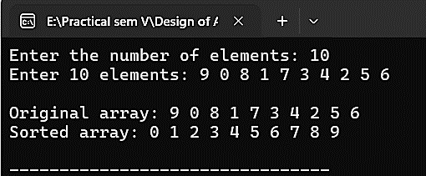

1. **Insertion Sort**

**Algorithm:**

**Step 1**: Start

**Step 2**: Consider the first element to be sorted and the rest to be unsorted

**Step 3**: Compare with the second element

3.1: If the second element < the first element, insert the element in the correct position of the sorted portion

3.2: Else, leave it as it’s

**Step 4**: Repeat 2 and 3 until all elements are sorted

**Step 5**: Stop.

**Source Code:**

#include <stdio.h>

void selection_sort(int arr[], int n) {

int i, j, min_idx, temp;

for (i = 0; i < n - 1; i++) {

min_idx = i;

for (j = i + 1; j < n; j++) {

if (arr[j] < arr[min_idx])

min_idx = j;

}

temp = arr[min_idx];

arr[min_idx] = arr[i];

arr[i] = temp;

} }

void print_array(int arr[], int n) {

int i;

for (i = 0; i < n; i++)

printf("%d ", arr[i]);

printf("\n");

}

int main() {

int i, n;

printf("Enter the number of elements: ");

scanf("%d", &n);

int arr[n];

printf("Enter %d elements: ", n);

for (i = 0; i < n; i++)

scanf("%d", &arr[i]);

printf("\nOriginal array: ");

print_array(arr, n);

selection_sort(arr, n);

printf("Sorted array: ");

print_array(arr, n);

return 0;

}

**Output:**

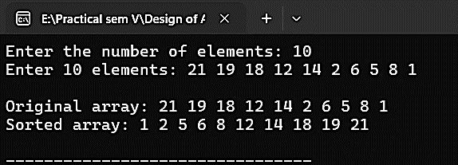

1. **Min-Max Algorithm**

**Algorithm:**

Max-Min-Element(numbers[])

Max = numbers[0]

Min = numbers[0]

For i = 1 to n do

If numbers[i] > max then

Max = numbers[i]

If numbers[i] < min then

Min = numbers[i]

Return(max, min)

**Source Code:**

#include <stdio.h>

void find_min_max(int arr[], int n, int *min, int *max) {

int i;

*min = *max = arr[0];

for (i = 1; i < n; i++) {

if (arr[i] < *min) {

*min = arr[i];

}

else if (arr[i] > *max) {

*max = arr[i];

} } }

int main() {

int i, n;

printf("Enter the number of elements: ");

scanf("%d", &n);

int arr[n];

printf("Enter %d elements: ", n);

for (i = 0; i < n; i++)

scanf("%d", &arr[i]);

int min, max;

find_min_max(arr, n, &min, &max);

printf("\nMinimum value: %d\n", min);

printf("Maximum value: %d\n", max);

return 0;

}

**Output:**

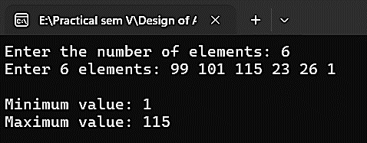

|  |  |  |  |  |  |  |  |
| --- | --- | --- | --- | --- | --- | --- | --- |
|  | **GCD** | **Fibonacci Numbers** | **Linear Search** | **Bubble Sort** | **Selection Sort** | **Insertion Sort** | **Min-Max Algorithm** |
| **Time Complexity** | **O**(n) | **O**(n) | **O**(n) | **O**(n2) | **O**(n2) | **O**(n2) | **O**(n) |
| **Space Complexity** | **O**(1) | **O**(1) | **O**(n) | **O**(1) | **O**(1) | **O**(1) | **O**(1) |

1. **Write algorithm and program to search an item in ordered list using binary search as divide and conquer Approach.**

**Algorithm:**

**Step** **1**: start

**Step** **2**: Read the search element from the user

**Step** **3**: Find the middle element in the sorted list

**Step** **4**: Compare the search element with the middle element in the sorted list

**Step** **5**: If both are matching, then display “Given element found!!!” and terminate the program

**Step** **6**: If both are not matching, then check whether the search element is smaller or larger than the middle element

**Step** **7**: If the search element is smaller than the middle element, then repeat 3, 4, 5 and 6 for the left sub-list of the middle element

**Step** **8**: If the search element is larger than the middle element, then repeat 3, 4, 5 and 6 for the right sub-list of the middle element

**Step** **9**: Repeat the same process until we find the search element in the list or until sub list contains only one element

**Step** **10**: If that element also doesn’t match with the search element, then display “Element not found!!!” and terminate the program

**Step** **11**: Stop.

**Source Code:**

#include <stdio.h>

int binary_search(int arr[], int target, int low, int high) {

if (low > high)

return -1; // not found

int mid = (low + high) / 2;

if (arr[mid] == target) {

return mid; // found

}

else if (arr[mid] < target) {

return binary_search(arr, target, mid + 1, high);

}

else {

return binary_search(arr, target, low, mid - 1);

} }

int main() {

int n;

printf("Enter the number of elements: ");

scanf("%d", &n);

int arr[n];

printf("Enter %d elements in sorted order: ", n);

for (int i = 0; i < n; i++)

scanf("%d", &arr[i]);

int target;

printf("Enter the target element: ");

scanf("%d", &target);

int result = binary_search(arr, target, 0, n - 1);

if (result != -1) {

printf("The searched element '%d' is found at index '%d'.", target, result);

}

else {

printf("Element not found!!!\n");

}

return 0;

}

**Output:**

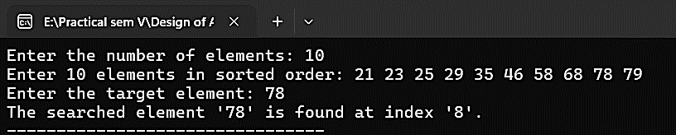

1. **Write algorithm and program to find the maximum and minimum element in a list of numbers using divide and conquer approach.**

**Algorithm:**

Max - Min(x, y)

if y – x ≤ 1 then

return (max(numbers[x],numbers[y]),min((numbers[x],numbers[y]))

else

(max1, min1):= maxmin(x, ⌊((x + y)/2)⌋)

(max2, min2):= maxmin(⌊((x + y)/2) + 1)⌋,y)

return (max(max1, max2), min(min1, min2))

**Source Code:**

#include <stdio.h>

void find_min_max(int arr[], int low, int high, int *min, int *max) {

if (low == high) {

*min = *max = arr[low];

}

else if (low + 1 == high) {

if (arr[low] < arr[high]) {

*min = arr[low];

*max = arr[high];

}

else {

*min = arr[high];

*max = arr[low];

}

}

else {

int mid = (low + high) / 2;

int min1, max1, min2, max2;

find_min_max(arr, low, mid, &min1, &max1);

find_min_max(arr, mid + 1, high, &min2, &max2);

*min = (min1 < min2) ? min1 : min2;

*max = (max1 > max2) ? max1 : max2;

}

}

int main() {

int i, n;

printf("Enter the number of elements: ");

scanf("%d", &n);

int arr[n];

printf("Enter %d elements: ", n);

for (i = 0; i < n; i++)

scanf("%d", &arr[i]);

int min, max;

find_min_max(arr, 0, n - 1, &min, &max);

printf("\nMinimum value: %d\n", min);

printf("Maximum value: %d\n", max);

return 0;

}

**Output:**

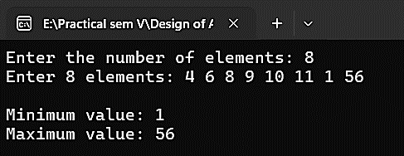

1. **Write algorithms and program using divide and conquer approach for following sorting algorithms**
2. **Heap Sort**

**Algorithms:**

HeapSort(A){

BuildHeap(A);

N = length[A];

For(i = n; i >= 2; i--){

Swap(A[1], A[n]);

n = n-1;

Heapify(A, 1);

}

}

**Source Code:**

#include <stdio.h>

void heapify(int arr[], int n, int i) {

int largest = i;

int left = 2 * i + 1;

int right = 2 * i + 2;

if (left < n && arr[left] > arr[largest])

largest = left;

if (right < n && arr[right] > arr[largest])

largest = right;

if (largest!= i) {

int temp = arr[i];

arr[i] = arr[largest];

arr[largest] = temp;

heapify(arr, n, largest);

}

}

void heapSort(int arr[], int n) {

int i;

for (i = n / 2 - 1; i >= 0; i--)

heapify(arr, n, i);

for (i = n - 1; i >= 0; i--) {

int temp = arr[0];

arr[0] = arr[i];

arr[i] = temp;

heapify(arr, i, 0);

} }

int main() {

int i, n;

printf("Enter the number of elements: ");

scanf("%d", &n);

int arr[n];

printf("Enter %d elements: ", n);

for (i = 0; i < n; i++)

scanf("%d", &arr[i]);

heapSort(arr, n);

printf("Sorted array: ");

for (i = 0; i < n; i++)

printf("%d ", arr[i]);

return 0;

}

**Output:**

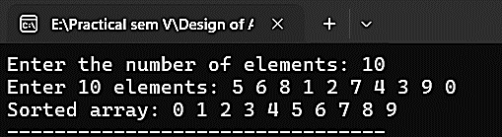

1. **Quick Sort**

**Algorithm:**

**Step 1**: Start

**Step 2**: Choose a pivot

**Step 3**: Set a left pointer and right pointer

**Step 4**: Compare the left pointer element (lelement) with the pivot and the right pointer element (relement) with the pivot

**Step 5**: Check if lelement < pivot and relement > pivot:

5.1: If yes, increment the left pointer and decrement the right pointer

5.2: If not, swap the lelement and relement

**Step 6**: When left >= right, swap the pivot with either left or right pointer

**Step 7**: Repeat steps 2-5 on the left half and the right half of the list till the entire list is sorted

**Step 8**: Stop.

**Source Code:**

#include <stdio.h>

int partition(int arr[], int low, int high) {

int pivot = arr[high];

int j, i = low - 1;

for (j = low; j < high; j++) {

if (arr[j] < pivot) {

i++;

int temp = arr[i];

arr[i] = arr[j];

arr[j] = temp;

} }

int temp = arr[i + 1];

arr[i + 1] = arr[high];

arr[high] = temp;

return i + 1;

}

void quickSort(int arr[], int low, int high) {

if (low < high) {

int pivot = partition(arr, low, high);

quickSort(arr, low, pivot - 1);

quickSort(arr, pivot + 1, high);

} }

int main() {

int i, n;

printf("Enter the number of elements: ");

scanf("%d", &n);

int arr[n];

printf("Enter %d elements: ", n);

for (i = 0; i < n; i++)

scanf("%d", &arr[i]);

quickSort(arr, 0, n - 1);

printf("Sorted array: ");

for (i = 0; i < n; i++)

printf("%d ", arr[i]);

return 0;

}

**Output:**

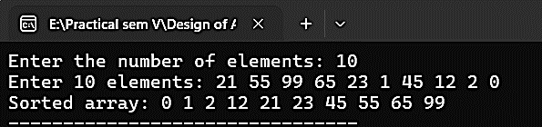

1. **Randomized quick Sort**

**Algorithm:**

int partition_left(int arr[], int low, int high) {

int pivot = arr[high];

int i = low; // Place for swapping

for (int j = low; j < high; j++) {

if (arr[j] <= pivot) {

swap(&arr[i], &arr[j]);

i++;

}

}

swap(&arr[i], &arr[high]);

return i; }

int partition_right(int arr[], int low, int high) {

int r = RandomNumber(low, high); // Randomly choose pivot index

swap(&arr[r], &arr[high]);

return partition_left(arr, low, high); }

void quicksort(int arr[], int low, int high) {

if (low < high) {

int pivot = partition_right(arr, low, high);

quicksort(arr, low, pivot - 1);

quicksort(arr, pivot + 1, high);

}

}

**Source Code:**

#include <stdio.h>

#include <stdlib.h>

#include <time.h>

void swap(int* a, int* b) {

int temp = *a;

*a = *b;

*b = temp;

}

// Function to partition the array

int partition(int arr[], int low, int high) {

// Choose a random pivot index

int pivot_index = low + rand() % (high - low + 1);

int pivot = arr[pivot_index];

// Move the pivot element to the end of the array

swap(&arr[pivot_index], &arr[high]);

int i = low - 1, j;

for (j = low; j < high; j++) {

if (arr[j] < pivot) {

i++;

swap(&arr[i], &arr[j]);

}

}

// Move the pivot element to its final sorted position

swap(&arr[i + 1], &arr[high]);

return i + 1;

}

// Function to perform randomized quick sort

void randomized_quick_sort(int arr[], int low, int high) {

if (low < high) {

int pivot = partition(arr, low, high);

// Recursively sort the two sub-arrays

randomized_quick_sort(arr, low, pivot - 1);

randomized_quick_sort(arr, pivot + 1, high);

}

}

// Function to print the array

void print_array(int arr[], int size) {

int i;

for (i = 0; i < size; i++)

printf("%d ", arr[i]);

printf("\n");

}

int main() {

int i, size;

printf("Enter the size of the array: ");

scanf("%d", &size);

int* arr = (int*)malloc(size * sizeof(int));

printf("Enter the elements of the array: ");

for (i = 0; i < size; i++)

scanf("%d", &arr[i]);

// Seed the random number generator

srand(time(NULL));

printf("\nOriginal array: ");

print_array(arr, size);

randomized_quick_sort(arr, 0, size - 1);

printf("Sorted array: ");

print_array(arr, size);

free(arr);

return 0;

}

**Output:**

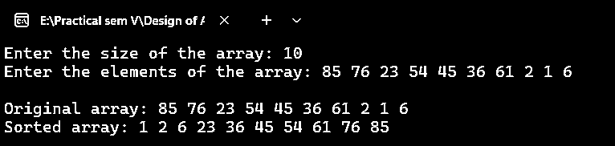

1. **Merge Sort**

**Algorithm:**

**Step 1**: Start

**Step 2**: Split the unsorted list into two groups recursively until there is one element per group

**Step 3**: Compare each of the elements and then sort and group them

**Step 4**: Repeat step 2 until the whole list is merged and sorted in the process

**Step 5**: Stop.

**Source Code:**

#include <stdio.h>

// Function to merge two sub-arrays

void merge(int arr[], int left, int mid, int right) {

int i, j, k;

int n1 = mid - left + 1;

int n2 = right - mid;

// Create temporary arrays

int left_arr[n1], right_arr[n2];

// Copy data to temporary arrays

for (i = 0; i < n1; i++)

left_arr[i] = arr[left + i];

for (j = 0; j < n2; j++)

right_arr[j] = arr[mid + 1 + j];

// Merge the temporary arrays

i = 0;

j = 0;

k = left;

while (i < n1 && j < n2) {

if (left_arr[i] <= right_arr[j]) {

arr[k] = left_arr[i];

i++;

}

else{

arr[k] = right_arr[j];

j++;

}

k++;

}

// Copy the remaining elements of left_arr[], if there are any

while (i < n1) {

arr[k] = left_arr[i];

i++;

k++;

}

// Copy the remaining elements of right_arr[], if there are any

while (j < n2) {

arr[k] = right_arr[j];

j++;

k++;

}

}

// Function to perform merge sort

void merge_sort(int arr[], int left, int right) {

if (left < right) {

int mid = left + (right - left) / 2;

// Recursively sort the two halves

merge_sort(arr, left, mid);

merge_sort(arr, mid + 1, right);

// Merge the two sorted halves

merge(arr, left, mid, right);

}

}

// Function to print the array

void print_array(int arr[], int size){

int i;

for (i = 0; i < size; i++)

printf("%d ", arr[i]);

printf("\n");

}

int main() {

int i, size;

printf("Enter the size of the array: ");

scanf("%d", &size);

int arr[size];

printf("Enter the elements of the array: ");

for (i = 0; i < size; i++)

scanf("%d", &arr[i]);

printf("\nOriginal array: ");

print_array(arr, size);

merge_sort(arr, 0, size - 1);

printf("Sorted array: ");

print_array(arr, size);

return 0;

}

**Output:**

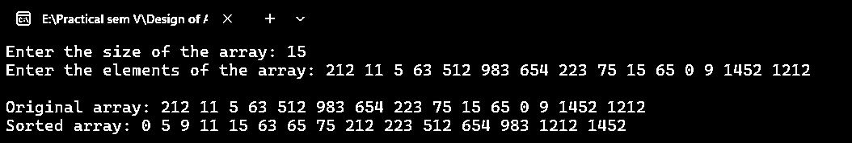

1. **Write a program to implement problem Job Sequencing with deadline using greedy algorithm**

**Source Code:**

#include <stdio.h>

// Structure to represent a job

typedef struct {

int id;

int deadline;

int profit;

}Job;

// Function to compare two jobs based on their profits

int compare(const void *a, const void *b) {

Job *job1 = (Job *)a;

Job *job2 = (Job *)b;

return job2->profit - job1->profit;

}

// Function to find the maximum profit

void jobSequencing(Job jobs[], int n) {

int i, j;

// Sort the jobs based on their profits

qsort(jobs, n, sizeof(Job), compare);

// Create a boolean array to track the deadlines

int deadlines[10] = {0};

// Initialize the maximum profit

int maxProfit = 0;

// Iterate through the sorted jobs

for (i = 0; i < n; i++) {

// Find a deadline that can accommodate the current job

for (j = jobs[i].deadline; j >= 1; j--) {

if (!deadlines[j]) {

deadlines[j] = 1;

maxProfit += jobs[i].profit;

break;

} } }

printf("Maximum Profit: %d\n", maxProfit);

}

int main() {

int i, n;

printf("Enter the number of jobs: ");

scanf("%d", &n);

Job jobs[n];

printf("Enter the job details (id, deadline, profit):\n");

for (i = 0; i < n; i++)

scanf("%d %d %d", &jobs[i].id, &jobs[i].deadline, &jobs[i].profit);

jobSequencing(jobs, n);

return 0;

}

**Output:**

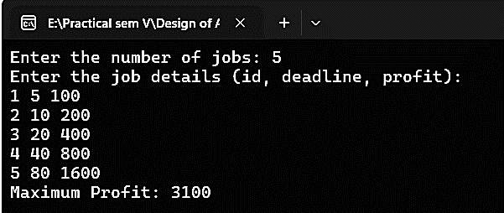

1. **Implement the Floyd- Warshall’s algorithm to compute all pair shortest path problem using dynamic programming approach.**

**Source Code:**

#include <iostream>

#include <climits>

int main() {

int V;

std::cout << "Enter the number of vertices: ";

std::cin >> V;

int graph[V][V];

std::cout << "Enter the adjacency matrix:" << std::endl;

for (int i = 0; i < V; i++) {

for (int j = 0; j < V; j++) {

std::cin >> graph[i][j];

if (graph[i][j] == 0 && i != j) {

graph[i][j] = INT_MAX;

} } }

std::cout << "\nOriginal graph:" << std::endl;

for (int i = 0; i < V; i++) {

for (int j = 0; j < V; j++) {

std::cout << graph[i][j] << " ";

}

std::cout << std::endl;

}

for (int k = 0; k < V; k++) {

for (int i = 0; i < V; i++) {

for (int j = 0; j < V; j++) {

if (graph[i][k] + graph[k][j] < graph[i][j])

graph[i][j] = graph[i][k] + graph[k][j];

} } }

std::cout << "\nShortest distances between all pairs of vertices:" << std::endl;

for (int i = 0; i < V; i++) {

for (int j = 0; j < V; j++) {

std::cout << graph[i][j] << " ";

}

std::cout << std::endl;

}

return 0;

}

**Output:**

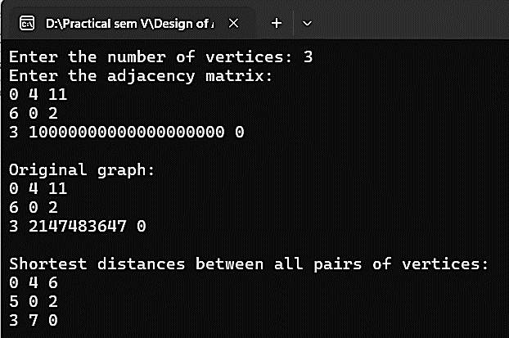

1. **Write a program to implement Matrix Chain Multiplication using dynamic programming algorithm.**

**Source Code:**

#include <stdio.h>

#include <limits.h>

int MatrixChainOrder(int p[], int n) {

int m[100][100];

int i, j, k, L, q;

for (i = 1; i <= n; i++)

m[i][i] = 0;

for (L = 2; L < n; L++) {

for (i = 1; i < n - L + 1; i++) {

j = i + L - 1;

m[i][j] = INT_MAX;

for (k = i; k <= j - 1; k++) {

q = m[i][k] + m[k + 1][j] + p[i - 1] * p[k] * p[j];

if (q < m[i][j])

m[i][j] = q;

} } }

return m[1][n - 1];

}

int main() {

int i, n;

printf("Enter the number of matrices: ");

scanf("%d", &n);

int p[n + 1];

printf("Enter the dimensions of the matrices:\n");

for (i = 0; i <= n; i++) {

scanf("%d", &p[i]);

}

printf("\nThe optimal multiplication cost is %d.", MatrixChainOrder(p, n + 1));

return 0;

}

**Output:**

