CHAPTER 7: OPTIMAL RISKY PORTFOLIOS

PROBLEM SETS

1. (a) and (e). Short-term rates and labor issues are factors that are common to all firms and therefore must be considered as market risk factors. The remaining three factors are unique to this corporation and are not a part of market risk.

2. (a) and (c). After real estate is added to the portfolio, there are four asset classes in the portfolio: stocks, bonds, cash, and real estate. Portfolio variance now includes a variance term for real estate returns and a covariance term for real estate returns with returns for each of the other three asset classes. Therefore, portfolio risk is affected by the variance (or standard deviation) of real estate returns and the correlation between real estate returns and returns for each of the other asset classes. (Note that the correlation between real estate returns and returns for cash is most likely zero.)

3. (a) Answer (a) is valid because it provides the definition of the minimum variance portfolio.

4. The parameters of the opportunity set are:
E(r_{S}) = 20%, E(r_{B}) = 12%, σ_{S} = 30%, σ_{B} = 15%, ρ = 0.10
From the standard deviations and the correlation coefficient we generate the covariance matrix [note that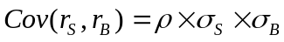]:
 | Bonds | Stocks
Bonds | 225 | 45
Stocks | 45 | 900
The minimum-variance portfolio is computed as follows:
w_{Min}(S) =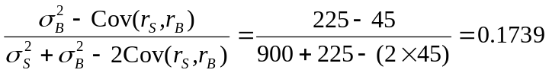
w_{Min}(B) = 1 − 0.1739 = 0.8261

The minimum variance portfolio mean and standard deviation are:
E(r_{Min}) = (0.1739 × .20) + (0.8261 × .12) = .1339 = 13.39%
σMin = 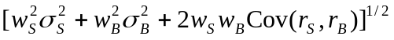
= [(0.1739² × 900) + (0.8261² × 225) + (2 × 0.1739 × 0.8261 × 45)]^{1/2}
= 13.92%

5.
Proportion  in Stock Fund | Proportion  in Bond Fund | Expected  Return | Standard  Deviation
0.00% | 100.00% | 12.00% | 15.00%
17.39 | 82.61 | 13.39 | 13.92 | minimum variance
20.00 | 80.00 | 13.60 | 13.94
40.00 | 60.00 | 15.20 | 15.70
45.16 | 54.84 | 15.61 | 16.54 | tangency portfolio
60.00 | 40.00 | 16.80 | 19.53
80.00 | 20.00 | 18.40 | 24.48
100.00 | 0.00 | 20.00 | 30.00
Graph shown below.

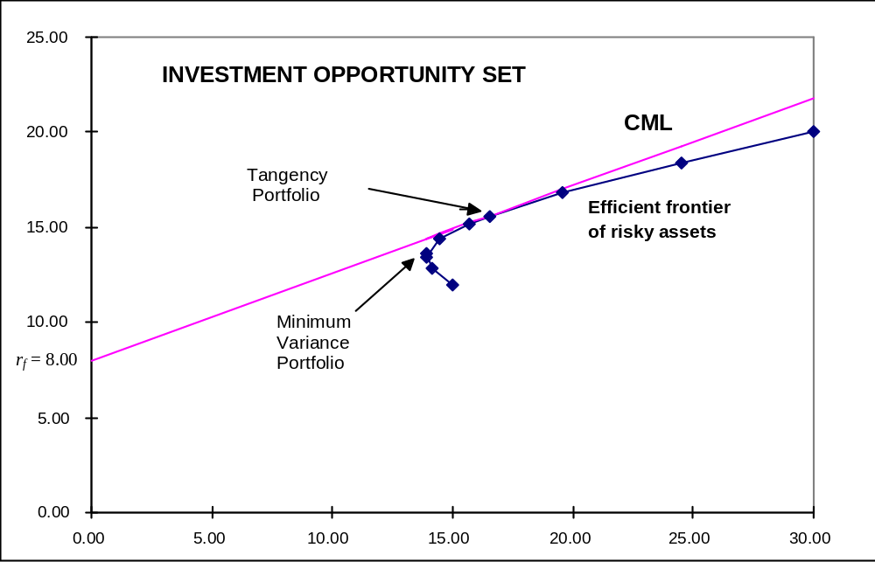

6. The above graph indicates that the optimal portfolio is the tangency portfolio with expected return approximately 15.6% and standard deviation approximately 16.5%.

7. The proportion of the optimal risky portfolio invested in the stock fund is given by:
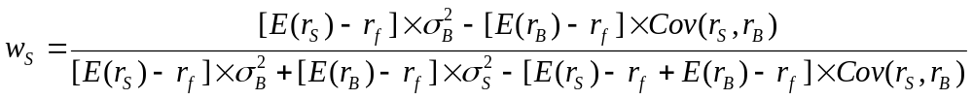
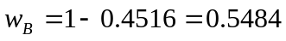
The mean and standard deviation of the optimal risky portfolio are:
E(r_{P}) = (0.4516 × .20) + (0.5484 × .12) = .1561
= 15.61%
σp = [(0.4516² × 900) + (0.5484² × 225) + (2 × 0.4516 × 0.5484 × 45)]^{1/2}
= 16.54%

8. The reward-to-volatility ratio of the optimal CAL is:
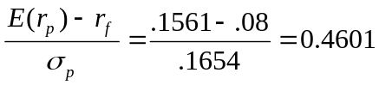

9. a. If you require that your portfolio yield an expected return of 14%, then you can find the corresponding standard deviation from the optimal CAL. The equation for this CAL is:
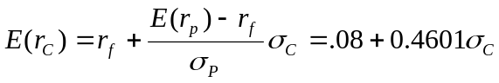

If E(r_{C}) is equal to 14%, then the standard deviation of the portfolio is 13.04%.

b. To find the proportion invested in the T-bill fund, remember that the mean of the complete portfolio (i.e., 14%) is an average of the T-bill rate and the optimal combination of stocks and bonds (P). Let y be the proportion invested in the portfolio P. The mean of any portfolio along the optimal CAL is:
Setting E(r_{C}) = 14% we find: y = 0.7884 and (1 − y) = 0.2119 (the proportion invested in the T-bill fund).
To find the proportions invested in each of the funds, multiply 0.7884 times the respective proportions of stocks and bonds in the optimal risky portfolio:
Proportion of stocks in complete portfolio = 0.7884 × 0.4516 = 0.3560
Proportion of bonds in complete portfolio = 0.7884 × 0.5484 = 0.4323

10. Using only the stock and bond funds to achieve a portfolio expected return of 14%, we must find the appropriate proportion in the stock fund (w_{S}) and the appropriate proportion in the bond fund (w_{B} = 1 − w_{S}) as follows:
0.14 = 0.20 × w_{S} + 0.12 × (1 − w_{S}) = 0.12 + 0.08 × w_{S} ⇒ w_{S} = 0.25
So the proportions are 25% invested in the stock fund and 75% in the bond fund. The standard deviation of this portfolio will be:
σ_{P} = [(0.25² × 900) + (0.75² × 225) + (2 × 0.25 × 0.75 × 45)]^{1/2} = 14.13%
This is considerably greater than the standard deviation of 13.04% achieved using T-bills and the optimal portfolio.

11. a.
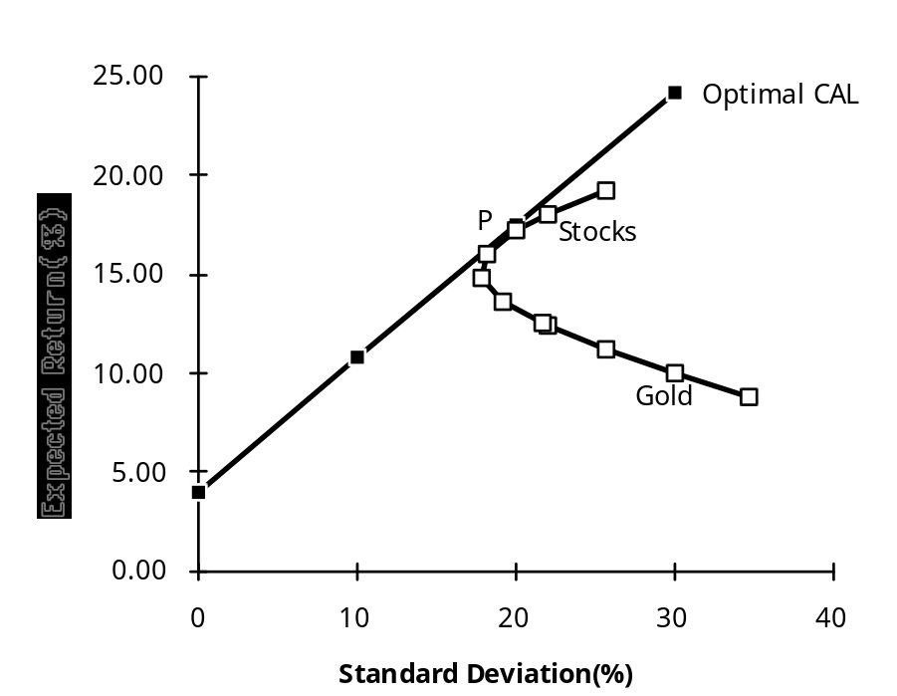

Even though it seems that gold is dominated by stocks, gold might still be an attractive asset to hold as a part of a portfolio. If the correlation between gold and stocks is sufficiently low (or even negative), gold will be held as a component in a portfolio, specifically, the optimal tangency portfolio.

- If the correlation between gold and stocks equals +1, then no one would be willing to hold gold: its return is lower than stocks, its standard deviation is higher, and, with perfect correlation, it offers no diversification benefits (such as those described in part a). The optimal CAL would be composed of bills and stocks only. Since the set of risk/return combinations of stocks and gold would plot as a straight line with a negative slope (see the following graph), any portfolio that contains gold would be dominated by the stock portfolio.

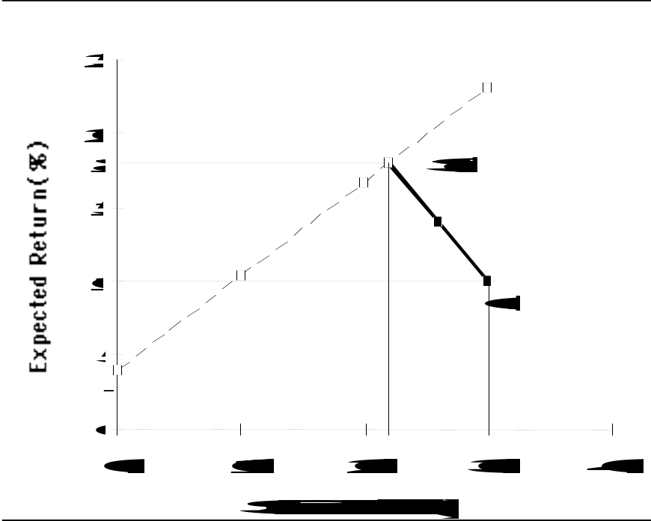

- Of course, this situation could not be an equilibrium. As long as no one is willing to hold gold, its price will fall and its expected rate of return will increase until it became sufficiently attractive to include in a portfolio.

12. Since Stock A and Stock B are perfectly negatively correlated, a risk-free portfolio can be created and the rate of return for this portfolio, in equilibrium, will be the risk-free rate. To find the proportions of this portfolio [with the proportion w_{A} invested in Stock A and w_{B} = (1 – w_{A} ) invested in Stock B], set the standard deviation equal to zero. With perfect negative correlation, the portfolio standard deviation is:
σ_{P} = Absolute value [w_{A}σ_{A} − w_{B}σ_{B}]
0 = 5 × w_{A} − [10 × (1 – w_{A})] ⇒ w_{A} = 0.6667
The expected rate of return for this risk-free portfolio is:
E(r) = (0.6667 × 10) + (0.3333 × 15) = 11.667%
Therefore, the risk-free rate is: 11.667%

13. False. If the borrowing and lending rates are not identical, then, depending on the tastes of the individuals (that is, the shape of their indifference curves), borrowers and lenders could have different optimal risky portfolios.

14. False. The portfolio standard deviation equals the weighted average of the component-asset standard deviations only in the special case that all assets are perfectly positively correlated. Otherwise, as the formula for portfolio standard deviation shows, the portfolio standard deviation is less than the weighted average of the component-asset standard deviations. The portfolio variance is a weighted sum of the elements in the covariance matrix, with the products of the portfolio proportions as weights.

15. The probability distribution is:
Probability | Rate of Return
0.7 | 100%
0.3 | −50
Mean = [0.7 × 100%] + [0.3 × (-50%)] = 55%
Variance = [0.7 × (100 − 55)²] + [0.3 × (-50 − 55)²] = 4725
Standard deviation = 4725^{1/2} = 68.74%

16. σ_{P} = 30 = y × σ = 40 × y ⇒ y = 0.75
E(r_{P}) = 12 + 0.75(30 − 12) = 25.5%

17. The correct choice is (c). Intuitively, we note that since all stocks have the same expected rate of return and standard deviation, we choose the stock that will result in lowest risk. This is the stock that has the lowest correlation with Stock A.
More formally, we note that when all stocks have the same expected rate of return, the optimal portfolio for any risk-averse investor is the global minimum variance portfolio (G). When the portfolio is restricted to Stock A and one additional stock, the objective is to find G for any pair that includes Stock A, and then select the combination with the lowest variance. With two stocks, I and J, the formula for the weights in G is:
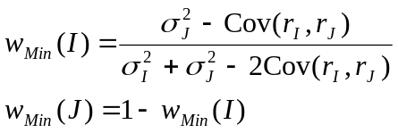
Since all standard deviations are equal to 20%:
This intuitive result is an implication of a property of any efficient frontier, namely, that the covariances of the global minimum variance portfolio with all other assets on the frontier are identical and equal to its own variance. (Otherwise, additional diversification would further reduce the variance.) In this case, the standard deviation of G(I, J) reduces to:
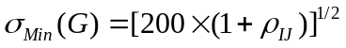
This leads to the intuitive result that the desired addition would be the stock with the lowest correlation with Stock A, which is Stock D. The optimal portfolio is equally invested in Stock A and Stock D, and the standard deviation is 17.03%.

18. No, the answer to Problem 17 would not change, at least as long as investors are not risk lovers. Risk neutral investors would not care which portfolio they held since all portfolios have an expected return of 8%.

19. Yes, the answers to Problems 17 and 18 would change. The efficient frontier of risky assets is horizontal at 8%, so the optimal CAL runs from the risk-free rate through G. This implies risk-averse investors will just hold Treasury bills.

20. Rearrange the table (converting rows to columns) and compute serial correlation results in the following table:

Nominal Rates
 | Small  Company  Stocks | Large  Company  Stocks | Long-Term  Government  Bonds | Treasury  Bills | Inflation
1920s | -3.72 | 18.36 | 3.98 | 3.56 | -1.00
1930s | 7.28 | -1.25 | 4.60 | 0.30 | -2.04
1940s | 20.63 | 9.11 | 3.59 | 0.37 | 5.36
1950s | 19.01 | 19.41 | 0.25 | 1.87 | 2.22
1960s | 13.72 | 7.84 | 1.14 | 3.89 | 2.52
1970s | 8.75 | 5.90 | 6.63 | 6.29 | 7.36
1980s | 12.46 | 17.60 | 11.50 | 9.00 | 5.10
1990s | 13.84 | 18.20 | 8.60 | 5.02 | 2.93
2000s | 6.70 | -1.00 | 5.00 | 2.70 | 2.50
Serial Correlation | 0.34 | -0.35 | 0.55 | 0.59 | 0.23
For example: to compute serial correlation in decade nominal returns for large-company stocks, we set up the following two columns in an Excel spreadsheet. Then, use the Excel function “CORREL” to calculate the correlation for the data.
 | Decade | Previous
1930s | -1.25% | 18.36%
1940s | 9.11% | -1.25%
1950s | 19.41% | 9.11%
1960s | 7.84% | 19.41%
1970s | 5.90% | 7.84%
1980s | 17.60% | 5.90%
1990s | 18.20% | 17.60%
2000s | -1.00% | 18.20%
Note that each correlation is based on only seven observations, so we cannot arrive at any statistically significant conclusions. Looking at the results, however, it appears that, with the exception of large-company stocks, there is persistent serial correlation. (This conclusion changes when we turn to real rates in the next problem.)

21. The table for real rates (using the approximation of subtracting a decade’s average inflation from the decade’s average nominal return) is:
Real Rates
 | Small  Company  Stocks | Large  Company  Stocks | Long-Term  Government  Bonds | Treasury  Bills
1920s | -2.72 | 19.36 | 4.98 | 4.56
1930s | 9.32 | 0.79 | 6.64 | 2.34
1940s | 15.27 | 3.75 | -1.77 | -4.99
1950s | 16.79 | 17.19 | -1.97 | -0.35
1960s | 11.20 | 5.32 | -1.38 | 1.37
1970s | 1.39 | -1.46 | -0.73 | -1.07
1980s | 7.36 | 12.50 | 6.40 | 3.90
1990s | 10.91 | 15.27 | 5.67 | 2.09
2000s | 4.20 | -3.5 | 2.5 | 0.2
Serial Correlation | 0.20 | -0.38 | 0.37 | 0.00
While the serial correlation in decade nominal returns seems to be positive, it appears that real rates are serially uncorrelated. The decade time series (although again too short for any definitive conclusions) suggest that real rates of return are independent from decade to decade.

22. The risk premium for the S&P portfolio is: 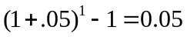
The 3-year risk premium for the hedge fund portfolio is 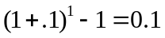

The S&P 3-year standard deviation is:
.
The hedge fund 3-year standard deviation is:
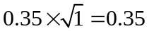

S&P Sharpe ratio is 5/20 = 0.25
The hedge fund Sharpe ratio is 10/35 = 0.2857.
23. With a ρ = 0, the optimal asset allocation is
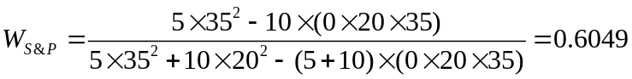 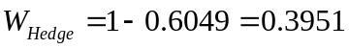 .
With these weights,
The resulting Sharpe ratio is 6.9753/18.3731= 0.3796

24. Greta has a risk aversion of A=3, Therefore, she will invest
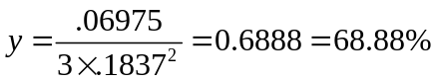
of her wealth in this risky portfolio. The resulting investment composition will be S&P: 0.6888 .6049 = 41.67% and Hedge: 0.6888 .3951 = 27.21%. The remaining 31.11% will be invested in the risk-free asset.

25. With ρ = 0.3, the annual covariance is 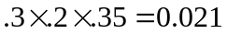.

26. With a ρ = .3, the optimal asset allocation is
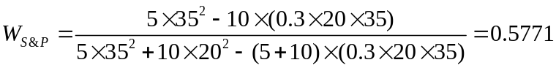 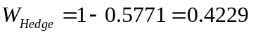 .
With these weights,
The resulting Sharpe ratio is 7.11/21.33 = 0.3336.

27. Greta has a risk aversion of A=3, Therefore, she will invest
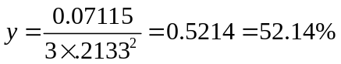
of her wealth in this risky portfolio. The resulting investment composition will be S&P: 0.5214 0.5771 = 30.09% and Hedge: .5214 .4229 = 22.05%. The remaining 47.86% will be invested in the risk-free asset.

CFA PROBLEMS

1. a. Restricting the portfolio to 20 stocks, rather than 40 to 50 stocks, will increase the risk of the portfolio, but it is possible that the increase in risk will be minimal. Suppose that, for instance, the 50 stocks in a universe have the same standard deviation (σ) and the correlations between each pair are identical, with correlation coefficient ρ. Then, the covariance between each pair of stocks would be ρσ², and the variance of an equally weighted portfolio would be:
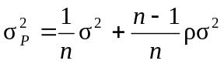
The effect of the reduction in n on the second term on the right-hand side would be relatively small (since 49/50 is close to 19/20 and ρσ² is smaller than σ²), but the denominator of the first term would be 20 instead of 50. For example, if σ = 45% and ρ = 0.2, then the standard deviation with 50 stocks would be 20.91%, and would rise to 22.05% when only 20 stocks are held. Such an increase might be acceptable if the expected return is increased sufficiently.

- Hennessy could contain the increase in risk by making sure that he maintains reasonable diversification among the 20 stocks that remain in his portfolio. This entails maintaining a low correlation among the remaining stocks. For example, in part (a), with ρ = 0.2, the increase in portfolio risk was minimal. As a practical matter, this means that Hennessy would have to spread his portfolio among many industries; concentrating on just a few industries would result in higher correlations among the included stocks.

2. Risk reduction benefits from diversification are not a linear function of the number of issues in the portfolio. Rather, the incremental benefits from additional diversification are most important when you are least diversified. Restricting Hennessy to 10 instead of 20 issues would increase the risk of his portfolio by a greater amount than would a reduction in the size of the portfolio from 30 to 20 stocks. In our example, restricting the number of stocks to 10 will increase the standard deviation to 23.81%. The 1.76% increase in standard deviation resulting from giving up 10 of 20 stocks is greater than the 1.14% increase that results from giving up 30 of 50 stocks.

3. The point is well taken because the committee should be concerned with the volatility of the entire portfolio. Since Hennessy’s portfolio is only one of six well-diversified portfolios and is smaller than the average, the concentration in fewer issues might have a minimal effect on the diversification of the total fund. Hence, unleashing Hennessy to do stock picking may be advantageous.

4. d. Portfolio Y cannot be efficient because it is dominated by another portfolio. For example, Portfolio X has both higher expected return and lower standard deviation.

5. c.

- d.

- b.

- a.

9. c.

10. Since we do not have any information about expected returns, we focus exclusively on reducing variability. Stocks A and C have equal standard deviations, but the correlation of Stock B with Stock C (0.10) is less than that of Stock A with Stock B (0.90). Therefore, a portfolio composed of Stocks B and C will have lower total risk than a portfolio composed of Stocks A and B.

11. Fund D represents the single best addition to complement Stephenson's current portfolio, given his selection criteria. Fund D’s expected return (14.0 percent) has the potential to increase the portfolio’s return somewhat. Fund D’s relatively low correlation with his current portfolio (+0.65) indicates that Fund D will provide greater diversification benefits than any of the other alternatives except Fund B. The result of adding Fund D should be a portfolio with approximately the same expected return and somewhat lower volatility compared to the original portfolio.
The other three funds have shortcomings in terms of expected return enhancement or volatility reduction through diversification. Fund A offers the potential for increasing the portfolio’s return but is too highly correlated to provide substantial volatility reduction benefits through diversification. Fund B provides substantial volatility reduction through diversification benefits but is expected to generate a return well below the current portfolio’s return. Fund C has the greatest potential to increase the portfolio’s return but is too highly correlated with the current portfolio to provide substantial volatility reduction benefits through diversification.

12. a. Subscript OP refers to the original portfolio, ABC to the new stock, and NP to the new portfolio.
i. E(r_{NP}) = w_{OP} E(r_{OP} ) + w_{ABC} E(r_{ABC} ) = (0.9 × 0.67) + (0.1 × 1.25) = 0.728%
ii. Cov = ρ × σ_{OP} × σ_{ABC} = 0.40 × 2.37 × 2.95 = 2.7966 ≅ 2.80
iii. σ_{NP} = [w_{OP}² σ_{OP}² + w_{ABC}² σ_{ABC}² + 2 w_{OP} w_{ABC} (Cov_{OP , ABC})]^{1/2}
= [(0.9 ² × 2.37²) + (0.1² × 2.95²) + (2 × 0.9 × 0.1 × 2.80)]^{1/2}
= 2.2673% ≅ 2.27%

b. Subscript OP refers to the original portfolio, GS to government securities, and NP to the new portfolio.
i. E(r_{NP}) = w_{OP} E(r_{OP} ) + w_{GS} E(r_{GS} ) = (0.9 × 0.67) + (0.1 × 0.42) = 0.645%
ii. Cov = ρ × σ_{OP} × σ_{GS} = 0 × 2.37 × 0 = 0
iii. σ_{NP} = [w_{OP}² σ_{OP}² + w_{GS}² σ_{GS}² + 2 w_{OP} w_{GS} (Cov_{OP , GS})]^{1/2}
= [(0.9² × 2.37²) + (0.1² × 0) + (2 × 0.9 × 0.1 × 0)]^{1/2}
= 2.133% ≅ 2.13%

c. Adding the risk-free government securities would result in a lower beta for the new portfolio. The new portfolio beta will be a weighted average of the individual security betas in the portfolio; the presence of the risk-free securities would lower that weighted average.

d. The comment is not correct. Although the respective standard deviations and expected returns for the two securities under consideration are equal, the covariances between each security and the original portfolio are unknown, making it impossible to draw the conclusion stated. For instance, if the covariances are different, selecting one security over the other may result in a lower standard deviation for the portfolio as a whole. In such a case, that security would be the preferred investment, assuming all other factors are equal.

e. i. Grace clearly expressed the sentiment that the risk of loss was more important to her than the opportunity for return. Using variance (or standard deviation) as a measure of risk in her case has a serious limitation because standard deviation does not distinguish between positive and negative price movements.
ii. Two alternative risk measures that could be used instead of variance are:
Range of returns, which considers the highest and lowest expected returns in the future period, with a larger range being a sign of greater variability and therefore of greater risk.
Semivariance can be used to measure expected deviations of returns below the mean, or some other benchmark, such as zero.
Either of these measures would potentially be superior to variance for Grace. Range of returns would help to highlight the full spectrum of risk she is assuming, especially the downside portion of the range about which she is so concerned. Semivariance would also be effective, because it implicitly assumes that the investor wants to minimize the likelihood of returns falling below some target rate; in Grace’s case, the target rate would be set at zero (to protect against negative returns).

13. a. Systematic risk refers to fluctuations in asset prices caused by macroeconomic factors that are common to all risky assets; hence systematic risk is often referred to as market risk. Examples of systematic risk factors include the business cycle, inflation, monetary policy, fiscal policy, and technological changes.
Firm-specific risk refers to fluctuations in asset prices caused by factors that are independent of the market, such as industry characteristics or firm characteristics. Examples of firm-specific risk factors include litigation, patents, management, operating cash flow changes, and financial leverage.

b. Trudy should explain to the client that picking only the top five best ideas would most likely result in the client holding a much more risky portfolio. The total risk of a portfolio, or portfolio variance, is the combination of systematic risk and firm-specific risk.
The systematic component depends on the sensitivity of the individual assets to market movements as measured by beta. Assuming the portfolio is well diversified, the number of assets will not affect the systematic risk component of portfolio variance. The portfolio beta depends on the individual security betas and the portfolio weights of those securities.
On the other hand, the components of firm-specific risk (sometimes called nonsystematic risk) are not perfectly positively correlated with each other and, as more assets are added to the portfolio, those additional assets tend to reduce portfolio risk. Hence, increasing the number of securities in a portfolio reduces firm-specific risk. For example, a patent expiration for one company would not affect the other securities in the portfolio. An increase in oil prices is likely to cause a drop in the price of an airline stock but will likely result in an increase in the price of an energy stock. As the number of randomly selected securities increases, the total risk (variance) of the portfolio approaches its systematic variance.

