CHAPTER 8: INDEX MODELS

PROBLEM SETS

1. The advantage of the index model, compared to the Markowitz procedure, is the vastly reduced number of estimates required. In addition, the large number of estimates required for the Markowitz procedure can result in large aggregate estimation errors when implementing the procedure. The disadvantage of the index model arises from the model’s assumption that return residuals are uncorrelated. This assumption will be incorrect if the index used omits a significant risk factor.

2. The trade-off entailed in departing from pure indexing in favor of an actively managed portfolio is between the probability (or the possibility) of superior performance against the certainty of additional management fees.

3. The answer to this question can be seen from the formulas for w ⁰ (equation 8.20) and w* (equation 8.21). Other things held equal, w ⁰ is smaller the greater the residual variance of a candidate asset for inclusion in the portfolio. Further, we see that regardless of beta, when w ⁰ decreases, so does w*. Therefore, other things equal, the greater the residual variance of an asset, the smaller its position in the optimal risky portfolio. That is, increased firm-specific risk reduces the extent to which an active investor will be willing to depart from an indexed portfolio.

4. The total risk premium equals: α + (β × Market risk premium). We call alpha a nonmarket return premium because it is the portion of the return premium that is independent of market performance.
The Sharpe ratio indicates that a higher alpha makes a security more desirable. Alpha, the numerator of the Sharpe ratio, is a fixed number that is not affected by the standard deviation of returns, the denominator of the Sharpe ratio. Hence, an increase in alpha increases the Sharpe ratio. Since the portfolio alpha is the portfolio-weighted average of the securities’ alphas, then, holding all other parameters fixed, an increase in a security’s alpha results in an increase in the portfolio Sharpe ratio.

5. a. To optimize this portfolio one would need:
n = 60 estimates of means
n = 60 estimates of variances
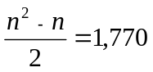estimates of covariances
Therefore, in total: 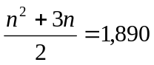estimates

- In a single index model: r_{i} − r_{f} = α _{i} + β _{i} (r _{M} – r_{f} ) + e _{i}
Equivalently, using excess returns: R _{i} = α _{i} + β _{i} R _{M} + e _{i}
The variance of the rate of return can be decomposed into the components:
(l) The variance due to the common market factor: 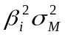
(2) The variance due to firm specific unanticipated events: 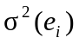
In this model: 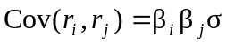
The number of parameter estimates is:
n = 60 estimates of the mean E(ri )
n = 60 estimates of the sensitivity coefficient β _{i}
n = 60 estimates of the firm-specific variance σ²(ei )
1 estimate of the market mean E(r_{M} )
1 estimate of the market variance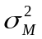
Therefore, in total, 182 estimates.
The single index model reduces the total number of required estimates from 1,890 to 182. In general, the number of parameter estimates is reduced from:
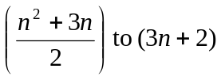

6. a. The standard deviation of each individual stock is given by: 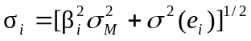
Since β_{A} = 0.8, β_{B} = 1.2, σ(e_{A} ) = 30%, σ(e_{B} ) = 40%, and σ_{M} = 22%, we get:
σ_{A} = (0.8² × 22² + 30² )^{1/2} = 34.78%
σ_{B} = (1.2² × 22² + 40² )^{1/2} = 47.93%

b. The expected rate of return on a portfolio is the weighted average of the expected returns of the individual securities:
E(r_{P} ) = w_{A} × E(r_{A} ) + w_{B} × E(r_{B} ) + w_{f} × r_{f}
E(r_{P} ) = (0.30 × 13%) + (0.45 × 18%) + (0.25 × 8%) = 14%
The beta of a portfolio is similarly a weighted average of the betas of the individual securities:
β_{P} = w_{A} × β_{A} + w_{B} × β_{B} + w_{f} × β _{f}
β_{P} = (0.30 × 0.8) + (0.45 × 1.2) + (0.25 × 0.0) = 0.78
The variance of this portfolio is:
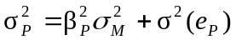
where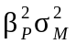is the systematic component and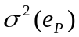is the nonsystematic component. Since the residuals (e_{i} ) are uncorrelated, the nonsystematic variance is:
= (0.30² × 30² ) + (0.45² × 40² ) + (0.25² × 0) = 405
where σ²(e_{A} ) and σ²(e_{B} ) are the firm-specific (nonsystematic) variances of Stocks A and B, and σ²(e _{f} ), the nonsystematic variance of T-bills, is zero. The residual standard deviation of the portfolio is thus:
σ(e_{P} ) = (405)^{1/2} = 20.12%
The total variance of the portfolio is then:
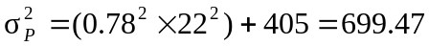
The total standard deviation is 26.45%.

7. a. The two figures depict the stocks’ security characteristic lines (SCL). Stock A has higher firm-specific risk because the deviations of the observations from the SCL are larger for Stock A than for Stock B. Deviations are measured by the vertical distance of each observation from the SCL.

b. Beta is the slope of the SCL, which is the measure of systematic risk. The SCL for Stock B is steeper; hence Stock B’s systematic risk is greater.

- The R² (or squared correlation coefficient) of the SCL is the ratio of the explained variance of the stock’s return to total variance, and the total variance is the sum of the explained variance plus the unexplained variance (the stock’s residual variance):
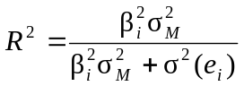
Since the explained variance for Stock B is greater than for Stock A (the explained variance is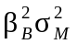, which is greater since its beta is higher), and its residual variance 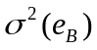 is smaller, its R² is higher than Stock A’s.

d. Alpha is the intercept of the SCL with the expected return axis. Stock A has a small positive alpha whereas Stock B has a negative alpha; hence, Stock A’s alpha is larger.

e. The correlation coefficient is simply the square root of R², so Stock B’s correlation with the market is higher.

8. a. Firm-specific risk is measured by the residual standard deviation. Thus, stock A has more firm-specific risk: 10.3% > 9.1%

b. Market risk is measured by beta, the slope coefficient of the regression. A has a larger beta coefficient: 1.2 > 0.8

c. R² measures the fraction of total variance of return explained by the market return. A’s R² is larger than B’s: 0.576 > 0.436

d. Rewriting the SCL equation in terms of total return (r) rather than excess return (R):
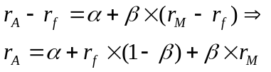
The intercept is now equal to:
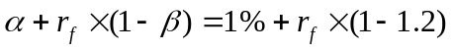
Since r_{f} = 6%, the intercept would be:

9. The standard deviation of each stock can be derived from the following equation for R²:
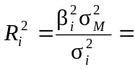
Therefore:
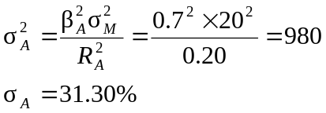
For stock B:
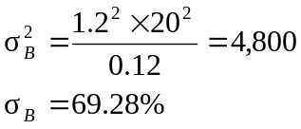

10. The systematic risk for A is:
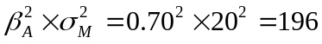
The firm-specific risk of A (the residual variance) is the difference between A’s total risk and its systematic risk:
980 – 196 = 784
The systematic risk for B is:
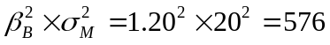
B’s firm-specific risk (residual variance) is:
4,800 – 576 = 4,224

11. The covariance between the returns of A and B is (since the residuals are assumed to be uncorrelated):
The correlation coefficient between the returns of A and B is:
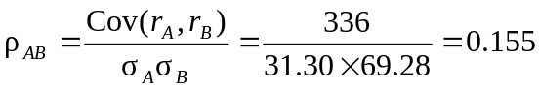

12. Note that the correlation is the square root of R²: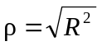
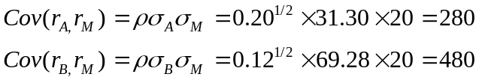

13. For portfolio P we can compute:
σ_{P} = [(0.6² × 980) + (0.4² × 4800) + (2 × 0.4 × 0.6 × 336)]^{1/2} = [1282.08]^{1/2} = 35.81%
β_{P} = (0.6 × 0.7) + (0.4 × 1.2) = 0.90
Cov(r_{P},r_{M} ) = β_{P}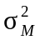=0.90 × 400=360
This same result can also be attained using the covariances of the individual stocks with the market:
Cov(r_{P},r_{M} ) = Cov(0.6r_{A} + 0.4r_{B}, r_{M} ) = 0.6 × Cov(r_{A}, r_{M} ) + 0.4 × Cov(r_{B},r_{M} )
= (0.6 × 280) + (0.4 × 480) = 360

14. Note that the variance of T-bills is zero, and the covariance of T-bills with any asset is zero. Therefore, for portfolio Q:
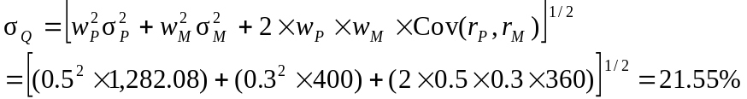
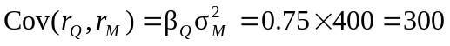

15. a. Beta Books adjusts beta by taking the sample estimate of beta and averaging it with 1.0, using the weights of 2/3 and 1/3, as follows:
adjusted beta = [(2/3) × 1.24] + [(1/3) × 1.0] = 1.16

- If you use your current estimate of beta to be βt–1 = 1.24, then
β_{t} = 0.3 + (0.7 × 1.24) = 1.168

16. For Stock A:
For stock B:
Stock A would be a good addition to a well-diversified portfolio. A short position in Stock B may be desirable.

17. a.
Alpha (α) | Expected excess return
αi = ri – [r_{f} + βi × (r_{M} – r_{f} ) ] | E(ri ) – r_{f}
α_{A} = 20% – [8% + 1.3 × (16% – 8%)] = 1.6% | 20% – 8% = 12%
α_{B} = 18% – [8% + 1.8 × (16% – 8%)] = – 4.4% | 18% – 8% = 10%
α_{C} = 17% – [8% + 0.7 × (16% – 8%)] = 3.4% | 17% – 8% = 9%
α_{D} = 12% – [8% + 1.0 × (16% – 8%)] = – 4.0% | 12% – 8% = 4%
Stocks A and C have positive alphas, whereas stocks B and D have negative alphas.
The residual variances are:
σ²(e_{A} ) = 58² = 3,364
σ²(e_{B}) = 71² = 5,041
σ²(e_{C}) = 60² = 3,600
σ²(e_{D}) = 55² = 3,025

b. To construct the optimal risky portfolio, we first determine the optimal active portfolio. Using the Treynor-Black technique, we construct the active portfolio:
A | 0.000476 | –0.6142
B | –0.000873 | 1.1265
C | 0.000944 | –1.2181
D | –0.001322 | 1.7058
Total | –0.000775 | 1.0000
Be unconcerned with the negative weights of the positive α stocks—the entire active position will be negative, returning everything to good order.

With these weights, the forecast for the active portfolio is:
α = [–0.6142 × 1.6] + [1.1265 × (– 4.4)] – [1.2181 × 3.4] + [1.7058 × (– 4.0)]
= –16.90%
β = [–0.6142 × 1.3] + [1.1265 × 1.8] – [1.2181 × 0.70] + [1.7058 × 1] = 2.08
The high beta (higher than any individual beta) results from the short positions in the relatively low beta stocks and the long positions in the relatively high beta stocks.
σ²(e) = [(–0.6142)²×3364] + [1.1265²×5041] + [(–1.2181)²×3600] + [1.7058²×3025]
= 21,809.6
σ (e) = 147.68%
The levered position in B [with high σ²(e)] overcomes the diversification effect and results in a high residual standard deviation. The optimal risky portfolio has a proportion w* in the active portfolio, computed as follows:
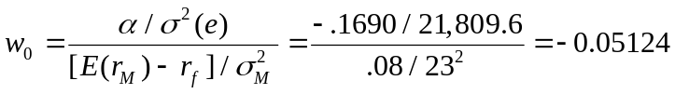
The negative position is justified for the reason stated earlier.
The adjustment for beta is:
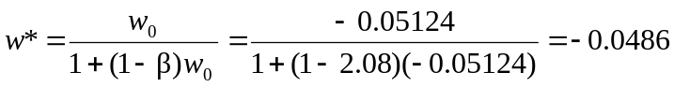
Since w* is negative, the result is a positive position in stocks with positive alphas and a negative position in stocks with negative alphas. The position in the index portfolio is:
1 – (–0.0486) = 1.0486
c. To calculate the Sharpe ratio for the optimal risky portfolio, we compute the information ratio for the active portfolio and Sharpe’s measure for the market portfolio. The information ratio for the active portfolio is computed as follows:
A = 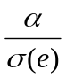 = –16.90/147.68 = –0.1144
A² = 0.0131
Hence, the square of the Sharpe ratio (S) of the optimized risky portfolio is:
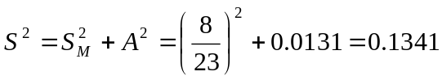
S = 0.3662

- Compare S = 0.3662 to the market’s Sharpe ratio:
S_{M} = 8/23 = 0.3478 → A difference of: 0.0184
The only moderate improvement in performance results from only a small position taken in the active portfolio A because of its large residual variance.

- To calculate the makeup of the complete portfolio, first compute the beta, the mean excess return, and the variance of the optimal risky portfolio:
β_{P} = w_{M} + (w_{A} × β_{A} ) = 1.0486 + [(–0.0486) × 2.08] = 0.95
E(R_{P}) = α_{P} + β_{P}E(RM) = [(–0.0486) × (–16.90%)] + (0.95 × 8%) = 8.42%
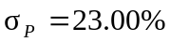
Since A = 2.8, the optimal position in this portfolio is:
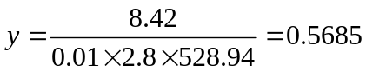
In contrast, with a passive strategy:
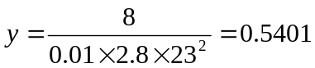→A difference of: 0.0284The final positions are (M may include some of stocks A through D):
Bills | 1 – 0.5685 = | 43.15%
M | 0.5685 × l.0486 = | 59.61
A | 0.5685 × (–0.0486) × (–0.6142) = | 1.70
B | 0.5685 × (–0.0486) × 1.1265 = | – 3.11
C | 0.5685 × (–0.0486) × (–1.2181) = | 3.37
D | 0.5685 × (–0.0486) × 1.7058 = | – 4.71
 | (subject to rounding error) | 100.00%

18. a. If a manager is not allowed to sell short, he will not include stocks with negative alphas in his portfolio, so he will consider only A and C:
 | Α | σ²(e)
A | 1.6 | 3,364 | 0.000476 | 0.3352
C | 3.4 | 3,600 | 0.000944 | 0.6648
 |  |  | 0.001420 | 1.0000
The forecast for the active portfolio is:
α = (0.3352 × 1.6) + (0.6648 × 3.4) = 2.80%
β = (0.3352 × 1.3) + (0.6648 × 0.7) = 0.90
σ²(e) = (0.3352² × 3,364) + (0.6648² × 3,600) = 1,969.03
σ(e) = 44.37%
The weight in the active portfolio is:
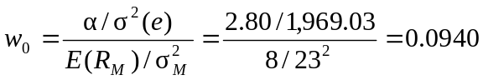
Adjusting for beta:
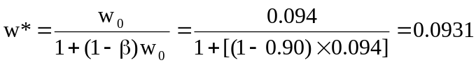
The information ratio of the active portfolio is:
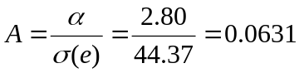
Hence, the square of the Sharpe ratio is:
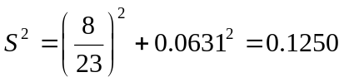
Therefore: S = 0.3535
The market’s Sharpe ratio is: S_{M} = 0.3478
When short sales are allowed (Problem 17), the manager’s Sharpe ratio is higher (0.3662). The reduction in the Sharpe ratio is the cost of the short sale restriction.
The characteristics of the optimal risky portfolio are:
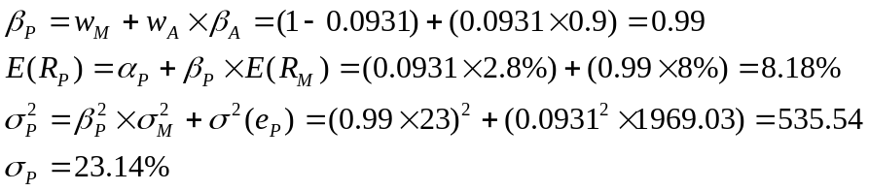
With A = 2.8, the optimal position in this portfolio is:
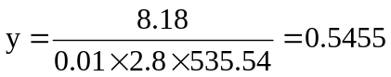
The final positions in each asset are:
Bills | 1 – 0.5455 = | 45.45%
M | 0.5455 × (1 − 0.0931) = | 49.47
A | 0.5455 × 0.0931 × 0.3352 = | 1.70
C | 0.5455 × 0.0931 × 0.6648 = | 3.38
 |  | 100.00

b. The mean and variance of the optimized complete portfolios in the unconstrained and short-sales constrained cases, and for the passive strategy are:
 | E(R_{C} ) | 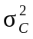
Unconstrained | 0.5685 × 8.42% = 4.79 | 0.5685² × 528.94 = 170.95
Constrained | 0.5455 × 8.18% = 4.46 | 0.5455² × 535.54 = 159.36
Passive | 0.5401 × 8.00% = 4.32 | 0.5401² × 529.00 = 154.31
The utility levels below are computed using the formula: 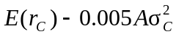
Unconstrained 8% + 4.79% – (0.005 × 2.8 × 170.95) = 10.40%
Constrained 8% + 4.46% – (0.005 × 2.8 × 159.36) = 10.23%
Passive 8% + 4.32% – (0.005 × 2.8 × 154.31) = 10.16%
19. All alphas are reduced to 0.3 times their values in the original case. Therefore, the relative weights of each security in the active portfolio are unchanged, but the alpha of the active portfolio is only 0.3 times its previous value: 0.3 × −16.90% = −5.07%
The investor will take a smaller position in the active portfolio. The optimal risky portfolio has a proportion w* in the active portfolio as follows:
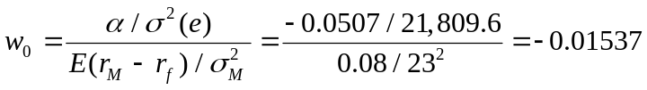
The negative position is justified for the reason given earlier.
The adjustment for beta is:
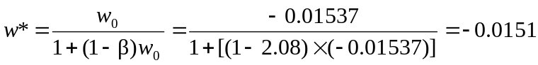
Since w* is negative, the result is a positive position in stocks with positive alphas and a negative position in stocks with negative alphas. The position in the index portfolio is: 1 – (–0.0151) = 1.0151
To calculate the Sharpe ratio for the optimal risky portfolio we compute the information ratio for the active portfolio and the Sharpe ratio for the market portfolio. The information ratio of the active portfolio is 0.3 times its previous value:
A = 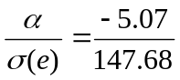= –0.0343 and A² =0.00118
Hence, the square of the Sharpe ratio of the optimized risky portfolio is:
S² = S²_{M} + A² = (8%/23%)² + 0.00118 = 0.1222
S = 0.3495
Compare this to the market’s Sharpe ratio: S_{M} = 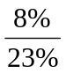= 0.3478
The difference is: 0.0017
Note that the reduction of the forecast alphas by a factor of 0.3 reduced the squared information ratio and the improvement in the squared Sharpe ratio by a factor of:
0.3² = 0.09

20. If each of the alpha forecasts is doubled, then the alpha of the active portfolio will also double. Other things equal, the information ratio (IR) of the active portfolio also doubles. The square of the Sharpe ratio for the optimized portfolio (S-square) equals the square of the Sharpe ratio for the market index (SM-square) plus the square of the information ratio. Since the information ratio has doubled, its square quadruples. Therefore: S-square = SM-square + (4 × IR)
Compared to the previous S-square, the difference is: 3IR
Now you can embark on the calculations to verify this result.
CFA PROBLEMS

1. The regression results provide quantitative measures of return and risk based on monthly returns over the five-year period.
β for ABC was 0.60, considerably less than the average stock’s β of 1.0. This indicates that, when the S&P 500 rose or fell by 1 percentage point, ABC’s return on average rose or fell by only 0.60 percentage point. Therefore, ABC’s systematic risk (or market risk) was low relative to the typical value for stocks. ABC’s alpha (the intercept of the regression) was –3.2%, indicating that when the market return was 0%, the average return on ABC was –3.2%. ABC’s unsystematic risk (or residual risk), as measured by σ(e), was 13.02%. For ABC, R² was 0.35, indicating closeness of fit to the linear regression greater than the value for a typical stock.
β for XYZ was somewhat higher, at 0.97, indicating XYZ’s return pattern was very similar to the β for the market index. Therefore, XYZ stock had average systematic risk for the period examined. Alpha for XYZ was positive and quite large, indicating a return of 7.3%, on average, for XYZ independent of market return. Residual risk was 21.45%, half again as much as ABC’s, indicating a wider scatter of observations around the regression line for XYZ. Correspondingly, the fit of the regression model was considerably less than that of ABC, consistent with an R² of only 0.17.
The effects of including one or the other of these stocks in a diversified portfolio may be quite different. If it can be assumed that both stocks’ betas will remain stable over time, then there is a large difference in systematic risk level. The betas obtained from the two brokerage houses may help the analyst draw inferences for the future. The three estimates of ABC’s β are similar, regardless of the sample period of the underlying data. The range of these estimates is 0.60 to 0.71, well below the market average β of 1.0. The three estimates of XYZ’s β vary significantly among the three sources, ranging as high as 1.45 for the weekly data over the most recent two years. One could infer that XYZ’s β for the future might be well above 1.0, meaning it might have somewhat greater systematic risk than was implied by the monthly regression for the five-year period.
These stocks appear to have significantly different systematic risk characteristics. If these stocks are added to a diversified portfolio, XYZ will add more to total volatility.

2. The R² of the regression is: 0.70² = 0.49
Therefore, 51% of total variance is unexplained by the market; this is nonsystematic risk.

3. 9 = 3 + β (11 − 3) ⇒ β = 0.75

4. d.

5. b.

