CHAPTER 9: THE CAPITAL ASSET PRICING MODEL

PROBLEM SETS

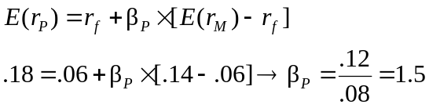1.

2. If the security’s correlation coefficient with the market portfolio doubles (with all other variables such as variances unchanged), then beta, and therefore the risk premium, will also double. The current risk premium on the security is: 14% – 6% = 8%. If the correlation coefficient doubles, while the standard deviations of the security and the market remain unchanged, then beta will double, and so will the security’s risk premium. The new risk premium will be 16%, and the new discount rate for the security will be: 16% + 6% = 22%.
If the stock pays a constant perpetual dividend, then we know from the original data that the dividend (D) must satisfy the equation for the present value of a perpetuity:
Price = Dividend/Discount rate
50 = D/0.14 ⇒ D = 50 × 0.14 = $7.00
At the new discount rate of 22%, the stock will be worth: $7/0.22 = $31.82
The increase in stock risk lowers its value by 36.36%.

3. a. False. β = 0 implies E(r) = r_{f} , not zero.

- False. Investors require a risk premium only for bearing systematic (undiversifiable or market) risk. Total volatility, as measured by the standard deviation, includes diversifiable risk.

- False. Your portfolio should be invested 75% in the market portfolio and 25% in T-bills. Then: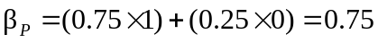

4. The expected return is the return predicted by the CAPM for a given level of systematic risk.
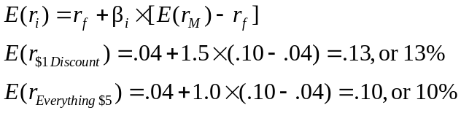

5. According to the CAPM, $1 Discount Stores requires a return of 13% based on its systematic risk level of β = 1.5. However, the forecasted return is only 12%. Therefore, the security is currently overvalued.
Everything $5 requires a return of 10% based on its systematic risk level of β = 1.0. However, the forecasted return is 11%. Therefore, the security is currently undervalued.

6. Correct answer is choice a. The expected return of a stock with a β = 1.0 must, on average, be the same as the expected return of the market which also has a β = 1.0.

7. Correct answer is choice a. Beta is a measure of systematic risk. Since only systematic risk is rewarded, it is safe to conclude that the expected return will be higher for Kaskin’s stock than for Quinn’s stock.

8. The appropriate discount rate for the project is:
r_{f} + β × [E(r_{M} ) – r_{f} ] = .08 + [1.8 × (.16 – .08)] = .224, or 22.4%
Using this discount rate:
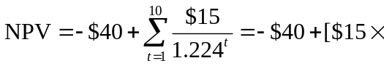Annuity factor (22.4%, 10 years)] = $18.09
The internal rate of return (IRR) for the project is 35.73%. Recall from your introductory finance class that NPV is positive if IRR > discount rate (or, equivalently, hurdle rate). The highest value that beta can take before the hurdle rate exceeds the IRR is determined by:
.3573 = .08 + β × (.16 – .08) ⇒ β = .2773/.08 = 3.47

9. a. Call the aggressive stock A and the defensive stock D. Beta is the sensitivity of the stock’s return to the market return, i.e., the change in the stock return per unit change in the market return. Therefore, we compute each stock’s beta by calculating the difference in its return across the two scenarios divided by the difference in the market return:
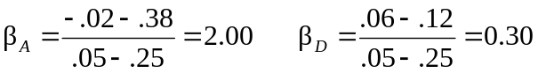

- With the two scenarios equally likely, the expected return is an average of the two possible outcomes:
E(r_{A} ) = 0.5 × (–.02 + .38) = .18 = 18%
E(r_{D} ) = 0.5 × (.06 + .12) = .09 = 9%

- The SML is determined by the market expected return of [0.5 × (.25 + .05)] = 15%, with β_{M} = 1, and r_{f} = 6% (which has β_{f} = 0). See the following graph:
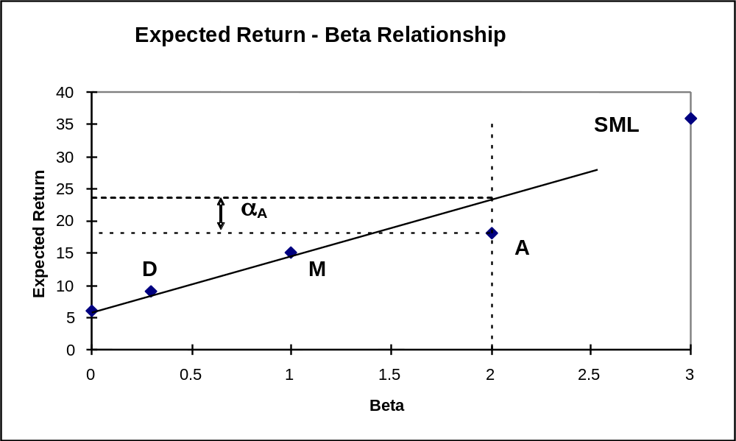
The equation for the security market line is:
E(r) = .06 + β × (.15 – .06)

d. Based on its risk, the aggressive stock has a required expected return of:
E(r_{A} ) = .06 + 2.0 × (.15 – .06) = .24 = 24%
The analyst’s forecast of expected return is only 18%. Thus the stock’s alpha is:
α_{A} = actually expected return – required return (given risk)
= 18% – 24% = –6%
Similarly, the required return for the defensive stock is:
E(r_{D}) = .06 + 0.3 × (.15 – .06) = 8.7%
The analyst’s forecast of expected return for D is 9%, and hence, the stock has a positive alpha:

α_{D} = Actually expected return – Required return (given risk)
= .09 – .087 = +0.003 = +0.3%
The points for each stock plot on the graph as indicated above.
e. The hurdle rate is determined by the project beta (0.3), not the firm’s beta. The correct discount rate is 8.7%, the fair rate of return for stock D.

- Not possible. Portfolio A has a higher beta than Portfolio B, but the expected return for Portfolio A is lower than the expected return for Portfolio B. Thus, these two portfolios cannot exist in equilibrium.

11. Possible. If the CAPM is valid, the expected rate of return compensates only for systematic (market) risk, represented by beta, rather than for the standard deviation, which includes nonsystematic risk. Thus, Portfolio A’s lower rate of return can be paired with a higher standard deviation, as long as A’s beta is less than B’s.

- Not possible. The reward-to-variability ratio for Portfolio A is better than that of the market. This scenario is impossible according to the CAPM because the CAPM predicts that the market is the most efficient portfolio. Using the numbers supplied:
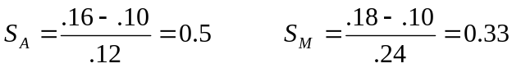
Portfolio A provides a better risk-reward trade-off than the market portfolio.

13. Not possible. Portfolio A clearly dominates the market portfolio. Portfolio A has both a lower standard deviation and a higher expected return.

14. Not possible. The SML for this scenario is: E(r) = 10 + β × (18 – 10)
Portfolios with beta equal to 1.5 have an expected return equal to:
E(r) = 10 + [1.5 × (18 – 10)] = 22%
The expected return for Portfolio A is 16%; that is, Portfolio A plots below the SML (α _{A} = –6%) and, hence, is an overpriced portfolio. This is inconsistent with the CAPM.

- Not possible. The SML is the same as in Problem 14. Here, Portfolio A’s required return is: .10 + (.9 × .08) = 17.2%
This is greater than 16%. Portfolio A is overpriced with a negative alpha:
α _{A} = –1.2%

- Possible. The CML is the same as in Problem 12. Portfolio A plots below the CML, as any asset is expected to. This scenario is not inconsistent with the CAPM.

- Since the stock’s beta is equal to 1.2, its expected rate of return is:
.06 + [1.2 × (.16 – .06)] = 18%
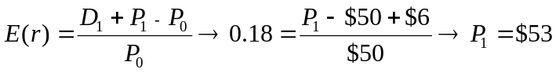

18. The series of $1,000 payments is a perpetuity. If beta is 0.5, the cash flow should be discounted at the rate:
.06 + [0.5 × (.16 – .06)] = .11 = 11%
PV = $1,000/0.11 = $9,090.91
If, however, beta is equal to 1, then the investment should yield 16%, and the price paid for the firm should be:
PV = $1,000/0.16 = $6,250
The difference, $2,840.91, is the amount you will overpay if you erroneously assume that beta is 0.5 rather than 1.

19. Using the SML: .04 = .06 + β × (.16 – .06) ⇒ β = –.02/.10 = –0.2

20. r₁ = 19%; r₂ = 16%; β₁ = 1.5; β₂ = 1
a. To determine which investor was a better selector of individual stocks we look at abnormal return, which is the ex-post alpha; that is, the abnormal return is the difference between the actual return and that predicted by the SML. Without information about the parameters of this equation (risk-free rate and market rate of return) we cannot determine which investor was more accurate.

- If r_{f} = 6% and r_{M} = 14%, then (using the notation alpha for the abnormal return):
α₁ = .19 – [.06 + 1.5 × (.14 – .06)] = .19 – .18 = 1%
α ₂ = .16 – [.06 + 1 × (.14 – .06)] = .16 – .14 = 2%
Here, the second investor has the larger abnormal return and thus appears to be the superior stock selector. By making better predictions, the second
investor appears to have tilted his portfolio toward underpriced stocks.

- If r_{f} = 3% and r_{M} = 15%, then:
α₁ = .19 – [.03 + 1.5 × (.15 – .03)] = .19 – .21 = –2%
α₂ = .16 – [.03+ 1 × (.15 – .03)] = .16 – .15 = 1%
Here, not only does the second investor appear to be the superior stock selector, but the first investor’s predictions appear valueless (or worse).
21. a. Since the market portfolio, by definition, has a beta of 1, its expected rate of return is 12%.

- β = 0 means no systematic risk. Hence, the stock’s expected rate of return in market equilibrium is the risk-free rate, 5%.

- Using the SML, the fair expected rate of return for a stock with β = –0.5 is:
The actually expected rate of return, using the expected price and dividend for next year is:
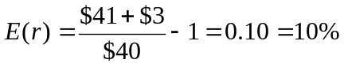
Because the actually expected return exceeds the fair return, the stock is underpriced.

22. In the zero-beta CAPM the zero-beta portfolio replaces the risk-free rate, and thus:
E(r) = 8 + 0.6(17 – 8) = 13.4%

23. a. E(r_{P}) = r_{f} + β_{P} × [E(r_{M} ) – r_{f} ] = 5% + 0.8 (15% − 5%) = 13%
α = 14% − 13% = 1%
You should invest in this fund because alpha is positive.

b. The passive portfolio with the same beta as the fund should be invested 80% in the market-index portfolio and 20% in the money market account. For this portfolio:
E(r_{P}) = (0.8 × 15%) + (0.2 × 5%) = 13%
14% − 13% = 1% = α

24. a. We would incorporate liquidity into the CCAPM in a manner analogous to the way in which liquidity is incorporated into the conventional CAPM. In the latter case, in addition to the market risk premium, expected return is also dependent on the expected cost of illiquidity and three liquidity-related betas which measure the sensitivity of: (1) the security’s illiquidity to market illiquidity; (2) the security’s return to market illiquidity; and, (3) the security’s illiquidity to the market return. A similar approach can be used for the CCAPM, except that the liquidity betas would be measured relative to consumption growth rather than the usual market index.

b. As in part (a), nontraded assets would be incorporated into the CCAPM in a fashion similar to part (a). Replace the market portfolio with consumption growth. The issue of liquidity is more acute with nontraded assets such as privately held businesses and labor income.
While ownership of a privately held business is analogous to ownership of an illiquid stock, expect a greater degree of illiquidity for the typical private business. If the owner of a privately held business is satisfied with the dividends paid out from the business, then the lack of liquidity is not an issue. If the owner seeks to realize income greater than the business can pay out, then selling ownership, in full or part, typically entails a substantial liquidity discount. The illiquidity correction should be treated as suggested in part (a).
The same general considerations apply to labor income, although it is probable that the lack of liquidity for labor income has an even greater impact on security market equilibrium values. Labor income has a major impact on portfolio decisions. While it is possible to borrow against labor income to some degree, and some of the risk associated with labor income can be ameliorated with insurance, it is plausible that the liquidity betas of consumption streams are quite significant, as the need to borrow against labor income is likely cyclical.

CFA PROBLEMS

1. a. Agree; Regan’s conclusion is correct. By definition, the market portfolio lies on the capital market line (CML). Under the assumptions of capital market theory, all portfolios on the CML dominate, in a risk-return sense, portfolios that lie on the Markowitz efficient frontier because, given that leverage is allowed, the CML creates a portfolio possibility line that is higher than all points on the efficient frontier except for the market portfolio, which is Rainbow’s portfolio. Because Eagle’s portfolio lies on the Markowitz efficient frontier at a point other than the market portfolio, Rainbow’s portfolio dominates Eagle’s portfolio.

b. Nonsystematic risk is the unique risk of individual stocks in a portfolio that is diversified away by holding a well-diversified portfolio. Total risk is composed of systematic (market) risk and nonsystematic (firm-specific) risk.
Disagree; Wilson’s remark is incorrect. Because both portfolios lie on the Markowitz efficient frontier, neither Eagle nor Rainbow has any nonsystematic risk. Therefore, nonsystematic risk does not explain the different expected returns. The determining factor is that Rainbow lies on the (straight) line (the CML) connecting the risk-free asset and the market portfolio (Rainbow), at the point of tangency to the Markowitz efficient frontier having the highest return per unit of risk. Wilson’s remark is also countered by the fact that, since nonsystematic risk can be eliminated by diversification, the expected return for bearing nonsystematic risk is zero. This is a result of the fact that well-diversified investors bid up the price of every asset to the point where only systematic risk earns a positive return (nonsystematic risk earns no return).

2. E(r) = r_{f} + β × [E(r _{M} ) − r_{f} ]
Furhman Labs: E(r) = .05 + 1.5 × [.115 − .05] = 14.75%
Garten Testing: E(r) = .05 + 0.8 × [.115 − .05] = 10.20%
If the forecast rate of return is less than (greater than) the required rate of return, then the security is overvalued (undervalued).
Furhman Labs: Forecast return – Required return = 13.25% − 14.75% = −1.50%
Garten Testing: Forecast return – Required return = 11.25% − 10.20% = 1.05%
Therefore, Furhman Labs is overvalued and Garten Testing is undervalued.

3. a.

4. d. From CAPM, the fair expected return = 8 + 1.25 × (15 − 8) = 16.75%
Actually expected return = 17%
α = 17 − 16.75 = 0.25%

5. d.

6. c.

7. d.

8. d. [You need to know the risk-free rate]

9. d. [You need to know the risk-free rate]

10. Under the CAPM, the only risk that investors are compensated for bearing is the risk that cannot be diversified away (systematic risk). Because systematic risk (measured by beta) is equal to 1.0 for both portfolios, an investor would expect the same rate of return from both portfolios A and B. Moreover, since both portfolios are well diversified, it doesn’t matter if the specific risk of the individual securities is high or low. The firm-specific risk has been diversified away for both portfolios.

11. a. McKay should borrow funds and invest those funds proportionately in Murray’s existing portfolio (i.e., buy more risky assets on margin). In addition to increased expected return, the alternative portfolio on the capital market line will also have increased risk, which is caused by the higher proportion of risky assets in the total portfolio.

b. McKay should substitute low-beta stocks for high-beta stocks in order to reduce the overall beta of York’s portfolio. By reducing the overall portfolio beta, McKay will reduce the systematic risk of the portfolio and, therefore, reduce its volatility relative to the market. The security market line (SML) suggests such action (i.e., moving down the SML), even though reducing beta may result in a slight loss of portfolio efficiency unless full diversification is maintained. York’s primary objective, however, is not to maintain efficiency but to reduce risk exposure; reducing portfolio beta meets that objective. Because York does not want to engage in borrowing or lending, McKay cannot reduce risk by selling equities and using the proceeds to buy risk-free assets (i.e., lending part of the portfolio).

12. a.
 | Expected Return | Alpha
Stock X | 5% + 0.8 × (14% − 5%) = 12.2% | 14.0% − 12.2% = 1.8%
Stock Y | 5% + 1.5 × (14% − 5%) = 18.5% | 17.0% − 18.5% = −1.5%

- i. Kay should recommend Stock X because of its positive alpha, compared to Stock Y, which has a negative alpha. In graphical terms, the expected return/risk profile for Stock X plots above the security market line (SML), while the profile for Stock Y plots below the SML. Also, depending on the individual risk preferences of Kay’s clients, the lower beta for Stock X may have a beneficial effect on overall portfolio risk.
ii. Kay should recommend Stock Y because it has higher forecasted return and lower standard deviation than Stock X. The respective Sharpe ratios for Stocks X and Y and the market index are:
Stock X: (14% − 5%)/36% = 0.25
Stock Y: (17% − 5%)/25% = 0.48
Market index: (14% − 5%)/15% = 0.60
The market index has an even more attractive Sharpe ratio than either of the individual stocks, but, given the choice between Stock X and Stock Y, Stock Y is the superior alternative.
When a stock is held as a single stock portfolio, standard deviation is the relevant risk measure. For such a portfolio, beta as a risk measure is irrelevant.
Although holding a single asset is not a typically recommended investment strategy, some investors may hold what is essentially a single-asset portfolio when they hold the stock of their employer company. For such investors, the relevance of standard deviation versus beta is an important issue.

