CHAPTER 12: BEHAVIORAL FINANCE
AND TECHNICAL ANALYSIS

PROBLEM SETS

1. Technical analysis can generally be viewed as a search for trends or patterns in market prices. Technical analysts tend to view these trends as momentum, or gradual adjustments to ‘correct’ prices, or, alternatively, reversals of trends. A number of the behavioral biases discussed in the chapter might contribute to such trends and patterns. For example, a conservatism bias might contribute to a trend in prices as investors gradually take new information into account, resulting in gradual adjustment of prices towards their fundamental values. Another example derives from the concept of representativeness, which leads investors to inappropriately conclude, on the basis of a small sample of data, that a pattern has been established that will continue well into the future. When investors subsequently become aware of the fact that prices have overreacted, corrections reverse the initial erroneous trend.

2. Even if many investors exhibit behavioral biases, security prices might still be set efficiently if the actions of arbitrageurs move prices to their intrinsic values. Arbitrageurs who observe mispricing in the securities markets would buy underpriced securities (or possibly sell short overpriced securities) in order to profit from the anticipated subsequent changes as prices move to their intrinsic values. Consequently, securities prices would still exhibit the characteristics of an efficient market.

3. One of the major factors limiting the ability of rational investors to take advantage of any ‘pricing errors’ that result from the actions of behavioral investors is the fact that a mispricing can get worse over time. An example of this fundamental risk is the apparent ongoing overpricing of the NASDAQ index in the late 1990s. Related factors are the inherent costs and limits related to short selling, which restrict the extent to which arbitrage can force overpriced securities (or indexes) to move towards their fair values. Rational investors must also be aware of the risk that an apparent mispricing is, in fact, a consequence of model risk; that is, the perceived mispricing may not be real because the investor has used a faulty model to value the security.

4. There are two reasons why behavioral biases might not affect equilibrium asset prices: first, behavioral biases might contribute to the success of technical trading rules as prices gradually adjust towards their intrinsic values, and second, the actions of arbitrageurs might move security prices towards their intrinsic values. It might be important for investors to be aware of these biases because either of these scenarios might create the potential for excess profits even if behavioral biases do not affect equilibrium prices.

In addition, an investor should be aware of his personal behavioral biases, even if those biases do not affect equilibrium prices, to help avoid some of these information processing errors (e.g. overconfidence or representativeness).

5. Efficient market advocates believe that publicly available information (and, for advocates of strong-form efficiency, even insider information) is, at any point in time, reflected in securities prices, and that price adjustments to new information occur very quickly. Consequently, prices are at fair levels so that active management is very unlikely to improve performance above that of a broadly diversified index portfolio. In contrast, advocates of behavioral finance identify a number of investor errors in information processing and decision making that could result in mispricing of securities. However, the behavioral finance literature generally does not provide guidance as to how these investor errors can be exploited to generate excess profits. Therefore, in the absence of any profitable alternatives, even if securities markets are not efficient, the optimal strategy might still be a passive indexing strategy.

6. a. Davis uses loss aversion as the basis for her decision making. She holds on to stocks that are down from the purchase price in the hopes that they will recover. She is reluctant to accept a loss.

7. a. Shrum refuses to follow a stock after she sells it because she does not want to experience the regret of seeing it rise. The behavioral characteristic used for the basis for her decision making is the fear of regret.

8. a. Investors attempt to avoid regret by holding on to losers hoping the stocks will rebound. If the stock rebounds to its original purchase price, the stock can be sold with no regret. Investors also may try to avoid regret by distancing themselves from their decisions by hiring a full-service broker.

9. a. iv
b. iii
c. v
d. i
e. ii

10. Underlying risks still exist even during a mispricing event. The market mispricing could get worse before it gets better. Other adverse effects could occur before the price corrects itself (e.g., loss of clients with no understanding or appetite for mispricing opportunities).

11. Data mining is the process by which patterns are pulled from data. Technical analysts must be careful not to engage in data mining as great is the human capacity to discern patterns where no patterns exist. Technical analysts must avoid mining data to support a theory rather than using data to test a theory.

12. Even if prices follow a random walk, the existence of irrational investors combined with the limits to arbitrage by arbitrageurs may allow persistent mispricings to be present. This implies that capital will not be allocated efficiently—capital does not immediately flow from relatively unproductive firms to relatively productive firms.

13. Trin =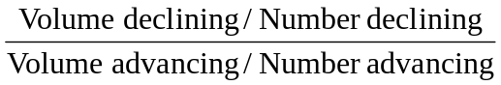=
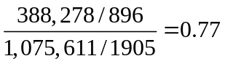
This trin ratio, which is below 1.0, would be taken as a bullish signal.

14. Breadth:
Advances | Declines | Net Advances
2,070 | 1,003 | 1,067

Breadth is positive—bullish signal (no one would actually use a one-day measure).

15. This exercise is left to the student; answers will vary, but successful students should be able to identify time periods when upward or downward trends are obvious. This exercise also shows the benefit of hindsight, which investors do not possess when making current decisions.

16. The confidence index increases from (5%/6%) = 0.833 to (6%/7%) = 0.857.
This indicates slightly higher confidence which would be interpreted by technicians as a bullish signal. But the real reason for the increase in the index is the expectation of higher inflation, not higher confidence about the economy.

17. At the beginning of the period, the price of Computers, Inc. divided by the industry index was 0.39; by the end of the period, the ratio had increased to 0.50. As the ratio increased over the period, it appears that Computers, Inc. outperformed other firms in its industry. The overall trend, therefore, indicates relative strength, although some fluctuation existed during the period, with the ratio falling to a low point of 0.33 on day 19.

18. Five day moving averages:
Days 1 – 5: (19.63 + 20 + 20.5 + 22 + 21.13) / 5 = 20.65
Days 2 – 6 = 21.13
Days 3 – 7 = 21.50
Days 4 – 8 = 21.90
Days 5 – 9 = 22.13
Days 6 – 10 = 22.68
Days 7 – 11 = 23.18
Days 8 – 12 = 23.45 ←Sell signal (day 12 price < moving average)
Days 9 – 13 = 23.38
Days 10 – 14 = 23.15
Days 11 – 15 = 22.50
Days 12 – 16 = 21.65
Days 13 – 17 = 20.95
Days 14 – 18 = 20.28
Days 15 – 19 = 19.38
Days 16 – 20 = 19.05
Days 17 – 21 = 18.93 ←Buy signal (day 21 price > moving average)
Days 18 – 22 = 19.28
Days 19 – 23 = 19.93
Days 20 – 24 = 21.05
Days 21 – 25 = 22.05
Days 22 – 26 = 23.18
Days 23 – 27 = 24.13
Days 24 – 28 = 25.13
Days 25 – 29 = 26.00
Days 26 – 30 = 26.80
Days 27 – 31 = 27.45
Days 28 – 32 = 27.80
Days 29 – 33 = 27.90 ←Sell signal (day 33 price < moving average)
Days 30 – 34 = 28.20
Days 31 – 35 = 28.45
Days 32 – 36 = 28.65
Days 33 – 37 = 29.05
Days 34 – 38 = 29.25
Days 35 – 39 = 29.00
Days 36 – 40 = 28.75

19. This pattern shows a lack of breadth. Even though the index is up, more stocks declined than advanced, which indicates a “lack of broad-based support” for the rise in the index.

20.
Day | Advances | Declines | Net Advances | Cumulative Breadth
1 | 906 | 704 | 202 | 202
2 | 653 | 986 | -333 | -131
3 | 721 | 789 | - 68 | -199
4 | 503 | 968 | -465 | -664
5 | 497 | 1,095 | -598 | -1,262
6 | 970 | 702 | 268 | -994
7 | 1,002 | 609 | 393 | -601
8 | 903 | 722 | 181 | -420
9 | 850 | 748 | 102 | -318
10 | 766 | 766 | 0 | -318
The signal is bearish as cumulative breadth is negative; however, the negative number is declining in magnitude, indicative of improvement. Perhaps the worst of the bear market has passed.

21. Trin =
This is a slightly bearish indicator, with average volume in advancing issues a bit smaller than average volume in declining issues.

22. Confidence Index = 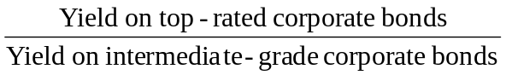
This year: Confidence index = (4%/6%) = 0.667
Last year: Confidence index = (7%/9%) = 0.778
Thus, the confidence index is decreasing.

23. Note: In order to create the 26-week moving average for the S&P 500, we converted the weekly returns to weekly index values, with a base of 100 for the week prior to the first week of the data set. The following graph shows the S&P 500 values and the 26-week moving average, beginning with the 26th week of the data set.
a. The graph summarizes the data for the 26-week moving average. The graph also shows the values of the S&P 500 index.
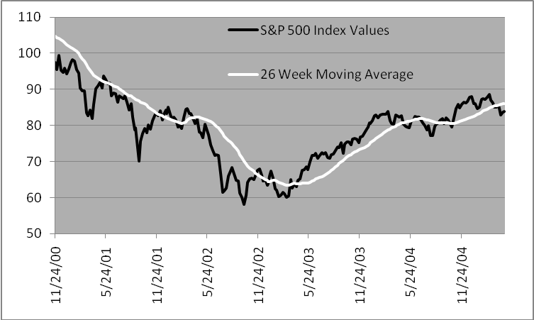

b. The S&P 500 crosses through its moving average from below 14 times, as indicated in the table below. The index increases seven times in weeks following a cross-through and decreases seven times.
Date of  Cross-Through | Direction of S&P 500 in Subsequent Week
05/18/01 | Decrease
06/08/01 | Decrease
12/07/01 | Decrease
12/21/01 | Increase
03/01/02 | Increase
11/22/02 | Increase
01/03/03 | Increase
03/21/03 | Decrease
04/17/03 | Increase
06/10/04 | Decrease
09/03/04 | Increase
10/01/04 | Decrease
10/29/04 | Increase

04/08/05 | Decrease
c. The S&P 500 crosses through its moving average from above 14 times, as indicated in the table below. The index increases nine times in weeks following a cross-through and decreases five times.
Date of  Cross-Through | Direction of S&P 500 in Subsequent Week | Date of  Cross-  Through | Direction of S&P 500 in Subsequent Week
06/01/01 | Increase | 03/28/03 | Increase
06/15/01 | Increase | 04/30/04 | Decrease
12/14/01 | Increase | 07/02/04 | Decrease
02/08/02 | Increase | 09/24/04 | Increase
04/05/02 | Decrease | 10/15/04 | Decrease
12/13/02 | Increase | 03/24/05 | Increase
01/24/03 | Decrease | 04/15/05 | Increase

d. When the index crosses through its moving average from below, as in part (b), this is regarded as a bullish signal. In our sample, the index is as likely to increase as it is to decrease following such a signal. When the index crosses through its moving average from above, as in part (c), this is regarded as a bearish signal. In our sample, contrary to the bearish signal, the index is actually more likely to increase than it is to decrease following such a signal.

24. In order to create the relative strength measure, we converted the weekly returns for the Fidelity Banking Fund and for the S&P 500 to weekly index values, using a base of 100 for the week prior to the first week of the data set. The first graph shows the resulting values, along with the relative strength measure (× 100). The second graph shows the percentage change in the relative strength measure over five-week intervals.
a. The following graph summarizes the relative strength data for the fund.

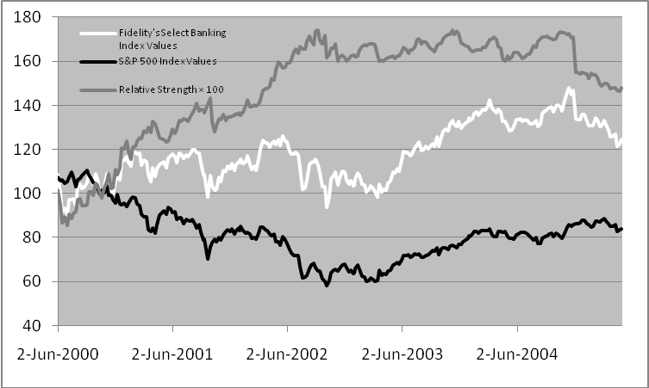

b. Over five-week intervals, relative strength increased by more than 5% 29 times, as indicated in the table and graph below. The Fidelity Banking Fund underperformed the S&P 500 index 18 times and outperformed the S&P 500 index 11 times in weeks following an increase of more than 5%.
Date of Increase | Performance of Banking Fund in Subsequent Week | Date of Increase | Performance of Banking Fund in Subsequent Week
07/21/00 | Outperformed | 03/09/01 |  | Outperformed
08/04/00 | Outperformed | 03/16/01 |  | Underperformed
08/11/00 | Underperformed | 03/30/01 |  | Underperformed
08/18/00 | Outperformed | 06/22/01 |  | Underperformed
09/22/00 | Outperformed | 08/17/01 |  | Underperformed
09/29/00 | Underperformed | 03/15/02 |  | Outperformed
10/06/00 | Underperformed | 03/22/02 |  | Underperformed
12/01/00 | Underperformed | 03/28/02 |  | Outperformed
12/22/00 | Underperformed | 04/05/02 |  | Outperformed
12/29/00 | Outperformed | 04/12/02 |  | Underperformed
01/05/01 | Underperformed | 04/26/02 |  | Outperformed
01/12/01 | Underperformed | 05/03/02 |  | Underperformed
02/16/01 | Underperformed | 05/10/02 |  | Underperformed
02/23/01 | Outperformed | 06/28/02 |  | Underperformed
03/02/01 | Underperformed

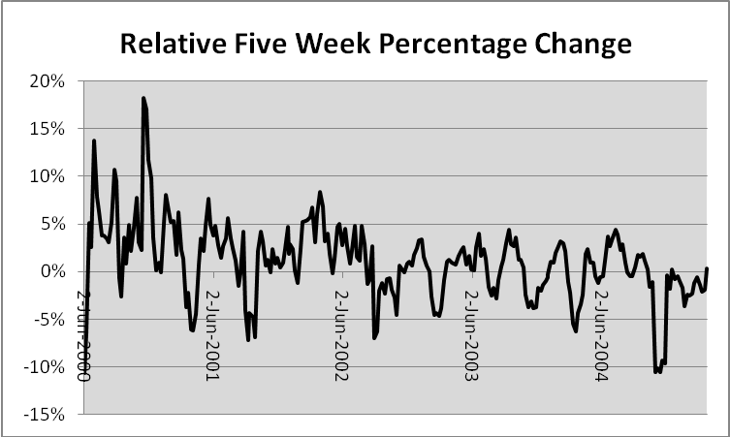

c. Over five-week intervals, relative strength decreases by more than 5% 15 times, as indicated in the graph above and table below. The Fidelity Banking Fund underperformed the S&P 500 index six times and outperformed the S&P 500 index nine times in weeks following a decrease of more than 5%.

Date of Decrease | Performance of Banking Fund in Subsequent Week | Date of Decrease | Performance of Banking Fund in Subsequent Week
07/07/00 | Underperformed | 04/16/04 | Underperformed
07/14/00 | Outperformed | 04/23/04 | Outperformed
05/04/01 | Underperformed | 12/03/04 | Outperformed
05/11/01 | Outperformed | 12/10/04 | Underperformed
10/12/01 | Outperformed | 12/17/04 | Outperformed
11/02/01 | Outperformed | 12/23/04 | Underperformed
10/04/02 | Outperformed | 12/31/04 | Underperformed
10/11/02 | Outperformed

d. An increase in relative strength, as in part (b) above, is regarded as a bullish signal. However, in our sample, the Fidelity Banking Fund is more likely to underperform the S&P 500 index than it is to outperform the index following such a signal. A decrease in relative strength, as in part (c), is regarded as a bearish signal. In our sample, contrary to the bearish signal, the Fidelity Banking Fund is actually more likely to outperform the index increase than it is to underperform following such a signal.

25. It has been shown that discrepancies of price from net asset value in closed-end funds tend to be higher in funds that are more difficult to arbitrage such as less-diversified funds.

CFA PROBLEMS

1. i. Mental accounting is best illustrated by Statement #3. Sampson’s requirement that his income needs be met via interest income and stock dividends is an example of mental accounting. Mental accounting holds that investors segregate funds into mental accounts (e.g., dividends and capital gains), maintain a set of separate mental accounts, and do not combine outcomes; a loss in one account is treated separately from a loss in another account. Mental accounting leads to an investor preference for dividends over capital gains and to an inability or failure to consider total return.
ii. Overconfidence (illusion of control) is best illustrated by Statement #6. Sampson’s desire to select investments that are inconsistent with his overall strategy indicates overconfidence. Overconfident individuals often exhibit risk-seeking behavior. People are also more confident in the validity of their conclusions than is justified by their success rate. Causes of overconfidence include the illusion of control, self-enhancement tendencies, insensitivity to predictive accuracy, and misconceptions of chance processes.
iii. Reference dependence is best illustrated by Statement #5. Sampson’s desire to retain poor-performing investments and to take quick profits on successful investments suggests reference dependence. Reference dependence holds that investment decisions are critically dependent on the decision-maker’s reference point. In this case, the reference point is the original purchase price. Alternatives are evaluated not in terms of final outcomes but rather in terms of gains and losses relative to this reference point. Thus, preferences are susceptible to manipulation simply by changing the reference point.

2. a. Frost's statement is an example of reference dependence. His inclination to sell the international investments once prices return to the original cost depends not only on the terminal wealth value, but also on where he is now, that is, his reference point. This reference point, which is below the original cost, has become a critical factor in Frost’s decision.
In standard finance, alternatives are evaluated in terms of terminal wealth values or final outcomes, not in terms of gains and losses relative to some reference point such as original cost.

b. Frost’s statement is an example of susceptibility to cognitive error, in at least two ways. First, he is displaying the behavioral flaw of overconfidence. He likely is more confident about the validity of his conclusion than is justified by his rate of success. He is very confident that the past performance of Country XYZ indicates future performance. Behavioral investors could, and often do, conclude that a five-year record is ample evidence to suggest future performance. Second, by choosing to invest in the securities of only Country XYZ, Frost is also exemplifying the behavioral finance phenomenon of asset segregation. That is, he is evaluating Country XYZ investment in terms of its anticipated gains or losses viewed in isolation.
Individuals are typically more confident about the validity of their conclusions than is justified by their success rate or by the principles of standard finance, especially with regard to relevant time horizons. In standard finance, investors know that five years of returns on Country XYZ securities relative to all other markets provide little information about future performance. A standard finance investor would not be fooled by this “law of small numbers.” In standard finance, investors evaluate performance in portfolio terms, in this case defined by combining the Country XYZ holding with all other securities held. Investments in Country XYZ, like all other potential investments, should be evaluated in terms of the anticipated contribution to the risk–reward profile of the entire portfolio.

c. Frost’s statement is an example of mental accounting. Mental accounting holds that investors segregate money into mental accounts (e.g., safe versus speculative), maintain a set of separate mental accounts, and do not combine outcomes; a loss in one account is treated separately from a loss in another account. One manifestation of mental accounting, in which Frost is engaging, is building a portfolio as a pyramid of assets, layer by layer, with the retirement account representing a layer separate from the speculative fund. Each layer is associated with different goals and attitudes toward risk. He is more risk averse with respect to the retirement account than he is with respect to the speculative fund account. The money in the retirement account is a downside protection layer, designed to avoid future poverty. The money in the speculative fund account is the upside potential layer, designed for a chance at being rich.
In standard finance, decisions consider the risk and return profile of the entire portfolio rather than anticipated gains or losses on any particular account, investment, or class of investments. Alternatives should be considered in terms of final outcomes in a total portfolio context rather than in terms of contributions to a safe or a speculative account. Standard finance investors seek to maximize the mean-variance structure of the portfolio as a whole and consider covariances between assets as they construct their portfolios. Standard finance investors have consistent attitudes toward risk across their entire portfolio.

3. a. Illusion of knowledge: Maclin believes he is an expert on, and can make accurate forecasts about, the real estate market solely because he has studied housing market data on the Internet. He may have access to a large amount of real estate-related information, but he may not understand how to analyze the information nor have the ability to apply it to a proposed investment.
Overconfidence: Overconfidence causes us to misinterpret the accuracy of our information and our skill in analyzing it. Maclin has assumed that the information he collected on the Internet is accurate without attempting to verify it or consult other sources. He also assumes he has skill in evaluating and analyzing the real estate-related information he has collected, although there is no information in the question that suggests he possesses such ability.

b. Reference point: Maclin’s reference point for his bond position is the purchase price, as evidenced by the fact that he will not sell a position for less than he paid for it. This fixation on a reference point, and the subsequent waiting for the price of the security to move above that reference point before selling the security, prevents Maclin from undertaking a risk/return-based analysis of his portfolio position.

c. Familiarity: Maclin is evaluating his holding of company stock based on his familiarity with the company rather than on sound investment and portfolio principles. Company employees, because of this familiarity, may have a distorted perception of their own company, assuming a “good company” will also be a good investment. Irrational investors believe an investment in a company with which they are familiar will produce higher returns and have less risk than nonfamiliar investments.
Representativeness: Maclin is confusing his company (which may well be a good company) with the company’s stock (which may or may not be an appropriate holding for his portfolio and/or a good investment) and its future performance. This can result in employees’ overweighting their company stock, thereby holding an underdiversified portfolio.

4. a. The behavioral finance principle of biased expectations/overconfidence is most consistent with the investor’s first statement. Petrie stock provides a level of confidence and comfort for the investor because of the circumstances in which she acquired the stock and her recent history with the returns and income from the stock. However, the investor exhibits overconfidence in the stock given the needs of her portfolio (she is retired) and the brevity of the recent performance history.

b. The behavioral finance principle of mental accounting is most consistent with the investor’s second statement. The investor has segregated the monies distributed from her portfolio into two “accounts”: the returns her portfolio receives on the Petrie stock and the returns on the rest of her portfolio. She is maintaining a separate set of mental accounts with regard to the total funds distributed. The investor’s specific uses should be viewed in the overall context of her spending needs and she should consider the risk and return profile of the entire portfolio.

5. i. Overconfidence (Biased Expectations and Illusion of Control): Pierce is basing her investment strategy for supporting her parents on her confidence in the economic forecasts. This is a cognitive error reflecting overconfidence in the form of both biased expectations and an illusion of control. Pierce is likely more confident in the validity of those forecasts than is justified by the accuracy of prior forecasts. Analysts’ consensus forecasts have proven routinely and widely inaccurate. Pierce also appears to be overly confident that the recent performance of the Pogo Island economy is a good indicator of future performance. Behavioral investors often conclude that a short track record is ample evidence to suggest future performance.

Standard finance investors understand that individuals typically have greater confidence in the validity of their conclusions than is justified by their success rate. The calibration paradigm, which compares confidence to predictive ability, suggests that there is significantly lower probability of success than the confidence levels reported by individuals. In addition, standard finance investors know that recent performance provides little information about future performance and are not deceived by this “law of small numbers.”

ii. Loss Aversion (Risk Seeking): Pierce is exhibiting risk aversion in deciding to sell the Core Bond Fund despite its gains and favorable prospects. She prefers a certain gain over a possibly larger gain coupled with a smaller chance of a loss. Pierce is exhibiting loss aversion (risk seeking) by holding the High Yield Bond Fund despite its uncertain prospects. She prefers the modest possibility of recovery coupled with the chance of a larger loss over a certain loss. People tend to exhibit risk seeking, rather than risk aversion, behavior when the probability of loss is large. There is considerable evidence indicating that risk aversion holds for gains and risk seeking behavior holds for losses, and that attitudes toward risk vary depending on particular goals and circumstances.
Standard finance investors are consistently risk averse and systematically prefer a certain outcome over a gamble with the same expected value. Such investors also take a symmetrical view of gains and losses of the same magnitude, and their sensitivity (aversion) to changes in value is not a function of a specified value reference point.

iii. Reference Dependence: Pierce’s inclination to sell her Small Company Fund once it returns to her original cost is an example of reference dependence. This is predicated on the current value as related to original cost, her reference point. Her decision ignores any analysis of expected terminal value or the impact of this sale on her total portfolio. This reference point of original cost has become a critical but inappropriate factor in Pierce’s decision.
In standard finance, alternatives are evaluated in terms of terminal wealth values or final outcomes, not in terms of gains and losses relative to a reference point such as original cost. Standard finance investors also consider the risk and return profile of the entire portfolio rather than anticipated gains or losses on any particular investment or asset class.

