**Group: B-3**

**Roll No.: 1909043, 1909044, 1909045, 1909046, 1909047, 1909048**

**Block Diagram of the Implemented Design:**

Determine the required operations with the user defined functions

**END**

Plot Magnitude Response, Phase Response,

Pole-Zeros (For Stability Check) and Display transfer function

Filtered Signal

Noisy Signal

Determine applicable Window and Filter coefficient

Input Parameters:

Filter-Type: Band Pass

Passband: 1500 – 2750 Hz Lower Stopband: 0-1KHz

Upper Stopband: 3.5-4.5KHz

Sampling rate: 8KHz

Passband Ripple: 0.5 dB

Stopband Attenuation: 40 dB

Calculate proper window function

**Start**

**Figure 3.1: Block Diagram of designed Band Pass FIR filter**

**Code:**

**main.m:**

% Calculate filter coefficient, window type and window function

[h] = filter_coefficient('bpf',8000,0,0,1000,3500,1500,2750,25);

[win_type,m] = window_type(0.5,40);

[num,h_win,w_win] = window_function(h,win_type,m);

figure(1)

subplot(311)

plot(w_win,20*log10(abs(h_win)))

grid;

xlabel('Frequency (Hz)');

ylabel('Magnitude Response (dB)');

subplot(312)

plot(w_win, 180*angle(h_win)/pi); grid;

xlabel('Frequency (Hz)');

ylabel('Phase (degrees)');

subplot(313),

plot(w_win,180*unwrap(angle(h_win))/pi);grid;

xlabel('Frequency (Hz)');

ylabel('Phase (degrees)');

figure(2)

subplot(1,1,1);

zplane(num,1);

title('Pole Zero plot(FIR Filter)');

grid on;

% Generate the input signal

fs=8000;

t = 0:1/fs:0.1; % Time vector from 0 to 0.1 seconds

input_signal = sin(0.06*pi*t) + 3*sin(0.14*pi*t);

B=reshape(h_win.',1,[]); %change matrix to vector

% Filter the noisy signal using the FIR filter for the signal

noisy_signal = input_signal+sqrt(0.1)*randn(size(input_signal));

filtered_signal = filter(h_win,1,noisy_signal);

% Plot the original signal, noisy signal, and filtered signal for the signal

figure(3);

subplot(3, 1, 1);

plot(t, input_signal);

title('Original Signal');

xlabel('Time (s)');

ylabel('Amplitude');

subplot(3, 1, 2);

plot(t, noisy_signal);

title('Noisy Signal');

xlabel('Time (s)');

ylabel('Amplitude');

subplot(3, 1, 3);

plot(t, filtered_signal);

title('Filtered Signal');

xlabel('Time (s)');

ylabel('Amplitude');

**check_digit.m:**

function x = check_digit(m,n)

k = round(max(m,n));

if mod(k,2)==0

x = k+1;

else

x = k;

end

end

**filter_coefficient.m:**

function [num] = filter_coefficient(filter_type,fs,fc_low,fc_up,f_stop1,f_stop2,f_pass1,f_pass2,n)

switch filter_type

case 'lpf'

M=(n-1)/2;

wl = 2*pi*fc_low/fs;

num = [];

for k = 0:1:M

pos = k+M+1;

if k == 0

num(pos) = wl/pi;

else

num(pos) = (sin(k*wl)/(k*pi));

new_pos = pos-(2*k);

num(new_pos) = num(pos);

end

end

[hz,w]=freqz(num,[1],512,fs);

case 'hpf'

M=(n-1)/2;

wh = 2*pi*fc_up/fs;

num = [];

for k = 0:1:M

pos = k+M+1;

if k == 0

num(pos) = (pi-wh)/pi;

else

num(pos) = -(sin(k*wh)/(k*pi));

new_pos = pos-(2*k);

num(new_pos) = num(pos);

end

end

[hz,w]=freqz(num,[1],512,fs);

case 'bsf'

M=(n-1)/2;

wl=2*pi*fc_low/fs;

wh = 2*pi*fc_up/fs;

num = []

for k = 0:1:M

pos = k+M+1;

if k == 0

num(pos) = pi-wh+wl/pi;

else

num(pos) = -(sin(k*wh)/(k*pi))+sin(k*wl)/(k*pi)

new_pos = pos-(2*k)

num(new_pos) = num(pos)

end

end

[hz,w]=freqz(num,[1],512,fs);

case 'bpf'

M=(n-1)/2;

fl=(f_stop1+f_pass1)/2;

fh=(f_stop2+f_pass2)/2;

wl=2*pi*fl/fs;

wh = 2*pi*fh/fs;

num = [];

for k = 0:1:M

pos = k+M+1;

if k == 0

num(pos) = (wh-wl)/pi;

else

num(pos) = (sin(k*wh)/(k*pi))-sin(k*wl)/(k*pi);

new_pos = pos-(2*k);

num(new_pos) = num(pos);

end

end

[hz,w]=freqz(num,[1],512,fs);

end

end

**window_type.m:**

function [win_type,M] = window_type(passband_ripple, stopband_attenuation)

f_stop1 = 1000;

f_pass1 = 1500;

f_pass2 = 2750;

f_stop2 = 3500;

fs=8000;

if (passband_ripple >= 0.7416) && (stopband_attenuation > 0 && stopband_attenuation <= 21) % Rectangular window

win_type = 'rect';

N1_rect = 0.9*fs/ abs(f_stop1-f_pass1);

N2_rect = 0.9*fs/ abs(f_stop2-f_pass2);

N_rect = check_digit(N1_rect,N2_rect);

M = (N_rect - 1) / 2;

elseif (passband_ripple >= 0.0546) && (stopband_attenuation > 21 && stopband_attenuation <= 44) % Hanning window

win_type = 'hann';

N1_hann = 3.1*fs/ abs(f_stop1-f_pass1);

N2_hann = 3.1*fs/ abs(f_stop2-f_pass2);

N_hann = check_digit(N1_hann,N2_hann);

M = (N_hann - 1) / 2;

elseif (passband_ripple >= 0.0194) && (stopband_attenuation > 44 && stopband_attenuation <= 53) % Hamming window

win_type = 'hamm';

N1_hamm = 3.3*fs/ abs(f_stop1-f_pass1);

N2_hamm = 3.3*fs/ abs(f_stop2-f_pass2);

N_hamm = check_digit(N1_hamm,N2_hamm);

M = (N_hamm - 1) / 2;

elseif (passband_ripple >= 0.0017) && (stopband_attenuation > 53 && stopband_attenuation <= 74) % Blackman window

win_type = 'black';

N1_black = 5.5*fs/ abs(f_stop1-f_pass1);

N2_black = 5.5*fs/ abs(f_stop2-f_pass2);

N_black = check_digit(N1_black,N2_black);

M = (N_black - 1) / 2;

else

disp('Invalid parameters');

end

end

**window_function.m:**function [num, h_win, w_win] = window_function(h, win_type, M)

fs = 8000;

w = ones(1, M); % Assuming M is the length of h

switch win_type

case 'rect'

% Rectangular window

% No changes needed for rectangular window

case 'hann'

% Hanning window

for n = 0:M-1

w(n + 1) = 0.5 + 0.5 * (1 - cos(2 * pi * n / M));

end

case 'hamm'

% Hamming window

for n = 0:M-1

w(n + 1) = 0.54 + 0.46 * cos(2 * pi * n / M);

end

case 'black'

% Blackman window

for n = 0:M-1

w(n + 1) = 0.42 + 0.5 * cos(2 * pi * n / M) + 0.08 * cos(4 * pi * n / M);

end

otherwise

error('Unsupported window type');

end

num = h .* w;

[h_win, w_win] = freqz(num, [1], 512, fs);

End

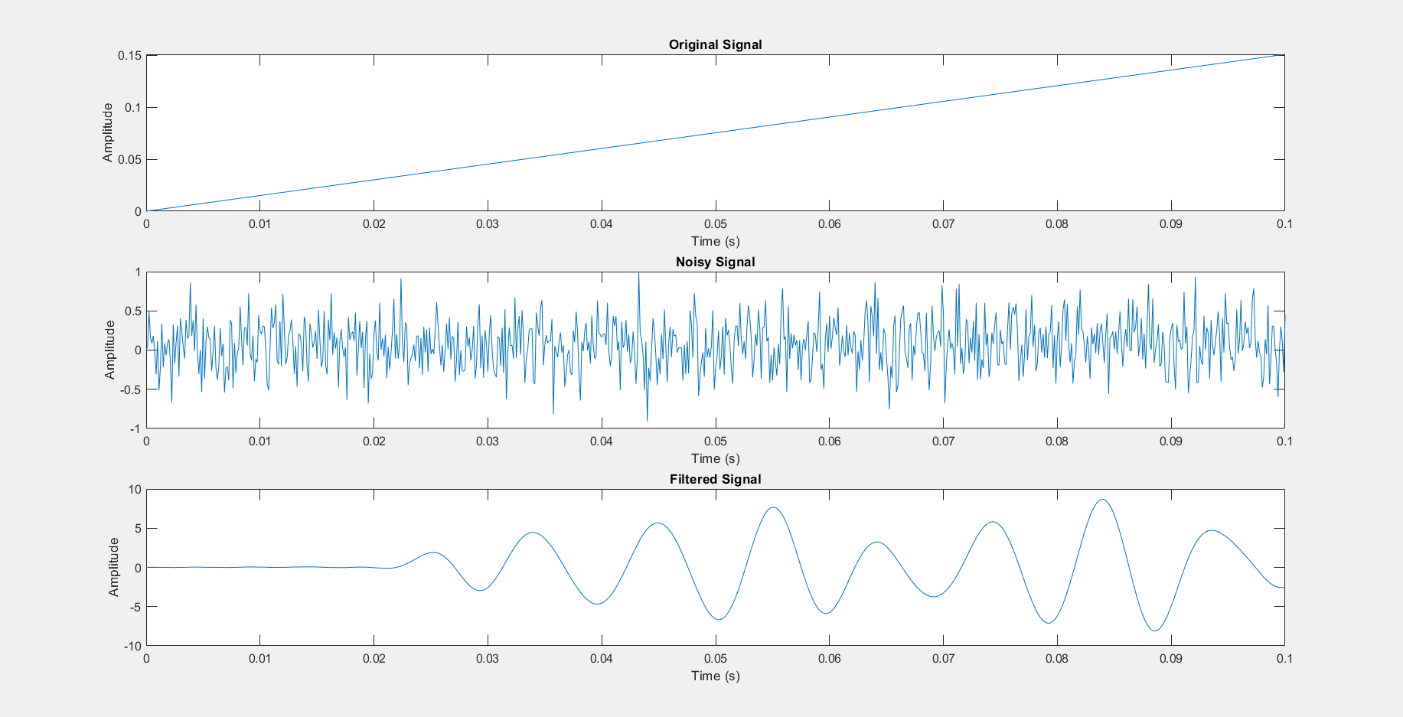**Obtained figures:**

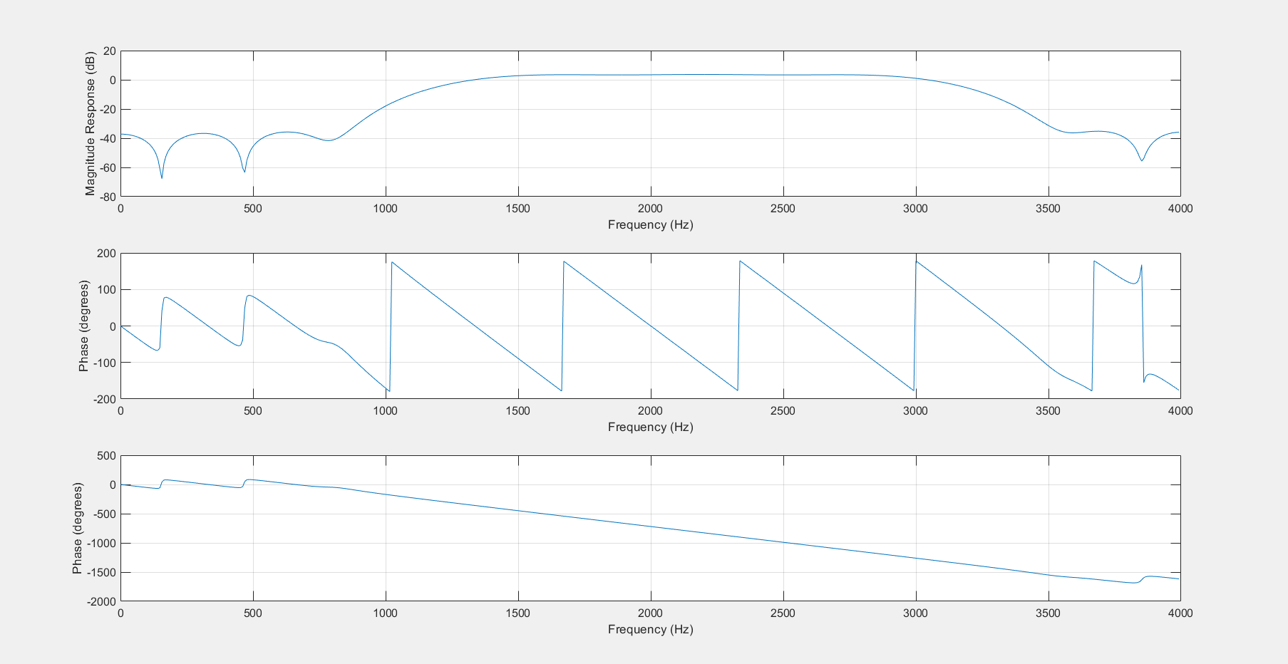**Figure 3.2: Waveform of the original signal and filtered signal**

**Figure 3.3: Magnitude Response & Phase Response of the designed FIR ­filter**

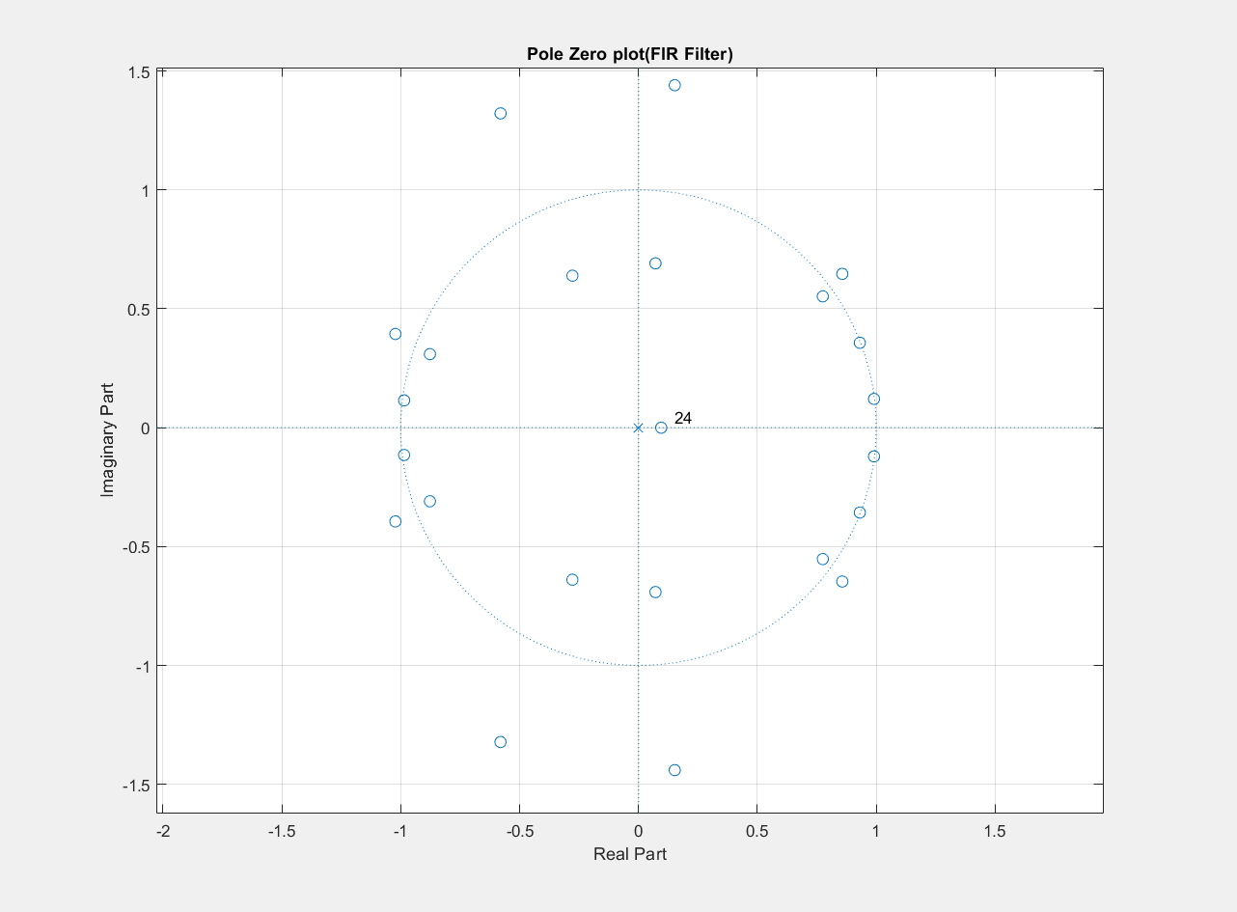

**Figure 3.4: Pole-Zeros Plot of the FIR ­Filter (Stability Check)**