**Khulna University of Engineering and Technology**

**Dept. of Electronics and Communication Engineering**

Course Title: **Antenna Engineering Laboratory**

Course no: ECE-3208

Date of submission: **16-11-2023**

***Submitted by:***

Md. Lavlu Mia

Roll: 1909034

Sumit Das

Roll: 1909044

Hasan Mahmud Shohardyo

Roll: 1909054

***Submitted to:***

Md. Minhajul Islam Arnab

Lecturer

Department of ECE,

KUET

Naymur Rahman

Lecturer

Department of ECE,

KUET

***Project Title:***

**UWB Vivaldi Antenna for Long-Distance Electromagnetic Transmission**

**Design and simulation of an UWB vivaldi antenna for long distance electromagnetic Transmission**

**Abstract**

The careful design and simulation of an Ultra-Wideband (UWB) Vivaldi antenna is the main topic of this project report's extensive investigation into the nuances of wireless communication. The antenna uses the high-performance computing power included in CST Studio Suite® to be placed in a deliberate manner between 2.5 and 4 GHz. In response to the increasing demand for accuracy in wireless detection systems, the UWB Vivaldi antenna, renowned for its technological prowess, aims to unlock the latent potential of the device. Notably, the device excels in high data rates, minimal power consumption, and adaptability to dynamic environmental conditions. This is especially true in the field of long-distance electromagnetic applications. As we progress through the project, the concept of mesh convergence becomes crucial, affirming the trustworthiness and accuracy of our results. This culmination involves a comprehensive comparison between the simulated and theoretically anticipated results, propelling this initiative into a visionary realm where wireless communication effortlessly merges with precision, efficiency, and groundbreaking innovation.

**Objectives**

* **Masterful Design and Simulation**

Proficiently design and simulate the Ultra-Wideband (UWB) Vivaldi antenna using CST software. Focus on applications such as high-speed data transfer in wireless communication systems requiring a broad frequency range.

* **Precise Performance Analysis**

Scrutinize key performance aspects like S-parameters, impedance bandwidth, radiation pattern, gain, and directivity of the UWB Vivaldi antenna. Emphasize applications in radar systems or imaging where precise characteristics are crucial for accurate target detection or imaging.

* **Insightful Mesh Convergence Evaluation**

Examine and understand how mesh convergence influences the UWB Vivaldi antenna simulation. Particularly, in applications like short-range communication networks, where optimized signal propagation is vital for minimizing interference.

* **Optimization for Peak Performance**

Fine-tune the design parameters of the UWB Vivaldi antenna to attain the expected output. Address applications in remote sensing or surveillance where optimized design enhances performance for long-range communication.

* **Thorough Deviation Analysis**

Scrutinize and analyze any discrepancies between theoretical and simulated results of the UWB Vivaldi antenna. Focus on applications in position tracking systems. Minimizing deviations is crucial for accurate location determination, especially in indoor or cluttered environments.

Introduction

In the dynamic realm of wireless communication, biomedical detection, and radar systems, Ultrawideband (UWB) antennas emerge as versatile components. Among them, the Vivaldi antenna, celebrated for its tapered slot design, boasts high gain, a directive radiation pattern, and an expansive bandwidth, particularly standing out in UWB technology and antenna arrays with its small transverse spacing.

However, challenges persist in optimizing the Vivaldi antenna, especially in achieving top-tier performance in the low-end working band. Traditional hurdles, such as the necessity for a large antenna size, have sparked innovative strategies from scholars to enhance the antenna's capabilities. These strategies include expanding the feeding part, modifying radiation elements, and exploring additional structures to augment gain.

While some designs excel in miniaturization, achieving optimal directional performance and gain remains a scholarly pursuit. This article ventures into the design of receiving and transmitting antennas based on the UWB Vivaldi antenna, forming a long-distance electromagnetic detection system. Operating in the 2.5~4 GHz frequency , the system necessitates a transmitting antenna with broad beamwidth and a receiving antenna with a narrow beamwidth for effective signal illumination and precise target detection.

The unique characteristics of the UWB Vivaldi antenna, notably its tapered slot design, position it optimally for this endeavor. This article aims to achieve long-distance detection with a system characterized by high transmitting power, excellent impedance matching, and superior gain performance. The ensuing discussion unravels the intricacies of the designed UWB Vivaldi antenna system, shedding light on its working principles and potential impact on target detection capabilities.

Motivation

**Choosing UWB Vivaldi Antennas: Where Tech Meets Everyday Solutions**

* **Precision in Tech:** UWB Vivaldi antennas excel in nailing tech precision. Picture them as dynamic tools transforming how we detect things from afar, simplifying complex tech challenges, especially in long-distance scenarios.
* **Health Champions:** Beyond tech, these antennas take charge in advancing health solutions. Envision them as proactive health champions, swiftly identifying strokes without invasive procedures. Moreover, they venture into cancer detection and treatment, revolutionizing healthcare approaches.
* **Tech All-Rounders:** UWB Vivaldi antennas are versatile tech all-rounders, seamlessly fitting into various tech roles—upgrading communication between gadgets, enhancing ID card capabilities, and elevating radar intelligence. They are the go-to tech companions for diverse applications.
* **Smart Savings:** Developing these antennas is a strategic financial move. It's an active decision to shift from extravagant prototyping to a nimble and cost-effective process. Instead of hefty spending, we can swiftly create and test these antennas without financial strain.
* **Learning Expedition:** This project isn't merely a discussion on tech; it's an active learning expedition. For students and researchers, it resembles a dynamic treasure hunt for knowledge, unraveling the intricacies of how these antennas operate. It's an engaging and hands-on exploration of tech education.

So, when opting for UWB Vivaldi antennas, envision an active convergence of tech precision and everyday solutions—a tech journey that is not only intelligent but also health-forward and immensely exciting to delve into.

**Theory**

Ultrawideband (UWB) antennas have been increasingly applied in wireless commu nication, biomedical detection, and radar systems in recent years. As a tapered slot antenna, the Vivaldi antenna is well-known for its high gain, directive radiation pattern, planar structure and fairly wide bandwidth, and it is one of the best options for the UWB technology. Its small transverse spacing makes it a good candidate for antenna arrays. The Vivaldi antenna can be classified into the category of end fire traveling wave antennas, has theoretically infinite bandwidth, and can be used to form an ultra wideband antenna system. However, the Vivaldi antenna requires a large antenna size to achieve excellent performance in the low-end working band. The width of a Vivaldi antenna should reach at least one half-wavelength so as to achieve effective radiation.

In order to reduce the size of the Vivaldi antenna and to further optimize it, some scholars have put forward many new strategies. The feeding part should be improved to realize miniaturization. To increase the area of feeding part and adopt feed with stepped structure, radiation parts should be improved. Some antennas can be seen to open unequal semicircle slots, while some can be witnessed to open multiple rectangular slots on the edge of the radiation part, which helps improve antenna gain. Some antenna reflects the method of increasing the length of the dielectric substrate to improve the directivity, and some has an enhanced gain over whole frequency band by adding an additional structure that supports spoof surface plasmon polaritons (SSPP) as the parasitic element. Some antenna perform better with miniaturization, but their performance with regard to the direction and gain is far from scholars’ satisfaction. Some antennas have higher antenna gain, while they cannot meet scholars’ expectations in miniaturization.

This project is designed for transmitting antenna based on Vivaldi antennae, and built a long-distance electromagnetic detection system. In the target detection test, the transmitting antenna is used as illumination feed, and the receiving antenna obtains the signal reflected by the target from scanning angle to find the target and the azimuth angle. Then, with the Time Domain Transmissometer (TDT) measurement results, the target position is judged. The working frequency band of the detection system is 2.5~4 GHz. According to the working principle of the detection system, the beamwidth of the transmitting antenna array needs to be strong in a particular direction. Therefore, the half-power beamwidth (HPBW) of the transmitting antenna array should be less than 70◦. Correspondingly, in order to quickly and accurately determine the azimuth angle and judge the position of the target, the beamwidth of the receiving antenna is required to be as narrow as possible and have good directivity. Therefore, the receiving antenna should be a typical one that has narrow HPBW and good directional performance and that should also be miniaturized. To achieve long-distance detection, the target detection system should have a high transmitting power, and the antenna should be characterized by boasting better impedance matching and higher gain performance.

In general, the bandwidth of a traditional Vivaldi antenna is determined by the transition from the feeding microstrip line to the slot line and the dimensions of the antenna. For the planar slit gradient antenna, the spacing of the narrow end of the slot line opening determines the highest working frequency, while the spacing of the wide end determines the lowest working frequency. Considering that the working frequency range is 2.5~4 GHz, the end width of the slot line can be set as 50 mm and the starting end width can be set as 2 mm. Since the radiation of the antenna is generated by the current extending along the gradient slots on both sides, widening the width of the antenna will make the current flow through a longer path and generate a wider main beam. However, it also affects the impedance of the antenna. By further optimized simulation, the width of the antenna’s metal sheet can be obtained. Figure 1 shows the configuration of the proposed transmitting antenna. The antenna is fabricated on a 150 × 150 × 1.6 mm FR4 substrate with a dielectric constant of 4.3. The structure of the Vivaldi antenna is composed by dielectric substrate, metal ground plane, and feeding microstrip transmission line. The exponential tapered slot, which is on the ground plane, can be expressed as:

y = C1eax + C2 (1)

C1 = (2)

where (x1, y1), (x2, y2) are the peak and bottom point, respectively, of the exponential tapered shape and a is the exponential factor of the antenna. The optimized dimensions of the proposed antenna are tabulated in Table 1.

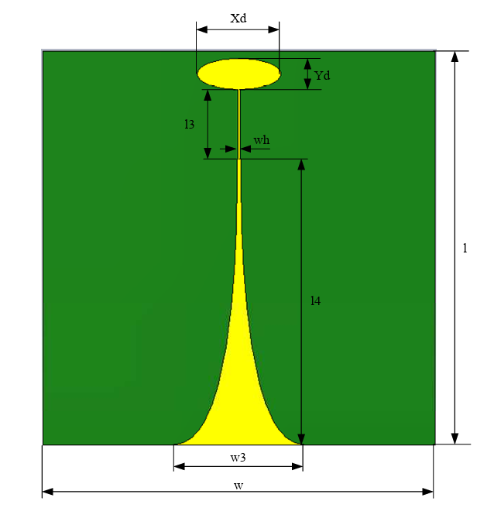

Figure 1: Structure of the transmitting antenna

Table 1: Transmitting antenna parameters (mm):

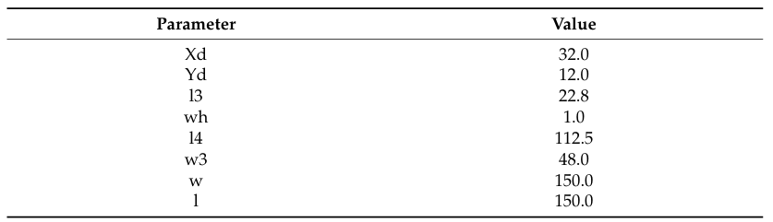

Xd and Yd are the short axis and long axis of the elliptical resonator cavity, respectively. The values l3 and wh are the length and width of the rectangular transitional slot, respectively. The value l4 is the length of the gradient slot, while w3 is the widest width of the gradient slot.

After optimizing the parameters of feed line structure, the working frequency range was 1.4–8 GHz. As shown in Figure 2a, the return loss of the simulated and measured antenna was adjusted to −10 dB over the frequency band from 1.4 GHz to 8 GHz.

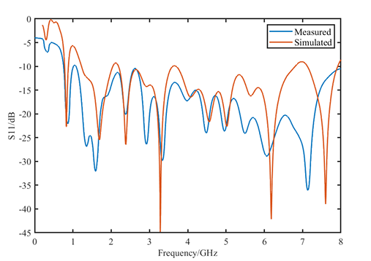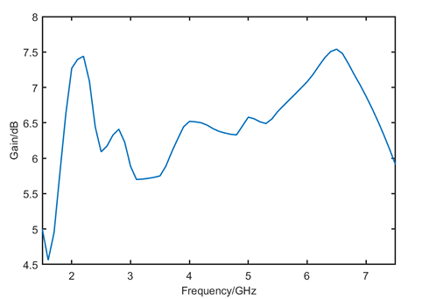

1. (b)

Figure 2: (a) Return loss of the measured and simulated transmitting antenna (b) The gain of the simulated transmitting antenna.

We’ve to analyze some parameters which are essential to determine the performance and efficiency of an antenna. These are:

**S-parameter**: The "S parameter" or scattering parameter of an antenna refers to a set of parameters used in electrical engineering to describe the electrical behavior of linear electrical networks when undergoing various steady-state stimuli by small signals. They are especially useful in the context of microwave engineering.

For an antenna, the most relevant S parameter is typically S11, which is known as the return loss or reflection coefficient. This parameter indicates how much of the signal is reflected back from the antenna, rather than being radiated out.

**S11(Return Loss or Reflection Coefficient):** It describes how much power is reflected from the antenna. A value close to 0 (or -∞ in dB) means that almost all the power is transmitted, indicating a good match between the antenna and the transmission line. Conversely, a value close to 1 (or 0 dB) indicates a poor match, meaning that much of the power is reflected back, which is undesirable. In antenna design and testing, ensuring a low S11 value is critical for efficient operation, as it means that the antenna is effectively radiating the energy it receives from the transmission line.

**VSWR:** VSWR (voltage standing wave ratio) is a measure of the impedance matching between the ratio or transmission line and antenna. It indicates the amount of power that can be safely delivered to an antenna without damaging it.

A low VSWR value means a better impedance match, and therefor more power being transferred efficiently from the radio or transmission line to the antenna. A higher VSWR means poorer impedance match, and therefore less power being transferred efficiently from the radio or transmission line to the antenna.

**Directivity:** Directivity is the measure of the concentration of an antenna's radiation pattern in a particular direction. Directivity is expressed in dB. The higher the directivity, the more concentrated or focused is the beam radiated by an antenna. A higher directivity also means that the beam will travel further.

An antenna that radiated equally well in all directions would be omni-directional and have a directivity of 1 (0 dB).

**Antenna Gain = Directivity x Antenna Efficiency**

Gain is the product of directivity and efficiency. Where efficiency accounts for the losses on the antenna such as manufacturing faults, surface coating losses, dielectric, resistance, VSWR, or any other factor.

**Radiation pattern:** The energy radiated by an antenna is represented by the Radiation pattern of the antenna. Radiation Patterns are diagrammatical representations of the distribution of radiated energy into space, as a function of direction. The radiation patterns can be field patterns or power patterns.

* The **field patterns** are plotted as a function of electric and magnetic fields. They are plotted on logarithmic scale.
* The **power patterns** are plotted as a function of square of the magnitude of electric and magnetic fields. They are plotted on logarithmic or commonly on dB scale.

**Impedance bandwidth**: The "impedance bandwidth" is just the ordinary bandwidth of the antenna.  Normally this is defined as the range of frequencies over which the return loss is acceptable.  Percentage is referring to a quantity more commonly called fractional bandwidth (FBW).  This is simply the absolute bandwidth (or impedance bandwidth) divided by the center frequency of the antenna.

**FBW = BW / fc**

The fractional bandwidth is a better measure for bandwidth when comparing different antennas because it is independent of scale.  For example, if you design an antenna that operates at 100 MHz and has a bandwidth of 10 MHz, the FBW is 10%.  If you make the same antenna, but with all physical dimensions halved, this new antenna will behave the same way as the old antenna, but at 200 MHz.  Its bandwidth is now 20 MHz, but its FBW is still 10%.  If you used only the absolute bandwidth, the 200 MHz antenna would seem better than the exact same antenna designed for 100 MHz.

The performance of a Vivaldi antenna, like most antennas, is significantly influenced by its dimensions and design parameters. Here are the key aspects:

**Aperture Size**: The size of the antenna's aperture (opening) greatly influences its lower frequency limit. Larger apertures allow for lower frequency operation.

**Taper Profile**: The shape of the tapering (exponential, linear, etc.) affects the antenna's impedance bandwidth and gain. An exponential taper is commonly used for a smoother impedance transition.

**Substrate Material and Thickness**: The dielectric constant and thickness of the substrate impact the antenna's impedance bandwidth and radiation pattern.

**Antenna Length**: The overall length of the antenna defines the upper frequency limit. Longer antennas can operate at lower frequencies.

**Balun Design**: The balun (balanced-unbalanced transformer) is critical for impedance matching and determines the efficiency of the antenna across its bandwidth.

**Feeding Mechanism**: The position and type of the feed (microstrip line, coaxial probe, etc.) affect the antenna's input impedance and bandwidth.

**Flare Angle**: The angle of the flare impacts the antenna's radiation pattern and gain. A larger flare angle can lead to higher gain.

**End Corrugations**: Adding corrugations or slots at the end of the antenna can help in improving the antenna's radiation pattern and reducing sidelobes.

**Antenna Thickness**: The thickness of the antenna elements (usually metallic) influences the radiation efficiency and bandwidth.

Each of these parameters can be tweaked to optimize the antenna's performance for specific applications, like radar systems, communication systems, and imaging systems. The design process often involves a trade-off between different parameters to achieve the desired performance. Advanced simulation tools are typically used to model and optimize these antennas before physical prototyping.

Certain equations and relationships are essential for understanding how its dimensions and parameters affect performance. Here are some key equations and relationships:  
1. **Lower Frequency Limit (flow):** The lower frequency limit is related to the aperture size (width W) of the antenna. A rough estimate can be given by:

**flow ≈ c/2W**

where c is the speed of light.

2. **Antenna Gain:** The gain of a Vivaldi antenna can be estimated by considering the effective aperture area (Aeff). G in dBi is approximately:

**G ≈ 10log10(4πAeff/ λ2)**

Where λ is the wavelength at the operating frequency.

3. **Beamwidth:** The Beamwidth of the antenna is related to the aperture size and wavelength. For a simple estimation:

**Beamwidth ≈ λ/W**

4. **Exponential Taper Profile:** In a Vivaldi antenna with an exponential taper, the taper profile can be described by:

**y(x) = eax**

Where a is a constant determining the rate of taper, y is the width of the taper at a distance x from the start of the taper.

5. **Impedance Matching**: The impedance (Z) of the antenna can be related to the geometry of the feedline, for a microstrip feed:

**Z ≈**

Where Wfeed is the width of the feedline, H is the substrate height and **r** is the relative permittivity of the substrate.

6. **Flare Angle():** The flare angle can impact the bandwidth and gain. While there's no simple equation for its optimal value, it's often chosen based on empirical results or simulation.

These equations provide a basic framework, but in practice, designing an UWB Vivaldi antenna often requires iterative simulation and optimization because the interactions between different parameters can be complex. Advanced electromagnetic simulation software is typically used for this purpose.

**Design:**

We designed an UWB Vivaldi antenna with the dimensions of 150mm x 150mm x 1.635mm. We operated the antenna in the frequency range of 3GHz to 11GHz. For long range EM transmission we’ve to check the parameters and characteristics between the frequency of 2.5GHz to 4GHz.

We used different layers and materials for this design. The antenna contains four layers:

1. Substrate
2. Shorted layer
3. Ground
4. Port on a microstrip line

**Materials:**

* **Substrate material**: **FR-4 (lossy) material** with dielectric constant of 4.3 and thermal conductivity of 0.3 W/K/m.
* **Shorted layer**: We used different blocks for this layer. But only **Copper (annealed) lossy metal** material was used for the whole layer. This material has an Electric Conductivity of 5.8e+007 S/m, Thermal Conductivity of 401.0 W/K/m, Heat capacity of 0.39 Kj/K/Kg and material density was 8930.0 Kg/m^3.
* **Ground**: We used the same **Copper (annealed) lossy metal** material for the ground with the same specifications used for the shorted layer.
* **Microstrip line**: We used three different blocks for the microstrip line. One of them had **PEC** material and the other two had **Copper lossy** material that has been used for shorted layer and ground.

**Design and other parameters:**

* We designed the antenna using the necessary layers and materials (Figure 1 & 2)
* We set variables for each parameters (table 1) and set different frequencies for simulation purposes.
* 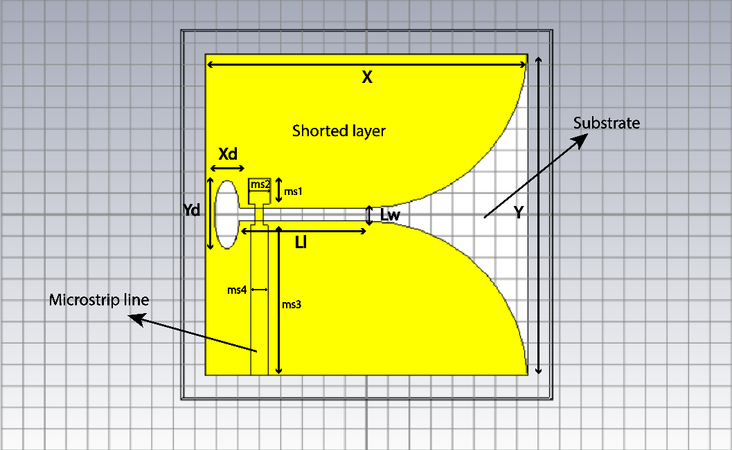We simulated the design in CST and observed & measured the required parameters (s-parameter, impedance bandwidth, resonant frequency, radiation pattern etc.) for different frequencies.

**Figure 3: UWB Vivaldi antenna (Front view)**

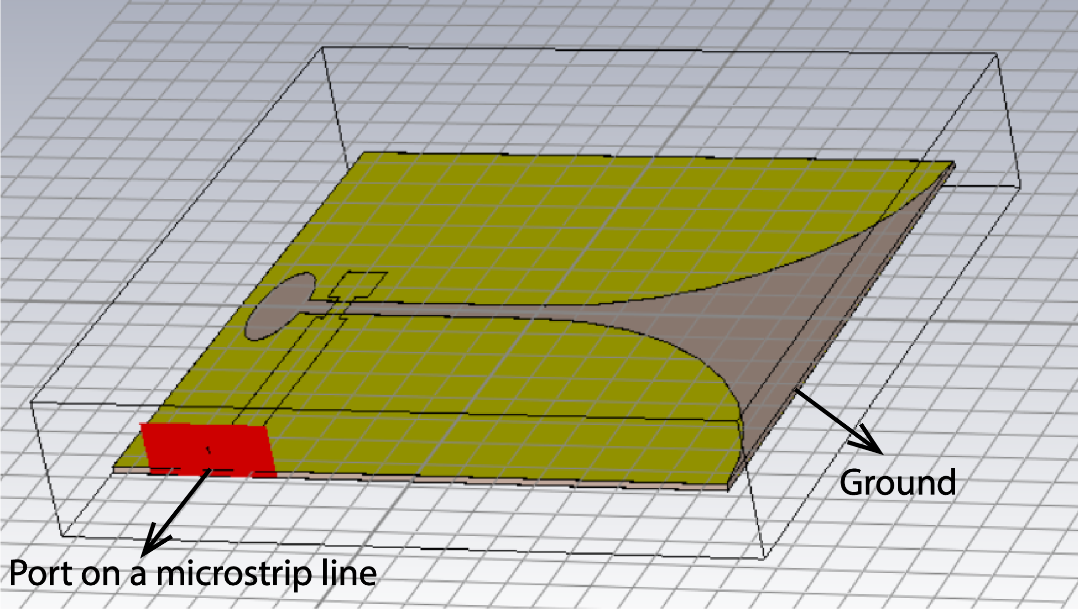**Figure 4: UWB Vivaldi antenna (side view**)

**Table 2: Design parameters of the UWB Vivaldi antenna:**

|  |  |  |  |
| --- | --- | --- | --- |
| **Parameters** | **Length (mm)** | **Parameters** | **Length (mm)** |
| X | 150 | ms3 | 70 |
| Y | 150 | ms4 | 8 |
| Xd | 6 | ms5 | 12 |
| Yd | 16 | ms6 | 4 |
| Z | 1.635 | Lz | 0.035 |
| ms1 | 12 | Li | 65 |
| ms2 | 10 | Lw | 4 |

* We used some variables in the simulation but only constant value is shown in the table

**Result Analysis:**

In this project, we have designed an UWB Vivaldi antenna and observed different parameters, characteristics curves and obtained the resultant frequency, radiation pattern and performed the mesh convergence test as well.

**Mesh convergence:** For the mesh convergence, we changed the cells per wavelength multiple times and ran the simulation every time. At one point the resultant frequency converged and the values were not changing that much. The data obtained from each simulation is stored in the below table:

**Table 3: Simulation results for mesh convergence:**

|  |  |  |  |  |  |
| --- | --- | --- | --- | --- | --- |
| Cells/wavelength | Meshcells | Impedance Bandwidth | Resonant frequency | VSWR | Return loss |
| 5 | **464,720** | **0.8205 GHz** | **5.08** | **1.048** | **-32.49 dB** |
| 6 | **696,600** | **0.7852 GHz** | **5.08** | **1.044** | **-33.24 dB** |
| 8 | **1,313,120** | **0.7913 GHz** | **3.208** | **1.034** | **-35.34 dB** |
| 10 | **2,195,908** | **0.7115 GHz** | **5.088** | **1.033** | **-35.98 dB** |
| 11 | **2,831,136** | **0.8148 GHz** | **5.088** | **1.033** | **-35.66 dB** |
| 12 | **3,689,868** | **0.733 GHz** | **5.088** | **1.032** | **-35.94 dB** |
| 13 | **4,548,600** | **0.723 GHz** | **3.2** | **1.028** | **-36.99 dB** |
| 14 | **5,485,350** | **0.7872 GHz** | **3.2** | **1.022** | **-38.88 dB** |
| 15 | **6,644,757** | **0.7142 GHz** | **3.2** | **1.019** | **-40.25 dB** |
| 16 | **7,697,760** | **0.7142 GHz** | **3.2** | **1.016** | **-41.85 dB** |
| 17 | **8,949,402** | **0.7142 GHz** | **3.2** | **1.011** | **-44.72 dB** |
| 18 | **10,768,032** | **0.7142 GHz** | **3.2** | **1.008** | **-47.06 dB** |

From the table we can see that for 18 cell per wavelength the resultant frequency, impedance bandwidth, VSWR and return loss all the parameters are almost saturated. This is why we will perform all other observations keeping this same cell per wavelength.

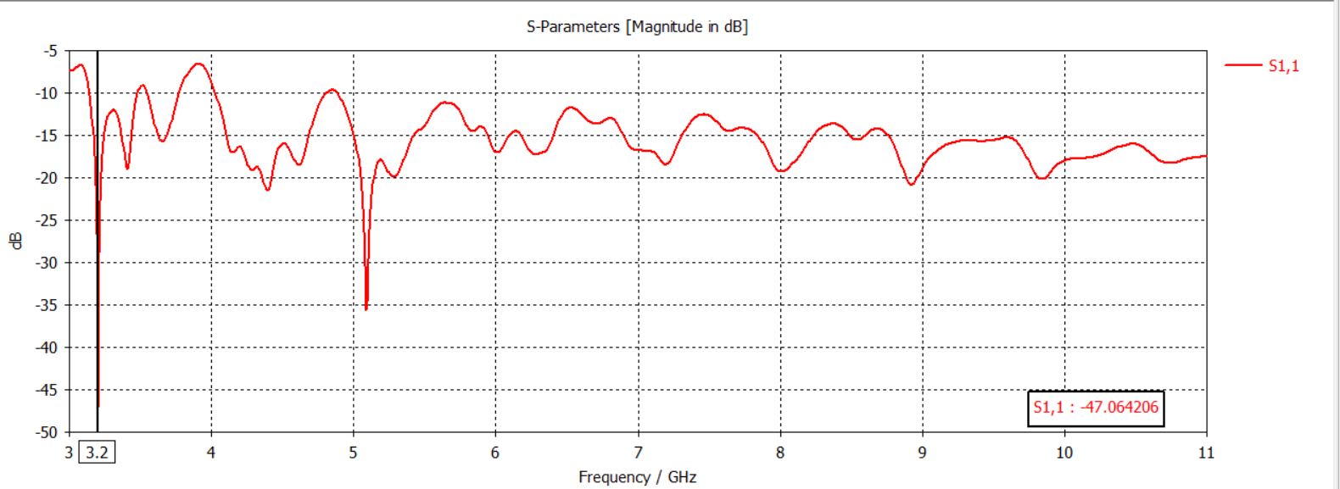**S-parameter:** We obtained the S parameter keeping the cells per wavelength 18. We can determine the resonant frequency, impedance bandwidth, return loss from the s-paramter.

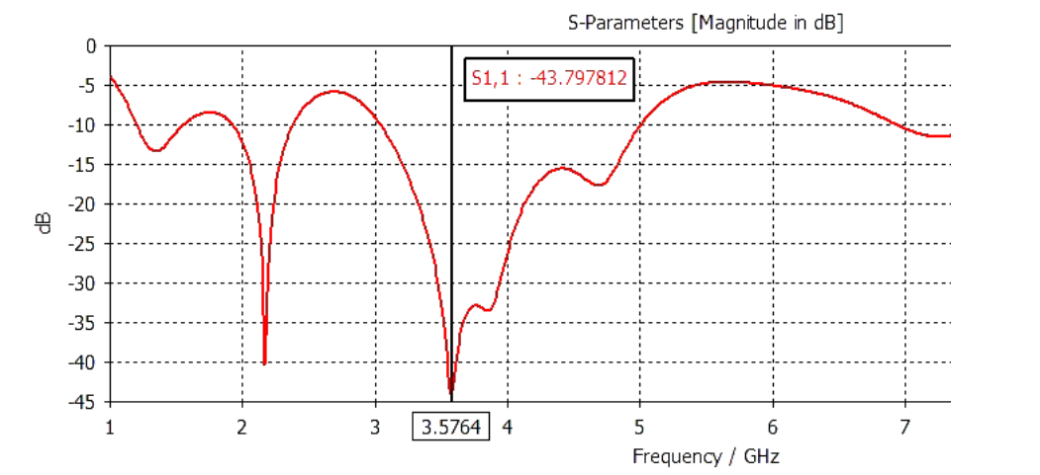**Figure 5: Obtained S-parameter curve from the designed UWB Vivaldi antenna**

**Figure 6: Expected S-parameter curve of an UWB Vivaldi antenna**

**Table 4:** From figure 5 and 6 we can see that:

|  |  |  |
| --- | --- | --- |
| **Parameters** | **Expected value** | **Obtained value** |
| Resonant Frequency | 3.5764 GHz | 3.2 GHz |
| Impedance Bandwidth | 0.59 GHz | 0.7142 GHz |
| Return loss | -43.79 dB | -4706 dB |

**So from the comparison we can say that our obtained values pretty much aligns with the expected values.** Also from the mesh convergence we can see that the resonant frequency, impedance bandwidth converges to a single value whereas the value of return loss decreases as the cell per wavelength increases.

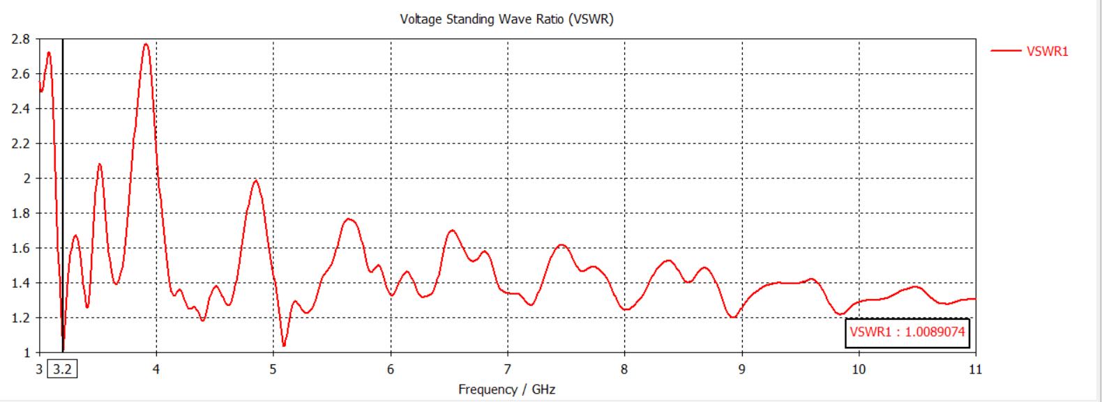**VSWR**: We obtained the VSWR values for different cells per wavelength which can be seen from Table 3. We’ll work with the one with the cell per wavelength of 18.

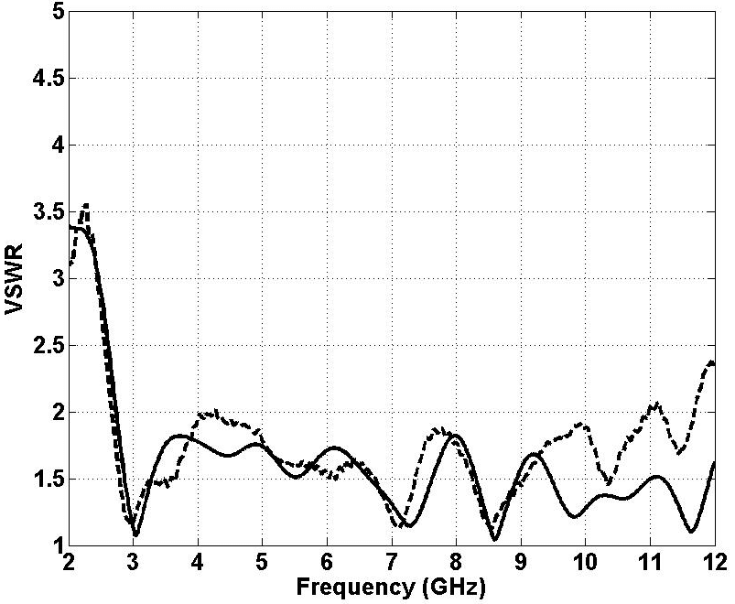**Figure 7: Obtained VSWR curve from the designed UWB Vivaldi antenna**

**Figure 8: Expected VSWR curve for an UWB Vivaldi antenna**

From Figure 7 and 8 it is clear that at resotant frequency 3.2GHz the value of VSWR is close to 1. We got 1.008 from the design antenna. That means the obtained value is very much acceptable.

**Directivity:** For our application the antenna should work within the frequency range of 2.5GHz to 4GHz. The resonant frequency obtained from the simulation is 3.2GHz. We will be looking into the radiation pattern for 3GHz, 3.2GHz, 3.5GHz and 4GHz.

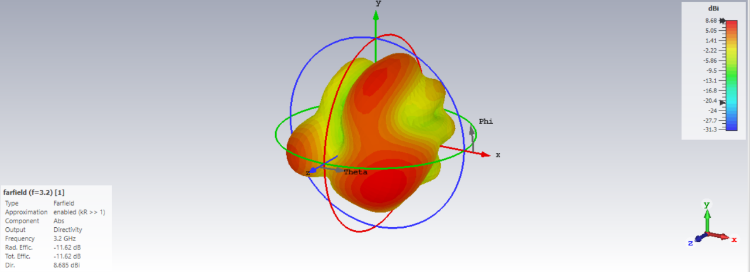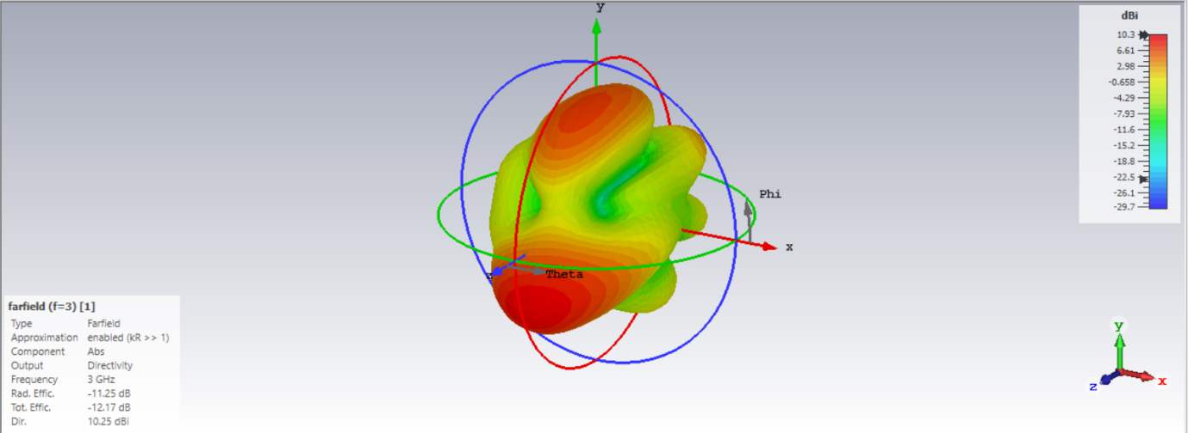

1. Radiation pattern for 3GHZ (b) Radiation pattern for 3.2GHz

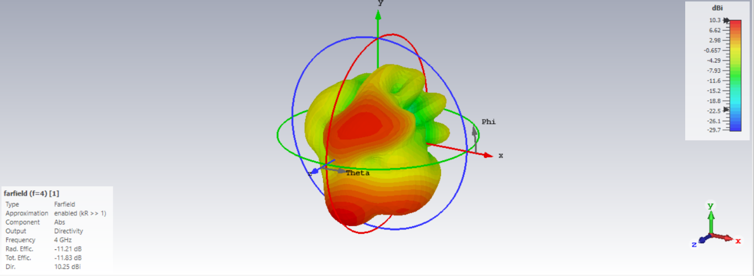

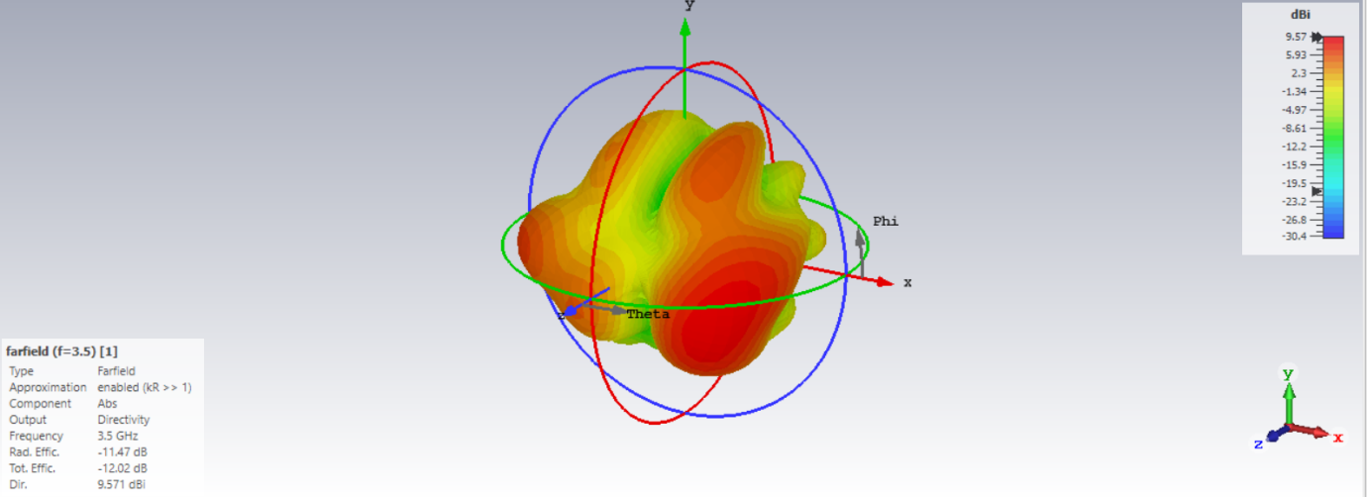

(c) Radiation pattern for 3.5GHZ (d) Radiation pattern for 4GHz

**Figure 9: Obtained radiation pattern for the designed antenna**

**Table 5:** Directivity from the radiation patterns:

|  |  |
| --- | --- |
| Frequency | Directivity |
| 3 GHz | 10.25 dBi |
| 3.2 GHz | 8.685 dBi |
| 3.5 GHz | 9.571 dBi |
| 4 GHz | 10.25 dBi |

Our desired directivity was around 10 dBi. From table 5 we can see that the objective is clearly achieved from the designed antenna.

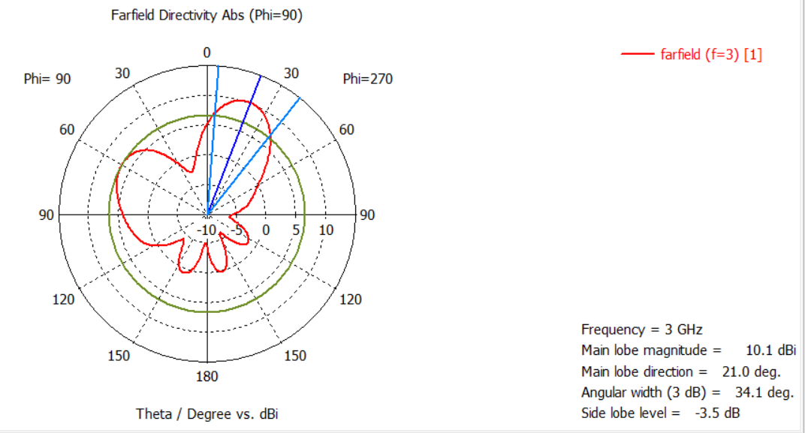**HPBW:** Similar to the directivity we will see the HPBW for 3GHz, 3.2GHz, 3.5GHz and 4GHz.

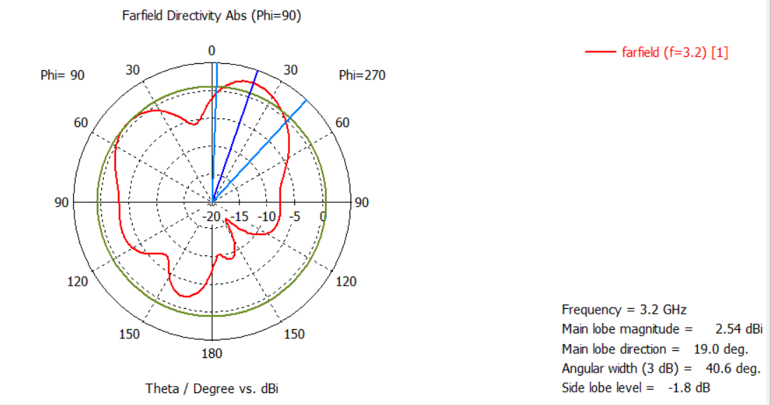**Figure 10.1: HPBW = 34.1 deg for 3GHZ**

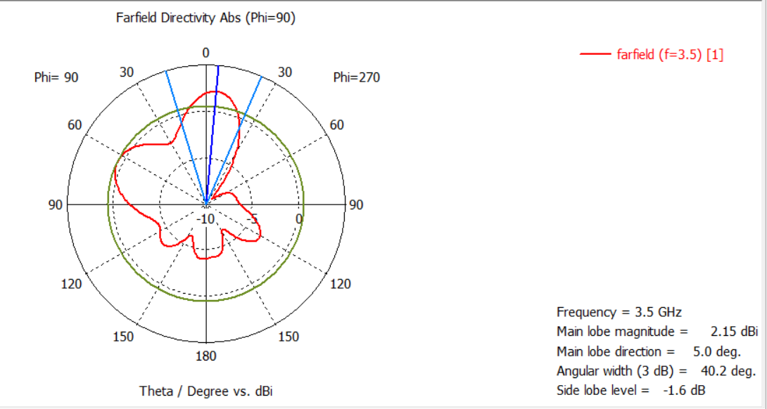**Figure 10.2: HPBW = 40.6 deg for 3.2GHZ**

**Figure 10.3: HPBW = 40.2 deg for 3.5GHZ**

**Figure 10.4: HPBW = 35.1 deg for 4GHZ**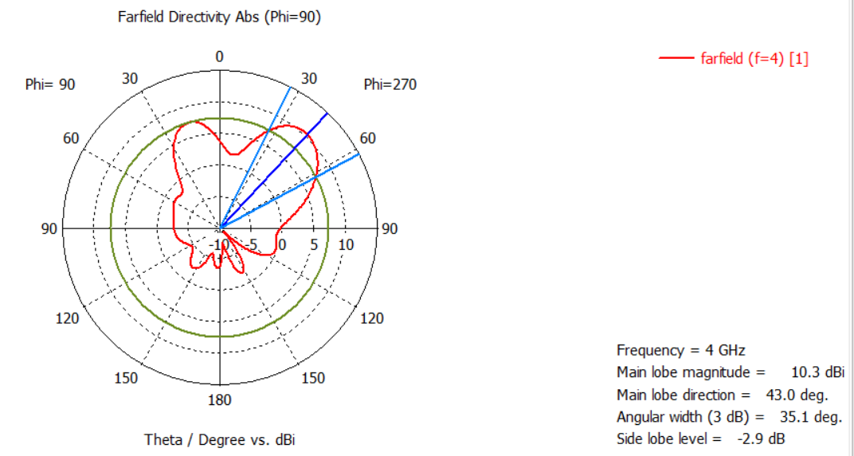

For our application we needed HPBW of less than 70 degrees which is clearly obtained from the above radiation patterns.

**Gain:** From the below graph we can see that our designed antenna shows high gain for higher frequencies