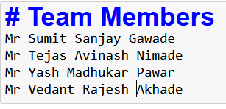

1. import pandas as pd

import numpy as np

import matplotlib.pyplot as plt

import seaborn as sns

1. dataset = pd.read_csv('NewWeb.csv')
2. dataset.head(2)

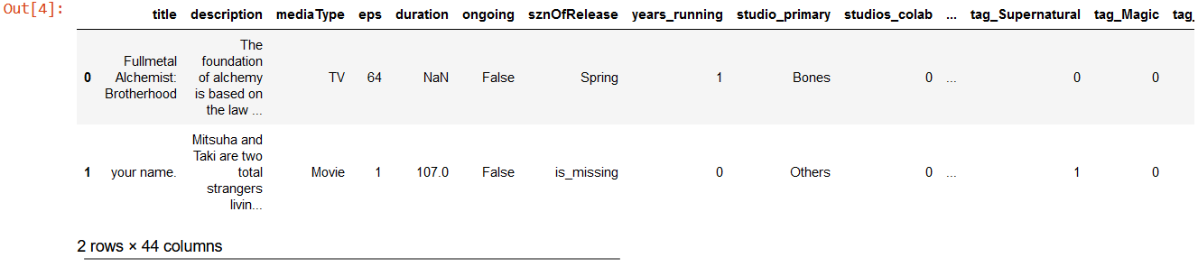

1. dataset.shape



5. dataset.eps.describe()

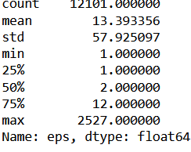

6.dataset.columns

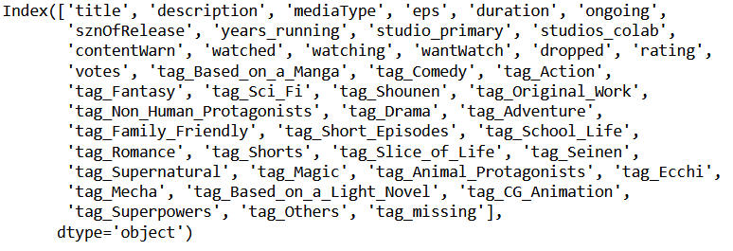

8. dataset[(dataset['eps']>24) & (dataset.duration.isna())].shape



9. dataset_excluding_out = dataset[dataset['eps']<50]

10. dataset_excluding_out['eps_brackets']= pd.cut(dataset_excluding_out['eps'],

bins=[1,10,20,30,40,50] ,\labels = ['cat1','cat2','cat3','cat4','cat5'])

11. import warnings warnings.filterwarnings("ignore")

12. dataset_excluding_out.shape



13. dataset_excluding_out.groupby(['eps_brackets']).duration.mean()

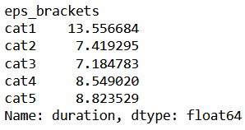

14. dataset_excluding_out.groupby(['eps_brackets']).title.count()

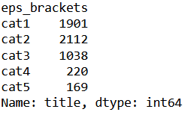

15. dataset_excluding_out[dataset_excluding_out['eps_brackets'] == 'cat1'].shape



16. dataset[(dataset['eps']<24) & (~dataset.duration.isna())].describe()

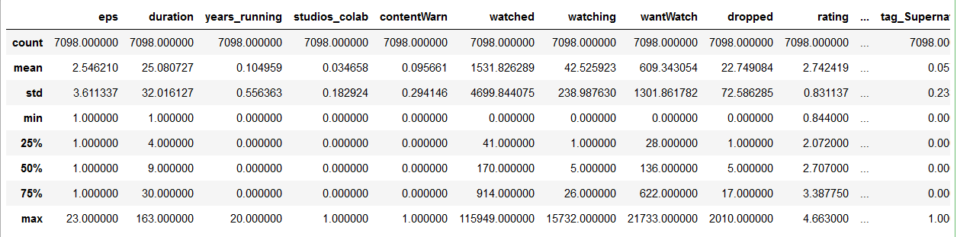

17. dataset_excluding_out.groupby('mediaType').agg({'duration'

'mean','mediaType':'count'})

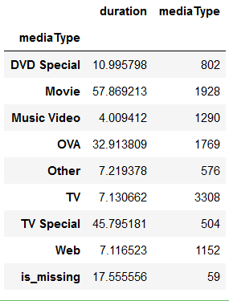

18. dataset.isna().sum()

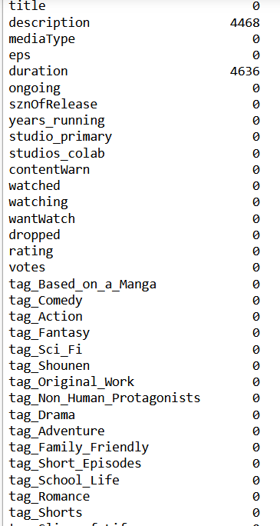

19. dataset.describe().T

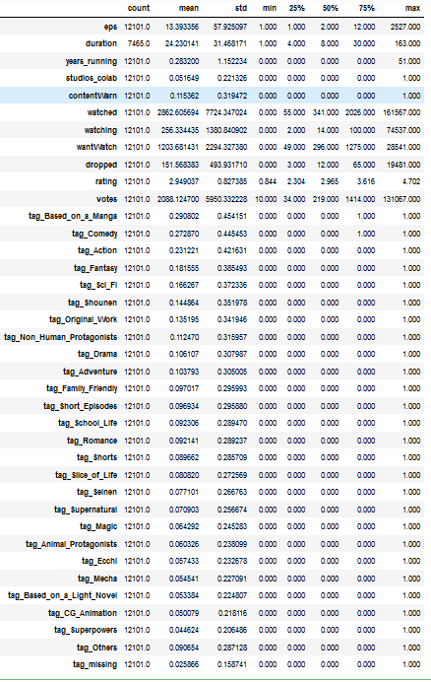

20. dataset.info()

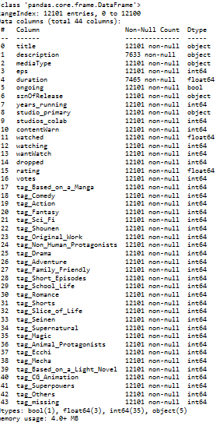

21. dataset.drop(columns = ['title','description'] , axis=1,inplace=True)

22. dataset.head()

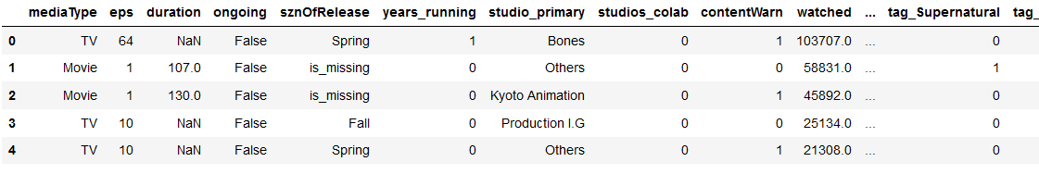

23. dataset.rating.describe()

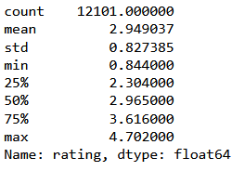

24. dataset.dropna(inplace=True) dataset.shape



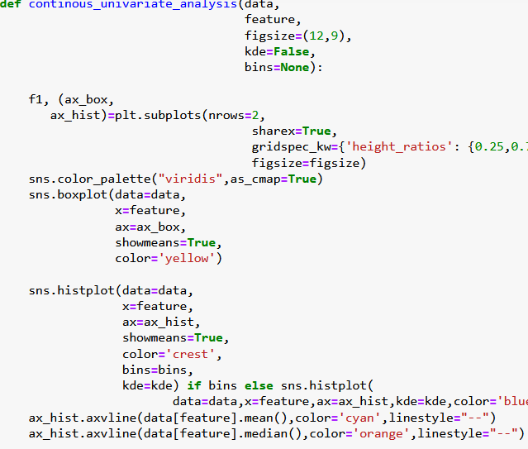

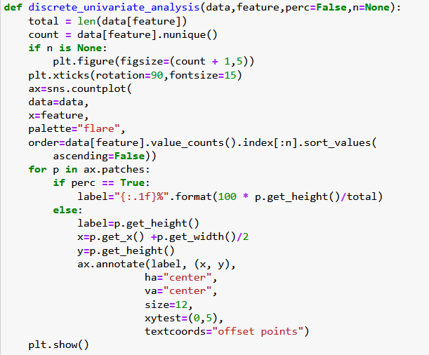

25. dataset.columns

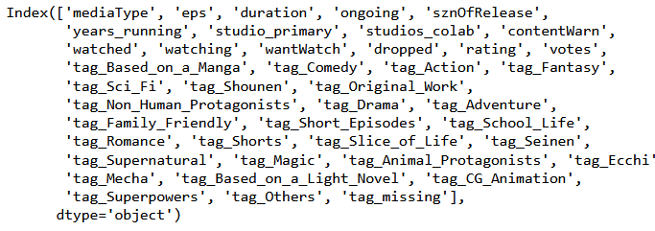

26. continous_univariate_analysis(dataset,'rating')

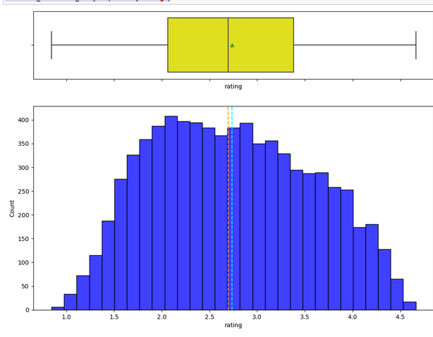

27.continous_univariate_analysis(dataset,'duration')

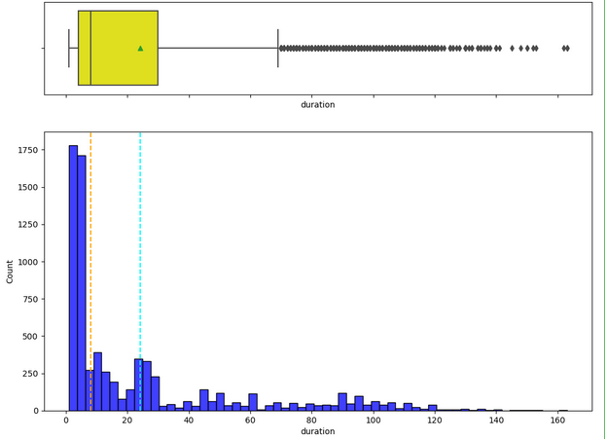

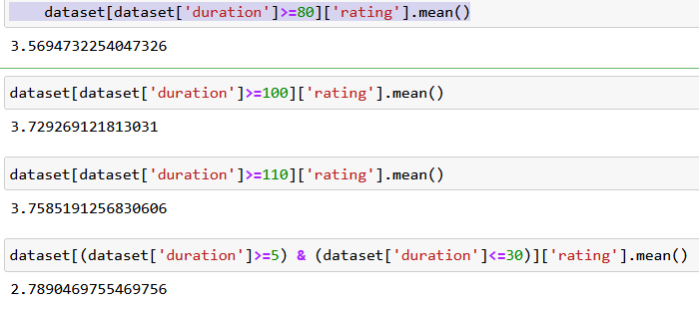

28.discrete_univariate_analysis(dataset,'ongoing',perc=True)

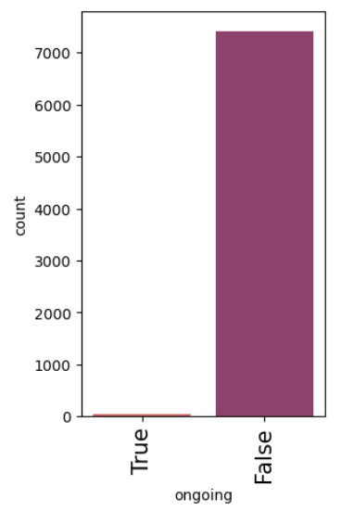

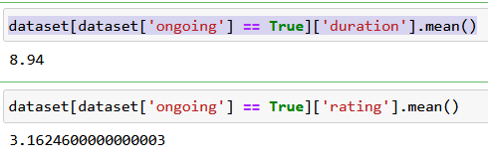

29.discrete_univariate_analysis(dataset,'sznOfRelease',perc=True)

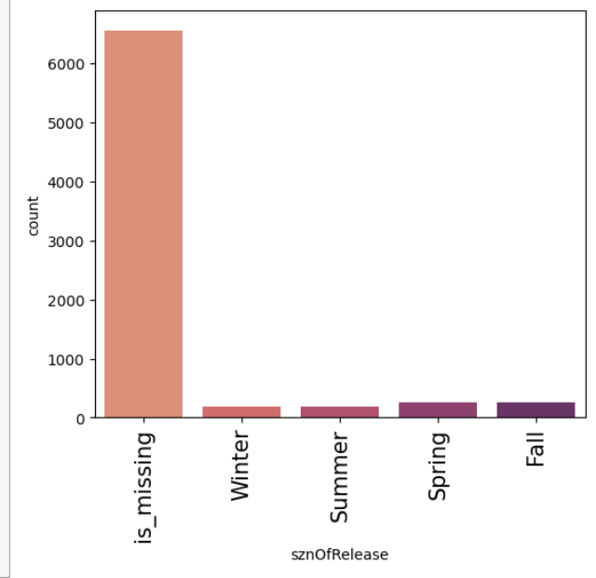

30.discrete_univariate_analysis(dataset,'studio_primary',perc=True)

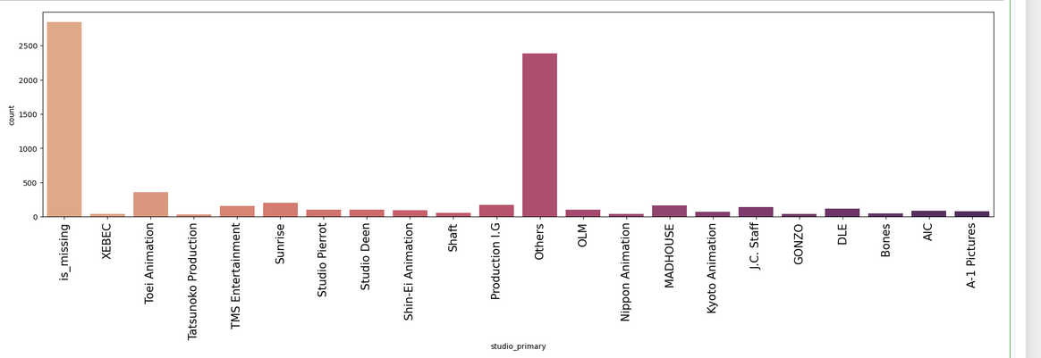

31.dataset[dataset['rating']>4]['studio_primary'].value_counts(normalize=True).mul(100).round(2)

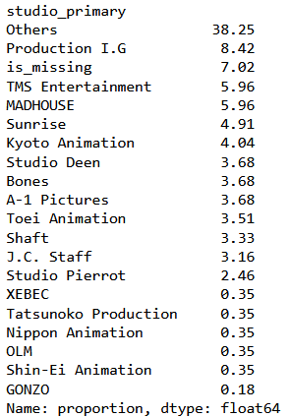

32.discrete_univariate_analysis(dataset,'contentWarn',perc=True)

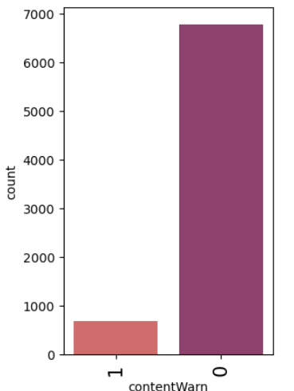

33.corr_cols = [item for item in dataset.columns if "tag" not in item]

corr_cols

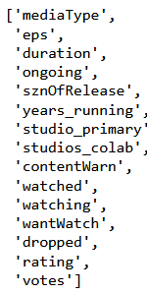

35.dataset['ongoing'] = dataset['ongoing'].astype(int)

36.corr_cols = ['eps', 'duration', 'ongoing', 'years_running', 'studios_colab', 'contentWarn', 'watched', 'watching', 'wantWatch', 'dropped', 'rating', 'votes']

plt.figure(figsize=(16,7))

37.sns.heatmap(dataset[corr_cols].corr(), annot=True, vmin = -1, fmt=' .2f', cmap='Spectral')

plt.show()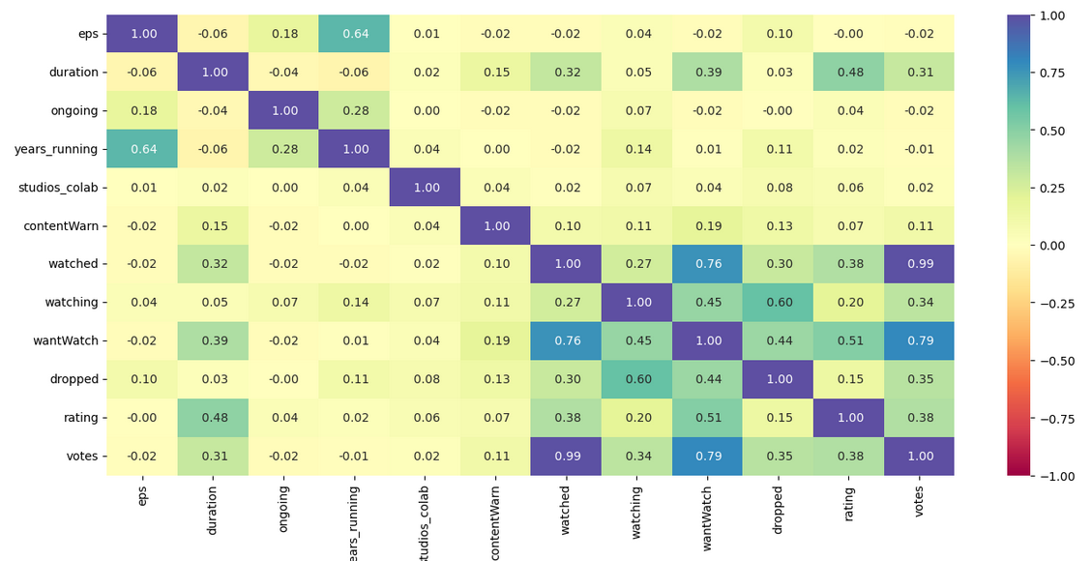

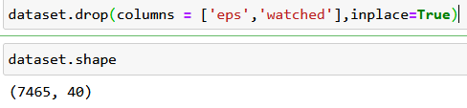

38.plt.figure(figsize=(15,8))

sns.boxplot(x='sznOfRelease',y='rating',data=dataset)

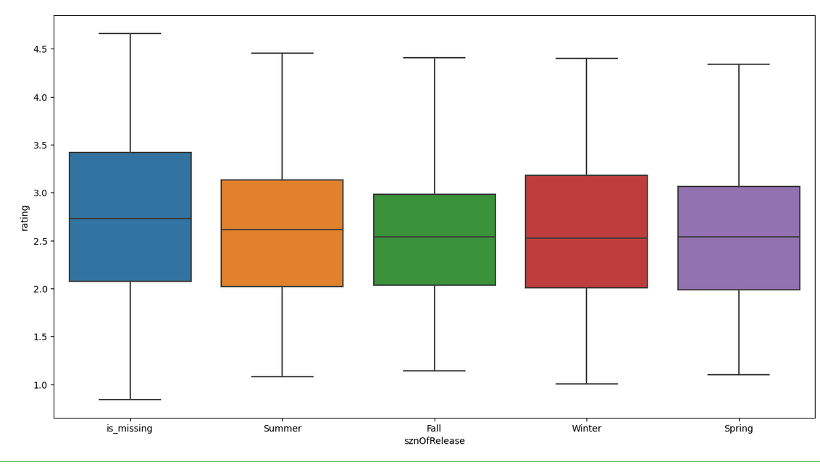

39.x=dataset.drop(['rating'],axis=1)

40.y=dataset['rating']

41.x = pd.get_dummies(x, columns=x.select_dtypes(include=['object','category']).columns.tolist(),drop_first=True)

x.head()

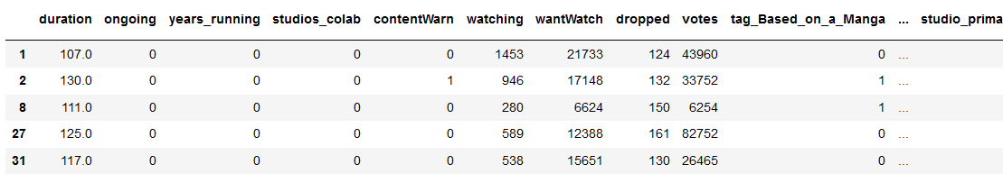

42.x.drop(columns='ongoing',inplace=True)

43.x.drop(columns='ongoing',inplace=True)

x.info()

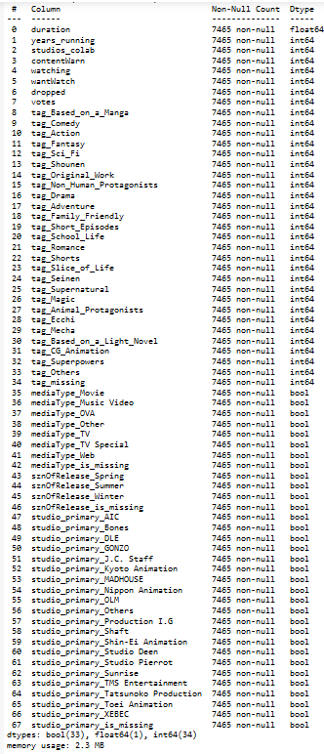

43.x.columns

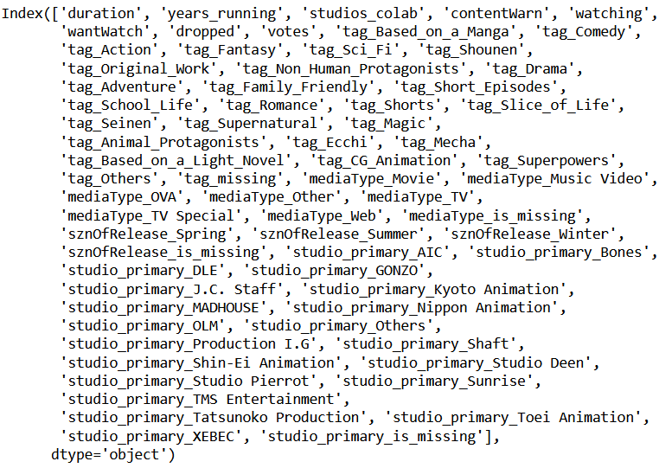

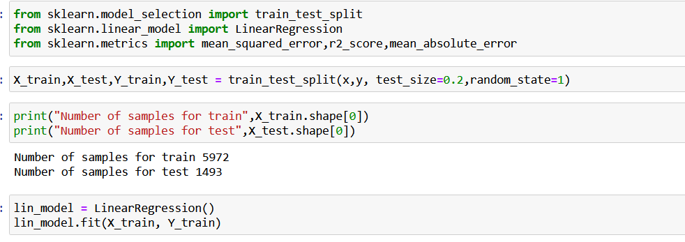

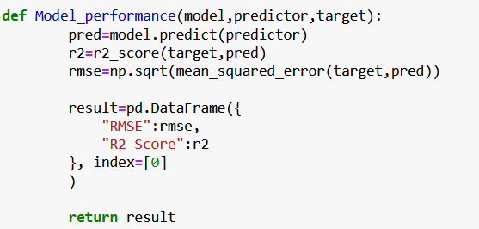

44.print("Training Data Performance")

lin_model_train = Model_performance(lin_model,X_train,Y_train)

lin_model_train

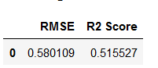

45.x.columns

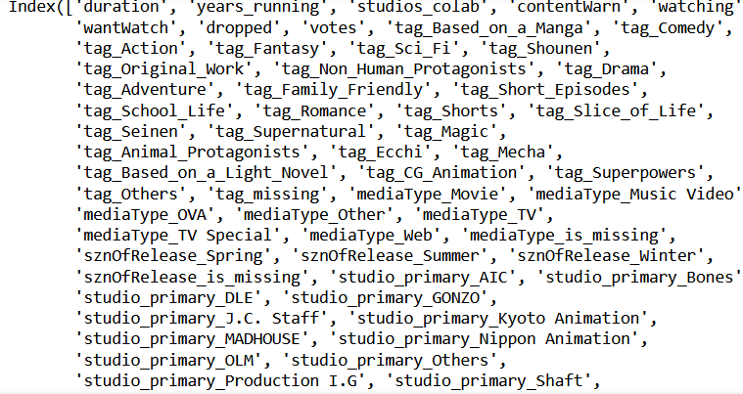

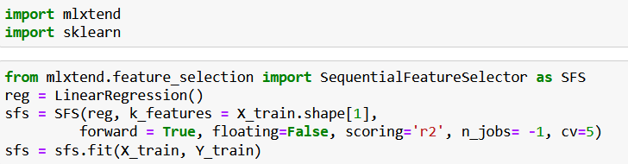

46.from mlxtend.plotting import plot_sequential_feature_selection as plot_sfs

fig1 = plot_sfs(sfs.get_metric_dict(), kind='std_err', figsize=(15,5))

plt.title("Feature Selector - SFS")

plt.xticks(rotation=90)

plt.show()

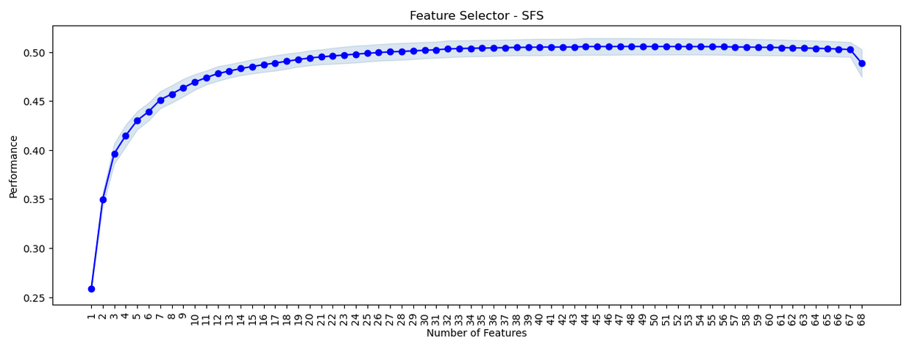

47.from mlxtend.feature_selection import SequentialFeatureSelector as SFS

reg = LinearRegression()

sfs = SFS(reg, k_features = 30, forward = True, floating=False, scoring='r2', n_jobs= -1, cv=5) sfs = sfs.fit(X_train, Y_train)

48.from mlxtend.plotting import plot_sequential_feature_selection as plot_sfs fig1 = plot_sfs(sfs.get_metric_dict(), kind='std_err', figsize=(15,5)) plt.title("Feature Selector - SFS")plt.xticks(rotation=90) plt.show()

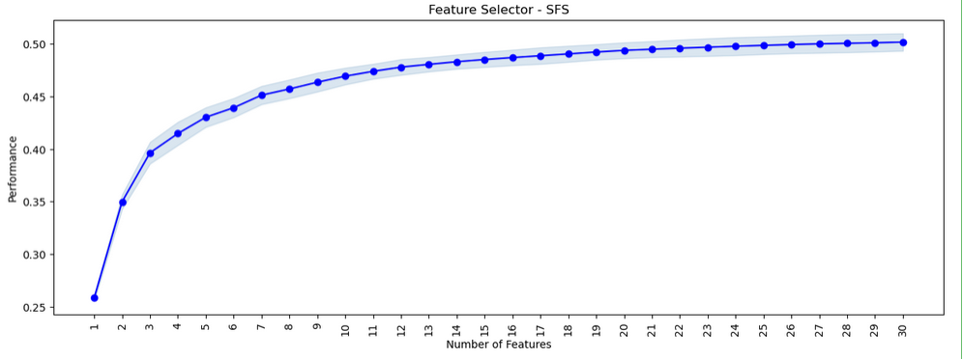

49.from mlxtend.feature_selection import SequentialFeatureSelector as SFS

reg = LinearRegression()

sfs = SFS(reg, k_features = 35,

forward = True, floating=False, scoring='r2', n_jobs= -1, cv=5)

sfs = sfs.fit(X_train, Y_train)

50.from mlxtend.plotting import plot_sequential_feature_selection as plot_sfs

fig1 = plot_sfs(sfs.get_metric_dict(), kind='std_err', figsize=(15,5))

plt.title("Feature Selector - SFS")

plt.xticks(rotation=90)

plt.show()

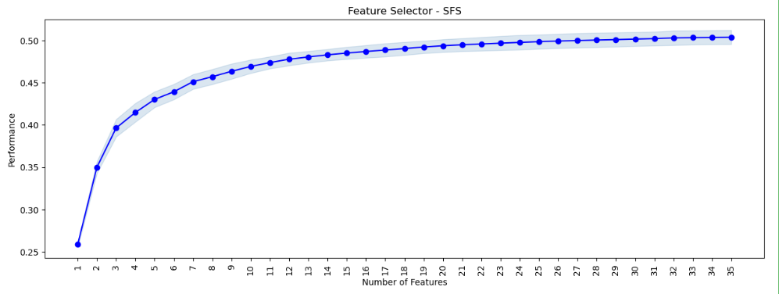

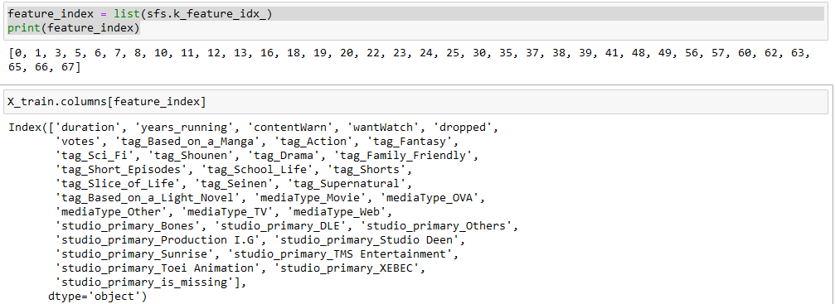

51.X_train_final = X_train[X_train.columns[feature_index]]

52.X_test_final = X_test[X_test.columns[feature_index]]

53.lin_model_v2 = LinearRegression()

54.lin_model_v2.fit(X_train_final, Y_train)

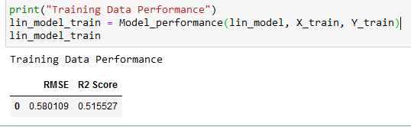

55.lin_model_v2 = LinearRegression()

56.lin_model_v2.fit(X_train_final, Y_train)

