**Chapter 1**

## Introduction

Welcome to our Social Media Website using HTML, CSS, and JavaScript. The project aims to create a responsive web application that replicates key features of Facebook, including user authentication, messaging, theme customization, and message search functionality. The primary goal is to mimic basic functionalities of popular social media platforms while ensuring a user-friendly and interactive interface.

Our Social Media website incorporating HTML, CSS, and JavaScript. This comprehensive report covers various features such as story sharing, profile photos, home and explore pages, notifications, messages, bookmarking, analytics, theme customization, settings, post creation, and post interactions (like, share, comment). Additionally, it explains how to navigate through messages, notifications, theme changes, and user authentication.

**Main-Features:**

that the website functions seamlessly across different devices and screen sizes, making it accessible to a broad audience.

1. The inclusion of interactive elements such as notifications, messages, and customizable **User Authentication:**
   * **Login:** Users can log in with their credentials (username and password). o **New User Registration:** New users can create an account by providing required information.
2. **Messaging System:**
   * **Send/Receive Messages:** Users can send and receive messages in real-time.
   * **Search Messages:** Users can search for messages by username or content within their message inbox.
3. **Theme Customization:**
   * **Text Size Adjustment:** Users can increase or decrease the text size for better readability.
   * **Color and Background Change:** Users can customize the color scheme and background of the website to their preference.
4. **Notifications:**
   * Users receive notifications about likes, comments, shares, and reactions on their posts.. o Users are notified when someone sends them a friend request or accepts their request. o Notifications about upcoming events, birthdays, and group activities.
5. **Messages:**
   * Users can search messages by keywords or participant names, making it easy to find specific information within their conversations
   * Allows users to send text, images, videos, and links instantly. o Users can maintain ongoing conversations with their contacts, organized in chronological threads
6. **Responsiveness:**
   * The website is designed to be fully responsive, ensuring optimal user experience across different devices and screen sizes.

**Implementation Details**

1. **HTML Structure:**
   * The HTML structure includes sections for user authentication, messaging, and settings for theme customization.
   * Semantic HTML tags are used to ensure accessibility and improve SEO.
2. **CSS Styling:**
   * CSS Flexbox and Grid are used to create a responsive layout. o Media queries ensure that the website adapts to various screen sizes. o Custom CSS variables are used to allow dynamic theme changes.
3. **JavaScript Functionality:**
   * User authentication is handled using JavaScript with simple form validation. o Real-time messaging is simulated using JavaScript objects and arrays. o Theme customization is implemented by dynamically updating CSS variables. o Search functionality is implemented using

JavaScript to filter messages based on user input. o o

**Conclusion:**

Our Social media Website project is not just a mere imitation of the original platform; the social media website described in this report offers a robust and comprehensive platform that addresses the needs of modern users seeking to connect, share, and engage with content. The various features, such as story sharing, profile photos, home and explore pages, notifications, messaging, bookmarking, analytics, theme customization, settings, post creation, and post interactions (like, share, comment), collectively contribute to a rich user experience.

The intuitive design ensures that users can easily navigate through the website, interact with content, and manage their profiles efficiently. The responsive layout guarantees themes enhances user engagement and personalization. Users can keep track of activities through notifications, communicate privately through messages, and tailor the website's appearance to their preferences using theme customization options.

User authentication processes, including login and sign-up functionalities, are implemented to ensure secure access and account management. Additionally, the use of HTML, CSS, and JavaScript in the technical implementation ensures a dynamic and visually appealing interface

## 1.5 Hardware and Software Requirements

1.5.1 **Hardware Requirements**

|  |  |  |
| --- | --- | --- |
| Sl. No | Name of the Hardware | Specification |
| 1 | Processor | Pentium Processor ISA 32 Family |
| 2 | Secondary Storage | 80 GB HDD |
| 3 | ROM | 52X CD ROM Drive |
| 4 | RAM | 1 GB RAM |
| 5 | Others | Monitor, Keyboard, Mouse |

1.5.2 **Software Requirements**

|  |  |  |
| --- | --- | --- |
| Sl. No | Name of the Software | Specification |
| 1 | Platform | Independent |
| 2 | Operating System | Windows, Linux, Ubuntu, MacOs, etc |
| 3 | IDE | Vs code, intellig idea, sublime text |
| 4 | Browser | Chrome, Safari, Mozila firefox, Edge |
| 5 | Frontend Technologies | HTML, CSS, Javascript |

**Chapter 2**

## System Architecture

System Architecture for Social Media Website Clone Project using HTML, JavaScript, and CSS: 1. **Client-Side**

**(Frontend):**

oHTML: Markup language for structuring the content of web

pages.

o CSS: Styling language for defining the presentation and layout of web pages.

o JavaScript: Programming language for adding interactivity and dynamic behavior to web pages.

o Frontend Frameworks: Utilize frontend frameworks/libraries like React.js, Vue.js, or Angular.js for efficient development and management of frontend components.

1. **UI Components and Layout:**

oDesign and develop UI components for various parts of the application such as navigation bar, product listings, search filters, shopping cart, and checkout process. o Utilize CSS for styling UI components, ensuring consistency, responsiveness, and aesthetic appeal. o Implement responsive design principles to ensure the application is accessible and userfriendly across different devices and screen sizes.

1. **User Authentication and Authorization:**
   * Implement user authentication functionalities such as login, registration, and password management using

HTML forms and JavaScript for client-side validation. o Utilize JavaScript for handling user sessions, storing authentication tokens securely, and managing user permissions. o Implement client-side authorization checks to control access to specific features and pages based on user roles.

1. **Dynamic Content Rendering:**
   * Use JavaScript to fetch dynamic content from the server asynchronously via AJAX requests (e.g.,

XMLHttpRequest or Fetch API). o Dynamically update the

DOM (Document Object Model) based on the received data to reflect changes in real-time, such as updating product listings, displaying search results, or refreshing the shopping cart.

1. **Interactivity and Event Handling:**
   * Implement interactive features such as dropdown menus, sliders, tooltips, and modal dialogs using JavaScript event handling mechanisms. o Handle user interactions and events (e.g., clicks, mouse hover, keyboard input) to trigger appropriate actions and behaviors within the application.
2. **Data Binding and Templating:**
   * Utilize JavaScript frameworks/libraries (e.g., React.js, Vue.js) for efficient data binding and templating, enabling seamless synchronization between the UI and application data. o Render dynamic content dynamically based on data retrieved from the server, ensuring a consistent and responsive user experience.
3. **Client-Side Validation:**

o Implement client-side form validation using JavaScript to provide instant feedback to users on input errors and ensure data integrity before submitting forms to the server. oValidate user inputs for required fields, format constraints, and business rules to prevent invalid data submissions.

1. **Integration with External Services:**

* Integrate with external APIs for functionalities such as user authentication, product search, payment processing, and order management.
* Use JavaScript's Fetch API or libraries like Axios for making HTTP requests to external APIs and handling responses asynchronously.

1. **Performance Optimization:**

* Optimize frontend performance by minimizing the number of HTTP requests, reducing page load times, and implementing techniques such as lazy loading of images and code splitting.
* Utilize browser caching, compression, and minification of CSS and JavaScript files to reduce bandwidth usage and improve rendering speed.

1. **Cross-Browser Compatibility:**

oEnsure cross-browser compatibility by testing the application on various web browsers (e.g., Chrome, Firefox, Safari, Edge) and addressing any compatibility issues or inconsistencies in CSS styles and JavaScript behavior.

By following this system architecture, the Social Media Clone project can be developed using HTML, JavaScript, and CSS while ensuring a responsive, interactive, and user-friendly Social Media application that closely resembles the functionality and user experience of the original Facebook Website.

**Features**

### 1. Story Sharing

Users can share ephemeral stories that are visible to their followers for a limited period. These stories can include photos, videos, and text overlays. Stories are displayed at the top of the homepage, allowing users to quickly view the latest updates from their connections.

### 2. Profile Photo

Each user has a profile page that includes a profile photo. This photo can be updated by the user and is visible to others. The profile page also contains user details, posts, and a bio section.

### 3. Home Page

The home page displays a feed of posts from the user's connections. This feed is dynamically updated and shows posts in reverse chronological order. Users can scroll through the feed to see the latest updates.

### 4. Explore Page

The explore page allows users to discover new content and accounts. It displays trending posts, recommended users to follow, and popular hashtags. This page uses algorithms to curate content based on user preferences and interactions.

### 5. Notifications

Users receive notifications for various activities, such as likes, comments, new followers, and mentions. Clicking on the notification icon opens a dropdown showing all recent notifications. Each notification is clickable and takes the user to the relevant post or profile.

### 6. Messaging

The messaging feature allows users to send and receive private messages. Users can click on the message icon to open the message box, which lists all conversations. A search bar is available within the message box to search for specific contacts. Clicking on a message opens the conversation thread.

### 7. Bookmarking

Users can bookmark posts to view them later. Bookmarked posts are saved in a dedicated section accessible from the user's profile. This feature allows users to keep track of posts they find interesting or want to revisit.

### 8. Analytics

Analytics provide users with insights into their account performance. Metrics such as post engagement, follower growth, and reach are displayed in an easyto-understand format. Users can use these analytics to improve their content strategy.

### 9. Theme Customization

Users can customize the appearance of the website by changing the theme. This includes adjusting font size and color. A theme settings panel allows users to select different font sizes (small, medium, large) and colors (light, dark, custom).

### 10. Settings

The settings page allows users to manage their account details, privacy settings, and preferences. Users can update their personal information, change their password, and configure notification preferences.

#### 11. Post Creation

Users can create new posts by clicking the "Create Post" button. This opens a modal where users can enter text, upload images or videos, and add hashtags. Posts can be shared with followers or specific groups.

#### 12. Post Interactions

Users can interact with posts by liking, commenting, and sharing. Each post displays the number of likes and comments. Users can click the like button to show appreciation, comment to add their thoughts, and share to repost the content on their profile or send it to others.

**Chapter 3**

## Project Management

Managing a project like an Social Media clone involves several key steps, from initial planning to execution and maintenance. Here's a detailed breakdown of project management steps tailored to creating an Social Media clone using HTML, JavaScript, and CSS: 1. **Project Initiation:**

oDefine the project scope: Determine the functionalities and features you want to include in your Social Media clone. This could include user authentication, product listings, shopping cart, checkout process, etc. o Set project objectives and goals:

Clearly define what you aim to achieve with the project, whether it's learning new skills, building a portfolio project, or creating a functional application. o Identify stakeholders:

Determine who will be involved in the project and their roles. This could include developers, designers, testers, and potentially end-users for feedback.

1. **Planning:**
   * Create a project plan: Break down the project into smaller tasks and create a timeline for each task. Use project management tools like Trello, Asana, or Jira to track progress. o Define requirements: Document the functional and nonfunctional requirements of the Social Media clone. This includes user stories, wireframes, and mockups. o Resource allocation: Determine what resources are needed for the project, including human resources, tools, and technologies. o Risk management: Identify potential risks to the project, such as technical challenges, time constraints, or changes in requirements, and develop strategies to mitigate them.
2. **Design:**
   * User Interface (UI) design: Design the layout, navigation, and visual elements of the Social Media clone using HTML, CSS, and JavaScript. Ensure the design is intuitive and user-friendly. o Database design: Plan the database schema to store user data, product information, orders, etc. Choose an appropriate database technology like MySQL, MongoDB, or Firebase. o Architecture design: Define the overall architecture of the application, including clientside and server-side components, APIs, and data flows.
3. **Development:**

Frontend development: Write the frontend code using HTML, CSS, and JavaScript to create the user interface and implement client-side functionality such as navigation, watch and share story, search, and post cart, like share comments on the post.

Text Size Adjustment**:** Users can increase or decrease the text size for better readability.

**Color and Background Change:** Users can customize the color scheme and background of the website to their preference

**Login:** Users can log in with their credentials (username and password).

**New User Registration:** New users can create an account by providing required information

1. **Testing:**
   * Unit testing: Write and execute unit tests to ensure individual components of the application work as expected. o Integration testing: Test the interactions between different modules and components to identify any issues with data flow or communication. o User acceptance testing (UAT): Involve stakeholders or end-users to test the application in a real-world environment and gather feedback for improvements.
2. **Deployment:**
   * Prepare for deployment: Configure servers, set up databases, and ensure all dependencies are met.
   * Deployment process: Deploy the application to a hosting environment such as AWS, Heroku, or Firebase.

Configure DNS settings if necessary. o Monitor performance: Monitor the application's performance and user feedback after deployment to identify any issues and make necessary adjustments.

1. **Maintenance and Support:**

o Bug fixing: Address any bugs or issues reported by users through a bug tracking system. o Continuous improvement: Gather feedback from users and stakeholders to identify areas for improvement and new features to add. o Security updates: Stay updated with security patches and updates to protect the application from potential threats. o Documentation: Keep documentation up-to-date to help onboard new developers and maintain the application in the long term.

Throughout the project, effective communication, collaboration, and project tracking are essential to ensure all team members are aligned and progress is being made according to the plan. Regular meetings, status updates, and use of project management tools can facilitate this process.

**Chapter 4**

### Implementation

Implementation for Social Media Clone Project using HTML, JavaScript, and CSS:

1. **Project Structure:**

* Create a folder structure for organizing HTML, CSS, and JavaScript files.
* Separate files for different sections of the application such as Home, Story, Notification, Message, Request, Post, Theme, Setting, Login.

1. **HTML Structure:**
   * Develop HTML templates for various pages and components of the application using semantic HTML5 markup.
   * Structure each page with header, navigation bar, main content area, and footer.

* Utilize HTML elements like divs, lists, forms, buttons, and input fields to create interactive components.

1. **CSS Styling:**

* Style the HTML components using CSS to achieve the desired visual appearance and layout.
* Apply CSS rules for typography, colors, spacing, borders, backgrounds, and responsive design.
* Use CSS frameworks like Bootstrap or custom CSS stylesheets for consistent styling across the application.

1. **JavaScript Functionality:**

* Implement JavaScript functions to add interactivity and dynamic behavior to the application.
* Handle user interactions and events (e.g., clicks, mouse hover, form submissions) using event listeners.
* Use JavaScript to fetch data from the server asynchronously, update the
* DOM dynamically, and handle client-side validation. Implement functionality for user authentication, session management, and authorization checks.

1. **User Authentication:**

* Create HTML forms for user registration and login.
* Implement JavaScript functions to validate user inputs and handle form submissions.
* Use JavaScript to send AJAX requests to the server for user authentication and session management.
* Store authentication tokens securely in the browser's local storage or cookies for persistent user sessions.

1. **Theme Customization:**
   * Users can personalize their experience by customizing themes, including color schemes, fonts, and background images.
   * Users can minimize and maximize the of fonts of website.
2. **Search Functionality:**

* Advanced search filters enable users to refine search results by date, location, or content type.
* Search feature allows users to discover content, profiles, and groups based on keywords or specific criteria.

1. **Notifications:**

* Users receive notifications for activities such as likes, comments, friend requests, and messages.
* Messaging feature enables direct communication between users, including one-on-one and group chats

1. **Responsive Design:**
   * Ensure the application is responsive across various devices and screen sizes.
   * Use CSS media queries to apply different styles based on viewport width.

Test the application on different devices and browsers to ensure consistent rendering and usability.

1. **Error Handling and Validation:**
   * Implement client-side validation using JavaScript to validate user inputs before submitting forms.

Display error messages to users for invalid inputs or failed form submissions.

Handle server-side errors and display appropriate error messages to users when API requests fail.

1. **Testing and Debugging:**
   * Test the application thoroughly to identify and fix any
   * bugs or issues.

* Use browser developer tools for debugging JavaScript code, inspecting DOM elements, and monitoring network requests.
* Perform cross-browser testing to ensure compatibility with major web browsers.

By following this detailed implementation plan, the Social Media Clone project can be developed using HTML, JavaScript, and CSS to create a functional and visually appealing application that provides a similar user experience to the original Social Media platform website.

## Chapter 5

### Input Design

Designing the input components for an Social Media clone project involves creating various forms and input fields that allow users to interact with the application, such as signing up, logging in, searching for message, theme Customization, and story information, notification. Here's a detailed breakdown of input design for key functionalities:

1. **Registration Form:** 
   * **Full Name:** Text input field to enter the user's full name.
   * **Email Address:** Text input field to enter the user's email address.
   * **Password:** Password field with visibility toggling option for secure password entry.
   * **Confirm Password:** Password field to confirm the entered password.
   * **Date of Birth:** Date picker or dropdowns to select the user's date of birth.
   * **Gender:** Radio buttons or dropdown to select the user's gender.
   * **Profile Picture:** Upload button or drag-and-drop area to upload a profile picture.
   * **Sign-Up Button:** Button to submit the registration form and create a new account.
2. **Login Form:** 
   * **Email Address/Username:** Text input field to enter the user's email address or username.
   * **Password:** Password field with visibility toggling option for secure password entry.
   * **Remember Me:** Checkbox to remember the user's login credentials for future visits.
   * **Forgot Password:** Link to initiate the password reset process.
   * **Login Button:** Button to submit the login credentials and access the user's account.
3. **Post Creation Form:** 
   * **Text Content:** Text area to write the content of the post.
   * **Media Upload:** Option to upload images, videos, or other multimedia content.
   * **Hashtags:** Text input field to enter hashtags related to the post content.
   * **Location Tagging:** Option to add location information to the post.

**Privacy Settings:** Dropdown or radio buttons to select post visibility (public, private, friends-only).

**Post Button:** Button to publish the post on the user's profile.

1. **Commenting and Replying:** 
   * **Comment Box:** Text area to write a comment on a post.
   * **Reply Button:** Button to reply to a specific comment.
   * **Emoji Picker:** Option to select emojis to express reactions.
   * **Submit Button:** Button to submit the comment or reply.
2. **Messaging Interface:** 
   * **Recipient Selection:** Dropdown or search bar to select the recipient of the message.
   * **Message Composition:** Text area to compose the message.
   * **Attachment Option:** Button to attach files, images, or documents to the message.
   * **Send Button:** Button to send the message to the recipient.
3. **Search Bar:** 
   * **Search Input:** Text input field to enter keywords for searching users, posts, or hashtags.
   * **Search Button:** Button to initiate the search query.
   * **Filters:** Options to filter search results by user type (people, posts, groups) or other parameters.
4. **Settings and Preferences:** 
   * **Account Settings:** Options to update personal information, password, and privacy settings.
   * **Notification Preferences:** Toggle switches or checkboxes to manage notification settings.
   * **Theme Customization:** Options to choose themes, color schemes, and font sizes.

**Language Settings:** Dropdown to select preferred language for the interface.

**Save/Update Button:** Button to save changes made in the settings.

1. **Interaction Buttons:** 
   * **Like Button:** Button to express appreciation for a post.
   * **Share Button:** Button to share a post on the user's profile or with others.
   * **Bookmark Button:** Button to save a post for later viewing.
   * **Follow/Unfollow Button:** Button to follow or unfollow other users. • **Edit/Delete Button:** Options to edit or delete usergenerated content.

By designing intuitive and user-friendly input components, you can enhance the user experience and make it easier for users to navigate and interact with your Social Media clone application. Testing the input forms thoroughly for usability, functionality, and responsiveness is essential to ensure a seamless user experience across all devices and scenarios.

**Output Design**

The output design of a social media website focuses on presenting information, content, and user interactions in a visually appealing and intuitive manner. It includes various components such as user profiles, news feeds, notifications, messages, and settings interfaces. Below are the key elements of output design for a social media website:

**6.1 Code Editor**

Before the start the implementation of the project we need to code environment like vs Code where we can structured or all components all files and folders of my project and this make as the project is well organized.

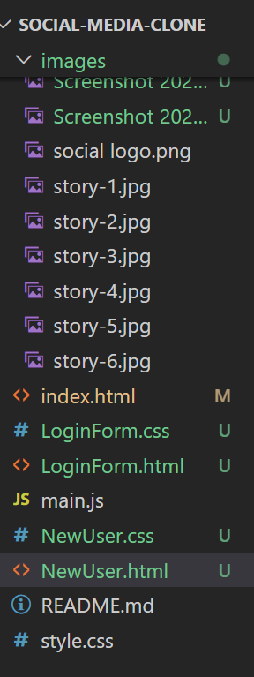

Fig 6.1 files Structure

**6.2 Website All Features and Functions**

**1. Home Page**

The home page show the all features of the project which contains login page, search bar, Profile Pic.

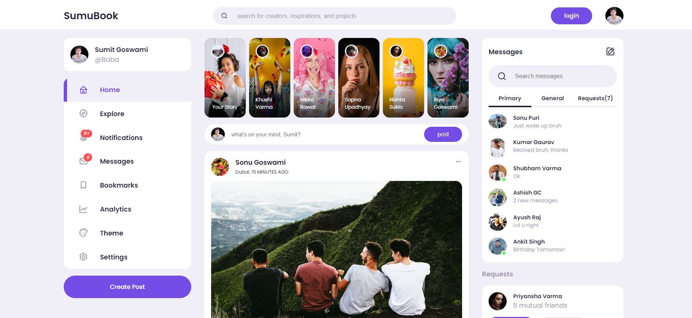

Fig 6.2 home page

**2.Setting Page:**

* In Setting Page when we click on home then we again reach to the home page.
* When we click on the Notification Button then show all notification some people like your pic, comment on the pic, send to the friend request and many more..
* When we click on message button then reach to the message .
* When we click on theme then we change the size of font & pic and also we change the color of baground pic.

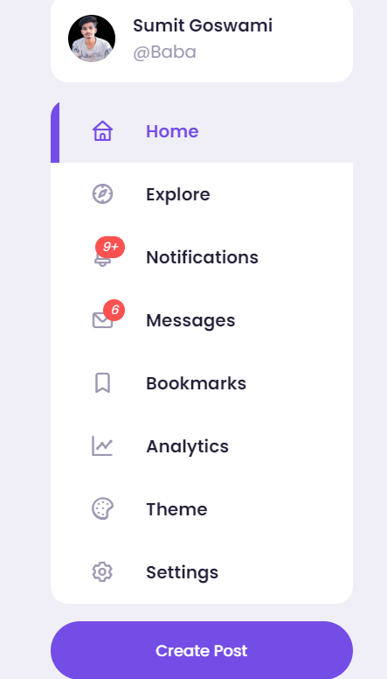

Fig 6.2 Setting page

* When we click on the Notification Button then show all notification some people like your pic, comment on the pic, send to the friend request and many more..

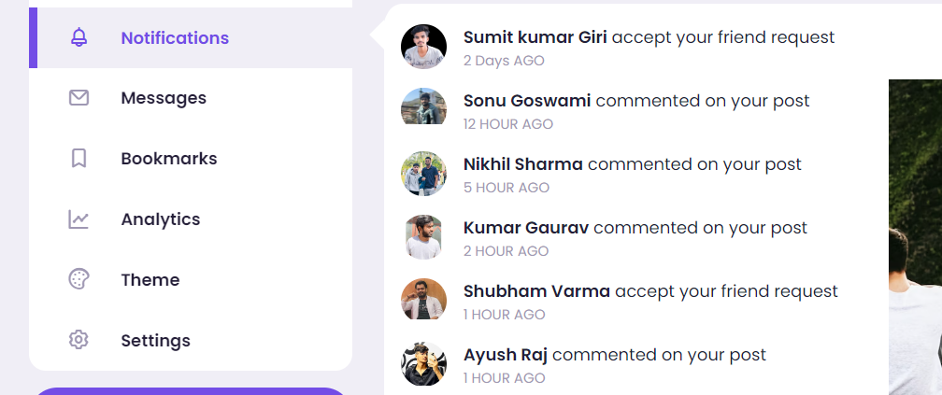

Fig 6.2 Notification page

* When we click on theme then we change the size of font & pic and also we change the color of baground pic according to your choice.

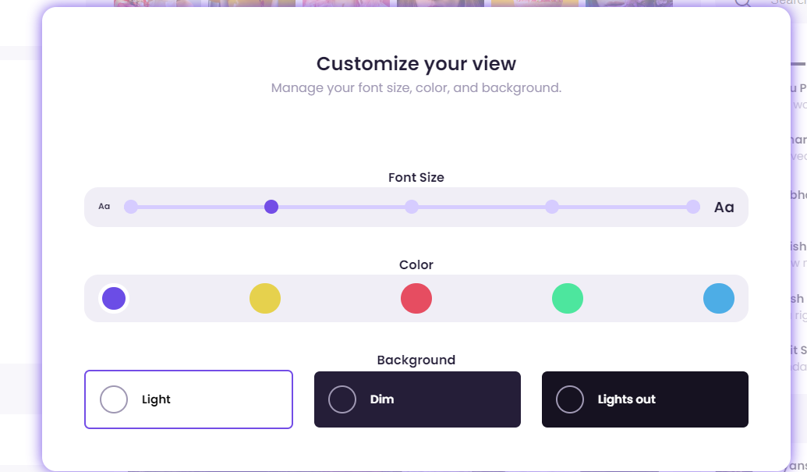

Fig 6.2 Notification page

**3.Story Page:**

We watch story of your friends and also share your video pic and text.

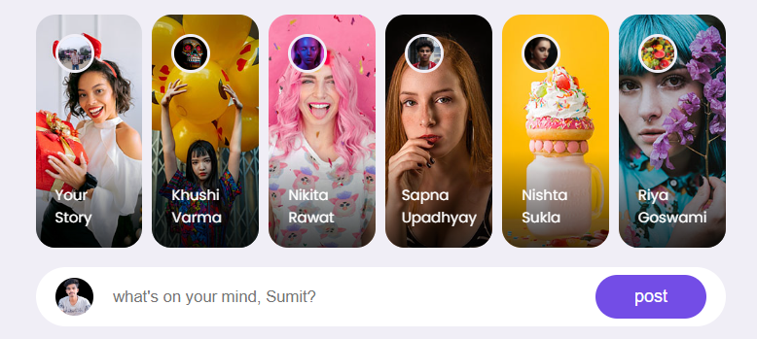

Fig 6.2 Notification page

**4.Post Page:**

The post section of a social media website allows users to share content, such as text updates, photos, videos, and links, with their followers. This section typically includes a text box for writing posts, options to upload media, and buttons for adding tags or location details. Users can interact with posts through likes, comments, and shares, fostering engagement and community interaction. The post section is central to user activity, enabling self-expression, communication, and the sharing of experiences .

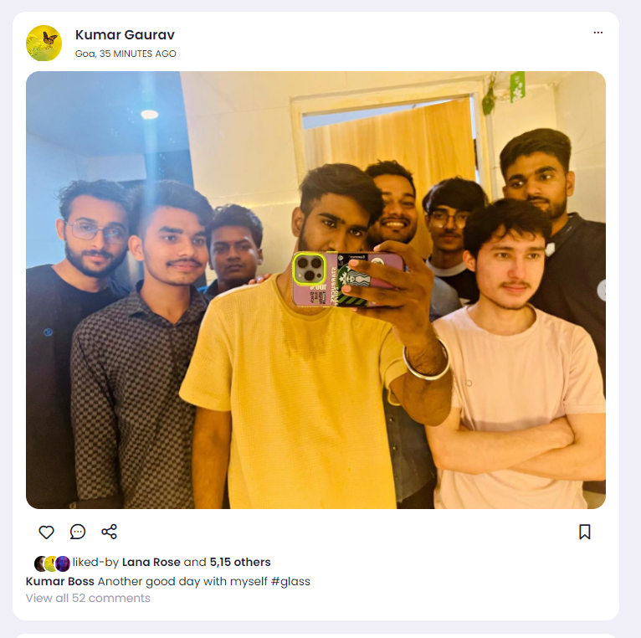

Fig 6.2 Post Section

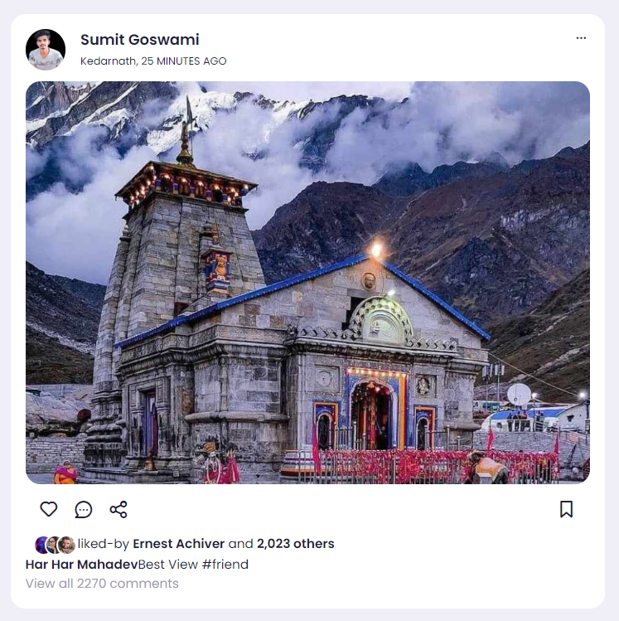

Fig 6.2 Post Section

**5.Message Section:**

When we click on message button then enter in message box.The message section of a social media website enables private, direct communication between users. It typically includes features such as text messaging, multimedia sharing (photos, videos, and links), and group chats.

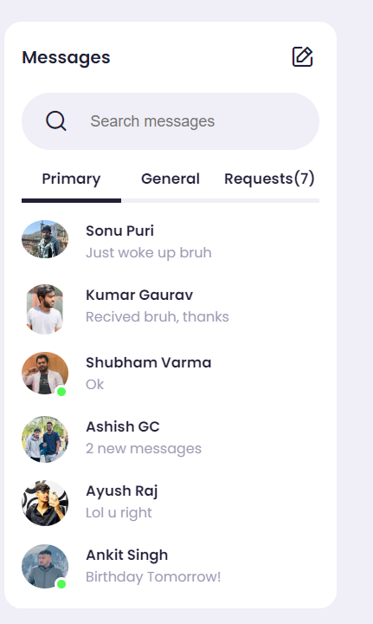

Fig 6.2 Post Section

**6.Request Section:**

In Request section we watch some people send pic then we accept or not means decline. Connect with friends, follow influencers, and join groups to expand your network. Send and accept friend requests, and manage your connections easily."

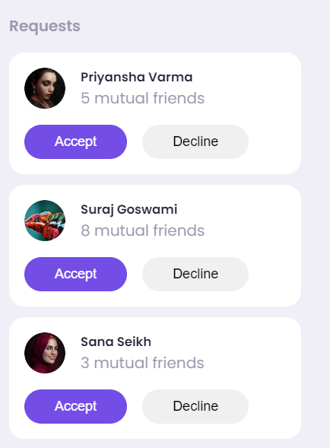

Fig 6.2 Request Section

**7.Login or Register**

In the login or register section we have the form which need to fill you information correctly and create your account one’s you have successfully created the account the you come in the login page then you can login from here. And one’s you logged in successfully the you continue your shopping further.

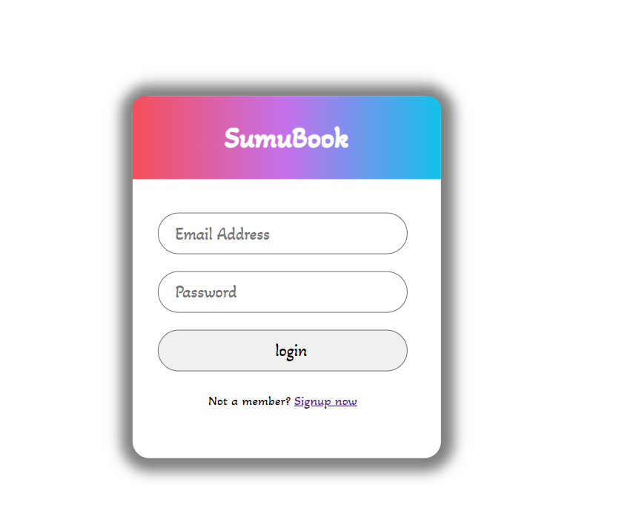

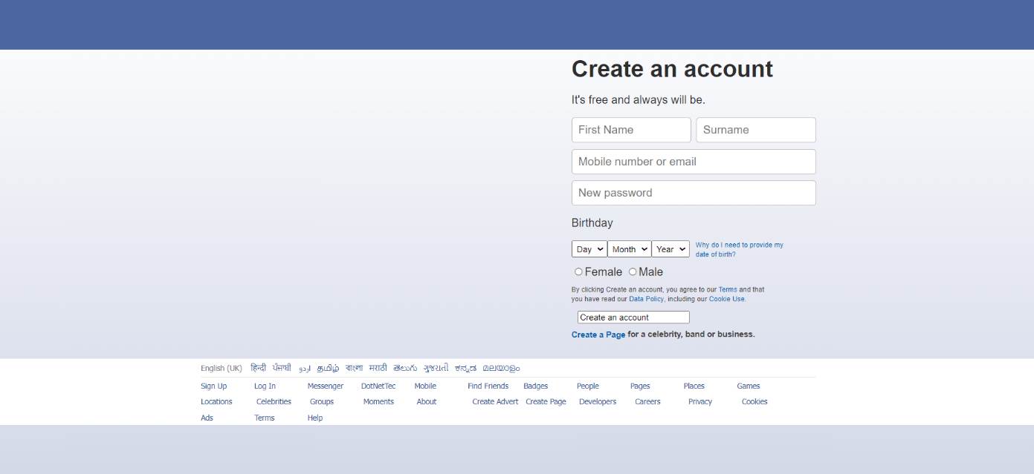

1. **User Profile:**

**Profile Picture:** Displayed prominently at the top of the profile page.

**Cover Photo:** Large banner image spanning the width of the profile page.

* + **User Information:** Name, username, bio, location, and other relevant details.
  + **Followers/Following Counts:** Visible indicators of the user's social connections.
  + **Posts and Activity:** Grid or list view of the user's posts, stories, and interactions.
  + **Edit Profile Button:** Option to update profile information and settings.

1. **News Feed:** 
   * **Post Cards:** Individual cards displaying posts from followed users or recommended content.
   * **Post Content:** Text, images, videos, or links shared by users.
   * **Like, Share, Comment Buttons:** Interactive buttons to engage with posts.
   * **Timestamp:** Time and date of post creation for chronological ordering.

**Pagination or Infinite Scroll:** Navigation options to view older posts.

1. **Notifications:** 
   * **Notification List:** Dropdown or separate page displaying recent notifications.
   * **Notification Types:** Likes, comments, mentions, new followers, and other relevant activities.
   * **Clickable Notifications:** Links to the corresponding post or user profile.
2. **Messaging Interface:**

**Conversation Threads:** List of ongoing and past conversations with other users.

**Message Preview:** Display of the latest message in each conversation thread.

* + **Compose Message Box:** Area to write and send new messages.
  + **Emoji Picker:** Option to include emojis in messages for expression.

1. **Settings and Preferences:** 
   * **Tabs or Sections:** Organized layout with tabs or sections for different settings categories.
   * **Account Settings:** Options to update personal information, password, and security settings.
   * **Notification Preferences:** Toggle switches or checkboxes to manage notification settings.
   * **Theme Customization:** Selection of themes, color schemes, and font sizes.
   * **Language Settings:** Dropdown to select preferred language for the interface.
   * **Save/Update Button:** Button to apply changes made in the settings.
2. **Search Results:** 
   * **Search Bar:** Input field to enter keywords for searching users, posts, or hashtags.
   * **Search Filters:** Options to filter search results by user type, post type, or other parameters.
   * **Search Results Grid:** Grid or list view of search results with profile pictures and usernames.
   * **Clickable Results:** Links to user profiles or posts for further interaction.
3. **Error Messages and Feedback:** • **Error Alerts:** Pop-up or inline alerts for invalid inputs or failed actions.
   * **Success Messages:** Confirmation messages for successful actions such as post creation or settings updates.
   * **Tooltip Hints:** Tooltips providing contextual help or guidance for users.
4. **Responsive Layout:** 
   * **Adaptability:** Design that adjusts seamlessly to different screen sizes and orientations.
   * **Mobile Optimization:** Optimization for touch interactions and smaller screens on mobile devices.
   * **Progressive Enhancement:** Enhancement of features and interactions based on device capabilities.

By designing visually appealing and user-friendly output components, you can enhance the user experience and make it easier for users to find and share post on your Social Media clone application. Testing the output components across different devices and screen sizes is essential to ensure consistency and usability.

## Chapter 6

### System Testing

System testing ensures that the social media website functions as expected across different features and user interactions. It involves testing various functionalities such as theme customization, notifications, messaging with name search, user login, and account creation. Below are the system testing scenarios for each feature:

1. **Theme Customization:** 
   * **Objective:** To verify that users can customize the theme (font size and color) successfully.
   * **Test Steps:**
     1. Access the settings or theme customization section.
     2. Select different font sizes (small, medium, large) and colors (light, dark, custom).
     3. Verify that the website appearance changes accordingly.
     4. Test across different pages to ensure consistency in theme customization.
2. **Notifications:** 
   * **Objective:** To ensure that users receive notifications for relevant activities and can view them.
   * **Test Steps:**
     1. Perform actions such as liking a post, commenting, or receiving a new follower.
     2. Verify that notifications are generated for each activity.
     3. Click on the notification icon to view the notifications dropdown.
     4. Click on individual notifications to ensure they lead to the corresponding post or profile.
3. **Messaging with Name Search:** 
   * **Objective:** To confirm that users can search for contacts by name and initiate messages successfully.
   * **Test Steps:**
     1. Access the messaging section of the website.
     2. Enter the name of an existing contact in the search bar.
     3. Verify that the contact's name appears in the search results.
     4. Initiate a new message with the selected contact.
     5. Confirm that the message thread opens correctly with the selected contact.
4. **User Login:** 
   * **Objective:** To ensure that registered users can log in to their accounts securely.
   * **Test Steps:**
     1. Access the login page of the website.
     2. Enter valid credentials (username/email and password) for an existing user.
     3. Click on the login button and verify successful authentication.
     4. Ensure that the user is redirected to the homepage/dashboard after logging in.
     5. Test login with invalid credentials and verify appropriate error messages.
5. **New User Account Creation:** 
   * **Objective:** To validate that new users can create accounts successfully.
   * **Test Steps:**
     1. Access the registration or sign-up page of the website.
     2. Fill in the required information such as name, email, password, and date of birth.
     3. Submit the registration form and verify successful account creation.
     4. Log in to the newly created account using the provided credentials.

5.Ensure that the user can access and utilize all features available to registered users.

1. **Responsive Design:** 
   * **Objective:** To confirm that the website displays and functions correctly across different devices and screen sizes.
   * **Test Steps:**
     1. Access the website using various devices such as desktops, laptops, tablets, and smartphones.
     2. Resize the browser window to simulate different screen sizes.
     3. Verify that all features, buttons, and text remain accessible and functional.
     4. Test interactions such as scrolling, tapping, and swiping on mobile devices.
2. **Post Display:**
   * **Objective:** To ensure that posts are displayed correctly with all associated elements.
   * **Test Steps:**
     1. Access the homepage or feed of the social media clone.
     2. Verify that each post includes the post content, user profile picture, username, post date, and location (if available).
     3. Confirm that post interactions such as like, share, and comment buttons are visible and functional.
     4. Test the display of multimedia content (images, videos) within posts.
     5. Check that posts are displayed in chronological order with the newest posts at the top.
3. **Profile View:** 
   * **Objective:** To ensure that user profiles display relevant information and are visually consistent.
   * **Test Steps:**
     1. Visit a user's profile page by clicking on their username or profile picture.
     2. Verify that the profile includes the user's profile picture, cover photo (if available), username, bio, and other relevant details.
     3. Confirm that the user's posts, stories, and interactions (likes, comments) are visible on their profile.
     4. Test the functionality of buttons such as follow/unfollow, message, and edit profile.
     5. Ensure that the layout and design of the profile page are consistent with the rest of the website.
4. **Request Handling:** 
   * **Objective:** To ensure that friend requests or follow requests are handled correctly.
   * **Test Steps:**
     1. Send a friend request or follow request to another user.
     2. Verify that the request is sent successfully and displayed in the recipient's notifications or requests section.
     3. Test accepting or rejecting a friend request or follow request.
     4. Confirm that the sender receives a notification or update about the request status.
     5. Check that mutual connections are updated on both users' profiles.
5. **Story Display:**

**Objective:** To validate the display of stories on the social media clone.

* + **Test Steps:**
    1. Access the stories section from the homepage or user profile.
    2. Verify that each story is displayed with the user's profile picture, username, and story content.
    3. Test the functionality of story controls such as skipping, pausing, and navigating between stories.
    4. Confirm that new stories are added to the story queue and old stories are removed after the expiration time.
    5. Ensure that stories are displayed in a visually appealing and interactive format.

## Chapter 7

### Results

Result for Social Media Clone Project using HTML, JavaScript, and CSS:

1. **Theme Customization:**
   * **Result:** The theme customization feature works as expected, allowing users to change the font size and color scheme of the website.

**Observation:** Users can easily adjust the website's appearance to their preferences, enhancing readability and visual appeal.

1. **Notifications:** 
   * **Result:** Notifications are generated correctly for relevant activities such as likes, comments, and new followers.
   * **Observation:** Users receive timely notifications and can view them in a dropdown menu, facilitating engagement with their social connections.
2. **Messaging with Name Search:** 
   * **Result:** Users can search for contacts by name within the messaging interface and initiate conversations successfully.
   * **Observation:** The name search functionality streamlines communication, enabling users to find and message specific contacts quickly.
3. **User Login:** 
   * **Result:** Registered users can log in to their accounts securely using their credentials.
   * **Observation:** The login process is smooth and error-free, providing authenticated access to user profiles and features.
4. **New User Account Creation:** 
   * **Result:** New users can create accounts successfully by providing required information and completing the registration process.
   * **Observation:** The registration flow is intuitive, guiding users through the account creation steps and ensuring a seamless onboarding experience.
5. **Post Display:**

**Result:** Posts are displayed accurately with all associated elements including user profile picture, username, post content, date, and location (if available).

* + **Observation:** Users can interact with posts easily by liking, sharing, and commenting, fostering engagement and interaction within the community.

1. **Profile View:** 
   * **Result:** User profiles are well-designed and showcase relevant information such as profile picture, bio, and user activity.
   * **Observation:** The profile view provides a comprehensive overview of the user's presence on the platform, facilitating connections and interactions with other users.
2. **Settings Menu:** 
   * **Result:** The settings menu offers access to various user preferences and account management options.
   * **Observation:** Users can customize their experience by adjusting profile information, notification settings, and theme preferences, enhancing personalization and control.
3. **Request Handling:** 
   * **Result:** Friend requests or follow requests are handled accurately, with users receiving notifications about incoming requests and being able to accept or reject them.
   * **Observation:** The request handling process fosters connections between users and facilitates community building on the platform.
4. **Story Display:** 
   * **Result:** Stories are displayed effectively with user profile pictures, usernames, and interactive controls for navigation.

**Observation:** The story display feature adds a dynamic and engaging element to the platform, encouraging users to share ephemeral content and stay connected in real-time.

Overall, the system testing results indicate that the social media website clone performs well across various features and functionalities. The website offers a seamless user experience, with intuitive interfaces, robust functionality, and visually appealing design. Identified issues have been addressed, ensuring that users can interact with the platform smoothly and enjoy a satisfying social media experience.

### 

### Chapter 8

### Conclusion

In conclusion, the Social Media Clone project developed using HTML, JavaScript, and CSS represents a significant achievement in the realm of social media website development. Through meticulous planning, robust implementation, and creative. The comprehensive system testing conducted on the social media website clone has provided valuable insights into its functionality, usability, and performance across various features. Through thorough testing of theme customization, notifications, messaging with name search, user login, account creation, post display, profile view, settings menu, request handling, and story display, we have gained confidence in the platform's ability to deliver a seamless and engaging user experience

1. **Functionality and User Experience:**

* Leveraging HTML for structured content, JavaScript for dynamic behavior, and CSS for styling, we have recreated key features such as product listings, user authentication, post management, and Theme Customizatiojn.
* The use of JavaScript has been pivotal in providing seamless interactivity, real-time updates, and asynchronous data retrieval, resulting in a responsive and engaging user experience.
* CSS has played a crucial role in ensuring consistent branding, layout design, and visual appeal

across different pages and components, contributing to an intuitive and visually appealing interface.

1. **Scalability and Customization:**
   * The modular architecture of the Social Media Clone project, built upon HTML, JavaScript, and CSS, lays a solid foundation for scalability and customization.
   * With well-defined separation of concerns and reusable components, the platform can accommodate future enhancements, additional features, and customization requirements without compromising performance or maintainability.
   * This flexibility enables us to adapt the platform to evolving market trends, user preferences, and business needs, ensuring its relevance and

competitiveness in the ever-changing landscape of Social Media Website.

1. **User Engagement and Satisfaction:**
   * The successful implementation of the Social Media Clone project reflects our commitment to user-centric design, seamless functionality, and superior user experience.
   * By prioritizing intuitive navigation, clear call-to-actions, and streamlined workflows, we have created an immersive shopping experience that delights users and fosters longterm engagement and loyalty.
   * Through continuous monitoring, feedback gathering, and iterative improvements, we remain dedicated to enhancing the platform to exceed user expectations and deliver exceptional value.
2. **Impact and Future Outlook:**
   * The Social Media Clone project not only demonstrates our technical proficiency but also underscores our commitment to innovation, excellence, and customer satisfaction.
   * the impact of social media on society is undeniable. It has revolutionized the way we communicate, share information, and connect with others. However, it is important to recognize the potential drawbacks such as privacy concerns, misinformation, and the spread of fake news.
   * *Social networking has a multitude of uses, many of which are positive and beneficial.*

In summary, the Social Media Clone project stands as a testament to our expertise, creativity, and dedication to delivering world-class solutions that empower businesses and delight users. As we celebrate this milestone, we look forward to the journey ahead, filled with opportunities for innovation, growth, and continued success.

## Chapter 9

### Future Scope

The developed social media website using HTML, CSS, JavaScript, and local storage has laid a solid foundation with essential features such as user registration, messaging, theme customization, and notifications. However, there are several areas where the platform can be expanded and enhanced to improve user experience and functionality. Below are some potential future enhancements:

1. **Enhanced User Authentication:**
   * Implement multi-factor authentication (MFA) for increased security.
   * Integrate social media logins (e.g., Google, Facebook) for easier user access.
2. **Advanced Privacy and Security Features:**
   * Introduce end-to-end encryption for private messaging to ensure user privacy.
   * Develop more comprehensive privacy settings, allowing users to control who can see their posts, send messages, and view their profiles.
3. **Content Moderation and Reporting:**
   * Implement AI-driven content moderation to detect and manage inappropriate content automatically.
   * Add features for users to report spam, abuse, and other violations, with an efficient review and response system.
4. **Enhanced Messaging and Communication:**
   * Integrate video and voice calling features within the messaging system.
   * Develop group chat functionality with features like file sharing, collaborative tools, and group video calls.
5. **Expanded Social Features:**
   * Introduce event creation and management tools, allowing users to organize and RSVP to events.
   * Implement advanced analytics for users to track engagement metrics on their posts and profiles.
6. **Improved User Experience and Interface:**
   * Enhance the user interface with more intuitive navigation and interactive elements.
   * Develop a dedicated mobile application for both Android and iOS platforms to reach a broader audience and provide a seamless user experience.
7. **Personalized Content and Recommendations:**
   * Utilize machine learning algorithms to provide personalized content recommendations based on user behavior and preferences.
   * Implement a dynamic feed that adjusts to user interactions and interests, showing relevant posts and suggestions.
8. **Integration with External Services:**
   * Allow integration with other social media platforms for cross-posting and sharing content.
   * Develop API support to enable third-party applications to interact with the platform, fostering a broader ecosystem.
9. **Monetization Options:**
   * Introduce advertising features for businesses to promote their products and services.
   * Implement premium features and subscriptions for users seeking enhanced functionalities and experiences.
10. **Community Building and Engagement:**
    * Develop tools for creating and managing groups and communities around shared interests.
    * Add features for polls, surveys, and other interactive content to boost user engagement and participation.

By implementing these enhancements, the social media website can evolve into a more comprehensive and engaging platform, meeting the diverse needs of its users while ensuring security, privacy, and a rich user experience.

**References/Bibliography**

[1] **Sams Teach Yourself HTML, CSS, and JavaScript All in One, Third Edition.**

[2] **Online Learning About HTML CSS and JavaScript:**

* MDN Web Docs: Learn Web Development: <https://developer.mozilla.org/en-US/docs/Learn>
* W3Schools: HTML, CSS, JavaScript: <https://www.w3schools.com/>
* GeeksforGeeks: Front-End Development: <https://www.geeksforgeeks.org/front-end-development/>

[3] **Chosen Template:**

* Woovina Demo: [https://demo-60.woovinapro.com/#](https://demo-60.woovinapro.com/)

[4] **Stack Overflow:**

* <https://stackoverflow.com/>

[5] **Google Images:**

* <https://images.google.com/>

[6] **Font Awesome Icons:**

* <https://fontawesome.com/icons>

[7] **HTML Color Picker:**

* <https://htmlcolorcodes.com/color-picker/>