Amazon Web Services
AWS Infrastructure Utilization Daily Report
Report Period: 12/02/2026 to 12/02/2026
──────────────────────────────────────────────────

EXECUTIVE SUMMARY
This report analyzes AWS resource utilization from 12/02/2026 to 12/02/2026. Includes performance metrics for EC2 instances and RDS databases.

REPORT STATISTICS
Total EC2 Instances: | 6
Running EC2 Instances: | 5
Stopped EC2 Instances: | 1
Total RDS Databases: | 2
Available RDS Databases: | 2

TABLE OF CONTENTS
1. Executive Summary
2. EC2 Instances Performance Analysis
3. RDS Databases Performance Analysis

Automation done by: Sumit Kuddor
Confidential - For Internal Use Only

2. EC2 INSTANCES PERFORMANCE ANALYSIS
2.1 AmazonLinux-CWAgent
Instance ID: | i-063b2300122b96c22
State: | stopped
Platform: | linux
Instance Type: | t2.micro

Status: Instance is not running. No performance metrics available.

2.2 Windows-CWAgent-2
Instance ID: | i-0cf6c0bd75e00a297
State: | running
Platform: | linux
Instance Type: | t2.micro

CPU Utilization (%)
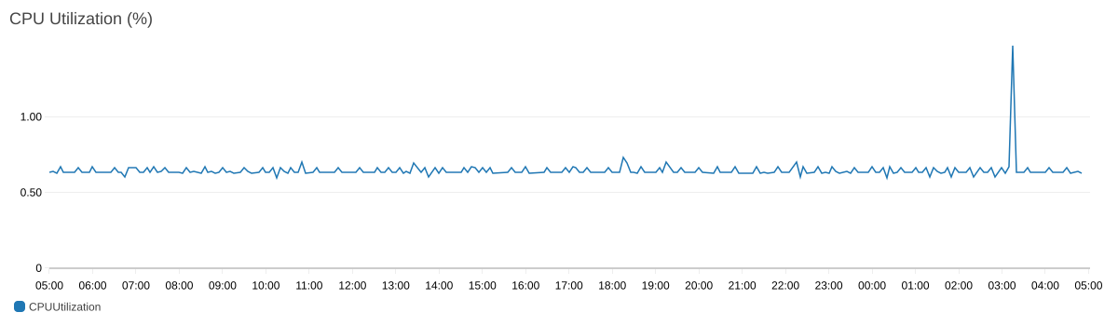

Memory Utilization (%)
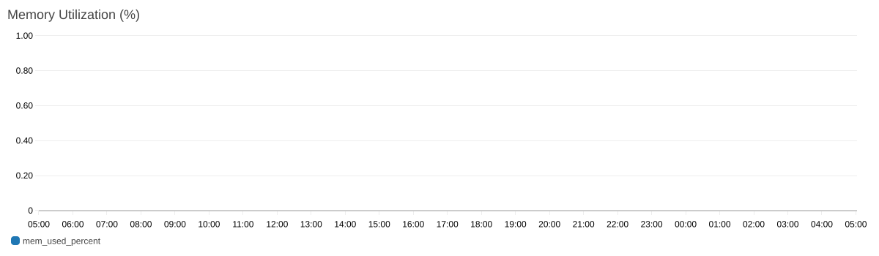

Disk Utilization (%)
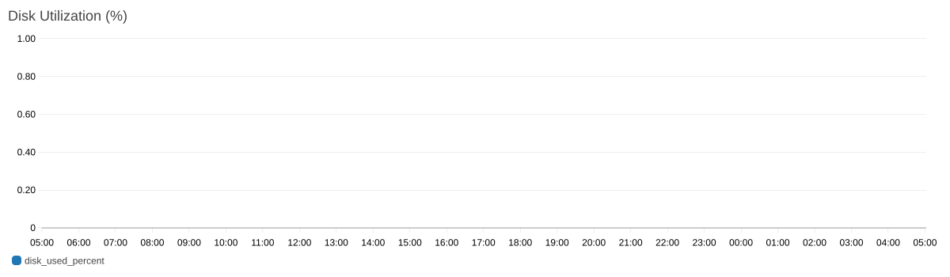

2.3 test server
Instance ID: | i-01d17c4644494fa8d
State: | running
Platform: | linux
Instance Type: | t3.micro

CPU Utilization (%)
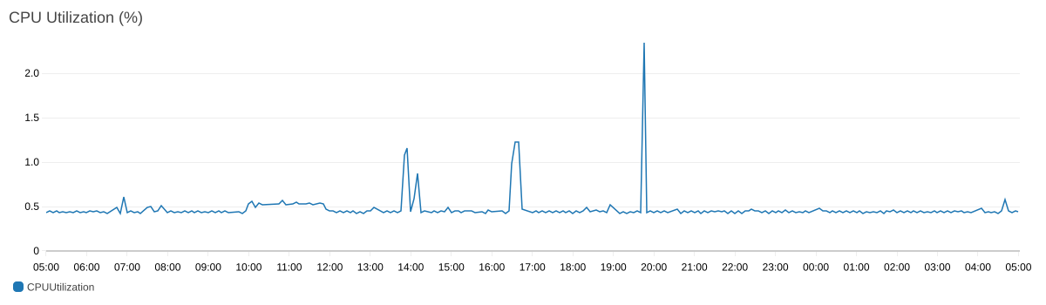

Memory Utilization (%)
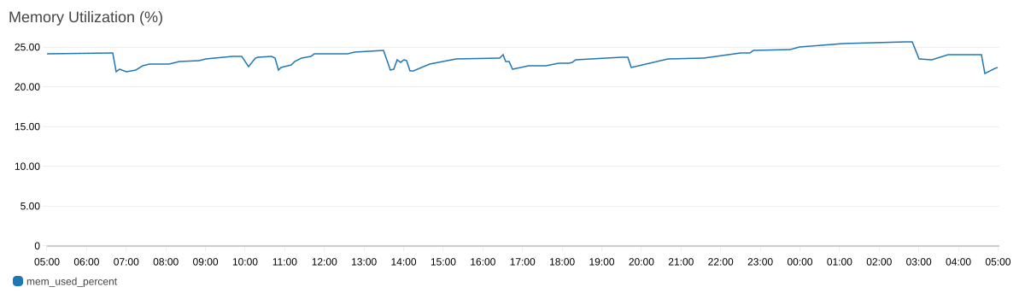

Disk Utilization (%)

2.4 Docker_instnace
Instance ID: | i-033e8b8435122c69f
State: | running
Platform: | linux
Instance Type: | t3.micro

CPU Utilization (%)
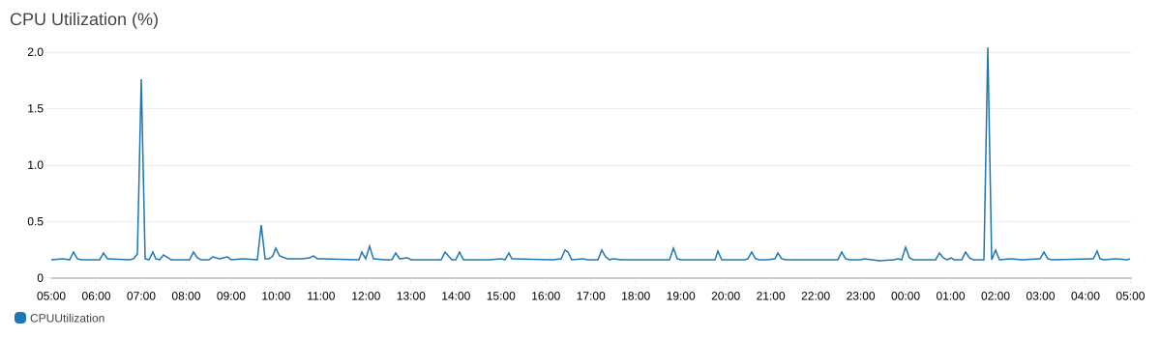

Memory Utilization (%)

Disk Utilization (%)

2.5 Autoscaling_1
Instance ID: | i-05fc5fbd9fe4e688b
State: | running
Platform: | linux
Instance Type: | t2.micro

CPU Utilization (%)
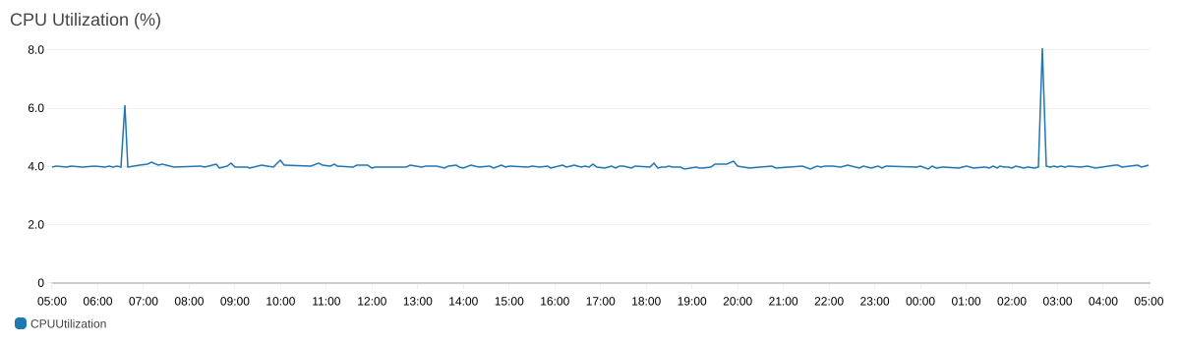

Memory Utilization (%)
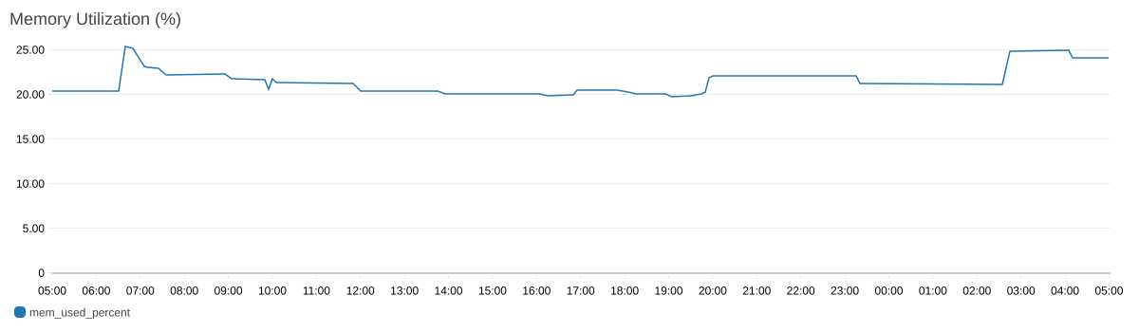

Disk Utilization (%)

2.6 web server
Instance ID: | i-0eeea35fd8cc241c3
State: | running
Platform: | windows
Instance Type: | t3.micro

CPU Utilization (%)
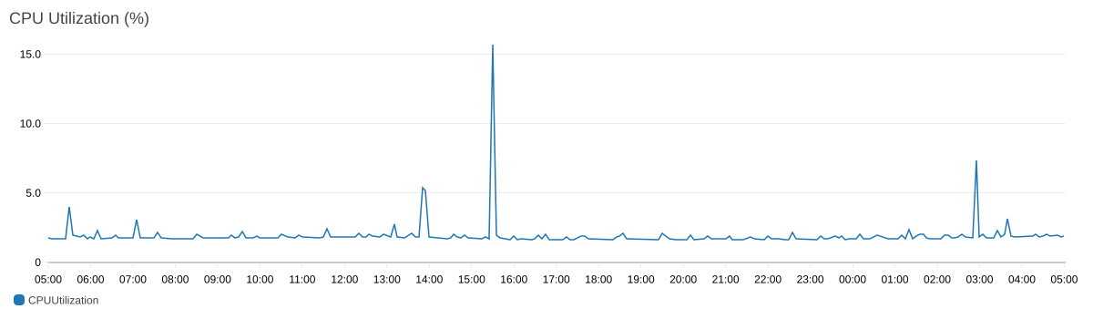

Memory Utilization (%)

Disk Utilization (%)

3. RDS DATABASES PERFORMANCE ANALYSIS
3.1 database-1
Database Identifier: | database-1
Status: | available
Engine: | mysql

CPU Utilization (%)
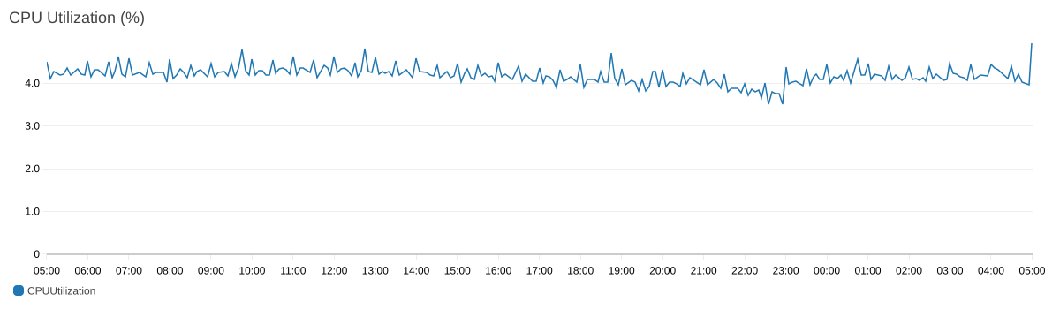

Freeable Memory (MB)
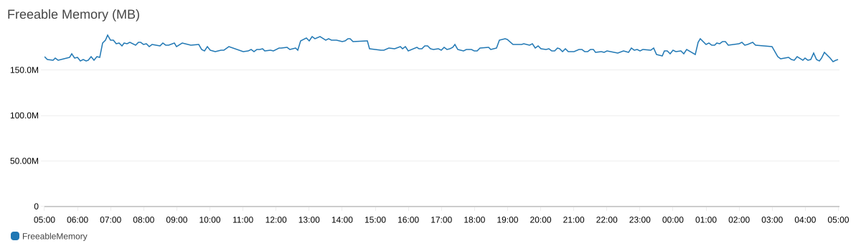

Database Connections
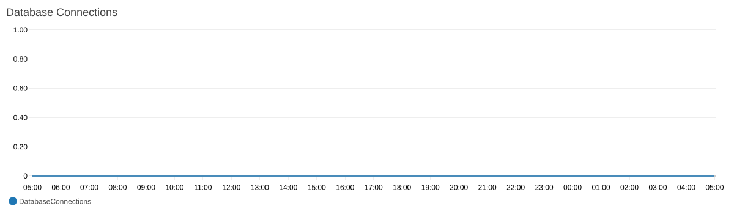

3.1 database-1 (Continued)

Read IOPS
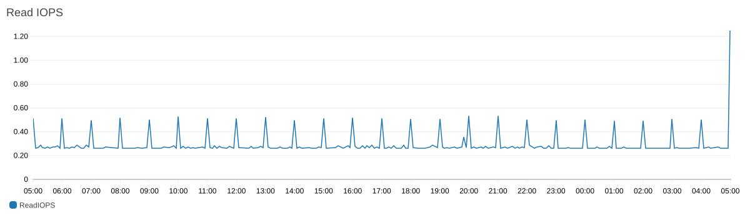

Write IOPS
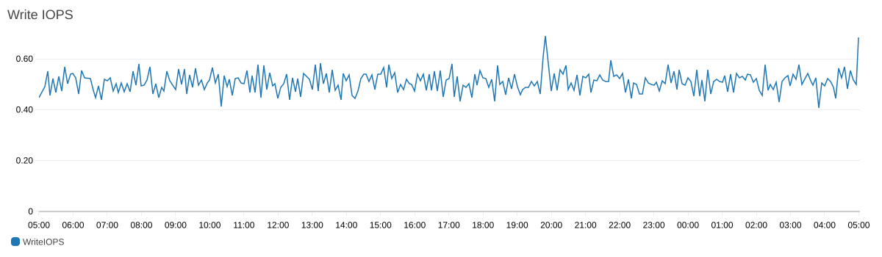

3.2 database-2
Database Identifier: | database-2
Status: | available
Engine: | postgres

CPU Utilization (%)
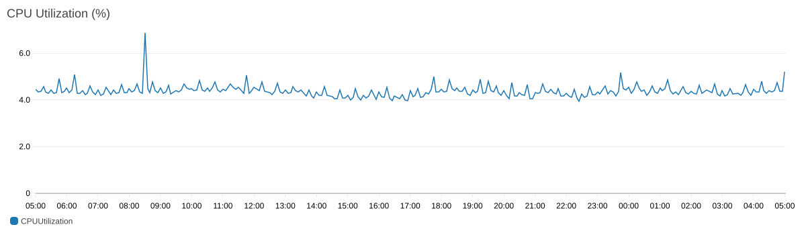

Freeable Memory (MB)
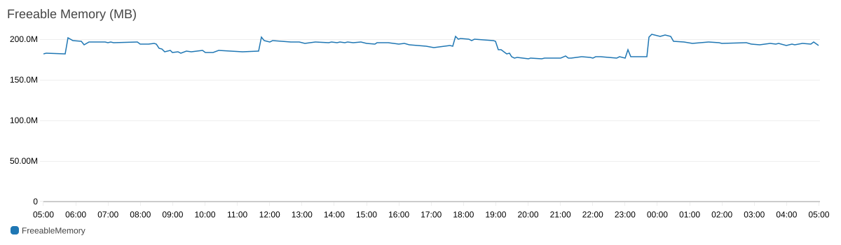

Database Connections

3.2 database-2 (Continued)

Read IOPS
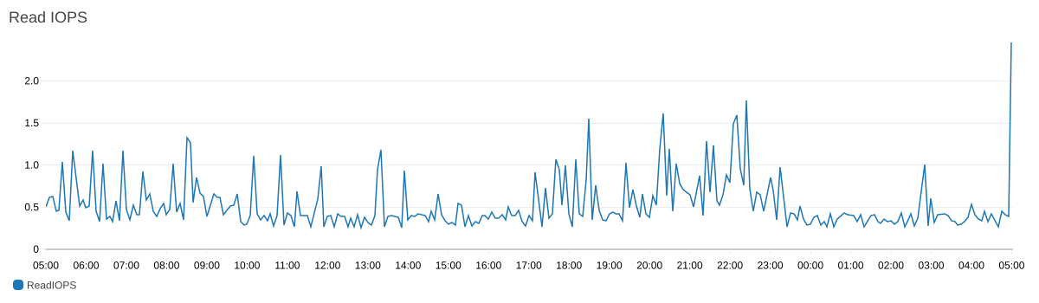

Write IOPS
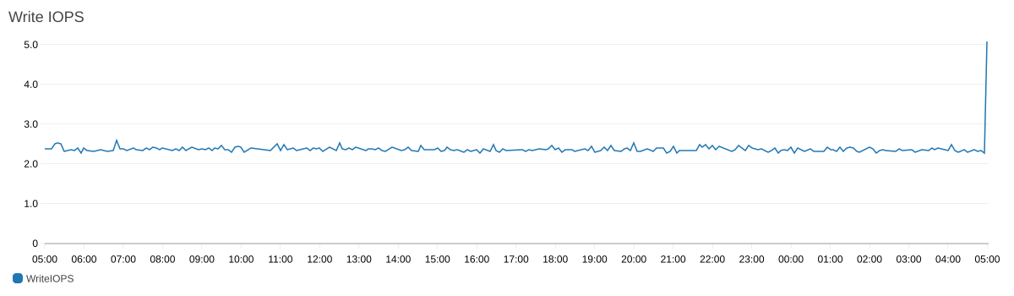

--- End of Report ---
Generated by Sumit Kuddor | Contact: sumitkuddor555@gmail.com

