**MAD III – Project mPlacementTracker Planning**

***Project Plan:***

**SDLC: Agile**

**Sprint 1:** Sprint planning and role distribution

**Roles:**

1. Sumit Kumar: Backend Developer
2. Yash: Database designer
3. Aastik: UI/UX designer

**Sprint Planning:**

**Sprint 1:**

Design UX Strategies

Make UI Designs

Role Distribution

**Sprint 2:**

Testing UI codes

Start coding for UI

Design effective database

Decide Architecture

**Sprint 3:**

Testing connectivity of DB and code

Project Deployment

Connect UI and database

***Work Meeting Schedule and Interaction Notes:***

Division of roles between team.

Discussed what work needs to be done.

Discussed different users of app for userstories.

Made testcases and debugged the code during meeting.

***User Stories:***

* As a student, I want to see all the companies coming to campus for hiring, So that I can apply for each placement drive.
* As a Student, I want to CRUD operations, so that I can update or delete my information accordingly.
* As a student, I want to receive automatic updates and notifications, so that I can apply in every company and know whether I got selected in any company.
* As a student, I want mock test papers, so that I can be prepared to give hiring tests easily.
* As a student, I want to see all the details of the companies and the jobs they are providing, so that I can apply according to my profile.
* As an admin, I want to see all the companies coming in the campus, so that I can update the same to every student and guide them properly.
* As an admin, I want to see which student gets placed and he/she joins that company, so that I can stop sending them further updates.
* As an admin, I want to see all the details of the students and companies, so that I can map the eligible students and companies accordingly.
* As an admin, I want to receive information of students that clears the first round and those who does not, so that I can send them updates/notifications accordingly.

***Use Case Diagram:***

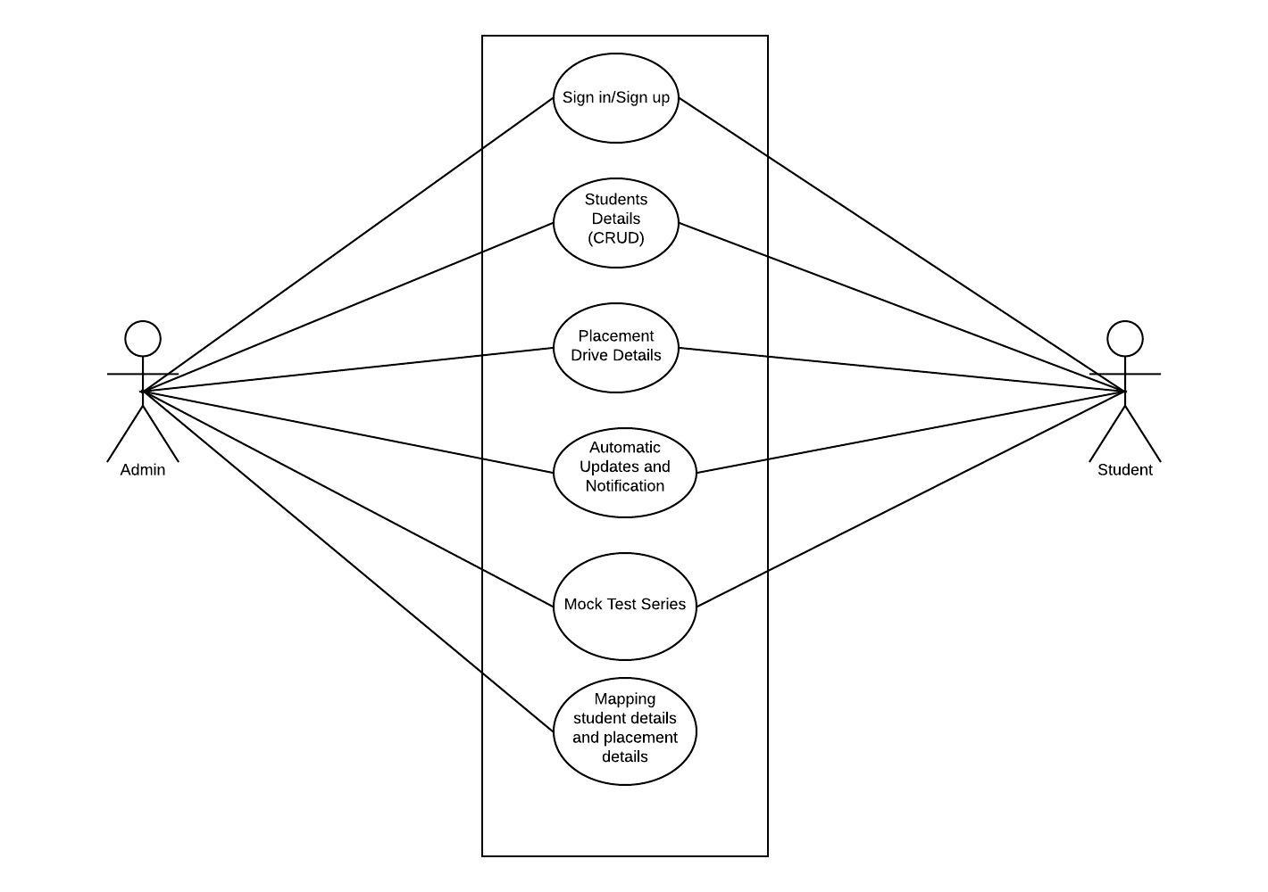

***Visual Designs and Graphic File:***

***Test Plan, Test cases, Test Execution, Test result:***

***Quality Analysis:***

**Making Code Changes**

**🡪** Test PRs rigorously before requesting review.

🡪 Include test cases you’ve checked for in your PR description

**Reviewing Code**

**🡪** If the change is substantial and user-facing, pull down the branch.

🡪 Test for cases (particularly edge cases) that the PR author may have missed.