Practical 2
Q1. Divide the screen into four region, draw circle, rectangle, ellipse and half ellipse in each region with appropriate messages.
Code:
#include <graphics.h>
#include <conio.h>
#include <stdio.h>
void main() {
int gd = DETECT, gm;
initgraph(&gd, &gm, " c:\\turboc3\\bgi");
int width = getmaxx();
int height = getmaxy();
int midX = width / 2;
int midY = height / 2;
line(midX, 0, midX, height);
line(0, midY, width, midY);
setcolor(RED);
circle(midX / 2, midY / 2, 50);
outtextxy(midX / 2 - 50, midY / 2 + 60, "This is a Circle");
setcolor(GREEN);
rectangle(midX + 50, 50, midX + 200, 150);
outtextxy(midX + 70, 160, "This is a Rectangle");
setcolor(BLUE);
ellipse(midX / 2, midY + midY / 2, 0, 360, 80, 40);
outtextxy(midX / 2 - 70, midY + midY / 2 + 50, "This is an Ellipse");
setcolor(YELLOW);
ellipse(midX + midX / 2, midY + midY / 2, 0, 180, 80, 40);
outtextxy(midX + midX / 2 - 70, midY + midY / 2 + 50, "This is a Half Ellipse");
getch();
closegraph();
}

Output:

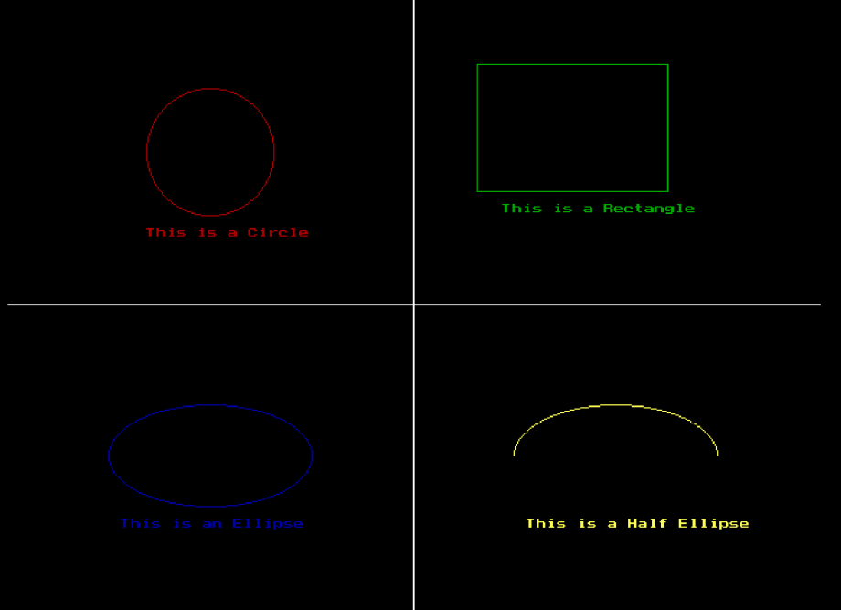

Q2. Draw a simple hut on the screen.
Code:
#include<stdio.h>
#include<stdlib.h>
#include<graphics.h>
#include<conio.h>
void main(){
int gd=DETECT ,gm;
initgraph(&gd,&gm,"c:\\turboc3\\bgi");
line(200,190,153,270);
line(200,190,270,270);
line(153,270,270,270);
line(270,270,550,270);
line(200,190,480,190);
line(480,190,550,270);
line(153,270,153,450);
line(270,270,270,450);
line(550,270,550,450);
line(153,450,550,450);
rectangle(250,350,170,450);//door
rectangle(350,330,430,380);//window
getch();
closegraph();
}

Output:

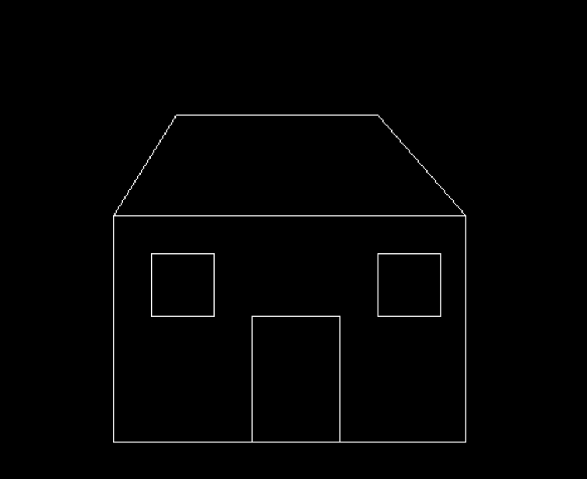

Practical 3
Q1. Draw a following basic shapes on the center of the screen
- Circle
- Rectangle
- Square
- Concentric circle
- Ellipse
- Line
Code:
#include<stdio.h>
#include<conio.h>
#include<stdlib.h>
#include<graphics.h>
void main(){
int gd=DETECT,gm;
initgraph(&gd,&gm,"c:\\turboc3\\bgi");
int maxx=getmaxx()/2;
int maxy=getmaxy()/2;
line(maxx,0,maxx,getmaxy());
line(0,maxy,getmaxx(),maxy);
circle(maxx,maxy,180);
circle(maxx,maxy,200);
rectangle(maxx-200,maxy-200,maxx+200,maxy+200);
rectangle(maxx-100,maxy-150,maxx+100,maxy+150);
ellipse(maxx,maxy,0,360,50,100);
getch();
closegraph();
}
Output:

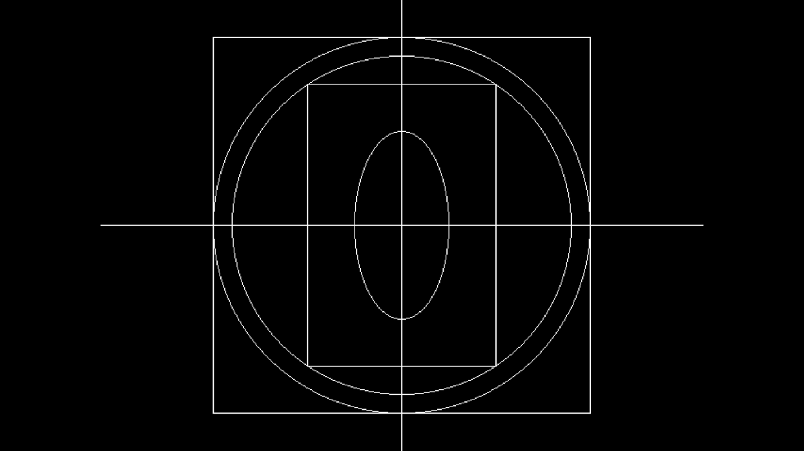

Q2. Draw a bouncing ball.
Code:
#include<stdio.h>
#include<dos.h>
#include<graphics.h>
#include<conio.h>
#include<stdlib.h>
int main(){
int gd=DETECT,gm;
initgraph(&gd,&gm,"c:\\turboc3\\bgi");
int i,x,y,f=0;
x=getmaxx()/2;
y=30;
while(!kbhit()){
if(y>getmaxy()-30 || y<=30)
f=!f;
setcolor(RED);
setfillstyle(1,RED);
circle(x,y,30);
floodfill(x,y,RED);
delay(50);
if(f){
y=y+15;
}
else{
y=y-15;
}}
getch();
closegraph();
return 0;
}
Output:

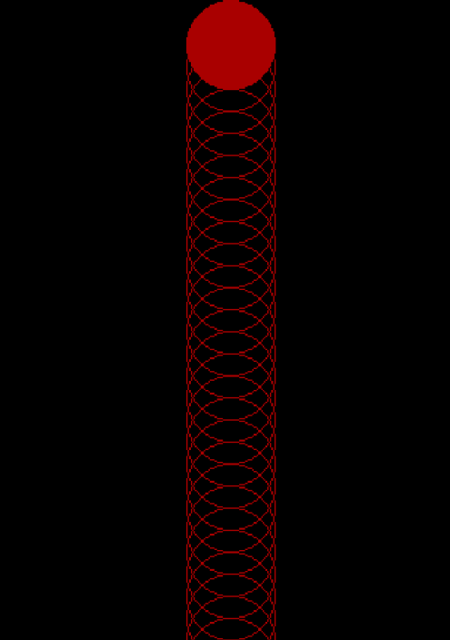

Practical 4
Q1. Develop the program for DDA line drawing algorithm.
Code: #include <graphics.h>
#include <conio.h>
#include <math.h>

void main() {

int gd = DETECT, gm;
initgraph(&gd, &gm, "");

int x1 = 100, y1 = 100, x2 = 400, y2 = 300;

int dx = x2 - x1;
int dy = y2 - y1;

int steps = (abs(dx) > abs(dy)) ? abs(dx) : abs(dy);

float Xinc = dx / (float)steps;
float Yinc = dy / (float)steps;

float x = x1;
float y = y1;

for (int i = 0; i <= steps; i++) {
putpixel(round(x), round(y), WHITE);
x += Xinc; // Increment X
y += Yinc; // Increment Y
}

getch();
closegraph();
}
Output:
Q2. Develop the program for Bresenham’s line drawing algorithm.
Code:
#include <graphics.h>
#include <conio.h>
#include <stdlib.h>

void bresenhamLine(int x1, int y1, int x2, int y2) {
int dx = abs(x2 - x1); // Difference in x
int dy = abs(y2 - y1); // Difference in y
int p = 2 * dy - dx; // Initial decision parameter

// Determine the increments for x and y
int twoDy = 2 * dy;
int twoDyMinusDx = 2 * (dy - dx);

int x, y;
if (x1 > x2) { // If x1 is greater, swap the points
x = x2;
y = y2;
x2 = x1;
y2 = y1;
} else {
x = x1;
y = y1;
}

// Plot the first point
putpixel(x, y, WHITE);

// Start drawing the line
while (x < x2) {
x++;
if (p < 0) {
p += twoDy; // Move horizontally
} else {
if (y < y2)
y++; // Move vertically
else
y--; // Move vertically in the opposite direction
p += twoDyMinusDx; // Adjust the decision parameter
}
putpixel(x, y, WHITE); // Plot the cu
Output:
Practical 5
Q1. Develop the program for the mid-point circle drawing algorithm.
Code: #include <graphics.h>
#include <conio.h>
#include <stdlib.h>

void midpointCircle(int xc, int yc, int r) {
int x = 0;
int y = r;
int p = 1 - r; // Initial decision parameter

// Plot the initial points
putpixel(xc + x, yc - y, WHITE); // (x, -y)
putpixel(xc - x, yc - y, WHITE); // (-x, -y)
putpixel(xc + x, yc + y, WHITE); // (x, y)
putpixel(xc - x, yc + y, WHITE); // (-x, y)
putpixel(xc + y, yc - x, WHITE); // (y, -x)
putpixel(xc - y, yc - x, WHITE); // (-y, -x)
putpixel(xc + y, yc + x, WHITE); // (y, x)
putpixel(xc - y, yc + x, WHITE); // (-y, x)

// Start the loop to plot the circle
while (x < y) {
x++;
if (p < 0) {
p = p + 2 * x + 1; // Move horizontally
} else {
y--; // Move vertically
p = p + 2 * x - 2 * y + 1;
}

// Plot the points for the 8 symmetric positions
putpixel(xc + x, yc - y, WHITE); // (x, -y)
putpixel(xc - x, yc - y, WHITE); // (-x, -y)
putpixel(xc + x, yc + y, WHITE); // (x, y)
putpixel(xc - x, yc + y, WHITE); // (-x, y)
putpixel(xc + y, yc - x, WHITE); // (y, -x)
putpixel(xc - y, yc - x, WHITE); // (-y, -x)
putpixel(xc + y, yc + x, WHITE); // (y, x)
putpixel(xc - y, yc + x, WHITE); // (-y, x)
}
}

void main() {
// Initialize the graphics driver and mode
int gd = DETECT, gm;
initgraph(&gd, &gm, "");

// Define the center and radius of the circle
int xc = 320, yc = 240, r = 100;

// Draw the circle using the Mid-Point Circle Drawing Algorithm
midpointCircle(xc, yc, r);

// Wait for the user to press a key
getch();

// Close the graphics mode
closegraph();
}
Output:
Q2. Develop the program for the mid-point ellipse drawing algorithm.
Code: #include <graphics.h>
#include <conio.h>
#include <stdlib.h>

void midpointEllipse(int xc, int yc, int a, int b) {
int x = 0;
int y = b;

int a2 = a * a;
int b2 = b * b;
int twob2 = 2 * b2;
int twoa2 = 2 * a2;

int p1 = b2 - (a2 * b) + (0.25 * a2); // Initial decision parameter for region 1
int px = 0;
int py = twob2 * x;

// Plot the initial points
putpixel(xc + x, yc - y, WHITE); // (x, -y)
putpixel(xc - x, yc - y, WHITE); // (-x, -y)
putpixel(xc + x, yc + y, WHITE); // (x, y)
putpixel(xc - x, yc + y, WHITE); // (-x, y)

// Region 1 - when the ellipse is more stretched in the y-direction
while (px < py) {
x++;
px += twob2;
if (p1 < 0) {
p1 += b2 + px; // Move horizontally
} else {
y--;
py -= twoa2;
p1 += b2 + px - py; // Move diagonally
}

// Plot the symmetric points for region 1
putpixel(xc + x, yc - y, WHITE); // (x, -y)
putpixel(xc - x, yc - y, WHITE); // (-x, -y)
putpixel(xc + x, yc + y, WHITE); // (x, y)
putpixel(xc - x, yc + y, WHITE); // (-x, y)
}

// Region 2 - when the ellipse is more stretched in the x-direction
int p2 = (b2 * (x + 0.5) * (x + 0.5)) + (a2 * (y - 1) * (y - 1)) - a2 * b2;

while (y > 0) {
y--;
py -= twoa2;
if (p2 > 0) {
p2 += a2 - py; // Move vertically
} else {
x++;
px += twob2;
p2 += a2 - py + px; // Move diagonally
}

// Plot the symmetric points for region 2
putpixel(xc + x, yc - y, WHITE); // (x, -y)
putpixel(xc - x, yc - y, WHITE); // (-x, -y)
putpixel(xc + x, yc + y, WHITE); // (x, y)
putpixel(xc - x, yc + y, WHITE); // (-x, y)
}
}

void main() {
// Initialize the graphics driver and mode
int gd = DETECT, gm;
initgraph(&gd, &gm, "");

// Define the center and radii of the ellipse
int xc = 320, yc = 240, a = 150, b = 100;

// Draw the ellipse using the Mid-Point Ellipse Drawing Algorithm
midpointEllipse(xc, yc, a, b);

// Wait for the user to press a key
getch();

// Close the graphics mode
closegraph();
}
Output:
Practical 6
Q1. Write a program to implement 2D scaling.
Code: #include <graphics.h>
#include <conio.h>
#include <stdlib.h>

void scale(int x1, int y1, int x2, int y2, float sx, float sy) {
// Calculate the scaled coordinates
int x1_scaled = x1 * sx;
int y1_scaled = y1 * sy;
int x2_scaled = x2 * sx;
int y2_scaled = y2 * sy;

// Draw the original and scaled rectangles
setcolor(WHITE); // Set color for original shape
rectangle(x1, y1, x2, y2); // Draw the original rectangle

setcolor(YELLOW); // Set color for scaled shape
rectangle(x1_scaled, y1_scaled, x2_scaled, y2_scaled); // Draw the scaled rectangle
}

void main() {
// Initialize the graphics driver and mode
int gd = DETECT, gm;
initgraph(&gd, &gm, "");

// Define coordinates for the rectangle (x1, y1) -> top-left, (x2, y2) -> bottom-right
int x1 = 100, y1 = 100, x2 = 200, y2 = 150;

// Scaling factors (sx, sy)
float sx = 1.5; // Scale factor in x-direction (1.5 means 150% in x)
float sy = 2.0; // Scale factor in y-direction (2.0 means 200% in y)

// Apply 2D scaling to the rectangle
scale(x1, y1, x2, y2, sx, sy);

// Wait for the user to press a key
getch();

// Close the graphics mode
closegraph();
}
Output:
Q2. Write a program to implement 2D translation.
Code:
Output:
Practical 7
Q1. Write a program to implement 2D rotation.
Code: #include <graphics.h>
#include <conio.h>
#include <stdlib.h>

// Function to implement 2D Translation
void translate(int x1, int y1, int x2, int y2, int tx, int ty) {
// Calculate the translated coordinates
int x1_translated = x1 + tx;
int y1_translated = y1 + ty;
int x2_translated = x2 + tx;
int y2_translated = y2 + ty;

// Draw the original rectangle
setcolor(WHITE); // Set color for original rectangle
rectangle(x1, y1, x2, y2); // Draw the original rectangle

// Draw the translated rectangle
setcolor(YELLOW); // Set color for translated rectangle
rectangle(x1_translated, y1_translated, x2_translated, y2_translated); // Draw the translated rectangle
}

void main() {
// Initialize the graphics driver and mode
int gd = DETECT, gm;
initgraph(&gd, &gm, "");

// Define the coordinates of the original rectangle
int x1 = 100, y1 = 100, x2 = 200, y2 = 150;

// Define the translation vector (tx, ty)
int tx = 150; // Translation in x-direction
int ty = 100; // Translation in y-direction

// Apply 2D Translation
translate(x1, y1, x2, y2, tx, ty);

// Wait for the user to press a key
getch();

// Close the graphics mode
closegraph();
}
Output:
Q2. Write a program to implement 2D reflection.
Code: #include <graphics.h>
#include <conio.h>
#include <stdlib.h>

// Function to reflect the rectangle across the X-axis
void reflectX(int x1, int y1, int x2, int y2, int height) {
int x1_reflected = x1;
int y1_reflected = height - y1;
int x2_reflected = x2;
int y2_reflected = height - y2;

// Draw the original rectangle
setcolor(WHITE);
rectangle(x1, y1, x2, y2);

// Draw the reflected rectangle across the X-axis
setcolor(YELLOW);
rectangle(x1_reflected, y1_reflected, x2_reflected, y2_reflected);
}

// Function to reflect the rectangle across the Y-axis
void reflectY(int x1, int y1, int x2, int y2, int width) {
int x1_reflected = width - x1;
int y1_reflected = y1;
int x2_reflected = width - x2;
int y2_reflected = y2;

// Draw the original rectangle
setcolor(WHITE);
rectangle(x1, y1, x2, y2);

// Draw the reflected rectangle across the Y-axis
setcolor(RED);
rectangle(x1_reflected, y1_reflected, x2_reflected, y2_reflected);
}

// Function to reflect the rectangle across the Line y = x
void reflectLineYX(int x1, int y1, int x2, int y2) {
int x1_reflected = y1;
int y1_reflected = x1;
int x2_reflected = y2;
int y2_reflected = x2;

// Draw the original rectangle
setcolor(WHITE);
rectangle(x1, y1, x2, y2);

// Draw the reflected rectangle across the Line y = x
setcolor(GREEN);
rectangle(x1_reflected, y1_reflected, x2_reflected, y2_reflected);
}

void main() {
// Initialize graphics mode
int gd = DETECT, gm;
initgraph(&gd, &gm, "");

// Define the rectangle's coordinates
int x1 = 100, y1 = 100, x2 = 200, y2 = 150;

// Get the screen's width and height
int width = getmaxx();
int height = getmaxy();

// Reflect the rectangle across the X-axis
reflectX(x1, y1, x2, y2, height);

// Reflect the rectangle across the Y-axis
reflectY(x1, y1, x2, y2, width);

// Reflect the rectangle across the line y = x
reflectLineYX(x1, y1, x2, y2);

// Wait for the user to press a key
getch();

// Close the graphics mode
closegraph();
}
Output:

