**Class:** Final Year (Computer Science and Engineering)

**Year:** 2024-25 **Semester:** 1

**Course:** High Performance Computing Lab

# Practical No. 10

**Exam Seat No : Full Name :**

**Title of practical :** Analysis of MPI Programs

# Problem Statement 1:

Execute the MPI program (Program A) with a fixed size broadcast. Plot the performance of the broadcast with varying numbers of processes (with constant messagesize). Explain the performance observed.

**Code:**

***#include* <mpi.h>**

***#include* <stdio.h>**

***#include* <stdlib.h>**

***#define* MSG_SIZE 1024**

**int main(int *argc*, char \**argv*[]) { int rank, size;**

**int message[MSG_SIZE];**

**double start_time, end_time;**

**MPI_Init(&*argc*, &*argv*);**

**MPI_Comm_rank(MPI_COMM_WORLD, &rank); MPI_Comm_size(MPI_COMM_WORLD, &size);**

***if* (rank == 0) {**

***for* (int i = 0; i < MSG_SIZE; i++) { message[i] = i;**

**}**

**printf("Root process (Rank %d) broadcasting message...\n", rank);**

**}**

**start_time = MPI_Wtime();**

**MPI_Bcast(message, MSG_SIZE, MPI_INT, 0, MPI_COMM_WORLD); end_time = MPI_Wtime();**

**printf("Process %d received message. First value: %d\n", rank, message[0]);**

***if* (rank == 0) {**

**printf("Number of processes: %d, Time taken for broadcast: %f seconds\n", size, end_time - start_time);**

**}**

**MPI_Finalize();**

***return* 0;**

**}**

**Analysis:**

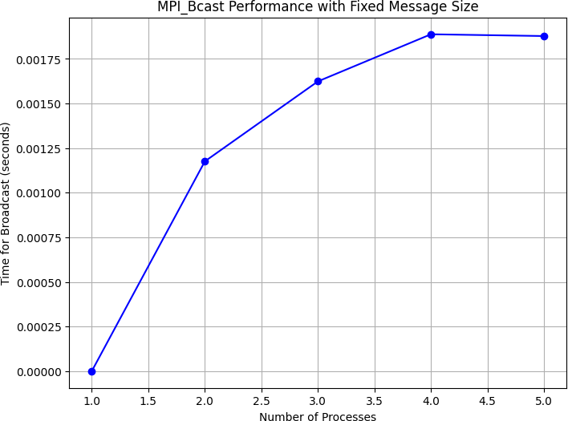

**Problem Statement 2:**

Repeat problem 2 above with varying message sizes for reduction (Program B). Explain the observed performance of the reduction operation.

# Code:

*#include* <mpi.h>

*#include* <stdio.h>

*#include* <stdlib.h>

int main(int *argc*, char \**argv*[]) { int rank, size;

int *message, *reduced_result; int message_size;

double start_time, end_time;

MPI_Init(&*argc*, &*argv*);

MPI_Comm_rank(MPI_COMM_WORLD, &rank); MPI_Comm_size(MPI_COMM_WORLD, &size);

*for* (message_size = 256; message_size <= 4096; message_size

*= 2) {

message = (int*) malloc(message_size * sizeof(int)); reduced_result = (int*) malloc(message_size *

sizeof(int));

*for* (int i = 0; i < message_size; i++) { message[i] = rank + i;

}

start_time = MPI_Wtime();

MPI_Reduce(message, reduced_result, message_size, MPI_INT, MPI_SUM, 0, MPI_COMM_WORLD);

end_time = MPI_Wtime();

*if* (rank == 0) {

printf("Message size: %d, Number of processes: %d, Time taken for reduction: %f seconds\n", message_size, size, end_time - start_time);

printf("Reduction result: First element = %d, Last element = %d\n", reduced_result[0],

reduced_result[message_size-1]);

}

free(message);

free(reduced_result);

}

MPI_Finalize();

*return* 0;

}

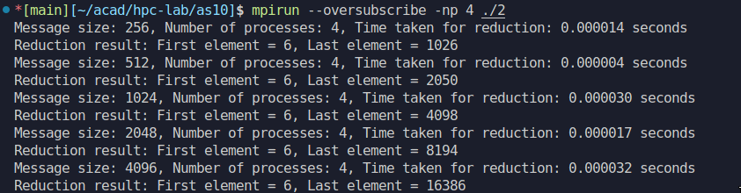**Analysis:**