**Class:** Final Year (Computer Science and Engineering)

**Year:** 2024-25 **Semester:** 1

**Course:** High Performance Computing Lab

# Practical No. 6

**Exam Seat No: 21510010**

# Title of practical: Implementation of OpenMP programs.

Implement following Programs using OpenMP with C:

1. Implementation of Matrix-Matrix Multiplication.
2. Implementation of Matrix-vector Multiplication.

**Problem Statement 1:** Implementation of Matrix-Matrix Multiplication.

# Screenshots:

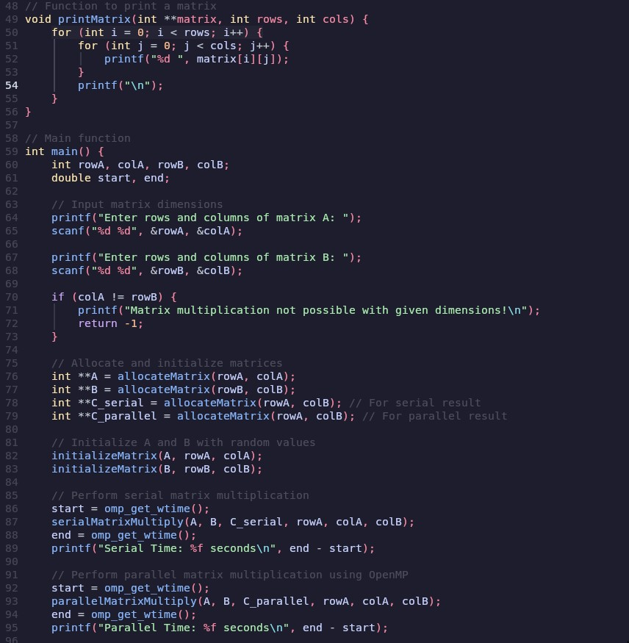

**Information:**

# Analysis:

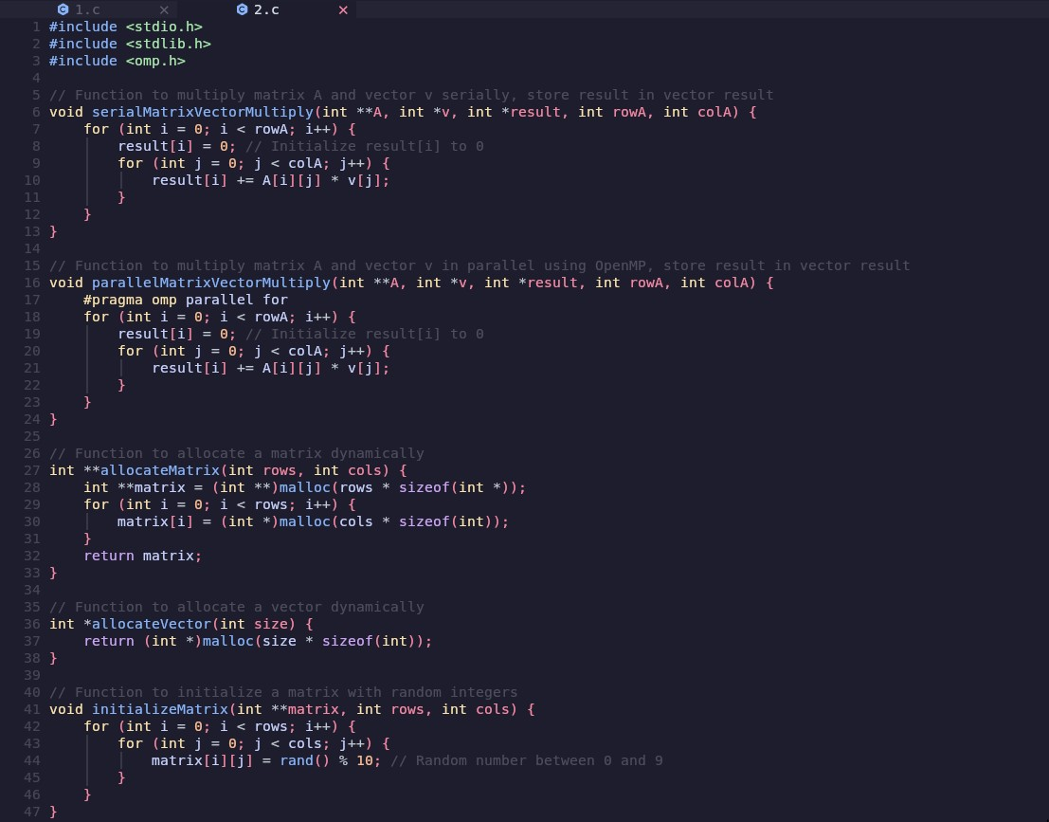**Problem Statement 2: Screenshots:**

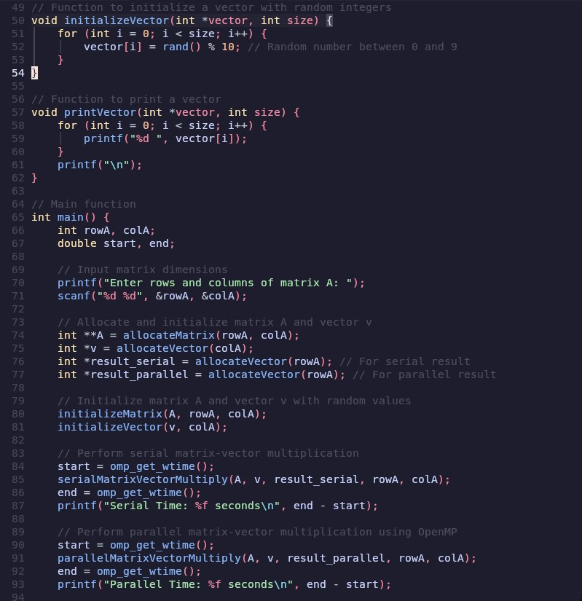

# Information:

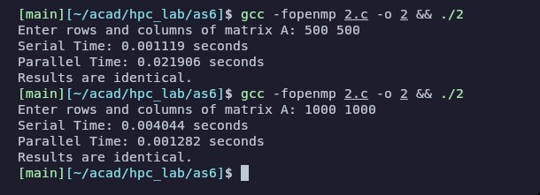**Analysis:**

**Github Link:**