**PRN : 21510010**

**Batch : B1**

**Title of practical:**

High Performance Computing Lab Practical No. 7

Installation of MPI & Implementation of basic functions of MPI

**Problem Statement 1:**

Implement a simple hello world program by setting number of processes equal to 10

**Screenshots:**

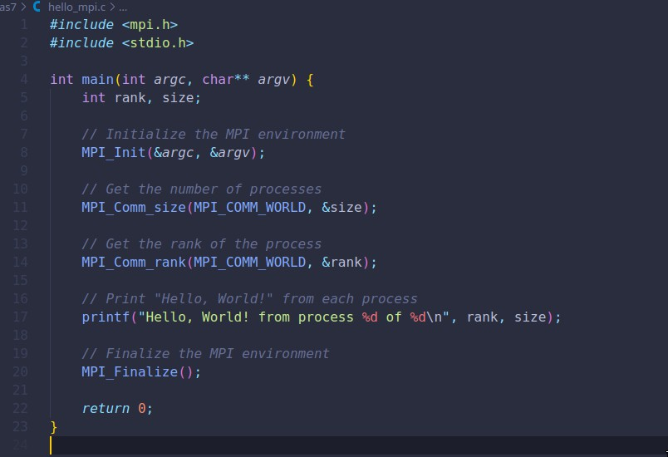

**Information 1:**

**Output :**

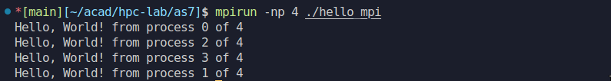

**Problem Statement 2:**

Implement a program to display rank and communicator group of five processes

**Screenshots:**

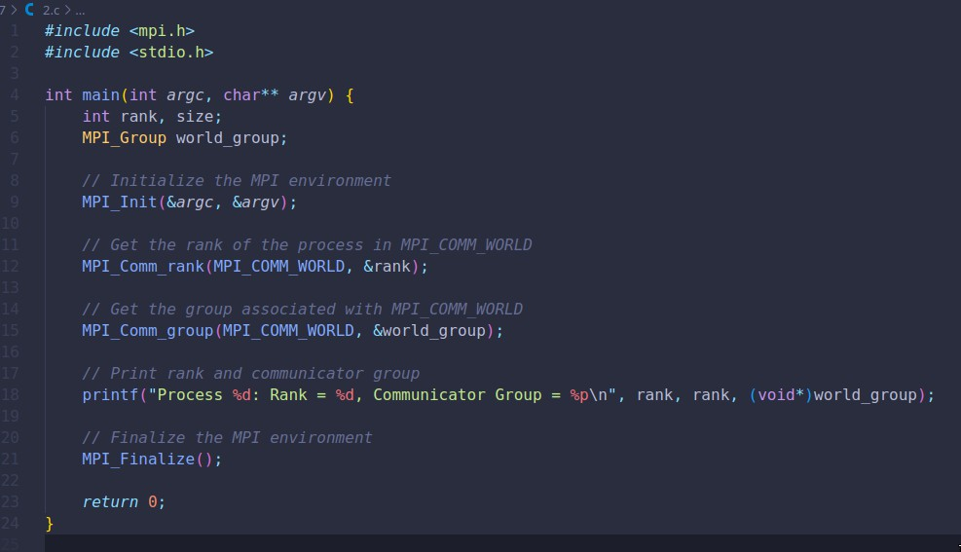

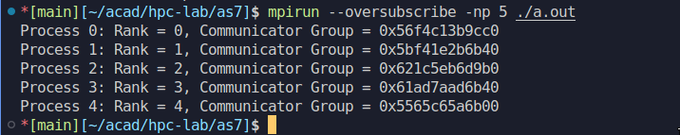**Information: Output:**