**Class:** Final Year (Computer Science and Engineering)

**Year:** 2024-25 **Semester:** 1

**Course:** High Performance Computing Lab

**Practical No.8**

PRN No : 21510111

Name : Siddharth Salunkhe

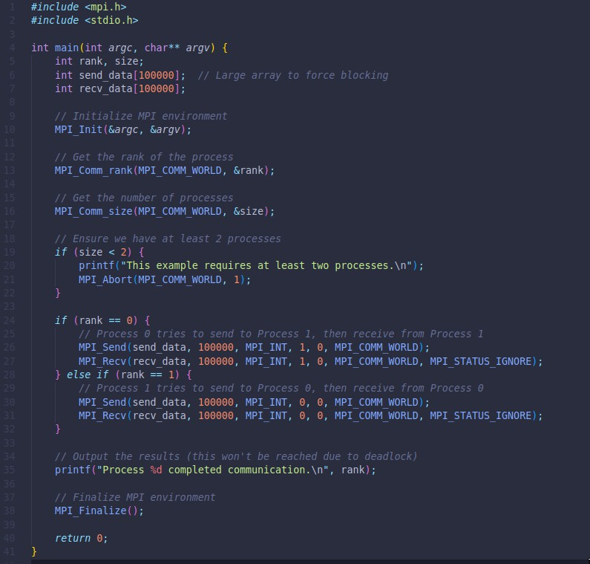Q1: Implement a MPI program to give an example of Deadlock.

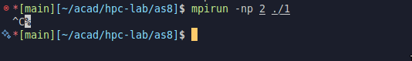**Output:**

Q2. Implement blocking MPI send & receive to demonstrate Nearest neighbor exchange of data in a ring topology.

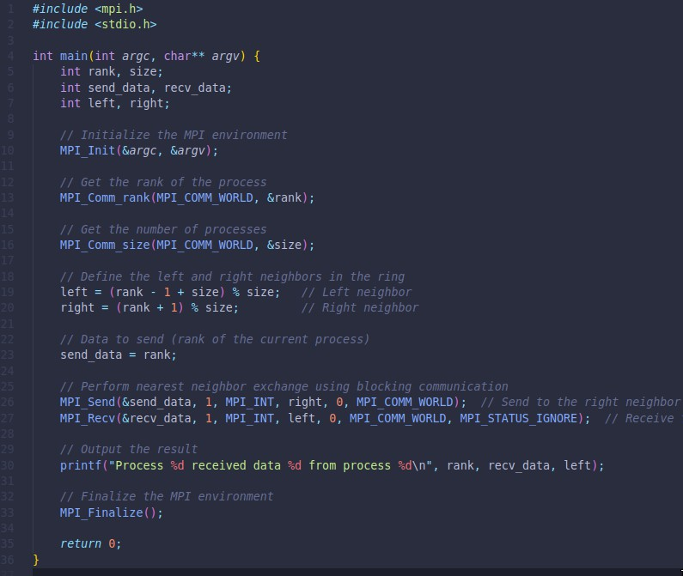

Output :

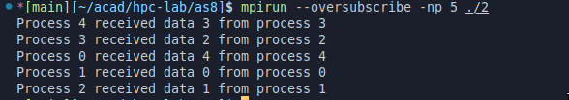

Q3. Write a MPI program to find the sum of all the elements of an array A of size

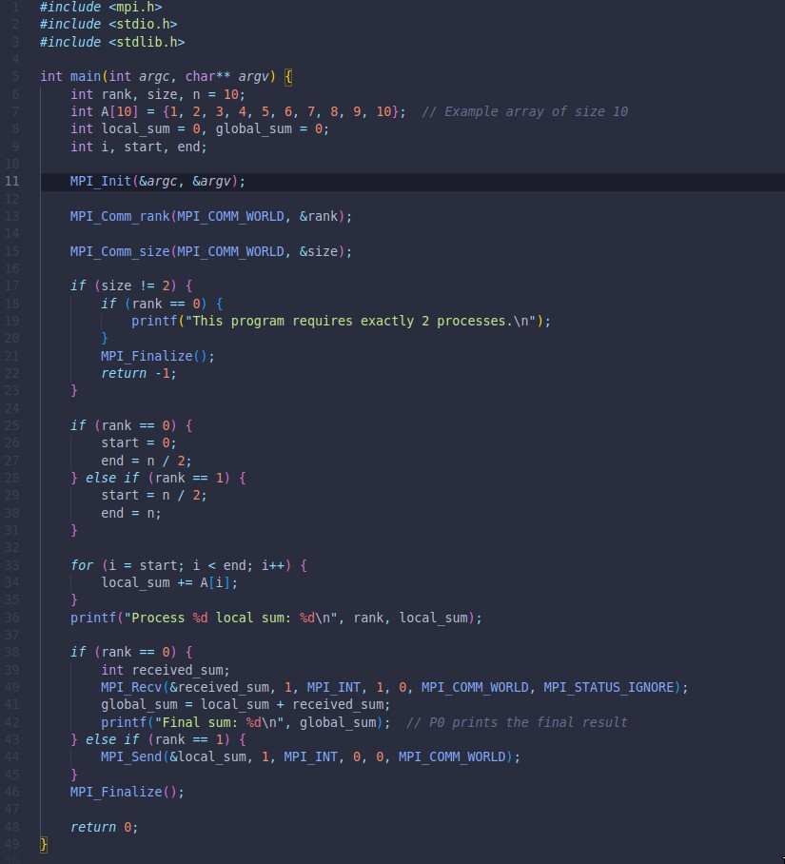n. Elements of an array can be divided into two equals groups. The first [n/2] elements are added by the first process, P0, and last [n/2] elements the by second process, P1. The two sums then are added to get the final result.

**Output** : 