**Final Year B. Tech., Sem VII 2024-25**

High Performance Computing Lab

**Practical No. 9**

PRN : 21510111

Name : Siddharth Salunkhe

# Implement Matrix-Vector Multiplication using MPI. Use different number of processes and analyze the performance.

Code :

*#include* <mpi.h>

*#include* <stdio.h> *#include* <stdlib.h> *#include* <time.h>

*#define* N 4 *// Matrix size (NxN)*

void matrix_vector_multiply(int *rank*, int *size*, int *n*, double*

*A*, double* *x*, double* *local_result*) {

int local_rows = *n* / *size*; *// Number of rows for each process*

*for* (int i = 0; i < local_rows; i++) {

*local_result*[i] = 0;

*for* (int j = 0; j < *n*; j++) {

*local_result*[i] += *A*[i * *n* + j] * *x*[j];

}

}

}

*// Sequential version of matrix-vector multiplication for single-process time*

void sequential_matrix_vector_multiply(int *n*, double* *A*, double*

*x*, double* *result*) {

*for* (int i = 0; i < *n*; i++) {

*result*[i] = 0;

*for* (int j = 0; j < *n*; j++) {

*result*[i] += *A*[i * *n* + j] * *x*[j];

}

}

}

int main(int *argc*, char** *argv*) { int rank, size;

int n = N; *// Matrix size*

double *A = NULL, *x = NULL, *result = NULL; double *local_A, *local_result;

int local_rows;

MPI_Init(&*argc*, &*argv*);

MPI_Comm_rank(MPI_COMM_WORLD, &rank); MPI_Comm_size(MPI_COMM_WORLD, &size);

local_rows = n / size; *// Number of rows per process*

*// Allocate memory for local matrices and vectors*

local_A = (double*) malloc(local_rows * n * sizeof(double)); local_result = (double*) malloc(local_rows * sizeof(double));

*// Master process initializes the matrix and vector if* (rank == 0) {

A = (double*) malloc(n * n * sizeof(double)); x = (double*) malloc(n * sizeof(double));

result = (double*) malloc(n * sizeof(double));

*// Initialize matrix A and vector x with random values*

srand(time(0));

*for* (int i = 0; i < n * n; i++) { A[i] = rand() % 10;

}

*for* (int i = 0; i < n; i++) { x[i] = rand() % 10;

}

printf("Matrix A:\n");

*for* (int i = 0; i < n; i++) {

*for* (int j = 0; j < n; j++) {

printf("%6.2f ", A[i * n + j]);

}

printf("\n");

}

printf("\nVector x:\n");

*for* (int i = 0; i < n; i++) { printf("%6.2f\n", x[i]);

}

}

*// Sequential execution to calculate T1*

double T1_start, T1_end, T1;

*if* (rank == 0) {

T1_start = MPI_Wtime(); *// Start timing for sequential execution*

double* seq_result = (double*) malloc(n * sizeof(double));

sequential_matrix_vector_multiply(n, A, x, seq_result);

T1_end = MPI_Wtime(); *// End timing for sequential execution*

T1 = T1_end - T1_start;

printf("\nSequential Result vector:\n");

*for* (int i = 0; i < n; i++) {

printf("%6.2f\n", seq_result[i]);

}

free(seq_result);

}

*// Scatter the matrix rows to all processes*

MPI_Scatter(A, local_rows * n, MPI_DOUBLE, local_A, local_rows * n, MPI_DOUBLE, 0, MPI_COMM_WORLD);

*// Broadcast the vector to all processes if* (rank == 0) {

MPI_Bcast(x, n, MPI_DOUBLE, 0, MPI_COMM_WORLD);

} *else* {

x = (double*) malloc(n * sizeof(double));

MPI_Bcast(x, n, MPI_DOUBLE, 0, MPI_COMM_WORLD);

}

*// Parallel execution to calculate Tp*

double Tp_start, Tp_end, Tp;

Tp_start = MPI_Wtime(); *// Start timing for parallel execution*

*// Perform local matrix-vector multiplication*

matrix_vector_multiply(rank, size, n, local_A, x, local_result);

*// Gather the local results into the global result*

MPI_Gather(local_result, local_rows, MPI_DOUBLE, result, local_rows, MPI_DOUBLE, 0, MPI_COMM_WORLD);

Tp_end = MPI_Wtime(); *// End timing for parallel execution*

Tp = Tp_end - Tp_start;

*// Master process prints the parallel result and calculates speedup*

*if* (rank == 0) {

printf("\nParallel Result vector:\n");

*for* (int i = 0; i < n; i++) {

printf("%6.2f\n", result[i]);

}

*// Calculate speedup: Speedup = T1 / Tp*

double speedup = T1 / Tp;

printf("\nTime (Sequential - T1): %f seconds\n", T1); printf("Time (Parallel - Tp): %f seconds\n", Tp);

printf("Speedup: %f\n", speedup);

}

*// Clean up*

free(local_A);

free(local_result);

*if* (rank == 0) { free(A);

free(x);

free(result);

} *else* {

free(x);

}

MPI_Finalize();

*return* 0;

}

Output :

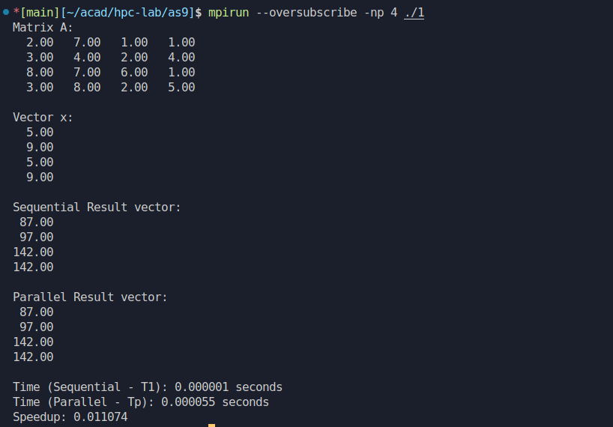

# Implement Matrix-Matrix Multiplication using MPI. Use different number of processes and analyze the performance.

Code :

*#include* <mpi.h>

*#include* <stdio.h> *#include* <stdlib.h> *#include* <time.h>

*#define* N 4 *// Matrix size (NxN)*

void matrix_multiply(int *rank*, int *size*, int *n*, double* *A*, double* *B*, double* *local_C*) {

int local_rows = *n* / *size*; *// Number of rows assigned to each process*

*for* (int i = 0; i < local_rows; i++) {

*for* (int j = 0; j < *n*; j++) {

j];

*local_C*[i * *n* + j] = 0;

*for* (int k = 0; k < *n*; k++) {

*local_C*[i * *n* + j] += *A*[i * *n* + k] * *B*[k * *n* +

}

}

}

}

*// Sequential version for time comparison*

void sequential_matrix_multiply(int *n*, double* *A*, double* *B*, double* *C*) {

*for* (int i = 0; i < *n*; i++) {

*for* (int j = 0; j < *n*; j++) {

*C*[i * *n* + j] = 0;

*for* (int k = 0; k < *n*; k++) {

*C*[i * *n* + j] += *A*[i * *n* + k] * *B*[k * *n* + j];

}

}

}

}

int main(int *argc*, char** *argv*) { int rank, size;

int n = N; *// Matrix size*

double *A = NULL, *B = NULL, *C = NULL; double *local_A, *local_C;

int local_rows;

MPI_Init(&*argc*, &*argv*);

MPI_Comm_rank(MPI_COMM_WORLD, &rank); MPI_Comm_size(MPI_COMM_WORLD, &size);

local_rows = n / size; *// Number of rows per process*

*// Allocate memory for local matrices*

local_A = (double*) malloc(local_rows * n * sizeof(double)); local_C = (double*) malloc(local_rows * n * sizeof(double));

*// Master process initializes matrices A and B if* (rank == 0) {

A = (double*) malloc(n * n * sizeof(double)); B = (double*) malloc(n * n * sizeof(double)); C = (double*) malloc(n * n * sizeof(double));

*// Initialize matrix A and B with random values*

srand(time(0));

*for* (int i = 0; i < n * n; i++) { A[i] = rand() % 10;

B[i] = rand() % 10;

}

printf("Matrix A:\n");

*for* (int i = 0; i < n; i++) {

*for* (int j = 0; j < n; j++) {

printf("%6.2f ", A[i * n + j]);

}

printf("\n");

}

printf("\nMatrix B:\n");

*for* (int i = 0; i < n; i++) {

*for* (int j = 0; j < n; j++) {

printf("%6.2f ", B[i * n + j]);

}

printf("\n");

}

}

*// Broadcast matrix B to all processes if* (rank == 0) {

MPI_Bcast(B, n * n, MPI_DOUBLE, 0, MPI_COMM_WORLD);

} *else* {

B = (double*) malloc(n * n * sizeof(double));

MPI_Bcast(B, n * n, MPI_DOUBLE, 0, MPI_COMM_WORLD);

}

*// Scatter rows of matrix A to all processes*

MPI_Scatter(A, local_rows * n, MPI_DOUBLE, local_A, local_rows * n, MPI_DOUBLE, 0, MPI_COMM_WORLD);

*// Perform local matrix multiplication*

double start_time = MPI_Wtime(); *// Start parallel time*

matrix_multiply(rank, size, n, local_A, B, local_C);

double end_time = MPI_Wtime(); *// End parallel time*

*// Gather the results back into matrix C in the master process*

MPI_Gather(local_C, local_rows * n, MPI_DOUBLE, C, local_rows

* n, MPI_DOUBLE, 0, MPI_COMM_WORLD);

*// Master process prints the final matrix C if* (rank == 0) {

printf("\nMatrix C (A * B):\n");

*for* (int i = 0; i < n; i++) {

*for* (int j = 0; j < n; j++) {

printf("%6.2f ", C[i * n + j]);

}

printf("\n");

}

printf("\nParallel execution time: %f seconds\n", end_time - start_time);

}

*// Sequential execution to calculate T1 for speedup comparison*

*if* (rank == 0) {

double* seq_C = (double*) malloc(n * n * sizeof(double));

double seq_start_time = MPI_Wtime();

sequential_matrix_multiply(n, A, B, seq_C); double seq_end_time = MPI_Wtime();

double sequential_time = seq_end_time - seq_start_time;

printf("\nSequential execution time: %f seconds\n", sequential_time);

*// Speedup calculation*

double speedup = sequential_time / (end_time - start_time);

printf("\nSpeedup: %f\n", speedup);

free(seq_C);

}

*// Clean up*

free(local_A); free(local_C);

*if* (rank == 0) { free(A);

free(B);

free(C);

} *else* {

free(B);

}

MPI_Finalize();

*return* 0;

}

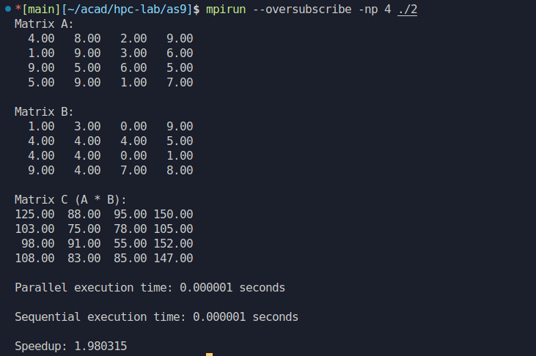Output :