## APPENDIX 1

**TITLE OF PROJECT:**

INCOME TAX CALCULATION SYSTEM FOR A SALARIED PERSON

**END TERM REPORT**

***by***

**Sumit Pradhan , Ravi Raj Kumar Singh,Anil Kumar Sharma**

Section: K19PT

Roll-Numbers: 50,40,39



**Department of Intelligent Systems,**

**School of Computer Science Engineering,**

**Lovely Professional University, Jalandhar**

November, 2020

## APPENDIX 2

**Student Declaration**

This is to declare that this report has been written by us. No part of the report is copied from other sources. All information included from other sources have been duly acknowledged. We assure that if any part of the report is found to be copied,

we shall take full responsibility for it.

Signature: Sumit Pradhan,

Ravi Raj Kumar Singh,

Anil Kumar Sharma

Name: SUMIT PRADHAN

RAVI RAJ KUMAR SINGH

ANIL KUMAR SHARMA

Roll Number: 50,40,39

Place: Lovely Professional University,Punjab

Date: 31/10/2020

**APPENDIX 3**

**TABLE OF CONTENTS**

**TITLE:** INCOME TAX CALCUATION SYSTEM A SALARIED PERSON

**5. Background and objectives of project assigned:**

**The objective of the project is to make a Income tax calculatiom system for a salaried person. In this we will take the information from the user and save it. The information will be like the amount of salary the person gets anually. The output would be the final amount of Tax the person has to pay. There will be a output giving the information of amount of tax to be paid.**

**6. Description of Project:**

**This project is helpful for calculation of tax a person has to pay. In this project we have fixed the rates of tax for salaries in different ranges. The user has to enter his annual salary and then the system will automatically calculate the tax the person has to pay.**

**7. Description of Work Division in terms of Roles among Students:**

**The work is done equally by three of us. We three have designed the project. Ravi Raj has made some part of Research work based on the topic , Sumit Pradhan has contributed in the development and designing of the project by helping with the codes. Anil has also contributed in the research and coding work.We all three have worked really hard to finish this project on time with utmost dedicationb,.**

**We made the project in two parts. First part is the research work in which we gathered information regarding how income tax is calculated and Second part is the desinging and coding of the project in which all the three had contributed their work and experience.**

**8. Implementation of scheduled work of Project:**

**It is the code for the project which shows how the project is made.**

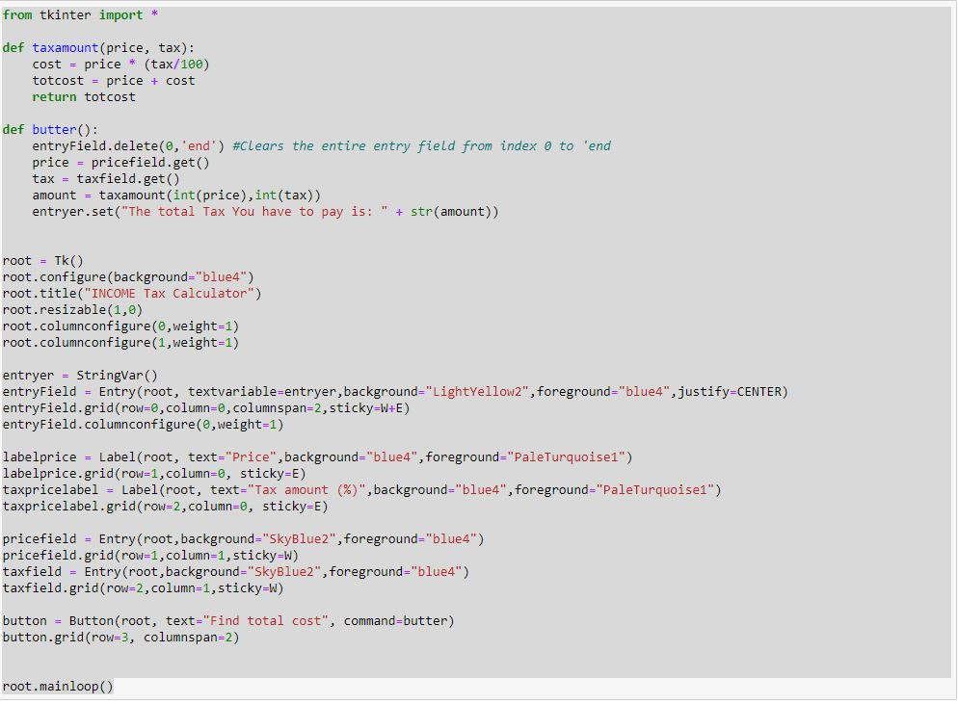

**It is the output of the income tax calculation system for a salaried person.**

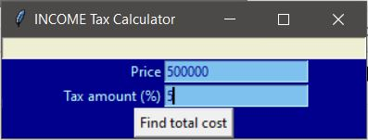

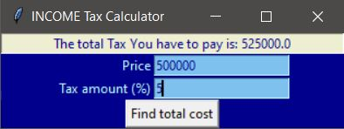

**The following information will be taken from the user and will save it as:**

**Price:_____**

**Tax Amount(%):________**

**Here the person has to enter his annual salary and the tax rate.**

**Then,**

**Output will be:**

**The Total Tax you have to pay is:_________**

**9.Technologies and Framework to be used:**

**Python and tkinter has been used to build this software.**

**The Platform for building this project is PyCHARM.**

**And it also has been tested on Anaconda and Jupyter.**

**10.SWOT Analysis:**

**Strength: Simple UI.**

**Eye Catching Design.**

**Weakness: No weakness.**

**Opportunities: Easy calculation of Income Tax of a salaried Person**

**Threats: No Threats.**

**REGISTRATION No.-11912387(SUMIT PRADHAN)**

**11918908(RAVI RAJ KUMAR SINGH)**

**11918826(ANIL KUMAR SHARMA)**