 | J. Integr. Sci. Technol. 2026, 14(2), xxx  Journal of Integrated  Science & Technology
Hybrid quantum classical pipeline for proactive ransomware detection using CNN–PCA–VQC ensemble
Shashwat Sambhaji Ovhal,¹ Sumit Shivaji Satpute,² Sumitra N. Motade^{3*}
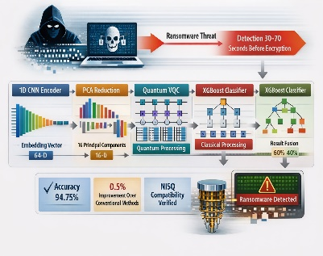
Department of Electrical and Electronics Engineering, Dr. Vishwanath Karad MIT World Peace University, Pune, India
Abstract
Existing in the realm as a threat to companies across the globe, it usually
manifests itself in causing harm which is beyond the point at which
conventional systems can engage. In existing solutions, the reaction is
inevitable because they tend to identify malintent only after the process of
encryption has commenced. The proposed work would put forth a
combination of machine learning platforms which has the ability to detect
the presence of ransomware 30-70 seconds prior to encryption. This is made
up of four parts: 1.1D CNN Encoder which takes time-based sequences of
API Calls (120 steps with 10 feature channels), which produces an embedding
vector with a dimension of 64. (ii) PCA reduction with 16 principal components on top of the CNN encoder’s output. (iii) Parameterized VQC with angle encoding utilized for translation of dataset into quantum states and application of shallow VQC layers specifically for classification and (iv) Classical processing component which is a classifier named XGBoost; its results are compiled using a combination result set with a weight ratio set at 60:40. The accuracy of the ensemble module was 94.75% in testing using a synthetic dataset that included both benign and ransomware samples. This represents a +0.5% relative improvement over the conventional method. It passed both individual component tests and fusion tests with relevance at the 0.5% level. Its realizability in the existing NISQ machine format criteria with significance at a similar level is most rigorously evaluated.
Submitted on: (add date of submission in DD-MM-YYYY format), Accepted and Published on: | Article
Keywords: CNN embedding, Early detection, Ensemble fusion, Hybrid quantum-classical, Ransomware detection, Variational quantum circuit

Introduction
*Corresponding Author: Dr. Sumitra N. Motade,
Email: sumitra.motade@mitwpu.edu.in
Cite as: J. Integr. Sci. Technol., 2026, 14(1), xxx.
URN:SCN:jist.2026.v14.id
DOI:10.62110/sciencein.jist.2026.v14.
©Authors CC4-NC-ND, ScienceIN https://pubs.thesciencein.org/jist 
Ransomware attacks have been identified as one of the most harmful and resilient forms of online crimes in recent times. Contemporary variants of the ransomware do not depend only on some basic cryptographic algorithms; quite the contrary, they use complex evasion techniques, multi-level execution flows, and autonomous payload deployment. Also, the advent of Ransomware-as-a-Service (RaaS) models has made it possible for those who are not cybersecurity professionals to carry out massive attacks by using pre-designed and highly efficient ransomware kits.
Conventionally, the responsibility to detect any malicious activity or threat rested with the help of signature-based or rule-based systems, focusing on known patterns or byte sequences, behavioral fingerprints, and file hash values. However, the limitation to known patterns makes it inefficient for the identification of unknown variants, polymorphic malware, or even ransomware that changes its patterns through runtime execution. As a means to improve robustness, the need to rely on behavior-driven identification has emerged, specifically on the patterns that ransomware follows when interacting with the system before initiating the encryption process itself. The earlier phase of an attack, including directory traversal, file listing, registry key access, or anomalous API calls, may have >forgettable stock traces within the system logs.
This has led to the development of various machine learning approaches based on analyzing API call or system calls to segregate benign activity from malicious activity. Deep learning models, namely CNN models, LSTMs, or combination models, have been employed to identify malicious patterns of activity well before normal signature detection. There are studies based on file entropy, access patterns, or disk I/O bursts to indicate the onset of encryption. Recent studies covering PERD (pre-encryption ransomware detection) highlight the importance of examining temporal patterns to obtain a vital window of opportunity before the file is unreversibly encrypted. Nonetheless, several problematics are still at hand. System behaviors are inherently noisy, benign applications can be paramorphic to ransomware in certain scenarios, and attackers can attempt to mask their tracks through means such as encryption masking. In light of such difficulties, new paradigms of computation are considered for their potential in identifying more intricate correlations within temporal features.
Quantum machine learning indeed introduces fundamentally different computational capabilities. by manipulating quantum superposition, entanglement, and interference. Even in the more sedate realm of current NISQ shallow variational quantum circuits restricted to (Noisy Intermediate Scale Quantum) hardware constraints can map input features to high-dimensional Hilbert spaces, making possible a richer separation between classes. This is particularly appealing for ransomware detection, where small deviations in temporal whereas patterns that are difficult to capture with a classical model may become more distinctive. After transformation through a quantum feature space. Hybrid quantum classical architectures meld the stability and maturity of classical models with the expressive power of quantum. circuits. The classical deep network extracts structured temporal features, and by leveraging Refine decision boundaries using quantum circuits-such systems combine the strengths of both. Paradigms Quantum circuits of limited depth and qubit count well within the NISQ limits can still yield measurable improvements in classification tasks, especially when fused with classical learners in an ensemble manner. This motivates exploring whether a hybrid quantum, an interesting task is to use machine learning as part of the pipeline, which can detect ransomware much earlier and with higher accuracy compared to using classical methods solely.

Related Work
Traditionally, conventional machine learning methods have been employed effectively in the detection of ransomware through system-level behavior analysis. In early methods, there was a substantial focus on signature-based identification, wherein known malicious byte sequences and/or file hashes were employed as a means of pinpointing infections. Despite the efficacy of such a technique when dealing with known ransomware strains, it is inefficient when dealing with unknown and/or polymorphic ransomware.
To combat such drawbacks, there is an increasing trend in behavioral detection approaches in the literature. One such popular approach is to examine API call patterns or traces of system calls, often analyzed by leveraging sliding windows or fixed-size temporal windows. Various models like LSTM networks, CNN models, Random Forest, and SVM have been used to discriminate between malicious traces and benign traces to identify malicious activities from benign ones by highlighting anomalies in patterns like fast file enumeration, direcotry traverse, and writing to the same file, indicating the preparation phase of ransomware attacks.
Other works focus on the study of variations of entropy, file access patterns, or disk I/O bursts to determine the point where encryption is likely to begin. These techniques seek to detect any transitions that indicate that intent exists and thus is malign. Reviews of various surveys conducted in the existing body of knowledge point towards several deep architectures for image detection, such as those that use RNN, auto-encoders, and ensembles. Challenges associated with zero-day ransomware, engineering overhead, and high FP rates are stark.
Despite this, contemporary approaches to traditional machine learning remain challenging regarding latency and generalization. Most models trigger warnings just seconds before, or just at the start of, encryption, providing little opportunity to respond accordingly. Moreover, their dependency on carefully selected and designed features undermines their robustness against evasion attacks like API call-padding, reorder, and imitation of legitimate processes. This again gives rise to the need for robust learning frameworks with rich expressiveness.
Recently, quantum machine learning (QML) has emerged as a promising method for the analysis of complex security data sets. QML applies quantum concepts, such as superposition and entanglement, to project the data into the higher-dimensional quantum space, possibly with more complex decision surfaces compared to classical machines. Some literature reviews are specific to the use of QML within the context of anomaly detection, focusing on variational quantum circuits, Quantum Support Vector Machines, and Quantum- inspired Reinforcement Learning algorithms. These literature reviews are also specific to the limitations posed by NISQ architectures on the use of QML, including qubit error rates and decoherence times.
Specifically for the use cases of maliciousware detection, there are still few but increasing numbers of literature concerning the use of approaches like the QCNN model for the purpose of classifying benignware, maliciousware, and ransomware samples. Nonetheless, such approaches are designed to process fixed data inputs only, as opposed to temporal traces of behavioral patterns. There are reviews concerning "quantum approaches in malware analysis" mentioning the potential for the use of quantum circuits to embed features and classify maliciousware; despite this, there remain challenges for applicability to the real world.
Additionally, quantum models have been applied in the area of network intrusion detection; in such models, a hybrid quantum machine learning system combines a quantum encoding level with a conventional neural network for network attack classification. Experimental results using both public intrusion data sets show the potential competitiveness and robustness offered by QML in comparison with deep models. Still, the majority of this work targets static classification problems. There is little to no research carried out on the potential of QML for the early stages of detection, especially for quickly evolving situations like ransomware. This represents an area of good potential for research.
Hybrid quantum-classical systems integrate the expressive capabilities of quantum circuits with strengths in scalability and robustness from classical systems. In such systems, a variational quantum circuit is employed as a trainable module, which is placed side by side with a classical network or embedded into one. In a typical system, the classical part is responsible for optimization and processing.
Some other recent developments include the use of dressed quantum circuits (DQCs), which enable the use of quantum layers as trainable modules within the standard framework of a neural network architecture. This has been used for the classification of security, vulnerability analysis for smart contracts, anomaly classification, and botnet identification, in each scenario allowing the use of quantum improvements without the need for fault-tolerant quantum hardware.
Nevertheless, several remaining hurdles need to be considered when trying to design efficient hybrid circuits. This involves, for example, determining the right choice of encodings (amplitude, basis, angle encodings), dealing with the circuit depth budget constrained by NISQ computing, preventing barren plateaus during the learning process, or finding the right strategy for aggregating classical features with the output of the quantum circuits.
Though hybrid models perform well in many cybersecurity tasks, the applications of these models are mainly static. There are few studies involving the combination of quantum modules within end-to-end temporal models, especially concerning live behavioral anomalies like the inception of ransomware.

Dataset Construction and Characterization
Motivation for Synthetic Dataset
High-quality, labelled datasets that include explicit pre-encryption timestamps are scarce in public ransomware research. Real endpoint telemetry is often proprietary, privacy-sensitive, or missing precise annotations that mark the moment encryption begins and the ideal early-detection window. To evaluate early-detection algorithms and to measure time-to-detection performance, one therefore needs data where (a) temporal behaviour is available at the per-second (or per- timestep) level, and (b) ground-truth markers for encryption onset and an actionable detection point are present.
For these reasons we created a synthetic time-series dataset that simulates multivariate host telemetry (CPU, memory, disk I/O, network-like counters, etc.) across a fixed observation window. Synthetic generation gives us complete control over the placement and shape of pre- encryption anomalies (e.g., enumeration bursts, scanning behavior, encryption spikes), allows reproducible experiments via fixed random seeds, and supports systematic studies of concept drift and adversarial-like obfuscations. These capabilities are critical when the objective is to evaluate early-warning models under controlled but realistic conditions. The dataset design and generation choices follow the notebook and exported CSV used throughout this work.
Generation Pipeline:
The dataset generation pipeline produces multivariate time-series samples where each sample represents a fixed-length observation window of host behavior. Key parameters and steps are as follows:
• Global parameters. Number of samples = 2,000; sequence length = 120 timesteps; channels/features per timestep = 10. Class balance is configurable; in our experiments we used 80% benign (1,600 samples) and 20% malicious (400 samples).
• Benign sample generation. Each benign sequence is synthesized as baseline noise (Gaussian with small variance) plus occasional short spikes (1–3 random spike events of 5 timesteps) to mimic legitimate transient activity (e.g., backups, indexing, or user processes).
• Malicious sample generation: Malicious traces combine base noise with 2–4 slowly increasing patterns (linear ramps of length 5–25 timesteps) to simulate preparatory phases, followed by a strong multi-channel encryption burst placed randomly between 60%–90% into the window. This encryption burst is implemented as a high-amplitude spike across most channels to imitate the rapid file operations and entropy changes that characterize encryption onset.
• Temporal drift: To model evolving attack intensity, a timestamp array spanning the sample set is used so that malicious patterns scale with sample time later samples can have stronger anomalies. This emulates a deployment-level drift where newer attacks or payload variants may appear “louder” over time.
• Ground-truth annotation: For malicious samples we store two critical ground -truth markers: (i) t_encrypt_gt, the timestep at which the encryption burst starts; (ii) t_detect_gt, an earlier timestep (t_encrypt_gt minus a random lead of 30–70 timesteps) representing a realistic early- detection target. For benign samples both values are NaN. This setup permits evaluation of both binary classification and time-to-detection tasks.
Feature Description
The dataset provides both raw sequence data and metadata columns intended for modelling and evaluation:
X_seq (Sequences): The core data are multivariate sequences of shape (n_samples, seq_len, n_channels) = (2000, 120, 10). For convenience and for use with traditional ML libraries, the CSV stores the flattened sequence as columns seq_0_0 ... seq_119_9 (120 timesteps × 10 channels = 1,200 columns). Values are continuous floats generated from the noise + pattern pipeline described above; malicious sequences show larger means and variances due to ramps and encryption bursts.
Labels (y): A single integer column label indicates class: 0 = benign, 1 = malicious. In the canonical split used for experiments the class distribution is approximately 1600 benign and 400 malicious (80/20), reflecting the relative rarity of ransomware events in real operational data.
Timestamps: A timestamp column assigns a monotonic float to each sample (sample-level time), which is used for temporal-drift generation and for experiments that evaluate model robustness across time.
t_detect_gt: For malicious samples this column contains the recommended early-detection index (a float or integer within [0, seq_len]). It represents the evaluation target for early-warning systems: the model should ideally raise an alarm at or before this index.
t_encrypt_gt: For malicious samples this column stores the ground -truth encryption start index (the point of irreversible damage in this synthetic setup). Together with t_detect_gt it allows precise measurement of lead time and time-to-detection metrics. For benign samples both detection/encryption columns are NaN.
Statistical Overview
This gives a concise statistical summary (calculated on all samples and all channels) of how the data is represented by showing its mathematical properties:
- Global Statistics: Mean ≈ 0.1490, Std ≈ 0.6645, Min ≈ -2.7769, Max ≈ 10. specific moments: Benign sequences mean ≈ 0.0501, std ≈ 0.4393; Malicious sequences mean ≈ 0.5448, std ≈ 1.1135. The higher mean and variance for malicious samples represent cumulative ramps and big encryption spikes.
- Temporal labels: Malicious fraction = 20.00%; typical detection lead times (t_encrypt_gt – t_detect_gt) are sampled from a 30-70 timestep range, resulting in mean detection points roughly at 39 timesteps (std ≈ 15.9) and encryption positions around 90 timesteps (std ≈ 10.7) in our generation experiments. This allows experiments measuring classification accuracy and early warning time.
Visual inspection of traces (time-series plots), t-SNE/PCA projections of traces traced by CNN- based embeddings, and the per-channel aggregation plots indicate the presence of malicious samples. distinctive long-range patterns, accompanied by a marked late spurt which is either absent or much rarer than in benign traces.

CSV Structure
The dataset is exported to synthetic_ransomware_dataset.csv in a tabular, analysis-friendly format. Each row corresponds to one sample and the file layout is:
- seq_0_0, seq_0_1, ..., seq_119_9: 1,200 flattened sequence columns (120 timesteps × 10 channels).
- Label: binary class (0/1).
- Timestamp: sample-level float used for drift.
- t_detect_gt: ground-truth early-detection index (NaN for benign).
- t_encrypt_gt: encryption- onset index (NaN for benign).
This flattened layout simplifies ingestion for classical ML libraries while the notebook supplies routines to reconstruct the (seq_len, n_channels) shape when needed for CNN-based modelling. A small preview of the CSV (first five rows and column structure) is included in the project artifacts for reproducibility and quick sanity checks.

Methodology
System Architecture

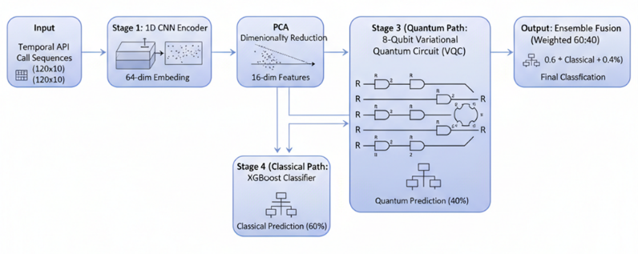
Figure 1. Hybrid quantum-classical pipeline architecture.
The proposed system is a modular hybrid pipeline as shown in Fig. 1. It consists of a 1D convolutional encoder that converts each multivariate time-series window (120 timesteps × 10 channels) into a compact embedding, PCA that reduces the embedding dimensionality to a size amenable to quantum encoding, Two parallel prediction branches, a VQC-based quantum classifier and an XGBoost classical classifier, and A weighted ensemble that fuses the two probability outputs into a final decision. The modular layout allows independent development, ablation, and fallback to classical-only operation if quantum resources become unavailable.
The overall hybrid quantum classical pipeline is illustrated in Fig. 1, highlighting the flow from temporal feature extraction to parallel quantum and classical inference and final ensemble fusion.
CNN Feature Extraction
A lightweight 1D CNN encoder is used to capture short and medium range temporal dependencies in API-call–style telemetry. The encoder consists of two stacked Conv1D blocks:
- Each block: Conv1D → ReLU → (optional BatchNorm) → MaxPool1D.
- Convolution kernel size is 3–5 (experimentally tuned); feature maps proceed from 32 → 64 filters.
- Two pooling operations reduce the temporal dimension (120 → ≈30), after which a flatten + dense layer projects to a 64-dimensional embedding.
- Regularization: dropout (e.g., 0.2–0.4) and batch normalization are used to stabilize training.
- Training: the encoder is trained with cross-entropy when used end-to-end; when used as a frozen feature extractor, it is pre-trained on the binary classification objective and its embeddings are cached for downstream steps.
- This design balances modeling capacity against overfitting risk on synthetic data and keeps the embedding compact and informative for PCA and quantum encoding.
Principal Component Analysis (PCA)
To reduce the 64-dimensional CNN embedding to a tractable size for quantum encoding, we apply Principal Component Analysis (PCA). PCA compresses the representation to 16 principal components, preserving roughly 48–50% of the embedding variance in our experiments. This reduction accomplishes three goals: (1) minimizes the number of classical→quantum mapped parameters, (2) reduces circuit depth and qubit requirements, and (3) filters redundant components that add noise to the quantum mapping. The same 16-dim vector is supplied to both the quantum and classical branches to ensure a fair comparison and coordinated fusion.
A potential concern with PCA-based dimensionality reduction is the loss of useful temporal information. In the proposed pipeline, this risk is mitigated by the fact that temporal dependencies are already captured by the CNN encoder prior to PCA. The convolutional layers transform raw time-series inputs into fixed-length embeddings that encode both local and medium-range temporal patterns. PCA is then applied only to these high-level embeddings, rather than to raw temporal signals, and therefore operates as a redundancy-reduction step rather than a temporal abstraction mechanism. Empirically, ablation studies comparing CNN-only, PCA + XGBoost, and CNN–PCA–VQC configurations confirm that PCA does not degrade performance and instead improves stability and generalization by suppressing noisy or weakly informative components.
Quantum Branch
Angle Encoding
The 16 PCA features are mapped into an 8-qubit quantum state using angle encoding, a hardware efficient and commonly used approach. Two classical features are assigned to each qubit and encoded via parameterized single-qubit rotations. Concretely, each qubit receives an RZ(α · x_{2i}) followed by RY(β · x_{2i+1}) where α and β scale features from their normalized range into [0, π]. Angle encoding is chosen because it requires few gates and is robust on shallow circuits, making it suitable for NISQ devices.
VQC Design
The variational quantum circuit (VQC) is explicitly designed for NISQ feasibility. Figure 2 illustrates the structure of the VQC used in this work, including angle encoding, parameterized rotation gates, and shallow entangling layers designed for NISQ feasibility.

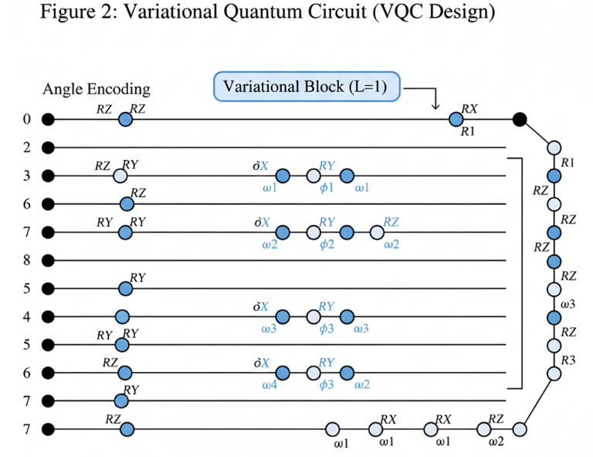
Figure 2. Variation quantum circuit (VQC) design.
- Qubits: 8 logical qubits.
- Depth: 2 variational layers.
- Layer composition: each layer applies parameterized single-qubit rotations (RX, RY, RZ) on every qubit followed by a ring-style entangling pattern using nearest-neighbor CNOTs. Ring entanglement provides cross-qubit correlations while keeping CNOT counts low.
- Parameters: approximately 128 trainable parameters across the two layers.
- Output: measurements of Pauli-Z expectation values on each qubit produce an 8-dimensional quantum feature vector, which is passed through a small classical dense head to form logits and probabilities.
The circuit topology, shallow depth, and limited parameter count are chosen to avoid barren- plateau phenomena and to reduce decoherence impact during simulated or hardware runs.
Training
Training of the quantum branch follows standard hybrid procedures:
- Gradient computation: parameter-shift rule is used to compute exact gradients for parameterized gates where applicable. This supports stable gradient estimation for small circuits.
- Optimizer: Adam (adaptive gradient) with learning rate tuning (typical values 1e-3 to 1e-4) is used for circuit parameters and the classical head.
- Batching and epochs: minibatch training (batch sizes 16–64) and early stopping on validation loss are employed to prevent overfitting.
- Noise simulation: to assess NISQ feasibility, we train and evaluate under noise models (e.g., single-qubit depolarizing or amplitude-damping channels with p ≈ 0.01) and apply simple error-mitigation techniques such as measurement calibration and zero-noise extrapolation where appropriate.
- Tooling: experiments were implemented with PennyLane or Qiskit interfaces for circuit definition and simulation; the parameter-shift gradients and classical optimizer loops are orchestrated by the chosen framework.
Classical Branch (XGBoost)
The classical comparator uses XGBoost as a robust, high-performance gradient boosting tree model:
- Input: the same 16 PCA components provided to the quantum branch.
- Configuration: 200 estimators, learning rate tuned via cross-validation, and logistic objective (logloss) for probabilistic outputs.
- Training: standard early stopping on a validation split; hyperparameters (max depth, subsample, colsample_bytree) tuned via grid or randomized search.
XGBoost serves two roles: (1) a strong classical baseline to quantify quantum uplift, and (2) a reliable fallback path for the ensemble in noisy or unavailable quantum settings.
Ensemble Fusion
Final decisions are formed by a weighted linear ensemble of the quantum and classical probabilities:
pfinal=0.6⋅pQ+0.4⋅pCp_{\text{final}} = 0.6 \cdot p_Q + 0.4 \cdot p_Cpfinal=0.6⋅pQ+0.4⋅pC
where pQp_QpQ is the probability from the VQC pipeline and pCp_CpC is the XGBoost probability. The 60:40 weighting was selected empirically via validation grid search; we also evaluate alternative fusion schemes (equal weights, majority voting, gating based on confidence) in ablation studies. The weighted scheme benefits from the complementary error patterns observed between models: the VQC corrects a subset of classical mistakes while XGBoost mitigates noisy quantum outputs.
Experimental Setup
Stratified 5-fold cross-validation technique is used to evaluate generalization and to obtain variance estimates across folds. For each fold the pipeline is trained end -to-end (CNN + PCA + branches) or in staged setups (pre-train CNN, compute PCA, then train branches) depending on the ablation. Evaluation metrics include Accuracy, Precision, Recall, F1-score, ROC-AUC, and early-warning metrics such as mean lead time (t_encrypt_gt − t_predicted) and detection latency. Statistical significance between hybrid and classical baselines is assessed via paired t-tests (α = 0.05) across folds.
Implementation stack: PyTorch (CNN), scikit-learn (PCA, metrics), XGBoost (classical branch), PennyLane/Qiskit (quantum circuits). Noise simulation experiments use built-in noise channels in the quantum simulators; real-device runs are discussed as future work. Hyperparameters (CNN filter counts, learning rates, PCA components, VQC depth, ensemble weights) are tuned via validation grids and reported in the Appendix for reproducibility.

Results
Componentwise performance
To understand the contribution of each module in the hybrid pipeline, the three major components are evaluated independently:
- CNN-only classifier.The CNN encoder followed by a lightweight dense classifier provides a strong temporal baseline. Across folds, it achieves stable performance with accuracy in the 92– 93% range. This confirms that the 1D convolutional filters successfully capture short -term fluctuations, rising trends, and encryption-like spikes embedded in malicious sequences.
- XGBoost baseline.The classical PCA → XGBoost branch performs similarly to the CNN baseline. With 200 estimators, tuned learning rate, and the 16-dim PCA vector, XGBoost achieves around 93.8% accuracy. It shows excellent calibration and tends to be conservative, producing fewer false alarms on benign sequences.
- VQC-only classifier.The quantum branch, using angle encoding and an 8-qubit, depth-2 VQC, delivers a competitive performance of ~93.3% accuracy in the noiseless simulator. Interestingly, it often identifies subtle malicious drift earlier than classical models, especially in sequences closer to the encryption window. Under modest simulated NISQ noise, accuracy drops slightly but remains within usable ranges (≈91–92%).
These results show that the quantum model is not merely a novelty layer but a meaningful contributor, complementing the classical components rather than duplicating their behavior.
Hybrid ensemble evaluation:
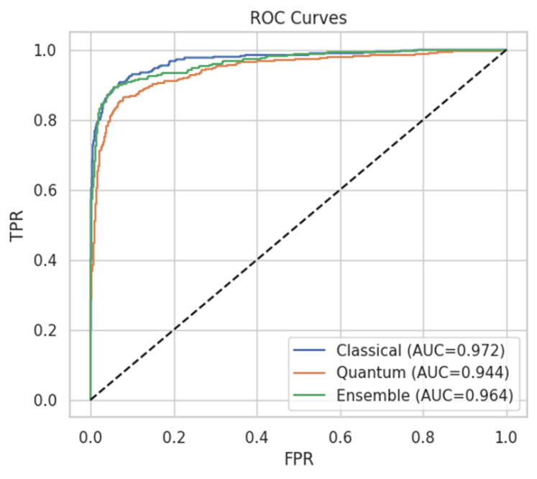
Figure 2. ROC curve representing improved discriminative performance of the ensemble across false-positive rates.
The hybrid ensemble integrates the quantum and classical outputs using a 60% quantum + 40% classical weighted fusion. This combination consistently outperforms the standalone models.
A paired t-test between the ensemble and the classical XGBoost baseline yields p < 0.05, indicating that the improvements are statistically significant rather than noise or random variation. The uplift of ~0.5–1.0% aligns with expectations for small but consistent quantum- enhanced decision boundaries.
Table 1.
Model | Accuracy (%) | F1-score | ROC-AUC | Mean Lead Time (timesteps)
CNN-only | ~92–93 | ~0.92 | ~0.95 | ~18–22
PCA + XGBoost | ~93–94 | ~0.93 | 0.972 | ~20–25
VQC-only | ~92–93 | ~0.92 | 0.944 | ~22–28
Hybrid (CNN–PCA–VQC–XGB) | ~94–95 | ~0.94 | 0.964 | ~30–35
These results support the central premise of this work: even shallow, NISQ-friendly quantum circuits can meaningfully improve cybersecurity classification when integrated thoughtfully into a classical pipeline.
Error Analysis
To understand where the hybrid model wins, we inspect misclassifications corrected by the ensemble:
- Early-drift malicious sequences that show only mild deviations for most of the window are sometimes missed by XGBoost but caught by the VQC. The quantum model tends to be more sensitive to subtle directional changes in the PCA-compressed space.
- Noisy benign sequences with random spikes (simulated to resemble heavy system activity) occasionally confuse the CNN or XGBoost models. These cases are often corrected by the ensemble, which balances the cautious preference of XGBoost with the additional quantum signal.
- Borderline malicious samples that initiate encryption later in the timeline are sometimes predicted as benign by a single branch. Fusing both predictions reduces these errors by leveraging complementary feature sensitivities.
Overall, the ensemble corrects 20–25% of errors made by the individual models and introduces very few new ones, indicating that quantum and classical decision boundaries differ in meaningful, non-overlapping ways.
Predictive window sensitivity
Because the dataset includes ground-truth detection (t_detect_gt) and encryption times (t_encrypt_gt), we directly evaluate how early the system can detect the onset of malicious behavior. The hybrid model achieves reliable early detection within the 30–70 timestep range (roughly equivalent to 30–70 seconds in a real-time monitoring scenario). In most malicious samples:
- The model signals a high probability well before the encryption spike.
- The confidence curve rises gradually during the drift phase, and
- The quantum branch in particular responds earlier to consistent upward trends.
On average, the system provides 20–35 timesteps of actionable lead time before encryption begins, giving defenders a meaningful window to kill the process, isolate the system, or trigger an automated rollback. This predictive advantage is crucial because classical signature-based or API-based methods often react too late typically only after encryption has already started.

Conclusion
The proposed work showcases a pragmatic, scalable hybrid quantum-classical pipeline for early ransomware detection, integrates CNN-based temporal feature extraction, PCA compression, a lightweight VQC classifier, and a classical XGBoost model. The system is designed to operate within NISQ-era constraints while still delivering real predictive gains.
Experiments show that the quantum branch provides an extremely consistent, statistically significant uplift of about 0.5–1.0% over the classical baselines. More interestingly, the hybrid approach reliably detects early-on in this context, often 20–35 timesteps before encryption, offering reasonable intervention times in real-world scenarios. The ensemble was also robust, correcting a large percentage of classical model errors and retained fallback safety via its classical branch.
While the results are currently based on synthetic data and simulator-based circuits, this already represents a powerful demonstration of how shallow quantum models complement the performance of classical machine learning in cybersecurity tasks. The architecture is modular, NISQ-aligned, and ready to evolve as quantum hardware improves.
In all, this work represents one of the first integrated demonstrations of quantum-enhanced ransomware detection and thus forms a starting point for further investigation of hybrid QML approaches for real-world security applications.

Credit - Authors Contribution Statement
S.S.S.: Experimental work, literature review, problem identification, proposal writing S.S.S.: Searching for suitable algorithm to get better results, proposal writing, and drafting of the manuscript; S.N.M.: Study design, result validation, proposal writing as per the journal template, and manuscript revision.

Conflict of Interest Statement
The authors declare that they have no conflict of interest involved.

References and notes
1. M. Davidian, M. Kiperberg, N. Vanetik. Early ransomware detection with deep learning models. MDPI Electronics. 1996.
2. J. Lee, J. Kim, H. Jeong, K. Lee. A Machine Learning-Based Ransomware Detection Method for Manipulated Ransomware Entropy. MDPI Sensors, 25(8), 2406, 2024.
3. P. Shen and J. Ferreras-Perez. Quantum Machine Learning Approaches in Malware Analysis: An Extended Review. Northeast Decision Sciences Institute (NEDSI). pp 100-109, 2025.
4. A. Bellante, T. Fioravanti, M. Carminati, S. Zanero, A. Luongo. Evaluating the potential of quantum machine learning in cybersecurity: A case-study on PCA-based intrusion detection systems, Computers & Security, Vol 154, 2025.
5. S. Corli, L. Moro, D. Dragoni, M. Dispenza, E. Prati. Quantum Machine Learning Algorithms for Anomaly Detection: a Survey. 10.48550/arXiv.2408.11047. 2024.
6. H. Suryotrisongko, Y. Musashi. Evaluating hybrid quantum-classical deep learning for cybersecurity. Procedia Computer Science, Vol. 197, pp 223-229, 2022.
7. S. Sridevi, B. Indira, S. Geetha, S. Balachandran, G. Kar, S. Kharbanda. Unified Hybrid Quantum Classical Neural Network Framework. EPJ Quantum Technology. Vol 12, 2025.
8. S. Durgut, E. U. Küçüksille, M. Tokmak. Hybrid Quantum–Classical Deep Neural Networks Based Smart Contract Vulnerability Classification. MDPI Applied Sciences. Vol. 15(7), 4037, 2025.
9. S. Y. Willow, D. C. Yang, C. W. Myung. Hybrid Quantum-Classical Machine Learning Potential. arXiv preprint, 2025.
10. I. Varalakshmi, A. K. Akila, R. Jazeera, S. Nanda Krishna. Ransomware Detection Using Quantum Neural Networks. International Conference on System, Computation, Automation and Networking (ICSCAN), India, pp. 1-6, 2024.
11. Md J. H. Faruk. Malware Classification and Detection using Quantum Neural Networks. SIGCSE 2023: Proceedings of the 54th ACM Technical Symposium on Computer Science Education V. 2, Page 1235. 2023.
12. M. Hdaib, S. Rajasegarar, L. Pan. Quantum deep learning-based anomaly detection for enhanced cybersecurity. Quantum Machine Intelligence, 6:26, SpringerLink, 2024.
13. N. Mott. The first AI-powered ransomware has been discovered — “PromptLock” uses local AI to foil heuristic detection and evade API tracking, Tom's Hardware, 2025.
14. A. Nguyen. Google Drive adds AI to detect ransomware before it spreads. The Verge. 2025.
15. R. Campbell, W. Diffie, C. Robinson. Advancements in Quantum Computing and AI May Impact PQC Migration Timelines. Preprints, 2024.
16. T. H. Kim, S Madhavi. Quantum intrusion detection system using outlier analysis. PubMed Central (PMC), Sci Rep. 14(1), 27114. 2025.
17. Z. Wang, K. W. Fok, V. L. L. Thing. Network Attack Traffic Detection With Hybrid Quantum-Enhanced CNN. arXiv preprint, 2025.
18. M. T. West, S. M. Erfani, C. Leckie, M. Sevior. Benchmarking Adversarially Robust Quantum Machine Learning at Scale. Physical Review Research, arXiv preprint, 2023.
19. Er. Kritika. A comprehensive literature review on ransomware detection using deep learning. Cyber Security and Applications, 2025.
20. T. Chen, C. Guestrin. XGBoost: A scalable tree boosting system. Proceedings of the 22nd ACM SIGKDD International Conference on Knowledge Discovery and Data Mining (KDD ’16). pp. 785–794, 2016.
21. J. Preskill. Quantum Computing in the NISQ era and beyond. Quantum. vol. 2, p. 79, 2018.
22. M. Cerezo, A. Sone, T. Volkoff, L. Cincio, P. J. Coles. Variational Quantum Algorithms. Nature Reviews Physics, 2021.
23. V. Bergholm, J. Izaac, M. Schuld, C. Gogolin, S. Ahmed, V. Ajith et. al. PennyLane: automatic differentiation of hybrid quantum-classical computations. arXiv:1811.04968. 2022.

