1. **Methodology**

**Research and Analysis**: Thoroughly scrutinizing and mustering data in order to have a clear picture of our project’s progress.

**Design**: Designing the algorithms used in the project.

**Implementation**: Implementing the algorithms using the best and worst case scenarios.

**Coding**: After the completion of research, designing coding phase initiation.

**Testing and Debugging**: After coding phase has been completed testing is done and the bugs arising will be removed in the debugging cycle.

If a fixed width of strip is counted, and if all organisms in the strip are seen, estimates of population size are simple, because strips are just long thin quadrats. In practice some organisms are undetected as one moves along a transect and in these cases it is best not to limit observations to a fixed strip width. Because individuals are missed, an undercounting bias occurs. In these cases estimation of population density is more difficult because we need to estimate the detection function (Figure 3). Figure 3 shows that in general the detectability will fall off with distance from the center line of the transect. If we can make 4 assumptions we can estimate population density from the detection function. We must assume:

1. Animals directly on the transect line will never be missed (i.e. their detection probability = 1).

2. Animals are fixed at the initial sighting position; they do not move before being detected and none are counted twice.

3. Distances and angles are measured exactly with no measurement error and no rounding errors.

4. Sightings of individual animals are independent events.

There is a key assumption of uniformity that is critical to line transect sampling. We must assume that the items being sampled are distributed at random in the landscape so that no matter where we place the line transect we would get the same shaped detection function.

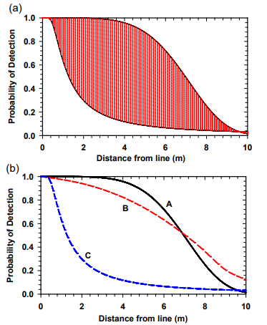

Figure.3 Some possible detection functions of line transect surveys.

The basic idea of these models is that the probability of detection fall off the farther an animal is from the line transect baseline. (a) The shaded area encloses the general zone for detection functions for wildlife populations. (b) The detection function for any particular set of data may take a variety of shapes, and the statistical problem is to decide what mathematical function to use and what values of its parameters fit best. The generalized exponential (A), the half-normal (B), and the Hayes and Buckland (1983) function (C) are illustrated here. Note that for all these detection functions, the area under the function represents the items counted and the area above the function represents the items missed.

If these assumptions are valid, we can estimate the density of the population by:

$$D=n/2La$$

Where

D = Density of animals per unit area

n = Number of animals seen on transect

L = Total length of transect

a = Half the effective strip width (a constant which must be estimated)

The constant a is simply the total area under the detection function and it estimates how wide the strip width would be if every organism was seen and none were missed. It is scaled in the same units of measurement as the lengths.