1. **Research**

A transect line is searched and each animal seen provide one measurement of the perpendicular distance to the transect line. Since in practice animals are often seen along the line, three measurements can be taken for each individual sighted.

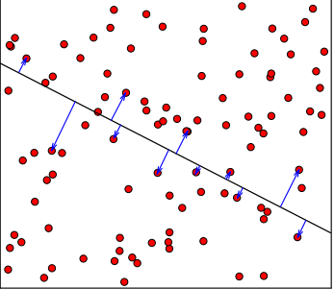

Figure 1 Schematic view of the method of line transect sampling.

The census zone is the whole area of the square. Only one transect is shown for illustration. The observer moves along the transect line and the distances indicated by the blue arrows are measured to the animals seen. In this example 13 animals were seen (including two right on the transect line). Transect lines may be traversed on foot, on horseback, in a vehicle, or in a helicopter or airplane.

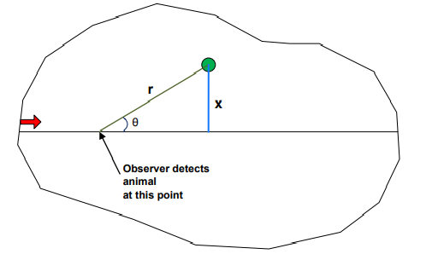

Figure 2 Illustration of the basic measurements that can be taken for each individual (green dot) sighted along a line transect.

(Figure 2): 1. Sighting distance (ri) 2. Sighting angle (Θi) 3. Perpendicular distance (xi)

The key measurement is the perpendicular distance (x, blue line). If the sighting distance (r, green line) is easier to record in the field, the sighting angle (θ)must also be measured. The perpendicular distance x = r sin(θ)