Ray AI Platform assignment submission
Prepared by Sumit Sharma for the DevOps and Platform Engineering assignment.
The implementation runs a corporate data pipeline on Kubernetes using Ray Data, a dedicated EntityResolver actor, transactional Apache Iceberg updates and CPU revenue-model training. The repository includes separate Terraform state layers, EKS and KubeRay, scoped workload identity, OIDC delivery, monitoring and centralized AWS logs. Evidence distinguishes completed cloud tests, the local rehearsal and prepared changes that have not yet been validated in AWS.
Repository: https://github.com/SumitSharma-DevOps-3107/contexq-assignment Review branch: codex/security-hardening Pull request: https://github.com/SumitSharma-DevOps-3107/contexq-assignment/pull/2

Requirement review
The assignment permits amendments to its skeleton. The executable is python -m ray_platform.pipeline; the implementation replaces the simulated LLM/hash resolver with deterministic identity keys. No LLM credential or GPU is needed for this synthetic fixture. It does not claim real-world fuzzy matching.
Assignment requirement | Implementation and evidence | Qualification
Two CSV datasets with at least 1000 rows each | datasets.py creates 1200 rows per source; 2400 input rows produce 1800 companies | Synthetic fixture
Resolve entities and transactionally update Iceberg | SHA-256 identity from country and normalized registration ID; real catalog commit and repeat/update tests | Single writer; not a distributed join
Revenue prediction from harmonized data | Training reads committed table; RandomForest uses 1440 training and 360 held-out companies | Synthetic accuracy; CPU driver training
Decoupled Terraform layers and managed Kubernetes | bootstrap, data, compute, platform and ci states; EKS module | Private access required for platform
Buckets and Iceberg catalog | S3 and Glue; cloud-validation-summary.json | Existing versions require separate encryption migration
KubeRay and separate node pools | On-Demand system pool and autoscaled Spot worker pool | One system node is not HA
Spot cost and resilience strategy | FIS interruption terminated one worker; actor recovered elsewhere; idempotent rerun | Head failure and distributed training checkpointing not tested
Ray Data and Train configuration explanation | README and scaling-and-alternatives.md cover resources, object stores, shared memory and distributed trainer configuration | Distributed Ray Train is design-only
EntityResolver placement | Ray custom resource plus pool labels and worker taint; placement evidence | Worker capacity required
Workload identity and access boundaries | Driver/actor IRSA verified; state-bucket access denied | Least privilege demonstrated, not a complete zero-trust certification
PR Terraform plan | OIDC and private CodeBuild; successful historic PR plan | Cloud CI deliberately paused between demo windows
Merge image build and RayJob execution | Successful recorded merged release, ECR digest and RayJob cleanup | New golden-image gate still blocks vulnerable candidates
Prometheus metrics | Head/worker, task, CPU and active-cluster families verified | Ephemeral short retention
Secure Ray Dashboard | Loopback forwarding and token authentication; unauthenticated request returned 401 | No public ingress
Centralized head and worker logs | Fluent Bit and scoped IRSA to CloudWatch; observability-validation.json | Ray UI capture shows driver logs; separate CloudWatch API evidence
Repository, setup, diagram and serverless alternative | README, infra documentation, diagram and managed alternative below | Final review branch must be included in handoff

Architecture
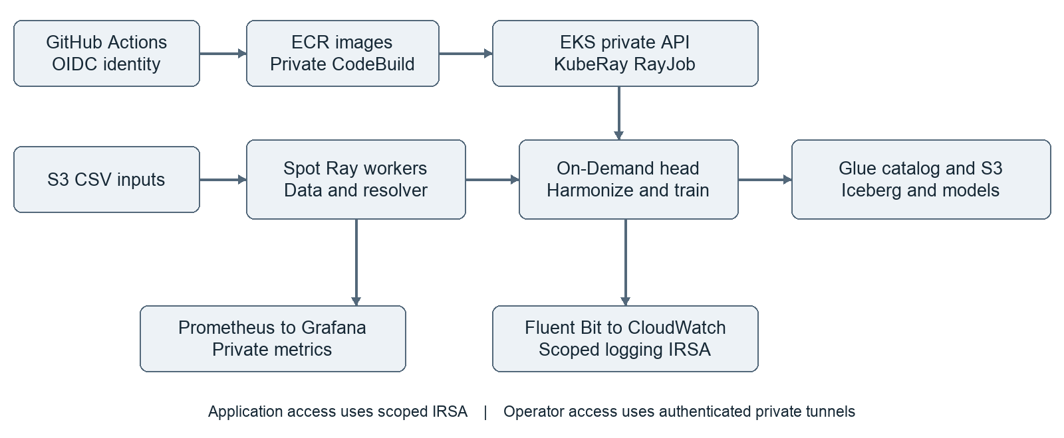
Cloud data path: S3 CSV inputs → Ray Data workers → EntityResolver actor → driver harmonization → Iceberg table in S3 with Glue catalog → model and metrics in S3. The head advertises zero task CPUs; the actor requests the entity_resolver custom resource available only on the worker group. Kubernetes labels and taints enforce physical separation. The local equivalent uses a SQLite catalog and filesystem warehouse solely for reproducibility.
Delivery path: GitHub Actions → repository-scoped OIDC → ECR image build and private CodeBuild → EKS RayJob. PR plans do not apply infrastructure. The platform layer owns KubeRay, autoscaling and collectors; application pods use scoped IRSA, separate from the provisioning role. Prometheus feeds Grafana; Fluent Bit sends head and worker stdout/stderr to CloudWatch. Dashboards remain private.

Local setup
Prerequisites: Docker Desktop, Python 3.11, kind, kubectl, Helm, make and Git. The tested ARM64 Mac has 16 GiB RAM; Docker is allocated 6 CPUs and about 8 GiB. Use synthetic data only. A fresh machine needs internet access for pinned tools, images and Python dependencies.
git clone https://github.com/SumitSharma-DevOps-3107/contexq-assignment.git
cd contexq-assignment
git checkout codex/security-hardening
bash scripts/install-kubectl.sh
export PATH="$PWD/.tools:$PATH"
make preflight
make setup
make test
make run
make image-offline
make local-up
make submit
make status
Inspect RayJob status and logs using the explicit kind-ray-assignment context. Outputs persist under runtime/kubernetes across Ray cluster lifecycles. Submit a second job after completion: inserts and updates should both be zero and the Iceberg snapshot should remain unchanged. make local-down removes only the named kind cluster and preserves outputs.
For Grafana run bash scripts/grafana-local.sh; use localhost port 3000 and the private runtime password file. Never publish credentials or raw runtime files. The screenshot rehearsal retained its Ray cluster temporarily by removing TTL when shutdownAfterJobFinishes was false, then explicitly removed both test jobs. Normal jobs keep automatic cleanup. Run bash scripts/test-monitoring-alerts.sh to validate alert pending, firing and recovery against deterministic fixtures.

AWS setup and teardown
Use Singapore ap-southeast-1 with the authorized assignment profile. Authentication is browser login followed by role assumption; no static keys are stored in Git. The reproducible private-access and screenshot procedure is in docs/eks-walkthrough.md. Source scripts/aws-env.sh, verify account identity and gross spend, and generate ignored configuration with scripts/aws-configure-project.py. Set an explicit bounded lease; configuration generation does not silently extend an old deadline.
Apply reviewed plans in dependency order: bootstrap, data, compute, then platform from private connectivity. Initialize each remote layer with its backend.hcl. The ci layer requires compute and data outputs. Current source uses private-only EKS access and customer-managed encryption keys. The earlier /32 public API setup is historical and must not be copied into a new deployment. Use an authenticated private path and retain TLS certificate verification.
Upload generated CSVs to the private data bucket input prefix. Use an immutable ECR digest with scripts/render-aws-job.py and submit through the private API. Verify SUCCEEDED, S3 artifacts, Glue table metadata, workload identity, the denied state-bucket read, and repeat-run idempotence. Confirm Prometheus targets and CloudWatch streams for both node types. Do not enable cloud CI until its settings, network path, image policy, budget and lease checks all pass.
Destroy platform while the API is reachable, followed by compute and any dependent CI networking resources in the documented order. Confirm node groups, cluster, NAT and EIP are gone. Retain state, evidence and storage keys while encrypted data or versions need them. The lease guard is a fallback; delayed billing and async cleanup mean it is not a hard dollar cap.

Module and delivery design
infra/modules/eks contains separate variables, locals, outputs and version constraints, validated node-pool inputs, dynamic worker taints and instance/volume tags. The stable system/worker resource addresses avoid needless state moves. The root pins provider versions and lock files; the reusable module declares a compatible version range. Its VERSION and CHANGELOG describe 1.0.0-rc.1; no remote release tag is claimed. Pin a reviewed commit for Git consumption.
Security checks include source and resolved-plan scanning, secret scanning, conventional PR titles, local hooks and required CI. Peer approval is temporarily paused at the owner's request; restoration policy is retained. The public GitHub Free repository contains sanitized evidence only. Atlantis is a plan-only configuration, not a live webhook service. These distinctions are intentional.

EKS validation
On 26 October 2026, the refactored module provisioned EKS 1.34 in Singapore with a private-only API and KMS secrets encryption. Both managed node pools became Ready. Operator access used Systems Manager and a loopback CONNECT bridge with the original hostname and CA verification. No ALB, domain or public ingress was created. The bounded lease expires at 09:19:05 UTC that day.
RayJob eks-screenshots-fz4wk succeeded. Its Ray submission eks-screenshots-fz4wk-wbpbn completed at 07:48:26 UTC in 15.072 seconds. The pipeline read 2400 S3 input rows and produced 1800 companies against the existing Glue/Iceberg table, with zero inserts and zero updates on this repeat run. Driver and worker identities both used the scoped pipeline IRSA role. Prometheus verified two healthy Ray targets. Fresh CloudWatch events from both ray-head and ray-worker were collected for this run. Unauthenticated Grafana and Ray API requests both returned HTTP 401. Alert fixture tests passed inside EKS.
The run used the previously tested immutable ECR digest ending in 0c16a242adeb4. This was a manual evidence execution, not golden-image promotion or a rerun of paused cloud CI. Earlier checks verified SSE-KMS state writes and data-bucket defaults. Existing object versions and CI artifact encryption were not migrated in this run. Machine-readable evidence is in docs/evidence/eks-rehearsal/final-capture-run.json.
At 13:34 UTC on 26 October, AWS confirmed the EKS cluster absent, with no assignment EC2 instances, active NAT gateways or allocated Elastic IPs in Singapore. Retained storage, encryption keys and CloudWatch logs remain. Out-of-band compute cleanup requires Terraform refresh and reconciliation before the next deployment.

Demonstration evidence
These four screenshots show the actual EKS environment on 26 October 2026, accessed through localhost tunnels. The separate local rehearsal remains in docs/evidence/rehearsal. Full-resolution cloud captures are in docs/evidence/eks-rehearsal.
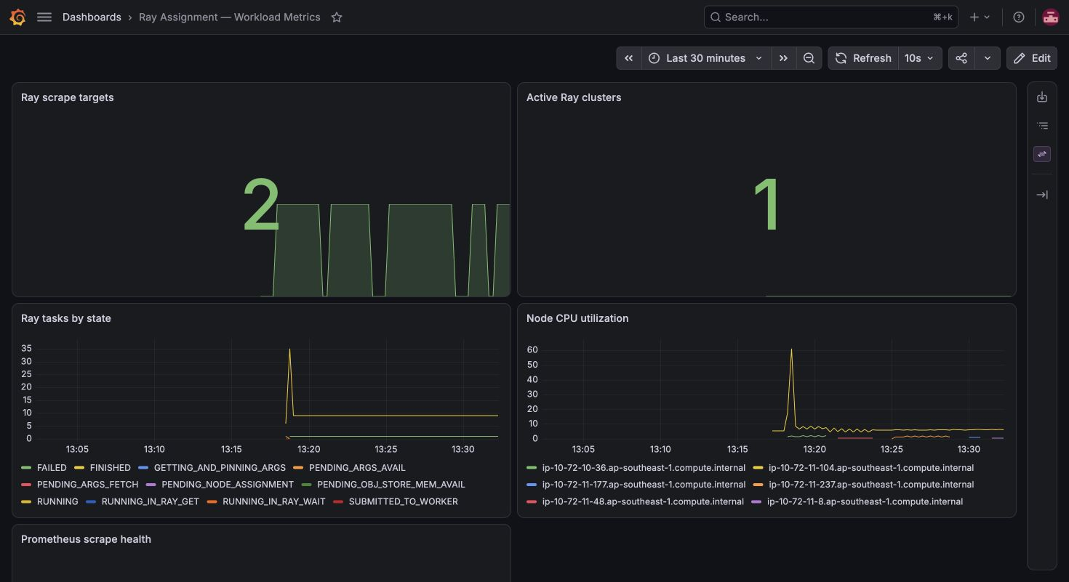
Two scrape targets and one retained Ray cluster. Grafana uses Asia/Kolkata time. The gaps show worker turnover during the retained demonstration window.
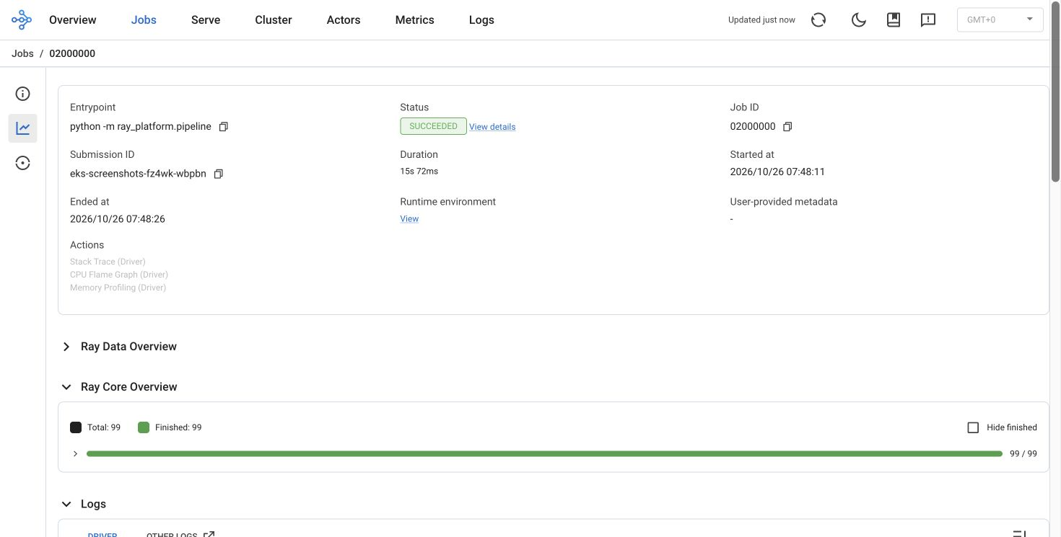
Submission eks-screenshots-fz4wk-wbpbn succeeded in 15.072 seconds. Ray timestamps are UTC. The retained cluster continued reporting task counters after completion.
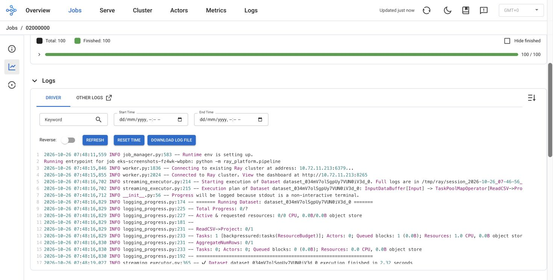
The same submission appears in the driver logs. Long lines are clipped by the native viewer; this screenshot is not a full archive or a CloudWatch UI capture.
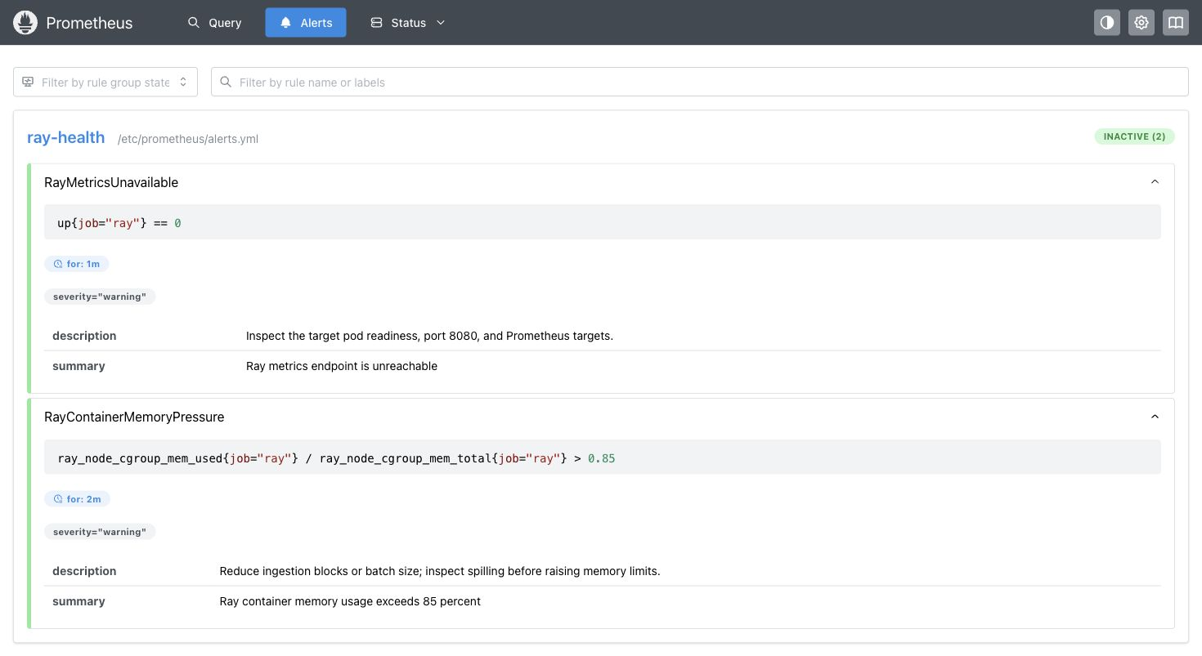
Both rules are inactive during normal operation. Saved promtool fixtures verify pending, firing and recovery. No Alertmanager or external notification delivery is claimed.

Known limitations and production work
The implementation is a working assignment with explicit production gaps: single system node and NAT, bounded worker capacity, ephemeral Prometheus storage, short CloudWatch retention, no external paging, no public domain/certificate and no HA monitoring. Localhost tunnels provide the demonstration access path. Ray's embedded Grafana panels are not wired; standalone Grafana works. The retained screenshot cluster showed repeated idle worker turnover and scrape gaps after job completion. Autoscaler interaction needs investigation and tuning before using long-lived Ray clusters in production.
Driver materialization is capped at 100000 rows. Larger inputs need partitioned Parquet, streaming transformations and distributed joins. Distributed Ray Train needs a simultaneous worker group, framework configuration and durable training checkpoints. The tested CPU baseline restarts training after failure. Entity resolution assumes valid registration identifiers and one record per company per source. Multi-writer conflict handling, GPU workloads and real LLM integration are outside the demonstrated fixture.
The newer local image candidate has 50 HIGH findings in the recorded OS/Python scan, excludes Java archives, and is not golden eligible. It was not pushed to ECR. Historic release success is not proof that a current vulnerable image passes the added gate. Remediation and a complete approved scan are required before a production release. The narrowly scoped HTTPS egress exception is temporary and expires on 1 November 2026; it is not domain-based outbound control.
The total AWS ceiling is USD 30 before credits. Posted gross spend was USD 4.18 at the post-cleanup check on 26 October; usage is delayed and this is not the final bill. KMS and retained storage can continue to incur cost after compute cleanup. Budget alerts and lease checks supplement manual verification.

Managed alternative
EventBridge Scheduler → Step Functions → Glue Spark ingestion and Iceberg updates → an ECS Fargate task for CPU sklearn training → S3 model artifacts removes EKS and node/operator management. Use scoped roles per stage and bounded retries. This requires adapting the Ray APIs and is a documented alternative, not a deployed or measured cheaper solution. Larger distributed/GPU training could use an on-demand SageMaker training job instead of the Fargate stage.

Validation record and handoff
At the module review checkpoint, 49 pytest tests passed. On commit cd603ad, PR checks validate, security and pr-title passed; cloud-plan was intentionally skipped. Later module/evidence changes require their own final CI check. Historic successful AWS runs include main/PR planning and merged release execution; links are in docs/cicd-validation.md. The submission must include this review branch, the final document and sanitized evidence; it should not imply PR merge or a production deployment has occurred.

