**Academic Tasks-1**

|  |
| --- |
| **Course Code: CSE307 Course Title: INTERNET WORKING ESSENTIALS** |
| **Course Instructor: BHUPINDER KAUR** |
| **Academic Task No.: CA 1 Academic Task Title: UNIVERSITY CAMPUS NETWORK DESIGN** |
| **Date of Allotment: 19/02/2025 Date of submission: 26/02/2025** |
| **Student’s Roll no:** K23FSB**24 Student’s Reg. no: 12310811** |
| **Evaluation Parameters: (Parameters on which student is to be evaluated- To be mentioned by students as specified at the time of assigning the task by the instructor)** |

**Learning Outcomes: (Student to write briefly about learnings obtained from the academic tasks)**

**Declaration:**

**I declare that this Assignment is my individual work. I have not copied it from any other student‟s work or from any other source except where due acknowledgement is made explicitly in the text, nor has any part been written for me by any other person.**

**Student’s Signature: Sumit Singh Ranawat**

**Evaluator’s comments (For Instructor’s use only)**

**General Observations Suggestions for Improvement Best part of assignment**

**Evaluator‟s Signature and Date:**

**Marks Obtained: Max. Marks: …………………………**

**University Campus Network Report**

**1. Physical Network Setup**

**Overview:**

This network design covers seven buildings on a university campus, each with a unique topology. A total of **seven routers** are interconnected in a **ring topology** to ensure reliability and prevent network failures. The connection between buildings utilizes **fiber-optic cables** to support high-speed data transfer.

**Implementation:**

* **Admin Building 1:** Star topology with a switch.
* **Admin Building 2:** Star topology using a hub.
* **Admin Building 3:** Mesh topology with a switch.
* **Library:** Hybrid topology (switch + hub).
* **Computer Science Department 1:** Mesh topology using a hub.
* **Computer Science Department 2:** Mesh topology with switches.
* **Engineering Department:** Bus topology using a hub.

**Snapshot:**

**The Network Designed**

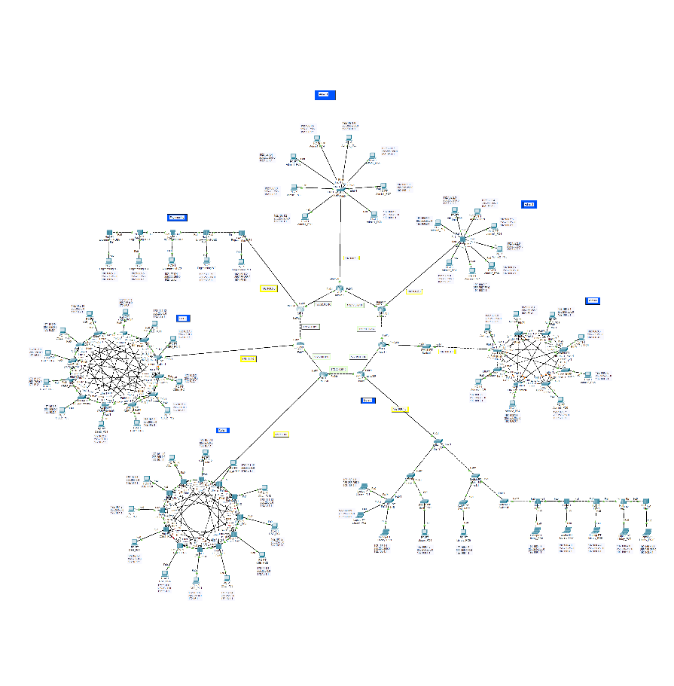

**Admin1 – Star topology with Switch**

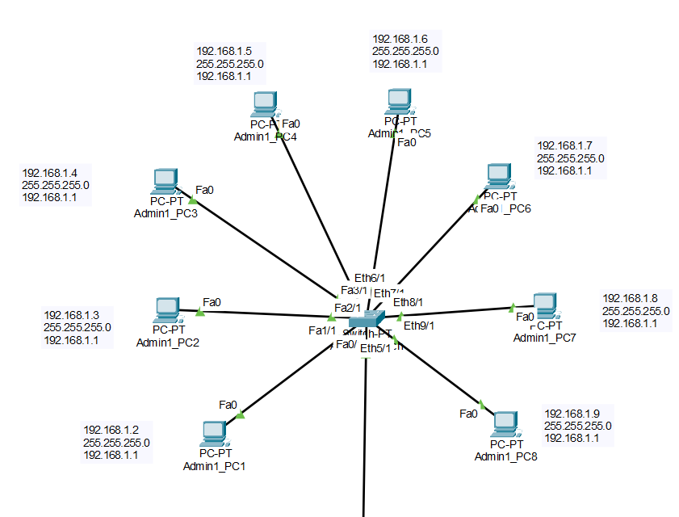

Admin2 – **Star topology with hub**

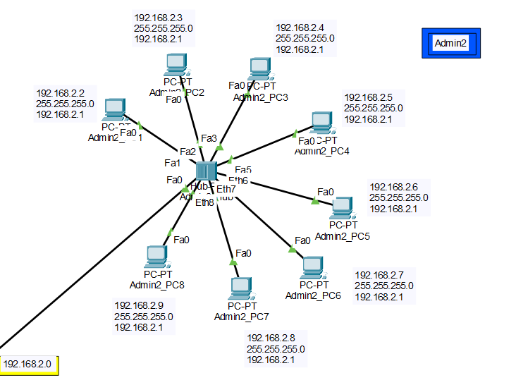

**Admin3 – Mesh Topology with switch**

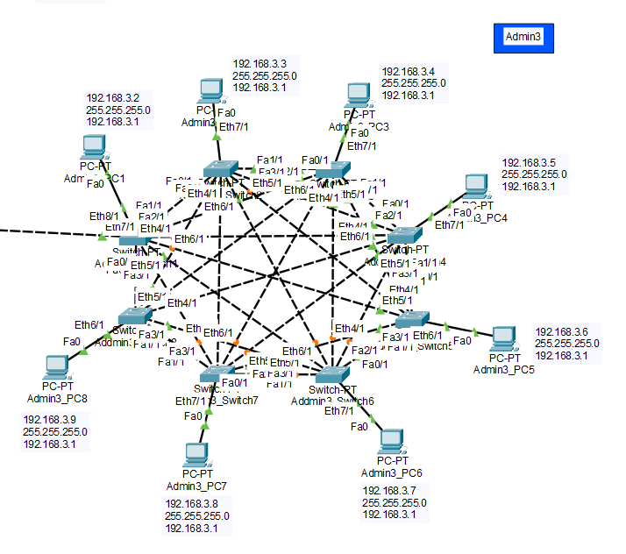

**Library – Hybrid Topology with switch and hub (Tree + Bus)**

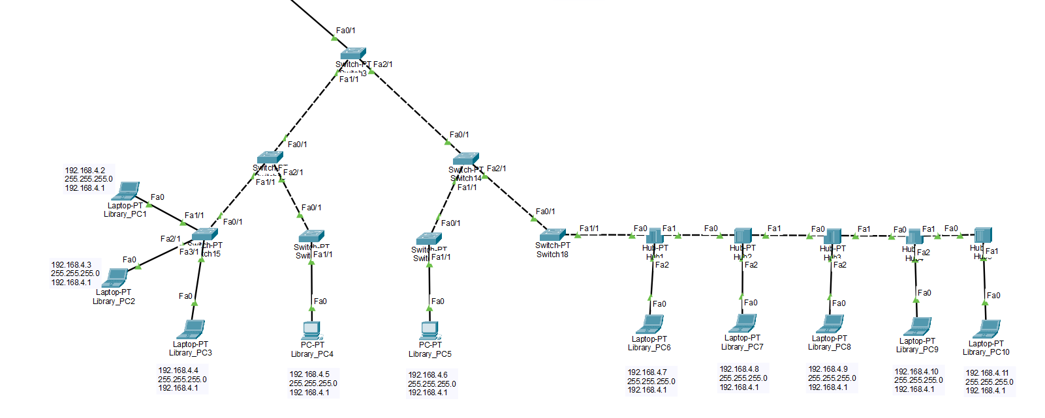

**Computer Science Department 1 - Mesh topology using a hub.**

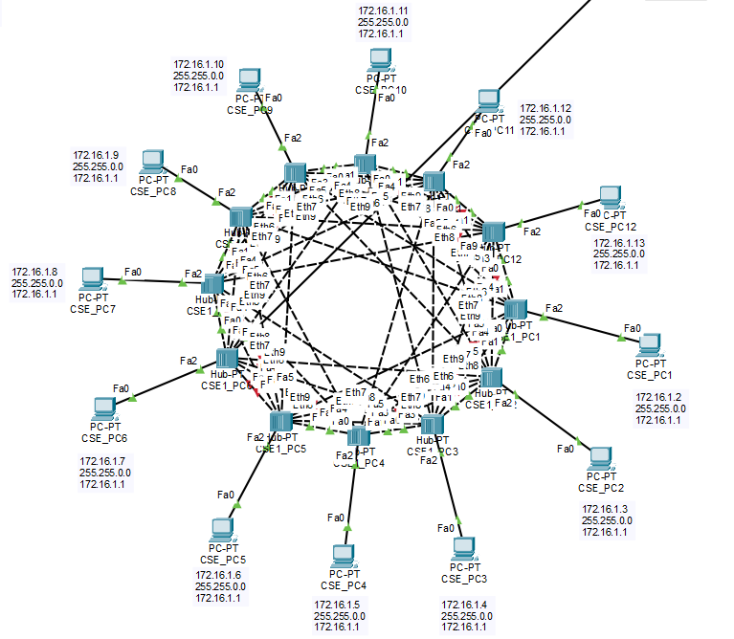

**Computer Science Department 2 - Mesh topology with switches.**

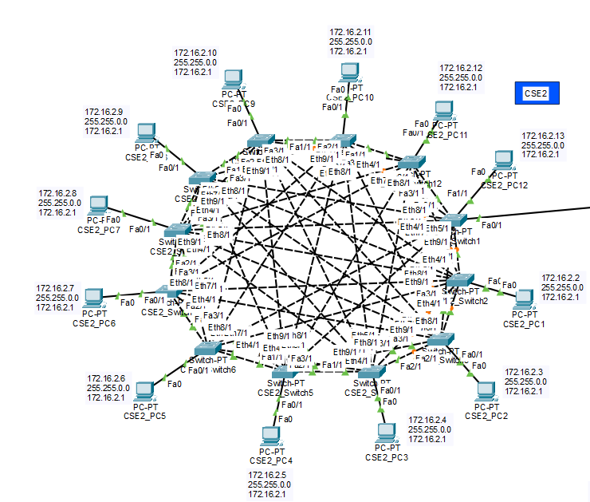

**Engineering Department - Bus topology using a hub.**

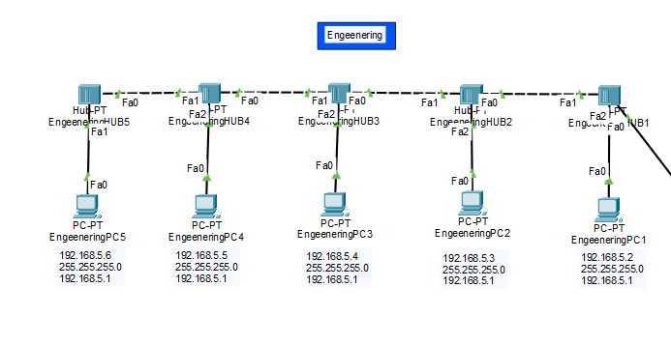

**2. IP Addressing Scheme**

**Overview:**

The network is assigned IPv4 addresses from **Class B (172.16.0.0/16) and Class C (192.168.0.0/24)** ranges. Each building has its dedicated subnet, and routers use **/30 subnets** for point-to-point links.

**IP Address Allocation:**

|  |  |  |  |
| --- | --- | --- | --- |
| **Building** | **Subnet Assigned** | **Subnet Mask** | **IP Range** |
| **Admin 1** | 192.168.1.0 | 255.255.255.0 | 192.168.1.1 - 192.168.1.8 |
| **Admin 2** | 192.168.2.0 | 255.255.255.0 | 192.168.2.1 - 192.168.2.8 |
| **Admin 3** | 192.168.3.0 | 255.255.255.0 | 192.168.3.1 - 192.168.3.8 |
| **Library** | 192.168.4.0 | 255.255.255.0 | 192.168.4.1 - 192.168.4.10 |
| **CSE 1** | 172.16.1.0 | 255.255.255.0 | 172.16.1.1 - 172.16.1.12 |
| **CSE 2** | 172.16.2.0 | 255.255.255.0 | 172.16.2.1 - 172.16.2.12 |
| **Engineering** | 192.168.5.0 | 255.255.255.0 | 192.168.5.1 - 192.168.5.5 |

**Router-to-Router Connections:**

* **Subnet for routers:** 172.17.0.0 - 172.23.0.0 (point-to-point links)

**Snapshot:**

|  |  |  |  |
| --- | --- | --- | --- |
| **Admin 1** | 192.168.1.0 | 255.255.255.0 | 192.168.1.1 - 192.168.1.8 |

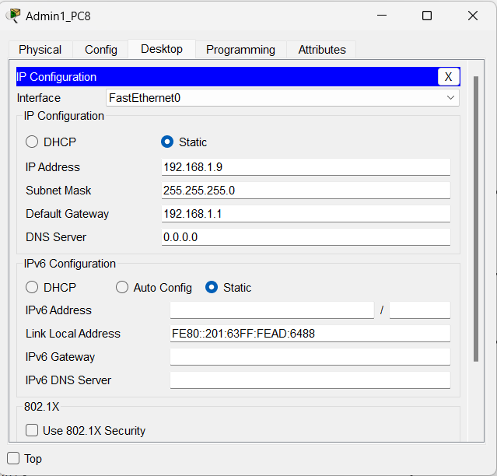

|  |  |  |  |
| --- | --- | --- | --- |
| **Admin 2** | 192.168.2.0 | 255.255.255.0 | 192.168.2.1 - 192.168.2.8 |

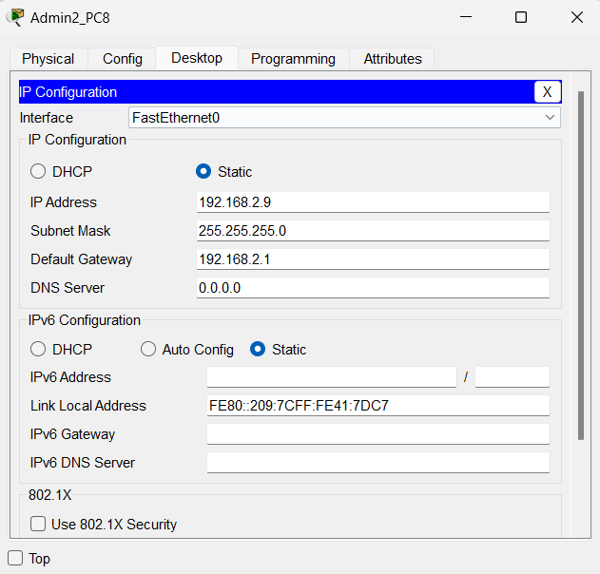

|  |  |  |  |
| --- | --- | --- | --- |
| **Admin 3** | 192.168.3.0 | 255.255.255.0 | 192.168.3.1 - 192.168.3.8 |

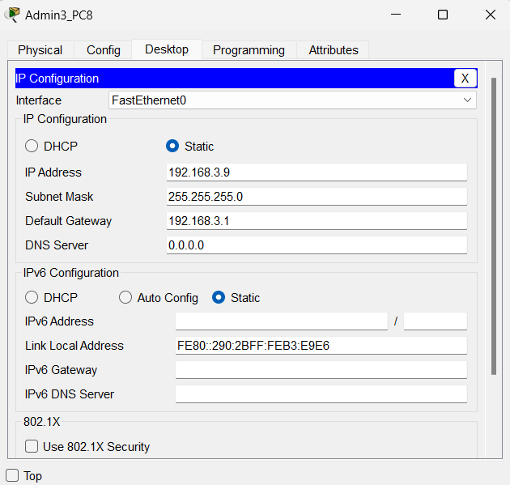

|  |  |  |  |
| --- | --- | --- | --- |
| **Library** | 192.168.4.0 | 255.255.255.0 | 192.168.4.1 - 192.168.4.10 |

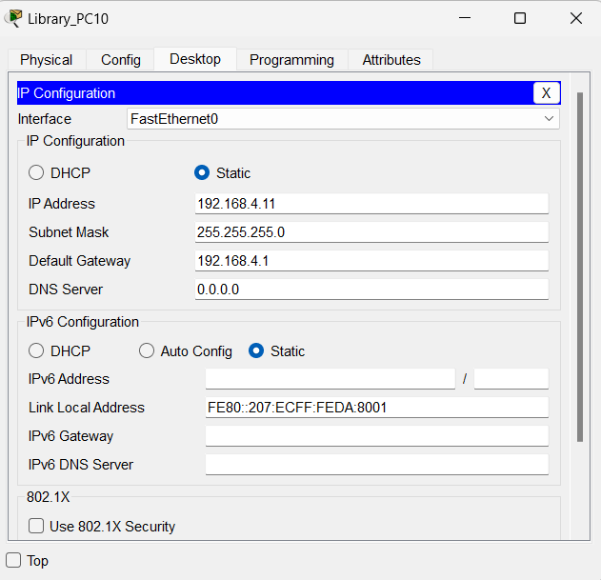

|  |  |  |  |
| --- | --- | --- | --- |
| **CSE 1** | 172.16.1.0 | 255.255.255.0 | 172.16.1.1 - 172.16.1.12 |

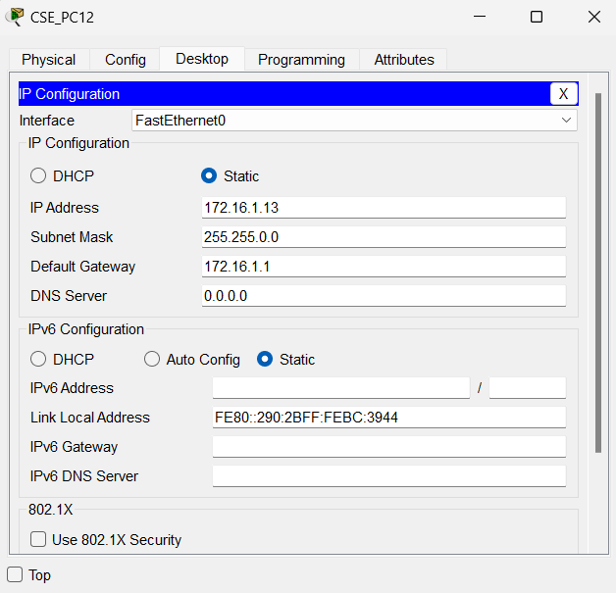

|  |  |  |  |
| --- | --- | --- | --- |
| **CSE 2** | 172.16.2.0 | 255.255.255.0 | 172.16.2.1 - 172.16.2.12 |

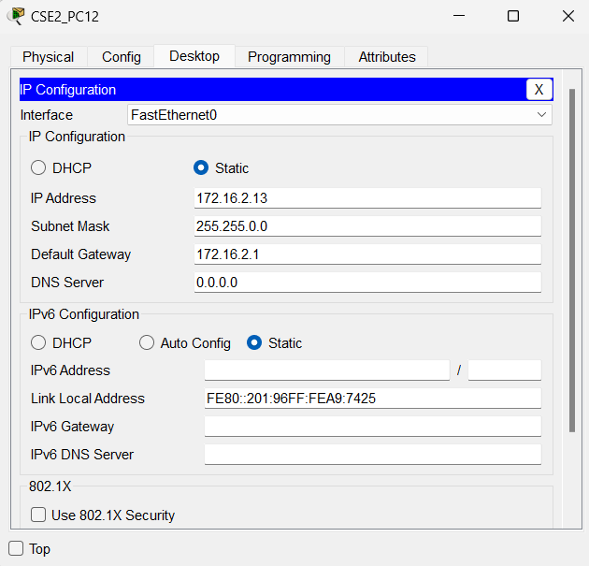

|  |  |  |  |
| --- | --- | --- | --- |
| **Engineering** | 192.168.5.0 | 255.255.255.0 | 192.168.5.1 - 192.168.5.5 |

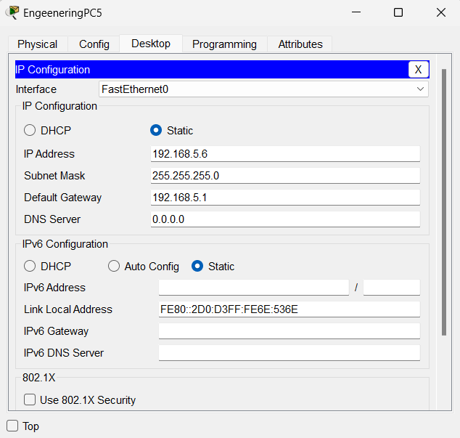

**Examples Of IP addressing in routers**

In all the routers connected to the topology the IP _._._.1 has been used for routers to put it in simple.

And in the subnetting the routers are given the IP 172.17.0.1 to 172.23.0.2 to make is easy to prepare.

Here are some snapshots for it.

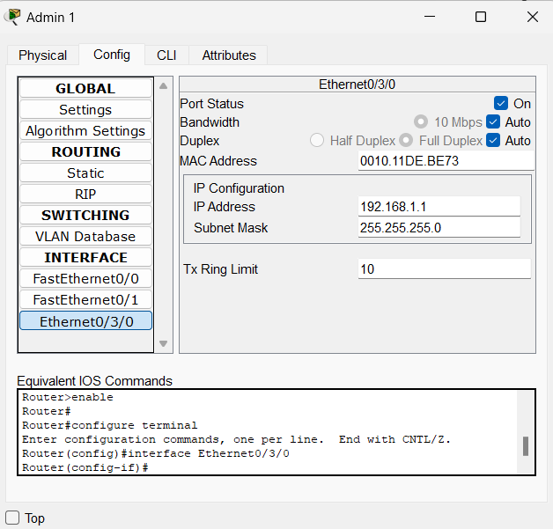

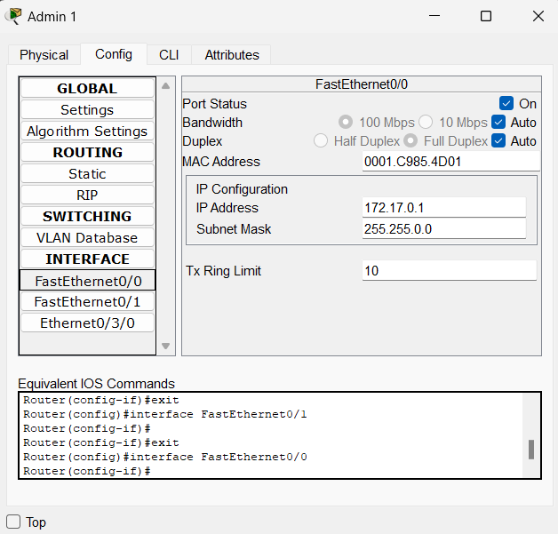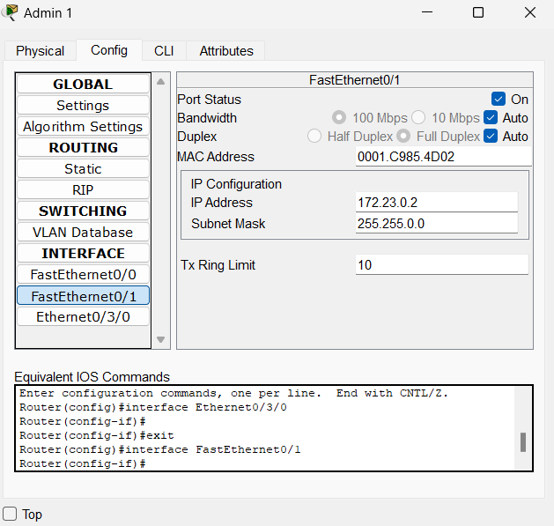

**3. Routing Configuration**

**Overview:**

To enable efficient communication between buildings, **OSPF (Open Shortest Path First) Dynamic Routing** is implemented. OSPF ensures fast convergence and optimized path selection.

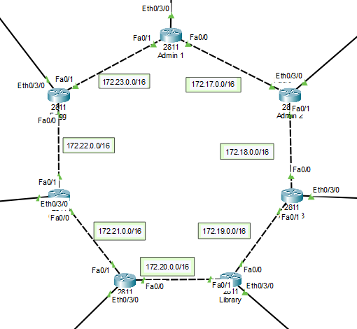

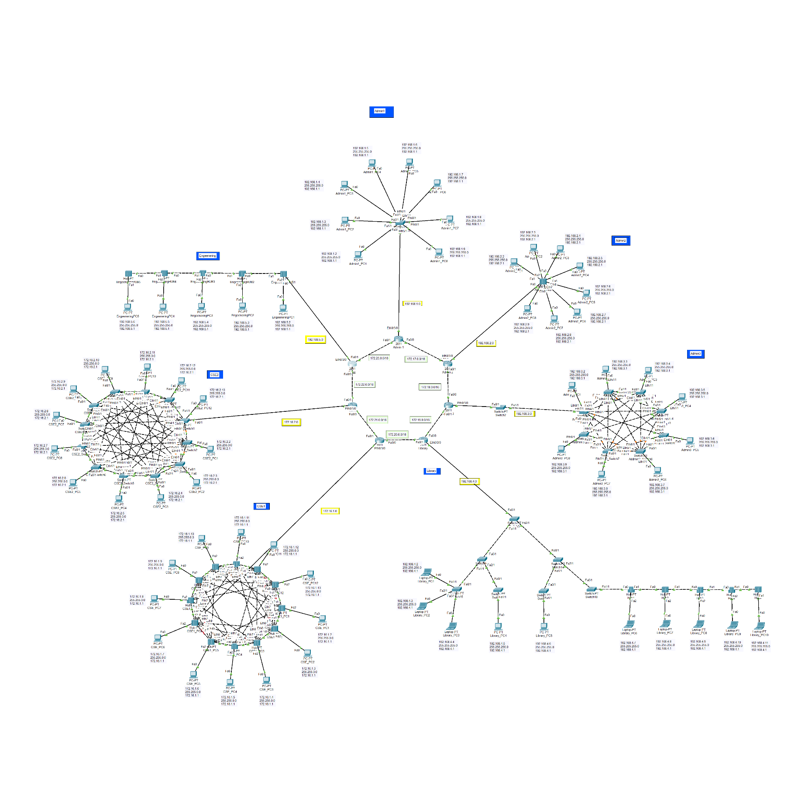**Snapshot:**

**Admin1 Router**

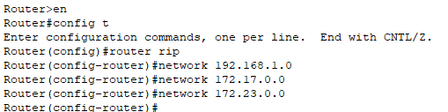

**Admin2 Router**

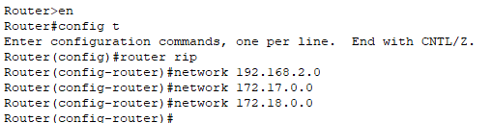

**Admin3 Router**

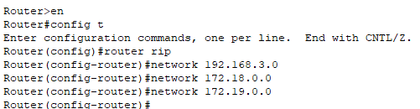

**Library Router**

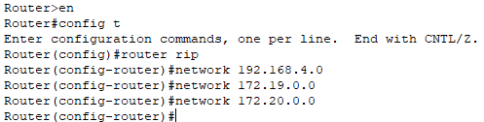

**CSE1 Router**  
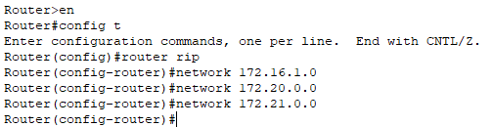

**CSE2 Router**

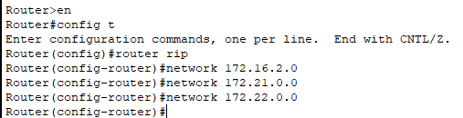

**Engineering Router**

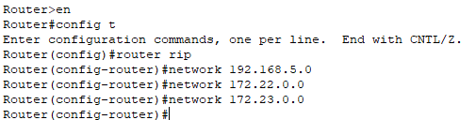

**4. Network Communication Testing**

**Overview:**

To verify connectivity, a **packet sharing test** was performed between devices in different buildings. The successful replies confirm that the network is functioning correctly.

All the networks are fully functional and are properly communicating with each other.

**Snapshots:**

From Admin1_PC1 to Admin2_PC2

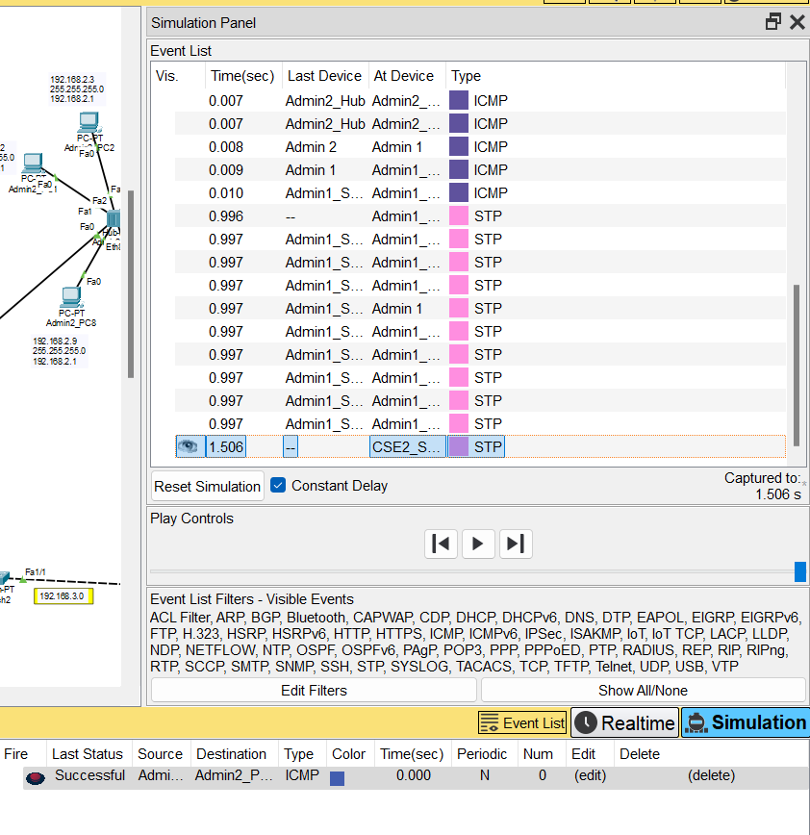

From Admin1_PC2 to Admin3_PC1

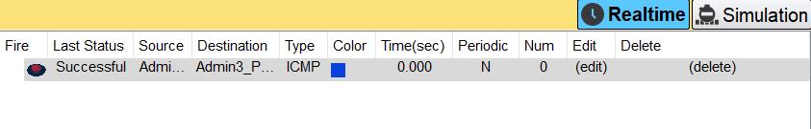

From Admin1_PC3 to Library_PC5

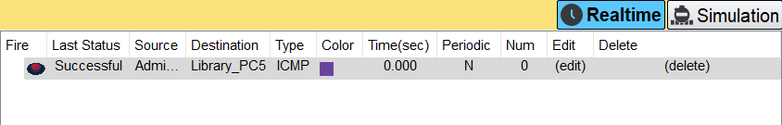

From CSE1_PC1 to Admin2_PC1

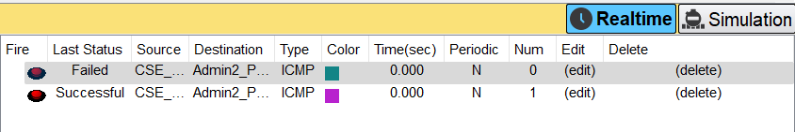

From Admin2_PC8 to CSE2_PC12

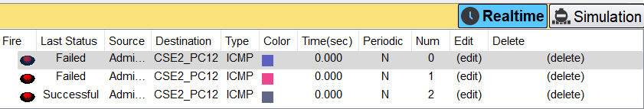

From Engineering_PC1 to Admin2_PC1

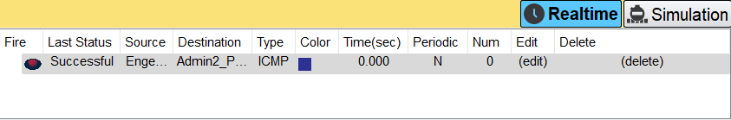

**Observation**

Due to the vast network and the use of outdated software versions, packets are failing multiple times before successfully reaching their destination. This issue highlights the need for upgrading software and optimizing network performance.

**Conclusion**

Designing this university campus network was both an enjoyable and enlightening experience. Exploring multiple strategies to structure the buildings' network led to the innovative idea of connecting routers in a **ring topology** for better efficiency and redundancy. However, some issues were encountered, and I plan to refine the design further to improve network stability and performance in the future.

GitHub : <https://github.com/SumitSingh3101/Networking-Laboratory>

Yours Faithfull

Sumit Singh Ranawat

12310811