An Offline-First Live Collaborative Code Editor with Contextual
Communication Support
Rajesh Phursule¹, Sphurti Deshmukh², Sumit Solanke³, Sahil Shendkar⁴, Nikhil Shinde⁵, Aniket Polkar⁶
^{1,2,3,4,5,6} Department of Information Technology, PCCOE, Pune
¹rajesh.phursule@pccoepune.org, ²rajesh.phursule@pccoepune.org, ³sumit.solanke22@pccoepune.org, ⁴sahil.shendkar22@pccoepune.org, ⁵nikhil.shinde22@pccoepune.org,, ⁶aniket.polkar22@pccoepune.org,

Abstract- Collaborative software development increasingly involves geographically distributed teams that rely on a combination of code editors, communication tools, and external knowledge platforms. While existing solutions support either real-time collaboration or asynchronous version control, they often fragment developer interaction across multiple tools and fail to preserve contextual awareness, particularly in offline or intermittently connected environments. This paper presents an offline-first live collaborative code editor that integrates contextual communication directly within the coding workflow.
The proposed system enables developers to observe ongoing edits, contribute through parallel side-by-side code views, and interact using communication mechanisms that are explicitly linked to files, code regions, and development context. Unlike conventional real-time editors that rely on simultaneous multi-cursor editing, the system emphasizes controlled collaboration, allowing contributors to work independently while maintaining awareness of peer activity. Offline contributions are treated as first-class entities, enabling uninterrupted development and deferred synchronization without disrupting collaborative continuity.
Built on a decentralized, version-controlled foundation, the editor unifies live collaboration, offline work, and contextual communication within a single environment. By embedding interaction and discussion directly into the codebase, the system reduces context switching, improves knowledge retention, and supports more effective collaboration in distributed software development teams.
Keywords- Code-centric collaboration, Contextual communication,Developer interaction, Distributed software development, Live collaborative code editing, Offline-first collaboration

Introduction
Software development has evolved into a highly collaborative activity involving geographically distributed teams working across different time zones and network conditions [9]. Modern development workflows require not only efficient code editing but also continuous communication, awareness of peer activity, and mechanisms for sharing knowledge during the development process [7], [11]. To support these needs, developers commonly rely on a combination of live collaboration tools, version control systems, messaging platforms, and external discussion forums [12]. While effective individually, this tool fragmentation often disrupts workflow continuity and reduces collaboration efficiency [12].
Live collaborative code editors have addressed part of this challenge by enabling developers to observe ongoing edits and participate in shared development sessions [4], [9]. However, many such systems emphasize tightly synchronized real-time editing, which may not align with practical development practices where contributors prefer controlled and independent work [5]. Additionally, these tools frequently assume constant connectivity and offer limited support for offline or intermittently connected contributors [3]. As a result, developers working under unreliable network conditions are often excluded from active collaboration or forced to defer meaningful interaction until connectivity is restored [9].
Communication remains another critical limitation in existing collaborative environments. Developer interaction is typically handled through external platforms such as messaging applications, video-conferencing tools, or issue-tracking systems [7], [11]. These communication channels are largely detached from the code being discussed, requiring developers to manually reconstruct context when switching between tools [6]. This separation leads to loss of information, repeated explanations, and difficulty in preserving knowledge that is directly relevant to specific parts of the codebase [6], [12].
Offline work further complicates collaboration. Although distributed version control systems support offline development at the repository level, live collaboration and communication tools often do not extend this capability to interactive workflows [3]. Offline contributors can modify code locally but lack mechanisms to participate in discussions, annotate code, or remain aware of ongoing collaborative activity [9]. When they reconnect, reintegrating their work and understanding prior interactions becomes time-consuming and error-prone [1], [12].
To address these challenges, this paper presents an offline-first live collaborative code editor that integrates contextual communication directly within the coding environment. The proposed system enables developers to collaborate through parallel, side-by-side code views, preserving individual autonomy while maintaining awareness of peer activity [5], [9]. Communication mechanisms are explicitly linked to files and code regions, ensuring that discussions remain tightly coupled with the development context [6]. Offline contributions and interactions are treated as first-class elements, allowing collaboration to continue despite temporary network disruptions [3].
Built on an existing decentralized, version-controlled foundation, the system focuses on improving collaborative experience rather than redefining version control mechanisms. By unifying live collaboration, offline work, and contextual communication within a single environment, the proposed approach reduces context switching, enhances knowledge retention, and supports more effective collaboration for distributed software development teams [11].

Related Work
Research and industry efforts in collaborative software development have produced a wide range of tools and systems addressing real-time editing, asynchronous collaboration, and developer communication [4], [7], [9]. However, these efforts often treat collaboration, communication, and knowledge sharing as separate concerns [11], [12]. This section reviews related work from an experience-centric perspective, highlighting limitations that motivate the proposed approach.

Real-Time Collaborative Code Editors
Real-time collaborative code editors enable multiple developers to participate in shared coding sessions by providing visibility into ongoing edits and collaborator activity [4], [9]. Some widely adopted systems allow developers to observe changes as they occur within a shared workspace, supporting pair programming and remote collaboration scenarios [2]. These tools primarily operate in session-based modes, where collaboration is initiated and managed through a designated host or coordinator [5].
While such systems improve immediacy and awareness, they introduce practical constraints. Collaboration sessions are often transient and tightly coupled to the host’s availability, limiting flexibility in long-running or asynchronous development workflows [5]. Additionally, most real-time editors assume continuous connectivity and do not adequately support offline participation [3]. Discussions and interactions that occur during sessions are frequently ephemeral, resulting in limited persistence of collaborative context once the session ends [9].
These characteristics make real-time editors effective for short-term collaboration but less suitable for workflows that require autonomy, offline continuity, and long-term preservation of development context [9].

Offline and Asynchronous Collaboration
Offline collaboration has traditionally been addressed through distributed version control systems, which allow developers to modify code and record changes locally without immediate network access [3]. This model supports asynchronous contribution and later synchronization, enabling productivity in environments with unreliable connectivity [12]. However, such systems primarily focus on source code and version history rather than interactive collaboration [6].
Outside the domain of software development, document-oriented tools provide offline editing capabilities combined with delayed synchronization [2]. While effective for text documents, these approaches do not directly translate to collaborative programming environments, where code structure, dependencies, and semantic correctness play a critical role [10].
As a result, a gap remains between offline code modification and interactive collaboration. Existing approaches support offline edits but do not extend offline participation to live collaboration features such as awareness, discussion, or contextual interaction [9].

Developer Communication and Knowledge Platforms
Developer communication and knowledge sharing are commonly supported through external platforms such as messaging applications, issue-tracking systems, and community forums [7], [11]. These tools facilitate discussion, problem-solving, and documentation across teams and broader developer communities [11]. However, communication in these platforms is typically detached from the code itself [6].
Discussions often reference code indirectly through links, screenshots, or descriptions, requiring participants to manually reconstruct context [6]. Fine-grained association between communication and specific code regions is generally absent, making it difficult to preserve intent, rationale, and decision history in a structured and reusable manner [12]. Over time, this separation leads to fragmented knowledge and repeated explanations, particularly in distributed teams.

Research Gap Summary
Existing collaborative programming environments address live editing, offline contribution, and developer communication as largely independent capabilities [9]. Real-time editors prioritize immediacy but lack offline continuity and persistent context [4], while asynchronous tools support offline work without interactive collaboration [3]. Communication and knowledge-sharing platforms operate externally, without fine-grained integration into the codebase [6], [11].
Consequently, no existing system unifies live collaboration, offline contribution, contextual communication, and community knowledge sharing within a single collaborative programming environment [9]. This gap motivates the design and exploration of the integrated approach presented in this work.

Methodology
This section presents the conceptual design of the proposed collaborative code editor. The methodology focuses on interaction models, collaboration flow, and communication integration rather than implementation-specific mechanisms. The design emphasizes flexibility, autonomy, and context preservation in distributed software development environments.

Design Philosophy
The proposed system adopts a collaboration-centric design philosophy, where collaboration is treated as a continuous activity rather than an auxiliary feature layered on top of version control. Code is viewed as a shared, living workspace that evolves through parallel contributions rather than a single authoritative editing stream [4].
Unlike repository-centric approaches that prioritize commit history and synchronization mechanics, the system prioritizes developer experience during active development. Contributors are encouraged to explore, modify, and discuss code without immediate risk of disrupting others’ work.
Communication is treated as a first-class entity within the system. Discussions, questions, and suggestions are embedded directly within the coding environment and persist alongside the code they reference [6]. This design ensures that collaborative intent and rationale are preserved and remain accessible over time .

Live Collaboration Model
As shown in Fig. 1. instead of enforcing a multi-cursor or tightly synchronized editing approach, the proposed system follows a parallel live collaboration model. When multiple developers work on the same file simultaneously, each contributor edits an independent live view of the file. These parallel views are displayed side-by-side or within separate collaborative panes.

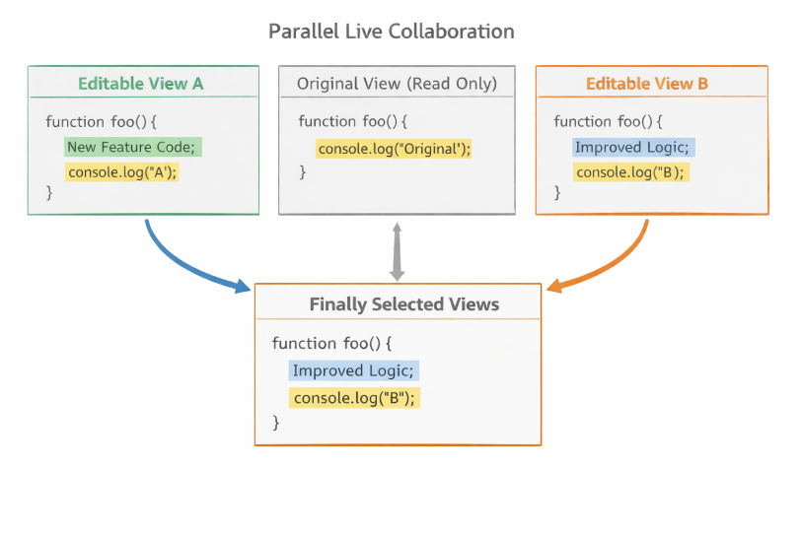

Fig. 1. Parallel Live Collaboration Model with Independent Editable Views and Controlled Integration

Diagram Description:
A conceptual diagram illustrating two developers working on the same source file. Each developer has an independent editable view, while a shared reference version remains visible. Changes made by collaborators are reflected as live previews or alternative versions rather than direct modifications.
Explanation:
This model preserves developer autonomy while maintaining awareness of peer activity. Contributors can observe what others are editing without risking accidental overwrites or merge conflicts during active sessions. If a developer chooses to integrate another contributor’s changes, the system provides controlled mechanisms for adoption rather than automatic modification.
Presence awareness is maintained by indicating which files or sections collaborators are currently working on, without enforcing cursor-level synchronization. Concurrent modifications are handled as parallel alternatives, allowing developers to compare and reconcile changes intentionally.
At a conceptual level, consistency between parallel views may be supported using established collaborative editing principles such as Operational Transformation (OT) or Conflict-Free Replicated Data Types (CRDTs) [2], [3]. These mechanisms are referenced only as theoretical foundations and are not explored in depth within this work.

Offline-First Collaboration Strategy
The system is designed with an offline-first collaboration strategy to accommodate intermittent connectivity and geographically distributed contributors. Developers can continue editing code locally without network access, with changes stored and tracked within the local workspace.

Diagram Description:
Fig. 2 shows the developer working offline, creating local edits and annotations, followed by deferred synchronization once connectivity is restored.
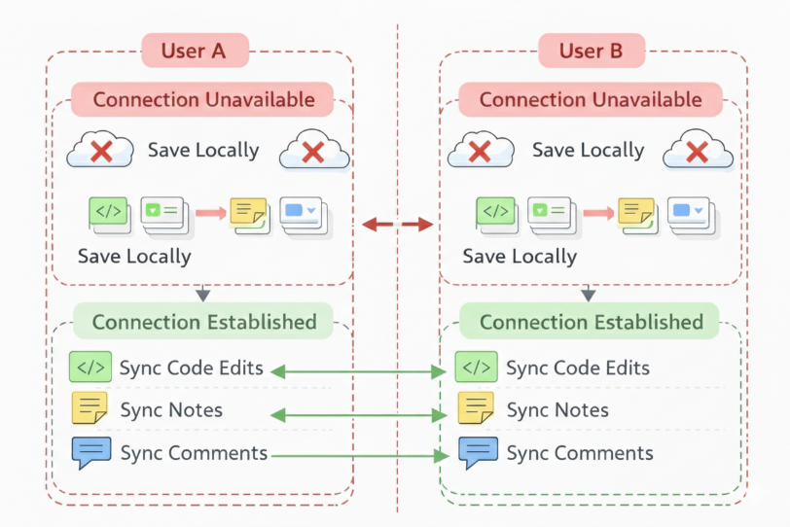
Fig. 2. Offline-First Collaboration and Deferred Synchronization Workflow
Explanation:
Offline edits are treated as valid collaborative contributions rather than isolated changes. When connectivity is re-established, the system synchronizes code modifications, annotations, and discussions in a deferred manner. This approach ensures that offline contributors remain part of the collaborative process rather than passive participants.
In addition to code changes, developers can create offline annotations, questions, or discussion threads linked to specific code regions. These interactions are queued locally and published once synchronization occurs, preserving the temporal context of collaboration.

Contextual Communication Model
As shown in Fig. 3. core contribution of the proposed system is its contextual communication model, where all interactions are explicitly linked to code artifacts [6]. Communication is not maintained in a separate global chat space but is embedded within the codebase itself [11].

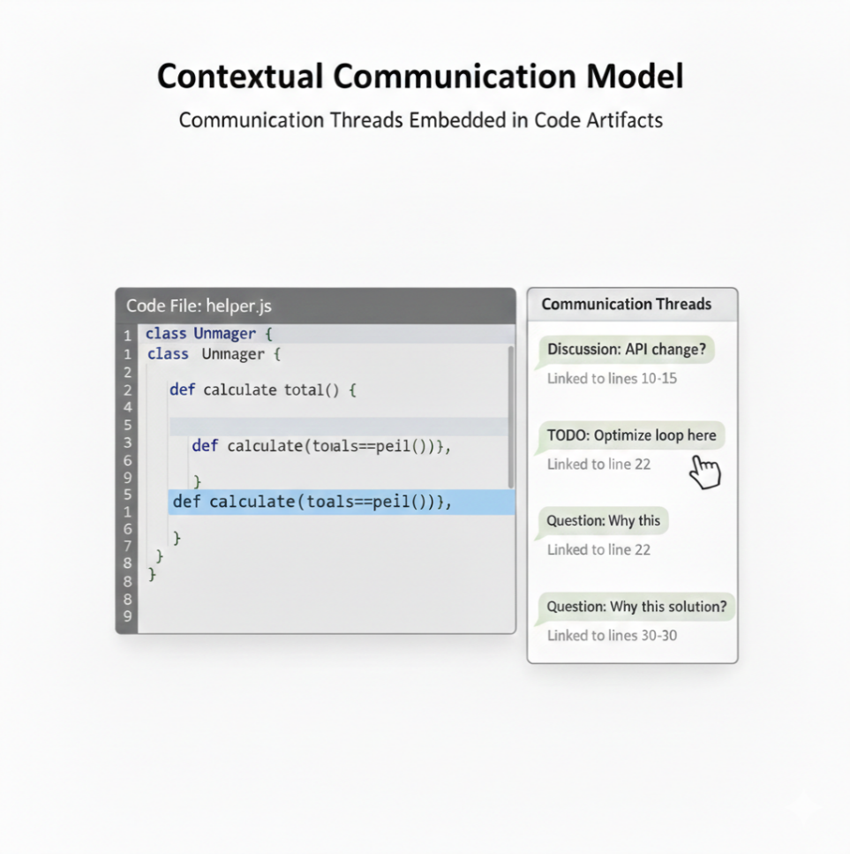
Fig. 3. Contextual Communication Threads Embedded within Code Artifacts
Diagram Description:
A layered diagram showing source code at the base, with communication threads attached to files, line ranges, and code blocks.
Explanation:
Developers can initiate discussions at multiple levels of granularity, including entire files, specific line ranges, or individual code blocks. Each discussion forms a threaded conversation, allowing participants to ask questions, provide clarifications, or suggest improvements without interrupting active editing.
Suggestions are designed to be non-blocking. Contributors can propose alternatives or improvements without enforcing immediate changes, allowing recipients to review and adopt suggestions at their discretion. This model supports collaborative refinement while avoiding disruption to ongoing development.

Access Control Strategy
Fig. 4 shows that it support selective collaboration and controlled knowledge sharing, the system incorporates fine-grained access control mechanisms. Instead of granting uniform access to entire repositories, developers can share specific code segments or files with collaborators.
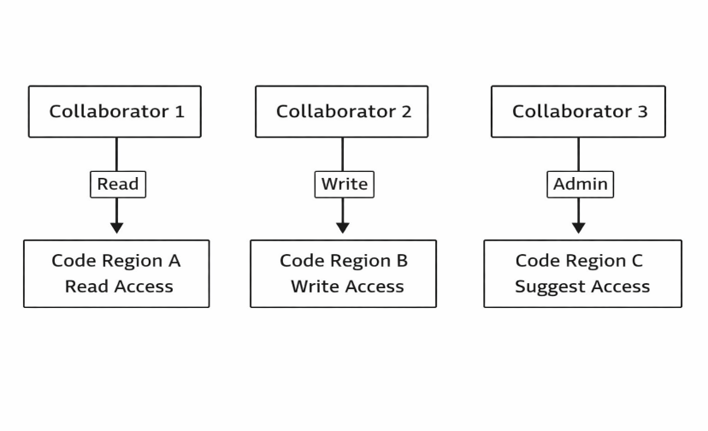

Fig. 4. permissions diagram

Diagram Description:
A permissions diagram illustrating different collaborators with read-only, comment, and suggest access applied to distinct code regions.
Explanation:
Access levels include read, comment, and suggest permissions, enabling tailored collaboration based on contributor roles and expertise. This approach allows domain experts to review or advise on specific components without exposing the entire codebase or enabling unrestricted modifications.
Selective collaboration enhances security, reduces cognitive overload, and supports focused peer review. By combining access control with contextual communication, the system enables precise, meaningful collaboration within distributed development teams.

Implementation
This section describes how the proposed design concepts are realized in practice. The implementation focuses on modular integration of live collaboration, offline support, and contextual communication within a single programming environment. Low-level infrastructure details related to distribution and version control are assumed as part of the underlying system and are not discussed here.

System Overview
As shown in Fig. 5. the system is organized as a set of loosely coupled functional layers that interact through well-defined interfaces. This modular structure enables independent evolution of collaboration and communication features while maintaining a cohesive user experience.

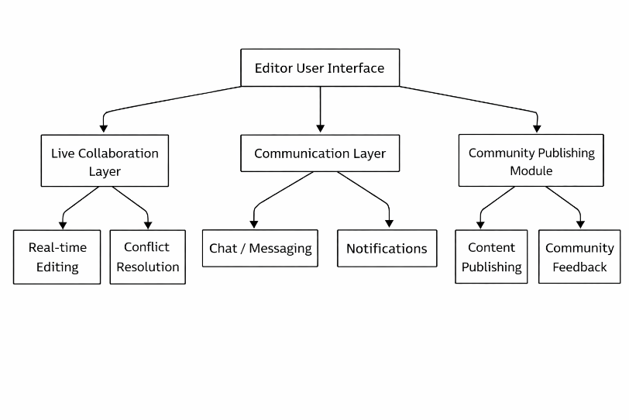

Fig. 5. High-level architectural diagram

Diagram Description:
A high-level architectural diagram showing the editor user interface connected to three core modules: a live collaboration layer, a communication layer, and a community publishing module.
Explanation:
The editor user interface serves as the primary interaction point for developers, providing code editing, collaboration awareness, and communication access. The live collaboration layer manages synchronization of parallel editing activities and presence information. The communication layer handles contextual discussions and questions linked to code artifacts. The community publishing module enables selective sharing of code-related discussions beyond the immediate team.
This separation of concerns ensures scalability, extensibility, and clarity in system behavior.

Live Editing Implementation
Live collaboration is implemented using an event-based update model. Instead of enforcing immediate shared-state modification, editing actions are captured as discrete events and propagated to collaborators as live updates.
Presence information, such as which files or sections collaborators are currently working on, is synchronized independently of code changes. This approach allows developers to remain aware of peer activity without introducing intrusive real-time interference.
By decoupling edit propagation from direct code modification, the system supports the parallel editing model described earlier. Developers can observe alternative versions of a file and selectively integrate changes, preserving stability during active collaboration sessions.

Offline Workflow Implementation
Offline collaboration is supported through local buffering and deferred synchronization mechanisms. When a developer operates without network connectivity, all edits, annotations, and discussion interactions are stored locally.
Diagram Description:
As shown in Fig. 6. the workflow diagram showing local edit buffering, change queue formation, and synchronization upon reconnection.
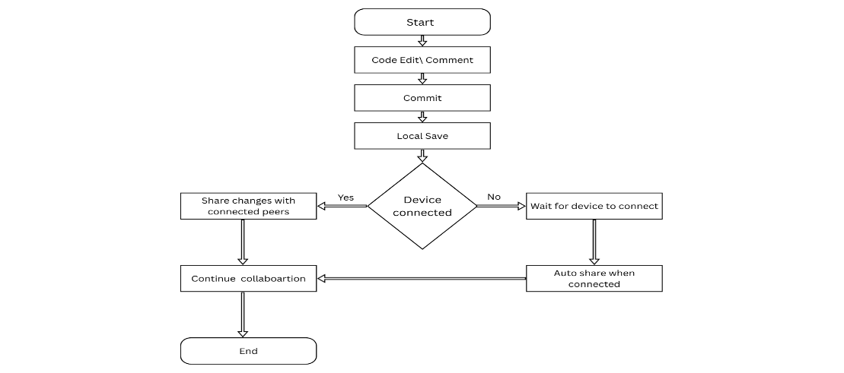
Fig. 6. Workflow diagram
Explanation:
Local changes are recorded in structured change queues that preserve the order and context of modifications. Upon reconnection, the system synchronizes these queued changes with the shared workspace, resolving integration through the same controlled mechanisms used in live collaboration.
This design ensures that offline work remains consistent with collaborative workflows and does not require special handling or manual intervention from contributors.

Contextual Chat and Q&A Implementation
Contextual communication is implemented by anchoring messages directly to code artifacts. Each discussion is associated with a specific file, line range, or code block, and is stored alongside metadata describing its scope and permissions.
Discussions follow a threaded lifecycle, allowing participants to initiate questions, provide responses, and mark resolutions when appropriate. Permission enforcement ensures that only authorized collaborators can view, comment, or suggest changes within a given discussion thread.
By integrating communication storage with code context, the system maintains persistent, searchable collaborative knowledge that evolves with the codebase.

Community Sharing Mechanism
The community sharing mechanism enables developers to publish selected discussions or questions beyond their immediate team. Rather than exposing entire projects, contributors can choose specific contextual discussions for sharing.
Visibility controls allow content to be marked as private, team-visible, or publicly accessible. Publicly shared discussions retain their original code context while omitting sensitive project details, enabling broader knowledge exchange without compromising collaboration boundaries.
This mechanism bridges internal development collaboration with external community learning, transforming contextual discussions into reusable knowledge assets.

Results, Analysis, and Discussion
This section discusses the observed outcomes of the proposed collaborative editor based on qualitative evaluation and representative collaboration scenarios. The analysis focuses on collaboration behavior, workflow efficiency, and knowledge persistence rather than quantitative performance metrics.

Observed Collaboration Behavior
Across collaborative scenarios, the system demonstrated a noticeable reduction in context switching during development activities. Since communication threads, annotations, and suggestions were embedded directly within the coding environment, developers were able to discuss and resolve issues without leaving the editor. This integration helped maintain cognitive continuity during problem-solving and code review activities.
Another significant observation was the continuity of collaboration in the presence of offline contributors. Developers working without connectivity could continue modifying code and attaching contextual questions or notes. Upon reconnection, their contributions were naturally reintegrated into the shared workspace, enabling uninterrupted collaboration despite network variability. This behavior supported a more inclusive development process, particularly for geographically distributed teams.

Comparative Analysis
When compared with commonly adopted collaboration workflows, the proposed system exhibited stronger retention of development context. Traditional live collaboration approaches emphasize immediate synchronization but often fail to preserve discussions beyond active sessions. In contrast, the proposed approach retained communication alongside the relevant code, allowing collaborators to revisit decisions and rationale.
Compared to asynchronous collaboration models that rely on separate communication platforms, the system reduced fragmentation by unifying code editing and discussion within a single workspace. Offline usability was also improved, as collaboration-related interactions were not restricted to online-only sessions.
Finally, knowledge reuse was enhanced through persistent, code-anchored discussions. Instead of being buried in external message histories or issue trackers, insights remained directly accessible at the point of relevance within the codebase.

Advantages
The primary advantage of the proposed approach is the unification of development activities into a cohesive workflow. Live collaboration, offline contribution, and communication coexist within the same environment, minimizing disruption and overhead.
Persistent contextual discussions enable long-term knowledge retention, allowing teams to preserve design decisions, explanations, and alternatives alongside the evolving code. Additionally, the offline-first design ensures that contributors remain active participants regardless of connectivity constraints, promoting inclusive and resilient collaboration.

Limitations
Despite its benefits, the system introduces certain limitations. The integration of multiple collaboration and communication features increases interface complexity, which may initially challenge new users. Familiarity with contextual interaction patterns is required to fully leverage the system’s capabilities.
The learning curve associated with parallel editing and selective integration of changes may also require adaptation, particularly for developers accustomed to tightly synchronized editing models. Furthermore, as the number of simultaneous collaborators increases, managing awareness and parallel views may impact usability in large-scale live sessions

Conclusion
Collaboration in software development extends beyond simultaneous code editing. It encompasses communication, shared understanding, knowledge preservation, and inclusive participation across varying work conditions. Treating collaboration solely as a real-time editing problem overlooks these broader dimensions that significantly influence developer productivity and team effectiveness.
This paper presented a collaborative programming environment that integrates live coding, offline contribution, and contextual communication within a unified workspace. By enabling parallel collaboration without intrusive synchronization, the system supports developer autonomy while maintaining awareness and coordination. Offline-first interaction ensures continuity of collaboration despite network limitations, allowing all contributors to remain active participants in the development process.
By embedding discussions, questions, and suggestions directly within the codebase, the proposed approach transforms communication into a persistent and reusable knowledge resource. Furthermore, selective community sharing extends the value of these interactions beyond individual teams, enabling broader learning while preserving contextual relevance.
Overall, the system bridges live collaboration, offline work, and community knowledge sharing into a cohesive collaborative experience. This integrated perspective highlights the importance of viewing collaborative programming as a holistic activity—one that unifies code, communication, and accessibility within a single, developer-centered environment.
7. References:
- Lamport, Leslie. "Time, clocks, and the ordering of events in a distributed system." Concurrency: the Works of Leslie Lamport. 2019. 179-196.
- Sun, Chengzheng, and Clarence Ellis. "Operational transformation in real-time group editors: issues, algorithms, and achievements." Proceedings of the 1998 ACM conference on Computer supported cooperative work. 1998.
- Shapiro, Marc, et al. "Conflict-free replicated data types." Symposium on Self-Stabilizing Systems. Berlin, Heidelberg: Springer Berlin Heidelberg, 2011.
- Goldman, Max, Greg Little, and Robert C. Miller. "Real-time collaborative coding in a web IDE." Proceedings of the 24th annual ACM symposium on User interface software and technology. 2011.
- Sarma, Anita, Zahra Noroozi, and André Van Der Hoek. "Palantír: raising awareness among configuration management workspaces." 25th International Conference on Software Engineering, 2003. Proceedings.. IEEE, 2003..
- Begel, Andrew, Robert DeLine, and Thomas Zimmermann. "Social media for software engineering." Proceedings of the FSE/SDP workshop on Future of software engineering research. 2010.
- Herbsleb, James D., and Rebecca E. Grinter. "Architectures, coordination, and distance: Conway's law and beyond." IEEE software 16.5 (2002): 63-70.
- S. Whitworth and A. Ahmad, “Collaborative programming environments: A systematic literature review,” Journal of Systems and Software, vol. 144, pp. 141–158, 2018.
- Gamma, Erich. Design patterns: elements of reusable object-oriented software. Pearson Education India, 1995.
- Storey, Margaret-Anne, et al. "The impact of social media on software engineering practices and tools." Proceedings of the FSE/SDP workshop on Future of software engineering research. 2010.

- De Souza, Cleidson RB, and David F. Redmiles. "An empirical study of software developers' management of dependencies and changes." Proceedings of the 30th international conference on Software engineering. 2008.
- LaToza, Thomas D., and Brad A. Myers. "Developers ask reachability questions." Proceedings of the 32Nd ACM/IEEE International Conference on Software Engineering-Volume 1. 2010.

