USCS303 – OS: Practical – 02: SJF Scheduling Algorithm

**Practical – 02: Shortest job first (SJF) Scheduling Algorithm** ……..................................

**Practical Date:** 24th July, 2021 ………………………………………………………………..

**Practical Aim:** Implement SJF (with no preemption) Scheduling Algorithm ..……….........

**Algorithm** …………………………………………………………………………………… 2

Solved Example ……………………………………………………………………………... 3

Gnatt Chart …………………………………………………………………………………... 4

Implementation ………………………………………………………………………………. 5

Input …………………………………………………………………………….…………… 9

Output …..……………………………………………………………………….…………… 9

Sample Output - 01 ………………………………………………………………………… 9

Sample Output - 02 ………………………………………………………………………… 10

Sample Output - 03 ………………………………………………………………………… 10

Sample Output - 04 ………………………………………………………………………… 11

Shortest Job First (SJF) Scheduling Algorithm

SJF is a Non-preemptive CPU Scheduling algorithm where each process with the **smallest burst time is executed first**. **Burst time** is the amount of time required by a process for its execution on the CPU..

More appropriate term for this scheduling method would be the **shortest next CPU burst** algorithm, because scheduling depends on the length of the next CPU burst of a process, rather than its total length.

**Algorithm**

**Step 1:** Input the number of processes required to be scheduled using SJF, burst time for each process.

**Step 2:** Using enhanced **Bubble sort technique**, sort the all given processes in ascending order according to **burst time** in a ready queue.

**Step 3:** Calculate the **Finish time, Turn Around time** and **Waiting time** for each process which in turn help to calculate **Average waiting time** and **Average Turn Around time** required by CPU to schedule given set of process using SJF.

**Step 3.1:** for i=0, Finish Time T0 = Arrival Time T0 + Burst Time T0

**Step 3.2:** for i>=1, Finish Time Ti = Burst Time Ti + Finish Time Ti-1

**Step 3.3:** for i=0, Turn Around Time T0 = Finish Time T0 - Arrival Time T0

**Step 3.4:** for i>=1, Turn Around Time Ti = Finish Time Ti - Arrival Time Ti

**Step 3.5:** for i=0, Waiting Time T0 = Turn Around Time T0 - Burst Time T0

**Step 3.5:** for i>=0, Waiting Time Ti = Turn Around Time Ti - Burst Time Ti-1

**Step 4:** Process with less arrival time comes first and gets scheduled first by the CPU.

**Step 5:** Calculate the **Average Waiting Time** and **Average Turn Around time**.

**Step 6:** Stop.

**Example of Shortest Job First algorithm**

Consider the following example containing five processes arrive at same time.

|  |  |
| --- | --- |
| Process ID | Burst Time |
| P1 | 3 |
| P3 | 3 |
| P4 | 4 |
| P0 | 6 |
| P2 | 8 |

**Step 1:** Processes get executed according to their arrival time.

|  |  |
| --- | --- |
| Process ID | Burst Time |
| P1 | 3 |
| P3 | 3 |
| P4 | 4 |
| P0 | 6 |
| P2 | 8 |

**Step 2:** Following shows the scheduling and execution of processes.

**Step 2.1:**  At start P1 has shortest execution time which is 0-3 seconds.

|  |  |
| --- | --- |
| System Time | 0 |
| Process Scheduled | P1 |
| Finish Time | 0+3=3 |
| Waiting Time | 3-3=0 |
| Turn Around Time | 3-0=3 |

**Step 2.2:**  Next shortest execution time is for process P3 for duration 3-6 seconds.

|  |  |
| --- | --- |
| System Time | 3 |
| Process Scheduled | P1,P3 |
| Finish Time | 3+3=6 |
| Waiting Time | 6-3=3 |
| Turn Around Time | 6-0=6 |

**Step 2.3:** Next job with shortest execution time is P4 for a duration 6-10 seconds.

|  |  |
| --- | --- |
| System Time | 6 |
| Process Scheduled | P1,P3,P4 |
| Finish Time | 6+4=10 |
| Waiting Time | 10-4=6 |
| Turn Around Time | 10-0=10 |

**Step 2.4:** Next job with the shortest duration P0 for duration of 10-16 seconds.

|  |  |
| --- | --- |
| System Time | 10 |
| Process Scheduled | P1,P3,P4,P0 |
| Finish Time | 10+6=16 |
| Waiting Time | 16-6=10 |
| Turn Around Time | 16-0=16 |

**Step 2.5:** Similarly, next job with shortest execution time is P2 for duration of 16-24 seconds.

|  |  |
| --- | --- |
| System Time | 16 |
| Process Scheduled | P1,P3,P4,P0,P2 |
| Finish Time | 16+8=24 |
| Waiting Time | 24-8=16 |
| Turn Around Time | 24-0=24 |

**Step 3:** Calculate Average Waiting time and Average turn Around Time.

Average Waiting Time = (0+3+6+10+16)/5 = 35/5 = 7

Average Turn Around Time = (3+6+10+16+24)/5 = 59/5 = 11.8

**Step 4:** After scheduling of all provided processes:

|  |  |  |  |  |  |
| --- | --- | --- | --- | --- | --- |
| Process Id | Burst Time | Arrival Time | Finish Time | Turn Around Time | Waiting Time |
|  |  |  | (Prev. finish time + Burst time | (Finish Time – Arrival Time) | (Turn Around Time – Burst Time) |
| P1 | 3 | 0 | 0+3 = 3 | 3-0=3 | 3-3=0 |
| P3 | 3 | 0 | 3+3 = 6 | 6-0=6 | 6-3=3 |
| P4 | 4 | 0 | 6+4 = 10 | 10-0=10 | 10-4=6 |
| P0 | 6 | 0 | 10+6 = 16 | 16-0=16 | 16-6=10 |
| P2 | 8 | 0 | 16+8 = 24 | 24-0 = 24 | 24-8= 26 |
|  |  |  | Average | 11.800000 | 7.000000 |

**Step 5:** Stop.

**Gnatt chart**

|  |  |  |  |  |  |
| --- | --- | --- | --- | --- | --- |
| P1 | P3 | P4 | P0 | P2 |  |
| 0 | 3 | 6 | 10 | 16 | 24 |

**Implement SJF scheduling algorithm in java**

**Implementation**

**Filename**: P2_SJF_HS.java

**Code:**

// Name: Sumit Telawane

// Batch: B1

// PRN: 2020016400825777

// Date: 24th July, 2021

// Prac-02: SJF (with no preemption) Algorithm

import java.util.Scanner;

class P2_SJF_ST{

// defining variables

int burstTime[];

int arrivalTime[] = {0};

String[] processId;

int numberOfProcess;

void getProcessData(Scanner input) {

System.out.println("Enter the number of Process for Scheduling: ");

int inputNumberOfProcess = input.nextInt();

numberOfProcess = inputNumberOfProcess;

burstTime = new int[numberOfProcess];

arrivalTime = new int[numberOfProcess];

processId = new String[numberOfProcess];

String st = "P";

for (int i=0; i<numberOfProcess; i++) {

processId[i] = st.concat(Integer.toString(i));

System.out.print("Enter the burst time for process - " + (i) + " : ");

burstTime[i] = input.nextInt();

}

}

void sortAccordingBurstTime(int[] at, int[] bt, String[] pid) {

boolean swapped;

int temp;

String stemp;

for (int i=0; i<numberOfProcess; i++) {

swapped = false;

for (int j=0; j<numberOfProcess-i-1; j++) {

if (bt[j] > bt[j+1]) {

// swapping burst time

temp = bt[j];

bt[j] = bt[j+1];

bt[j+1] = temp;

// swapping arrival time

temp = at[j];

at[j] = at[j+1];

at[j+1] = temp;

// swapping process id

stemp = pid[j];

pid[j] = pid[j+1];

pid[j+1] = pid[j+1];

pid[j+1] = stemp;

// enhanced bubble sort

swapped = true;

}

}

if (swapped == false) {

break;

}

}

}

void shortestJobFirstNPAlgorithm() {

int finishTime[] = new int[numberOfProcess];

int bt[] = burstTime.clone();

int at[] = arrivalTime.clone();

String pid[] = processId.clone();

int waitingTime[] = new int[numberOfProcess];

int turnAroundTime[] = new int[numberOfProcess];

sortAccordingBurstTime(at, bt, pid);

// calculating waiting & turn-around time for each process

finishTime[0] = at[0] + bt[0];

turnAroundTime[0] = finishTime[0] - at[0];

waitingTime[0] = turnAroundTime[0] - bt[0];

for (int i=1; i<numberOfProcess; i++) {

finishTime[i] = bt[i] + finishTime[i-1];

turnAroundTime[i] = finishTime[i] - at[i];

waitingTime[i] = turnAroundTime[i] - bt[i];

}

float sum = 0;

for (int n:waitingTime) {

sum += n;

}

float averageWaitingTime = sum / numberOfProcess;

sum = 0;

for (int n:turnAroundTime) {

sum += n;

}

float averageTurnAroundTime = sum/numberOfProcess;

// print on console the order of processes scheduled using shorted job

// first (with no preemption) Algorithm

System.out.println("SJF(with no preemption) Scheduling Algorithm: ");

System.out.format("%20s%20s%20s%20s%20s%20s\n", "ProcessId", "BurstTime","ArrivalTime", "FinishTime", "TurnAroundTime","WaitingTime");

for (int i=0; i<numberOfProcess; i++) {

System.out.format("%20s%20d%20d%20d%20d%20d\n", pid[i], bt[i], at[i], finishTime[i], turnAroundTime[i], waitingTime[i]);

}

System.out.format("%80s%20f%20f\n", averageTurnAroundTime,averageWaitingTime);

}

public static void main(String[] args) {

Scanner input = new Scanner(System.in);

P2_SJF_ST obj = new P2_SJF_ST();

obj.getProcessData(input);

obj.shortestJobFirstNPAlgorithm(); } }

**Input:**

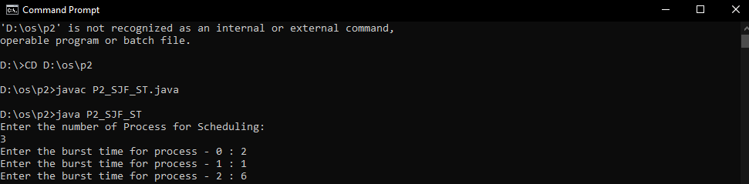

**Output:**

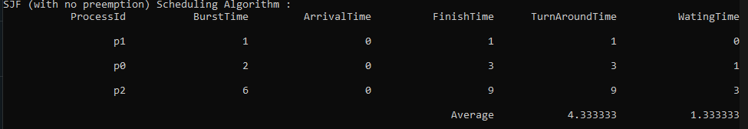

**Table:**

|  |  |  |  |  |  |
| --- | --- | --- | --- | --- | --- |
| Process Id | Burst Time | Arrival Time | Finish Time | Turn Around Time | Waiting Time |
|  |  |  | (Prev. finish time + Burst time | (Finish Time – Arrival Time) | (Turn Around Time – Burst Time) |
| P1 | 1 | 0 | 0+1 = 1 | 1-0=1 | 1-0=0 |
| P0 | 2 | 0 | 1+2 = 3 | 3-0=3 | 3-2=1 |
| P2 | 6 | 0 | 3+6 = 9 | 9-0=9 | 6-3=3 |
|  |  |  | Average | 4.333333 | 1.333333 |

**Gnatt chart:**

|  |  |  |  |
| --- | --- | --- | --- |
| P1 | P0 | P2 |  |
| 0 | 1 | 3 | 9 |

**Sample output 1:**

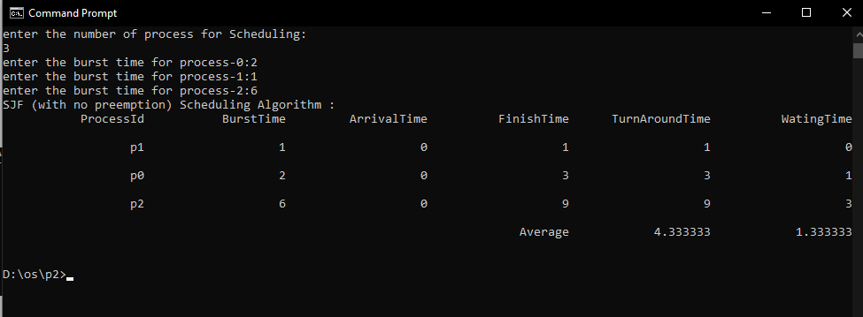

**Table:**

|  |  |  |  |  |  |
| --- | --- | --- | --- | --- | --- |
| Process Id | Burst Time | Arrival Time | Finish Time | Turn Around Time | Waiting Time |
|  |  |  | (Prev. finish time + Burst time | (Finish Time – Arrival Time) | (Turn Around Time – Burst Time) |
| P1 | 1 | 0 | 0+1 = 1 | 1-0=1 | 1-0=0 |
| P0 | 2 | 0 | 1+2 = 3 | 3-0=3 | 3-2=1 |
| P2 | 6 | 0 | 3+6 = 9 | 9-0=9 | 6-3=3 |
|  |  |  | Average | 4.333333 | 1.333333 |

**Gnatt chart:**

|  |  |  |  |
| --- | --- | --- | --- |
| P1 | P0 | P2 |  |
| 0 | 1 | 3 | 9 |

**Sample output 2:**

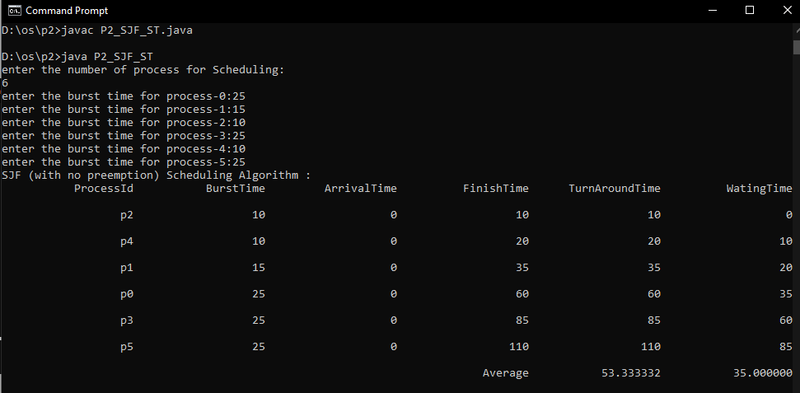

**Table:**

|  |  |  |  |  |  |
| --- | --- | --- | --- | --- | --- |
| Process Id | Burst Time | Arrival Time | Finish Time | Turn Around Time | Waiting Time |
|  |  |  | (Prev. finish time + Burst time | (Finish Time – Arrival Time) | (Turn Around Time – Burst Time) |
| P2 | 10 | 0 | 10 | 10 | 0 |
| P4 | 10 | 0 | 20 | 20 | 10 |
| P1 | 15 | 0 | 35 | 35 | 20 |
| P0 | 25 | 0 | 60 | 60 | 35 |
| P3 | 25 | 0 | 85 | 85 | 60 |
| P5 | 25 | 0 | 110 | 110 | 85 |
|  |  |  | Average | 53.333332 | 35.000000 |

**Gnatt chart:**

|  |  |  |  |  |  |  |
| --- | --- | --- | --- | --- | --- | --- |
| P2 | P4 | P1 | P0 | P3 | P5 |  |
| 0 | 10 | 20 | 35 | 60 | 85 | 110 |

**Sample output 3:**

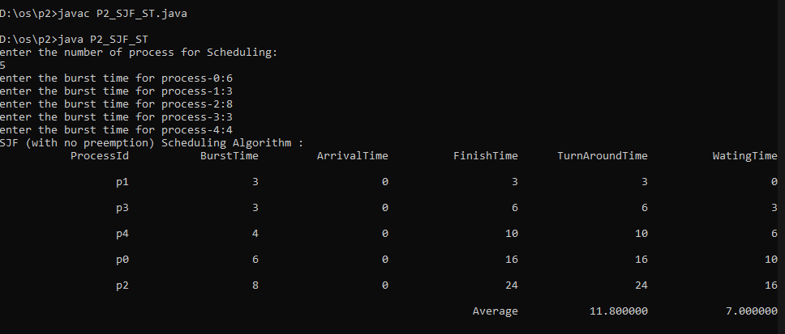

**Table:**

|  |  |  |  |  |  |
| --- | --- | --- | --- | --- | --- |
| Process Id | Burst Time | Arrival Time | Finish Time | Turn Around Time | Waiting Time |
|  |  |  | (Prev. finish time + Burst time | (Finish Time – Arrival Time) | (Turn Around Time – Burst Time) |
| P1 | 3 | 0 | 3 | 3 | 0 |
| P3 | 3 | 0 | 6 | 6 | 3 |
| P4 | 4 | 0 | 10 | 10 | 6 |
| P0 | 6 | 0 | 16 | 16 | 10 |
| P2 | 8 | 0 | 24 | 24 | 16 |
|  |  |  | Average | 11.8000000 | 7.000000 |

**Gnatt chart:**

|  |  |  |  |  |  |
| --- | --- | --- | --- | --- | --- |
| P1 | P3 | P4 | P0 | P2 |  |
| 0 | 3 | 6 | 10 | 16 | 24 |

**Sample output 4:**

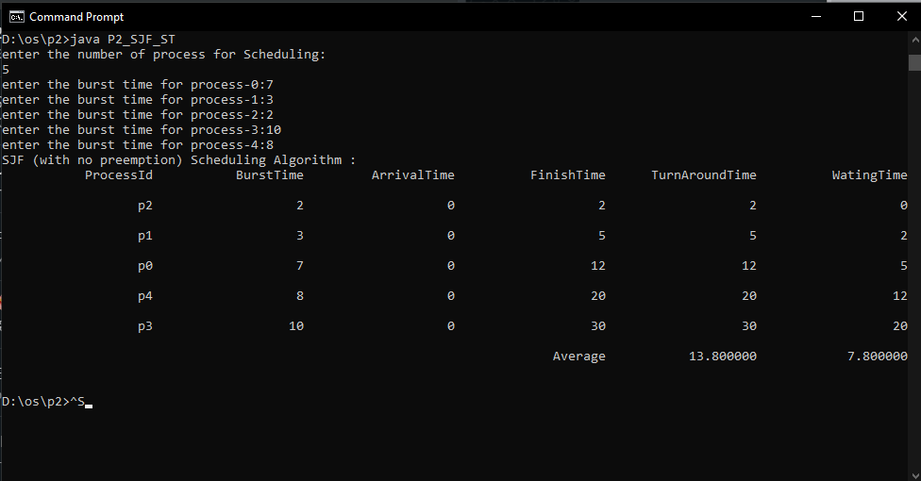

**Table:**

|  |  |  |  |  |  |
| --- | --- | --- | --- | --- | --- |
| Process Id | Burst Time | Arrival Time | Finish Time | Turn Around Time | Waiting Time |
|  |  |  | (Prev. finish time + Burst time | (Finish Time – Arrival Time) | (Turn Around Time – Burst Time) |
| P2 | 2 | 0 | 2 | 2 | 0 |
| P1 | 3 | 0 | 5 | 5 | 2 |
| P0 | 7 | 0 | 12 | 12 | 5 |
| P4 | 8 | 0 | 20 | 20 | 12 |
| P3 | 10 | 0 | 30 | 30 | 20 |
|  |  |  | Average | 11.8000000 | 7.000000 |

**Gnatt chart:**

|  |  |  |  |  |  |
| --- | --- | --- | --- | --- | --- |
| P2 | P1 | P0 | P4 | P3 |  |
| 0 | 2 | 5 | 12 | 20 | 30 |