| Experiment No. 8 |
| --- |
| Name : Sumit yesade |
|  |
| Program to demonstrate CRUD (create, read, update and  delete) operations on database (SQLite/ MySQL) using python |
| Date of Performance: |
| Date of Submission: |

# Experiment No. 8

**Title:** Program to demonstrate CRUD (create, read, update and delete) operations on database (SQLite/ MySQL) using python

**Aim:** To study and implement CRUD (create, read, update and delete) operations on database (SQLite/ MySQL) using python

**Objective:** To introduce database connectivity with python

### Theory:

In general CRUD means performing Create, Retrieve, Update and Delete operations on a table in a database. Let’s discuss what actually CRUD means,

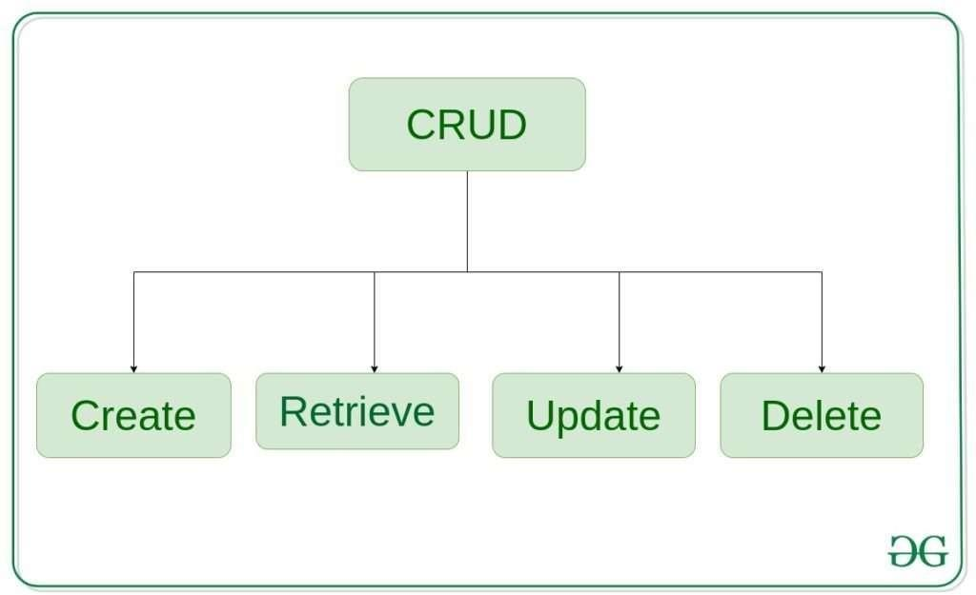

**Create** – create or add new entries in a table in the database.

**Retrieve** – read, retrieve, search, or view existing entries as a list(List View) or retrieve a particular entry in detail (Detail View)

**Update** – update or edit existing entries in a table in the database

**Delete** – delete, deactivate, or remove existing entries in a table in the database

### Code:

### 

### 

### 

### Output:

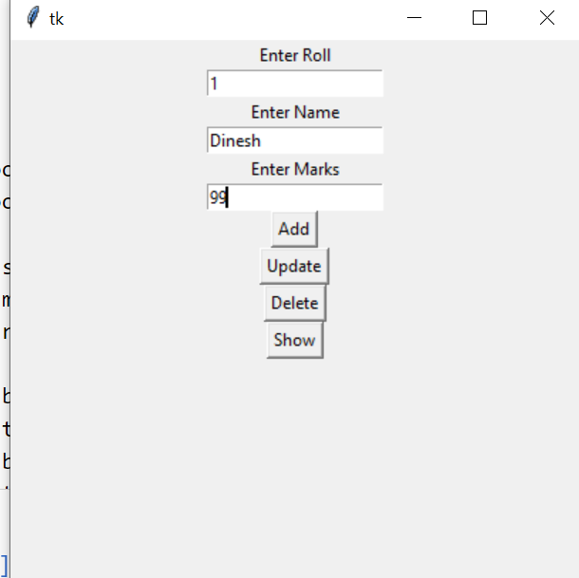

**Conclusion:** CRUD operations has been studied and implemented.

