COMPANY MANAGEMENT SYSTEM
A PROJECT REPORT
Submitted by

DABHI SUMITBHAI

220020107010
In partial fulfillment for the award of the degree of
BACHELOR OF ENGINEERING
in
Computer Engineering
Ahmedabad Institute of Technology, Ahmedabad

Gujarat Technological University, Ahmedabad
April, 2026


Ahmedabad Institute of Technology
Nr. Vasantnagar Township, Gota-Ognaj Road,
Ahmedabad, Gujarat - 380061
CERTIFICATE
This is to certify that the project report submitted along with the project entitled Company Management System has been carried out by the Dabhi Sumit under my guidance in partial fulfillment for the degree of Bachelor of Engineering in Computer Engineering, 8th Semester of Gujarat Technological University, Ahmedabad during the academic year 2025-26.

Ms. Archana Jethava  Internal Guide | Dr. Harsha Padheriy  Head of the Department

INTERNSHIP COMPLETION CERTIFICATE

Offer Letter


Ahmedabad Institute of Technology
Nr. Vasantnagar Township, Gota-Ognaj Road,
Ahmedabad, Gujarat - 380061
DECLARATION
I hereby declare that the Internship report submitted along with the project entitled Company Management System (CMS), submitted in partial fulfillment for the degree of Bachelor of Engineering in Computer Engineering to Gujarat Technological University, Ahmedabad, is a bonafide record of original work carried out by me. The project was undertaken as a personal project during my internship at Technman Consulting Pvt Ltd (January 2026 to April 2026) under the supervision of Moksha Patidar. The internship involved a structured learning journey starting from Python fundamentals, followed by Django and React.js, culminating in the independent development of the CMS. No part of this report has been directly copied from any other source without providing due reference.

___________________________
Sumit Dabhi

ACKNOWLEDGEMENT
I would like to express my sincere gratitude to everyone who supported me during this internship. The journey from learning Python from scratch to independently building a complete enterprise web application would not have been possible without their guidance and encouragement.
I am deeply grateful to my internship mentor, Ms. Moksha Patidar at Technman Consulting Pvt Ltd, for providing a structured and supportive learning environment that guided me progressively from Python fundamentals through Django and React.js to real-world project development.
I extend my heartfelt thanks to my internal college guide, Ms. Archana Jethava, for her continuous academic support, constructive feedback, and encouragement throughout the internship period.
I am also thankful to the Head of the Department of Computer Engineering and all faculty members at Ahmedabad Institute of Technology for providing the academic foundation that made this self-directed learning journey possible.

Sumit Dabhi

ABSTRACT
The Company Management System is a web-based application developed to manage
and automate various organizational operations such as employee records,
department management, project tracking, and administrative activities.

The system provides role-based access for Admin and Employees, ensuring secure
handling of company data. It helps in maintaining employee information, assigning
projects, tracking work progress, and generating reports efficiently.

By replacing manual record keeping with a centralized digital platform, the
Company Management System improves accuracy, reduces paperwork, and enhances
overall operational efficiency. The application is built using modern web
technologies and a centralized database for scalability and reliability.
LIST OF FIGURES
Fig 1.1 Organization Chart of Technman Consulting 3
Fig 3.1 System Architecture Diagram — Frontend, Backend, and RBAC Roles 23
Fig 3.2 Gantt Chart — Project Schedule and Phase Timeline 16
Fig 4.1 Activity / Process Diagram — Proposed CMS System Workflow 20
Fig 5.1 System Architecture Diagram — Full-Stack CMS Overview 23
Fig 5.2 Entity Relationship (ER) Diagram — All 9 CMS Database Entities 24
Fig 5.3 System Flow Diagram — Login, RBAC Navigation, and Module Operations 25

LIST OF TABLES
Table 1.1 Organization Structure of Technman Consulting 3
Table 2.1 Technical Specifications of Major Tools and Equipment 8
Table 3.1 Roles and Responsibilities 15
Table 3.2 Project Effort and Time Estimation 16
Table 4.1 Main Modules of the Company Management System 20
Table 4.2 Hardware and Software Requirements 21
Table 5.1 Database Design — CMS Entity Relationships 26
Table 5.2 REST API Architecture and Endpoints 27
Table 6.1 Technical Challenges and Solutions 34

LIST OF SYMBOLS, ABBREVIATIONS AND NOMENCLATURE
API Application Programming Interface
CMS Company Management System
CORS Cross-Origin Resource Sharing
DB Database
Django Python-Based High-Level Web Framework
DRF Django REST Framework
ER Entity Relationship
GTU Gujarat Technological University
HTTP Hypertext Transfer Protocol
HTTPS Hypertext Transfer Protocol Secure
JWT JSON Web Token
MVC Model View Controller
ORM Object Relational Mapping
RBAC Role-Based Access Control
REST Representational State Transfer
SDLC Software Development Life Cycle
SPA Single Page Application
SQL Structured Query Language
UI User Interface
UX User Experience

TABLE OF CONTENTS
Section | Title | Page
Abstract | Project Abstract | i
Acknowledgement | Acknowledgement | ii
List of Figures | List of Figures | iii
List of Tables | List of Tables | iv
List of Abbreviations | List of Abbreviations and Nomenclature | v
Table of Contents | Table of Contents | vi
Chapter 1 | Overview of the Company | 1
1.1 | History of Technman Consulting Pvt Ltd | 1
1.2 | Scope of Work | 2
1.3 | Organization Chart | 3
1.4 | Team and Capacity | 3
Chapter 2 | Overview of Departments and Work Processes | 4
2.1 | Details of Work Carried Out in Each Department | 4
2.2 | Technical Specifications of Major Tools and Equipment | 8
2.3 | Schematic Layout and Sequence of Operations | 9
Chapter 3 | Introduction to Project | 11
3.1 | Project Summary | 11
3.2 | Purpose | 11
3.3 | Objective | 12
3.4 | Scope | 13
3.5 | Technology and Literature Review | 14
3.6 | Project Planning | 17
3.7 | Project Scheduling (Gantt Chart) | 18
Chapter 4 | System Analysis | 19
4.1 | Study of Current System | 19
4.2 | Problems of Current System | 19
4.3 | Requirements of New System | 20
4.4 | System Feasibility | 21
4.5 | Activity / Process in New System | 22
4.6 | Features of New System | 22
4.7 | Main Modules of the System | 23
4.8 | Hardware / Software / Technology Selection | 23
Chapter 5 | System Design | 25
5.1 | System Architecture Diagram | 25
5.2 | Entity Relationship (ER) Diagram | 26
5.3 | System Flow Diagram | 27
5.4 | Database Design | 28
5.5 | API Architecture | 29
Chapter 6 | Implementation | 30
6.1 | Implementation Platform / Environment | 30
6.2 | Modules Specification | 32
6.3 | Findings / Results / Outcomes | 35
References | References / Bibliography | 38

1. OVERVIEW OF THE COMPANY
1.1 HISTORY
Technman Consulting Pvt Ltd is a technology consulting and software development company focused on delivering custom enterprise software solutions and providing structured internship training programs for engineering students. The company specializes in full-stack web application development, enterprise resource planning systems, and digital transformation services.
A key part of Technman Consulting’s work is its structured internship program, which takes fresh engineering students from zero programming knowledge to independently building real-world full-stack web applications within a four-month period. Interns follow a progressive learning path — Python first, then Django and React.js, then a personal project — before completing their internship.
Vision
Technman Consulting envisions a business world where technology integrates seamlessly with organizational operations. The company is committed to both delivering enterprise-grade software and nurturing the next generation of software developers through its training programs.
Values
The company places strong emphasis on structured learning, continuous self-improvement, and technical excellence. Interns are encouraged to learn independently, build practical skills through hands-on project work, and develop the confidence to tackle real-world software engineering challenges.
1.2 SCOPE OF WORK
Technman Consulting operates across multiple domains of Information Technology, offering a comprehensive suite of services to its clients. The following are the key areas of work and service offerings of the company:
Full-Stack Web Application Development
The company develops end-to-end web applications using modern technology stacks. This includes frontend development with React.js, Angular, and Vue.js, combined with backend development using Django, Node.js, and other frameworks. Technman Consulting follows REST API architecture to ensure seamless integration between frontend and backend systems.
Cloud Computing and DevOps
Technman Consulting provides cloud integration and deployment services, primarily leveraging Amazon Web Services (AWS). Services include provisioning EC2 instances, configuring RDS for managed database services, using S3 for object storage, and containerizing applications using Docker. The company’s DevOps practices include CI/CD pipeline setup, infrastructure automation, and cloud cost optimization.
IT Consulting and Digital Transformation
The company provides strategic IT consulting to help businesses identify technology gaps and implement digital transformation initiatives. This includes system architecture planning, technology stack evaluation, and guidance on migrating legacy systems to modern platforms.
EdTech and Custom Software Solutions
Technman Consulting has developed educational technology solutions, including learning management systems, online assessment platforms, and student performance tracking tools. The Company Management System (CMS) developed during this internship is a prime example of the company’s work in enterprise software solutions.
1.3 ORGANIZATION CHART
Technman Consulting follows a structured organizational hierarchy that promotes clear communication, accountability, and efficient project delivery. The organization is divided into core functional teams, each contributing to the company’s overall objectives.

Department | Role | Responsibility
Management | Director / CEO | Strategic planning, client relations, and overall operations
Engineering | Tech Lead / Senior Engineers | System design, code review, and technical guidance
Development | Full-Stack Developers | Frontend, backend development and API integration
DevOps / Cloud | Cloud Engineers | AWS deployment, Docker containerization, CI/CD pipelines
QA / Testing | QA Engineers | Test planning, functional testing, and bug tracking
Internship | Interns | Project development under mentorship of senior team members
Table 1.1 Organization Structure of Technman Consulting
1.4 TEAM AND CAPACITY
Technman Consulting maintains a lean but highly capable team structure that allows it to handle projects of varying complexities and scales. The company currently operates with a core team of experienced engineers, designers, and consultants, supplemented by interns from leading engineering institutions.
The company’s internship program, in which the author participated, runs in cycles. Each intern is assigned to a specific project under the guidance of a dedicated industry mentor. The current internship involved building the Company Management System (CMS) — a full-stack enterprise web application.
The infrastructure capacity of the company is primarily cloud-based. Technman Consulting uses AWS as its primary cloud provider, with compute capacity managed through EC2 instances and storage managed via Amazon S3. The company uses Docker containers to ensure environment consistency across development, staging, and production systems.

2. OVERVIEW OF DEPARTMENTS AND WORK PROCESSES
2.1 DETAILS OF WORK CARRIED OUT IN EACH DEPARTMENT
Software Development Department
The Software Development Department is the core functional unit of Technman Consulting. It is responsible for designing, building, testing, and maintaining all software products and solutions delivered to clients. The department follows Agile development methodology, conducting bi-weekly sprints to ensure continuous delivery and stakeholder alignment. Key activities include:
• Developing custom web and mobile applications based on client requirements and business use cases.
• Creating RESTful APIs to facilitate seamless data exchange between frontend and backend systems.
• Implementing component-based user interfaces using React.js and TypeScript to ensure maintainability and scalability.
• Developing backend services using Django (Python) with ORM-based database interactions for structured data management.
• Following clean code principles, SOLID design patterns, and conducting peer code reviews to maintain high code quality.
DevOps and Cloud Engineering Department
The DevOps and Cloud Engineering Department is responsible for the deployment, scaling, monitoring, and maintenance of all software systems. The team primarily works with Amazon Web Services (AWS) and Docker to manage the company’s cloud infrastructure. Key activities include:
• Setting up and managing AWS EC2 instances for hosting web applications and backend services.
• Configuring Amazon RDS (Relational Database Service) for managed PostgreSQL database deployments.
• Using Amazon S3 for static file storage, media uploads, and frontend hosting.
• Containerizing applications using Docker and Docker Compose to ensure environment parity across development and production.
• Implementing CI/CD pipelines to automate the build, test, and deployment workflow.
Quality Assurance (QA) Department
The Quality Assurance Department ensures that all software products delivered by Technman Consulting meet the required standards of functionality, performance, and security. The QA team collaborates closely with the development team throughout the SDLC. Key activities include:
• Writing and executing functional test cases for all application modules.
• Performing API testing using Postman to validate backend endpoint behavior.
• Conducting performance testing to identify and resolve bottlenecks under load.
• Tracking and reporting bugs using issue management tools.
Internship and Training Department
Technman Consulting maintains a structured internship and training program designed to develop the next generation of software engineers. Interns are assigned to live projects and work under the supervision of senior mentors. The training department ensures that interns are equipped with both theoretical knowledge and hands-on practical exposure before they are assigned to project tasks.
2.2 TECHNICAL SPECIFICATIONS OF MAJOR TOOLS AND EQUIPMENT
The following table summarizes the major tools, technologies, and platforms used by Technman Consulting across its departments, along with their primary specifications and use cases within the organization.

Tool / Technology | Version / Specification | Primary Use
React.js | v18.x | Frontend SPA development with component-based architecture
React | v5.x | Statically typed JavaScript for frontend development
Django | v4.2 (Python 3.11) | Backend REST API development and ORM-based DB management
PostgreSQL (RDS) | v15.x on AWS RDS | Relational database for application data and user records
Docker | v24.x | Containerization of frontend and backend services
AWS EC2 | t2.micro (Ubuntu 22.04) | Hosting backend Django application
AWS S3 | Standard Storage Class | Static file hosting and media storage
VS Code | Latest Stable | Primary IDE for development
Postman | Latest Stable | API testing and documentation
Git / GitHub | Latest Stable Version | Version control and collaborative code management
Nginx | v1.24.x | Reverse proxy and web server for production deployment
Table 2.1 Technical Specifications of Major Tools and Equipment
2.3 SCHEMATIC LAYOUT AND SEQUENCE OF OPERATIONS
The development workflow at Technman Consulting follows a well-defined sequence of operations that ensures quality, traceability, and efficient delivery. The sequence of operations for the Company Management System project is described below:
• Requirement Gathering: Initial discussions with the industry mentor to define the scope, features, and technical requirements of the Company Management System.
• System Design: Creating architectural diagrams, ER diagrams, use case diagrams, and defining the technology stack before writing any code.
• Environment Setup: Configuring the development environment, setting up the Django backend, React frontend, and connecting to the database.
• Frontend Development: Building the React.js TypeScript application with reusable components, routing, and API integration.
• Backend Development: Developing Django REST Framework (DRF) APIs for data management, user authentication (JWT), and RBAC-based access control.
• Database Configuration: Designing and migrating database schemas using Django ORM.
• Testing: Performing functional, integration, and API testing using Postman and the Django test framework.
• Review and Iteration: Code review sessions with the industry mentor followed by refinements based on feedback.

3. INTRODUCTION TO PROJECT
3.1 PROJECT SUMMARY
The Company Management System (CMS) is a full-stack web-based enterprise application developed as a personal project during the internship at Technman Consulting Pvt Ltd. The project was self-conceived, independently designed, and entirely built by the intern during the final two months of the internship (March–April 2026), following a two-month structured learning program in Python, Django, and React.js.
The CMS centralizes all core organizational operations — employee management, department structure, team allocation, project tracking, attendance, work progress, and reporting — into a single role-aware digital platform. It was built using React.js (frontend), Django REST Framework (backend), and SQLite (database), with JWT authentication and RBAC enforced throughout.
3.2 PURPOSE
The project served a dual purpose. First, it was the practical culmination of the structured learning journey — a way to apply Python, Django, and React.js skills learned from scratch in a real-world context. Second, the CMS was designed to solve a genuine organizational problem: replacing fragmented, manual processes with a unified, secure, digital platform for managing company operations.
3.3 OBJECTIVE
• To apply Python, Django, and React.js skills learned during the internship in a complete personal project.
• To implement RBAC with separate Admin and Employee interfaces and API permissions.
• To digitally manage employee records with department and designation information.
• To organize departments, teams, and team leads in a structured hierarchy.
• To create projects with budget definition and team allocation with over-budget prevention.
• To track attendance via Clock In / Clock Out with automatic working hour calculation.
• To allow employees to submit daily work progress logs per project.
• To generate department performance and attendance reports in Excel format.
• To demonstrate end-to-end full-stack development capability as a personal achievement.
3.4 SCOPE
Included in Current Scope
• Full employee lifecycle: create profile, assign department, update designation.
• Department and team management with team lead designation.
• Project creation with status tracking and total budget definition.
• Project allocation to teams with real-time budget validation.
• Daily Clock In / Clock Out with automatic working hour calculation.
• Employee daily work progress logs linked to specific projects.
• Admin dashboard with live organizational summary statistics.
• Excel report generation for attendance and department performance.
Outside Current Scope (Future Enhancements)
• Payroll and salary management module.
• Leave management and approval workflow.
• Mobile application support.
• Real-time notifications and alerts.
• Cloud deployment (PostgreSQL and production hosting).
3.5 TECHNOLOGY AND LITERATURE REVIEW
Python Programming
Python is a high-level, interpreted, general-purpose programming language that formed the starting point of the entire internship. Its clean syntax, strong standard library, and extensive third-party ecosystem make it the dominant language for backend web development. The OOP principles learned in Python directly enabled understanding of Django’s class-based views and model architecture.
Django and Django REST Framework
Django is a high-level Python web framework following the Model-View-Template (MVT) pattern. It provides a built-in ORM, admin panel, URL routing, middleware, and comprehensive security features. Django REST Framework (DRF) extends Django for API development, providing serializers, class-based API views, viewsets, routers, and authentication systems. DRF was used to build all RESTful endpoints consumed by the React frontend.
React.js
React.js is a declarative JavaScript library for building component-based user interfaces. React’s virtual DOM ensures efficient UI updates for dynamic data. React Router v6 provided client-side navigation, and Axios provided a clean, promise-based interface for making JWT-authenticated HTTP requests to the Django API.
JWT Authentication
JSON Web Tokens (JWT) are a compact, URL-safe mechanism for securely transmitting authentication claims. SimpleJWT for Django issues access and refresh tokens upon login. The role field encoded in the token payload allows the React frontend to render the appropriate dashboard without an additional API call after login.
SQLite and Relational Database Design
SQLite is a lightweight, serverless, file-based relational database that is the default backend in Django. Its zero-configuration setup made it ideal for the development phase. Django ORM handles all database interactions through Python model definitions, with ForeignKey and OneToOneField relationships enforcing data integrity.
Role-Based Access Control (RBAC)
RBAC is a security model where permissions are assigned to roles rather than individuals. In the CMS, RBAC is implemented by extending AbstractUser with a role field and creating custom DRF permission classes that inspect the authenticated user’s role before permitting access to Admin-only endpoints.
Pandas for Excel Reporting
Pandas is a powerful Python data analysis library. In the CMS, it was used to aggregate department performance data and attendance records into structured DataFrames, then exported as formatted Excel files using the openpyxl engine — producing professional reports with minimal code.
3.6 PROJECT PLANNING
Development Approach
The internship followed a strict sequential learning-then-build approach: Python first (January), Django and React.js second (February), personal project development third (March–April). This ensured each new technology was built on a solid foundation, minimizing confusion and maximizing skill retention.
Roles and Responsibilities
Role | Person | Responsibilities
Intern / Developer | Sumit Dabhi | Full system design, development, testing, and documentation
Industry Mentor | Moksha Patidar | Guidance, feedback, and internship supervision
Internal Guide | Ms. Archana Jethava | Academic oversight and report guidance
Table 3.1 Roles and Responsibilities
Project Effort and Time Estimation
Activity | Duration | Period
Python Fundamentals (all concepts) | 4 Weeks | January 2026
Django Fundamentals and DRF | 2 Weeks | February 2026
React.js and Axios Integration | 2 Weeks | February 2026
CMS: Database Schema Design | 1 Week | March 2026
CMS: Backend API (All Modules) | 3 Weeks | March 2026
CMS: React Frontend Development | 2 Weeks | March–April 2026
CMS: API Integration and Testing | 1 Week | April 2026
CMS: Reporting Module (Pandas) | 1 Week | April 2026
Bug Fixes and Documentation | 1 Week | April 2026
Total | ~4 Months | Jan–Apr 2026
Table 3.2 Project Effort and Time Estimation
3.7 PROJECT SCHEDULING — GANTT CHART
The following Gantt chart represents the overall project schedule across the four-month internship period, showing the planned phases and their respective timelines:
Task | January | February | March | April
Python Fundamentals | ✔
Django and DRF |  | ✔
React.js and Axios |  | ✔
CMS Database Schema |  |  | ✔
Backend API Development |  |  | ✔
React Frontend |  |  | ✔ | ✔
API Integration and Testing |  |  |  | ✔
Reporting Module (Pandas) |  |  |  | ✔
Bug Fixes and Documentation |  |  |  | ✔
Report Writing |  |  |  | ✔
Fig 3.2 Gantt Chart — Project Schedule and Phase Timeline

4. SYSTEM ANALYSIS
4.1 STUDY OF CURRENT SYSTEM
Prior to the CMS, most small and medium enterprises manage operations through a combination of Excel spreadsheets, paper-based forms, and disconnected tools. Employee records are stored in Excel, attendance is marked manually, project assignments are communicated via email, and reports are generated manually. This results in data duplication, poor real-time visibility, no budget enforcement, and heavy administrative overhead.
4.2 PROBLEMS OF CURRENT SYSTEM
• No centralized data — employee and project information spread across multiple files.
• Manual attendance marking is error-prone and difficult to audit.
• No real-time project budget tracking — risk of overspending not flagged.
• No role-based access — sensitive data accessible to all staff.
• Report generation requires manual data aggregation and is time-consuming.
• No formal work progress logging — managers have no visibility into daily productivity.
• No structured digital workflow for team and project assignment.
4.3 REQUIREMENTS OF NEW SYSTEM
Functional Requirements
• Create and manage employee profiles with department, designation, and contact details.
• Implement RBAC with separate Admin and Employee interfaces and API permissions.
• Enable employees to Clock In and Clock Out with automatic working hour calculation.
• Allow project creation with budget definition, status tracking, and team allocation.
• Prevent allocation of budget exceeding the project’s total defined budget.
• Allow daily work progress submission per employee per project.
• Generate Excel reports for department performance and attendance summaries.
Non-Functional Requirements
• Security: all API routes protected with JWT authentication.
• Scalability: schema compatible with PostgreSQL migration.
• Usability: role-aware UI intuitive for non-technical users.
• Performance: ORM queries optimized to prevent N+1 problems.
4.4 SYSTEM FEASIBILITY
Technical Feasibility
The system uses entirely open-source technologies (Python, Django, React.js, SQLite) with extensive documentation and proven production usage. All tools are free and available, and the full stack was mastered during the internship learning phases, making technical feasibility high.
Operational Feasibility
The role-based interface ensures usability for both technical administrators and non-technical employees. The system directly addresses real pain points identified in the current manual system and is operationally ready for use.
Economic Feasibility
The system was built using free and open-source tools with zero licensing costs. Development was completed during the internship at no additional expense. Future cloud hosting on platforms such as AWS or DigitalOcean represents minimal ongoing cost for the lightweight application.
4.5 ACTIVITY / PROCESS IN NEW SYSTEM
• Admin logs in with JWT-authenticated credentials and accesses the Admin Dashboard.
• Admin creates departments, then adds employees and assigns them to departments.
• Admin creates teams within departments and assigns a team lead.
• Admin creates projects with total budget and allocates them to teams.
• Employees log in and view their assigned projects and team details.
• Employees clock in at the start and clock out at the end of the workday.
• Employees submit daily work progress entries per project.
• Admin views attendance, work summaries, and department performance via dashboard.
• Admin generates and downloads Excel reports for departmental review.
4.6 FEATURES OF NEW SYSTEM
• Centralized employee data management with department and designation.
• Role-Based Access Control (RBAC) with Admin and Employee roles.
• JWT-secured API with token refresh support.
• Automated working hour calculation from Clock In / Clock Out records.
• Real-time project budget tracking with over-allocation prevention.
• Daily work progress logging with project-level hour tracking.
• Admin dashboard with real-time organizational summary statistics.
• Excel report generation via Pandas for department and attendance data.
4.7 MAIN MODULES OF THE SYSTEM
Module | Description
User and Role Management | Custom User model with role field (ADMIN/EMPLOYEE), JWT authentication, and protected API routes.
Employee Management | Employee profile linked to User, department, designation, and contact information.
Department Management | Create departments, assign employees, and generate department-wise reports.
Team Management | Create teams, assign employees, designate team lead, and enforce unique membership.
Project Management | Create projects, track status (Pending/In Progress/Completed), and define total budget.
Project Allocation | Allocate budget to teams with validation against total project budget.
Attendance Management | Clock In/Out per employee per day with automatic working hour calculation.
Work Progress Tracking | Daily work logs per project with hours worked and productivity monitoring.
Admin Dashboard | Real-time summary statistics: employees, projects, departments, budget, and work hours.
Reporting System | Excel exports for department performance and attendance summaries using Pandas.
Table 4.1 Main Modules of the Company Management System
4.8 HARDWARE / SOFTWARE / TECHNOLOGY SELECTION
Hardware Requirements
• Processor: Multi-core processor (Intel Core i5 or equivalent).
• RAM: Minimum 8 GB for running Django server, React development server, and browser.
• Storage: Minimum 10 GB for project files, virtual environments, and database.
Software Requirements
Component | Technology / Tool
Programming Language | Python 3.10+, JavaScript (ES6+)
Backend Framework | Django 4.x, Django REST Framework
Frontend Framework | React.js 18, React Router v6
Authentication | SimpleJWT for Django
Database | SQLite (development phase)
Reporting | Pandas, openpyxl
API Testing | Postman
IDE | Visual Studio Code
Version Control | Git and GitHub
Package Managers | pip (Python), npm (Node.js)
Table 4.2 Hardware and Software Requirements

5. SYSTEM DESIGN
5.1 SYSTEM ARCHITECTURE DIAGRAM
The Company Management System follows a three-layer full-stack architecture: a React.js frontend, a Django REST Framework backend, and a SQLite database. All communication between frontend and backend occurs via JSON-based REST API calls. All routes are protected with JWT authentication, and RBAC permission classes enforce role-based data access at the API level.
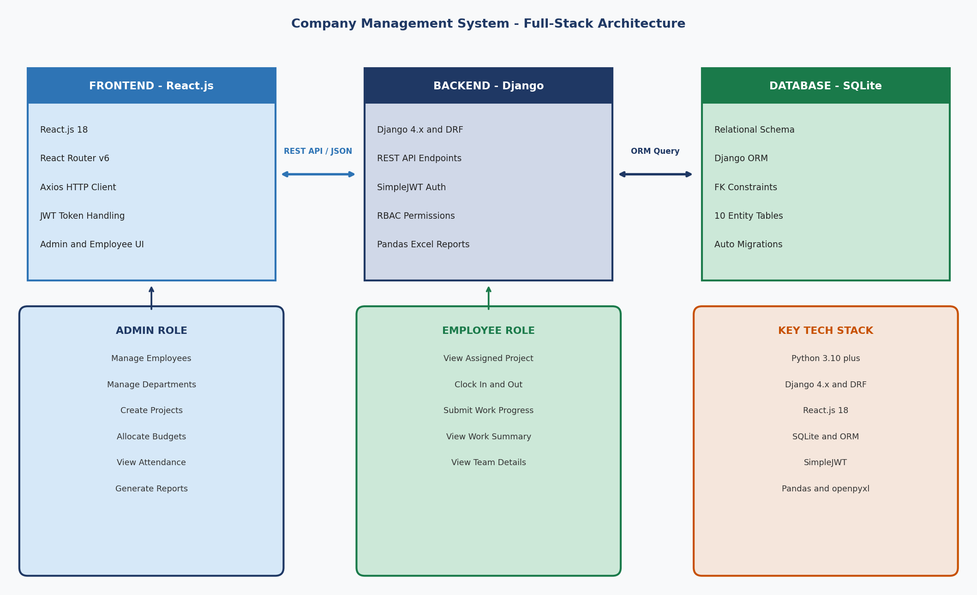
Fig 5.1 System Architecture Diagram — Full-Stack CMS Overview
The Admin role has full access to all management endpoints including employee, department, team, project, allocation, attendance, work progress, and report generation. The Employee role has restricted access limited to viewing their own assigned data, submitting attendance, and logging daily work progress. Role detection is performed on the React frontend using the role field in the decoded JWT token payload.

5.2 ENTITY RELATIONSHIP (ER) DIAGRAM
The ER diagram below shows all nine entities in the CMS database and their relationships. The diagram uses Django ORM’s relational field types (ForeignKey and OneToOneField) to enforce data integrity. Primary Keys (PK) are shown in blue and Foreign Keys (FK) in red for clarity.
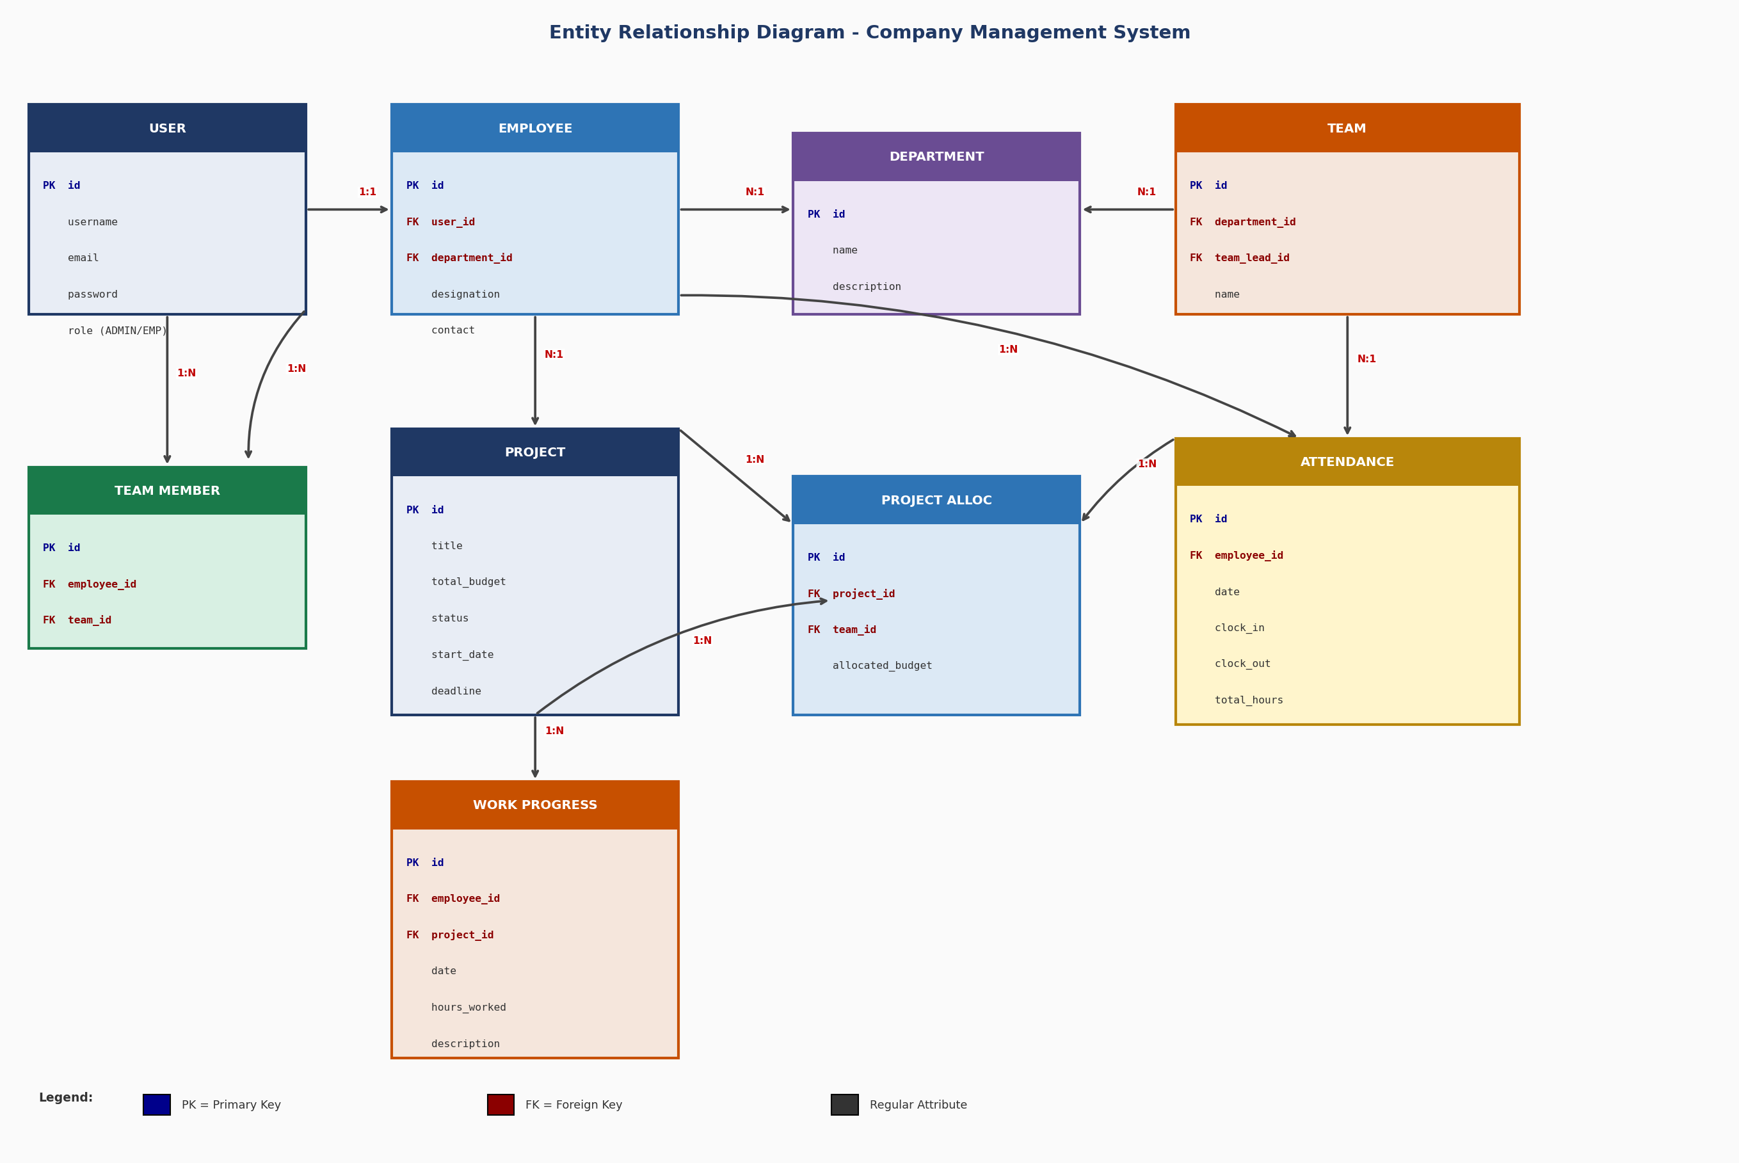
Fig 5.2 Entity Relationship (ER) Diagram — All 9 CMS Database Entities
Key Relationships
• User and Employee: OneToOne — each system user has exactly one employee profile.
• Employee and Department: ForeignKey (Many-to-One) — many employees belong to one department.
• Team and Department: ForeignKey — each team belongs to a specific department.
• TeamMember: ForeignKey to Employee and Team — unique_together constraint prevents duplicate membership.
• ProjectAllocation: ForeignKey to Project and Team — links projects to teams with allocated budget.
• Attendance and Employee: ForeignKey — one clock-in/out record per employee per day.
• WorkProgress: ForeignKey to Employee and Project — daily work logs per employee per project.
5.3 SYSTEM FLOW DIAGRAM
The system flow diagram below illustrates the complete operational workflow of the CMS from user login through to session end. The flow splits at the role check — Admin users are directed to the Admin Dashboard with full management capabilities, while Employee users see a restricted Employee Dashboard.
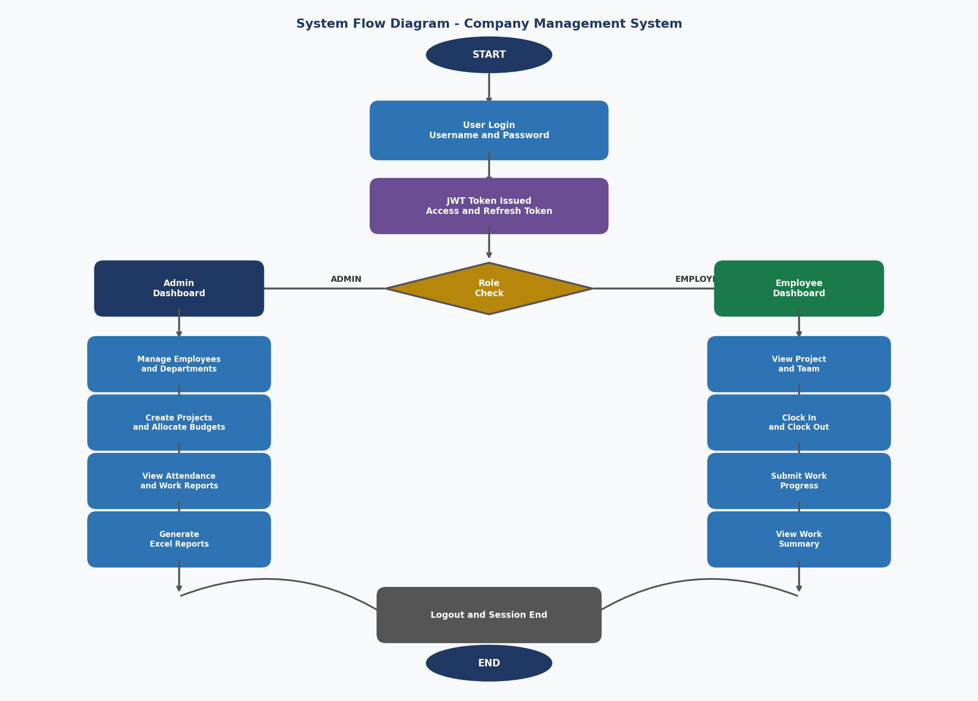
Fig 5.3 System Flow Diagram — Login, RBAC Navigation, and Module Operations
5.4 DATABASE DESIGN
Entity | Related Entity | Relationship Type
User | Employee | OneToOne — each user has one employee profile.
Employee | Department | ForeignKey — many employees per department.
Employee | TeamMember | ForeignKey — employee can join a team.
Team | Department | ForeignKey — team belongs to a department.
Team | ProjectAllocation | ForeignKey — team can have project allocations.
Project | ProjectAllocation | ForeignKey — project can be allocated to teams.
Employee | Attendance | ForeignKey — one attendance record per employee per day.
Employee | WorkProgress | ForeignKey — employee logs daily progress entries.
Project | WorkProgress | ForeignKey — work progress is linked to a project.
Table 5.1 Database Design — CMS Entity Relationships
5.5 API ARCHITECTURE
Endpoint | Method | Access | Description
/api/auth/login/ | POST | Public | Obtain JWT access and refresh tokens.
/api/employees/ | GET, POST | Admin | List and create employee profiles.
/api/departments/ | GET, POST | Admin | Manage departments.
/api/teams/ | GET, POST | Admin | Manage teams and team leads.
/api/projects/ | GET, POST | Admin | Create and list projects with budget.
/api/allocations/ | GET, POST | Admin | Allocate projects to teams with budget.
/api/attendance/ | GET, POST | Employee | Clock In and Clock Out.
/api/workprogress/ | GET, POST | Employee | Submit daily work progress logs.
/api/dashboard/ | GET | Admin | Aggregated organizational statistics.
/api/reports/department/ | GET | Admin | Download Excel department report.
Table 5.2 REST API Architecture and Endpoints

6. IMPLEMENTATION
6.1 IMPLEMENTATION PLATFORM / ENVIRONMENT
Backend Environment — Django
The backend was implemented using Django 4.x with Django REST Framework. A Python virtual environment was created using venv to isolate all project dependencies. Key packages installed for the backend:
• django: Core web framework providing URL routing, ORM, admin panel, and security features.
• djangorestframework: Provides serializers, class-based API views, viewsets, routers, and response handling.
• djangorestframework-simplejwt: JWT token generation, validation, and refresh token management.
• django-cors-headers: Handles CORS to allow React frontend requests from a different port.
• pandas: Used for data aggregation and Excel report generation.
• openpyxl: Excel file creation backend for Pandas exports.
Frontend Environment — React.js
The frontend was bootstrapped using Create React App with React 18. Key libraries used:
• react-router-dom v6: Client-side routing for navigation between modules without page reload.
• axios: HTTP client for making authenticated JWT API requests to the Django backend.
• React Hooks (useState, useEffect, useContext): State management and lifecycle handling.
Custom User Model
Django’s default User model was extended using AbstractUser to add a custom role field accepting values ADMIN or EMPLOYEE. This was registered in settings.py using AUTH_USER_MODEL before the first migration to ensure Django uses the custom model as the primary authentication model.
JWT Authentication Flow
On login, the frontend posts credentials to /api/auth/login/ and receives an access token and refresh token from SimpleJWT. The access token is stored in React application state and sent as a Bearer token in the Authorization header of every Axios request. The role field in the token payload is decoded on the frontend to determine which dashboard to render.
CORS Configuration
Since the Django backend runs on port 8000 and React on port 3000 during development, CORS headers were configured using django-cors-headers. CORS_ALLOWED_ORIGINS in settings.py was set to permit requests from the React development server — this was a critical configuration step for frontend-backend communication.
6.2 MODULES SPECIFICATION
User and Role Management
The User model was extended from AbstractUser with a role field. Custom DRF permission classes were created by extending BasePermission and checking the request.user.role field before allowing access to Admin-only endpoints. JWT tokens include the role in their payload for frontend role detection.
Employee Management
The Employee model has a OneToOneField to User and a ForeignKey to Department, with additional fields for designation and contact. The employee serializer uses nested serialization to include user and department details in a single API response, eliminating additional round trips.
Department Management
Departments are standalone entities with name and description. Employees are linked via ForeignKey on the Employee model. The reporting module aggregates employee performance per department using Django ORM’s annotate and values to produce department-level summaries.
Team and Team Lead Management
Teams belong to a Department via ForeignKey. Team membership is managed through a TeamMember junction model. A unique_together constraint on TeamMember prevents duplicate employee-team assignments. The team lead is a ForeignKey from Team to Employee, with validation ensuring the lead belongs to the team’s department.
Project Management
Projects store title, description, total_budget, start_date, deadline, and status. The project serializer includes calculated budget_utilized — the sum of all related ProjectAllocation records — providing real-time budget tracking in API responses without a separate endpoint.
Project Allocation with Budget Validation
ProjectAllocation links a Project to a Team with an allocated_budget. A pre-save validation in the serializer aggregates all existing allocations for the project and raises a ValidationError if the new allocation would cause total allocated budget to exceed the project’s defined total budget.
Attendance Management
The Attendance model stores clock_in_time, clock_out_time, date, and total_hours per employee. Clock In creates a new record; Clock Out updates the existing record for today and calculates total_hours using Python’s timedelta. A constraint prevents duplicate Clock In for the same employee on the same date.
Work Progress Tracking
WorkProgress stores date, hours_worked, and description linked to both Employee and Project via ForeignKey. The Admin dashboard aggregates total work hours per employee and per project using Django ORM’s Sum annotation, providing management with real-time productivity visibility.
Admin Dashboard and Reporting
The Admin Dashboard aggregates live statistics including total employees, departments, projects by status, total budget allocated, and total work hours logged. The reporting module queries department-wise data, builds a Pandas DataFrame, and returns it as a formatted Excel file via an HTTP response with the appropriate content-type header.

REFERENCES / BIBLIOGRAPHY
1. Django Software Foundation. (2023). Django Documentation (v4.2). https://docs.djangoproject.com/en/4.2/
2. Encode OSS Ltd. (2023). Django REST Framework Documentation. https://www.django-rest-framework.org/
3. Meta Open Source. (2023). React.js Documentation (v18). https://react.dev/
4. Jbauer-reify. (2023). django-rest-framework-simplejwt Documentation. https://django-rest-framework-simplejwt.readthedocs.io/
5. The Pandas Development Team. (2023). pandas: Powerful Python Data Analysis Toolkit. https://pandas.pydata.org/docs/
6. Python Software Foundation. (2023). Python 3.11 Documentation. https://docs.python.org/3.11/
7. SQLite Consortium. (2023). SQLite Documentation. https://www.sqlite.org/docs.html
8. jwt.io. (2023). Introduction to JSON Web Tokens. https://jwt.io/introduction/

