PROBLEM-1

DESIGN A SMART ATTENDANCE SYSTEM TO MONITOR THE ATTENDANCE IN THE CLASSROOM

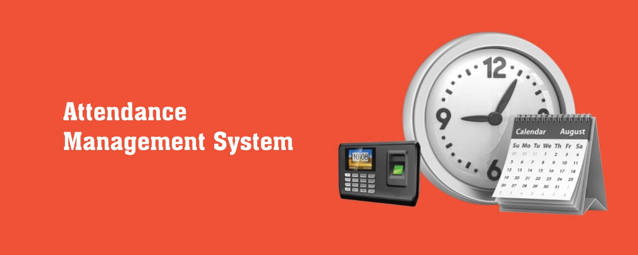

SOLUTION :- In many areas of education, keeping track of student engagement is required. For crowded study halls, manually administering the participation forms is challenging.

1. The first purpose of face detection and identification frameworks, one of the components of computer vision, was for surveillance purposes.
2. We can also connect the attendance marking device with Bluetooth /WIFI of students mobile phone .becuase in this generation everyone having mobile phone .
3. We can also develop the entrance of classroom as biometric scanner .

For ex- If a student is having biometric Id card the if he/she passing through entrance of classroom the time at which he/she has entered attendance and many other info

will be mark for the particular student who have passed from intrance .

1. Here we can add AI bot for whole the process .
2. We can link the device with university portal or university app so every student can see the attendance update .

BENEFITS :

1. Where Id card will be compulsory because whole attendance procees will be based on Biometric Id card .
2. There will be contactless attendance between all student
3. There will be proper record of attendance of teacher as well as student .
4. The students will be able to see the attendance anytime and if not marked then can talk to teacher so the chance of getting absent will be solved

Problem-3

DESIGN A SECURED WIRELESS CONTROLLER FOR PEAK HOUR TRAFFIC MANAGEMENT

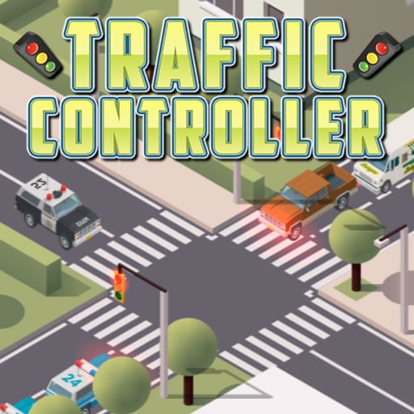  
SOLUTION:- Secure wireless remote-control system for handheld operations of traffic signals during peak hours. The conventional traffic signal systems do not handle variable flow approaching the junction, leading to traffic congestion and accidents. To address this issue, our proposed system allows traffic police officers to control the traffic lights and barriers manually using a secure remote.

1. The remote features a biometric unlock mechanism for added security.
2. By pressing a key in the remote, the traffic lights and barriers can be adjusted accordingly
3. The barriers automatically emerge when the signal is red, descend when the signal is yellow, and stay beneath the road when the signal is green.
4. We can use codes to secure the device and server from hacking . Also we can create the stronger codeing Wall to secure the privacy and hacking of the server and device .
5. The AI will be also used to make it more effective device and can increase functioning in the device

Problem-4

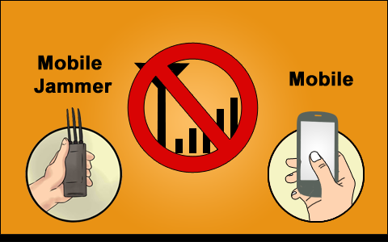DESIGN A MOBILE JAMMER FOR COLLEGE CAMPUS.

SOLUTION:- It would be a safer solution to use a “mobile jammer”, which is a compact and customizable unit that can be conveniently used in schools to prevent high-tech copying. It effectively disables signals inside the controlled zones without interfering with other forms of communication, such as radio and television. It can be used in any area, but it is most often used in areas where a phone call would be disruptive, such as libraries, hospitals, movie theatres, schools, and colleges

1. For the circuit of the mobile jammer containing the three important-functional part
2. RF Amplifier
3. Voltage-Controled- Oscilator
4. Tuning Circuit
5. Both cell phones can automatically re-establish contact and provide full signal once the mobile jammers are switched off.
6. Portable mobile jammers, remote control mobile jammers, adjustable mobile jammers, and other solutions to this issue are currently available

PROBLEM-7

DESIGN A NO CONTACT SMART LOCK WITH SECURITY

Security and safety are one of the common issues

that brings worries for human being. As Security of

human life and property is one of the paramount

challenges facing nations and corporate organization

Security and safety are one of the common issues

that brings worries for human being. As Security of

human life and property is one of the paramount

challenges facing nations and corporate organization

Security and safety are one of the common issues

that brings worries for human being. As Security of

human life and property is one of the paramount

challenges facing nations and corporate organization

Security and safety are one of the common issues

that brings worries for human being. As Security of

human life and property is one of the paramount

challenges facing nations and corporate organization

Security and safety are one of the common issues

that brings worries for human being. As Security of

human life and property is one of the paramount

challenges facing nations and corporate organization

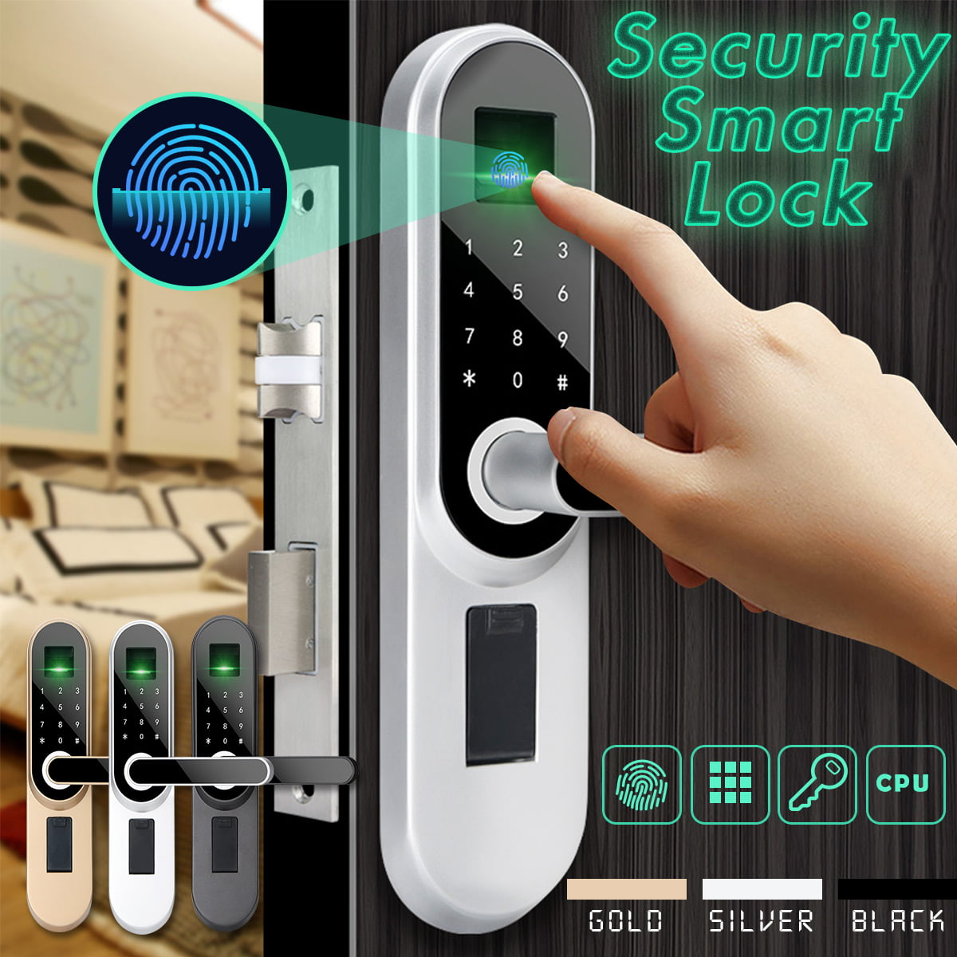

SOLUTION:-Electronic smart locks are growing as a result of IoT. These battery-powered locks often require features such as BLE, Sub-1 GHz, Wi-Fi connectivity, interactive RGBW HMI, audio and sensing and more. Our integrated circuits and reference designs help you address complex design issues while reducing time to market.

1. Energy efficiency and long battery life with a wide operating temperature range.
2. Secure management of keys and access control.
3. Low-power HMI like RGBW LEDs, touch, proximity sensing and audio notification.
4. Support of multiple industry standards like ZigBee®, 6LoWPAN and ZigBee RF4CE remote control applications.
5. Configurable BLE advertisement intervals to reduce power consumption.

PROBLEM:-5

DESIGN A SMART STREET LIGHT SYSTEM WITH RENEWABLE ENERGY SOURCES. 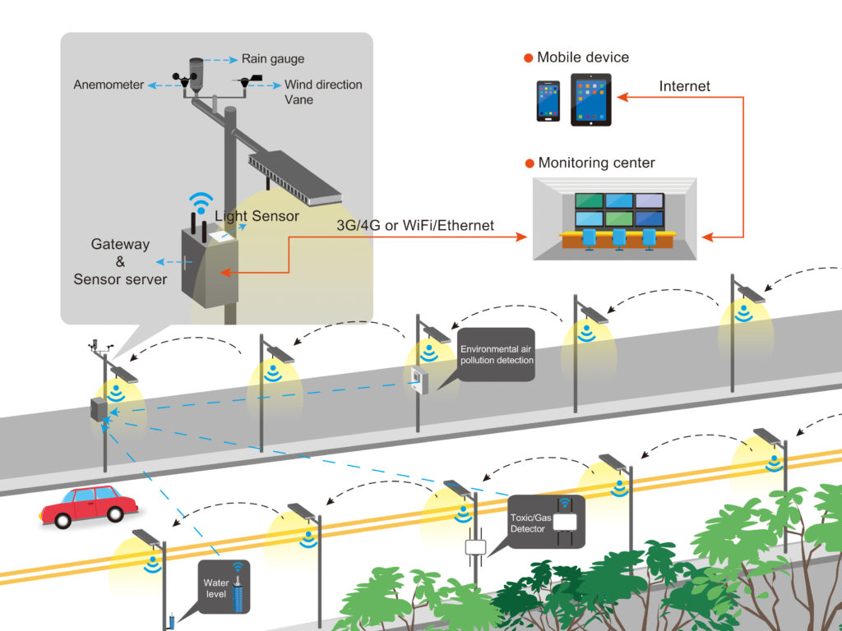

SOLUTION:- The advances in the technology of renewable energy sources have also contributed to the increased dependence on renewable energy, as opposed to the conventional fossil-based sources

1. **Arduino:-** The digital and analog input/output pins equipped in this board can be interfaced to various expansion boards and other circuits
2. **Solar Panel:-**The device which converts the solar energy into electric energy is called Solar Panel.
3. **Wind Mill:**The device which converts the Wind Energy into Rotational Mechanical Energy is called Wind Mill.
4. **IR Sensors:**The component we use to find whether there is any obstacle in the path in which our trolley is going are IR sensors (Infrared).
5. **Inverter Circuit:**Inverter Circuit: The Inverter circuit is a circuit used to convert AC power to DC power and vice versa.
6. **Wi-Fi Module:**ESP8266 Wi-Fi module is generally used to establish the wireless communication between the devices. But this module is not capable of 5-3V logic shifting and will require an external logic level converter