EBS & EFS Practical Exercise

* Task1:

* Create an EBS volume, attach it to an EC2 instance, take a snapshot, and try attaching it to another instance.

* Experiment with EFS by mounting it across multiple EC2 instances and test file sharing.

Step 1: Create an EBS Volume
- Go to the EC2 Dashboard > Elastic Block Store > Volumes.
- Click Create Volume.
  - Select Volume Type (e.g., gp2).
  - Choose Size (e.g., 8 GiB).
  - Availability Zone must match your target EC2 instance.
- Click Create Volume.

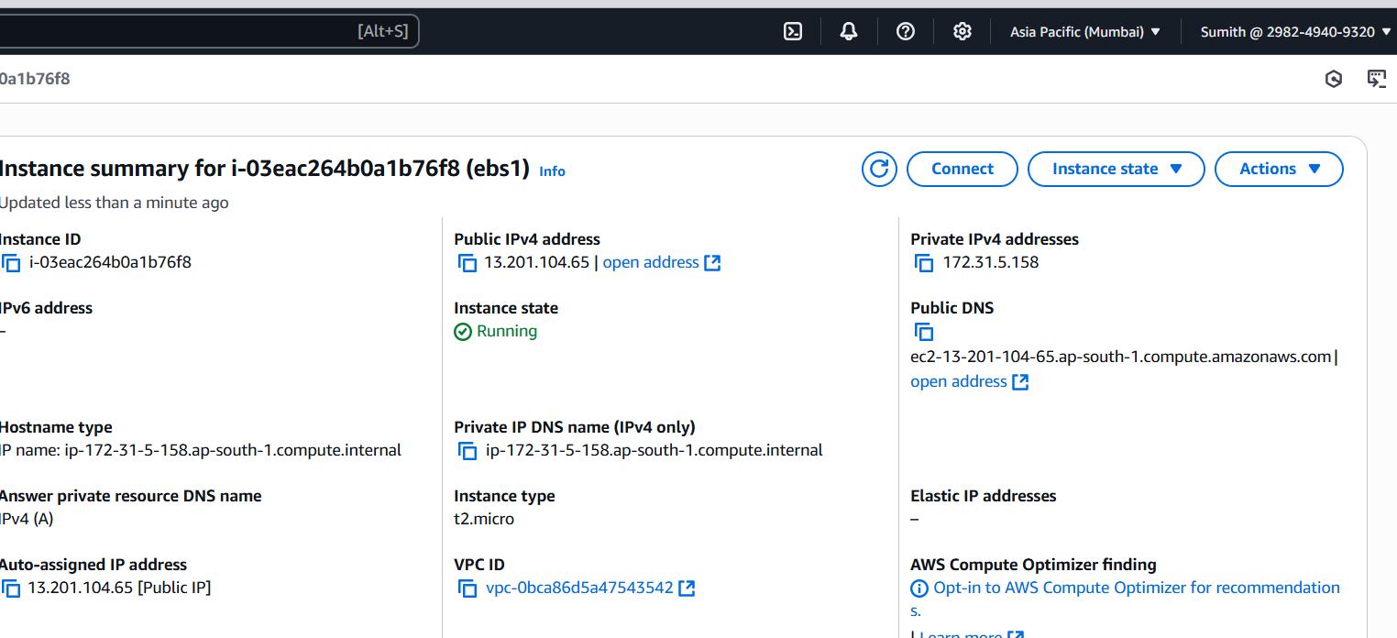
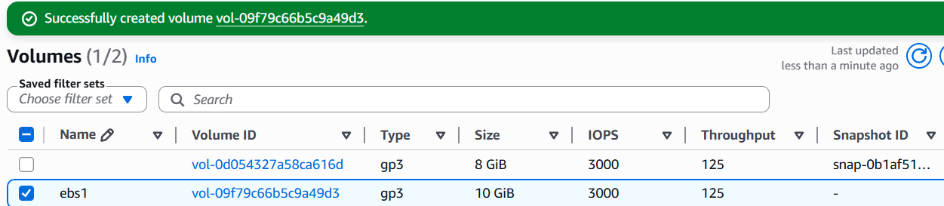
Step 2: Attach EBS Volume to an EC2 Instance
- Select the created volume > Actions > Attach Volume.
- Select your running EC2 instance.
- Provide a device name (e.g., /dev/xvdf), then Attach.

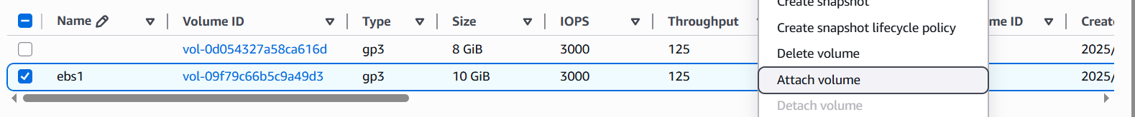
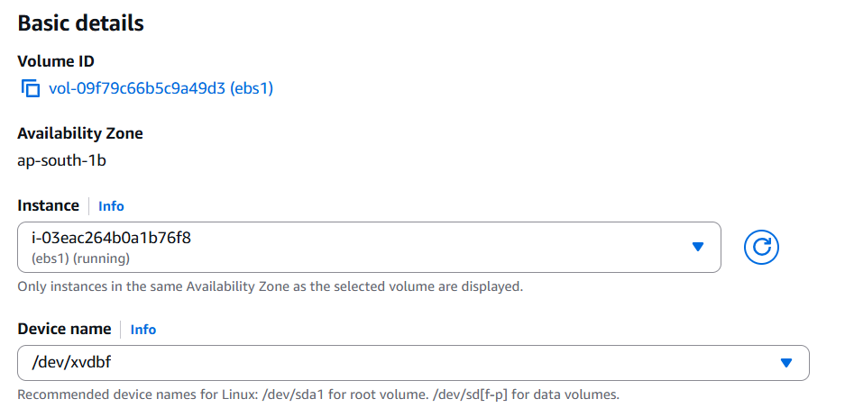
Step 3: Format & Mount EBS Volume on EC2
- SSH into your EC2 instance.
- Run:
lsblk # Check if /dev/xvdf appears
sudo mkfs -t ext4 /dev/xvdf
sudo mkdir /mnt/ebs
sudo mount /dev/xvdf /mnt/ebs
- Create a sample file to verify:
echo "Hello from EBS" | sudo tee /mnt/ebs/ebs-test.txt
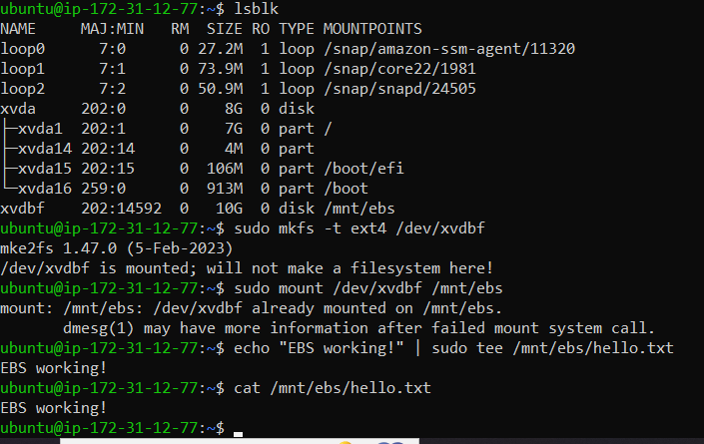
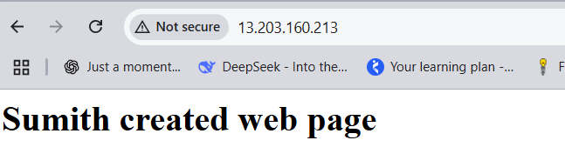
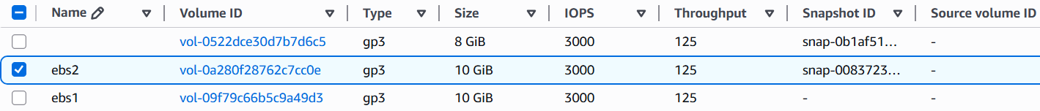

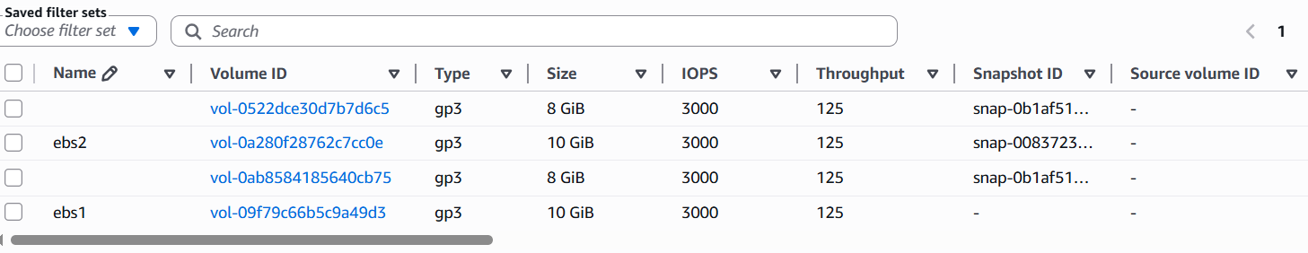
Step 5: Create a New Volume from Snapshot & Attach to Another EC2
- Go to Snapshots > select your snapshot > Create Volume.
- Make sure to use the same AZ as your second EC2.
- Attach it to another EC2 instance > SSH into that instance.
- Mount it:
bash
CopyEdit
lsblk
sudo mkdir /mnt/ebs2
sudo mount /dev/xvdf /mnt/ebs2
cat /mnt/ebs2/ebs-test.txt

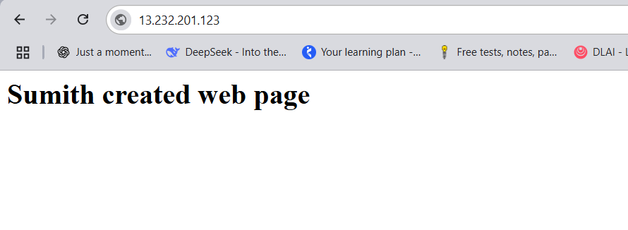
EFS PRACTICAL TASK
🔹 Step 1: Create an EFS File System
- Go to EFS dashboard > Create file system.
- Choose VPC, leave default settings.
- Click Next until Create File System.
Step 2: Mount EFS to Multiple EC2 Instances
- Ensure EC2 instances are in the same VPC & security group allows NFS (port 2049).
- SSH into each EC2 instance.
- Install NFS client:
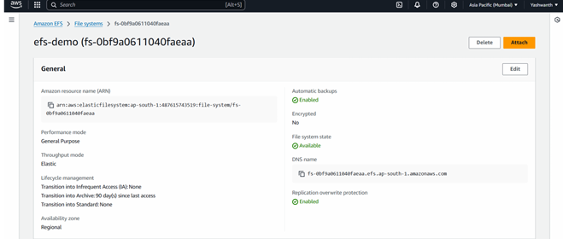
sudo yum install -y nfs-utils # For Amazon Linux
sudo apt install -y nfs-common # For Ubuntu
- Mount EFS:
sudo mkdir /mnt/efs
sudo mount -t nfs4 -o nfsvers=4.1 [Your_EFS_DNS]:/ /mnt/efs
Replace [Your_EFS_DNS] with DNS from EFS console (e.g., fs-xxxx.efs.us-east-1.amazonaws.com).
- Test file sharing:
  - On Instance 1
echo "Shared via EFS" | sudo tee /mnt/efs/test.txt
  - On Instance 2:
cat /mnt/efs/test.txt # Should display "Shared via EFS"

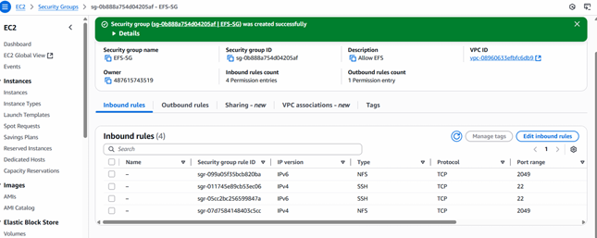
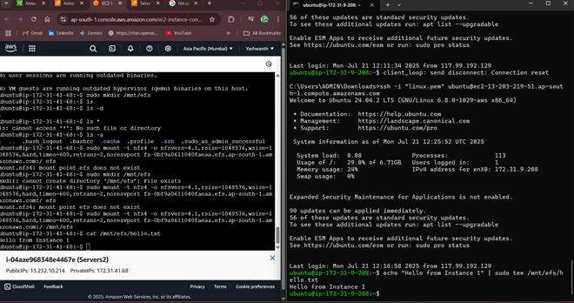

Task: Auto Scaling & Load Balancer Setup

🛠️ 1. Create a Launch Template from Existing EC2
This template will be used to auto-launch instances when needed.
- Go to EC2 Dashboard > Launch Templates > Create launch template
- Name it: e.g., web-app-template
- Select:
  - AMI: same as your running EC2
  - Instance Type: same (e.g., t2.micro)
  - Key pair, Security group, User data (optional)
- Click Create launch template
✅ You now have a reusable template for Auto Scaling.

🔁 2. Create Auto Scaling Group (ASG)
- Go to EC2 > Auto Scaling Groups > Create
- Choose Launch Template → Select the one you just created
- VPC & Subnet: Choose same as EC2
- Load Balancer (optional but recommended):
  - Select an existing Target Group or create a new Application Load Balancer (ALB)
- Set capacity:
  - Minimum: 1
  - Desired: 1
  - Maximum: 2 or more (as you wish)
- Health checks: Enable EC2 or ELB based
- Tag: Name = AutoEC2
✅ ASG now manages EC2 lifecycle automatically.

💣 3. Test Auto-Replacement by Termination
- Go to EC2 > Instances
- Find the EC2 launched by ASG (check tag or instance ID)
- Terminate it manually
🎯 Expected behavior:
- Auto Scaling Group detects missing instance
- Launches a new one automatically
- Within a few minutes, the new instance appears with same launch template settings

🧪 Optional: Connect with Load Balancer
If using an Application Load Balancer (ALB):
- Go to EC2 > Load Balancers
- Copy the DNS name of the ALB
- Paste in browser: should serve from backend EC2 managed by ASG
✅ This proves:
- Auto Scaling is working
- Load Balancer is routing requests to available instances

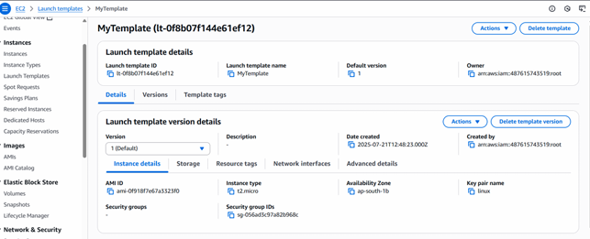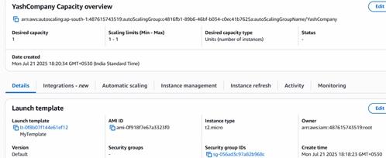

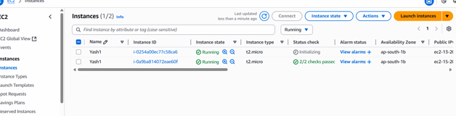

DOCUMENTS
EBS vs. EFS vs. S3 – AWS Storage Comparison:
Amazon EBS (Elastic Block Store)
📌 Description:
EBS is block-level storage designed to be attached to a single EC2 instance at a time, like a virtual hard disk. It acts as persistent storage for operating systems, databases, and applications that require fast, low-latency access to data.
✅ Use Cases:
- Boot volumes for EC2
- Databases like MySQL, PostgreSQL
- Applications requiring transactional I/O (e.g., ERP)
- Custom file systems
⚙️ Key Features:
- Comes in various volume types: gp3, io2, sc1, st1
- Supports snapshots (backed by S3) for backups
- Data remains even after EC2 shutdown
- Encryption using AWS KMS

💰 Pricing:
- Charged per GB/month (e.g., gp3 ~$0.08/GB)
- Additional costs for provisioned IOPS (for io2)
- Snapshots: ~$0.05/GB/month
- More cost-effective than EFS for single-instance workloads

🔵 Amazon EFS (Elastic File System)
📌 Description:
EFS provides shared, scalable file storage that can be mounted concurrently by multiple EC2 instances across Availability Zones. It uses the NFS protocol and behaves like a managed NAS (Network Attached Storage).
✅ Use Cases:
- Shared storage for web servers and containers
- Machine learning pipelines
- Development environments
- CMS like WordPress (shared asset folders)

⚙️ Key Features:
- Automatically grows and shrinks as files are added or deleted
- Supports two performance modes (General Purpose, Max I/O)
- Supports lifecycle management (automatically moves files to infrequent access tier)
- Offers regional redundancy (multi-AZ)
💰 Pricing:
- Standard: ~$0.30/GB/month
- Infrequent Access tier: ~$0.025/GB/month + per-access fee
- Much costlier than EBS if frequently accessed
- Better suited for workloads that truly require shared access

🟢 Amazon S3 (Simple Storage Service)
📌 Description:
S3 is object storage built for the cloud, capable of storing any amount of unstructured data. Unlike EBS or EFS, S3 does not support traditional file system mounting — instead, data is accessed via APIs, SDKs, or S3-compatible tools.
✅ Use Cases:
- Static website hosting
- Big data analytics (data lake)
- Media storage (images, videos)
- Backup and archival (via Glacier)
⚙️ Key Features:
- 11 9’s durability (99.999999999%)
- Supports versioning, encryption, access control policies
- Lifecycle rules to transition data across storage tiers (Standard → Infrequent → Glacier)
- Accessed over HTTP/HTTPS using RESTful API
💰 Pricing:
- S3 Standard: ~$0.023/GB/month
- S3 IA: ~$0.0125/GB/month
- Glacier: ~$0.004/GB/month
- Additional charges for PUT/GET requests and data transfer

🧠 Summary: When to Use What?
Need | Best Option
Attach persistent disk to EC2 | EBS
Share files across EC2 instances | EFS
Store backups, images, static files | S3
Require low-latency transactional I/O | EBS
Need scalable shared storage | EFS
Need web-scale, durable object storage | S3

💡 Final Thought:
- EBS is like your laptop’s SSD: fast, private, and attached.
- EFS is like a shared network drive: good for collaboration.
- S3 is like a cloud hard drive: scalable, durable, and globally accessible
Vertical vs. Horizontal Scaling: Real-World Insights & Comparison
🌐 Overview
In cloud computing and system architecture, scaling is the process of adjusting resources to meet demand. There are two primary methods:
- Vertical Scaling (Scale Up): Adding more power (CPU, RAM, SSD) to an existing machine.
- Horizontal Scaling (Scale Out): Adding more machines/nodes to handle the load in parallel.

🏢 Real-World Examples
Company | Scaling Type | How They Use It
Netflix | Horizontal | Distributes traffic across thousands of EC2 instances  using auto-scaling groups
Facebook | Horizontal | Shards user data across servers; uses Memcached clusters  for distributed caching
Amazon | Horizontal | Leverages microservices architecture with containers (ECS, EKS)
LinkedIn | Combination | Uses vertical scaling for Kafka brokers and horizontal for web servers
Small Startups | Vertical | Start with vertically scaled VMs for simplicity and cost efficiency

⚖️ Pros & Cons
🔼 Vertical Scaling (Scale-Up)
Increase capacity of a single machine.
✅ Pros:
- Simpler to implement (especially on monolithic apps)
- No changes in application logic
- Lower initial complexity
- Easier to manage in small deployments
❌ Cons:
- Limited by hardware limits (CPU/RAM ceiling)
- Downtime may be required during upgrades
- Poor fault tolerance — if one machine fails, service is down
- Not cost-effective beyond a point

🔁 Horizontal Scaling (Scale-Out)
Increase capacity by adding multiple machines.
✅ Pros:
- High availability and fault tolerance
- Infinite scalability (in theory)
- Ideal for cloud-native, distributed systems
- Load balancing can distribute traffic efficiently
❌ Cons:
- More complex infrastructure (e.g., load balancers, data sharding)
- Requires stateless app design or session management
- Data consistency across nodes can be challenging
- Increased ops cost in managing multiple nodes

🔍 Choosing the Right Scaling Method
Criteria | Go for Vertical Scaling | Go for Horizontal Scaling
Small apps/startups | ✅ Simple and cost-effective | ❌ Unnecessary overhead
Large-scale web apps | ❌ Hardware limits | ✅ Scales elastically with demand
Legacy monoliths | ✅ Easier to adapt | ❌ May require major refactor
Cloud-native microservices | ❌ Less flexibility | ✅ Designed to scale horizontally
Budget constraints | ✅ Cheaper to begin with | ❌ Costlier at first but pays off with scale

🧠 Summary Analogy
- Vertical Scaling = Upgrading your car engine — more power, same vehicle.
- Horizontal Scaling = Adding more cars to a fleet — better throughput, more complexity.

📌 Final Thought
- Most modern, large-scale applications (like Netflix, Amazon, and Facebook) rely heavily on horizontal scaling for resilience and scalability.
- Vertical scaling is suitable for quick performance boosts or simpler systems — but has physical and risk limitations.
Troubleshooting AWS Auto Scaling Group (ASG) Misconfiguration
🧪 Scenario: Intentional Misconfiguration
Problem Setup:
We create an Auto Scaling Group (ASG) using a non-functional Launch Template — either referencing a missing AMI ID or incorrect key pair name.

⚙️ Configuration Details
Component | Value
Launch Template | LT-Broken Template
AMI ID | ami-0xyz123wrongid (nonexistent)
Instance Type | t2.micro
Key Pair | Non Existent Key Pair
ASG Min/Max/Des. | 1/3/1
Target Group | Attached (ELB)

❗ Error Messages Observed
1. EC2 Launch Failure
In the EC2 Auto Scaling > Activity History, you might see:
"Failed to launch instance. Reason: The image id '[ami-0xyz123wrongid]' does not exist"
🛠️ Fix:
- Go to EC2 → AMIs → Check for a valid AMI ID.
- Update the Launch Template version with a correct AMI (e.g., Amazon Linux 2).

2. Key Pair Not Found
"The key pair 'Non Existent Key Pair' does not exist"
🛠️ Fix:
- Go to EC2 → Key Pairs → Create or choose an existing one.
- Edit Launch Template and associate the correct key.

3. Health Check Failures in ELB
"Instance failed ELB health checks and was replaced"
🛠️ Fix:
- Check if the launched instance has the proper web server installed (Apache, Nginx, etc.).
- Verify security group allows HTTP/HTTPS (port 80/443).
- Ensure the instance's user data properly installs the service.

4. Insufficient Capacity or AZ Mismatch
"Capacity error or AZ mismatch"
🛠️ Fix:
- Make sure your ASG’s subnets span across available AZs in the selected region.
- Ensure instance type is available in those AZs (especially with spot instances).

🧭 Steps to Resolve
- Audit the Launch Template
  - Verify AMI, instance type, key pair, user data script.
- Update Launch Template
  - Create a new version with fixed values — do not edit existing version.
- Update ASG to use correct template version
  - Set default version or manually select a version in ASG config.
- Manually trigger instance refresh
  - Force instance replacement using "Instance refresh" if needed.
- Review Scaling Policies
  - Ensure target tracking or step scaling policies are not firing too quickly.

✅ Post-Fix Behavior
Once properly configured:
- New instances launch successfully
- ELB shows healthy status
- Scaling in/out events work as expected
- CloudWatch alarms are stable

🧠 Tips
Issue | Resolution
Wrong AMI or key | Fix in Launch Template → create new version
Launch config vs. template mismatch | Ensure ASG uses Launch Template OR Launch Config, not both
Unhealthy after launch | Fix user data, security groups, and ELB health checks
Stuck at 0 instances | Check subnet, AZ, quota, and desired capacity settings

Build AWS Lambda Triggered by S3 Uploads:
🔹 Use Case:
Whenever a file is uploaded to an S3 bucket, a Lambda function will be triggered to log the filename and metadata.

🔧Step-by-Step Guide:
1. Create an S3 Bucket
- Go to AWS S3 → Create bucket (e.g., lambda-trigger-bucket).
- Enable versioning (optional) and allow public/private based on use case.
2. Create IAM Role for Lambda
- Go to IAM → Roles → Create Role.
- Select Lambda as use case.
- Attach policies:
  - AmazonS3ReadOnlyAccess
  - CloudWatchLogsFullAccess
- Name: LambdaS3ExecutionRole.
3. Create the Lambda Function
- Go to Lambda → Create function.
- Name: S3TriggerLogger
- Runtime: Python 3.12
- Execution role: Use existing (LambdaS3ExecutionRole)
4. Lambda Code (Python)
import json
import logging

logger = logging.getLogger()
logger.setLevel(logging.INFO)

def lambda_handler(event, context):
for record in event['Records']:
bucket = record['s3']['bucket']['name']
key = record['s3']['object']['key']
logger.info(f"New file uploaded: s3://{bucket}/{key}")

return {
'statusCode': 200,
'body': json.dumps('Success!')
}

5. Add S3 Trigger to Lambda
- In Lambda → Triggers → Add trigger.
- Select S3, choose your bucket.
- Event type: PUT (i.e., on upload)
- Enable trigger.

✅ PART 2: 📊 Cost Monitoring with AWS Cost Explorer
🎯 Goal:
Track how much you’re spending on Lambda, S3, and related services during experiments.
Steps:
- Enable Cost Explorer
  - Go to Billing → Cost Explorer → Enable (if not already).
  - Takes ~24 hours to populate data.
- Set Up a Daily Cost Report
  - Choose Daily granularity, group by Service.
  - Filter for services: Lambda, S3, CloudWatch.
  - Set alerts using AWS Budgets.
- Pro Tip: Use Tags
  - Tag your resources (Project: LambdaS3Demo) and filter in Cost Explorer by tag.

✅ PART 3: 📁 Upload Scripts to GitHub Portfolio
aws-lambda-s3-trigger/
├── lambda_function.py # Lambda handler code
├── create_lambda.py # Boto3 script to automate deployment
├── s3_upload_trigger_test.py # Script to upload test files
├── README.md # Project overview
└── requirements.txt # Boto3, etc.

🧠 create_lambda.py (Boto3 deployment script)
import boto3

client = boto3.client('lambda')

with open('lambda_function.zip', 'rb') as f:
zipped_code = f.read()

response = client.create_function(
FunctionName='S3TriggerLogger',
Runtime='python3.12',
Role='arn:aws:iam::<your-account-id>:role/LambdaS3ExecutionRole',
Handler='lambda_function.lambda_handler',
Code=dict(ZipFile=zipped_code),
Timeout=15,
MemorySize=128,
Publish=True,
)
print("Lambda Created:", response['FunctionArn'])
🔧 Automate the Build (Optional)
- Use GitHub Actions to deploy Lambda with AWS CLI.
- Add a workflow file in .github/workflows/deploy.yml.

