Member Hub Application: Design & Architecture

1. Feature Breakdown

Core Authentication & Profile Management
• Secure lookup using Email + Member ID
• Member Dashboard with profile snapshot
• Detailed profile card (name, status, plan, dates)
• QR Code generation for check-ins
• Profile editing (name, phone, age)
• Secure OTP-based email change
• Profile photo upload

Workout & Fitness Tracking
• Workout logging with dynamic exercise lists
• Workout history with detailed breakdown
• Body weight tracking with line chart
• PR (1RM) auto-calculation
• Workout summary dashboard

Generative AI Features
• AI Fitness Assistant (Gemini)
• AI Workout Planner (Beginner → Advanced)

Gym & Member Communication
• Gym announcements
• Realtime messaging using Supabase Realtime

Membership & Payments
• Membership renewal flow
• UPI QR code + app payment links
• Check-in history with bar chart

2. Technical Architecture
• Next.js 15 (App Router)
• TypeScript
• ShadCN UI + Tailwind CSS
• Gemini AI via Genkit
• Firebase Anonymous Auth
• Firestore (primary NoSQL storage)
• Supabase (Relational DB + Realtime Messaging)
• Supabase Storage for images
• Nodemailer for OTP verification

3. Database Design
The system uses both Firestore and Supabase. The schema diagram is included below:
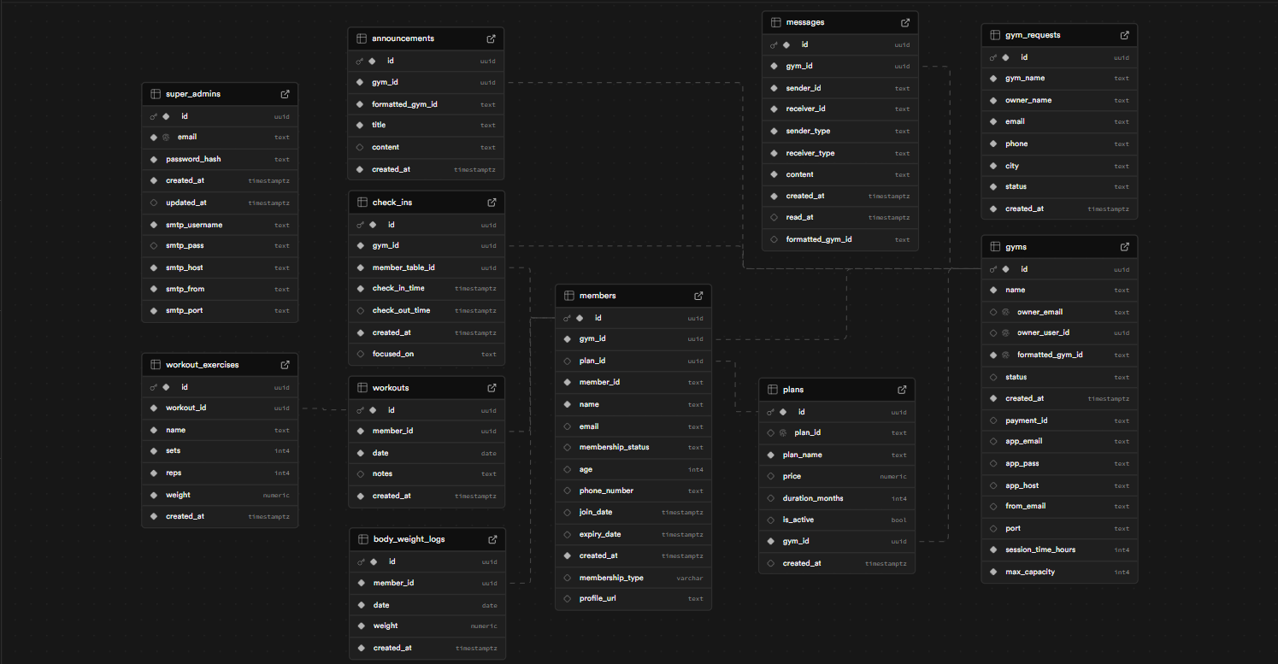

Supabase Tables Overview
Table | Columns | Description
members | id, gym_id, plan_id, member_id, email, name, membership_status, join_date, expiry_date | Stores verified member data
gyms | id, name, owner_email, formatted_gym_id, status, session_time_hours, max_capacity | Gym master data
plans | id, gym_id, plan_name, price, duration_months, is_active | Membership plans per gym
check_ins | id, gym_id, member_table_id, check_in_time, check_out_time | Tracks member visits
announcements | id, gym_id, title, content, created_at | Gym announcements
messages | id, gym_id, sender_id, receiver_id, message, created_at | Realtime chat system
workouts | id, member_id, date, notes, created_at | Workout session entries
workout_exercises | id, workout_id, name, sets, reps, weight, created_at | Exercises per workout
body_weight_logs | id, member_id, weight, date, created_at | User body weight history
gym_requests | id, gym_name, owner_name, email, phone, city, status | New gym onboarding requests

