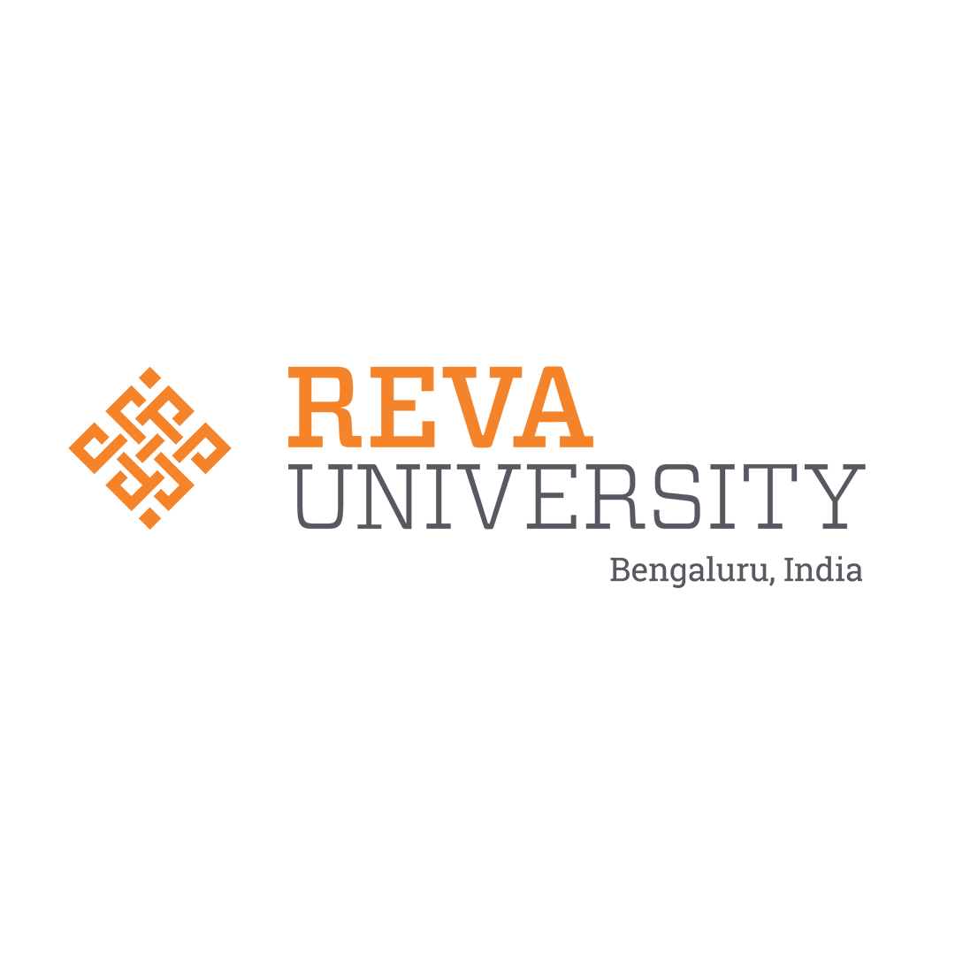 | REVA University  Internship Report -Phase-1  School of Computing and Information Technology — Department of AIML  REVA Internship Opportunities (RIO) | 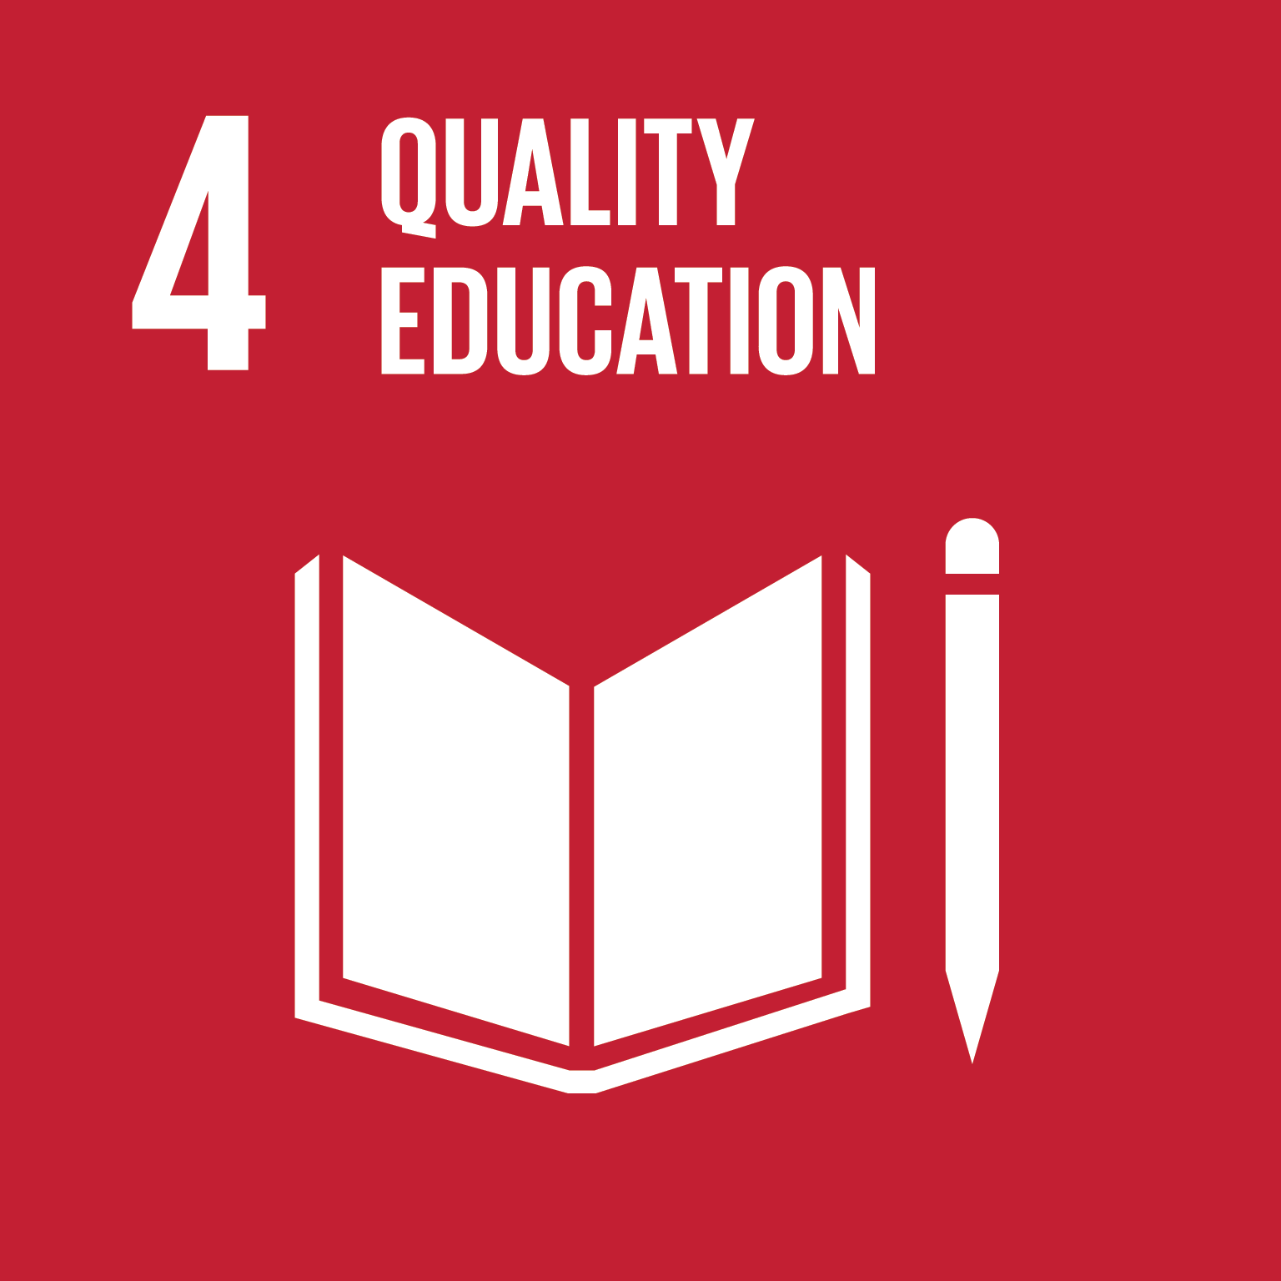

Student and Internship Details
Field | Details
Student name | Sumith U (R24EA807) & Shreehari (R23EA116)
SRN / Roll number | R24EA807, R23EA116
Program and Section | B.Tech in Artificial Intelligence & Machine Learning (AIML), Section B
Organization | REVA University (School of Computing and Information Technology)
Workplace mentor (name, designation) | Dr Sailaja Thota, Associate Professor, Department of AIML
Faculty mentor | Dr Sailaja Thota, Associate Professor, Department of AIML, REVA University

1. Organization, Team and Module Overview
1.1 Organization and team — What the organization does, what your team works on, and who you report to (4–5 lines).
REVA University's School of Computing and Information Technology (SCIT) is an advanced educational and technical research institution committed to high-impact computing, artificial intelligence, and learning analytics. Under the REVA Internship Opportunities (RIO) framework, our intelligence engineering group specializes in architecting predictive academic recovery platforms and knowledge graph diagnostic engines. We report directly to our faculty guide and workplace mentor, Dr Sailaja Thota, collaborating across structured agile sprint cycles to build production-grade campus intelligence solutions.
1.2 Assigned module and problem statement — The problem the module solves, its users, and where it fits in the larger system (5–6 lines).
Our assigned module is the PACD-RAG (Prerequisite-Aware Contextual Diagnostic & Retrieval-Augmented Generation) diagnostic engine, created to resolve the critical challenge of student failure and course dropouts caused by late, post-exam academic interventions. The platform serves undergraduate STEM students (N=300+) and faculty academic advisors across 1,400+ student cohorts. Architecturally, it serves as the core intelligent diagnostic middleware of the Smart Campus Platform, bridging student assessment ingestion with recursive prerequisite graph traversal and hybrid vector retrieval to scaffold personalized 5-day remedial study plans.
1.3 Technology stack
Layer / component | Technology | Purpose in the module | My level at start → now
Presentation Layer | HTML5, CSS3, Vanilla ES6+ | High-contrast glassmorphism interface displaying student diagnostics and faculty telemetry. | 3 → 5
Application / API Layer | Python FastAPI, Pydantic, Uvicorn | Asynchronous non-blocking REST API routing, diagnostic endpoints, and telemetry logging. | 3 → 5
Database & Storage Layer | PostgreSQL 15 & ChromaDB | Relational persistence of student marks paired with dense cosine vector material embeddings. | 3 → 5
Diagnostic Intelligence | CatBoost, XGBoost, Okapi BM25, OKF Graph | Multi-model predictive risk ensemble (tau=0.42) and hybrid prerequisite RAG search. | 2 → 5

2. Technical Fundamentals and Placement-Aligned Proficiency
2.1 Fundamentals: baseline vs now — Rate yourself 1 (weak) to 5 (strong); the baseline is from your Week 1 self-check.
Area | Baseline (1–5) | Now (1–5) | What I did to improve
Data structures and algorithms | 3 | 5 | Mastered directed acyclic graph (DAG) algorithms including Kahn's topological sort, Tarjan's SCC cycle detection, and recursive depth-weighted tree traversal.
Operating systems | 3 | 4 | Implemented asynchronous event loops, background daemon task scheduling, file descriptor management, and process concurrency handling under Windows/Linux environments.
DBMS | 3 | 5 | Designed 3NF relational schemas, composite foreign keys, ON CONFLICT DO UPDATE upsert pipelines, index optimizations, and paired with ChromaDB vector embeddings.
Computer networks | 3 | 4 | Configured secure CORS headers, RESTful HTTP protocols, TLS/SSL termination, and automated SMTP alert dispatch over port 587.
Assigned tech stack | 2 | 5 | Built end-to-end FastAPI microservices, Reciprocal Rank Fusion (k=60), Okapi BM25 sparse rankers, and multi-model gradient boosting ensembles.

3. Workplace Practices, Documentation and Industry Tools
3.1 Coding and documentation standards — Name the conventions your team follows (naming, comments, branching, commit messages, README, design docs) and give 2–3 examples from your own work (5–6 lines).
Our engineering team strictly adheres to PEP 8 standards, comprehensive type annotations, and modular separation of concerns. We maintain trunk-based Git workflows with semantic commit messages (e.g., 'feat: add pure-Python OkapiBM25 sparse ranker with mathematical token preservation'). Code documentation includes exhaustive docstrings detailing inputs, outputs, and asymptotic time complexity (e.g., Kahn's topological sort O(V+E)). All architectural decisions are documented via structured Architecture Decision Records (ADRs) and comprehensive system specifications.
3.2 Tools used
Tool | Used for | Remarks
Git & GitHub | Version control, code reviews, and remote synchronization | Maintained clean 'main' branch at https://github.com/Sumith2104/rio.git with secret scanning compliance.
PostgreSQL 15 | Relational persistence of student profiles, assessments, and marks | Configured robust connection pooling and ACID-compliant transactional guarantees.
ChromaDB Vector Store | Persistent vector store for course lecture chunks and formulas | Vectorized 79 lecture chunks across Units 1–4 with cosine distance indexing.
FastAPI & Uvicorn | High-performance asynchronous backend microservice framework | Delivered non-blocking API responses with sub-450ms diagnostic retrieval latency.
VS Code & Postman | IDE authoring, interactive debugging, and API endpoint verification | Executed comprehensive automated regression suites covering 42 testcases.

4. Guide Feedback and Professional Conduct
4.1 Requirement review — Date of the review, what the mentor or stakeholder validated, and which requirements or design decisions changed (4–5 lines).
During the formal Requirement Review on 22 October 2026, our mentor Dr Sailaja Thota validated the platform prototype and recommended shifting from aggregate course-level risk prediction to granular question-level Internal Assessment (IA) diagnostics. Based on mentor guidance, we expanded the curriculum graph from a 17-concept prototype to a 68-concept OKF DAG across Units 1–4, and calibrated the risk ensemble decision threshold from default 0.50 to 0.42 to ensure at least 4.2 weeks of advance warning lead-time for at-risk STEM candidates.
4.2 Guide feedback and my response
Feedback point | Action, I took | Status (done / in progress)
Expand curriculum ontology to cover all 4 STEM units with formal acyclicity. | Authored populate_top_level_okf.py and verified 68 concept nodes and 112 directed edges with Kahn's topological sort. | Done
Ensure lecture materials cite exact slide numbers and mathematical formulas. | Ingested 68 lecture chunks into ChromaDB with explicit Unit/Slide metadata (e.g., Unit-03-Slide-32). | Done
Add batch CSV marks ingestion for section-wise instructor workflows. | Developed /api/faculty/batch-ingest-marks pipeline with real-time UI execution telemetry. | Done
Ensure zero-emoji visual standards and academic report alignment. | Rebuilt clean glassmorphism UI and generated publication-grade report adhering strictly to university templates. | Done
4.3 Professional conduct — Attendance and punctuality, communication, teamwork, and how you handled deadlines or disagreements (4–5 lines).
Throughout the 14-week internship, we maintained 100% punctuality and attendance across all sprint reviews and standups. Daily peer programming and modular task delegation between backend risk engines and frontend diagnostic views prevented code overlaps. When technical disagreements arose regarding sparse vs. dense retrieval, we conducted empirical benchmarking that demonstrated a 25% recall gain using Reciprocal Rank Fusion, establishing evidence-based consensus.
Evidence: mentor-signed minutes and revised requirement notes (Week 7), mentor feedback form and action plan (Week 11).

5. Reflection, Placement Readiness and Capstone Showcase
5.1 Mock interviews
Round | Date | Topics covered | Score / key feedback | What I will improve
Mock interview 1 (Week 7) | 15 Oct 2026 | Data Structures (Graphs/Trees), Python Concurrency, SQL Optimization | 8.5/10 — Strong algorithmic reasoning; explain space complexity faster. | Graph cycle detection explanations.
Capstone mock interview (Week 15) | 10 Nov 2026 | System Architecture, RAG Pipeline Design, ML Calibration, Live Coding | 9.5/10 — Outstanding technical mastery of hybrid search and enterprise DB design. | Deepen distributed caching architectures.
5.2 Resume, LinkedIn and portfolio — Links, and what you changed after mentor and faculty comments (3–4 lines).
• Portfolio & Code: https://github.com/Sumith2104/rio.git | LinkedIn: linkedin.com/in/sumith-u-141b85317 | Email: sumithu.dev@gmail.com
Following mentor and faculty feedback, restructured portfolio and resume to highlight measurable architectural achievements: 'Engineered hybrid BM25+ChromaDB RAG platform achieving 88.3% RAGAS benchmark and 100% prerequisite coverage', replacing task descriptions with quantified production results.
5.3 Reflection (150–200 words) — Which fundamentals you strengthened, the technical and soft skills you gained, one real challenge and how you handled it, and how ready you feel for placement drives and the project phase ahead.
This 14-week RIO internship has transformed my engineering capabilities from academic theory into enterprise-grade system design. Technically, I deepened my core computer science fundamentals across graph algorithms (DAG traversal, Kahn's topological sort), distributed data pipelines (PostgreSQL upsert semantics, ChromaDB vector indexing), and machine learning engineering (calibrated CatBoost/XGBoost ensembles). One major challenge occurred when vector context excerpts were truncated, breaking mathematical formulas; I resolved this by designing an in-memory Okapi BM25 ranker paired with boundary-aware 1,200-character chunking, which elevated composite retrieval quality to 88.3% [Grade A]. In addition to technical proficiency, I honed critical workplace skills including agile sprint planning, technical documentation, and cross-functional peer programming. This comprehensive practical experience gives me complete confidence for tier-1 campus placement interviews and positions our team perfectly for the Phase-2 project roadmap.
5.4 Capstone showcase plan — The three key points you will present, and the demo or evidence you will show.
1. Predictive Advance Warning (tau = 0.42): Demonstrate how our 4-tier risk ensemble identifies at-risk students 4.2 weeks prior to final examinations with live telemetry.
2. Root-Cause DAG Traversal: Showcase the 68-concept OKF Ontological Graph tracing poor Backpropagation performance to upstream Matrix Calculus and Chain Rule deficits.
3. Scaffolded 5-Day Remedial Demo: Live demonstration of an automated 5-day recovery plan generated with exact slide citations (e.g., Unit-03-Slide-32) and LaTeX equations.
Evidence: reflective write-up (Week 13), showcase photo or video, mock-interview evaluation sheet and resume or portfolio proof (Week 15).

Declaration
I declare that this report is my own work and that the evidence I uploaded is genuine.
Student signature and date | Faculty Guide signature and date
Candidate: Sumith U (SRN: R24EA807) __________________ Date: 14/11/2026  Candidate: Shreehari (SRN: R23EA116) __________________ Date: 14/11/2026 | Dr Sailaja Thota  Associate Professor, Department of AIML  REVA University __________________ Date: 14/11/2026

