**Receipt Data Extraction Report**

**1. Codebase**

Find the repository <https://github.com/Sumith24/Document_Parsing_using_VisionModels.git> with **Readme** file, I used **"naver-clova-ix/donut-base-finetuned-cord-v2"** for this evaluation.

**2. JSON Output**

Extracted Json data stored in **output folder**.

**3. Comparison Report**

Accuracy and Performance Analysis:

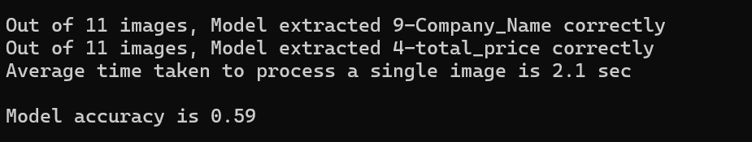

**4. Conclusion and Recommendations**

* **Suitability for Real-World Use:**
  + Model is not yet generalized for all type of receipt to extract all the required data
  + Here I considered only **Company-Name** and **Total-Price** for which model was able to extract these data with key-value pairs
  + Note: I have considered the **Company name** as first **“menu”** element just to evaluation purpose but still model need to be fine tuned for required receipt types to extract accurate data.
* **Trade-offs in Accuracy vs. Processing Time:**
  + **Model** is having 59% accuracy while extracting company name and total price
  + Took average **2.1 seconds** to process single receipt.

**5. Bonus: Confidence Scores**

To calculate the confidence score, I need annotated data with ground-truth values. However, generating this data requires significant time, making it challenging to extract confidence scores for the predictions within the given timeframe.

**Final Thoughts:**

The model used in this process is not yet fully generalized for all types of receipts or documents. To improve its accuracy in extracting the required data, fine-tuning on a custom dataset is necessary. This involves preparing the data by organizing all document images in a single folder and creating a corresponding metadata file structured as a JSON Lines file.

Fine-tuning the Donut model with this structured data will enhance its ability to accurately extract relevant information.

**Prepared By:** Sumith Jeevapur  
**Date:** 23/02/2025