Week 4 Task
Predictive Modeling and Optimization in Logistics Systems
Forecasting Delivery Time and Optimizing Depot Allocation and Routing
Prepared by: Sumitha A M
Tools: Python 3, pandas, scikit-learn, SciPy, Matplotlib

1. Executive Summary
This report develops a machine learning model to forecast delivery time for a last-mile logistics network and uses the model's outputs to drive two optimization methods: a linear program that assigns zone demand to depots, and a route-sequencing heuristic that shortens driver routes. Because no real operational data was supplied, the work uses a simulated dataset of 5,000 delivery runs whose structure mirrors real logistics drivers (distance, stops, traffic, weather, vehicle type, and zone).
Key results. Four model families were compared with 5-fold cross-validation. A tuned Gradient Boosting Regressor performed best, with a test RMSE of 4.8 minutes, MAE of 3.8 minutes, and R² of 0.978. The depot-allocation linear program lowers total predicted delivery minutes by 16.2% against an equal-split baseline, and nearest-neighbour plus 2-opt sequencing cuts an example 12-stop route from 165.8 km to 88.4 km.
Important caveat: the dataset is synthetic, so the absolute accuracy figures reflect how clean the simulated relationships are and should not be expected on real data. The value of the report is the end-to-end method, which can be re-run on real shipment records with minimal change.

2. Problem Definition

2.1 Business context
A regional courier operates five delivery zones served by three depots, using bikes, vans and trucks. Dispatchers currently promise delivery windows using rules of thumb, which leads to missed windows on rainy or congested days and uneven workloads across depots. Better estimates of how long each run will take would improve customer promises, driver scheduling and depot planning.

2.2 Prediction problem
Target variable: delivery_time_min, the total time in minutes for a delivery run from dispatch to the final drop-off.
Task type: supervised regression.
Objective: predict delivery time before dispatch so that planners can set accurate customer windows, balance depot load and pick routes and vehicles that reduce total time.

2.3 Success criteria
- Prediction error (MAE) below 5 minutes on a run averaging about 100 minutes, i.e. under 5% typical error.
- A model that is stable across cross-validation folds, with no large gap between training and test error.
- At least one optimization method that turns predictions into a measurable cost or distance saving.

3. Dataset Description and Simulation
The dataset was generated in Python with a fixed random seed (42) for reproducibility. Delivery time was built from a transparent formula based on logistics logic, plus random noise (standard deviation 4 minutes) to mimic unmodelled effects such as driver differences and parking delays. Missing values were deliberately injected (100 in traffic_index and 50 in package_weight_kg) so that the cleaning step is realistic.
Feature | Type | Description / simulation rule
distance_km | Numeric | Route distance; gamma-distributed, clipped to 1–80 km
package_weight_kg | Numeric | Total load weight; gamma-distributed, 0.2–50 kg
num_stops | Numeric | Drop-off points on the run; integer 1–15
hour_of_day | Numeric | Dispatch hour, 8–20; peaks at 9–10 and 17–19
day_of_week | Categorical | Mon–Sun; weekends have lighter traffic
weather | Categorical | Clear (60%), Rain (30%), Heavy Rain (10%)
traffic_index | Numeric | Congestion score from 1 (free) to 10 (gridlock)
vehicle_type | Categorical | Bike (30%), Van (50%), Truck (20%) with different average speeds
warehouse_zone | Categorical | Zones A–E, each with a different handling/access penalty
delivery_time_min | Target | Total run time in minutes
Table 1. Dataset schema

3.1 Summary statistics
Statistic | Distance (km) | Weight (kg) | Stops | Traffic idx | Delivery (min)
mean | 15.03 | 8.12 | 8.08 | 5.48 | 100.42
std | 8.60 | 5.83 | 4.32 | 2.60 | 32.69
min | 1.00 | 0.20 | 1.00 | 1.00 | 22.00
max | 80.00 | 50.00 | 15.00 | 10.00 | 303.40
Table 2. Summary statistics of numeric variables (n = 5,000)

3.2 Data generation code
import numpy as np, pandas as pd
rng = np.random.default_rng(42)
N = 5000
df = pd.DataFrame({
'distance_km': rng.gamma(3.0, 5.0, N).clip(1, 80),
'package_weight_kg': rng.gamma(2.0, 4.0, N).clip(0.2, 50),
'num_stops': rng.integers(1, 16, N),
'hour_of_day': rng.integers(8, 21, N),
'day_of_week': rng.choice(['Mon','Tue','Wed','Thu','Fri','Sat','Sun'], N),
'weather': rng.choice(['Clear','Rain','Heavy Rain'], N, p=[0.6, 0.3, 0.1]),
'traffic_index': rng.uniform(1, 10, N),
'vehicle_type': rng.choice(['Bike','Van','Truck'], N, p=[0.3, 0.5, 0.2]),
'warehouse_zone': rng.choice(['Zone A','Zone B','Zone C','Zone D','Zone E'], N),
})
# target: travel time + service time per stop + load effect + congestion + peak/weather/zone penalties + noise
df['delivery_time_min'] = (travel_min + 4.5*df.num_stops + 0.35*df.package_weight_kg
+ 2.2*df.traffic_index + 8*is_peak + weather_delay
- 3*is_weekend + zone_penalty
+ 0.015*df.distance_km*df.traffic_index
+ rng.normal(0, 4, N)).clip(10)

4. Data Preparation
Preparation followed four steps. First, missing numeric values were filled with the column median, which is robust to the skew in weight and traffic. Second, three engineered features were added: is_peak (dispatch in a rush-hour window), is_weekend, and dist_x_traffic, an interaction capturing that congestion hurts long routes more. Third, categorical variables were one-hot encoded and numeric variables standardised inside a scikit-learn ColumnTransformer, so exactly the same transformation is applied at training and prediction time. Fourth, the data was split 80/20 into training (4,000 rows) and a held-out test set (1,000 rows) that is used only once for final evaluation.
from sklearn.model_selection import train_test_split
from sklearn.compose import ColumnTransformer
from sklearn.preprocessing import OneHotEncoder, StandardScaler

# 1. Impute missing values with the median
for c in ['traffic_index', 'package_weight_kg']:
df[c] = df[c].fillna(df[c].median())

# 2. Feature engineering
df['is_peak'] = df.hour_of_day.isin([9, 10, 17, 18, 19]).astype(int)
df['is_weekend'] = df.day_of_week.isin(['Sat', 'Sun']).astype(int)
df['dist_x_traffic'] = df.distance_km * df.traffic_index

# 3. Encode + scale inside one reusable transformer
y = df['delivery_time_min']; X = df.drop(columns='delivery_time_min')
cat = ['day_of_week', 'weather', 'vehicle_type', 'warehouse_zone']
num = [c for c in X.columns if c not in cat]
pre = ColumnTransformer([('num', StandardScaler(), num),
('cat', OneHotEncoder(handle_unknown='ignore'), cat)])

# 4. Hold out 20% for the final test
Xtr, Xte, ytr, yte = train_test_split(X, y, test_size=0.2, random_state=42)

5. Model Selection
Four regression models of increasing complexity were compared. Starting with a simple baseline and moving to ensembles shows whether added complexity is actually justified, which matters in operations where explainability and maintenance cost count.
Model | Why it was chosen | Main trade-off
Linear Regression | Fast, fully interpretable baseline; coefficients show minutes added per unit of each driver | Cannot capture non-linear effects or interactions unless engineered by hand
Decision Tree (depth 8) | Rule-based and easy to explain to dispatchers; handles non-linearity | High variance; a single tree overfits easily
Random Forest (150 trees) | Averages many trees to reduce variance; robust to outliers | Less interpretable; large model; averages poorly on smooth additive signals
Gradient Boosting | Builds trees sequentially to correct earlier errors; typically the strongest on tabular data | Needs tuning; slower to train; can overfit without regularisation
Table 3. Candidate models and rationale

6. Training, Validation and Evaluation

6.1 Evaluation metrics
- RMSE (Root Mean Squared Error): error in minutes, penalising large misses more heavily. This is the primary metric because a badly wrong promise costs more than several small ones.
- MAE (Mean Absolute Error): the average miss in minutes, easy to explain to operations managers.
- R² (coefficient of determination): share of variation in delivery time explained by the model.

6.2 Cross-validation strategy
Each model was evaluated with 5-fold cross-validation on the training set (shuffled, fixed seed). The mean and standard deviation of fold RMSE show both accuracy and stability. The test set was kept untouched until the models were fitted, so the reported test figures are an honest estimate of performance on unseen runs.
from sklearn.pipeline import Pipeline
from sklearn.model_selection import KFold, cross_val_score
from sklearn.linear_model import LinearRegression
from sklearn.tree import DecisionTreeRegressor
from sklearn.ensemble import RandomForestRegressor, GradientBoostingRegressor
from sklearn.metrics import mean_absolute_error, mean_squared_error, r2_score

models = {
'Linear Regression': LinearRegression(),
'Decision Tree': DecisionTreeRegressor(max_depth=8, random_state=42),
'Random Forest': RandomForestRegressor(n_estimators=150, n_jobs=-1, random_state=42),
'Gradient Boosting': GradientBoostingRegressor(random_state=42),
}
kf = KFold(n_splits=5, shuffle=True, random_state=42)

for name, model in models.items():
pipe = Pipeline([('pre', pre), ('model', model)])
cv_rmse = -cross_val_score(pipe, Xtr, ytr, cv=kf,
scoring='neg_root_mean_squared_error')
pipe.fit(Xtr, ytr)
pred = pipe.predict(Xte)
print(name, cv_rmse.mean(), cv_rmse.std(),
mean_squared_error(yte, pred) ** 0.5,
mean_absolute_error(yte, pred), r2_score(yte, pred))

6.3 Baseline comparison results
Model | CV RMSE | CV Std | Test RMSE | Test MAE | Test R²
Linear Regression | 6.043 | 0.130 | 6.128 | 4.721 | 0.964
Decision Tree | 11.672 | 0.581 | 11.547 | 9.236 | 0.873
Random Forest | 7.813 | 0.431 | 7.685 | 6.091 | 0.944
Gradient Boosting | 5.444 | 0.258 | 5.464 | 4.299 | 0.972
Gradient Boosting (tuned) | 4.767 | - | 4.813 | 3.827 | 0.978
Table 4. Model performance (errors in minutes). Green row is the final model.
Gradient Boosting was clearly the best of the four default models, and Linear Regression was a strong second because the simulated data is largely additive. The single Decision Tree was the weakest, with a test RMSE roughly double that of the boosted model, which is the typical overfitting pattern of one deep tree. Random Forest performed worse than Linear Regression here: averaging independent trees approximates smooth, additive relationships less efficiently than a model that fits them directly. On real data with messier interactions the ranking could differ, which is why all candidates are worth running.

6.4 Hyperparameter tuning
The Gradient Boosting model was tuned with RandomizedSearchCV: 20 random parameter combinations, each scored with the same 5-fold split on RMSE. Random search was chosen over a full grid because it covers a wide space at a fraction of the computing cost.
from sklearn.model_selection import RandomizedSearchCV

gb = Pipeline([('pre', pre), ('m', GradientBoostingRegressor(random_state=42))])
param_space = {
'm__n_estimators': [100, 200, 300, 400],
'm__learning_rate': [0.03, 0.05, 0.1],
'm__max_depth': [2, 3, 4],
'm__subsample': [0.7, 0.85, 1.0],
'm__min_samples_leaf': [1, 5, 10],
}
search = RandomizedSearchCV(gb, param_space, n_iter=20, cv=kf,
scoring='neg_root_mean_squared_error',
random_state=42, n_jobs=-1)
search.fit(Xtr, ytr)
best_model = search.best_estimator_

The best configuration was 400 trees, learning rate 0.1, maximum depth 2, subsample 0.85 and minimum leaf size 1. Tuning lowered test RMSE from 5.464 to 4.813 minutes and raised R² from 0.972 to 0.978. The tuned cross-validation RMSE (4.767) is very close to the test RMSE (4.813), indicating the model is not overfitted to the training data. The shallow depth of 2 suggests that many small corrections to a mostly additive signal work better than deep trees.

6.5 Diagnostic plots
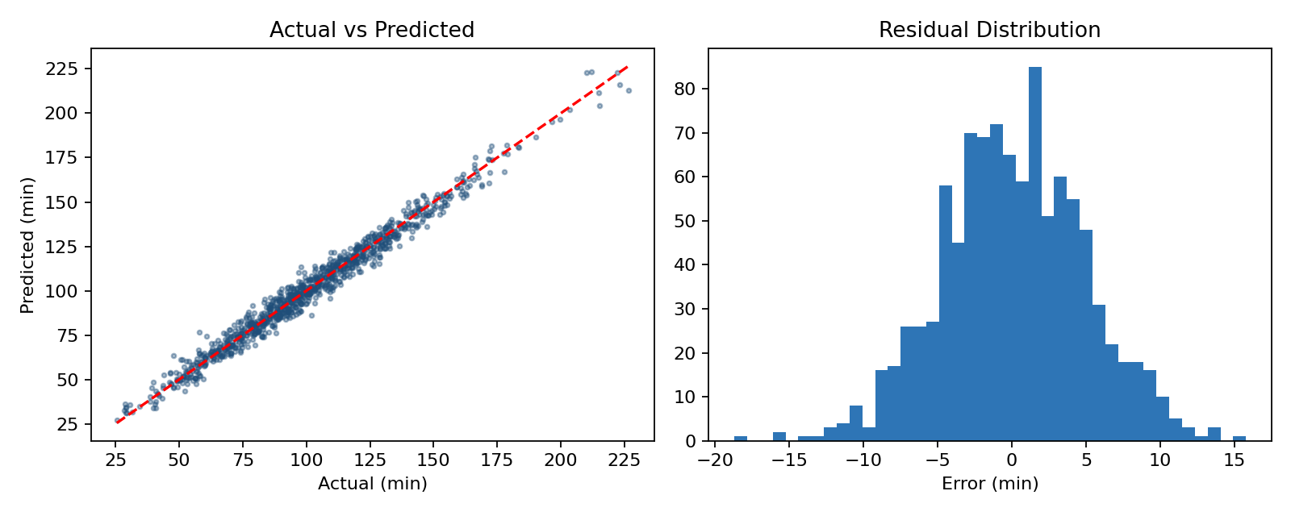
Figure 1. Actual vs predicted delivery time (left) and residual distribution (right) on the test set
Predictions sit tightly along the diagonal, and residuals are roughly symmetric around zero, so the model has no strong bias toward over- or under-estimating. Residual spread is slightly wider for the longest runs, which is common because long runs have more room for unmodelled delay.

6.6 What drives delivery time?
Permutation importance measures how much prediction error rises when a feature is shuffled, so it reflects real influence on the model's accuracy.
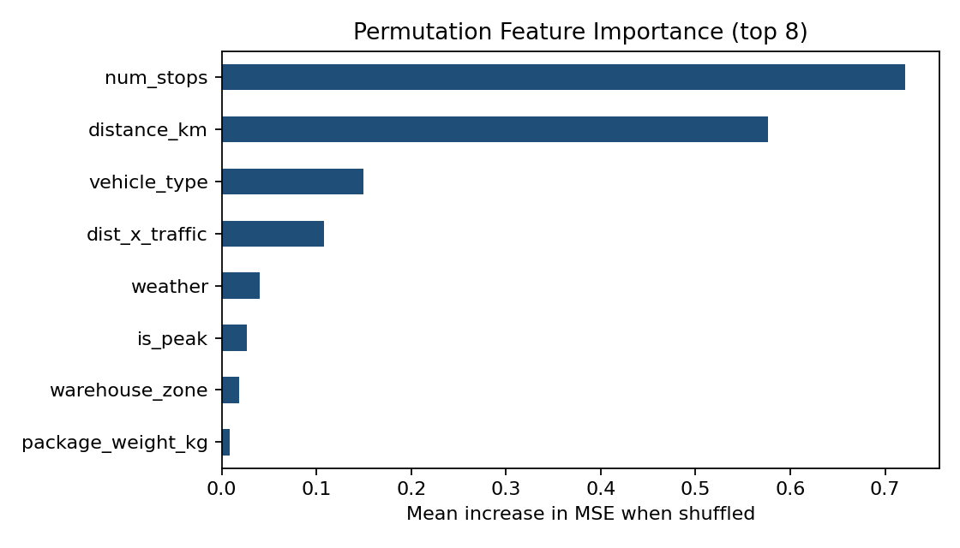
Figure 2. Permutation feature importance on the test set
- Number of stops and distance dominate. They are far ahead of every other feature, so route design (fewer, better-clustered stops) has the largest lever on time.
- Vehicle type is third. Bikes are much slower over distance, so matching vehicle to route length matters.
- Congestion matters through its interaction with distance. The engineered dist_x_traffic feature ranks above raw traffic_index, confirming that congestion mostly hurts long routes.
- Weather and peak hours have smaller but real effects, useful for adding buffers rather than redesigning routes.

7. Optimization Strategies
Prediction alone does not improve operations. Three strategies convert the model's insights into decisions.

7.1 Strategy A: Depot allocation by linear programming
Problem: choose how many shipments from each zone each depot should handle, so that total predicted delivery minutes are minimised while respecting depot capacity and meeting all demand.
Formulation. Let x(i,j) be shipments from zone i handled by depot j.
minimise sum_ij c[i,j] * x[i,j] (total predicted minutes)
subject to sum_j x[i,j] = demand[i] (every zone fully served)
sum_i x[i,j] <= capacity[j] (depot capacity)
x[i,j] >= 0

The unit cost c(i,j) is the model's average predicted delivery time for zone i, scaled by an assumed depot-to-zone distance factor. Demand (320, 260, 410, 180, 230 shipments per day for Zones A–E) and depot capacity (600, 500, 450 for North, Central, South) are illustrative assumptions.
from scipy.optimize import linprog

zone_base = Xte.assign(pred=best_model.predict(Xte)) \
.groupby('warehouse_zone').pred.mean().values
cost = zone_base[:, None] * dist_factor # shape (5 zones, 3 depots)

A_eq = np.zeros((5, 15)); A_ub = np.zeros((3, 15))
for i in range(5): A_eq[i, i*3:(i+1)*3] = 1 # each zone's demand
for j in range(3): A_ub[j, j::3] = 1 # each depot's capacity

res = linprog(cost.flatten(), A_ub=A_ub, b_ub=capacity,
A_eq=A_eq, b_eq=demand, bounds=(0, None), method='highs')
allocation = res.x.reshape(5, 3).round()

Zone | Demand | North | Central | South
Zone A | 320 | 320 | 0 | 0
Zone B | 260 | 130 | 130 | 0
Zone C | 410 | 0 | 190 | 220
Zone D | 180 | 0 | 180 | 0
Zone E | 230 | 0 | 0 | 230
Depot load | 1400 | 450 | 500 | 450
Capacity |  | 600 | 500 | 450
Table 5. Optimal daily shipment allocation (shipments per day)
Result. The optimal plan needs 129,568 predicted minutes per day, against 154,634 for a naive equal split across depots. That is a saving of 25,066 minutes (about 418 driver-hours) per day, or 16.2%. North absorbs all of Zone A, South serves Zone E, and Central takes the balance, with total load of 1,400 shipments against 1,550 capacity. Note that the equal-split baseline is a simple benchmark, not the company's actual current policy, so the real saving should be measured against actual allocations.

7.2 Strategy B: Route sequencing
Because the number of stops and distance are the strongest drivers of time, shortening the path directly cuts delivery time. A 12-stop route from a central depot was sequenced with a nearest-neighbour construction followed by 2-opt improvement, which repeatedly reverses segments of the route when doing so shortens the total distance.
def route_len(r):
return sum(D[r[i], r[(i + 1) % len(r)]] for i in range(len(r)))

# Nearest-neighbour construction
route, left = [0], set(range(1, n))
while left:
nxt = min(left, key=lambda j: D[route[-1], j])
route.append(nxt); left.remove(nxt)

# 2-opt improvement
improved = True
while improved:
improved = False
for i in range(1, n - 1):
for j in range(i + 1, n):
cand = route[:i] + route[i:j + 1][::-1] + route[j + 1:]
if route_len(cand) < route_len(route) - 1e-9:
route, improved = cand, True

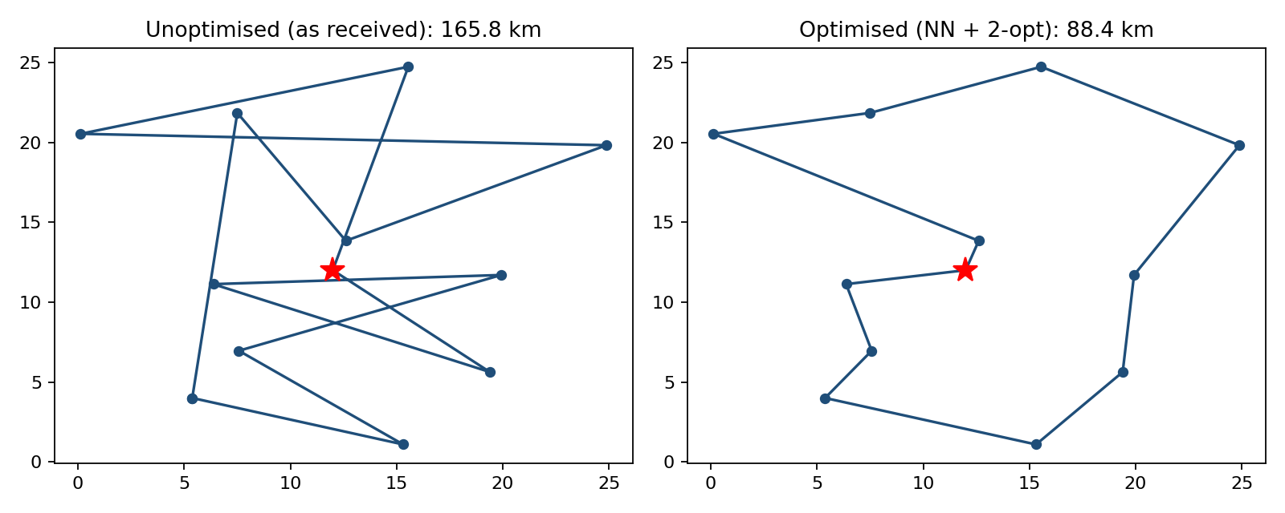
Figure 3. Example 12-stop route before and after optimisation
Route length fell from 165.8 km (stops visited in the order received) to 90.0 km with nearest-neighbour and 88.4 km after 2-opt, a 46.7% reduction. The unoptimised order here is random, so the percentage is an upper-bound illustration; the real gain depends on how dispatchers currently order stops. For production use, a solver such as Google OR-Tools with time windows and vehicle capacities would handle larger problems.

7.3 Strategy C: Prediction-driven operating policies
- Dynamic delivery windows. Quote customers the model's predicted time plus a buffer of about one MAE to one RMSE (roughly 4–5 minutes here). This replaces fixed rules of thumb and reduces missed promises.
- Weather and congestion buffers. Add automatic buffers when forecast rain or a high traffic index is expected, and schedule fewer stops per run on those days.
- Vehicle matching. Assign bikes to short, dense routes and vans to long routes, since vehicle type is the third most influential feature.
- Peak-hour planning. Shift flexible, non-urgent runs out of the 9–10 and 17–19 windows, or add drivers there.
- Stop clustering. Group nearby addresses into the same run to lower stops-per-kilometre variance, because stops and distance explain most delivery time.

8. Recommendations
# | Recommendation | Evidence from this analysis | Expected benefit
1 | Deploy the tuned Gradient Boosting model to quote delivery windows | RMSE 4.8 min, R² 0.978 on held-out data | Fewer missed windows; better customer trust
2 | Re-plan depot allocation daily with the LP using fresh predictions | 16.2% fewer predicted minutes than equal split | Lower labour and fuel cost; balanced depot load
3 | Automate stop sequencing with 2-opt, then OR-Tools for large routes | Example route 46.7% shorter than random order | Shorter distance and driver hours
4 | Cap stops per run and cluster addresses | Stops and distance are the top two drivers | Largest single lever on delivery time
5 | Add weather and traffic buffers and shift flexible work off-peak | Weather, peak and congestion interaction all rank in the model | More reliable service on bad days
6 | Retrain monthly and monitor MAE drift | Model quality depends on current conditions | Prevents silent accuracy decay
Table 6. Prioritised recommendations

9. Limitations and Future Work
- The data is simulated, so accuracy is higher and relationships cleaner than in a real network. The next step is to retrain on actual shipment records.
- Real data would include features not simulated here: driver experience, road closures, time-window constraints, failed deliveries, package type and address quality.
- The depot LP uses assumed demand, capacity and distance factors, and the equal-split baseline is only a benchmark. Real figures should replace them.
- The routing example is a single small problem. Production routing needs vehicle capacities and delivery time windows, handled by a vehicle routing problem solver.
- Future work: add quantile regression or conformal prediction to give prediction intervals rather than single values, add SHAP for per-run explanations, and test XGBoost or LightGBM.

10. Conclusion
This project built a complete pipeline for logistics forecasting: problem definition, simulated data, cleaning and feature engineering, comparison of four models with cross-validation, hyperparameter tuning, and interpretation. A tuned Gradient Boosting model predicts delivery time to within about four minutes on a run of roughly 100 minutes. Its outputs feed an allocation model and a routing heuristic that together reduce predicted time and distance, and a set of operating policies translate the key drivers (stops, distance, vehicle, congestion and weather) into practical actions for dispatchers. Rerunning the same code on real operational data is the logical next step.

Appendix: Final Prediction Function
The tuned pipeline can be applied to a new planned run as shown below. Preprocessing is bundled in the pipeline, so only raw fields are needed.
new_run = pd.DataFrame([{
'distance_km': 18.0, 'package_weight_kg': 7.5, 'num_stops': 9,
'hour_of_day': 17, 'day_of_week': 'Fri', 'weather': 'Rain',
'traffic_index': 7.2, 'vehicle_type': 'Van', 'warehouse_zone': 'Zone C',
'is_peak': 1, 'is_weekend': 0, 'dist_x_traffic': 18.0 * 7.2,
}])
eta = best_model.predict(new_run)[0]
print(f'Predicted delivery time: {eta:.0f} min (quote window: +/- 5 min)')

The complete runnable script (pipeline.py) and the simulated dataset (logistics_deliveries.csv) accompany this report.

