# 1.INTRODUCTION

## 1.1 Overview

A brief description about your project

## 1.2 Purpose

The project use for the automotive industry purpose

# 2.Problem Definition & design thinking

## 2.1 Empathy Map

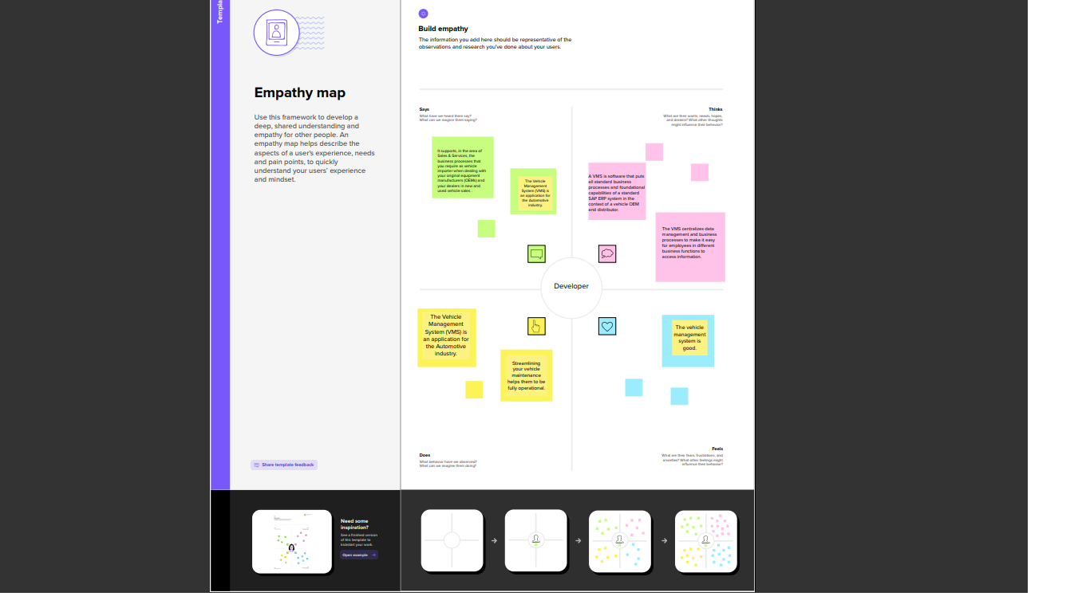

## 2.2 Ideation & Branstroming Map

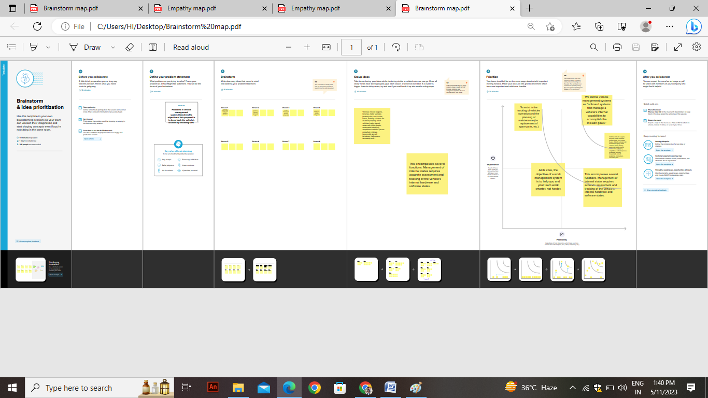

# 3.RESULT

## 3.1 Data Model:

|  |  |
| --- | --- |
| Object name | Field in the object |
| Obj 1 | |  |  | | --- | --- | | Field label | Data type | | Driver Name | Text | |  |  | |
| Obj 2 | |  |  | | --- | --- | | Field label | Data type | | Mobile No | Number | |  |  | |

# 4. Trailhad Profile Public URL

Team Lead-https://trailblazer.me/id/sumia7

Team Member 1 –https://trailblazer.me/id/sunmathi1702

Team Member 2 –https://trailblazer.me/id/vijip9

Team Member 3 –https://trailblazer.me/id/anaveen31