TECHNICAL DOCUMENTATION
Gut Microbiome ML Pipelines
PCOS · Endometriosis · Pooled (3-class demo)
How the data looks after preprocessing, how the models were built and
checked, which model won and why, and how to read the results
R Sumithra (255hsbd026) · P. Hemachandar (255hsbd010)
Mentor: Dr. Shyam Rajagopalan · IBAB, Bengaluru
Code: github.com/sumithraju/GutDys

1. Overview
This document explains three machine-learning pipelines that try to tell apart healthy people from people with a disease, using only the mix of bacteria in the gut (measured by 16S rRNA sequencing). There are three pipelines:
- PCOS — Control vs PCOS, 91 real stool samples from two studies.
- Endometriosis — Control vs Endometriosis, 129 real gut samples from two studies.
- Pooled (demo) — a 3-class version (Control / Endometriosis / PCOS) on 720 synthetic samples. This one is only a demonstration, not real patients.
All three use the exact same steps, so they are easy to compare. The flow is simple: raw sequencing files are cleaned into a table of bacteria, that table is checked, and then a model is trained and tested. The goal of this project was to be honest — we spent as much effort catching mistakes (data leakage, overfitting, batch effects) as on the model itself.

2. PCOS pipeline

2.1 How the data looks after preprocessing
After cleaning, every sample becomes one row. The columns split into 5 label/ID columns (dropped before training) and 22 feature columns (bacteria amounts in %, plus a diversity score and a predicted enzyme). There are 91 samples: 57 PCOS and 34 Control.

Group | Columns | Meaning
ID / label | sample_id, study, diagnosis, sample_type, country | who the sample is; dropped before training
Bacteria % | Firmicutes, Bacteroidetes, Bacteroides, Lactobacillus, … (20 taxa) | relative abundance, add up to ~100%
Function | beta_glucuronidase | predicted estrobolome enzyme (empty for PCOS — see note)
Diversity | shannon_diversity | how varied the sample is
PCOS table: 91 rows × 27 columns.

2.2 Preprocessing quality report
Before trusting the table, we checked how many sequencing reads survived the cleaning (DADA2). If too few survive, the bacteria numbers are unreliable.

Study | Samples | Reads kept | Note
SRP077213 | 43 | 37% | acceptable
SRP085887 | 48 | 13% | low — fewer reads, noisier
DADA2 read retention per PCOS study.
One PCOS study (SRP085887) kept only 13% of reads, so its bacteria numbers are noisier. Also, beta_glucuronidase is empty for PCOS (the PICRUSt2 enzyme step was run only for endometriosis), so it is dropped automatically — the PCOS model uses bacteria + diversity only.

2.3 Looking at the data before ML (EDA)
We checked class balance (more PCOS than Control, so we used balanced class weights), missing values (almost none, except the empty enzyme column), and how the bacteria compare between the two groups.
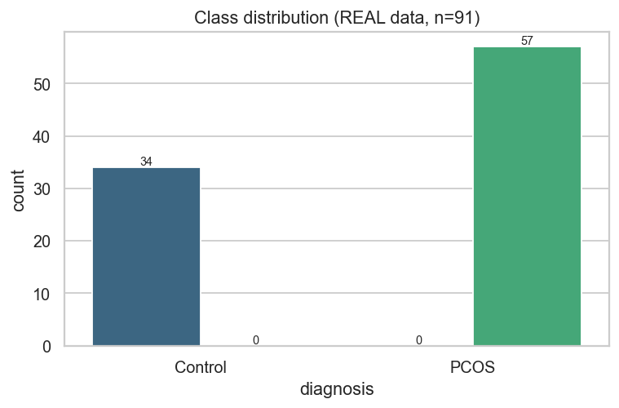
Class balance.
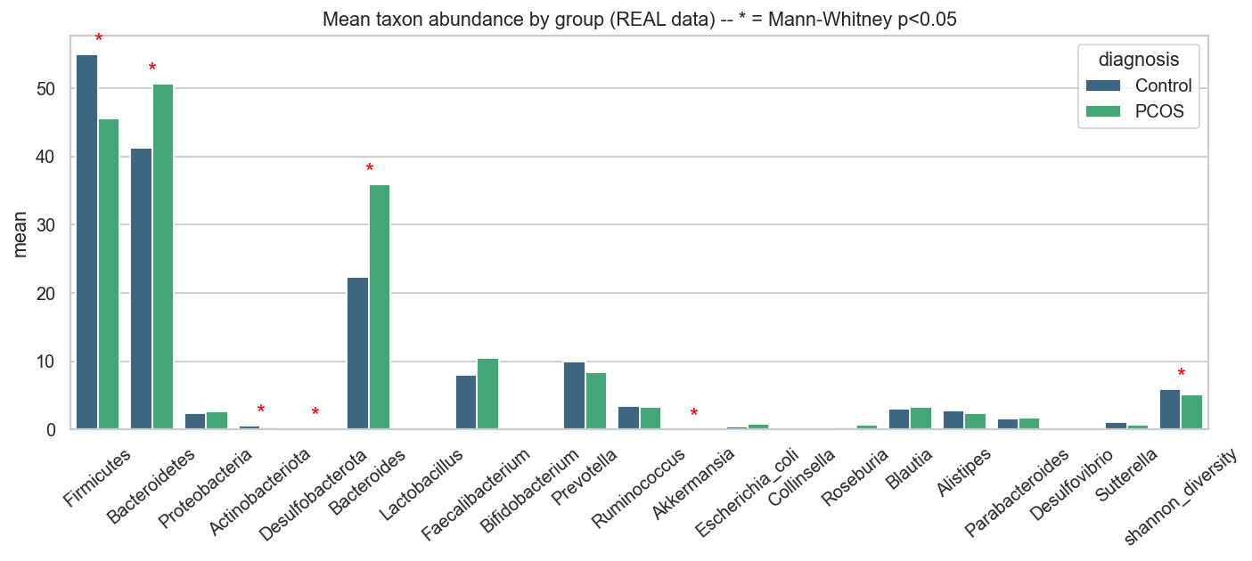
Average amount of each bacteria in the two groups. The stars mark differences that are statistically clear.

2.4 The 10 models and which one won
We did not pick one model by guessing. We tried 10 different models — from simple ones (Logistic Regression, Naive Bayes) to complex ones (Random Forest, Gradient Boosting, Neural Network). Each was scored by cross-validation. The table below shows the top ones.

Model | CV F1 | Train−CV gap
MLP (won) | 0.789 | 0.050
Gaussian NB | 0.775 | 0.044
Logistic Reg. | 0.774 | 0.073
Random Forest | 0.755 | 0.200
AdaBoost | 0.737 | 0.263
Model leaderboard (top 5). Selected by cross-validation F1.
The small Neural Network (MLP) won with the best cross-validation F1 (0.79) and a tiny train−CV gap (0.05), which means it was not memorising. Notice Random Forest and AdaBoost had big gaps (0.20, 0.26) — they memorised the training data, so they were rejected even though their training score looked high.

2.5 Results and how to read the graphs
On the held-out test set: accuracy 0.68, balanced accuracy 0.66, F1 0.75, ROC-AUC 0.79. The model catches PCOS well (recall 0.75) but is weaker on Control (recall 0.57).
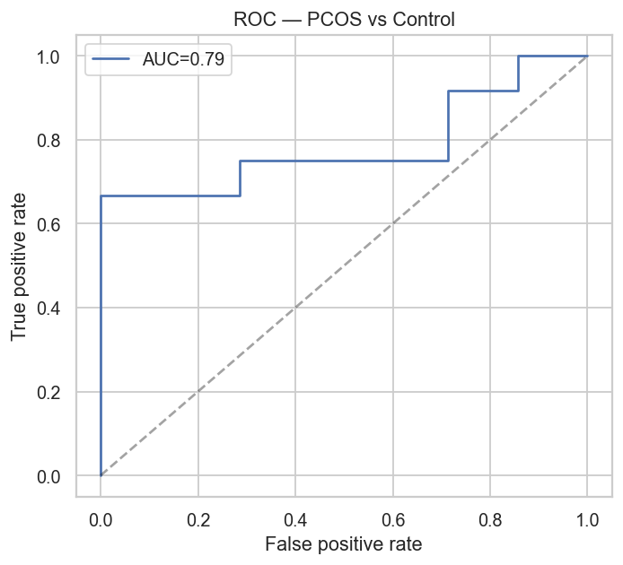
ROC curve. Higher/left is better; the diagonal is random guessing. AUC 0.79.
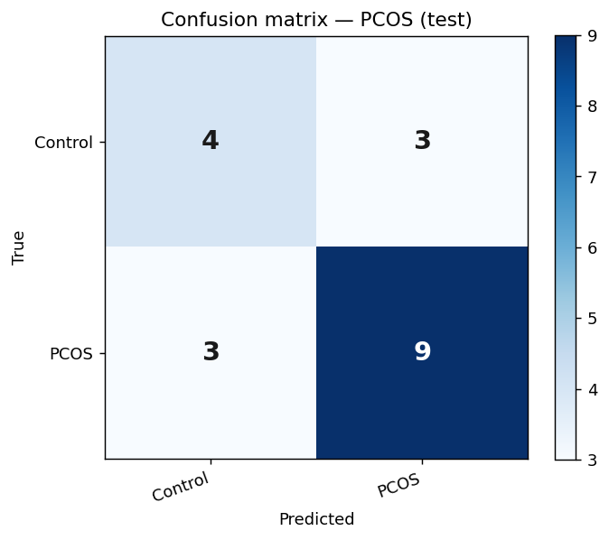
Confusion matrix. Diagonal = correct; off-diagonal = mistakes.
Reading this matrix (test set = 19: 7 Control, 12 PCOS). Top row = the 7 Controls: 4 correct, 3 wrongly flagged as PCOS. Bottom row = the 12 PCOS: 9 caught, 3 missed.
 | Predicted Control | Predicted PCOS
True Control (7) | 4 (TN) | 3 (FP)
True PCOS (12) | 3 (FN) | 9 (TP)
Sensitivity (catch PCOS) = TP/(TP+FN) = 9/12 = 0.75. Specificity (clear healthy) = TN/(TN+FP) = 4/7 = 0.57.
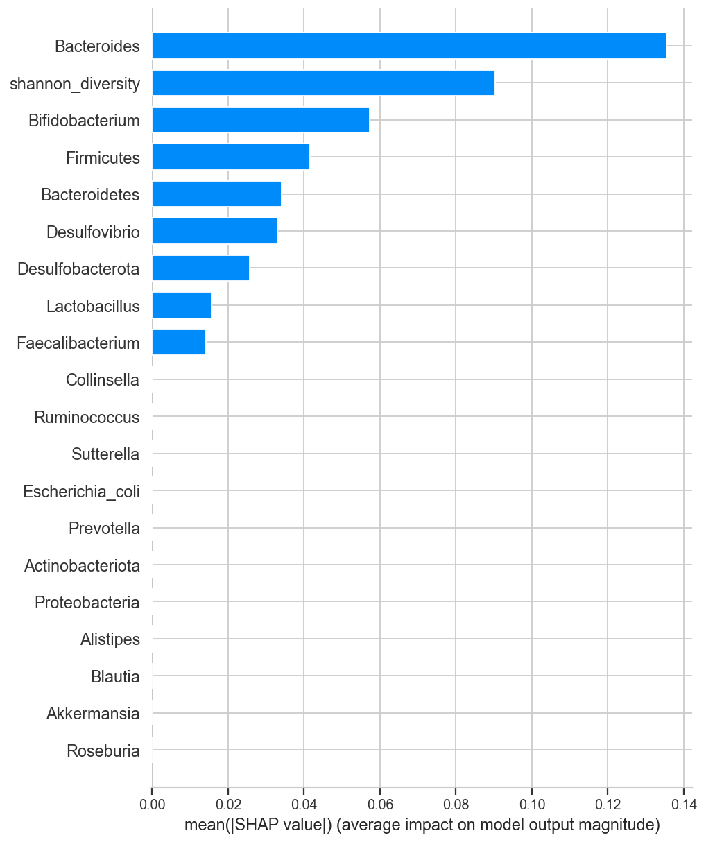
SHAP — which bacteria the model relied on most.
SHAP shows Bacteroides, Shannon diversity and Bifidobacterium were the strongest signals. The bacteria that went up in PCOS (Proteobacteria, E. coli, Bacteroides) agree with the published literature, which is a good sign.
Important point. A batch check showed 15 of 21 features tell the two studies apart better than they tell the disease apart. Shannon diversity was almost a perfect 'study barcode'. So the 0.79 is an optimistic within-study number — it does not prove the model works on a brand-new hospital's patients.

3. Endometriosis pipeline

3.1 How the data looks after preprocessing
Same layout as PCOS. 129 gut samples: 67 Endometriosis and 62 Control, from two studies. Here the predicted enzyme (beta_glucuronidase) is filled in by PICRUSt2.

Group | Columns | Meaning
ID / label | sample_id, study, diagnosis, sample_type, country | dropped before training
Bacteria % | Firmicutes, Bacteroidetes, Bacteroides, … (20 taxa) | relative abundance
Function | beta_glucuronidase | PICRUSt2-predicted enzyme (z-scored per study)
Diversity | shannon_diversity | excluded as a feature (acted as a batch marker)
Endometriosis table: 129 rows × 27 columns.

3.2 Preprocessing quality report
Before trusting the table, we checked how many sequencing reads survived the cleaning (DADA2). If too few survive, the bacteria numbers are unreliable.

Study | Samples | Reads kept | Note
PRJNA1145097 | 50 | 64% | good
PRJNA424567 | 79 | 91% | good (after V4 fix)
DADA2 read retention per endometriosis study.
One study (PRJNA424567) first kept only 4.5% of reads because it was processed with the wrong primer settings. After fixing this (correct V4 primer trimming), it jumped to 91%. This shows why the quality check matters — the earlier bad model was a data problem, not biology.

3.3 Looking at the data before ML (EDA)
The two groups are almost balanced (67 vs 62). Missing values were small. The per-group bacteria comparison gives a first look at which taxa differ.
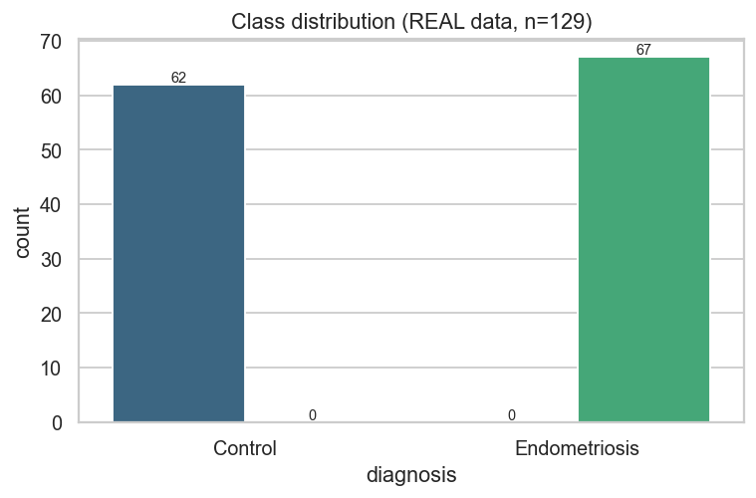
Class balance.
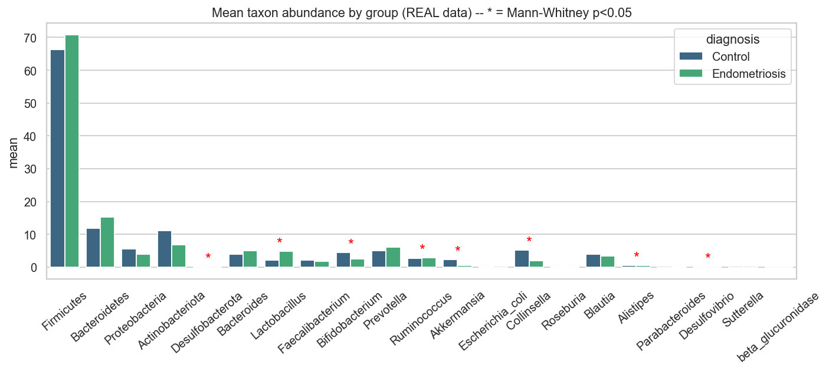
Average amount of each bacteria in the two groups. The stars mark differences that are statistically clear.

3.4 The 10 models and which one won
We did not pick one model by guessing. We tried 10 different models — from simple ones (Logistic Regression, Naive Bayes) to complex ones (Random Forest, Gradient Boosting, Neural Network). Each was scored by cross-validation. The table below shows the top ones.

Model | CV F1 | Train−CV gap
Extra-Trees (won) | 0.640 | 0.132
MLP | 0.637 | 0.090
SVM (RBF) | 0.611 | 0.134
Logistic Reg. | 0.606 | 0.097
Gaussian NB | 0.605 | 0.112
Model leaderboard (top 5). Selected by cross-validation F1.
Extra-Trees won with CV F1 0.64 and a controlled gap (0.13). Gradient Boosting and AdaBoost again memorised (training F1 near 1.0, huge gaps) and were rejected.

3.5 Results and how to read the graphs
On the held-out test set: accuracy 0.73, balanced accuracy 0.74, F1 0.72, ROC-AUC 0.77. It catches Control well (recall 0.83) and Endometriosis moderately (recall 0.64). This 0.77 is a clear improvement over the earlier broken run (0.68).
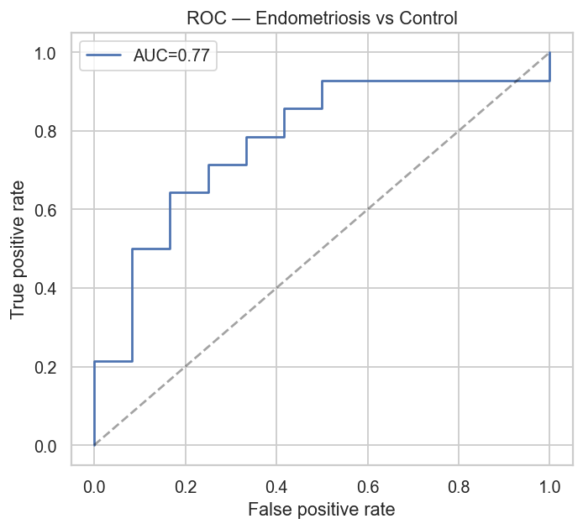
ROC curve. Higher/left is better; the diagonal is random guessing. AUC 0.77.
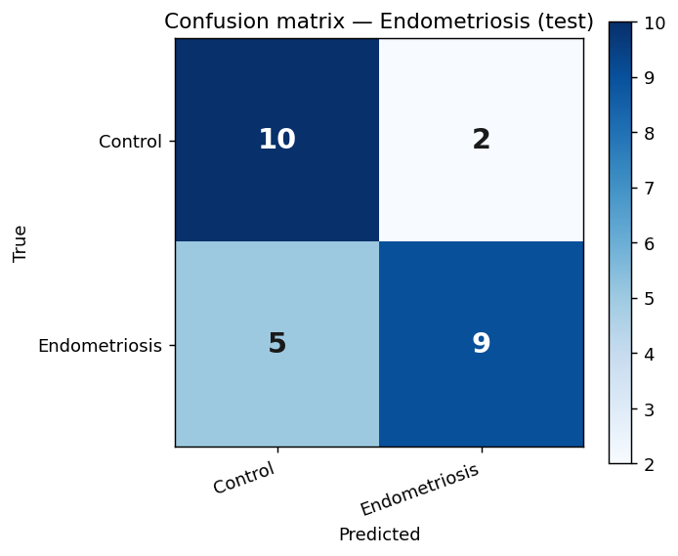
Confusion matrix. Diagonal = correct; off-diagonal = mistakes.
Reading this matrix (test set = 26: 12 Control, 14 Endometriosis). Top row = the 12 Controls: 10 correct, 2 wrongly flagged. Bottom row = the 14 Endometriosis: 9 caught, 5 missed.
 | Predicted Control | Predicted Endo
True Control (12) | 10 (TN) | 2 (FP)
True Endo (14) | 5 (FN) | 9 (TP)
Sensitivity (catch Endometriosis) = TP/(TP+FN) = 9/14 = 0.64. Specificity (clear healthy) = TN/(TN+FP) = 10/12 = 0.83. So it clears healthy people better than it catches every case; lowering the threshold would raise sensitivity at the cost of more false positives.
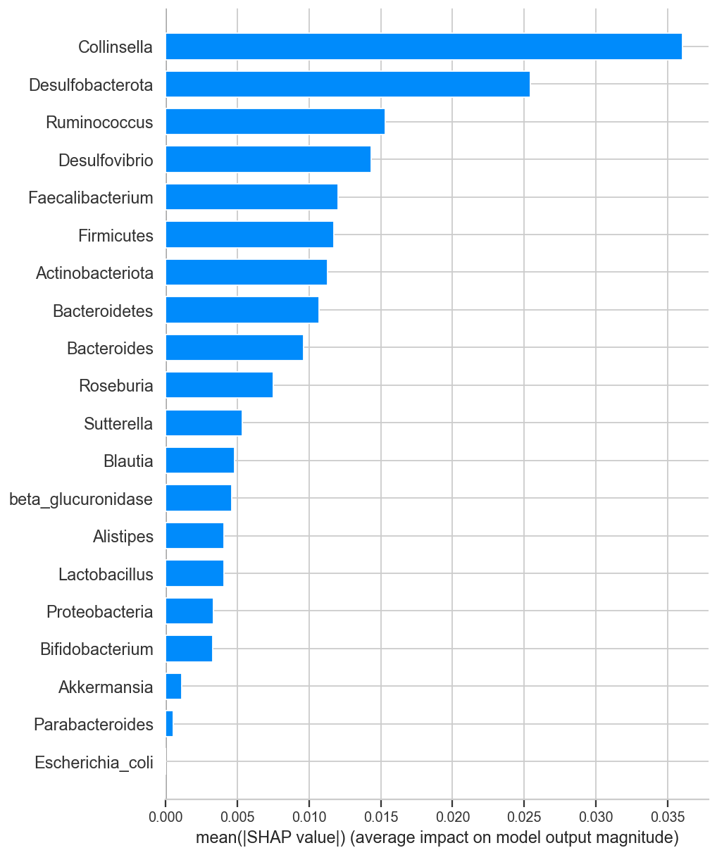
SHAP — which bacteria the model relied on most.
SHAP shows Collinsella, Desulfobacterota and Ruminococcus were the strongest signals. Only the strongest literature link (E. coli / Proteobacteria) partly agreed.
Important point. When we trained on one study and tested on the completely different study (leave-one-study-out), the AUC fell to 0.52 — basically random. So the model works within a study, but does NOT yet transfer to a new, unseen study. That gap (0.77 → 0.52) is the batch effect, and it is the honest headline for endometriosis.

4. Pooled 3-class pipeline (demo)
This arm is SYNTHETIC / DEMO data — not real patients. It exists only to show the same pipeline working on three classes at once (Control / Endometriosis / PCOS). Its results must not be read as biology.

4.1 How the data looks
720 samples: 346 Control, 235 PCOS, 139 Endometriosis. 14 feature columns. Because the data is synthetic, the numbers are already standardised (z-scored), so they are not percentages — you see values like −2.0 instead of 60%. It also carries ready-made ratio features (FB_ratio, dysbiosis_index, etc.).

4.2 Method
Same design as the real arms: all preprocessing (fill-missing → scale → pick best features) is done inside the cross-validation folds, the same 10 models are tried, the best is grid-searched, and the model is judged with accuracy, balanced accuracy, macro-F1 and one-vs-rest ROC. Because it is a single synthetic table, there is no leave-one-study-out step here.

4.3 Results
The small Neural Network (MLP) won (CV macro-F1 0.86). On the test set it scored accuracy 0.90, macro-F1 0.87, and one-vs-rest AUC of 0.99 (Control), 0.92 (Endometriosis) and 0.98 (PCOS).

Model | CV F1 | Train−CV gap
MLP (won) | 0.856 | 0.124
Logistic Reg. | 0.794 | 0.031
SVM (RBF) | 0.754 | 0.136
Gradient Boosting | 0.744 | 0.256
Extra-Trees | 0.744 | 0.256
Pooled leaderboard (top 5).
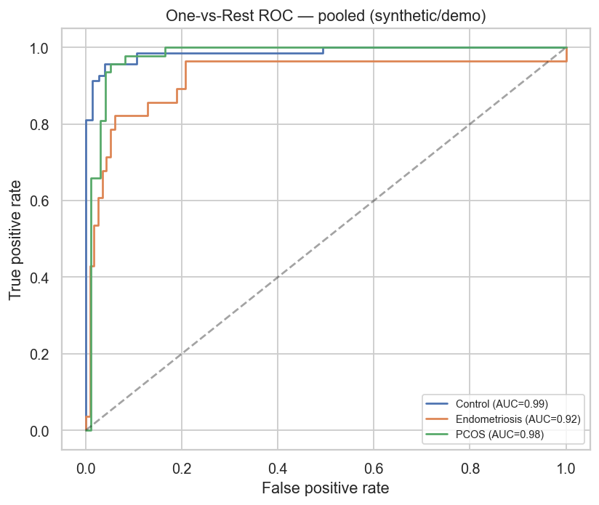
One-vs-Rest ROC for the 3 classes (synthetic/demo).
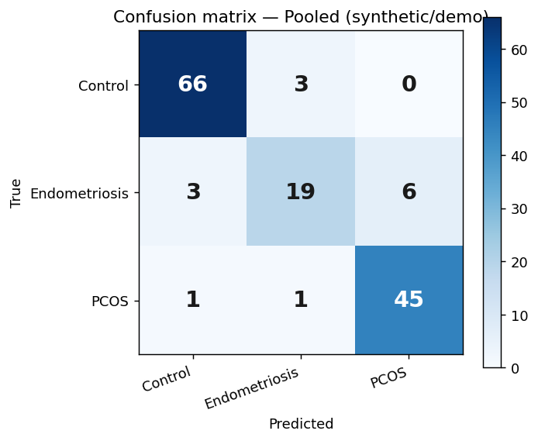
Confusion matrix, 3 classes (synthetic/demo).
Important point. These scores (AUC 0.92–0.99) are MUCH higher than the real arms (0.77–0.79). That is NOT a real achievement — it only happens because the data is synthetic and cleanly separable. It shows the pipeline works mechanically on easy data, nothing more. The tree models (Gradient Boosting, Extra-Trees, Random Forest) again hit training F1 = 1.0 with big gaps, so they were caught as over-fitting even here.

5. How I handled leakage, overfitting and underfitting
These are the mistakes that make ML results look better than they really are. Here is how each was controlled in all pipelines.

Data leakage (test data secretly helping training)
- All preprocessing — filling missing values, scaling, choosing features — is done inside each cross-validation fold, on the training part only. The test data is never seen during these steps.
- The test set is split off once at the start and only touched at the very end.
- ID columns (sample_id, study) are never used as features.

Overfitting (memorising the training data)
- Tree depth is capped; the neural network is kept small; the number of features is kept low.
- We report the train-minus-CV gap for every model. A big gap means memorising. Models like Gradient Boosting (training F1 = 1.0, gap ≈ 0.46) were caught and rejected this way.

Underfitting (model too simple to learn)
- We try a wide range of models, from simple to complex, and let cross-validation pick the winner — so an over-simple model does not win by default.

Batch effect (learning 'which study' instead of 'which disease')
- For every feature we check: does it predict the study or the disease? Features that mostly predict the study are flagged.
- For endometriosis we do leave-one-study-out: train on one study, test on a totally unseen study. This is the true generalisation test.
- We z-scored the predicted enzyme within each study, and dropped Shannon diversity, because both behaved as study markers.

6. Metrics used and why
Metric | What it tells us
CV F1 (macro) | Main score used to pick the model. Macro = treats both classes equally, good for imbalance.
CV F1 std | How stable the score is across folds. Low = reliable.
Train − CV gap | Overfitting detector. Big gap = memorising.
Accuracy | Overall % correct (can be misleading with imbalance).
Balanced accuracy | Fair accuracy that does not favour the bigger class.
Sensitivity (recall) | Of the real disease cases, how many the model catches = TP/(TP+FN).
Specificity | Of the real healthy people, how many are correctly cleared = TN/(TN+FP).
ROC-AUC | How well the model separates the two groups overall.
LOSO AUC (endo) | The honest cross-study test — does it work on a new study?
Study-vs-disease AUC | Batch detector — is a feature biology or just study identity?
SHAP / LIME | Which bacteria drove the prediction (overall and per patient).

7. Summary of the three pipelines
Pipeline | Samples | Best model | Within-study AUC | Cross-study AUC | Data type
PCOS | 91 | MLP | 0.79 | not tested* | real
Endometriosis | 129 | Extra-Trees | 0.77 | 0.52 | real
Pooled (demo) | 720 | MLP | 0.90 (synth) | n/a | synthetic
* PCOS did not have a formal leave-one-study-out run, but its batch check showed most features track the study, so its cross-study number would likely also be weak.
Main message: within a single study both real models work moderately (AUC 0.77–0.79) and point to some believable bacteria. But across different studies the signal does not carry over yet (endometriosis 0.52). The batch effect between studies is the biggest challenge. The strength of this project is that the pipeline finds and shows this problem honestly, instead of hiding it behind a big number. Next steps: more data, proper batch correction, and measured (not predicted) enzyme values.

