Predicting Gut Dysbiosis in PCOS and Endometriosis
A reproducible machine-learning pipeline over real 16S rRNA gut-microbiome data
Project report for discussion — methods, datasets, results and interpretation
Author: Subha · Estrobolome / Gut-Dysbiosis ML project
Code: github.com/sumithraju/GutDys

Summary
This report describes the two classifiers I built to separate healthy controls from women with polycystic ovary syndrome (PCOS) and with endometriosis, using only gut bacterial composition measured by 16S rRNA sequencing. Both models share one deliberately conservative pipeline, and my main goal throughout was honesty rather than a large headline number — so I spent as much effort on detecting leakage, over-fitting and batch confounding as on the modelling itself.
The short version of the results: the PCOS model reaches a random-split test AUC of 0.79, but a batch diagnostic shows that 15 of 21 features separate the two source studies better than they separate disease, so that number is optimistic. The endometriosis model reaches a random-split AUC of 0.68, but its honest leave-one-study-out AUC is only 0.52 (chance). I traced most of that failure to a bioinformatics bug in the larger endometriosis cohort — 95% of its reads were being discarded — which I am currently reprocessing. The take-home is that within a single cohort there is a weak, literature-consistent signal, but robust cross-cohort prediction is not yet demonstrated for either disease at this sample size.

1. Motivation and aim
The gut microbiome is increasingly linked to women's reproductive and metabolic health through the estrobolome — the community of gut bacteria that reactivate estrogens via the enzyme β-glucuronidase. Dysbiosis in this system has been associated with both PCOS (a metabolic/endocrine disorder) and endometriosis (an inflammatory, estrogen-dependent disorder). If a consistent microbial signature exists, a non-invasive stool test could in principle support diagnosis.
My aim was to test that idea rigorously on real, public 16S data: build one reproducible pipeline that (a) classifies Control vs disease from gut taxa, (b) reports which taxa drive the prediction, and (c) — most importantly — does not fool itself. Microbiome ML is notorious for inflated results caused by data leakage and study batch effects, so the pipeline is built around catching those, and I report the pessimistic, defensible metrics rather than the flattering ones.

2. Datasets
Everything here is real sequenced data downloaded from NCBI/ENA — no simulation. I treat both arms as pilot-scale, because sample sizes are small and the cohorts come from different labs.

2.1 PCOS arm
Two public stool 16S studies were processed and pooled: SRP077213 (Lindheim et al.) and SRP085887. After processing, the combined set is 91 samples (57 PCOS / 34 Control).

2.2 Endometriosis arm
Three studies were collected. PRJNA1145097 (Kommagani lab, stool, 50 samples, 31 Control / 19 Endometriosis) is clean, single-cohort data. PRJNA424567 (the Endobiota study, Perrotta et al.) contributes 162 vaginal + rectal samples; because pooling body sites lets a model learn ‘which body site’ instead of disease, I kept only the 79 rectal/gut samples and dropped the 82 vaginal ones. PRJNA722289 (21 samples) had to be excluded entirely — its records carry only GEO sample IDs with no disease field, so the labels are unknown. The final trainable, gut-only set is 129 samples (67 Endometriosis / 62 Control).

Arm | Study accession | Samples used | Labels | Notes
PCOS | SRP077213 | 43 | Control/PCOS | stool
PCOS | SRP085887 | 48 | Control/PCOS | stool
Endo | PRJNA1145097 | 50 | 31 C / 19 E | stool, clean
Endo | PRJNA424567 | 79 (of 162) | rectal only | vaginal dropped; being reprocessed
Endo | PRJNA722289 | 0 (of 21) | none | excluded — no disease labels
Table 1. Real 16S datasets. PCOS combined n = 91; Endometriosis gut-only combined n = 129.

3. How it works — architecture and methods
The project has two stages: a bioinformatics stage that turns raw sequencing reads into a table of bacterial abundances, and a machine-learning stage that learns from that table. Both disease arms run through the same ML code (only the input studies differ), which keeps the comparison fair.
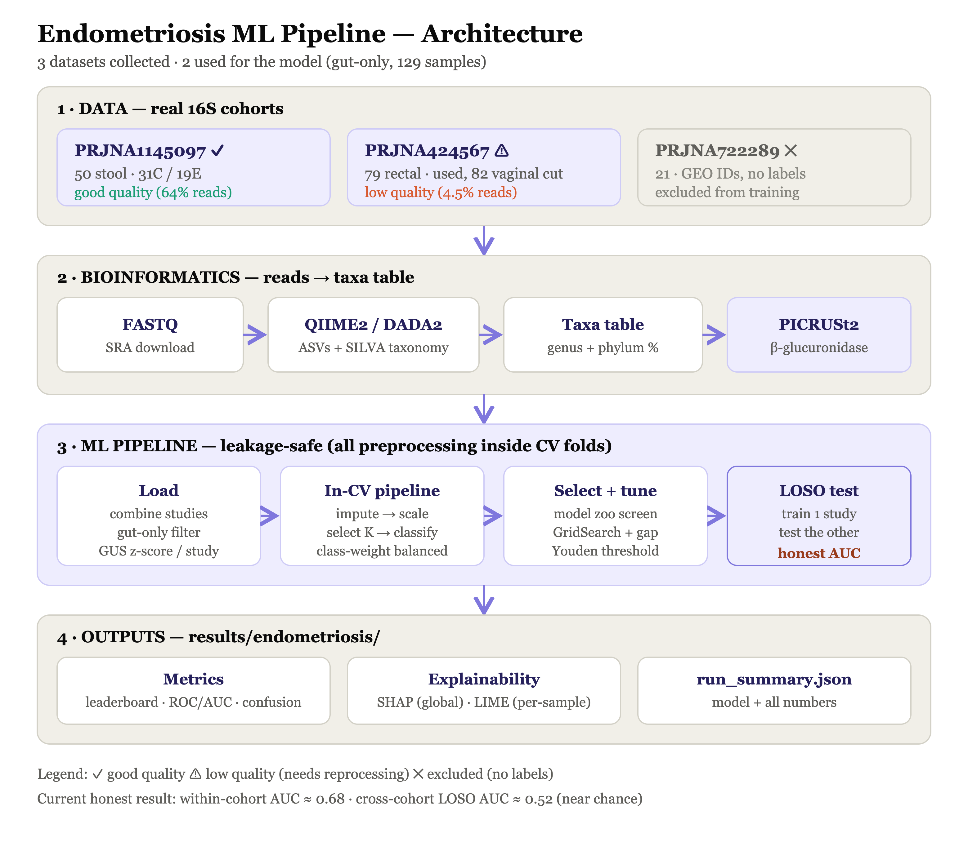
Figure 1. End-to-end architecture: from raw FASTQ through QIIME2/PICRUSt2 to the leakage-safe ML pipeline and outputs.

3.1 Bioinformatics (reads → taxa table)
Raw paired-end FASTQ files are downloaded from SRA, denoised into amplicon sequence variants with QIIME2 / DADA2, and given taxonomy against the SILVA 138 reference. I collapse these to phylum and genus level and convert them to relative abundances, producing ~20 taxonomic features per sample plus a Shannon diversity value. Separately, because 16S tells you who is present but not what genes they carry, I use PICRUSt2 to predict β-glucuronidase abundance (EC 3.2.1.31) — the estrobolome enzyme — from the sequences. (Getting PICRUSt2 to run required switching its phylogenetic placement to SEPP, as the default tool crashed under emulation on Apple Silicon.)

3.2 The machine-learning pipeline
For each sample the model sees the taxa abundances, a set of biologically-motivated ratio features (e.g. Firmicutes/Bacteroidetes), and the predicted β-glucuronidase. Every preprocessing step lives inside a scikit-learn Pipeline — KNN imputation → ratio engineering → standardisation → univariate feature selection → classifier — so that these steps are re-fit on the training portion of each cross-validation fold and never see held-out data. Ten models are screened (from logistic regression and naïve Bayes to random forests, gradient boosting, SVM and an MLP) with repeated stratified cross-validation; the winner is tuned with grid search, and the decision threshold is chosen by Youden's J on out-of-fold predictions.

3.3 Guarding against leakage, over- and under-fitting
- Leakage: identifier columns are never features; all imputation/scaling/selection are re-fit per fold; a single held-out test set is split off once, before any tuning.
- Over-fitting: tree depth is capped, the MLP uses early stopping, feature count is kept small, and the train-minus-CV gap is reported for every model so memorisers are visible and rejected.
- Under-fitting: the deliberately wide model zoo and CV-based selection mean an over-simple model does not win by default.
- Batch confounding: this turned out to be the central issue — see §4. I added an explicit leave-one-study-out (LOSO) evaluation and a per-feature ‘does this predict study or disease?' diagnostic, and I z-score the predicted β-glucuronidase within each study to strip its batch magnitude.

4. Results

4.1 PCOS classifier
The best model was a small multilayer perceptron (cross-validated F1 0.79, train-vs-CV gap only 0.05, i.e. not over-fit). On the untouched test set it reached accuracy 0.68, balanced accuracy 0.66, F1 0.75, and ROC-AUC 0.79.

Model | CV F1 | Train-CV gap
MLP (best) | 0.789 | 0.050
GaussianNB | 0.775 | 0.044
LogisticRegression | 0.774 | 0.073
RandomForest | 0.755 | 0.200
AdaBoost | 0.737 | 0.263
Table 2. PCOS model leaderboard (top five). Large gaps flag over-fitting; the pipeline selects on CV F1.
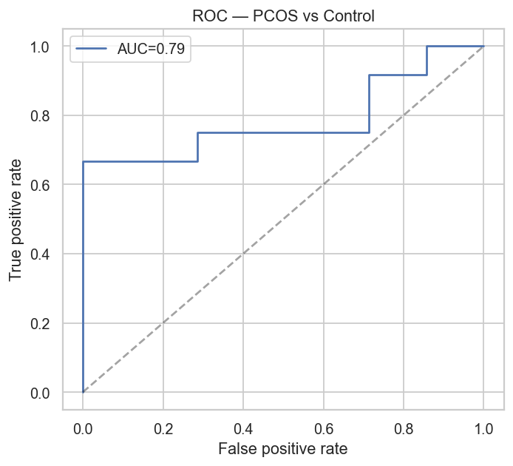
Figure 2. PCOS ROC curve (random-split test, AUC ≈ 0.79).
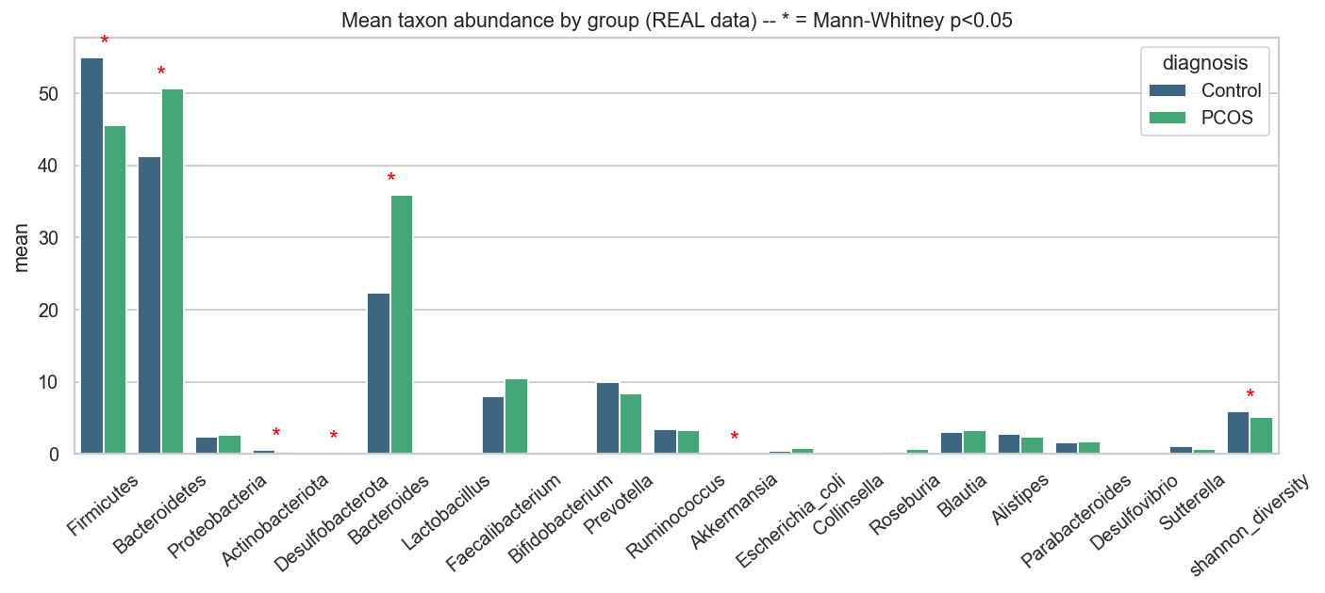
Figure 3. Mean taxon abundance, Control vs PCOS.
Important caveat. A batch check showed 15 of 21 features separate the two source studies better than they separate disease. The worst offenders — Shannon diversity (study-AUC 0.998 vs disease-AUC 0.71), Actinobacteriota and Collinsella — are essentially study barcodes. So the 0.79 is partly the model recognising sequencing/lab differences, not biology, and it should be read as an optimistic upper bound.
On the positive side, the biology that does appear is literature-consistent: Proteobacteria, Escherichia coli and Bacteroides are all elevated in PCOS as expected (strong-evidence matches), and SHAP ranks Bacteroides and Bifidobacterium among the top drivers.

4.2 Endometriosis classifier
The best model was Extra-Trees (CV F1 0.63). On the random-split test it reached accuracy 0.62, balanced accuracy 0.61, F1 0.64, AUC 0.68 — modest. But the honest number is the leave-one-study-out result, where the model is trained on one cohort and tested on a completely unseen one:

Evaluation | AUC | Balanced acc
Random split (optimistic) | 0.679 | 0.613
LOSO — test on PRJNA1145097 | 0.564 | 0.565
LOSO — test on PRJNA424567 | 0.474 | 0.400
LOSO mean (honest) | 0.519 | —
Table 3. Endometriosis — random-split vs cross-cohort (LOSO). The gap between 0.68 and 0.52 is the batch effect.
A cross-cohort AUC of 0.52 is essentially chance — the model does not generalise to a new cohort. Before concluding ‘no biological signal', though, I checked the data quality and found a real problem.
Root cause — a bioinformatics bug I found and am fixing. PRJNA424567 (79 of the 129 samples) had catastrophic read loss in DADA2: only 4.5% of reads survived (≈1,300 per sample), versus 64% (≈35,000) for the clean cohort. The cause is that this study is actually the V4 region (515F/806R, ~253 bp) sequenced 2×250, but it was first processed as if it were V3–V4 without primer removal, so the reads mis-merged and were discarded as chimeras. That corrupted table is almost certainly why Prevotella and Lactobacillus came out reversed from the literature. I am reprocessing it now with proper primer trimming (cutadapt) and V4 settings, so the endometriosis result here is provisional.
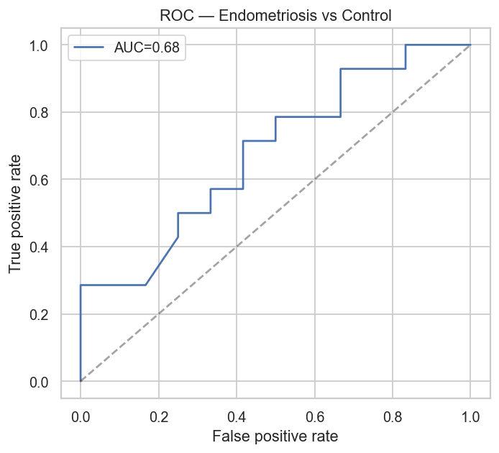
Figure 4. Endometriosis ROC (random-split test). LOSO performance is markedly lower — see Table 3.
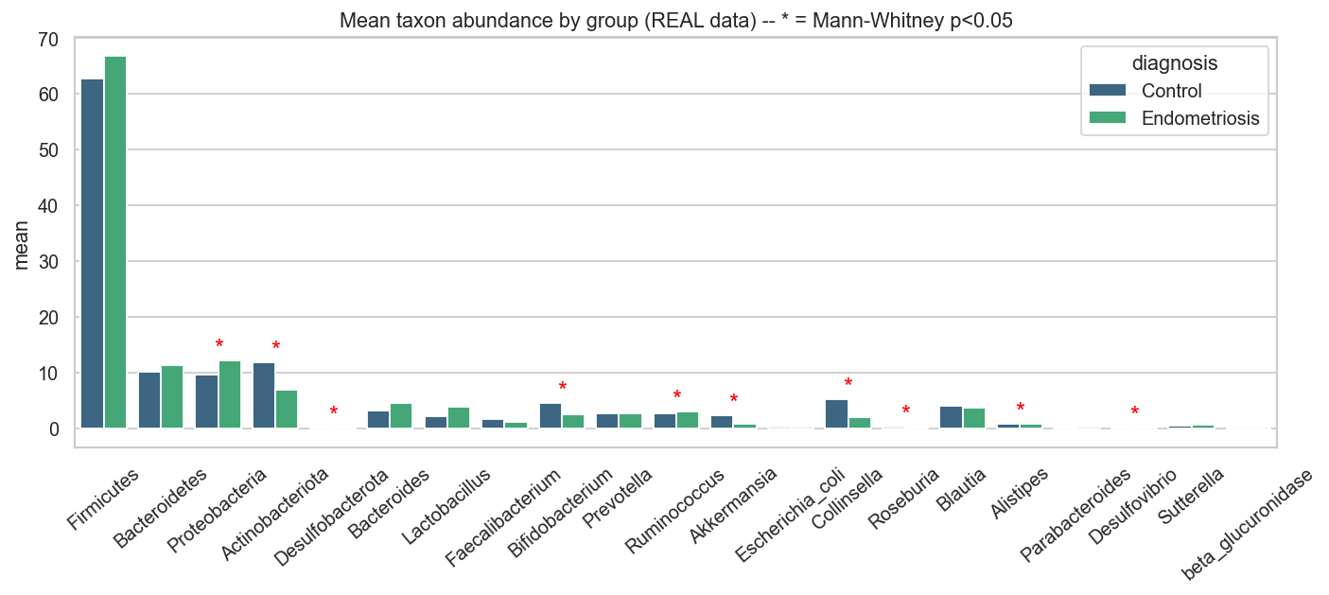
Figure 5. Mean taxon abundance, Control vs Endometriosis (current, pre-reprocessing).
Even so, the strongest-evidence associations survive: Escherichia coli and Proteobacteria are correctly elevated in endometriosis, consistent with the Endobiota and 2025 reviews.

5. Interpretation
Read together, both arms tell the same cautionary story. There is a weak, biologically-plausible signal within a cohort, but performance is dominated by batch / study effects, and it degrades sharply when the model has to generalise to an independent cohort. This is exactly the failure mode the microbiome-ML literature warns about, and I think surfacing it clearly is the most valuable part of the project.
- PCOS: an apparently good AUC (0.79) that is partly batch — the driver taxa (Proteobacteria, E. coli, Bacteroides up) are literature-consistent, but Shannon and a few genera behave as study barcodes and must not be read clinically.
- Endometriosis: cross-cohort performance is currently at chance, but this is confounded by a data-quality bug in the larger cohort, so no biological conclusion can be drawn until reprocessing is done.
- Estrobolome / β-glucuronidase: the predicted enzyme abundance differed ~13× between studies (a batch artefact), so I z-score it within study; its within-cohort disease contrast is weak so far.
So my honest headline for a supervisor is: ‘within-cohort classifiable, cross-cohort not yet demonstrated', with the endometriosis number pending clean reprocessing. I would rather present that than a polished-but-fragile 0.9.

6. Limitations
- Small sample sizes (91 and 129) — wide confidence intervals; treat as pilots.
- Between-study batch effects (different labs, DNA kits, and amplicon regions — V4 vs V3–V4) are the dominant nuisance.
- β-glucuronidase is PICRUSt2-predicted functional potential, not measured enzyme activity.
- One endometriosis cohort (PRJNA424567) is being reprocessed; PRJNA722289 is unusable without disease labels.

7. Next steps
- Finish the V4 reprocessing of PRJNA424567 and re-evaluate LOSO — the key test of whether the bad result was data quality or real biology.
- Add explicit batch correction (e.g. ComBat / MMUPHin) applied inside cross-validation, and report bootstrap confidence intervals.
- Recover PRJNA722289 labels from the GEO series, and add further cohorts to strengthen the cross-cohort test.
- Where feasible, obtain measured β-glucuronidase (shotgun metagenomics or enzyme assay) rather than predicted.

8. Reproducibility
All code, processed taxa tables, results and figures are in the repository github.com/sumithraju/GutDys. Each disease arm is a single command (python3 pcos_pipeline.py / python3 endometriosis_pipeline.py); the QIIME2 and PICRUSt2 steps are scripted, with PICRUSt2 containerised in Docker to avoid dependency issues. The run summaries (JSON), leaderboards, and SHAP/LIME explanations regenerate automatically.
Note: the endometriosis numbers in this report reflect the run before PRJNA424567 reprocessing; they will be updated once the corrected table is in.

