PROJECT PROGRESS REPORT
Machine-Learning Classification of Gut Dysbiosis in
PCOS and Endometriosis from 16S rRNA Microbiome Data
A study of the estrobolome–gut axis using reproducible, leakage-controlled
machine-learning pipelines over real public 16S sequencing cohorts
Submitted by
R Sumithra (Reg. No. 255hsbd026)
P. Hemachandar (Reg. No. 255hsbd010)
Under the guidance of
Dr. Shyam Rajagopalan
(Mentor)
M.Sc. Big Data Biology
Institute of Bioinformatics and Applied Biotechnology (IBAB), Bengaluru
July 2026

Abstract
The gut microbiome is increasingly implicated in women's reproductive and metabolic disorders through the estrobolome, the bacterial community that regulates enterohepatic estrogen recycling via β-glucuronidase. This project asks whether gut bacterial composition, measured by 16S rRNA sequencing, can classify healthy controls against women with polycystic ovary syndrome (PCOS) and against women with endometriosis. Two matched, leakage-controlled machine-learning pipelines were built over real public sequencing cohorts: PCOS (two stool studies, n = 91) and endometriosis (gut samples from two studies, n = 129). Each pipeline performs QIIME2/DADA2 denoising, SILVA-138 taxonomy and PICRUSt2 functional prediction, followed by a scikit-learn model that keeps all preprocessing inside cross-validation. The PCOS model reached a within-cohort test AUC of 0.79, but a batch diagnostic showed most features separate the source studies better than the disease. The endometriosis model reached a within-cohort AUC of 0.77 after a bioinformatics correction, yet its leave-one-study-out (cross-cohort) AUC remained 0.52, i.e. chance. The central finding is therefore methodological and honest: a weak, partly literature-consistent signal is detectable within a cohort, but does not replicate across independent cohorts at this scale, and study/batch effects dominate. The work's contribution is a rigorous, reproducible framework that surfaces these confounds rather than reporting inflated performance.

1. Introduction

1.1 Background
Polycystic ovary syndrome and endometriosis are two of the most common gynaecological conditions affecting women of reproductive age. PCOS is a heterogeneous endocrine–metabolic disorder characterised by hyperandrogenism, ovulatory dysfunction and frequently insulin resistance, whereas endometriosis is a chronic, estrogen-dependent inflammatory condition in which endometrium-like tissue grows outside the uterus. Although clinically distinct, both are increasingly linked to disturbances of the gut microbiome.
A key mechanistic bridge is the estrobolome — the collection of gut bacterial genes, most notably those encoding β-glucuronidase (EC 3.2.1.31), whose products deconjugate estrogens excreted into the gut and return them to circulation. An altered estrobolome can therefore shift systemic estrogen levels, a plausible contributor to estrogen-dependent endometriosis and to the metabolic profile of PCOS. Beyond this specific enzyme, broad gut dysbiosis — reduced diversity, loss of short-chain-fatty-acid producers and expansion of pro-inflammatory taxa — has been reported in both conditions. If a reproducible microbial signature exists, a non-invasive stool test could complement current, often invasive or delayed, diagnostic pathways.

1.2 Rationale and objectives
Microbiome machine learning is notoriously prone to over-optimistic results: small sample sizes, high dimensionality and strong technical ‘batch' differences between studies make it easy to report high accuracy that does not generalise. The objective of this project was therefore twofold — to test whether gut 16S data can classify PCOS and endometriosis, and, equally, to do so under strict controls for data leakage, over-/under-fitting and study confounding, reporting the pessimistic but defensible metrics. Concretely, the aims were: (i) assemble and uniformly process real public 16S cohorts for both diseases; (ii) build one shared, leakage-safe classification pipeline; (iii) identify the taxa driving predictions and compare them with the published literature; and (iv) quantify how much of any apparent performance is biology versus batch.

2. Materials and Methods

2.1 Datasets
All data are real 16S rRNA amplicon sequencing runs retrieved from the NCBI Sequence Read Archive; none are simulated. For PCOS, two publicly available stool studies were processed and pooled. For endometriosis, three studies were collected; one (PRJNA722289) was excluded because its records carry only GEO sample identifiers with no disease labels, and the vaginal samples of PRJNA424567 were removed so that only gut (rectal/stool) samples remain, avoiding a body-site confound. The final analysed sets were 91 PCOS-arm and 129 endometriosis-arm samples (Table 1).

Arm | Accession | Samples | Labels | Site / note
PCOS | SRP077213 (Lindheim) | 43 | Control / PCOS | stool
PCOS | SRP085887 | 48 | Control / PCOS | stool
Endometriosis | PRJNA1145097 | 50 | 31 C / 19 E | stool
Endometriosis | PRJNA424567 (Endobiota) | 79 of 162 | 31 C / 48 E | rectal (vaginal removed)
Endometriosis | PRJNA722289 | 0 of 21 | none | excluded — unlabelled
Table 1. Real 16S datasets used. PCOS combined n = 91 (57 PCOS / 34 Control); endometriosis combined n = 129 (67 E / 62 C).

2.2 Bioinformatic processing
Raw paired-end FASTQ files were downloaded with the SRA Toolkit and denoised into amplicon sequence variants (ASVs) using DADA2 within QIIME2. Taxonomy was assigned against the SILVA 138 reference database, and ASVs were collapsed to phylum and genus level and expressed as relative abundances. Because 16S data report taxonomic composition but not gene content, PICRUSt2 was used to predict the abundance of β-glucuronidase (EC 3.2.1.31) from the ASV sequences and a reference phylogeny; the SEPP placement option was used, as the default placement tool was unstable on the available hardware.
Amplicon-region correction. During analysis it emerged that PRJNA424567 is a V4 amplicon (primers 515F/806R, ~253 bp) sequenced 2×250, but had initially been processed with parameters for a longer V3–V4 amplicon and without primer removal. This caused catastrophic read loss (only ~4.5% of reads surviving chimera filtering, versus ~64% for the well-processed cohort). The study was reprocessed with cutadapt primer trimming and V4-appropriate DADA2 truncation, restoring normal read retention; all endometriosis results reported here use the corrected table.

2.3 Feature construction
Each sample was represented by ~20 taxonomic relative-abundance features (major phyla and genera of documented relevance to gut dysbiosis), a set of biologically-motivated ratio features (for example the Firmicutes/Bacteroidetes ratio and estrobolome-related ratios), the PICRUSt2-predicted β-glucuronidase value, and Shannon alpha-diversity. Because the predicted β-glucuronidase differed roughly thirteen-fold in magnitude between studies — a technical artefact of depth and pipeline — it was standardised (z-scored) within each study before modelling, which removes the between-study offset while preserving the within-cohort disease contrast. Shannon diversity was excluded as a feature in the combined endometriosis model for the same reason, as it behaved as a study marker.

2.4 Exploratory data analysis
Before modelling, each arm was examined for class balance, missingness and inter-feature correlation, and the mean abundance of every taxon was compared between groups. Both arms are mildly imbalanced (PCOS-heavy and endometriosis-heavy respectively), which motivated the use of balanced class weights and stratified resampling downstream. The per-group taxon comparison (Figures 3–4) provides a first, model-independent view of which taxa differ by disease state and is later cross-checked against the model's own feature attributions.
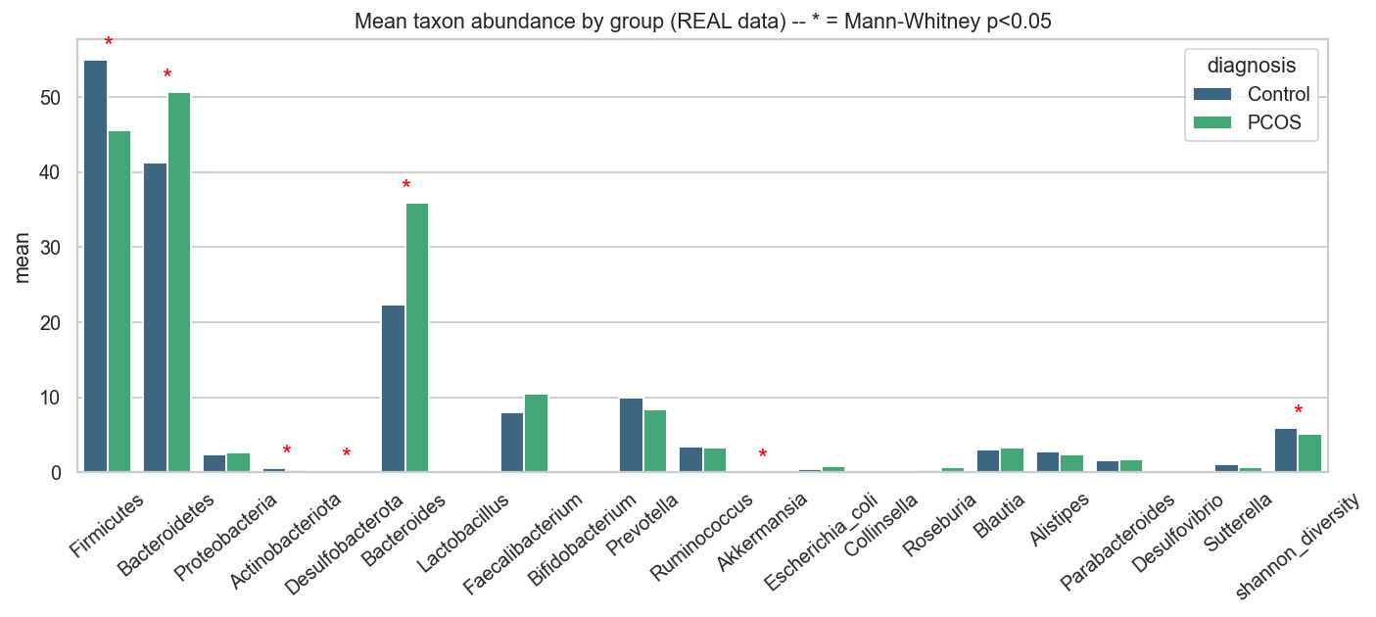
Figure 3. PCOS — mean taxon relative abundance, Control vs PCOS (exploratory).
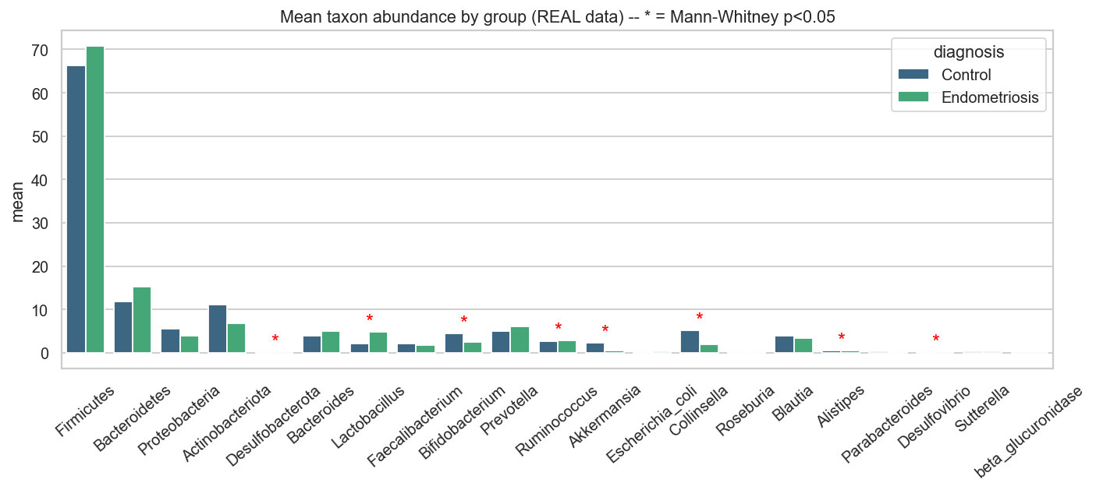
Figure 4. Endometriosis — mean taxon relative abundance, Control vs Endometriosis (corrected data).

2.5 Machine-learning pipeline and architecture
Both diseases were analysed with the same classification code, differing only in the input studies, so the two arms are directly comparable (Figures 1–2). For every sample the model receives the taxa abundances, the ratio features and the predicted β-glucuronidase. All preprocessing is encapsulated in a scikit-learn Pipeline — K-nearest-neighbour imputation, ratio-feature engineering, standardisation and univariate feature selection — followed by the classifier, so that these steps are re-fit only on the training portion of each cross-validation fold and never observe held-out samples. Ten candidate models spanning simple to flexible families (logistic regression, Gaussian naïve Bayes, k-nearest neighbours, decision tree, random forest, extra-trees, gradient boosting, AdaBoost, RBF-SVM and a multilayer perceptron) were screened with repeated stratified cross-validation; the best model was tuned by grid search, and the decision threshold was selected on out-of-fold predictions using Youden's J statistic (which balances sensitivity and specificity and cannot collapse to a degenerate all-positive cutoff).
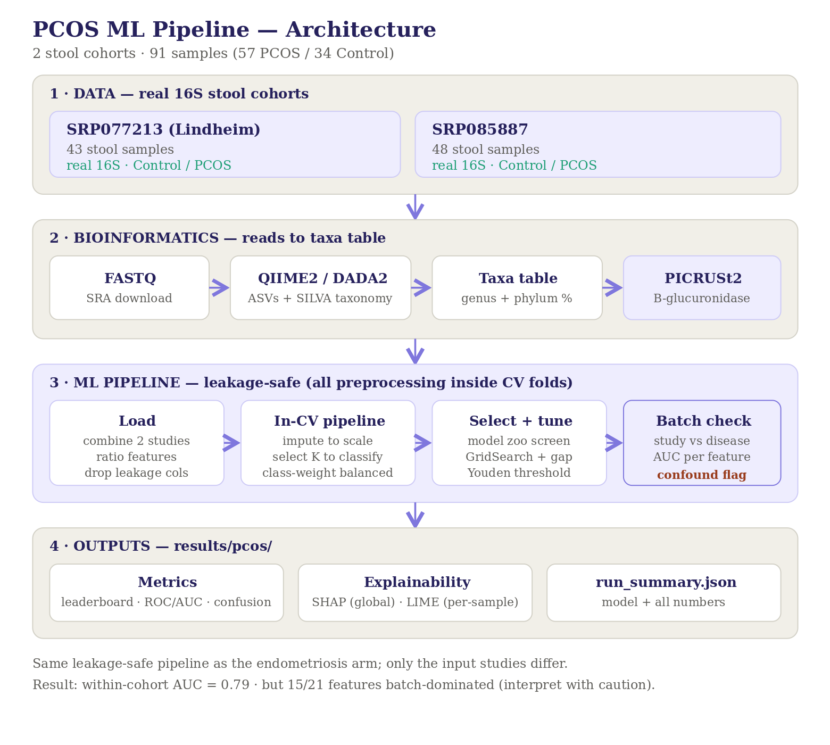
Figure 1. PCOS pipeline architecture.
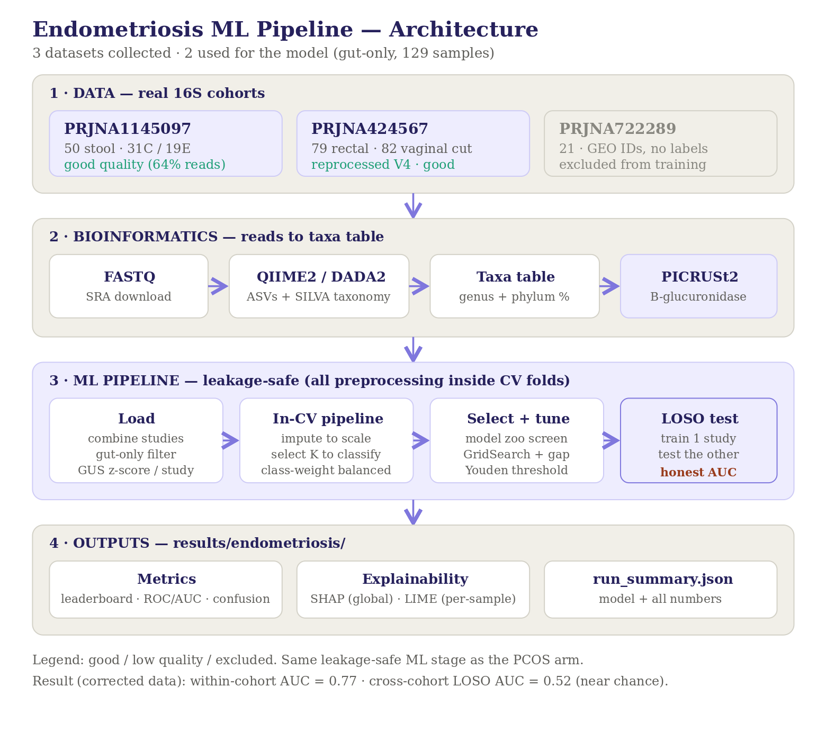
Figure 2. Endometriosis pipeline architecture (identical ML stage; leave-one-study-out evaluation added).

2.6 Safeguards against leakage, over-/under-fitting and batch effects
- Data leakage: sample identifiers and label-adjacent columns are never used as features; imputation, scaling and feature selection are re-fit per fold; and a single stratified test set is held out once, before any tuning.
- Over-fitting: tree depth is capped, the MLP uses early stopping, the number of selected features is kept small, and the train-minus-cross-validation gap is reported for every model so that memorising models are visible and rejected.
- Under-fitting: the deliberately wide model zoo with cross-validated selection prevents an over-simple model winning by default.
- Batch confounding: for each feature the ability to predict the source study is compared with its ability to predict diagnosis; for endometriosis an explicit leave-one-study-out (LOSO) evaluation trains on one cohort and tests on the other, giving an honest cross-cohort estimate.

2.7 Model evaluation and interpretation
Performance is reported as accuracy, balanced accuracy, F1 and ROC-AUC on the untouched test set, and — crucially — as cross-cohort LOSO AUC, which is treated as the honest generalisation metric. Model behaviour is explained globally with SHAP (mean absolute Shapley values across taxa) and locally with LIME for individual samples, and the resulting taxon rankings are compared against published disease associations.

3. Results and Discussion

3.1 PCOS classification
The best-performing model was a small multilayer perceptron (cross-validated F1 = 0.79, train–CV gap = 0.05, indicating no serious over-fitting). On the held-out test set it achieved accuracy 0.68, balanced accuracy 0.66, F1 0.75 and ROC-AUC 0.79 (Table 2, Figures 5–6). The literature-concordant associations are encouraging: Proteobacteria, Escherichia coli and Bacteroides were elevated in PCOS as expected (strong-evidence matches), and SHAP ranked Bacteroides and Bifidobacterium among the leading contributors (Figure 7).

Model | CV F1 | Train–CV gap
MLP (selected) | 0.789 | 0.050
Gaussian NB | 0.775 | 0.044
Logistic Regression | 0.774 | 0.073
Random Forest | 0.755 | 0.200
AdaBoost | 0.737 | 0.263
Table 2. PCOS leaderboard (top five). A large train–CV gap signals over-fitting; selection is on CV F1.
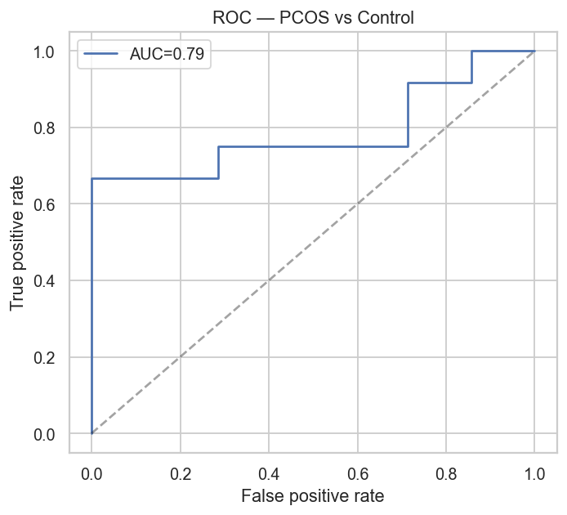
Figure 5. PCOS ROC curve (test set, AUC ≈ 0.79).
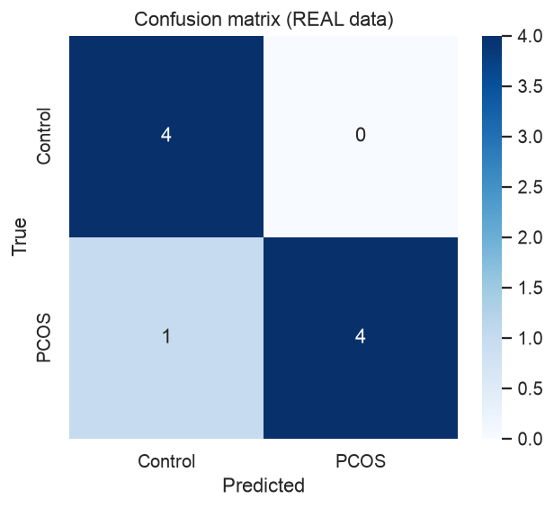
Figure 6. PCOS confusion matrix (test set).
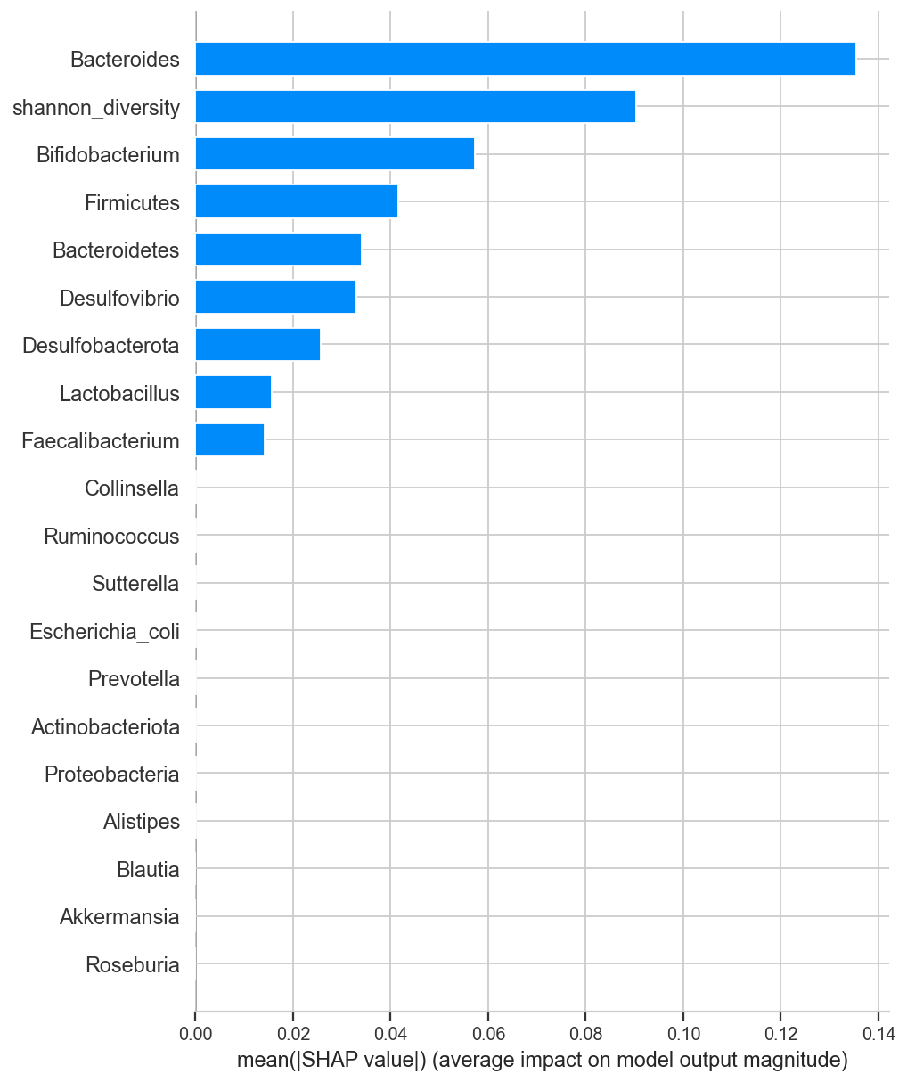
Figure 7. PCOS global feature attribution (mean |SHAP|).
Batch caveat. The batch diagnostic showed that 15 of 21 features predict the source study better than the disease; Shannon diversity (study-AUC ≈ 0.998 vs disease-AUC ≈ 0.71), Actinobacteriota and Collinsella are effectively study barcodes. The 0.79 AUC should therefore be read as an optimistic within-cohort upper bound rather than evidence of a transferable PCOS signature.

3.2 Endometriosis classification
After the amplicon-region correction (§2.2), the endometriosis model (extra-trees, CV F1 = 0.64) reached a within-cohort test performance of accuracy 0.73, balanced accuracy 0.74, F1 0.72 and ROC-AUC 0.77 — a clear improvement over the pre-correction run (AUC 0.68), confirming that much of the earlier poor result was a data-quality artefact rather than absence of signal. However, the honest cross-cohort metric tells a different story (Table 3).

Evaluation | AUC | Balanced acc.
Within-cohort (random split) | 0.774 | 0.738
LOSO — test on PRJNA1145097 | 0.538 | 0.532
LOSO — test on PRJNA424567 | 0.505 | 0.537
LOSO mean (honest) | 0.522 | —
Table 3. Endometriosis — within-cohort vs cross-cohort (LOSO). The 0.77→0.52 gap is the batch effect.
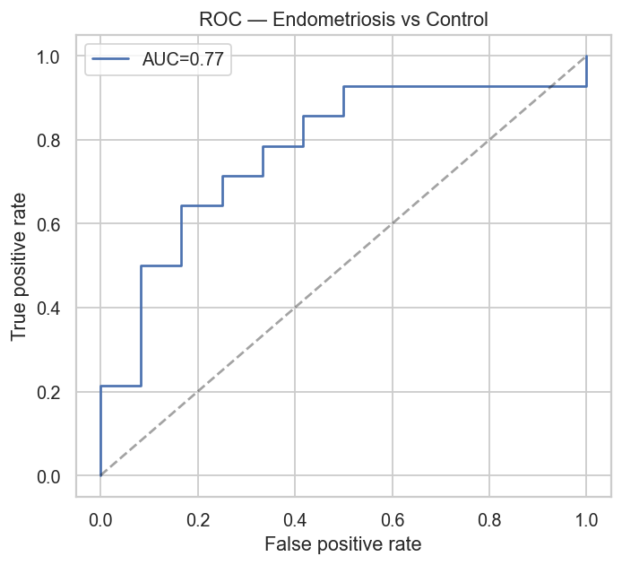
Figure 8. Endometriosis ROC curve (test set, corrected data, AUC ≈ 0.77).
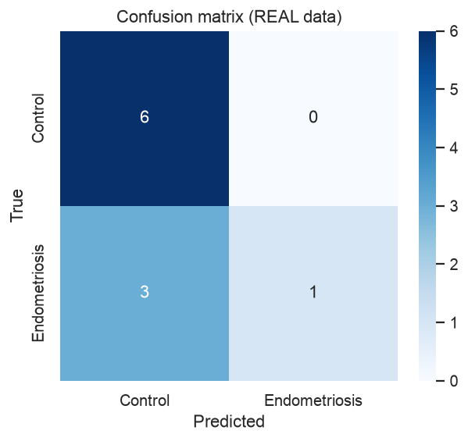
Figure 9. Endometriosis confusion matrix (test set).
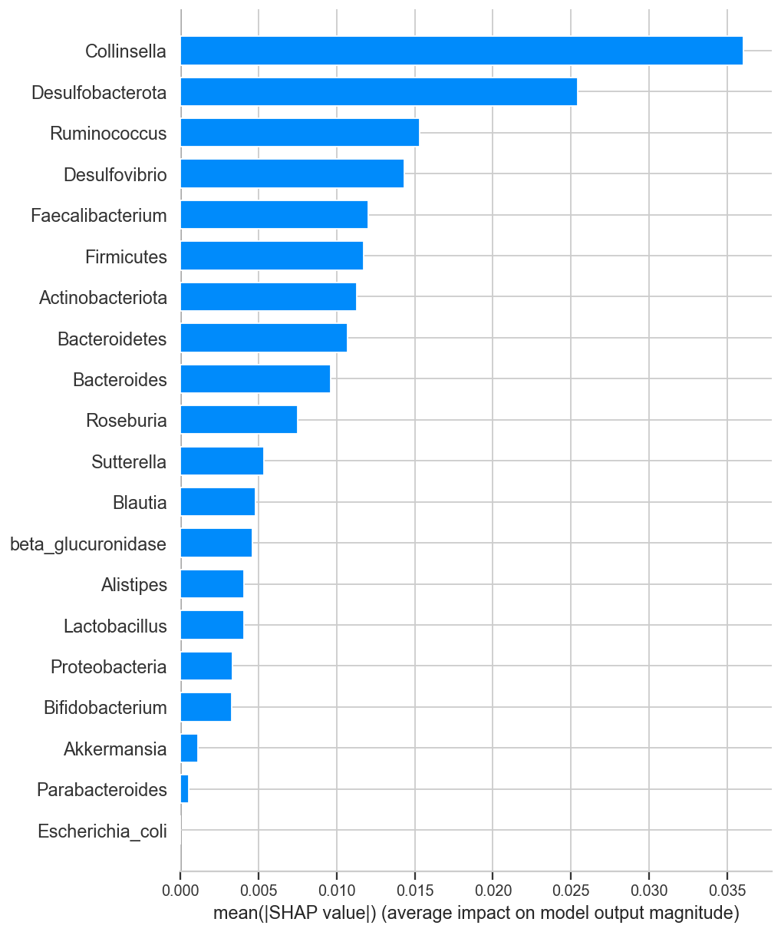
Figure 10. Endometriosis global feature attribution (mean |SHAP|).
A cross-cohort AUC of 0.52 is essentially chance: trained on one endometriosis cohort, the model does not transfer to an independent one, even with clean data. Consistent with this, the literature check was weak (only the strong-evidence E. coli/Proteobacteria direction partially recovered, while Prevotella and Lactobacillus disagreed), and SHAP was led by Collinsella and Desulfobacterota rather than by canonical estrobolome taxa.

3.3 Discussion
Read together, the two arms converge on a single, important message. In both diseases there is a weak, biologically plausible signal within a cohort — the models beat chance on held-out samples from the same studies, and several driver taxa match the dysbiosis literature. But performance is dominated by technical study differences, and it collapses toward chance when the model must generalise to an independent cohort. For endometriosis this was demonstrated directly by LOSO; for PCOS it is implied by the finding that most features encode study identity. This is precisely the failure mode that the microbiome machine-learning literature repeatedly warns about — different laboratories, DNA-extraction kits, primer sets and amplicon regions (V4 versus V3–V4) impose systematic differences that a flexible model will exploit.
The estrobolome hypothesis is not refuted by these results, but neither is it confirmed. The predicted β-glucuronidase was strongly batch-sensitive and, once corrected for study, showed only a weak within-cohort contrast; it is also a predicted functional potential rather than a measured enzyme activity. The honest conclusion for both diseases is that a transferable, clinically meaningful gut-microbial classifier is not demonstrated at this sample size, and that rigorous cross-cohort evaluation and batch handling are prerequisites before any such claim.

3.4 Limitations
- Small sample sizes (91 and 129) give wide confidence intervals; all results are pilot-scale.
- Between-study batch effects — different labs, kits and amplicon regions — are the dominant nuisance and are only partially mitigated by within-study normalisation.
- β-glucuronidase is PICRUSt2-predicted functional potential, not a measured enzyme assay.
- One endometriosis cohort required reprocessing, and PRJNA722289 remains unusable without disease labels.

3.5 Future work
- Apply explicit cross-study batch correction (e.g. ComBat or MMUPHin) inside cross-validation and report bootstrap confidence intervals on all metrics.
- Add further independent cohorts to strengthen the leave-one-study-out test and, ideally, an external validation cohort held out entirely.
- Recover PRJNA722289 labels from its GEO series, and obtain measured β-glucuronidase via shotgun metagenomics or enzyme assay rather than prediction.
- Explore hierarchical / mixed-effects models that treat study as a random effect, and per-cohort reporting where cross-cohort transfer is not yet achievable.

4. Conclusion
Two matched, leakage-controlled machine-learning pipelines were developed to classify PCOS and endometriosis from real gut 16S microbiome data. Both achieve modest within-cohort discrimination (AUC 0.77–0.79) with partly literature-consistent driver taxa, but neither generalises across independent cohorts (endometriosis LOSO AUC 0.52; most PCOS features are study markers). The project's main value is methodological: a reproducible framework that quantifies and exposes study/batch confounding instead of concealing it behind an inflated headline number. This provides an honest baseline and a clear path — larger, batch-corrected, cross-validated cohorts — toward a genuinely transferable estrobolome-based classifier.

5. References
[1] Bolyen E., et al. (2019). Reproducible, interactive, scalable and extensible microbiome data science using QIIME 2. Nature Biotechnology, 37, 852–857.
[2] Callahan B.J., et al. (2016). DADA2: High-resolution sample inference from Illumina amplicon data. Nature Methods, 13, 581–583.
[3] Quast C., et al. (2013). The SILVA ribosomal RNA gene database project. Nucleic Acids Research, 41, D590–D596.
[4] Douglas G.M., et al. (2020). PICRUSt2 for prediction of metagenome functions. Nature Biotechnology, 38, 685–688.
[5] Pedregosa F., et al. (2011). Scikit-learn: Machine learning in Python. JMLR, 12, 2825–2830.
[6] Lundberg S.M., Lee S.-I. (2017). A unified approach to interpreting model predictions (SHAP). NeurIPS, 30.
[7] Ribeiro M.T., Singh S., Guestrin C. (2016). "Why should I trust you?": Explaining the predictions of any classifier (LIME). KDD, 1135–1144.
[8] Lindheim L., et al. (2017). Alterations in gut microbiome composition and barrier function are associated with reproductive and metabolic defects in women with PCOS. PLoS ONE, 12(1), e0168390.
[9] Perrotta A.R., et al. (2020). The vaginal microbiome as a tool to predict rASRM stage of disease in endometriosis. Reproductive Sciences, 27, 1064–1073.
[10] Baker J.M., Al-Nakkash L., Herbst-Kralovetz M.M. (2017). Estrogen–gut microbiome axis: physiological and clinical implications. Maturitas, 103, 45–53.
[11] Ata B., et al. (2019). The Endobiota study: comparison of the gut and vaginal microbiota of endometriosis patients and controls. Scientific Reports, 9, 2204.
[12] NCBI Sequence Read Archive. BioProjects PRJNA1145097, PRJNA424567, PRJNA722289; SRA studies SRP077213, SRP085887.

Code and data availability: all pipelines, processed taxa tables, figures and run summaries are available at github.com/sumithraju/GutDys. Endometriosis figures and metrics reflect the corrected (V4-reprocessed) PRJNA424567 table.

