Wildlife & Plantlife
Record Management System
Campus Biodiversity Portal
Project Documentation
Group 1
Stack: React · Node.js / Express · PostgreSQL · Docker · Nginx
Submitted: April 2026

1. Requirement Specifications
The Wildlife & Plantlife Record Management System is a full-stack web application designed to help the campus community record, manage, and visualise wildlife and plant observations. It provides role-based access for administrators, researchers, and viewers, and consolidates biodiversity data that is currently scattered across notebooks, spreadsheets, and personal devices.

1.1 Purpose
To build a unified digital portal that enables systematic capture of biodiversity observations on campus, supports research activities, and makes the data easily accessible for future study, awareness, and conservation planning.

1.2 Scope
The system covers end-to-end management of wildlife and plant records: authentication, data entry, editing, deletion, filtering, spatial visualisation on a campus map, dashboards, and user administration. It runs locally via Docker and is also exposed on the IBAB network for live demonstration.

1.3 Functional Requirements
- User registration and login with JWT-based authentication.
- Role-based access: Admin, Researcher, and Viewer.
- CRUD operations on wildlife records (species, observation date, location, notes, images).
- CRUD operations on plant records (scientific name, family, flowering season, IUCN status, height, location, notes).
- Filtering and searching records by species, date, and location.
- Map view to visualise observations using latitude and longitude.
- Dashboard summarising total records, species diversity, and recent activity.
- User management for administrators.
- Image upload for observations.

1.4 Non-Functional Requirements
- Security: JWT authentication, hashed passwords (bcrypt), and role-based API protection.
- Performance: Paginated queries and indexed database columns for fast retrieval.
- Portability: Entire stack containerised with Docker Compose; runs with a single command.
- Usability: Clean, responsive UI built with React; suitable for both desktop and tablet.
- Maintainability: Clear separation of concerns — frontend, backend, and database each in their own module.
- Testability: Automated tests using Jest + Supertest (backend) and React Testing Library (frontend).

1.5 User Roles
Role | Capabilities
Admin | Manage users, delete any record, full access to all features
Researcher | Create, edit, and view wildlife and plant records
Viewer | Read-only access to records, map, and dashboard

1.6 Technology Stack
Layer | Technology
Frontend | React 18, Vite, Axios, React Router
Backend | Node.js 20, Express, JWT, Multer (file uploads)
Database | PostgreSQL 15
Deployment | Docker, Docker Compose, Nginx
Testing | Jest, Supertest, React Testing Library

1.7 Screenshot — Edit Plant Record
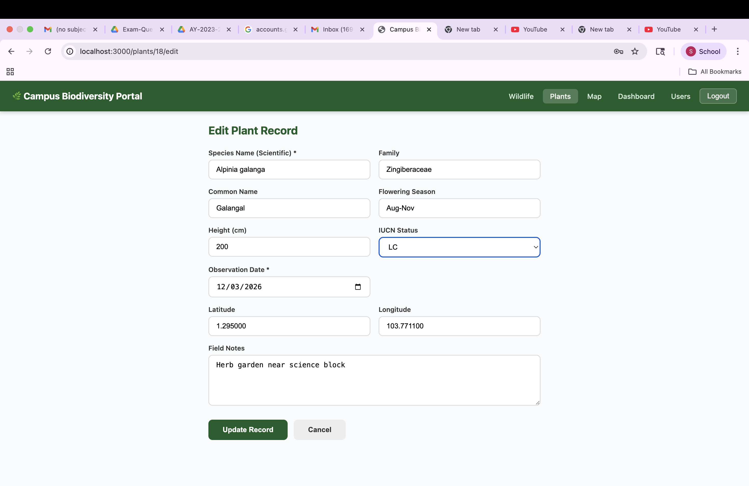
Figure 1: Edit Plant Record page (Campus Biodiversity Portal)

2. Modules and Folder Structure
The project is organised into three primary modules — frontend, backend, and database — with supporting configuration at the root of the repository. Each module has a single, clear responsibility and communicates with the others through well-defined interfaces (REST API between frontend and backend; SQL schema between backend and database).

2.1 High-Level Modules
Module | Responsibility
frontend/ | React single-page application served via Vite in development and Nginx in Docker.
backend/ | Express REST API handling authentication, business logic, and file uploads.
database/ | PostgreSQL schema, ENUMs, triggers, and seed data.
docker-compose.yml | Orchestration of all services (frontend, backend, db, pgAdmin).

2.2 Repository Folder Structure
├── backend/
│ ├── src/
│ │ ├── app.js # Express app entry point
│ │ ├── config/ # Database connection pool
│ │ ├── controllers/ # Route handlers (auth, wildlife, plants, users)
│ │ ├── middleware/ # JWT auth, role checks, file upload (Multer)
│ │ ├── models/ # SQL queries for each entity
│ │ └── routes/ # API endpoint definitions
│ ├── scripts/ # Utility scripts (e.g., resetPasswords.js)
│ ├── tests/ # Jest + Supertest tests
│ ├── uploads/ # Uploaded observation images
│ ├── Dockerfile
│ └── package.json
│
├── frontend/
│ ├── src/
│ │ ├── main.jsx # React entry point
│ │ ├── App.jsx # Top-level router
│ │ ├── api/ # Axios API client
│ │ ├── components/ # Reusable UI components
│ │ ├── context/ # Auth context (JWT + user)
│ │ └── pages/ # Wildlife, Plants, Map, Dashboard, Users, Login
│ ├── tests/ # React Testing Library tests
│ ├── nginx.conf # Nginx config for Docker image
│ ├── vite.config.js
│ ├── Dockerfile
│ └── package.json
│
├── database/
│ ├── init.sql # Schema, ENUMs, triggers
│ └── seed.sql # 5 users, 30 wildlife, 25 plant records
│
├── docker-compose.yml # Services: frontend, backend, db, pgAdmin
├── README.md
└── .gitignore

2.3 Backend Module Breakdown
- config — PostgreSQL connection pool using environment variables.
- controllers — Request handlers for /api/auth, /api/wildlife, /api/plants, /api/users.
- middleware — JWT verification, role-based guards (admin, researcher), Multer image upload.
- models — Parameterised SQL queries mapping each REST action to the database.
- routes — Express routers that wire middleware and controllers to URL paths.
- scripts — One-off helpers such as resetPasswords.js used on first run.
- tests — Jest + Supertest integration tests covering auth and CRUD flows.

2.4 Frontend Module Breakdown
- pages — Route-level components: Login, Dashboard, Wildlife list & form, Plants list & form, Map, Users.
- components — Reusable UI pieces (navigation, record cards, forms, modals, map markers).
- context — AuthContext storing JWT and current user; persists across navigation.
- api — Centralised Axios instance with base URL and auth header interceptor.
- tests — React Testing Library tests for forms, authentication, and rendering.

2.5 Database Module Breakdown
- init.sql — Creates users, wildlife_records, and plant_records tables; ENUM types for role and IUCN status; triggers to auto-update the updated_at column.
- seed.sql — Inserts 5 demo users, 30 wildlife records, and 25 plant records for immediate testing.

2.6 Screenshot — GitHub Repository View
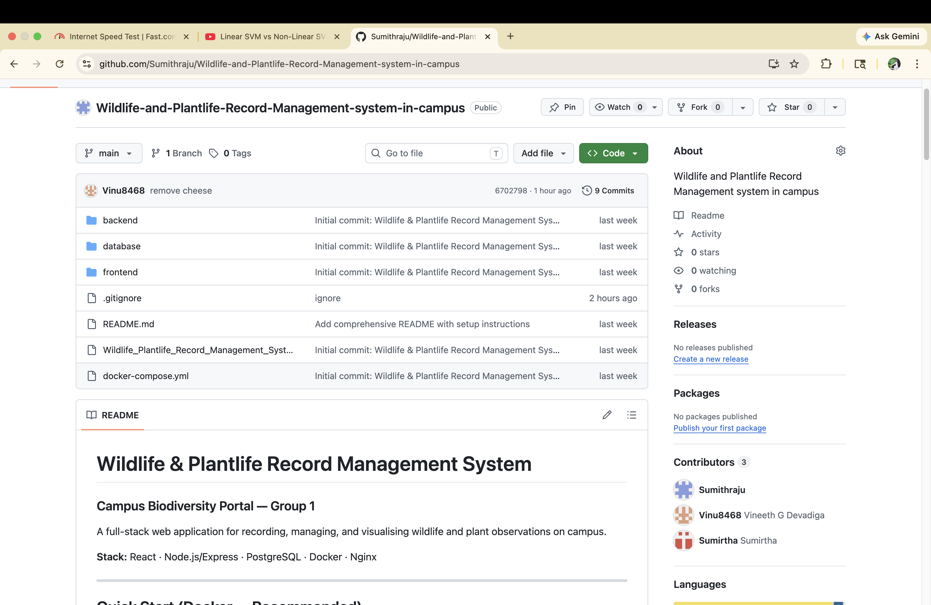
Figure 2: GitHub repository structure (backend, frontend, database modules)

3. Team Contributions
The project was delivered by a three-member team, with clear ownership of each layer of the stack. Weekly sync meetings and shared commits on GitHub kept integration smooth across the frontend, backend, and database modules.

3.1 Contributors Overview
Member | Module | Area of Ownership
Sumirtha | Frontend | React UI, pages, components, API integration
Sumithra | Backend | Node.js / Express API, authentication, business logic
Vineeth | Database | PostgreSQL schema, queries, seed data, integrity

3.2 Frontend — Sumirtha
Sumirtha built the entire client-side of the application using React and Vite.
- Designed and implemented the Campus Biodiversity Portal UI with a green-themed layout.
- Built pages for Wildlife, Plants, Map, Dashboard, Users, and Login / Register.
- Implemented forms for creating and editing wildlife and plant records, including validation.
- Integrated the map view for visualising observations using latitude / longitude.
- Set up the Axios API client and the AuthContext for JWT-based session handling.
- Wrote React Testing Library tests for key components and user flows.
- Configured Nginx for serving the production build inside Docker.

3.3 Backend — Sumithra
Sumithra built the server-side REST API with Node.js and Express.
- Designed and implemented all REST endpoints under /api/auth, /api/wildlife, /api/plants, and /api/users.
- Implemented JWT-based authentication and role-based middleware (Admin, Researcher, Viewer).
- Added bcrypt password hashing and a resetPasswords.js utility for demo accounts.
- Configured Multer to support image uploads for observation records.
- Wrote Jest + Supertest tests for authentication and CRUD endpoints.
- Authored the backend Dockerfile and integrated the service into docker-compose.

3.4 Database — Vineeth
Vineeth designed and maintained the PostgreSQL database that powers the application.
- Authored init.sql with tables for users, wildlife_records, and plant_records.
- Defined ENUM types for user roles and IUCN conservation status.
- Added triggers to auto-update timestamp columns (updated_at).
- Wrote seed.sql with 5 demo users, 30 wildlife records, and 25 plant records.
- Tuned indexes on frequently queried columns (species, observation_date) for performance.
- Configured pgAdmin inside Docker for easy database inspection.

3.5 Screenshot — README Setup Section
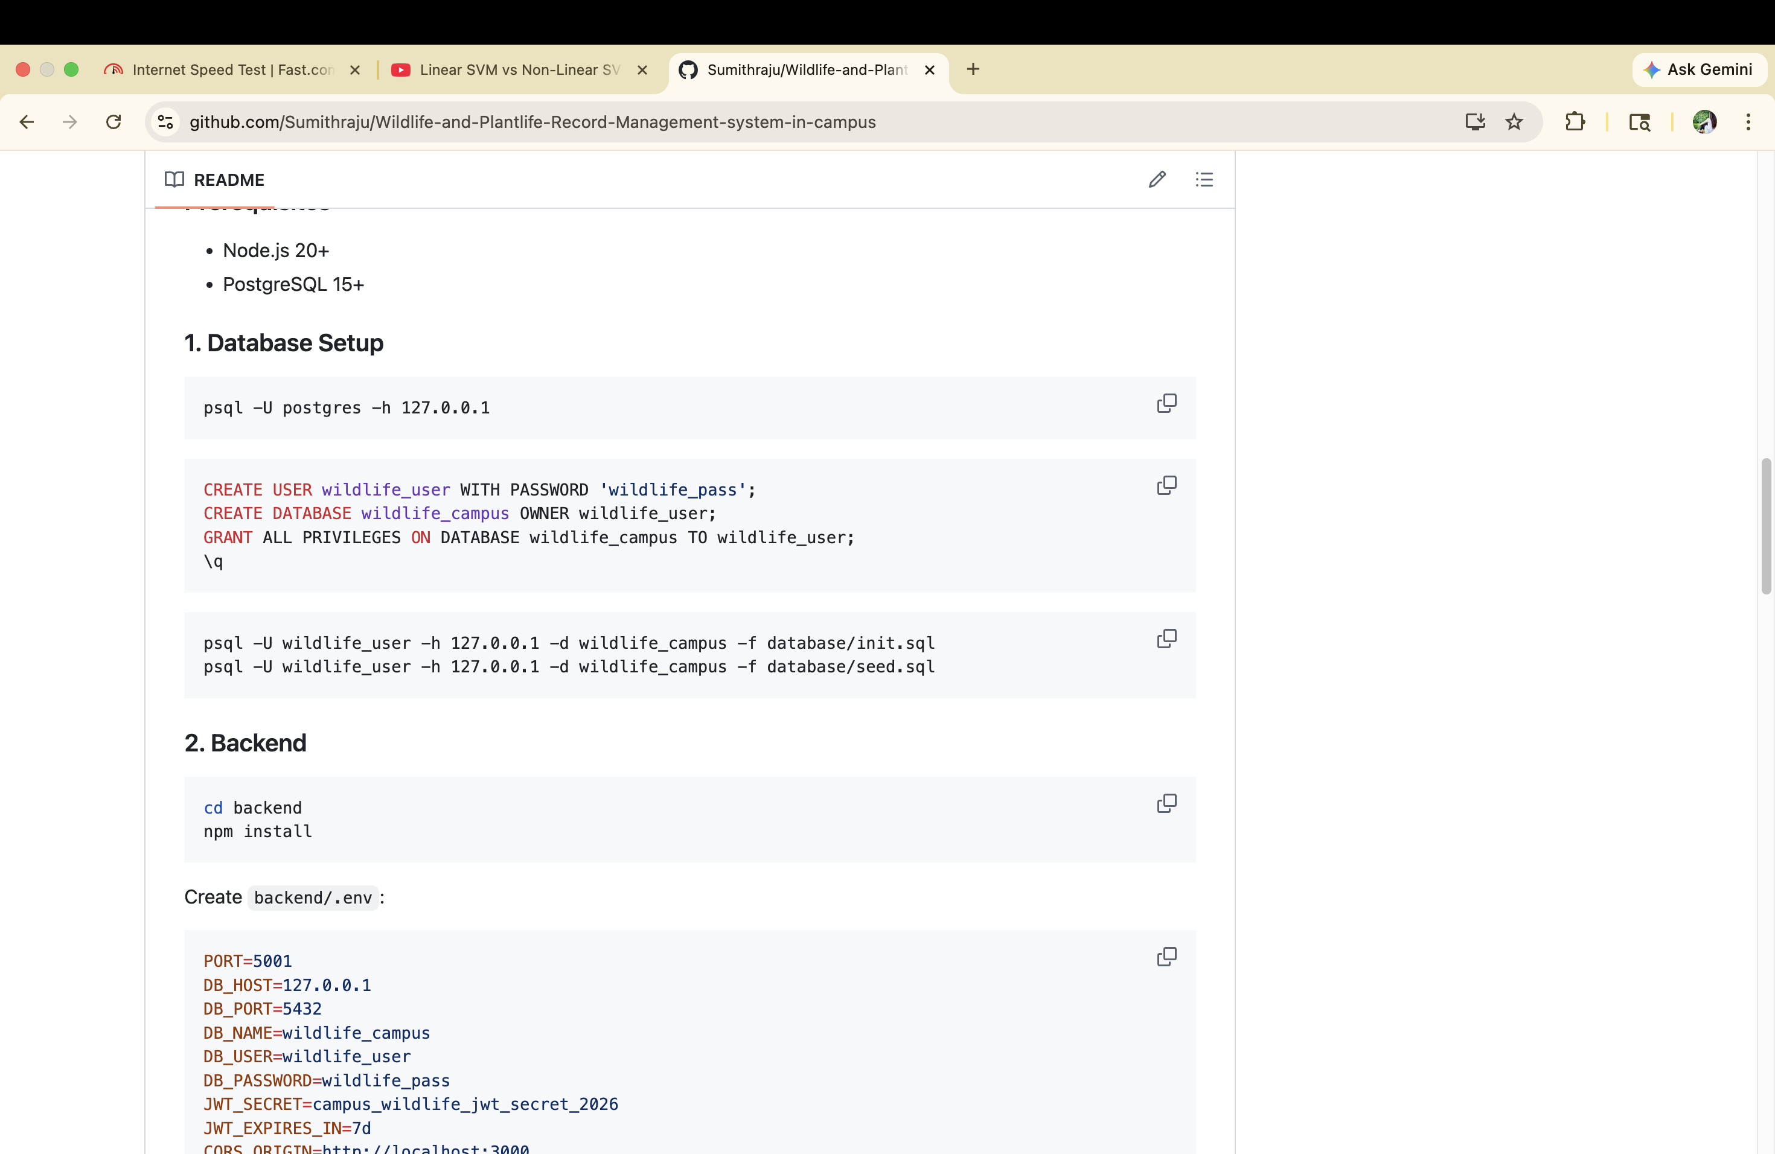
Figure 3: README showing database and backend setup steps

4. Future Improvements & How to Run Locally

4.1 Future Improvements
The current release meets the core requirements of the project. The following enhancements are planned to make the system more powerful, more accessible, and more useful for real conservation work on campus.
- Mobile app (React Native or PWA) so observations can be logged directly in the field.
- Automatic species identification using an image-classification model.
- Offline mode with local caching and later sync to the server.
- Advanced analytics — species diversity indices, seasonal trends, and heat maps.
- Export to CSV, Excel, and PDF for reports and academic use.
- Email notifications when new rare species are recorded.
- Integration with external biodiversity databases (GBIF, iNaturalist).
- Multi-campus support with per-campus datasets.
- Audit logs capturing every create / update / delete for research integrity.
- Continuous integration pipeline (GitHub Actions) running tests on every pull request.

4.2 How to Run Locally

Option A — Docker (Recommended)
Runs the entire application (frontend, backend, database, pgAdmin) with a single command. Only Docker Desktop is required.
# 1. Start everything
docker compose up --build -d

# 2. First-time only: reset demo account passwords
docker exec -it wildlife_backend node scripts/resetPasswords.js

# 3. Stop when finished
docker compose down
Once the containers are running, the application is available at:
Service | URL
Frontend | http://localhost:3000
Backend API | http://localhost:5002
pgAdmin | http://localhost:5050
PostgreSQL | localhost:5433

Option B — Local Development (Without Docker)
Requires Node.js 20+ and PostgreSQL 15+ installed locally.
Step 1 — Database setup:
psql -U postgres -h 127.0.0.1
CREATE USER wildlife_user WITH PASSWORD 'wildlife_pass';
CREATE DATABASE wildlife_campus OWNER wildlife_user;
GRANT ALL PRIVILEGES ON DATABASE wildlife_campus TO wildlife_user;
\q
psql -U wildlife_user -h 127.0.0.1 -d wildlife_campus -f database/init.sql
psql -U wildlife_user -h 127.0.0.1 -d wildlife_campus -f database/seed.sql
Step 2 — Backend:
cd backend
npm install
Create a file named backend/.env with the following contents:
PORT=5001
DB_HOST=127.0.0.1
DB_PORT=5432
DB_NAME=wildlife_campus
DB_USER=wildlife_user
DB_PASSWORD=wildlife_pass
JWT_SECRET=campus_wildlife_jwt_secret_2026
JWT_EXPIRES_IN=7d
CORS_ORIGIN=http://localhost:3000
node scripts/resetPasswords.js
npm run dev
The backend now runs at http://localhost:5001.
Step 3 — Frontend:
cd frontend
npm install
npm run dev
The frontend now runs at http://localhost:3000.

4.3 Demo Login Credentials
Role | Email | Password
Admin | admin@campus.edu | Admin@123
Researcher | sarah.chen@campus.edu | Research@123
Researcher | james.ok@campus.edu | Research@123
Researcher | priya.s@campus.edu | Research@123
Viewer | viewer@campus.edu | Viewer@123

4.4 Live Demo (IBAB Network)
The application is hosted on a MacBook Air M4 registered with the IBAB institute network. No setup is required on the viewer's side — just open a browser on any device connected to the IBAB network.
http://10.52.92.90:3000

4.5 API Endpoints
Method | Endpoint | Description | Auth
POST | /api/auth/login | Login | Public
POST | /api/auth/register | Register | Public
GET | /api/wildlife | List wildlife records | Required
POST | /api/wildlife | Create wildlife record | Researcher
PUT | /api/wildlife/:id | Update record | Researcher
DELETE | /api/wildlife/:id | Delete record | Admin
GET | /api/plants | List plant records | Required
POST | /api/plants | Create plant record | Researcher
PUT | /api/plants/:id | Update record | Researcher
DELETE | /api/plants/:id | Delete record | Admin
GET | /api/users | List users | Admin

4.6 Running Tests
Backend:
cd backend
npm test
Frontend:
cd frontend
npm test
— End of Documentation —

