**DATA ANALYTICS WITH TABLEAU**

**INTRODUCTION**

* 1. **OVERVIEW**

Data analytics is a broad term that encompasses many diverse types of data analysis. Any type of information can be subjected to data analytics techniques to get insight that can be used to improve things. Data analytics techniques can reveal trends and metrics that would otherwise be lost in the mass of information. This information can then be used to optimize processes to increase the overall efficiency of a business or system.

Data analytics can do much more than point out [bottlenecks](https://www.investopedia.com/terms/b/bottleneck.asp) in production. Gaming companies use data analytics to set reward schedules for players that keep the majority of players active in the game. Content companies use many of the same data analytics to keep you clicking, watching, or re-organizing content to get another view or another click.

**PROJECT ENTITLED**

Plugging into the future : an exploration of electricity consumption patterns

* 1. **PURPOSE**

Big data analytics refers to collecting, processing, cleaning, and analyzing large datasets to help organizations operationalize their big data.

1. Collect Data

2. Process Data

3. Clean Data

4. Analyze Data

**PROBLEM DEFINITION & DESIGN THINKING**

**2.1 EMPATHY MAP**

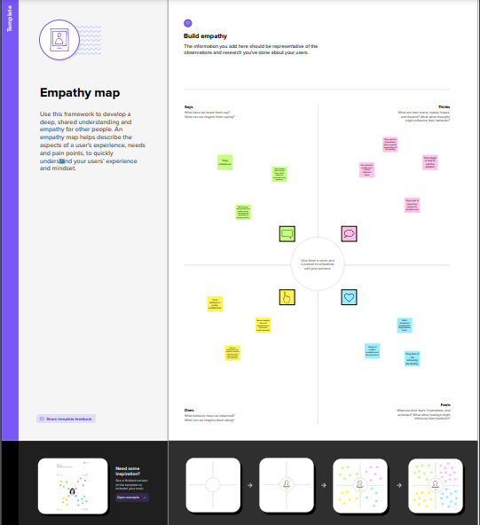

**2.2-IDEATION & BRAIN STORMING MAP**

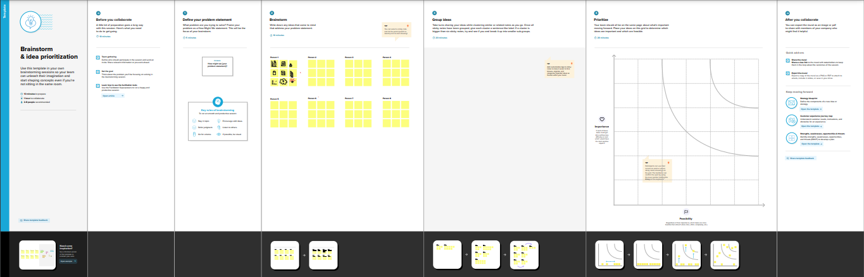

**RESULT**

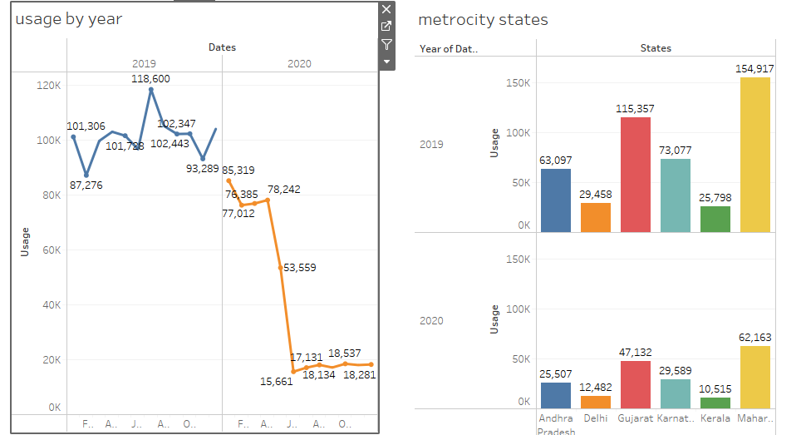





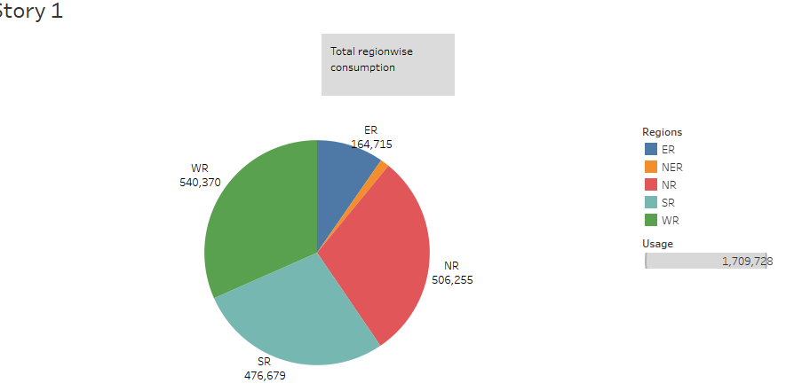

**ADVANTAGES & DISADVANTAGES**

## ADVANTAGES

## **Data visualization**

## **Ease of Implementation**

## **Quickly Create Interactive visualizations:**

## **Can handle large amounts of data**

**DISADVANTAGES**

* **Scheduling or notification of reports**
* **No Custom Visual Imports**
* **Custom formatting in Tableau**
* **Static and single value parameters**

**APPLICATIONS**

* Transportation
* Logistics and Delivery
* Web Search or Internet Web Results
* Manufacturing
* Security
* Education
* Communication, Media, and Entertainment

**CONCLUSION**

The use of Analytics is taking incredible walks on practically all roads over the globe. On the off chance that we can get information and examine it, it can help in expanding our general occupation productivity to a ton. Improving productivity also increases the overall profitability of the company as well as reduces the number of errors and uncertainty. Whenever utilized correctly, data analytics can achieve a significant positive effect on our general public and world everywhere and increment the general efficiency of specific areas.

To solidify Data Analysis & Management concepts, you should check out our [Integrated Program In Business Analytics](https://u-next.com/integrated-program-in-business-analytics/), in collaboration with IIM Indore. This 10-month online live program is easy to understand and designed by highly experienced experts to help learners become Future Leaders and transition into leadership roles.

**FUTURE SCOPE**

Data Analytics helps government organizations and companies in collecting data and identifying patterns in that data. These extensive insights into the data help organizations in decision-making that is based on the data, therefore automating the process. [**Data Analytics Courses**](https://emeritus.org/in/programmes/data-analytics-courses/) are transforming businesses and reducing the time and cost invested in making quick decisions.

Companies have experienced a significant impact because of the data analytics industry, especially in their day-to-day businesses. Data analytics courses online have allowed industries to automate several aspects of their businesses.

Data is the new oil, and so government organizations and companies are focusing on it to make better products and deliver higher-quality services. Indian companies have been estimated to send 2 billion US Dollars in the financial year of 2021, recording an 11.5% growth.

**APPENDIX**

1. Github
2. Tableau
3. My SQL
4. Mural