CONFIDENTIAL

Project name: Event management System

Class Design Specification

DOCUMENT VERSION HISTORY

Document Version | Date Issued | Comments
1.0 | 02-04-2012 | First version of the Web Portal

Table of Contents

Table of Contents 2
Class Design
1 Introduction 3
2 Conventions followed 3
3 Class Diagrams 4

Introduction

The class diagram is the main building block of object oriented modelling. It is used both for general conceptual modelling of the systematics of the application, and for detailed modelling translating the models into programming code. Class diagrams can also be used for data modeling. The classes in a class diagram represent both the main objects and or interactions in the application and the objects to be programmed. In the class diagram these classes are represented with boxes which contain three parts:
A class with three sections:
- The upper part holds the name of the class
- The middle part contains the attributes of the class
- The bottom part gives the methods or operations the class can take or undertake

Conventions followed

Hungarian Convention

Class Diagrams

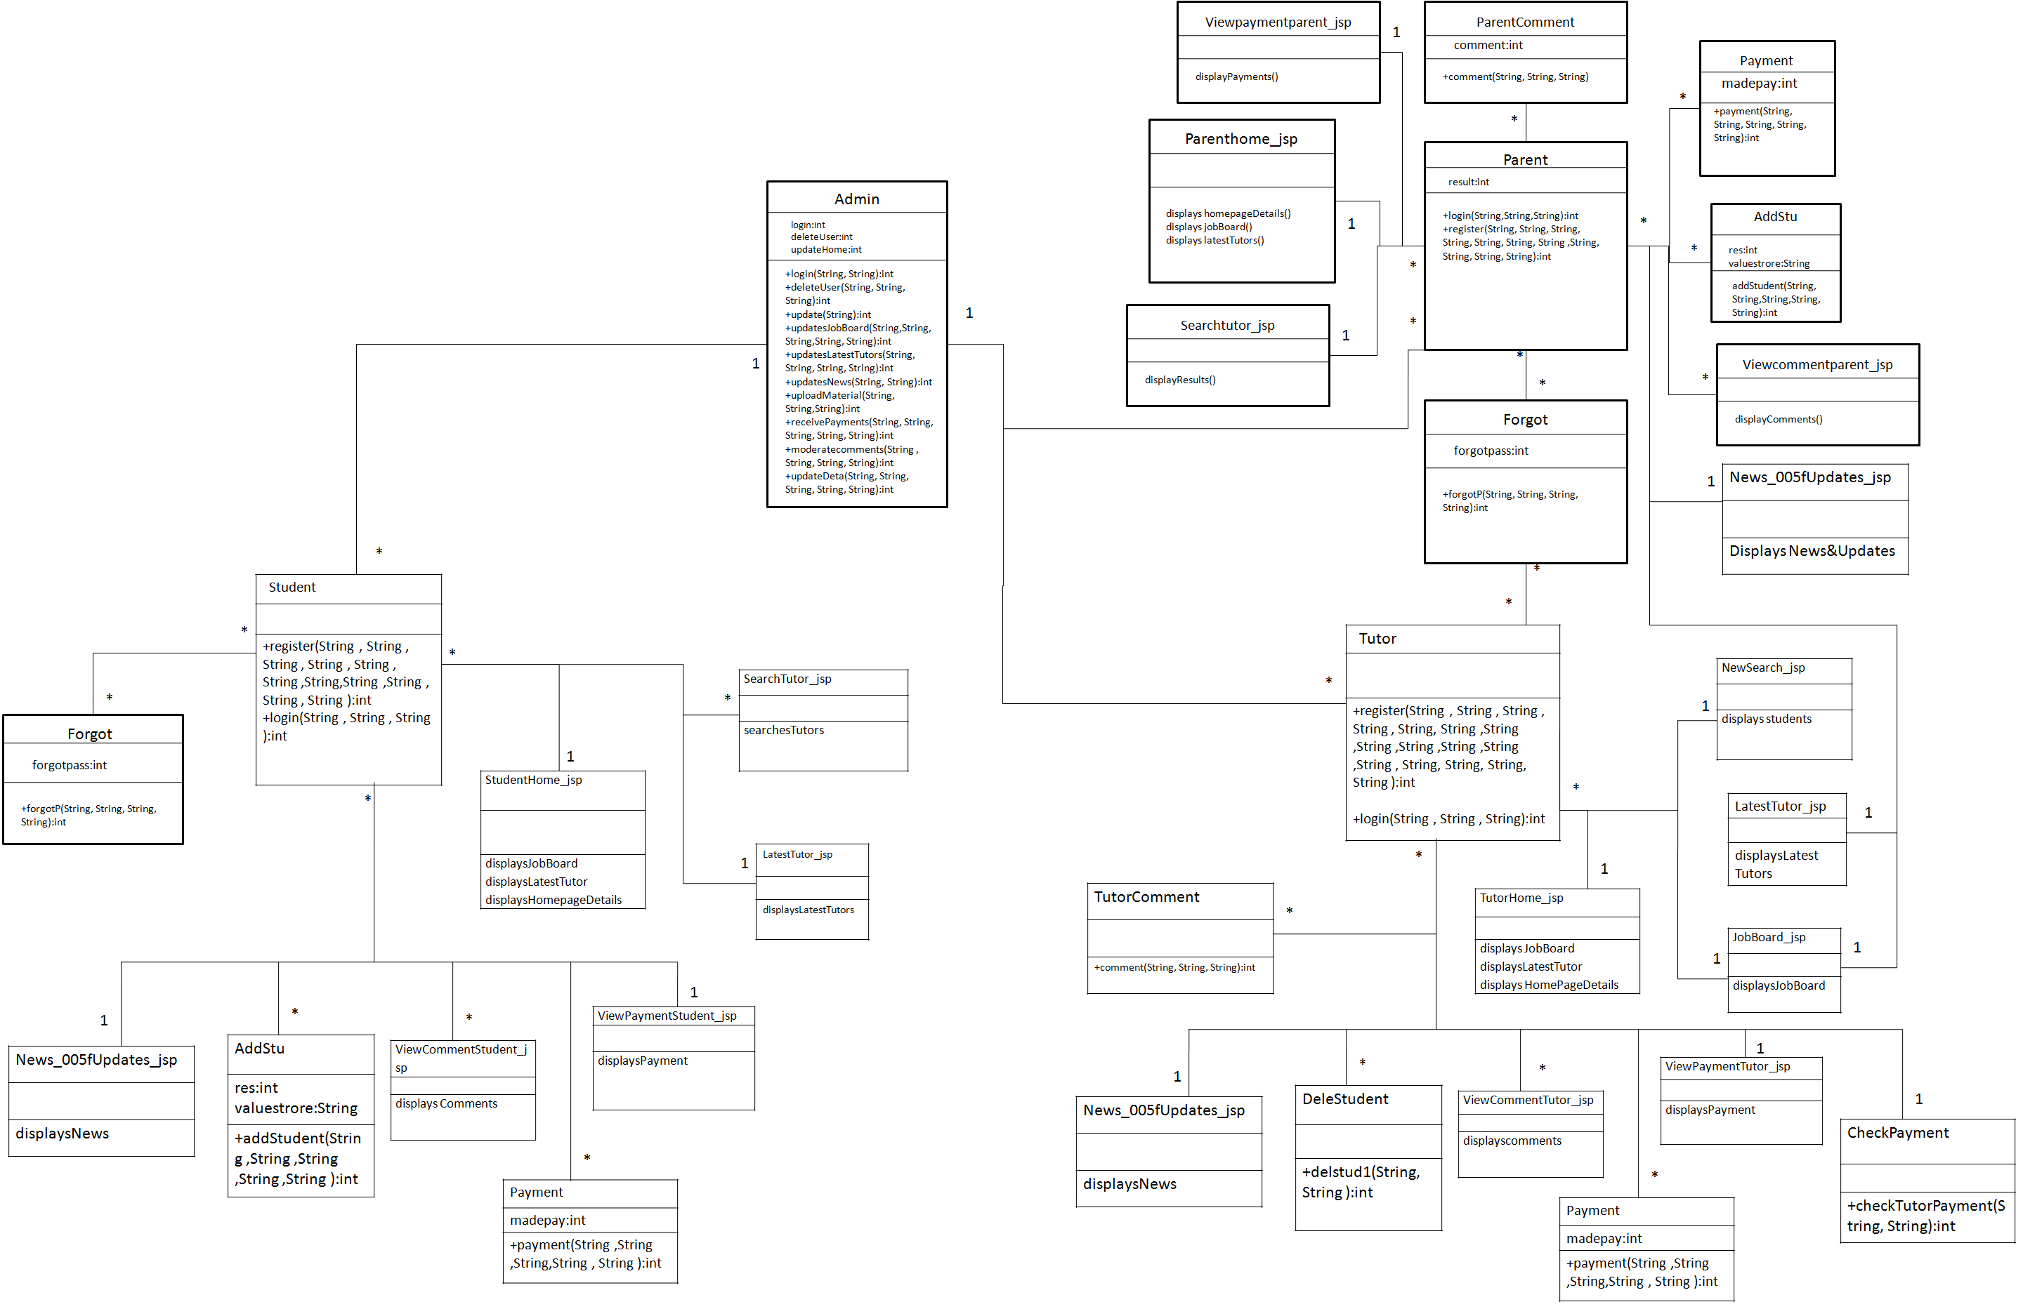

Classes

Admin

Class Description :
The Admin class holds those attributes and functions which may be used for the functioning of the system. The admin manages user. The admin uploads online materials and moderates comments.

Methods
 | Function | OutPut Parameters | Description
1 | deleteUser(String, String, String) | int | This function deletes the existing user from the database
2 | login(String, String) | int | checks for the authentic username and password and provides the login
3 | updateDeta(String, String, String, String, String) | int | the admin make changes in the user details, Specifications, etc
4 | uploadMaterials(String, String, String) | int | the admin uploads materials which can be accessed online or downloaded and can be used by user for events.
5 | update(String) | int | the admin keeps the website updated by updating the home page details

User

Class Description :
The User class contains the attributes and related functionality for the users

Methods
 | Function | OutPut Parameters | Description
1 | User(String, String, String, String, String, String, String, String, String, String, String) | int | registers the new User in the portal
2 | login(String, String,String) | int | authenticates the user to login

Forgot

Class Description :
The Forgot class enables the user to reset his username and password if he/she has forgot it.

Methods
 | Function | OutPut Parameters | Description
1 | forgot(String, String, String, String) | int | This function enables the user to reset his password.  updates password to the new one.

StudentHome_jsp

Class Description :
This class holds the business logic to display the values stored in the database.

Methods
 | Function | OutPut Parameters | Description
1 | displaysJobBoard | displays the JobBoard
2 | displayLatestTutor | displays the Latest Tutors
3 | displaysHomePageDetails | displays the homepage details

SearchTutor_jsp

Class Description :
This class holds the business logic to display the values stored in the database.

Methods
 | Function | OutPut Parameters | Description
1 | searchesTutors | displays the list of tutor’s on the searched query

LatestTutor_jsp

Class Description :
This class holds the business logic to display the values stored in the database.

Methods
 | Function | OutPut Parameters | Description
1 | displayLatestTutors | displays the latest tutors added in the portal

News_005fUpdates_jsp

Class Description :
This class holds the business logic to display the values stored in the database.

Methods
 | Function | OutPut Parameters | Description
1 | displayNews | displays the latest news subjects and their links

AddStu

Class Description :
This class holds the business logic to display the values stored in the database.

Methods
 | Function | OutPut Parameters | Description
1 | addStudent(String, String, String, String, String) | int | enables the student to get added in the batch of the particular tutor

Viewcommentstudent_jsp

Class Description :
This class holds the business logic to display the values stored in the database.

Methods
 | Function | OutPut Parameters | Description
1 | displayComments | displays the comments done by the tutor on the student

Payment

Class Description :
This class holds the business logic to display the values stored in the database.

Methods
 | Function | OutPut Parameters | Description
1 | payment(String, String, String, String, String) | int | enables the student to make payments to study under a particular tutor, or download a material

ViewpaymentStudent_jsp

Class Description :
This class holds the business logic to display the values stored in the database.

Methods
 | Function | OutPut Parameters | Description
1 | displayPayment | displays the payment done by the student for various reasons

1 | displayNews | displays the latest news subjects and their links

DeleSudent

Class Description :
This class enables the tutor to delete the student from the batch.

Methods
 | Function | OutPut Parameters | Description
1 | delstud1(String, String) | int | enables the tutor to delete the student from the Batch

ViewcommentTutor_jsp

Class Description :
This class holds the business logic to display the values stored in the database.

Methods
 | Function | OutPut Parameters | Description
1 | displayComments() | displays the comments done by the tutor on the parent’s ward

Payment

Class Description :
This class enables the tutor to store payments done by the tutor.

Methods
 | Function | OutPut Parameters | Description
1 | payment(String, String, String, String, String) | int | enables the tutor to make payments to take classes.

ViewpaymentTutor_jsp

Class Description :
This class holds the business logic to display the values stored in the database.

Methods
 | Function | OutPut Parameters | Description
1 | displayPayment | displays the payment done by the tutor for various reasons

TutorComment

Class Description :
This class enables the tutor to comment on the performance of the particular student.

Methods
 | Function | OutPut Parameters | Description
1 | comment(String, String, String) | int | enables the tutor to comment on the particular student

CheckPayment

Class Description :
This class enables the tutor to check for payments made by the Tutor.

Methods
 | Function | OutPut Parameters | Description
1 | checkTutorPayment(String, String) | int | enables the tutor to check for the payments made

